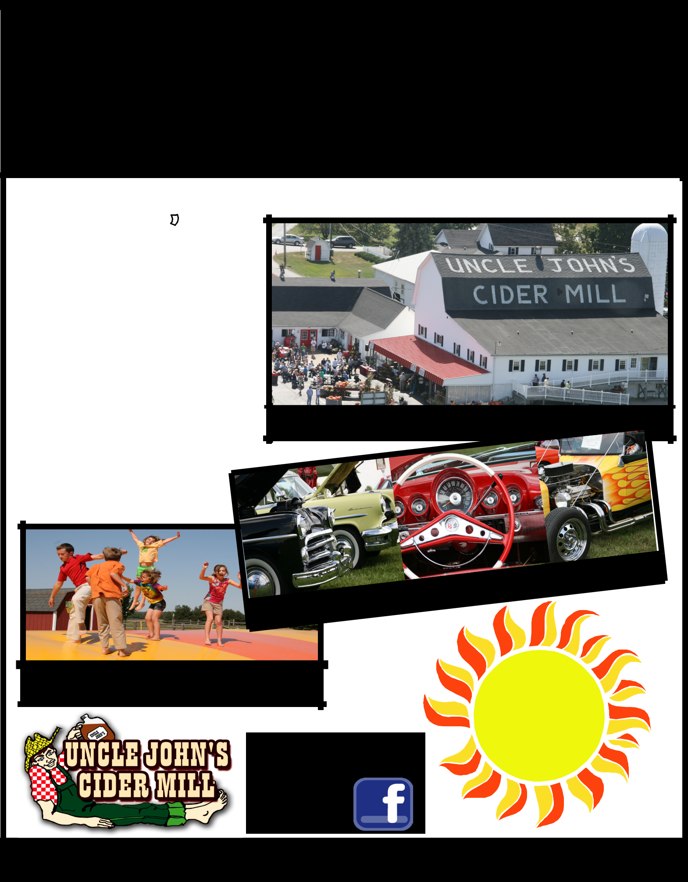
UNCLE JOHN'S CIDER MILL - ST. JOHNS
CAR SHOW

SUN AUG 31, 2014

Join us for our Annual Car Show at Uncle John’s Cider Mill - St. Johns. Registration from 9-12 pm, Awards given out at 3 pm
$5 REGISTRATION INCLUDES:

Voting Rights for the top 10 Car Awards Dash plaque (first 250 ppl)

Coupon for a Glass of Cider & a Donut Ticket for Prizes & Specials
Swap Meet Vendors?

Conntact Becky at 989-224-3686

Bring the Family, Enjoy the Fun!

Great location, 30 min. north of Lansing on US 127

Toy Store, | Candy, | Gifts, Bakery | & More!

Family Fun: Jumping Pillow, Kids Corral, Pony Hops Gemstone Mining & Much More!

MORE FAMILY FUN? 

Follow us on Facebook for details!

$ 5
REGISTRATION

PER CAR

8614 N US 127 ST JOHNS MICHIGAN 989-224-3686 www.ujcidermill.com

