2019 Fiesta Days CAR SHOW
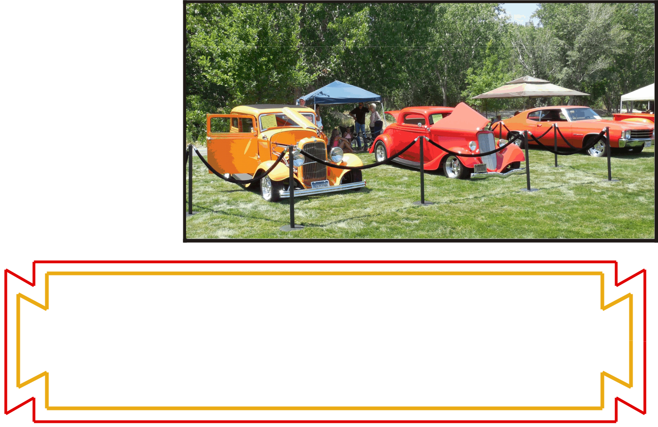

Saturday, July 20
Spanish Fork Sports Park – 493 West Volunteer Drive
(Approximately 1000 S; turn west at light from Main Street)

7 a.m. Registration & Shine, 9 a.m. Car Show Begins

SCHEDULE:

- Live band – CryWolf (a great 4-piece accoustic band) 11 a.m. to 1:30 p.m.

- Classic rock will be playing when the band is not performing.

- Food – Several vendors will be at the Sports Park during the Car Show – Food, treats and cold drinks for purchase.

- 2 p.m. – Car Show ends

- 2 p.m. – Awards will be announced.

- Hang out and make a day of music, food, friends & car fun!
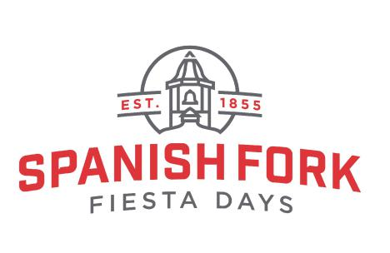

REGISTRATION & FEES:

- $20 for your 1st entry & $10 for each additional entry. A T-shirt will be given to the first 100 entries. Pre-registration is recommended.

- Pre-registration available through July 18 at 5 p.m. After this date, day of event registration begins at 7 a.m. on July 20 (Details on Entry Form)

Car Show Entry Form & Information on the back of this flyer.
Complete Fiesta Days information at sfFiestaDays.com .

