Central LakeArea ChamberofCommerce
Car Show
— DOWNTOWN CENTRAL —
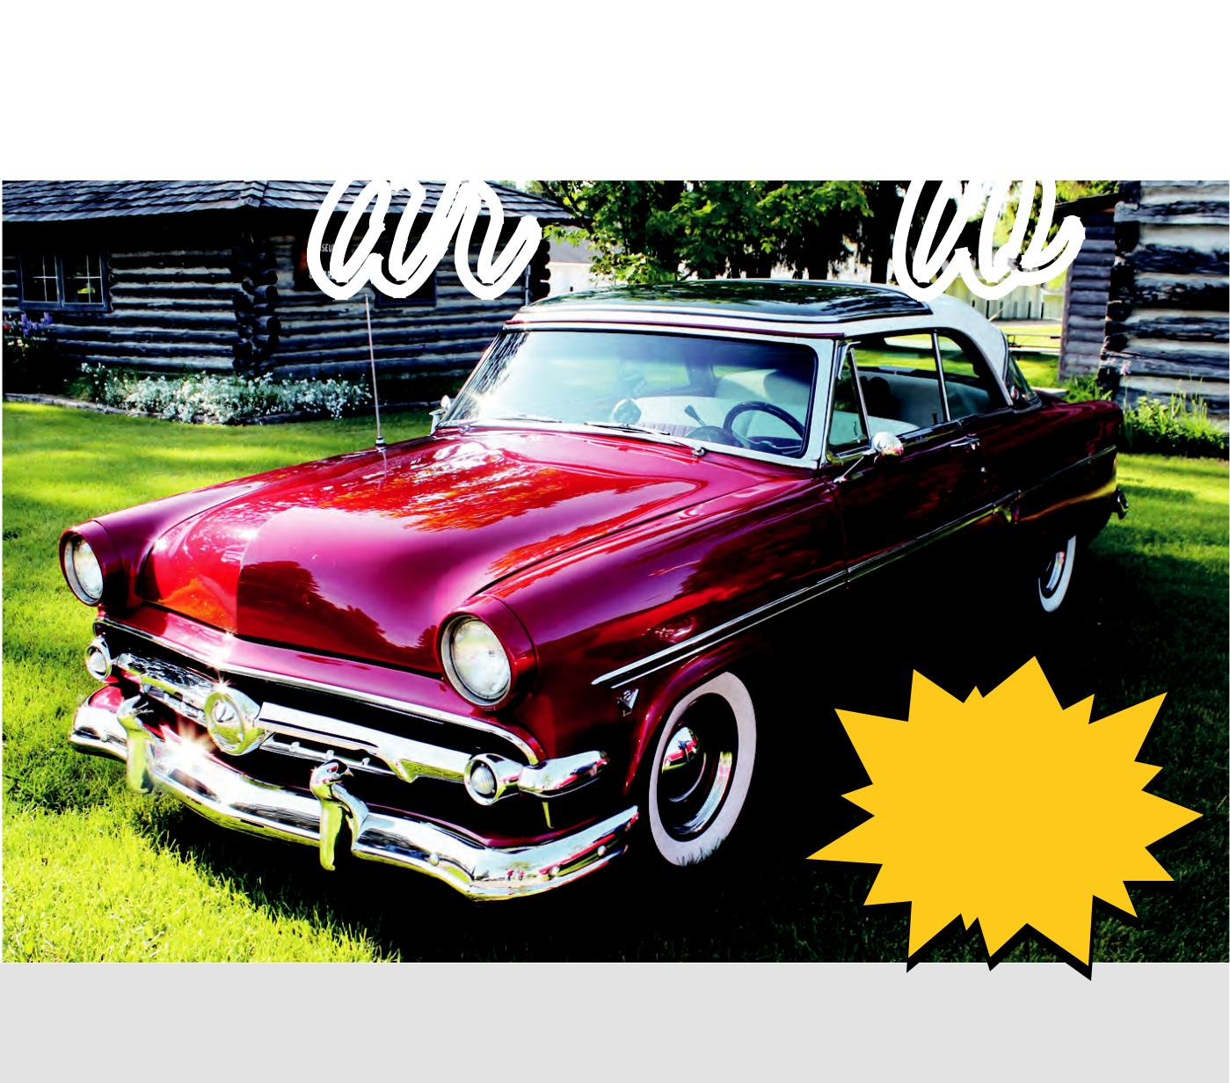

Always
Held 2nd
Saturday
In June!

JUNE 8, 2019 10:00 AM

Trophies

- Door Prizes

$10.00 Entry Fee · Pre-Register by June 1, 2019 · $20.00 Day of Show

All Registration Starts at 8:00 a.m. · Show Starts at 10:00 a.m.

CHECK-IN AT SAGE PARK

Downtown between Bachmann’s and Patton’s Insurance


EVERYONE WELCOME! FREE SPECTATOR ADMISSION!

For more info, contact:

Melissa Zelenak (231.350.1778 or MelissaZelenak@icloud.com)

or visit the Chamber Web Page (centrallakechamber.com)

(you can download and print form from the website)

Music By
Kenny

Thompson

DAY OF SHOW!

 facebook.com/CentralLakeCarShow

CentralLakeChamber.com

Dear Central Lake Car Show Registrants,

Please save the date for the second Saturday in June for the car show this year! While I told you last year at the show that we were changing the date, we discovered that the new date con icts with another important hometown event nearby.

Many of the people who visit our car show or enter their vehicles participate in that event and we do not want people having to choose which event they will go to. We want people to enjoy both events at their leisure and have fun visiting both communities on non-con icting days.

I deeply apologize if the date switch is an inconvenience to you and am ever hopeful you will visit CL as in years past. I know some folks plan their show calendars in advance but please know how important you are to our little town and car show, just as our locals and community goodwill are. I promise you that the CL Car Show team will strive to bring you the best 2019 CL Car Show ever--on the second Saturday of June from here on out.

See you on June 8, safe travels :)

MZ

231.350.1778

MelissaZelenak@icloud.com
Central Lake Area Chamber of Commerce
you can download and print form from the website.


Always — DOWNTOWN CENTRALLAKE —
Held 2nd
Car Show DAY OF SHOW!
Saturday
In June! | Music By

Kenny
Thompson


— Watch the Central Lake Car Show Page for Updates —

$10.00 Entry Fee · Pre-Register by June 1, 2019 · Late Registration $20.00 All Registration Starts at 8:00 a.m. · Show Starts at 10:00 a.m. CHECK-IN AT SAGE PARK · Downtown between Bachmann’s and Patton’s Insurance

Year Make

Model

Special Features

Name

Address

Mailing Address (if different)

City State Zip

Phone

Email

(The Central Lake Chamber DOES NOT SHARE email information with any other organization)

I would like to pre-order (qty) 2019 Car Show Shirt(s). Size(s):


(Shirts are $15.00 each. Pay and pickup day of show – they will be held with your registration paperwork at sign in table)
☛ Mail Check and Registration form by June 1, 2018 to:

Central Lake Chamber · PO Box 428 · Central Lake, MI 49622

JUNE 8, 2019
10:00 AM

EVERYONE WELCOME! FREE SPECTATOR ADMISSION!

For more info, contact: Melissa Zelenak (231.350.1778 or

MelissaZelenak@icloud.com or visit the Chamber Web Page:

centrallakechamber.com -

