VEHICLE PRE INSPECTION CHECK LIST

VEHICLE REG |  | DRIVER DETAILS
DATE & TIME TAKEN |  | PRINT NAME
DATE & TIME  RETURNED |  | SIGNATURE
DESTINATION |  | PURPOSE OF VISIT
If the engine oil warning lights come on during the course of the time you have the vehicle top up engine oil can be purchased using the pool car fuel card. In this instance ensure that you check you have purchased the correct engine oil for that particular make and model.
- Ensure that there is at least ¾ of a tank of fuel when you return the vehicle
- Ensure that the warning light on the dashboard goes out for coolant and engine oil
- Physically check that the wipers work and that there is windscreen wash in the bottle by operating the washer.
- Brakes – ensure that the warning light on the dashboard goes out and that the brakes feel responsive during normal driving.
- Turn all of the vehicle lights on and check that no bulbs need replacing.
- Check that the indicators work correctly and that no bulbs need replacing.
In the event of a break down or a crash you need to contact ALD on 08000 32 32 77
If there are any faults with the vehicle prior to setting off you must make sure that they are reported and dealt with prior to undertaking your journey by contacting the site transport department in the first instance. If there is no one available at site then you will need to contact ALD on 08000 32 32 77.

VISUAL INSPECTIONS (TICK)

 | Fuel (1) | Coolant (2) | Engine Oil (2) | Windscreen Wash (3) | Brakes (4) | Wipers (3) | Lights (5) | Indicators (6)
MON
TUES
WED
THURS
FRI
SAT
SUN

DRIVER DEFECT REPORT – What have you done? Who have you told?
Any damage to bodywork or any damage caused by an accident MUST be recorded in this space

DEFECT RECTIFICATION
ACTION TAKEN
RECTIFIED BY | DATE

Please mark any existing damage and get counter signed by a Manager before commencing your journey.

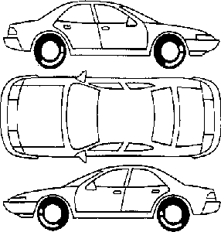

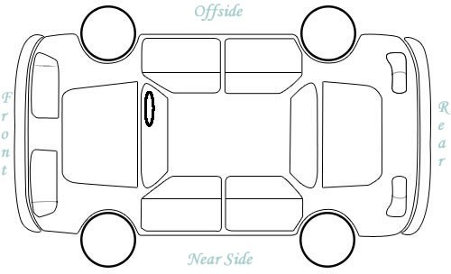

I have checked the vehicle as described above, the vehicle appears to be in a roadworthy condition. I have made myself familiar with the vehicle controls, I have a full and valid licence for this type of vehicle, I have supplied a copy of my licence to my HR department, I am aware of the Company Car and Fuel Policy (available on intranet or from HR), should I find any defects with the vehicle or be involved in an accident of any kind I will report this to my line manager or their deputy as soon as possible.

Signed Print

