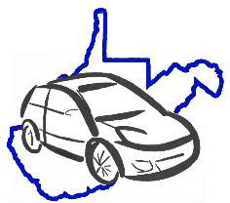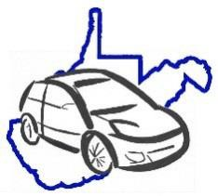

**Fleet Vehicle Inspection Checklist**

Page 1 of 1

**X** = Satisfactory **O** = Requires Attention

**DATES**

**VEHICLE INSPECTION:**

**PRE-START UP**

**am**

**pm**

**am**

**pm**

**am**

**pm**

**am**

**pm**

**am**

**pm**

**Comments:**

Check all fluids

(oil, washer, transmission)

**INTERIOR (Start Engine)**

Fuel Level

Horn

Sterring Wheel (Feel)

Foot Brake/Parking Brake

Registration / Insurance Cards

Heat/Defrost/AC

Interior Lights

Upholstery, Loose Objects

Seatbelts/Child Car Seats

First Aid Kit/Body Fluids Kit

Fire Extinguisher

Emergency (chains, flares, flashlight, blankets)

**WINDOWS/MIRRORS**

Wipers/Washers

Mirrors/Glass Clean/Clear View

**EXTERIOR**

Head Lights (High/Low)

Turn Signals (Front/Rear)

Emergency Flashers

Tires (Wear, PSI with gauge)

Spare Tire (Pressure)

Tail Lights/Back-Up Lights

Exhaust (Sound/Emmissions)

Dents / Scratches

**UNDER CARRIAGE**

Obvious Leaking fluids

Loose/Hanging Objects

**DRIVER'S INITIALS**

**Last 6 of VIN:**

**License Plate:**

**Odometer Reading:**

**Make and Model:**

**Driver Name:**

**Agency:**