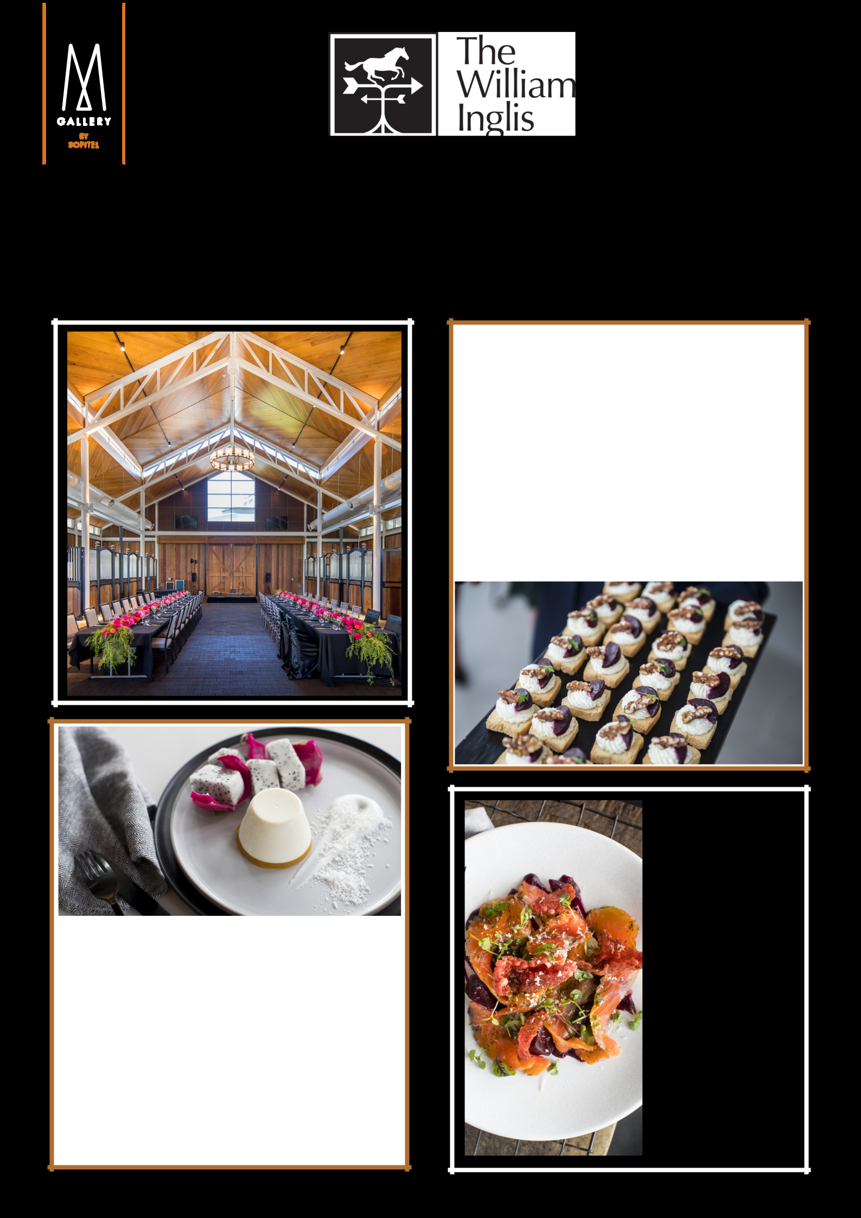

2018 CHRISTMAS PARTY PACKAGES

Dance the night away with your colleagues at your corporate Christmas party hosted at The William Inglis Hotel.

Speak to our team today: 9058 0312 or email hb042-sb@accor.com

Prancer's Plated package

$115 per person

3 course plated alternate drop

4.5 hour Bronze beverage package

5 hour room hire

Christmas Bonbons

Deck the Stalls Cocktail Package

$100 per person

2.5 hour Canape service

4 hour Bronze beverage package

4.5 hour room hire

Christmas Bonbons

Silly Season

Seafood Buffet

$125 per person

Christmas Seafood

buffet

4.5 hour Bronze

beverage package

5 hour room hire

Christmas Bonbons

