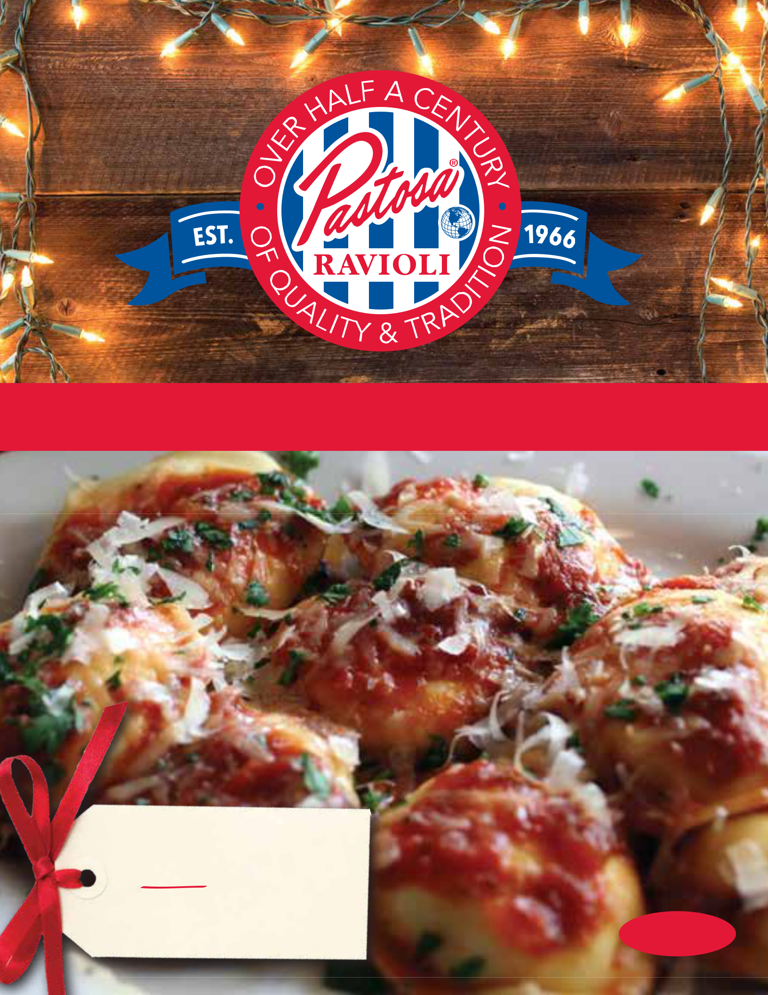

A HOMEMADE HOLIDAY JUST GOT EASIER

RECEIVE A
FREE BAG OF

CAVATELLI*
With Any $50 Purchase

Family Owned

& Operated

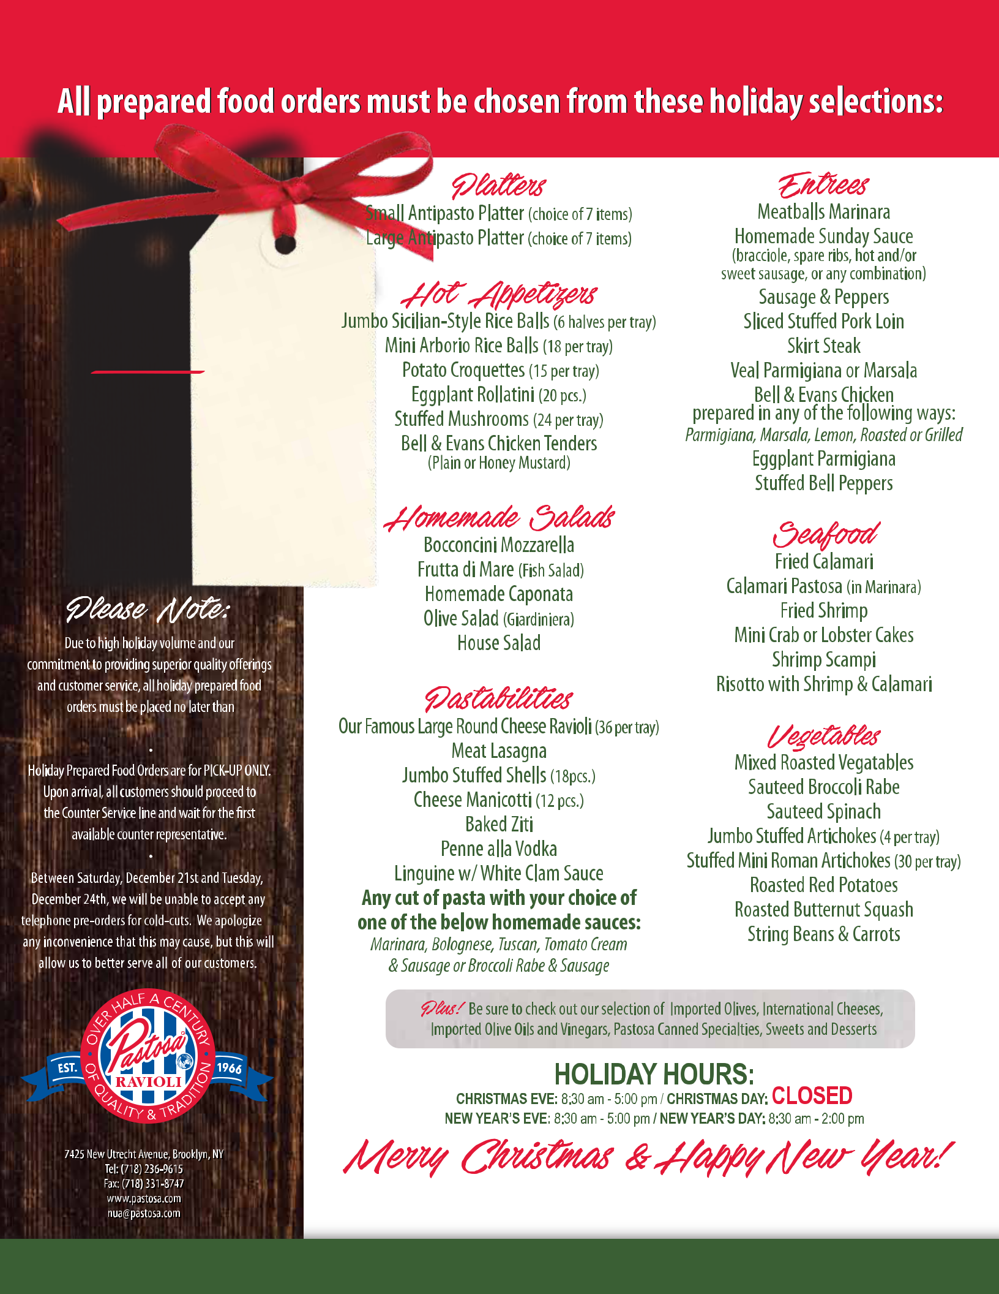
A HOMEMADE HOLIDAY JUST GOT EASIER

RECEIVE A

FREE

BAG OF

CAVATELLI*

With Any $50 Purchase

*O er valid only with this yer
at the New Utrecht Avenue (Brooklyn)
Pastosa location through 12/31/19.
Limit one bag of cavatelli per customer
while supplies last.

TUESDAY, DECEMBER 17th

REGULAR STORE HOURS:

Monday-Friday: 8:30 am-6:30 pm / Saturday:8:30 am-6:00 pm / Sunday: 8:30 am-3:00 pm

We ship our products nationwide via FedEx delivery services. Shop online at pastosa.com.

