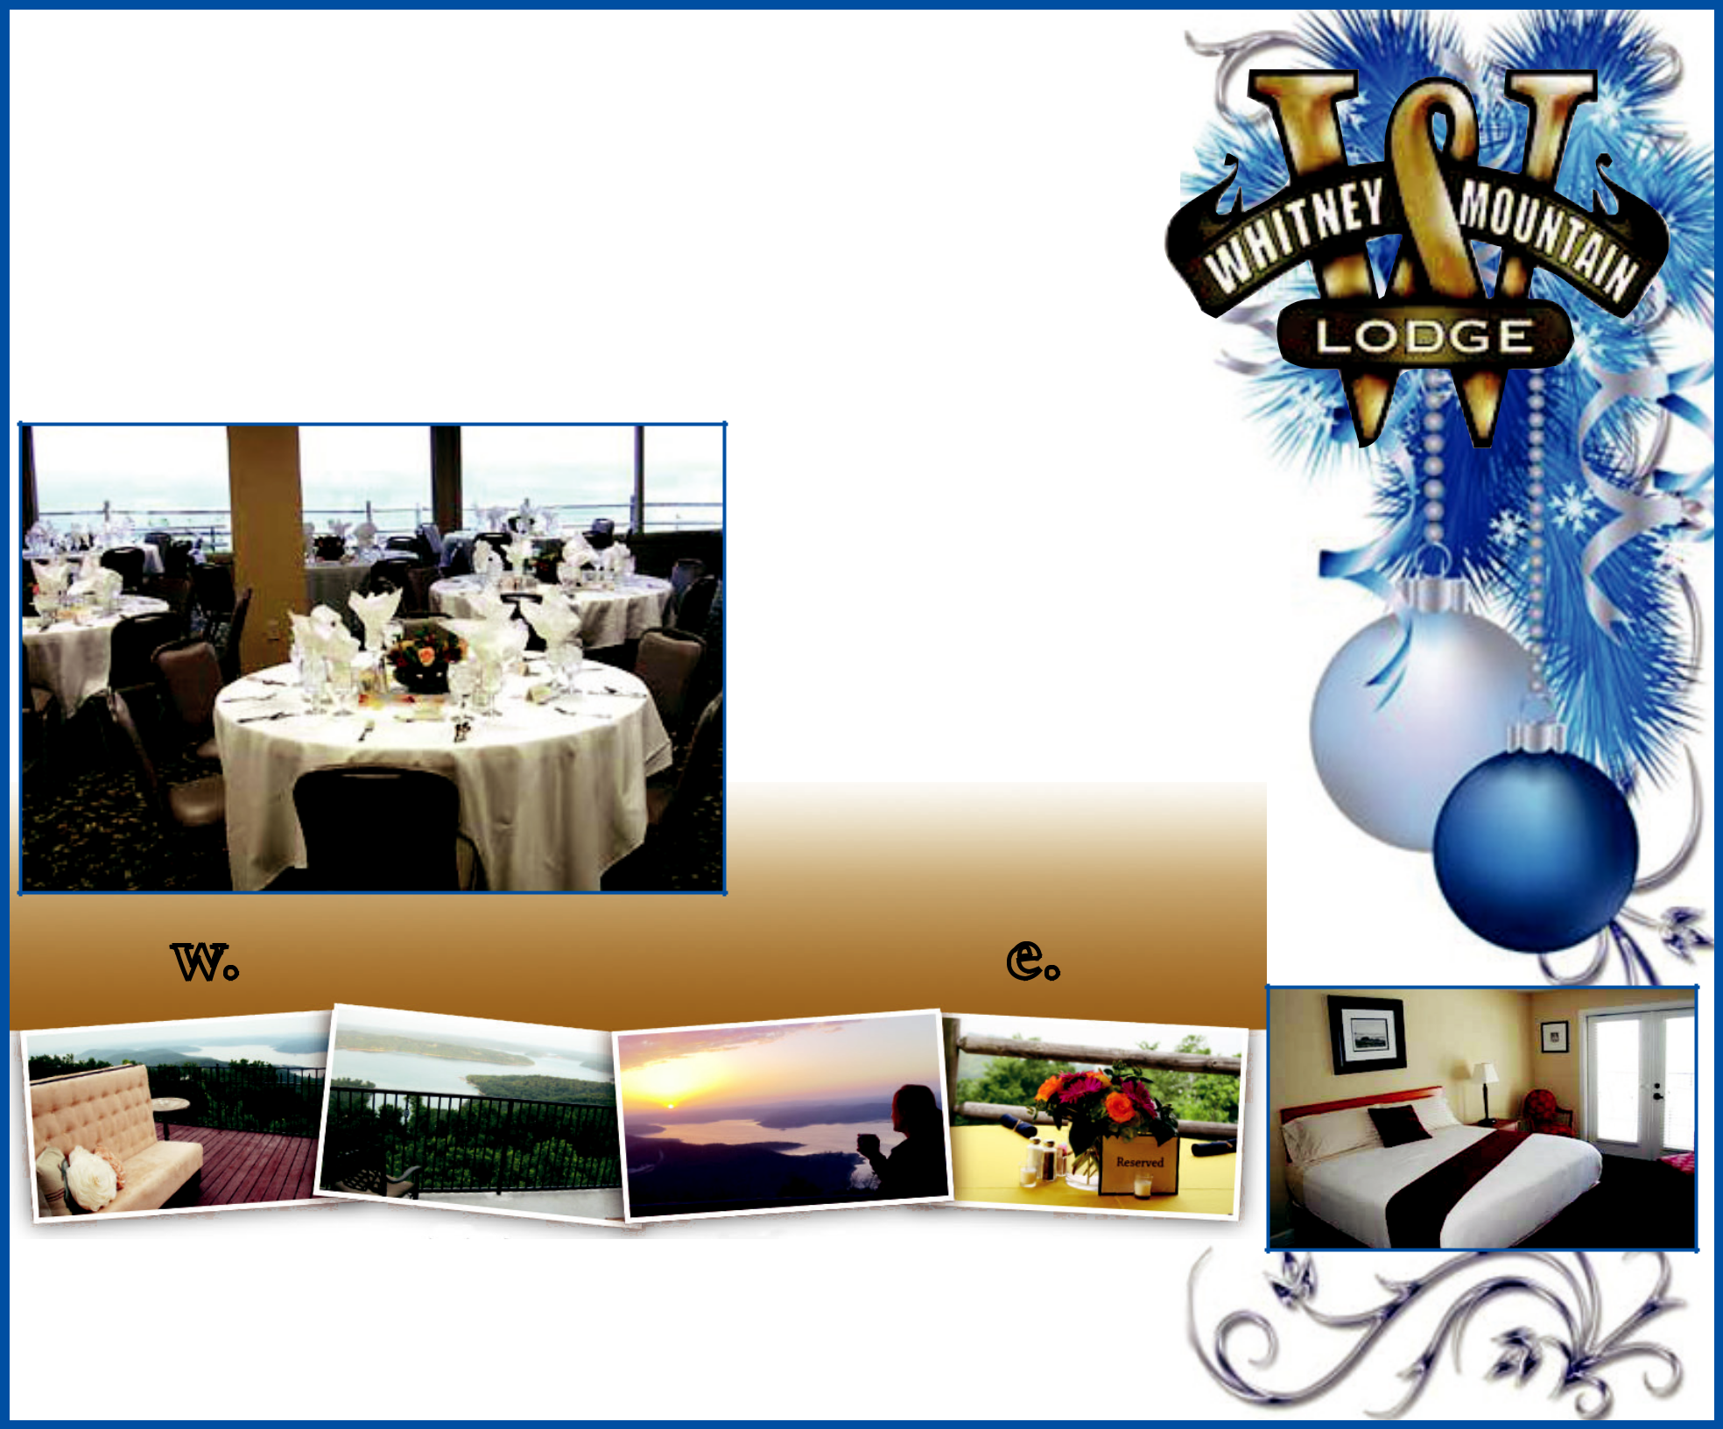
November & December dates still available - Christmas Party Perfection!

Only 20 Minutes from Rogers or Bentonville. Overlooking Beaver Lake from the Highest Point in Benton County. Inspiring Views from all Balcony Hotel Rooms & Meeting Areas.

Whitney Mountain Lodge is the
perfect setting for any event...

• Christmas Parties • Group Retreats • Corporate Retreats • Elegant or Casual Fundraisers • Family Reunions • Weddings & Receptions • Small or Large Private Parties • Special Romatic Getaways

www.whitneymountainlodge.com

Whitney Mountain Lodge

12483 Lodge Drive • Garfield, AR 72732

(479) 899-2432 Event Planning

