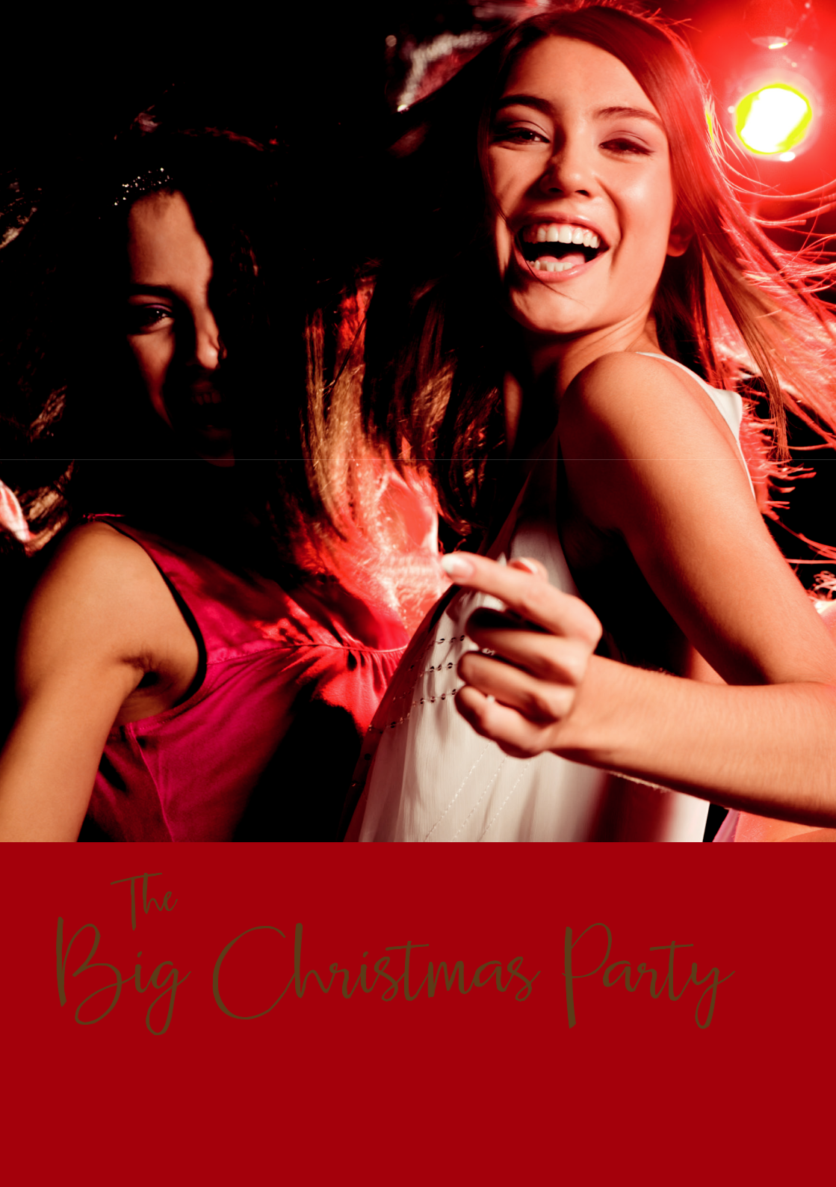

IN AVIEMORE

CHRISTMAS AT MACDONALD AVIEMORE RESORT

CHRISTMAS AT MACDONALD AVIEMORE RESORT


It’s time to start planning your big Christmas Night Out.

Celebrate in style with delicious food and drink, an incredible live band and a great atmosphere.
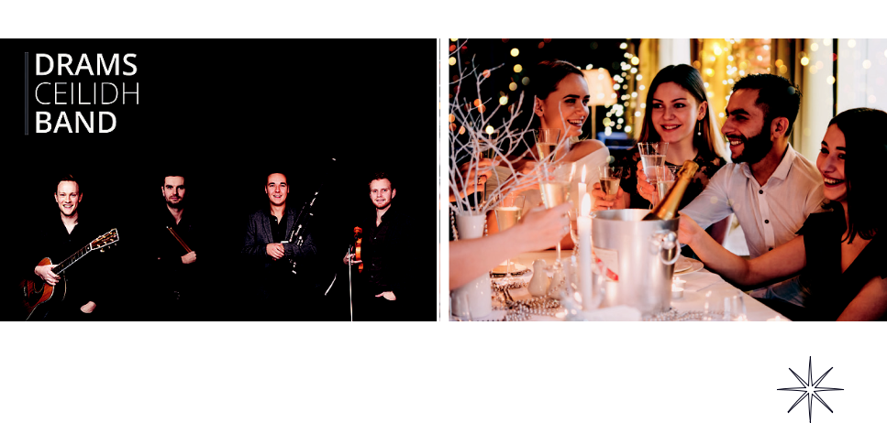

Saturday 14 December 2019



The Entertainment: Drams Ceilidh Band

The Food: 3 course choice menu plus tea/coffee and mince pies

The Drink: Half a bottle of house wine per person or soft drink alternative

The Price: Only £40 per ticket. Ticket and overnight stay from £75

Early Bird Offer: 10% discount for bookings made by 30th June



Looking for a private party for a group of you?

No problem. We’ve got a great selection of small to medium rooms that will fit perfectly.

Just get in touch.


To book call us on 01479 815 195

or email specialevents.aviemore@macdonald-hotels.co.uk www.macdonaldhotels.co.uk/aviemore/party

