
C leaning C heck list

LIFESTYLE

RITUALS

FENG SHUI

b y B r i d g e t S a r a k a
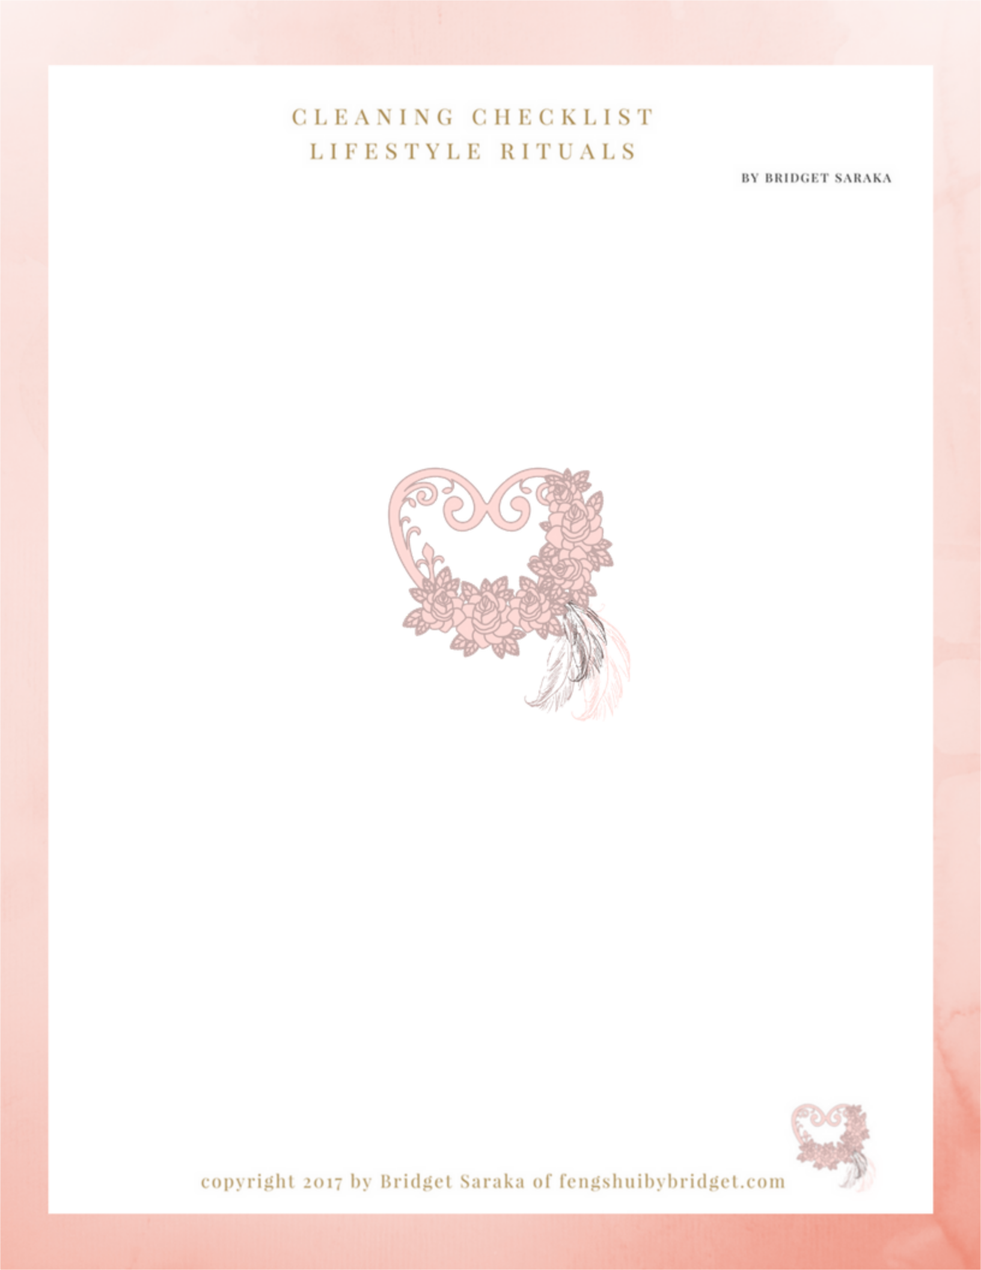

Copyright 2017 by Bridget Saraka

of Feng Shui by Bridget

all rights reserved.

No part of this book may be reproduced or shared in any form or by any electronic or mechanical means including, photocopying, recording, emailing, information storage and
retrieval systems, without permission in writing from the author.

Printed in Canada

First E Published: December 2017
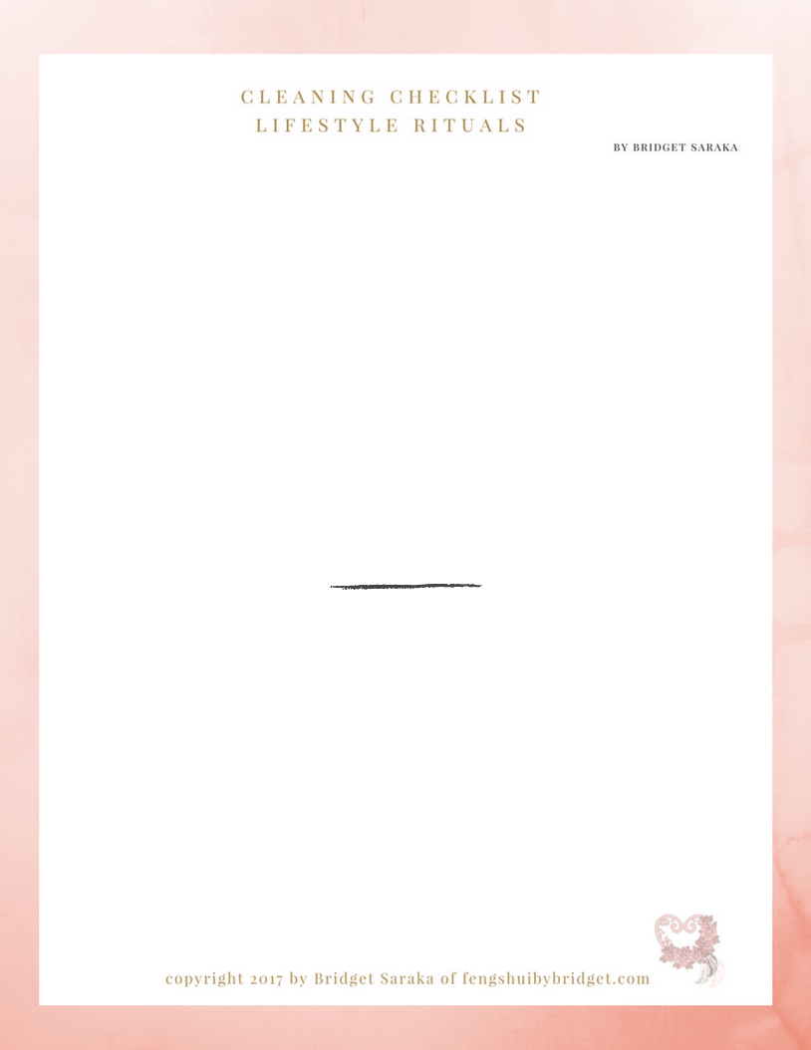

they say"

cleanliness is next to godliness"

"Woo the Universe by creating a sacred space to receive all your heartfelt desires."
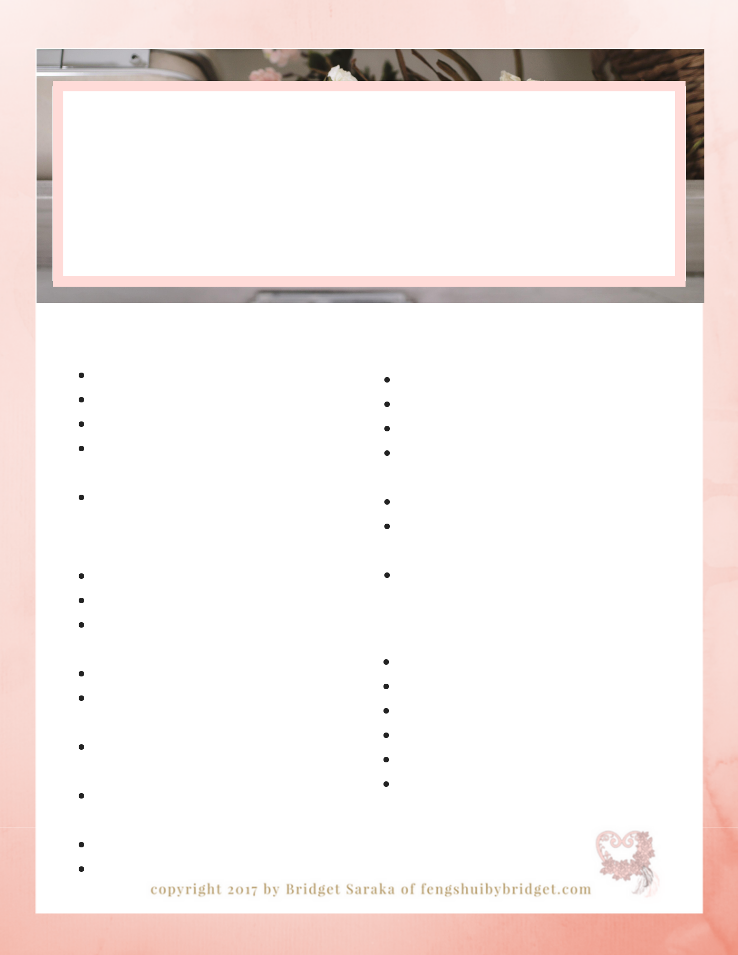
feng shui for the foyer c l e a n i n g c h e c k l i s t

b y b r i d g e t s a r a k a

daily rituals

hang coats

hang backpacks, purse and briefcase put shoes in closet/baskets
put mitts and scarves away

(seasonally)

sweep floor

monthly rituals

dust light fixtures

clean door tracks

remove excess shoes, coats

seasonal accessories

remove excess hangers

sweep, vacuum and wash the floors deep in the closet

clean out backpacks, purses and briefcases

clean screens on doors and windows

deep clean floor mat

fertilize plants

weekly rituals

dust all shelving & seating

edit closet of all paper, soiled clothing wash door windows

clean all door pulls, knobs, light switches

dust vent covers

sweep, vacuum and wash floors & mats

water plants

quarterly rituals

maintain closet doors

store seasonal outdoor clothing touch up paint on walls and trim wash walls

oil door hinges

amend plant soil

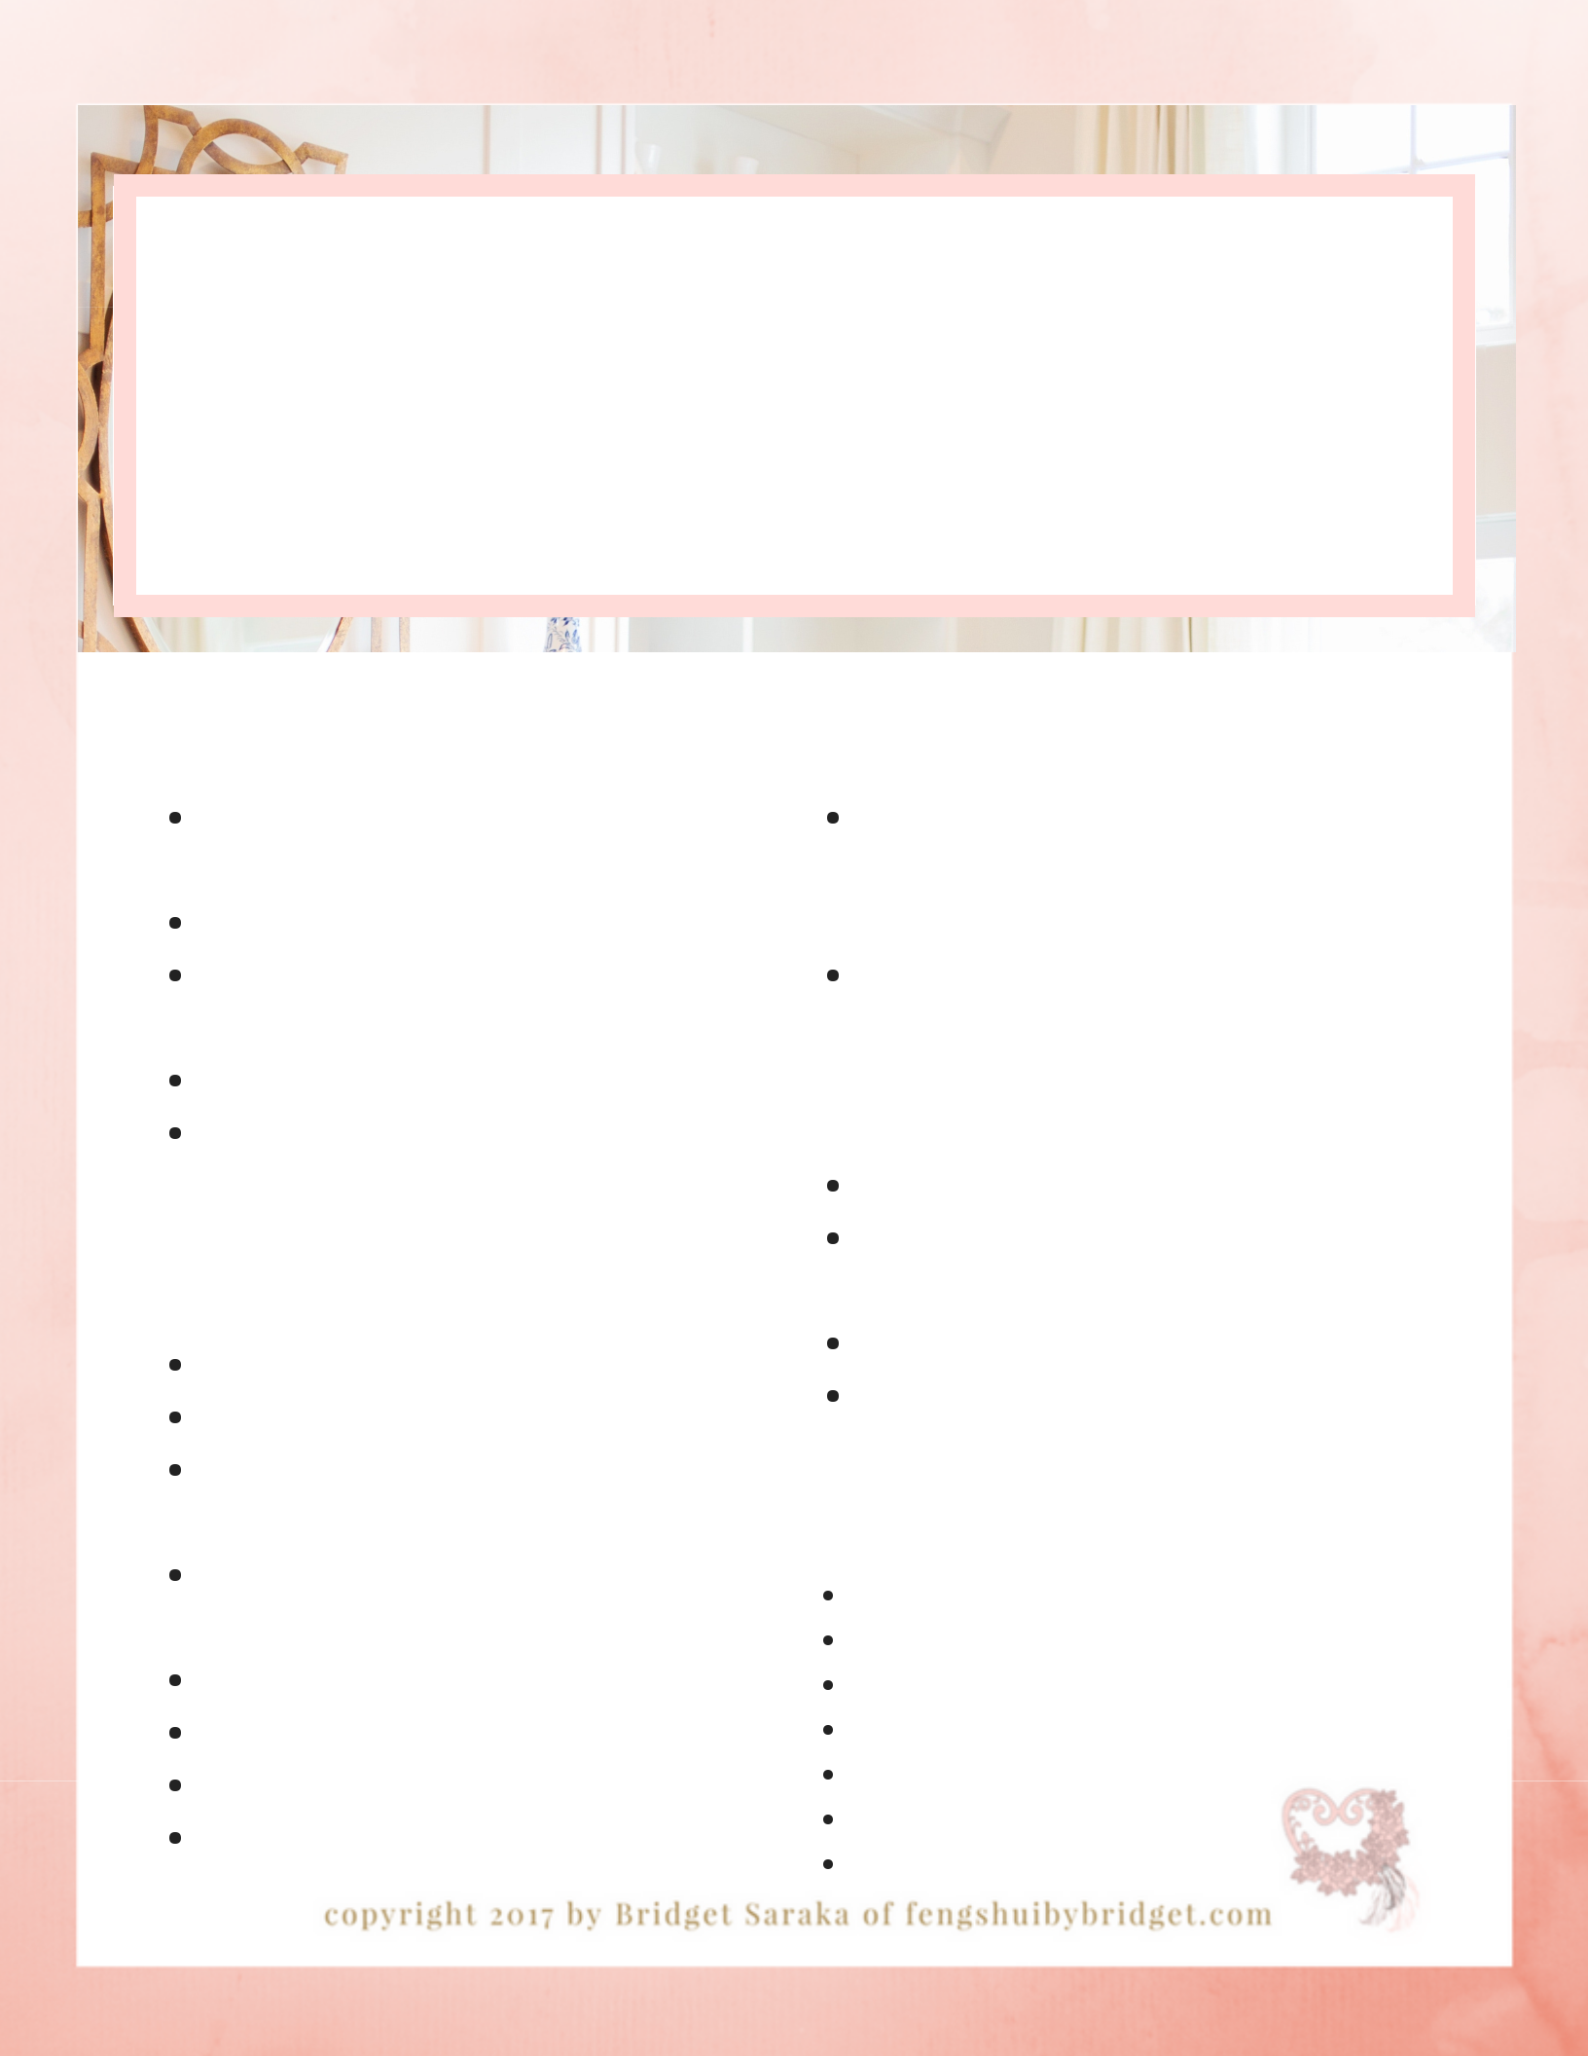
feng shui for the

common rooms

c l e a n i n g c h e c k l i s t

b y b r i d g e t s a r a k a

{living, dinning, family rooms} daily rituals

edit books, magazines, newspapers, from space

put dishes away after using them put all toys away into the kids bedroom or playroom fold blankets and throws

fluff and put accent cushions where they belong

monthly rituals

flip cushions

vacuum all sofa and chairs vacuum under furniture seat cushions

wash all throw pillow covers and blankets

vacuum all vents out clean all window screens clean fireplace fertilize plants

weekly rituals

dust all flat surfaces, all home decor items and electronics, lamp shades and bases

dust all baseboards. vent covers, window sills trim, stair railings, pictures and mirror frames, and all blinds

clean all windows

wipe down light switches and door knobs and remote controls

water all plants, pinch off dead leaves vacuum floors and rugs and behind all furniture

quarterly rituals

replenish plant soil

get fireplace chimney checked

touch up paint on walls and trim

wash walls

wash all curtains

shampoo carpets

amend plant soil

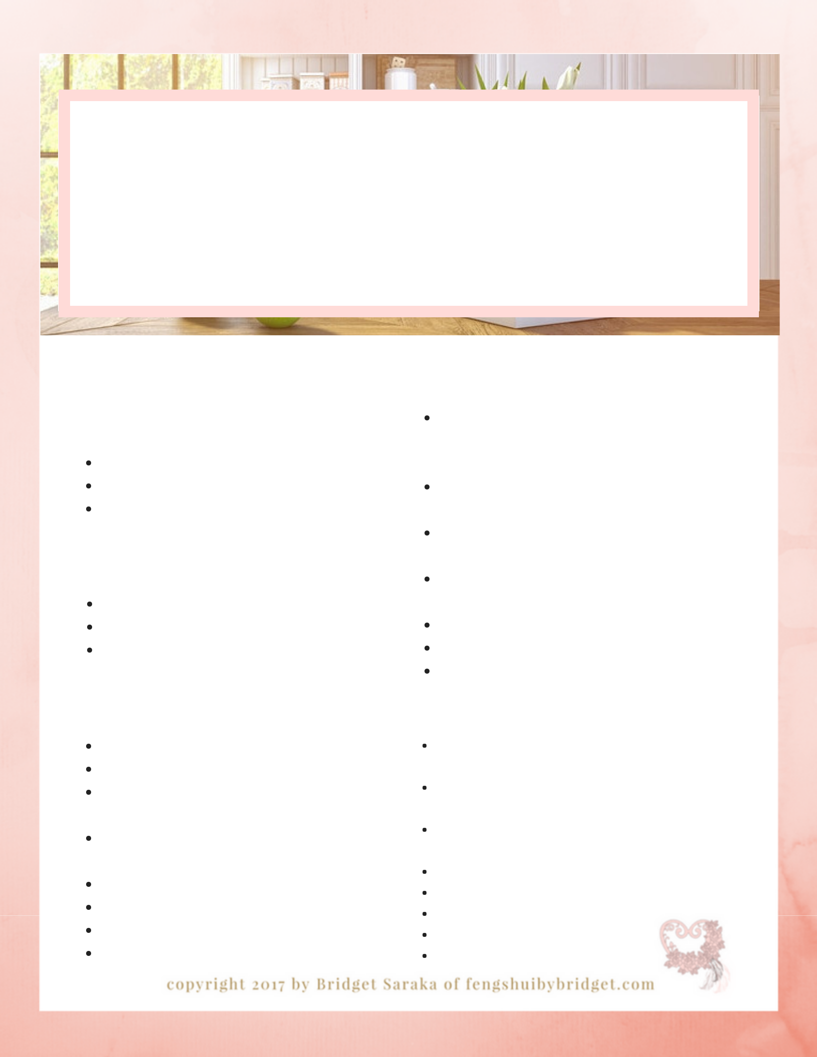
feng shui for the

kitchen

c l e a n i n g c h e c k l i s t

b y b r i d g e t s a r a k a

daily rituals

morning

unload dishwasher

load breakfast dishes

clean island, counter tops, sink, faucet and appliances

evening

unload dishwasher

load breakfast dishes

clean island, counter tops, sink, faucet and appliances

weekly rituals

clean back splash, all hardware, dish soap container, all appliances including range hood

dust all surfaces including cabinet door fronts, shelves

dust baseboard, door, window trims, pictures,

mirror frames, blinds and vent covers

purge fridge and pantry of all expired and

spoiled food

clean windows

vacuum & wash hardwood and mats water plants

monthly rituals

clean toaster and coffee pot

clean out junk drawer and under sink organize Tupperware cupboard, throw out items with missing lids and containers pullout and clean behind fridge, stove, microwave and range hood
wash down cabinets and interior shelves clean window screens vacuum all vents out

fertilize plants

quarterly rituals

purge cabinets of all outdated dry food items and spices

purge all kitchen gadgets that haven't been used in a year

purge all broken or chipped dishes and or kitchen gadgets

oil door hinges

wash walls and tops of cabinets touch up paint on walls and trim wash all curtains replenish plant soil

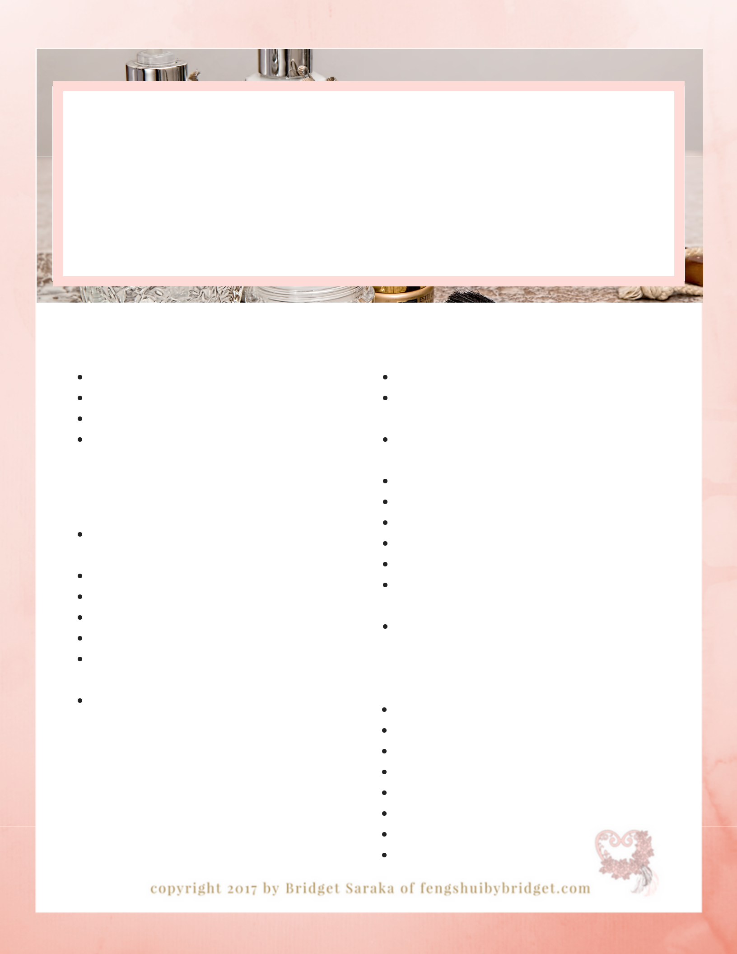
feng shui for the

powder room

c l e a n i n g c h e c k l i s t

b y b r i d g e t s a r a k a

daily rituals

hang towels

put toiletries away

wipe down sink, counter top and faucets wipe down toilet

monthly rituals

go through all drawers purging all old makeup, medicines and toiletries clean exhaust vents wipe down light-switches

clean under sink

check plumbing pipes for leaks

disinfect toilet bowl brush, plunger and

garbage cans

clean drains

Place a bowl of Epson salt with 9 drops of lemongrass essential oils on the countertop to infuse the space with a clean fresh scent.

weekly rituals

dust home decor accessories & blinds

dust baseboard, door, window trims, pictures, mirror frames, blinds and vent covers clean sink / faucet, towel rack and toilet paper holder & door knobs

clean tooth brush holder & soap dispenser wipe down vanity doors, cabinet and walls clean all windows & mirrors
wash towels and bath mats empty garbage

clean toilet in and out / dust toilet tank and

handle

wash floors

quarterly rituals

clean window screens

repair caulking and grout

wash walls

touch up paint on walls and trim wash curtains

oil door hinges repair/replace toilet seat replace toilet bowl brushes

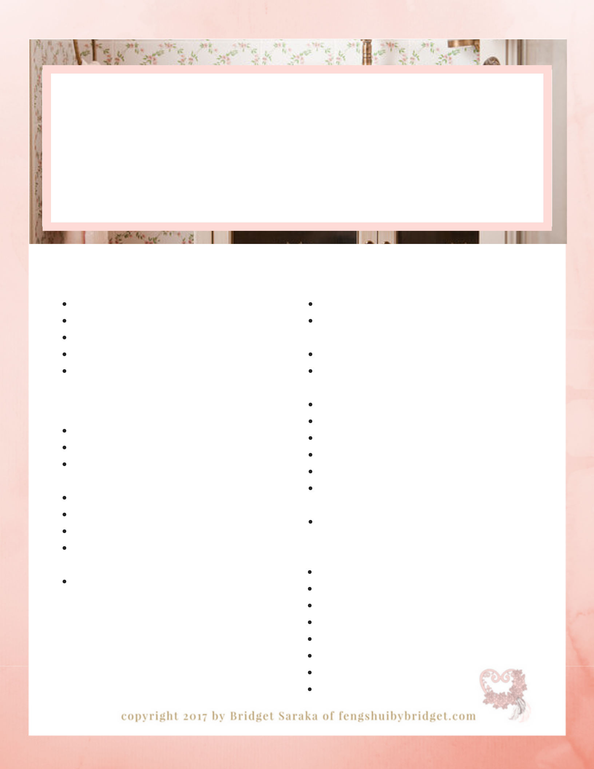
feng shui for the

bathroom

c l e a n i n g c h e c k l i s t

b y b r i d g e t s a r a k a

daily rituals

squeegee shower

put toiletries away

wipe down sink, counter top and faucets wipe down toilet

hang towels and bath mat

monthly rituals

wash shower curtains

clean under the sink

go through all drawers purging all old makeup and toiletries wipe down light-switches

clean exhaust vents

check plumbing pipes for leaks

disinfect toilet bowl brush, plunger and

garbage cans

clean drains

Soaking in a tub with 2 cups of Epson salts and 6 drops of orange essential oils is the perfect way to end a day

weekly rituals

clean tooth brush holder & soap dispenser clean sink / faucet, towel rack and toilet paper holder & door knobs
dust home decor accessories & blinds

dust baseboard, door, window trims, pictures, mirror frames, blinds and vent covers wash tub / tub surround, shower doors wipe down vanity doors, cabinet and walls clean all windows & mirrors

wash towels and bath mats empty garbage

clean toilet in and out / dust toilet tank and

handle

wash floors

quarterly rituals

clean window screens

repair caulking and grout

wash walls

touch up paint on walls and trim wash curtains

oil door hinges repair/replace toilet seat replace toilet bowl brushes

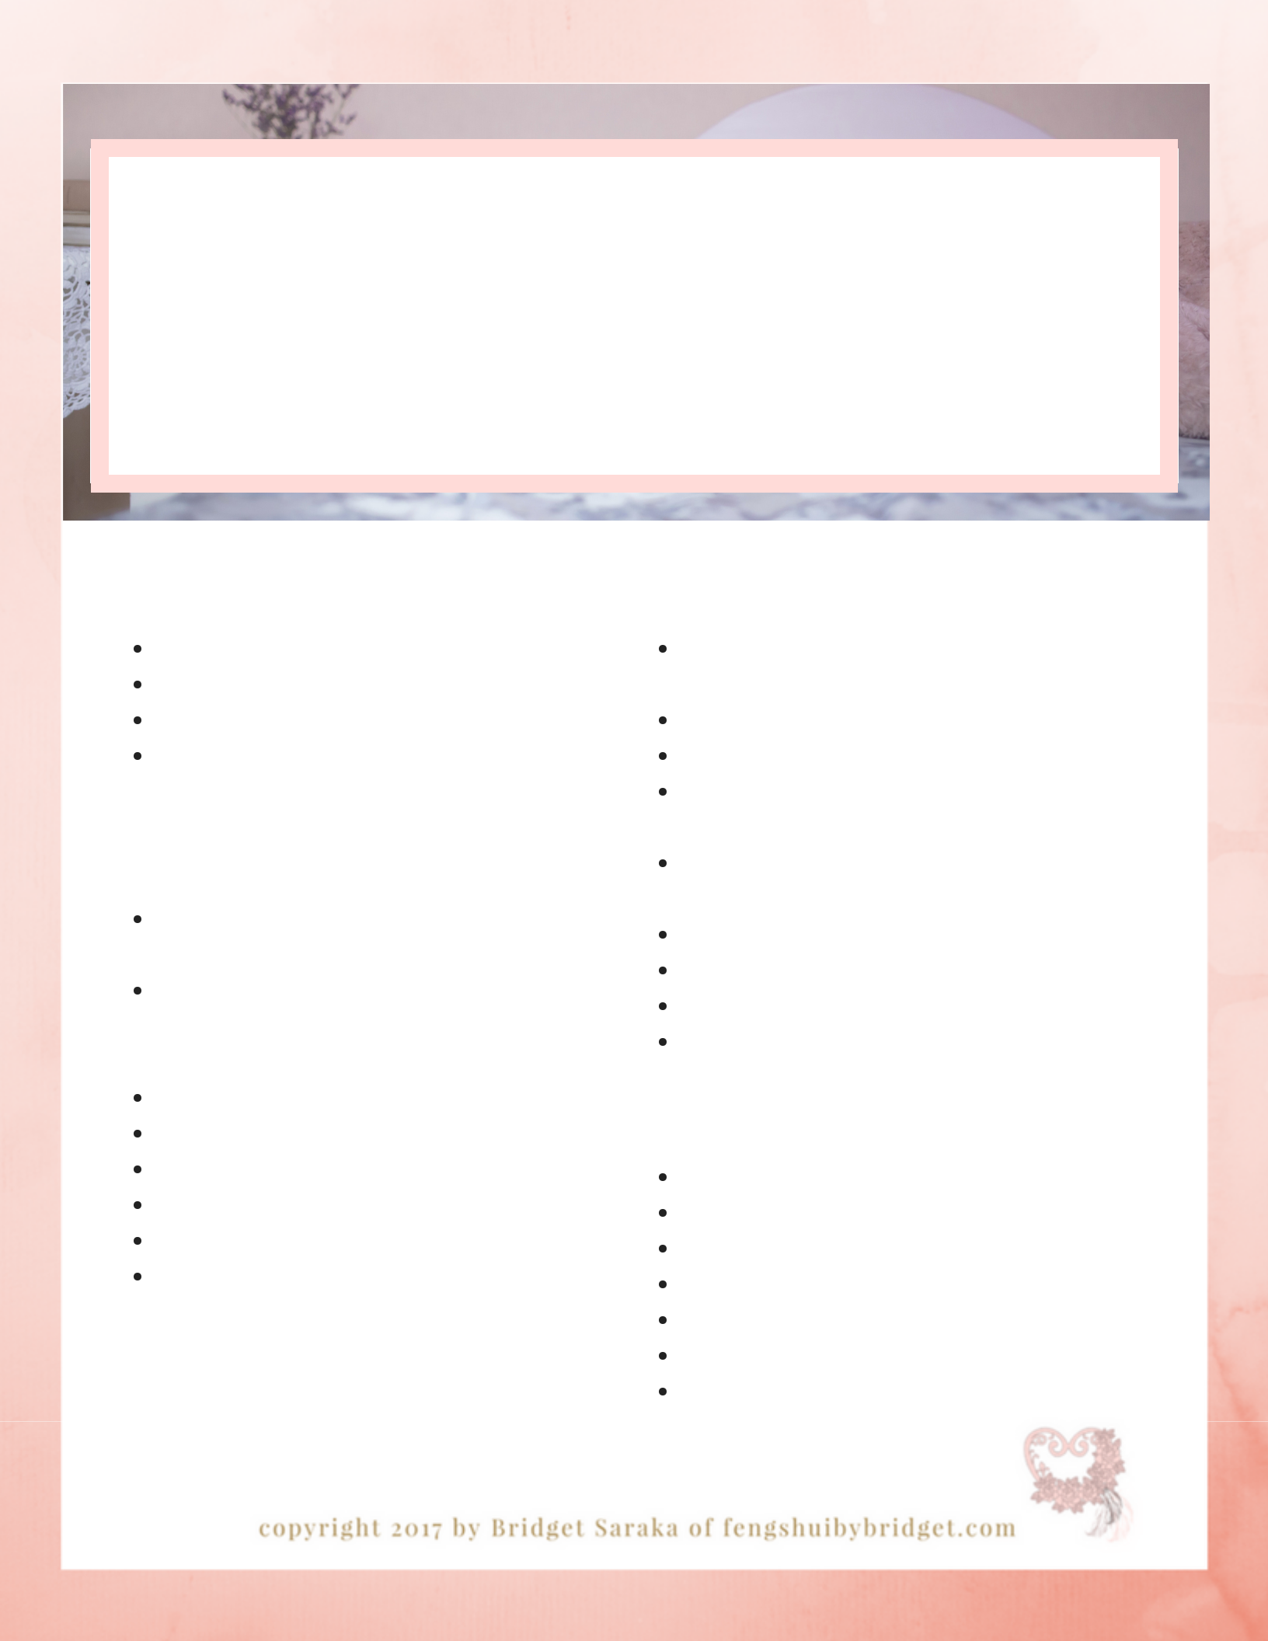
feng shui for the

master bedroom

c l e a n i n g c h e c k l i s t

b y b r i d g e t s a r a k a

daily rituals

make bed

put laundry away

tidy night stands

put dirty clothes in laundry basket

monthly rituals

purge dressers and closet of any torn, stained, warn, un-loved

remove read and un-read books (only keep

one book that is being read in the

bedroom)

clothing items

vacuum mattress

wash pillows

dust window screens

vacuum all vents

disinfect garbage cans & laundry baskets

A diffuser on the bedside table with lavender essential oil will help you sleep better.

weekly rituals

wash sheets, mattress covers, towels and clothes

fold and put clothes away

purge any torn, stained, warn clothing items dust all flat surfaces & home decor accessories & light fixtures

dust baseboard, door, window trims, pictures, mirror frames, blinds and vent covers disinfect all adult toys

wipe down all switch plates and door knobs water plants and dispose of any dead leaves vacuum carpets/wash floors

quarterly rituals

flip mattress

wash walls

touch up paint on walls and trim clean window screens wash all curtains

shampoo carpets

burn all old journals (outdoors in a fire safe container and location)

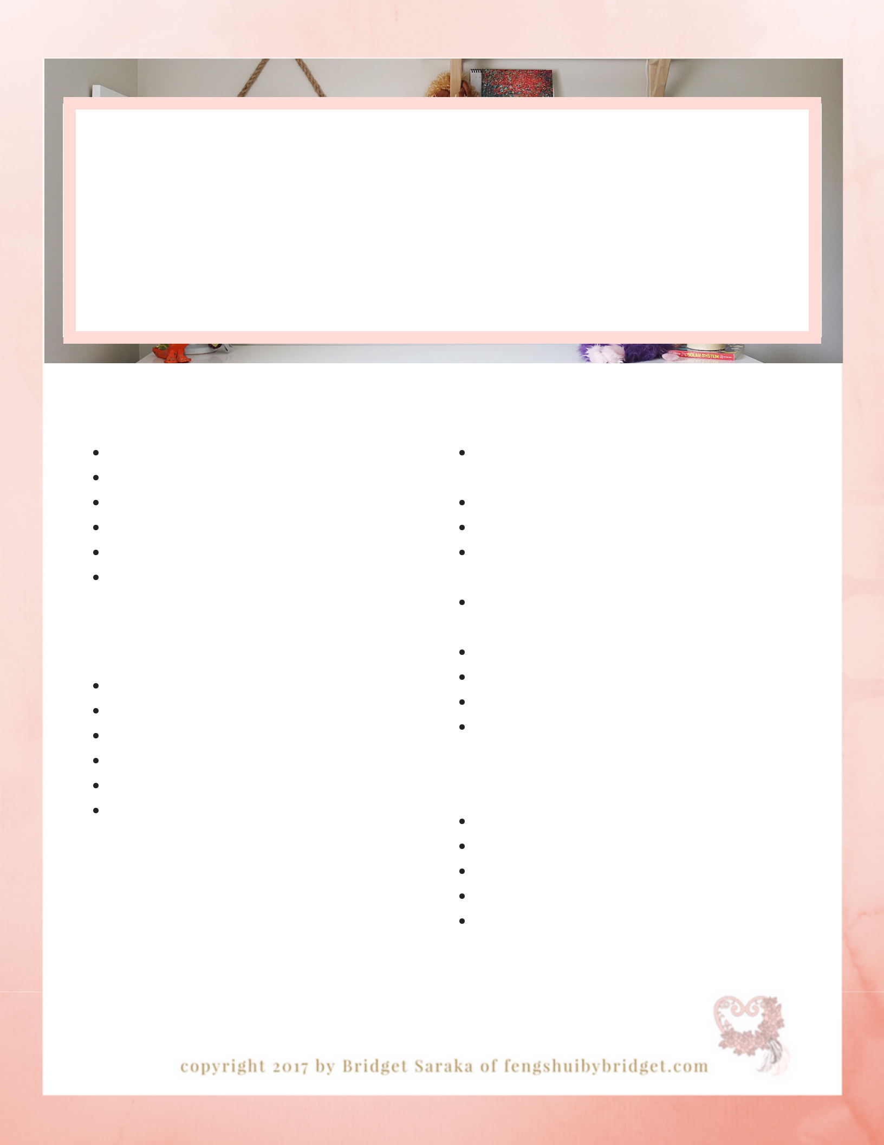
feng shui for the

nursery

c l e a n i n g c h e c k l i s t

b y b r i d g e t s a r a k a

daily rituals

make bed

put laundry away

tidy night stands

put dirty clothes in laundry basket dispose of dirty diaper bags pick up toys

monthly rituals

pack outgrown clothes & toys flip mattress

clean under bed and closets vacuum vents

disinfect garbage cans & laundry baskets wash diaper bag

create a sacred space to get cozy, cozy

weekly rituals

wash sheets, mattress covers, towels and clothes

fold and put clothes away

purge any torn, stained, warn clothing items dust all flat surfaces, home decor accessories, light fixtures

dust baseboard, door, window trims, pictures, mirror frames, blinds and vent covers

wipe down all switch plates and door knobs

clean out diaper bag

disinfect all toys

vacuum carpets/wash floors

quarterly rituals

wash walls

touch up paint on walls and trim clean window screens wash all curtains

shampoo carpets

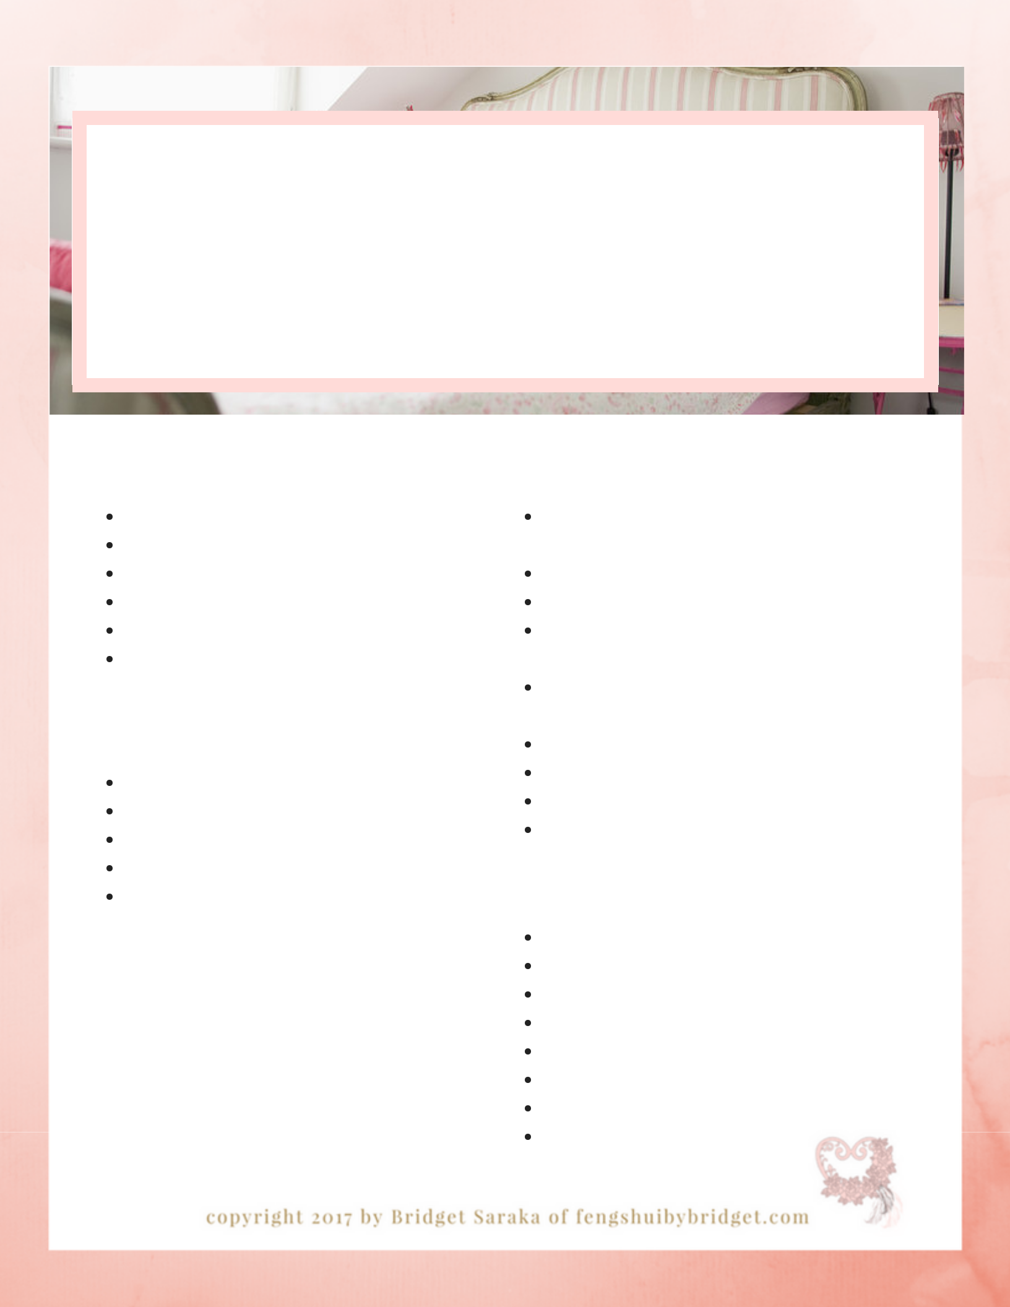
feng shui for a

child's room

c l e a n i n g c h e c k l i s t

b y b r i d g e t s a r a k a

daily rituals

make bed

put laundry away

tidy night stands

put dirty clothes in laundry basket

clean backpack

pickup toys

monthly rituals

flip mattress

clean under bed and closets vacuum vents

disinfect garbage cans and laundry baskets edit torn, stained and outgrown clothes, broken toys and books

you've got this!

weekly rituals

wash sheets, mattress covers, towels and clothes

fold and put clothes away

purge any torn, stained, warn clothing items dust all flat surfaces & home decor accessories and light fixtures

dust baseboard, door, window trims, pictures, mirror frames, blinds and vent covers

wipe down all switch plates and door knobs vacuum carpets/wash floors wash backpack

disinfect all toys

quarterly rituals

wash walls

touch up paint on walls and trim clean window screens wash all curtains

shampoo carpets

wash all curtains

shampoo carpets

flip mattress

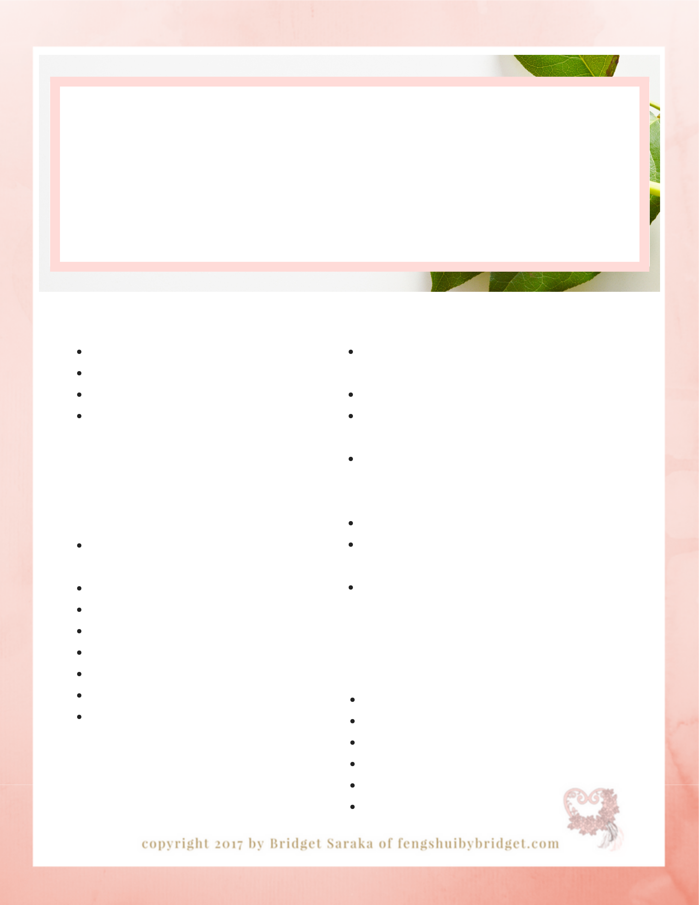
feng shui for the

guest room

c l e a n i n g c h e c k l i s t

b y b r i d g e t s a r a k a

daily rituals

make bed

put laundry away

tidy night stands

put personal items such as crafts, yoga mats and sacred meditation items away

monthly rituals

purge all personal and sacred

items that no-longer inspire you

remove read and un-read books

clothing items

vacuum mattress

wash pillows

dust window screens

vacuum all vents

disinfect garbage cans & laundry baskets

weekly rituals

wash sheets, mattress covers, towels and clothes

put personal items away

dust all flat surfaces & home decor accessories & light fixtures

dust baseboard, door, window trims, pictures, mirror frames, blinds and vent covers

wipe down all switch plates and door knobs water plants and dispose of any dead leaves

vacuum carpets/wash floors

quarterly rituals

flip mattress

wash walls

touch up paint on walls and trim clean window screens wash all curtains

shampoo carpets

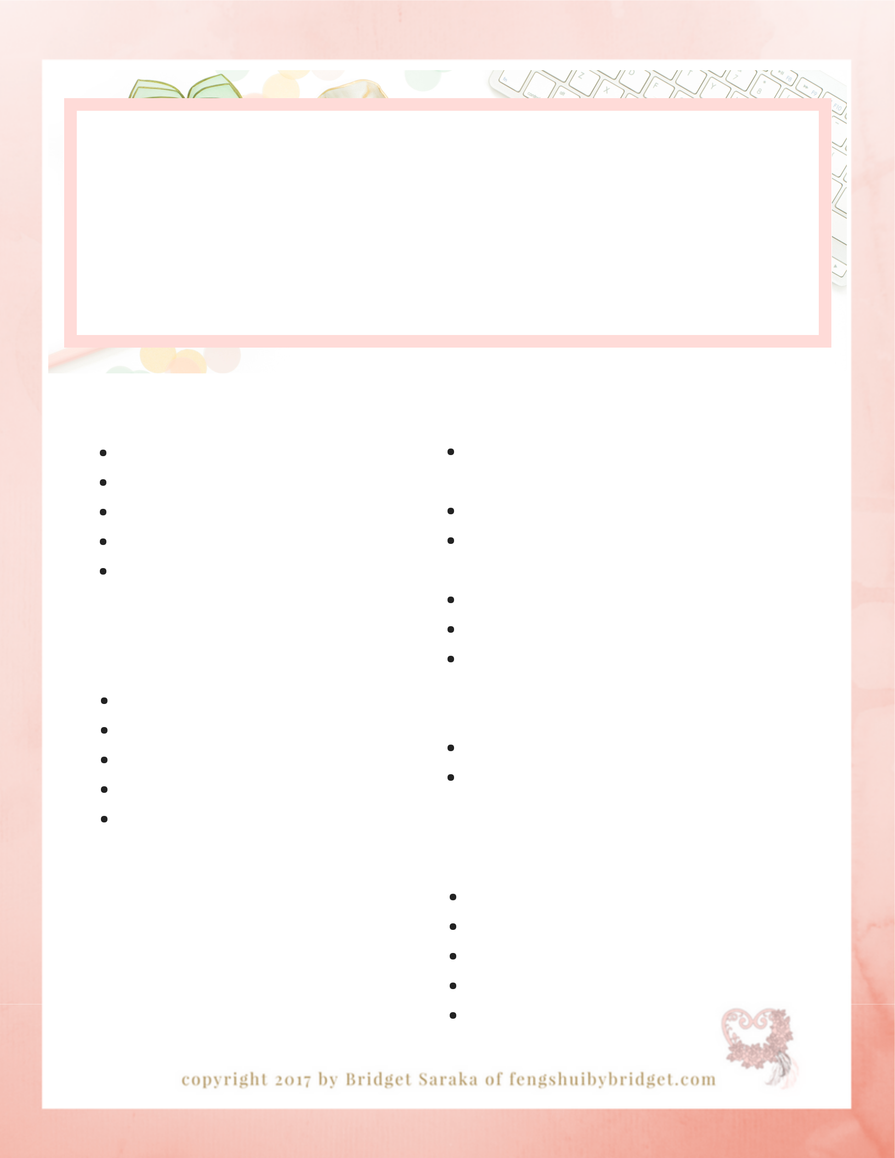
feng shui for the office c l e a n i n g c h e c k l i s t

b y b r i d g e t s a r a k a

daily rituals

open all mail

throw out all extra scrap paper pay bills

file paid bills

clean desk surface

monthly rituals

backup computer hard drive dust all light fixtures vacuum all floor vents clean all window screens

wipe down all light switches and door knobs

Place a piece of citrine and

pyrite to the left of your computer to attract more wealth and abundance.

weekly rituals

throw out broken and empty pens and pencils and extra papers

dust all surfaces & electronics

dust computer screen, vent and key board

dust all hot and cool air vent covers empty garbage

dust baseboard, door, window trims, pictures, mirror frames, blinds and vent covers

clean windows

vacuum carpets/wash floors

quarterly rituals

file monthly documents wash walls
touch up paint on walls and trim wash all curtains shampoo carpets

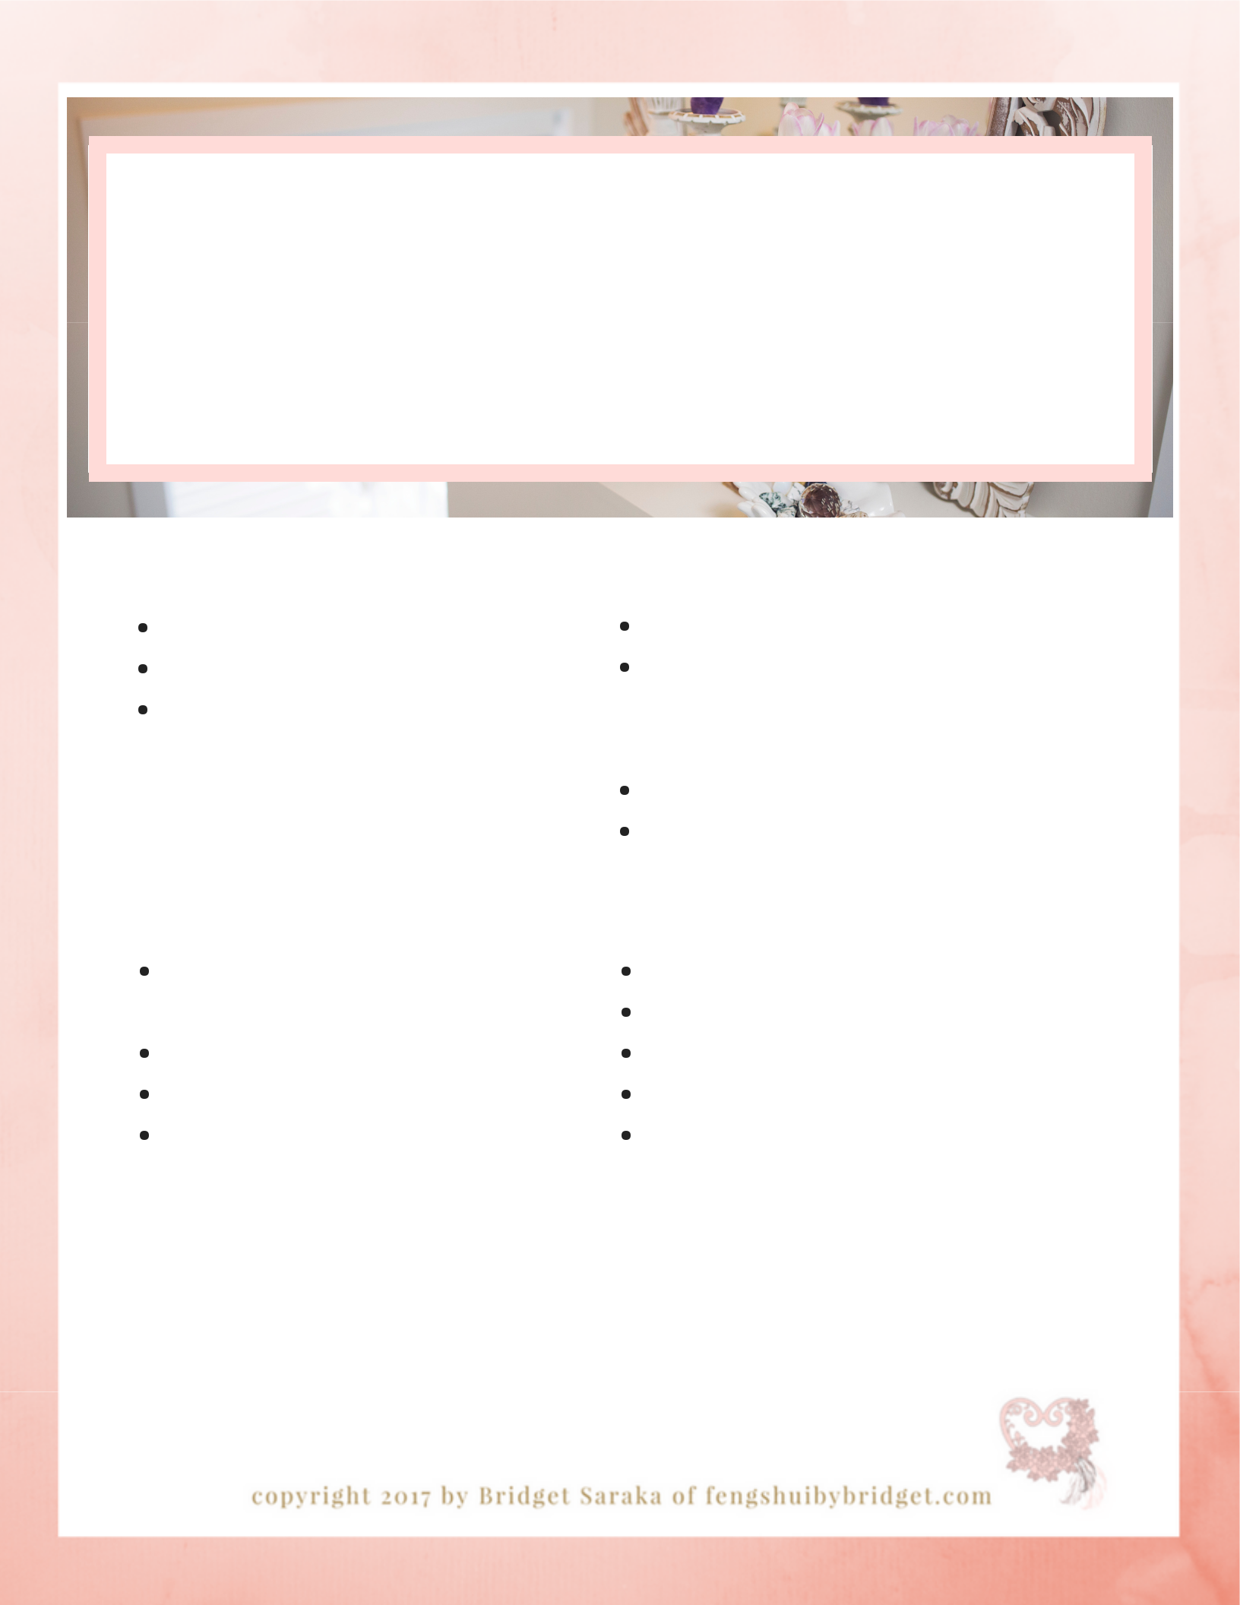
feng shui for

hallways + stairwells c l e a n i n g c h e c k l i s t

b y b r i d g e t s a r a k a

daily rituals

clear all clutter such as laundry and toys

sweep floors and stairs

monthly rituals

wipe down all light switches and door knobs

dust all light fixtures clean all window screens vacuum all floor vents

weekly rituals

dust all hot and cool air vent covers dust baseboard, door, window trims, pictures, mirror frames, blinds and vent covers

clean windows

vacuum and wash floors/mats

quarterly rituals

wash walls

touch up paint on walls and trim clean window screens wash all curtains

shampoo carpets

Don't get tripped up!

Make sure that all hallways

and stairwells are well lit with

LED DAYLIGHTS.

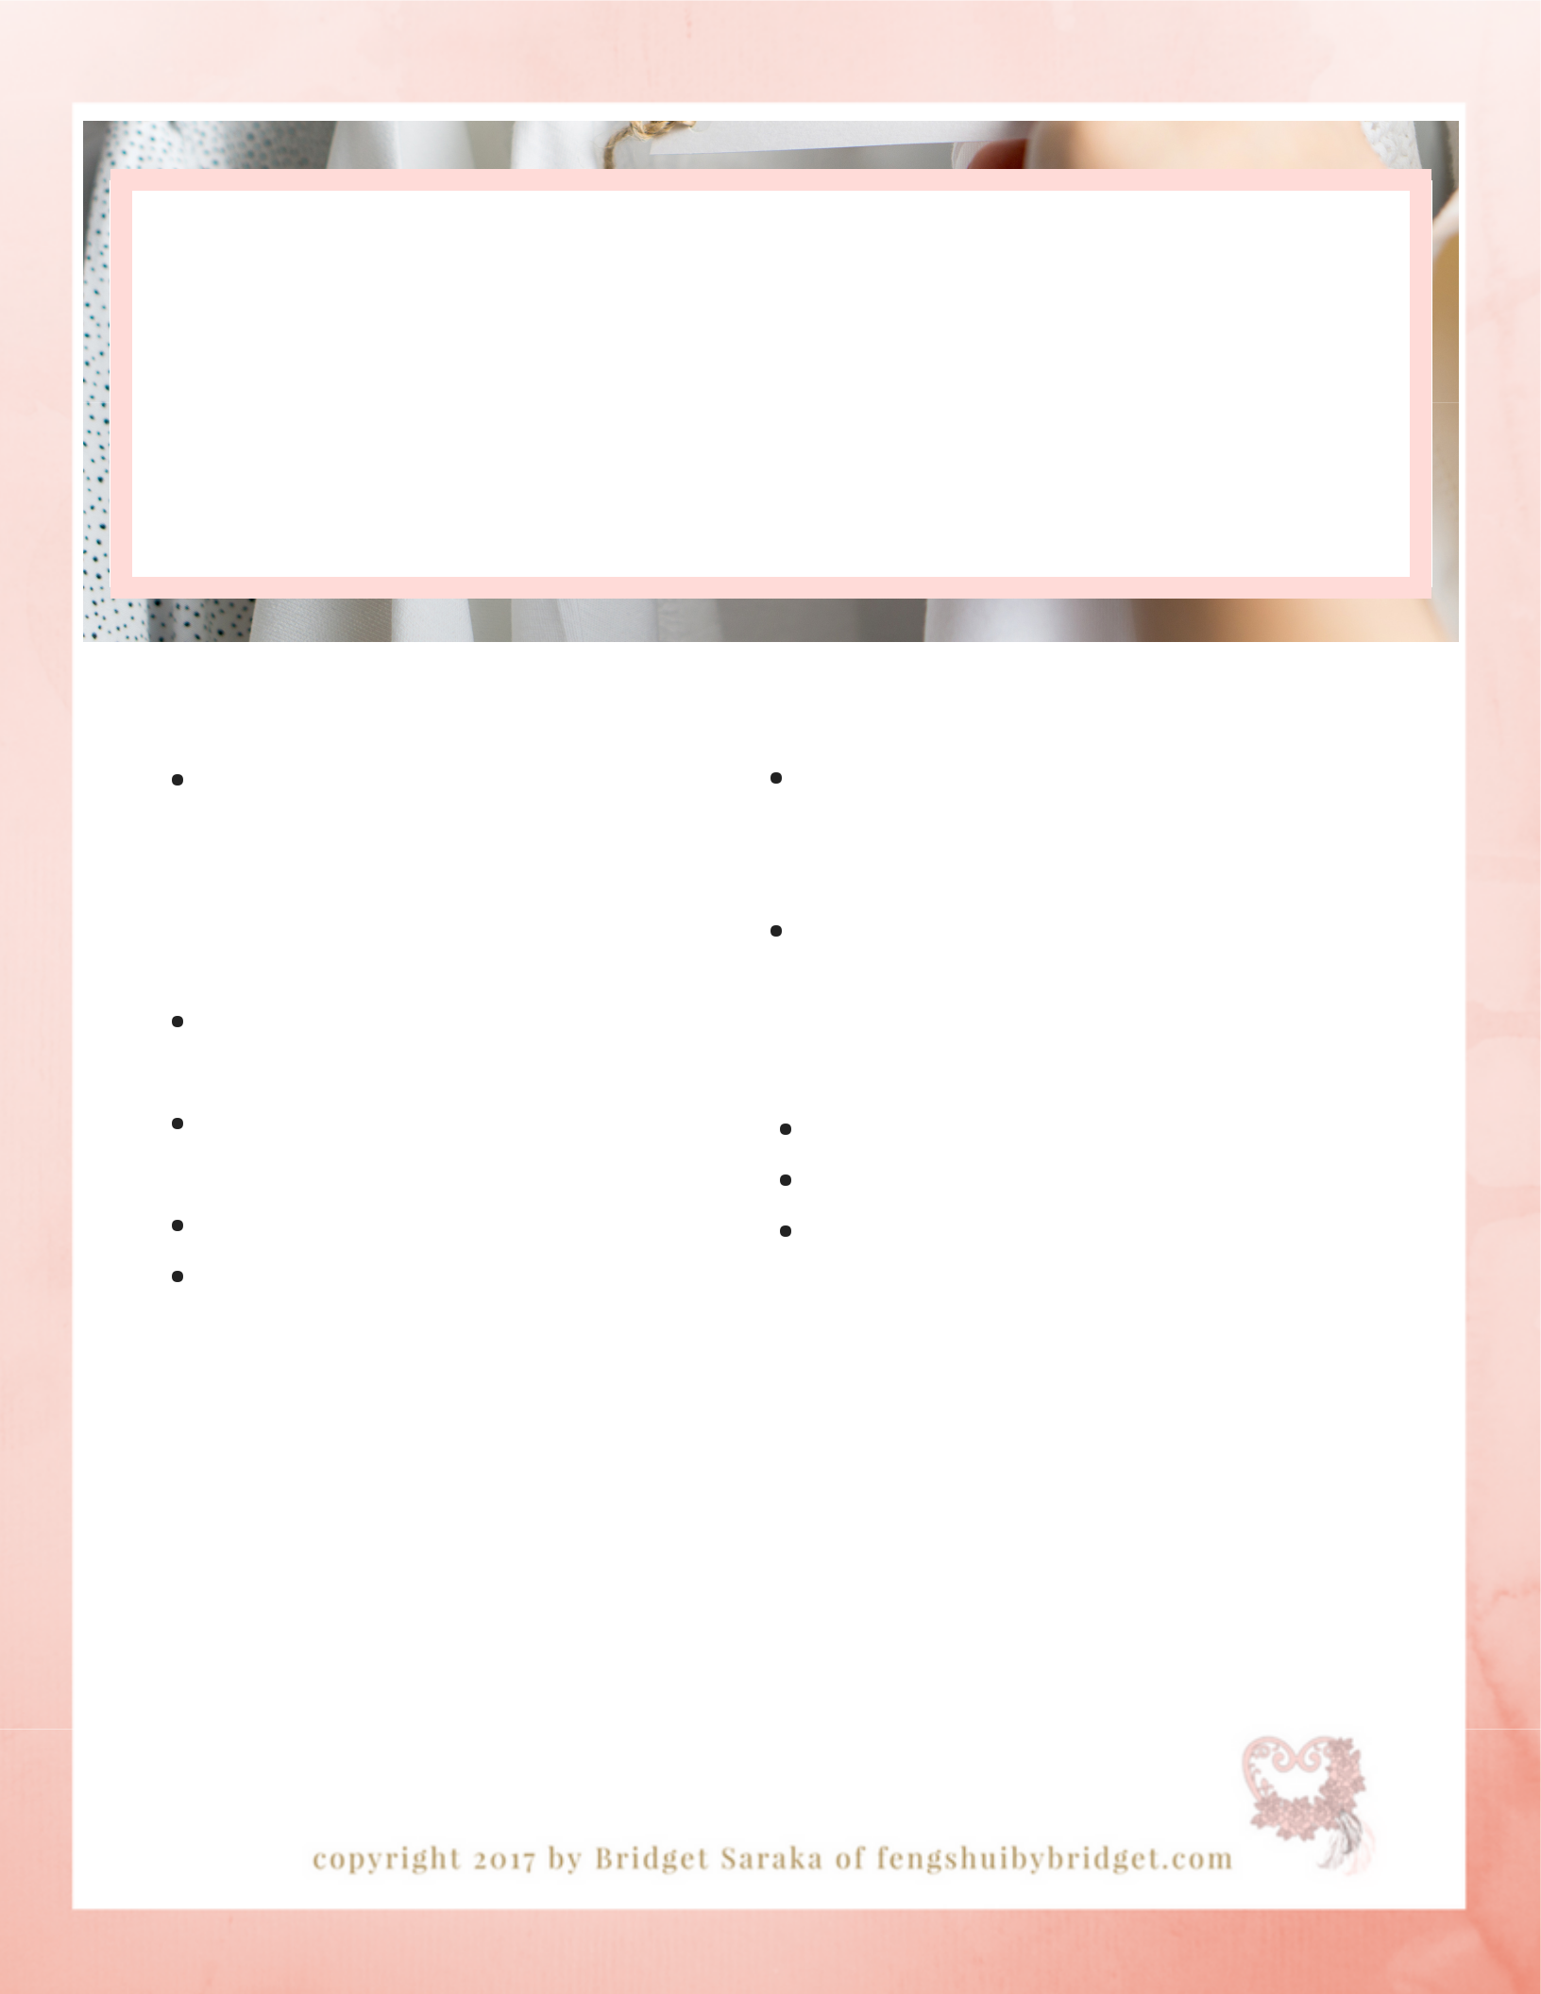
feng shui for

storage + linen closets

c l e a n i n g c h e c k l i s t

b y b r i d g e t s a r a k a

daily rituals

put items away in their proper locations

monthly rituals

purge worn, stained, broken and un-used items

wipe down all light switches and door knobs

dust all light fixtures replace sachet

weekly rituals

dust baseboard, door, window trims, picture, mirror frames, blinds and vent covers

vacuum and wash floors

quarterly rituals

wash walls

touch up paint on walls and trim shampoo carpets

Hang a sachet filled with 1/4 cup of Epson salt and 9 drops of lavender essential oil on the inside of the closet to infuse the space with a calm pleasing scent.

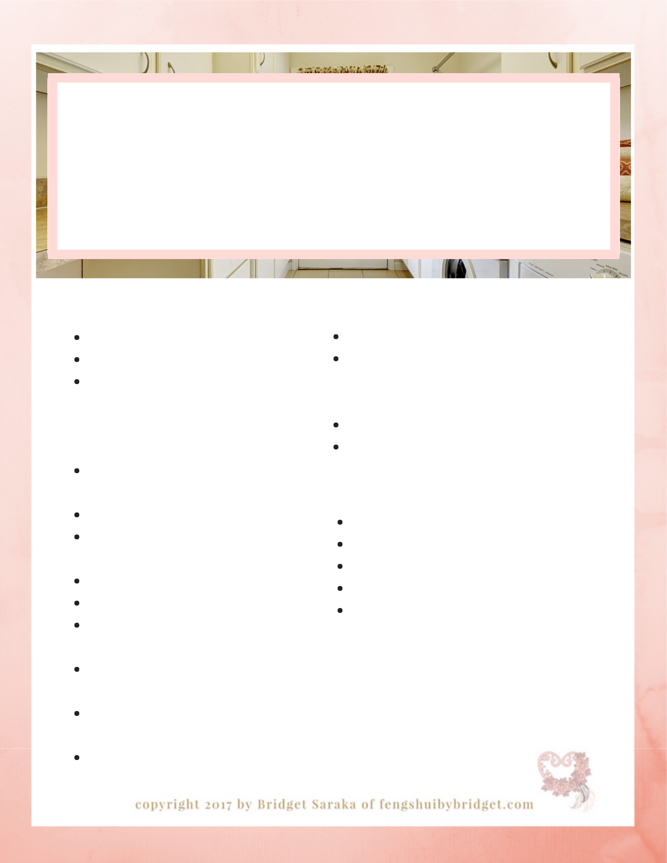
feng shui for the

laundry room

c l e a n i n g c h e c k l i s t

b y b r i d g e t s a r a k a

daily rituals weekly rituals

fold, organize and put laundry away clean dryer vent after every use wipe down appliances after every use

monthly rituals

clean seals around appliance doors

clean detergent trays vacuum all ceiling and floor vents

clean all window screens dust all light fixtures
dust all appliance cords and plumbing tubes

wipe down all light switches and door knobs

check plumbing fixtures for leaks

clean dryer vent inside and out

dust all hot and cool air vent covers dust baseboard, door, window trims, picture, mirror frames, blinds and vent covers

clean windows

vacuum and wash floors/mats

quarterly rituals

wash walls

touch up paint on walls and trim clean window screens wash all curtains

wash floors

Wash towels

separate from all other items to reduce excess dust/lint.

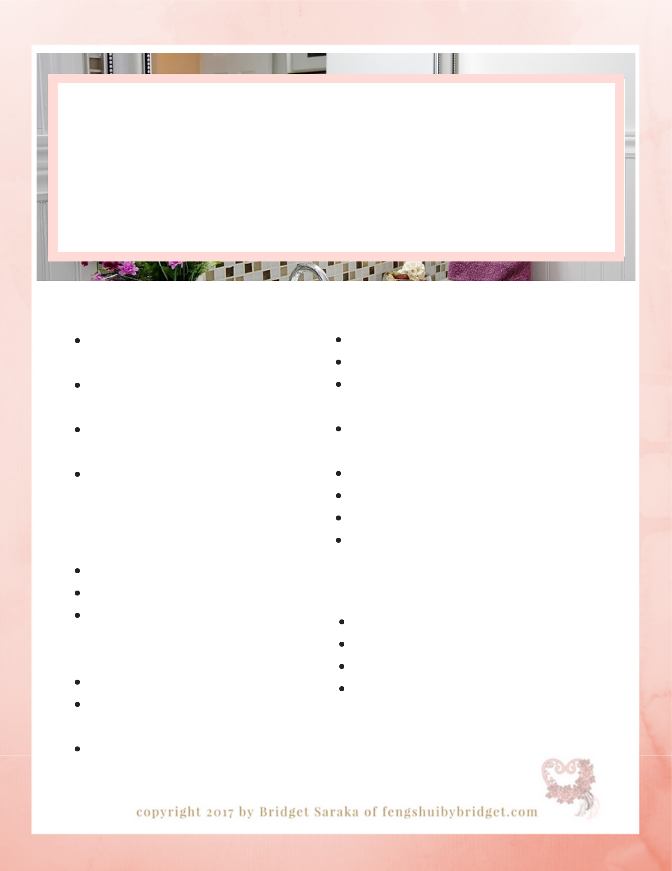
feng shui for the

utility room

c l e a n i n g c h e c k l i s t

b y b r i d g e t s a r a k a

daily rituals weekly rituals

clean litter box and take out to garbage

keep cleaning supplies neatly put away

keep preserves and non-perishables safely stored in a clean dry place keep seasonal storage items neatly put away and organized

monthly rituals

change furnace filters clean windows
dust baseboard, door, window trims, picture, mirror frames, blinds and vent covers dust all shelving
dust all light fixtures and switches

clean door knobs and pulls

take out garbage

disinfect litter box

dust utilities (furnace, hot water tank, electrical panel, etc)

empty vacuum canister and replace or

clean filter

clean broom

wash mop and bucket wash all cleaning cloths vacuum and wash floors

quarterly rituals

check all valves and gauges on utilities check for water leaks check sump pump

edit space of broken, un-used and expired items

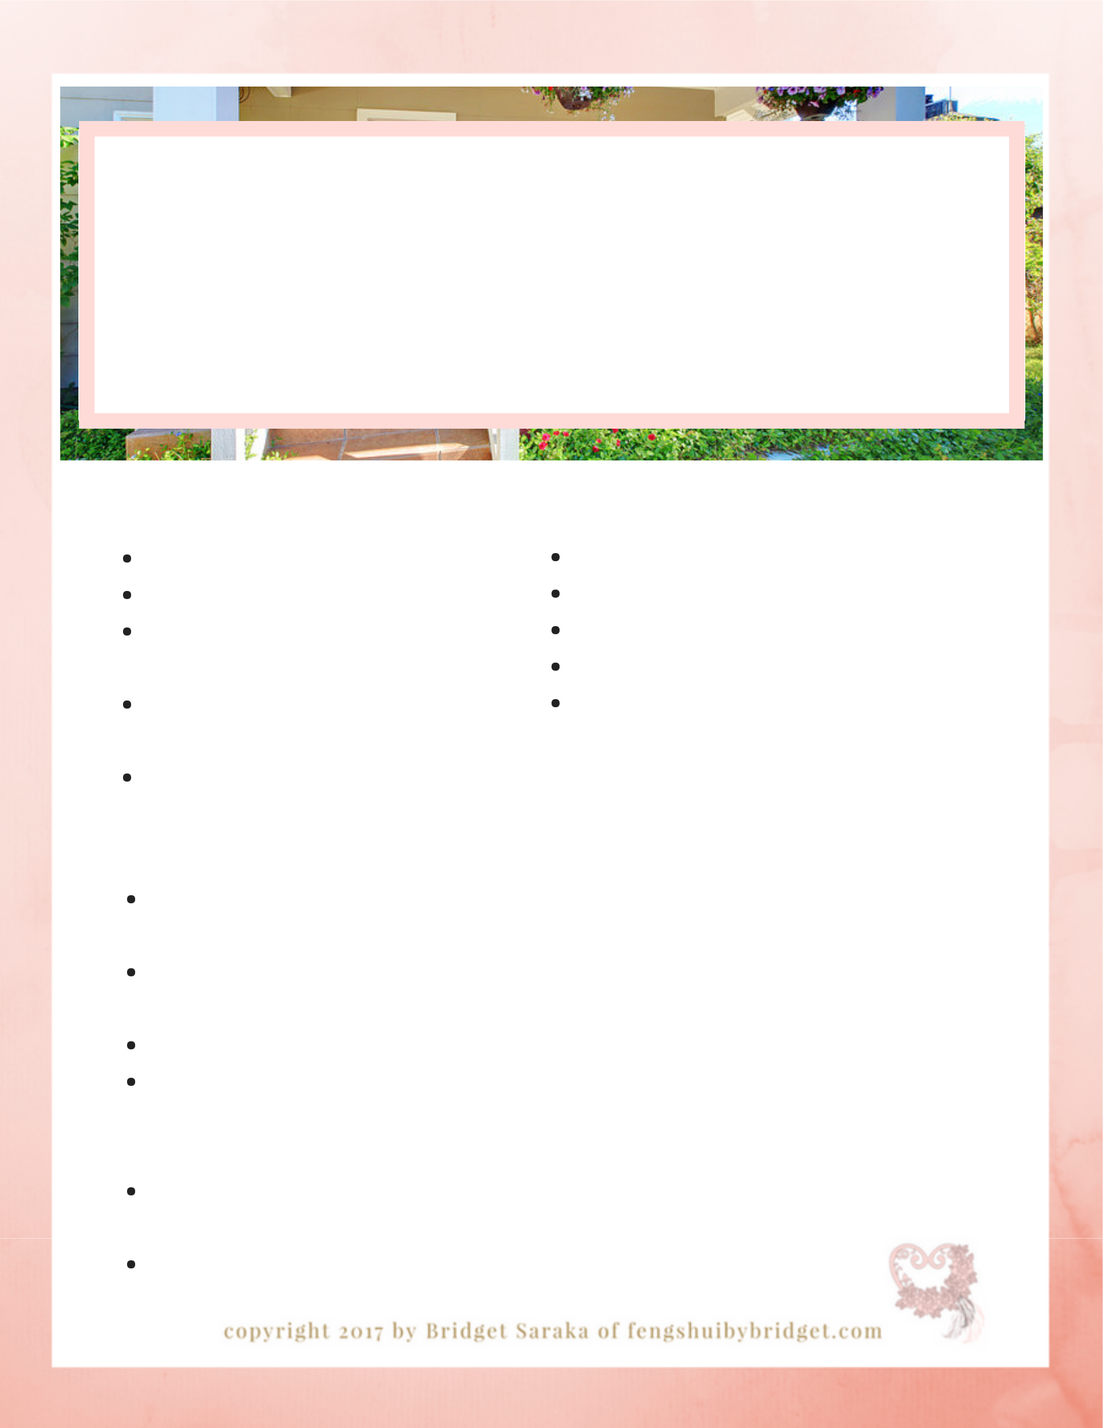
feng shui for exterior maintenance c l e a n i n g c h e c k l i s t
b y b r i d g e t s a r a k a

daily rituals weekly rituals

pick up mail

clean garbage

clear sidewalks and driveway of all obstacles

water plants and grass (spring, summer)

roll up garden hose

sweep steps and sidewalks deadhead plants (spring, summer, fall) cut grass (spring, summer, fall) remove cobwebs

put out garbage and recycling

monthly rituals quarterly rituals

prune shrubs and trees when repair chipped or peeling paint

needed repair and replace worn weather

clean windows, doors, light stripping around doors

fixtures and mailbox maintain and store outdoor

wash door knobs and handrails recreational vehicles and equipment

hose down garbage and

recycling bins (spring, summer, Be the brightest home

fall) on the block

hose down house and garage Turn your exterior lights

(spring, summer, fall) on every night at dusk.

check gate latches and hinges

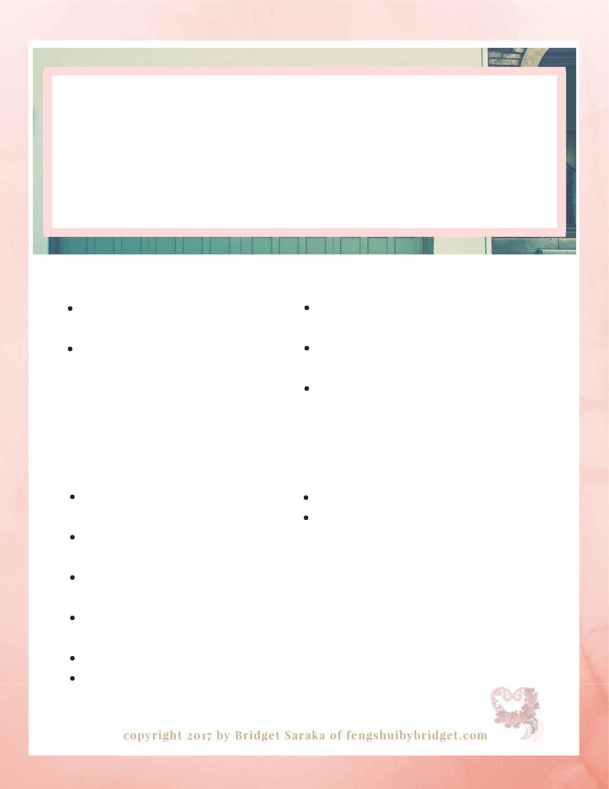
feng shui for garage maintenance c l e a n i n g c h e c k l i s t
b y b r i d g e t s a r a k a

daily rituals weekly rituals

keep exterior and interior paths clean and clear

keep clean of all garbage

make sure that all flammables are stored in a safe, high and dry space

make sure that all tools are put where they belong

make sure that all gardening tools and equipment is stored properly

monthly rituals | quarterly rituals
make sure that doors can open | repair chipped or peeling paint
fully and are unobstructed | maintain and store outdoor
clean stairs, floors, windows and | recreational vehicles and equipment
doors
check lubricate garage door
opener
dust light fixtures and light | Keep all extension cords and
switches | hoses neatly wrapped and
check hinges | hung up to avoid injury.
organize shelving

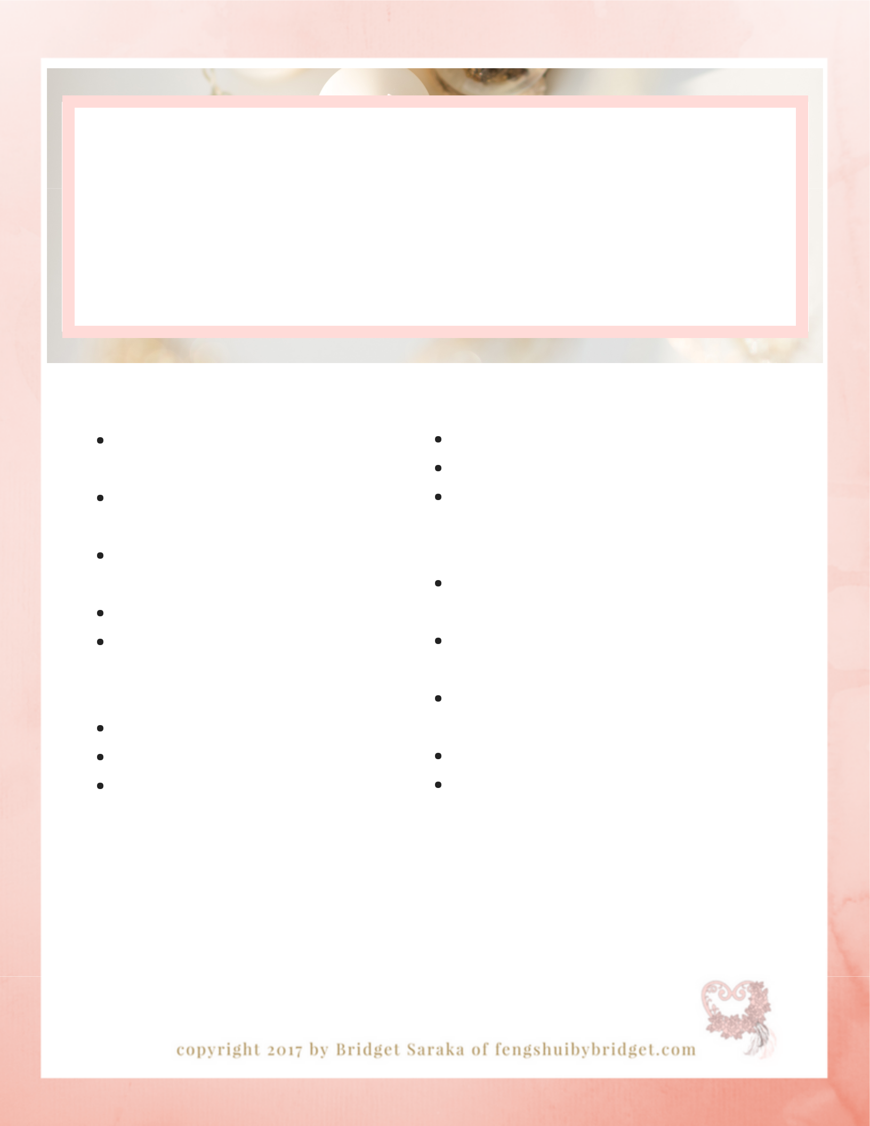
feng shui

home maintenance

s a f e t y c h e c k l i s t

b y b r i d g e t s a r a k a

quarterly rituals yearly rituals

check security of interior and exterior handrails

check security of windows and doors

clean all tracks of windows and doors

maintain mailbox

check fire alarm, carbon monoxide detectors and home security systems

clean chimney

clean exterior light fixtures

check hoses and water fixtures for leaks

have ducts cleaned have shingles checked
check exterior surface of home for compromised surfaces and have repaired

check foundation for compromised areas and have repaired
check exterior lights and plugins for loose wires

repair any damage to sidewalks and driveways

clean eaves-troughs

check down spouts and reroute away from the house

Schedule your next safety

check now to avoid any mishaps.

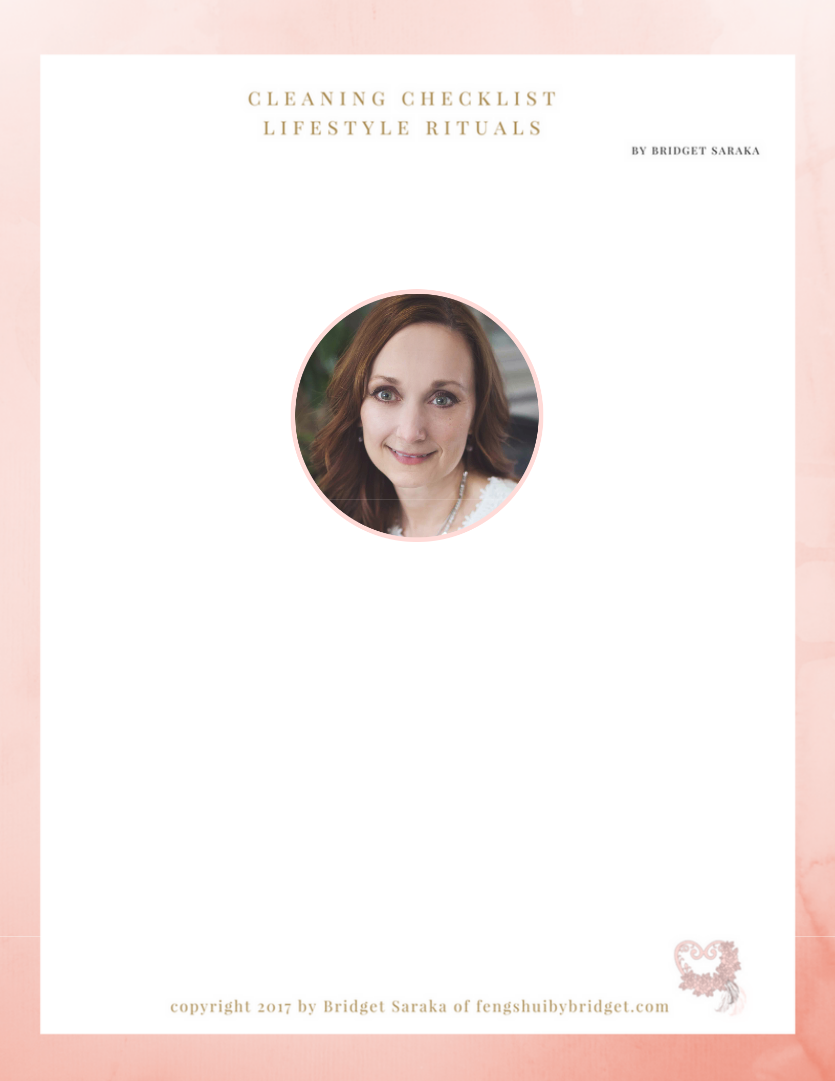

Bridget Saraka

feng shui expert . intuitive practitioner

If you desire to fully integrate the entire Body, Soul, Spirit, Home® Lifestyle formula

into your life visit fengshuibybridget.com for a complete list of Packages and Services. While you're there check out the Lifestyle Resources available as well.

Remember to put your heart into it....B♥

306 249 2064

