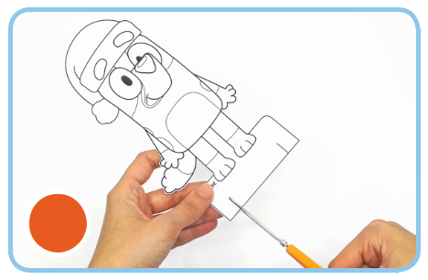

2
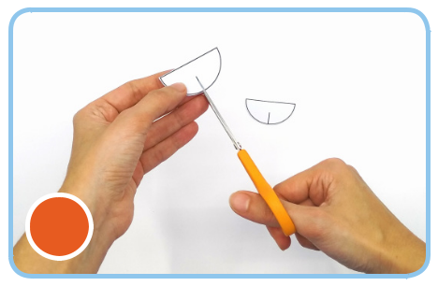

2
festive crafts

Colour-me-in

Table place card

You will need:

- White cardstock - Glue

- Scissors
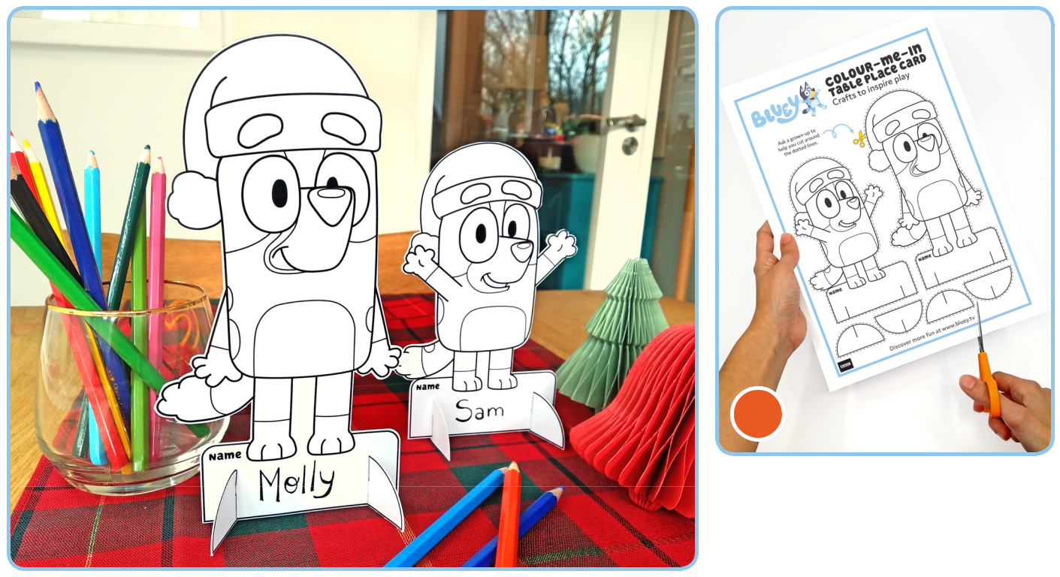

1

1. Print and glue the template on to the white cardstock and carefully cut out.
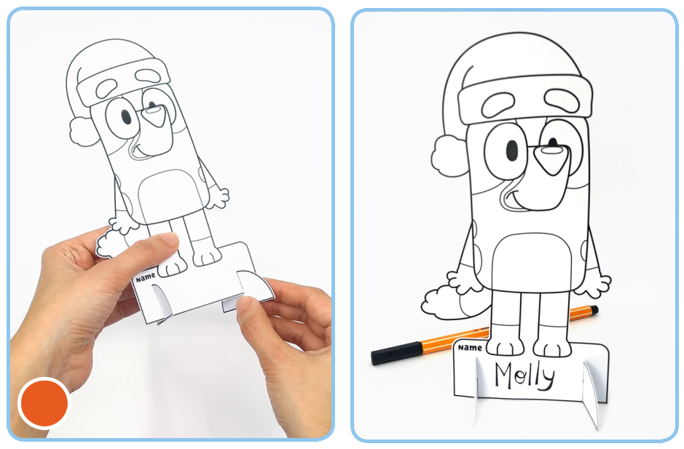

3

- Cut two vertical slits at the base of Blue and Bingo place cards, following the black lines.

Repeat for the stand pieces, as the picture shows.

- Write your child’s name on the base of the place card.

Slot the stand pieces into the base of the place cards to help them stand on the table.

Tah-Dah! colour-me-in fun while you’re waiting for the turkey to make an entrance.

Discover more fun at www.bluey.tv


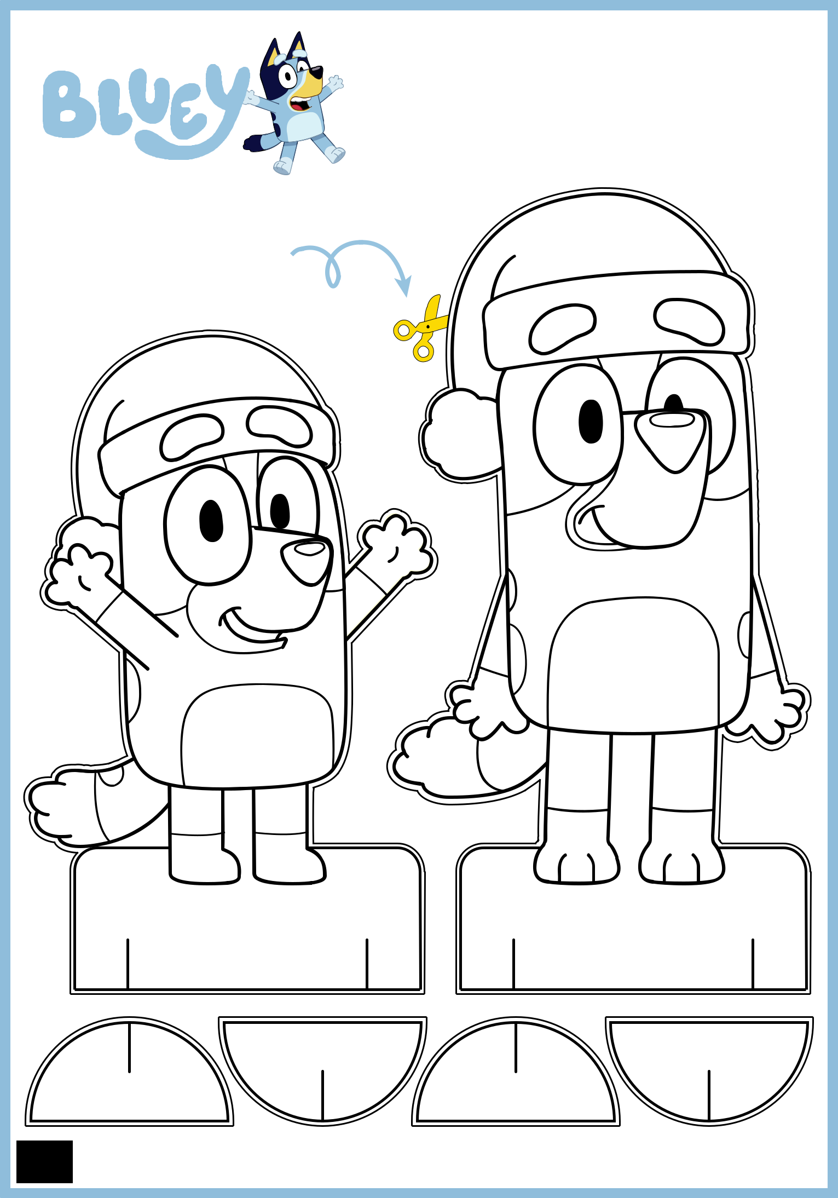
Colour-me-in
Table place card
Cra ts to inspire play

Ask a grown-up to
help you cut around
the do ted lines.

Name  Name

Discover more fun at www.bluey. v

