HOMELESS SERVICES DONATION DRIVE

WE JUST OPENED OUR DOORS AT THE
GAIL MILLER RESOURCE CENTER SOON AND NEED YOUR HELP TO ENSURE OUR CLIENTS WILL HAVE EVERYTHING THEY NEED TO START THEIR JOURNEYS TO SELF-SUFFICIENCY

HYGIENE
MOST NEEDED ITEMS

CLOTHING (CONT.)

Shampoo/Conditioner Mouth Wash (alcohol-free) Feminine Hygiene Products
Deodorant Lotion Body Wash
Razors/Shaving Cream Toothbrush/Toothpaste Lice Treatment
Lip Balm Sunscreen Bug Spray
Hair Brushes/Combs

CLOTHING
Shirts Pants
Plus-size Clothing
Socks
Underwear (new only) Bras
Coats/Rain Ponchos
In-season Shoes (boots, sandals, etc.) Pajama/Sweats

MISCELLANEOUS
Twin-size Sheets
Blankets (please no throws) Non-perishable food items & snacks
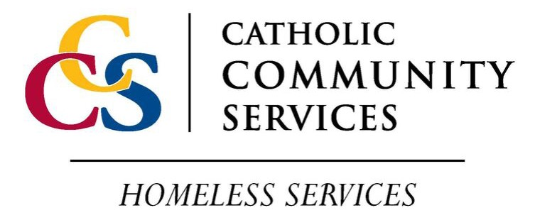
Water Bottles One-person Tents Sleeping Bags Flashlights Reading Glasses Umbrellas
Bike Locks

Donations can be taken to our Gail Miller Resource Center
242 W. Paramount Ave, SLC 84115 || Mon-Fri 9 AM - 5 PM || (801) 428-1321 www.ccsutah.org

