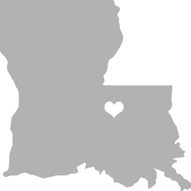
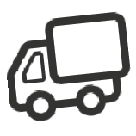

FLOOD RELIEF DONATION DRIVE
RELIEF ROUND TWO
WHEN: Sat. 8/27 - Wed. 8/31
WHERE: Winn Dixie Parking Lot
Hwy 82 in Northport
DROP OFF: 7:30 a.m. - 6 p.m.
TIMES Saturday - Wednesday

Donation Drive Provided By:

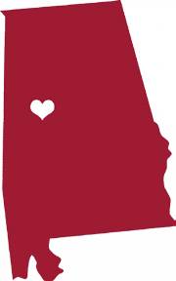
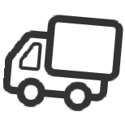
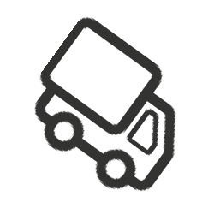
PET SUPPLIES NEEDED

TOILETRIES NEEDED
Brushes • Combs • Hair Dryers
Ponytail Holders
TOYS NEEDED
Games • Books • Cards
LINENS NEEDED
Blankets (NEW) • Sheets (NEW)
Towels • Washcloths
KITCHEN ITEMS
NEEDED
Plates • Bowls • Glasses
Coffee Cups • Can Openers
Pots • Pans • Baking Dishes
Cooking Utensils • Flatware
Containers • Storage Containers
Coffee • Coffee Makers/Filters
Powder Cream • Sugar
Kitchen Towels • Sponges
Small Kitchen Appliances
(toasters, microwaves, etc.)

Dog Food • Cat Food
Cat Litter • Crates
Food Bowls • Puppy Pads
Leashes • Collars

CLEANING SUPPLIES
NEEDED
Mops • Brooms • Buckets
Borate Solution • Bleach
Nonphosphate Detergent
Shop Vac w/ HEPA Filter
CLEANING SUPPLIES NEEDED

CLEAR STORAGE BINS NEEDED
PLEASE NOTE: Donated items must be in good
condition. Remember, if you can't use it, neither
can those who have lost everything. Thank you
so much for your generosity. Roll Tide!

