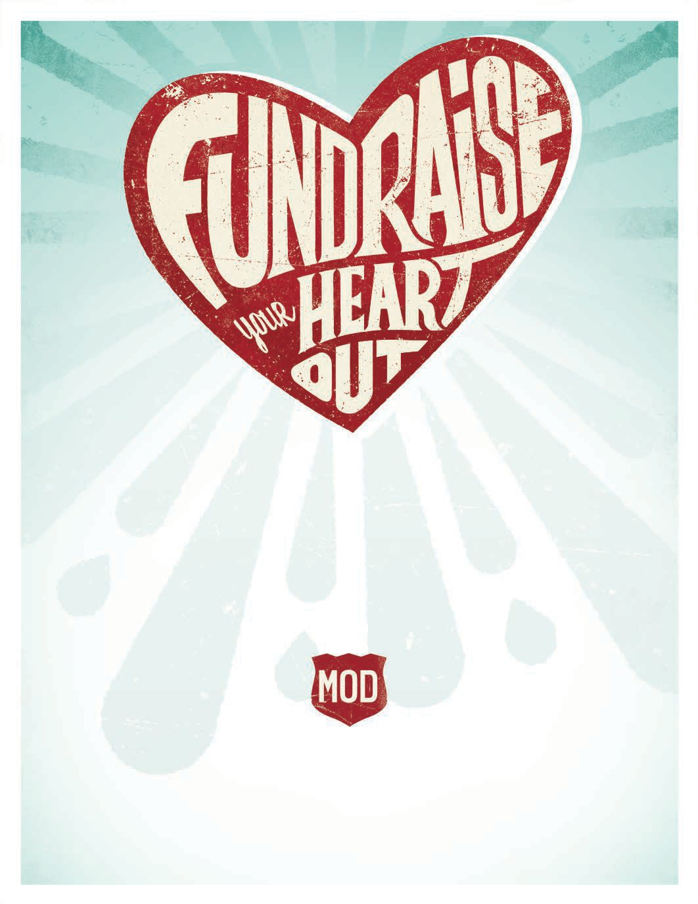

JOIN MOD IN SUPPORTING
Pleasant Valley PTA
Thursday, November 29th • All Day

Bring in this flyer and MOD will donate 20% of your bill to support their great work!

MOD PIZZA • Hazel Dell 7916 NE 6th Ave Vancouver, WA 98665
(360)828-5220
Offer valid only on the date(s) and at the MOD location identified on this flyer. Only non-profit organizations and non-profit schools are eligible to participate in the MOD fundraising program. MOD will donate 20% of food and beverage sales to the organization. Tax, gift cards and retail sales are excluded from the donation. Offer valid for dine in, take out or phone orders. Not valid for online orders. Offer void if the flyer is distributed in or near the restaurant. For more information about fundraising, visit https://modpizza.com/fundraisers/

© 2018 MOD Super Fast Pizza, LLC. All rights reserved.

