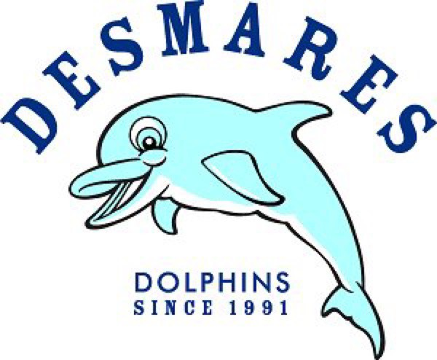
AND

Invite you to a Family Paint Night to benefit the F A Desmares Elementary School PTO!
Join us at for an evening of family painting and a lot of FUN!

When? - Monday, May 14th from 6:30 - 8:00pm
Where? - F A Desmares Elementary School
16 Old Clinton Road, Flemington, NJ 08822
Cost? - $20 per person (Includes canvas, smock, and all painting supplies)
To register and reserve your seat/s, visit ww w.paintpartyfarm.com and click on the CALENDAR tab for the May 14th evening Fundraiser session. During the registration process, please include the name of the painting you wish to paint that night. (Minecraf t, Unicorn, or Yellow Flower) Payment can be made at the time of registration through PayPal or a check can be mailed to Paint Party Farm - 24 Rosemont Ringoes Road - Ringoes, NJ 08551. Be sure you are registered online so that your seat/s are reserved. Registration
for this event will close on Saturday, May 12nd. Children must be accompanied by an adult throughout the paint session and are encouraged to paint along with the children. For each registered painter, Paint Party Farm will donate $5 back to the F A Desmares Elementary School PTO. We look forward to seeing you there!

Questions? - Contact Brian Fisher - paintpartyfarm@gmail.com
(609) 460 - 4582

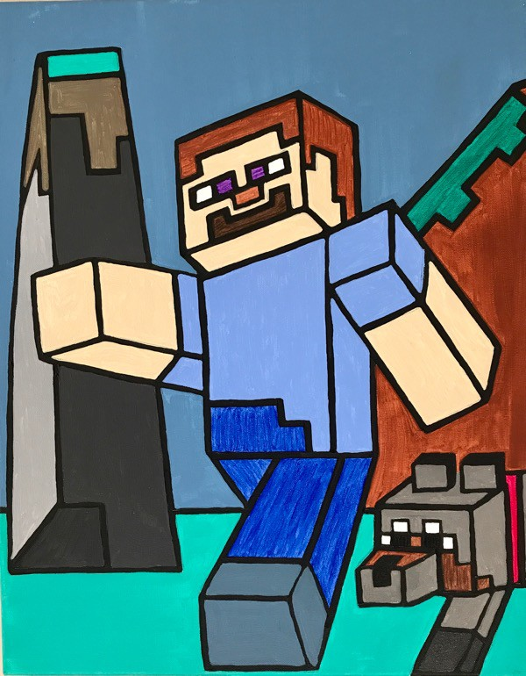
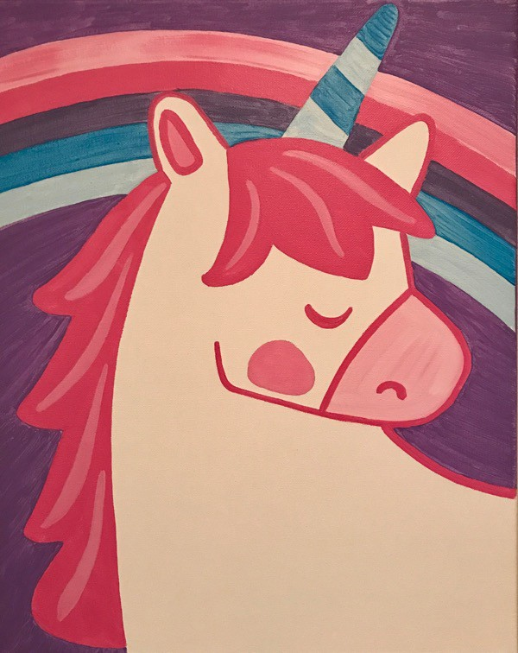
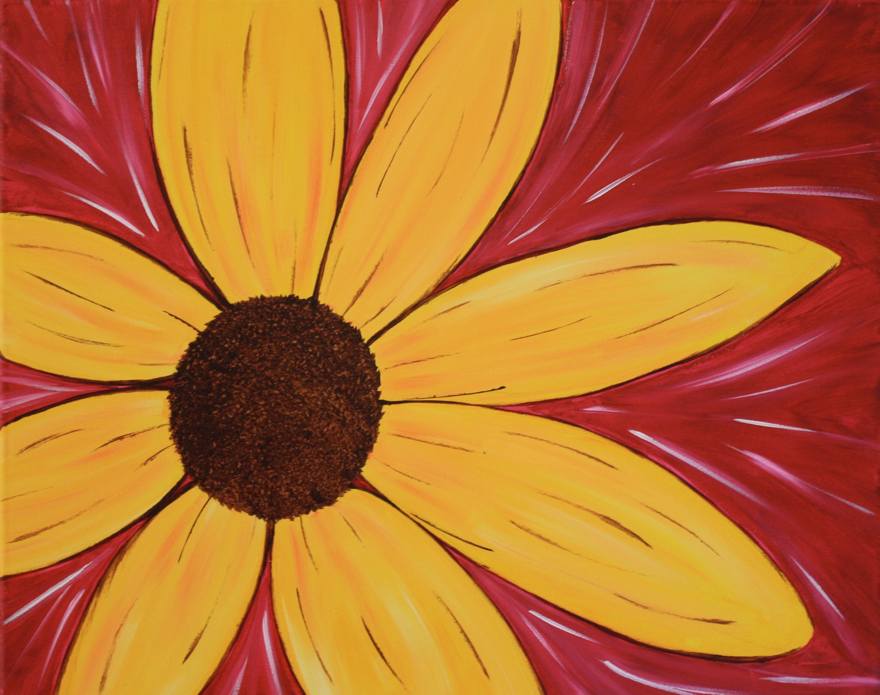
Minecraft Unicorn Yellow Flower

