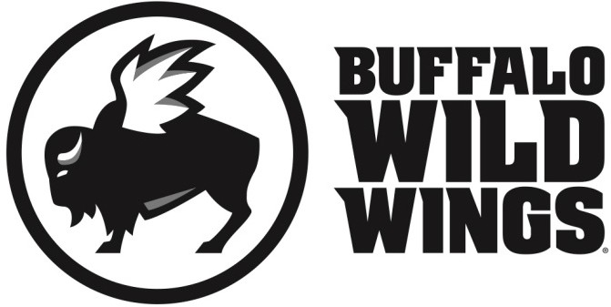

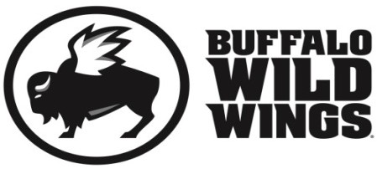

**Paton PTO Fundraiser**

A great cause and some great food

All friends, family and supporters of Paton PTO are invited to participate in their fundraising event on

**Wednesday, February 22, 2017**

Everyone is invited to gather at Buffalo Wild Wings in Shrewsbury (476 Boston Turnpike) for lunch, dinner, or a snack. On this day, 20% of purchases* accompanied by the certificate below will be donated to

**Paton PTO.**

**Paton PTO Fundraiser Wednesday, February 22, 2017**

Present this certificate to your server at the time of your order and 20% of your purchases* will go to support

**Paton PTO.**

*Valid towards Dine-In and Carry-Out. Not valid towards gift card purchases. Flyers are not permitted to be distributed inside or outside the restaurant.

**Only valid at 476 Boston Turnpike, Shrewsbury, MA (508) 845-2999**