School Fundraiser

20% Goes to our school!

Every Friday!
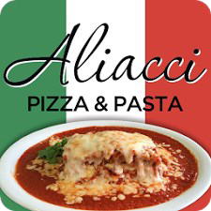

Time of Sale: 11am—10pm

Location:
4336 South Street
Lakewood, CA 90712

20% of your order at Aliacci Pizza & Pasta goes to Stephen Foster Elementary School
Bring this flyer to Aliacci Pizza and Pasta in Lakewood on any Friday, beginning Friday, April 22, and order delicious Italian food. Aliacci’s will write Stephen Foster Elementary School a check equal to 20% of the total orders for each Friday.

A new flyer much be brought in each time you visit Aliacci’s.
Flyers will be available in the school office and on the school’s website.

Thank you for your support!

