Coordinating a Donation Drive

1832 S. School Ave Fayetteville, AR 72701
(479) 966-4644
Website: www.7hillscenter.org

Email: donate@7hillscenter.org

Donation Drive Planning Kit

Are you interested in setting up your own donation drive? Do you have a plan for what you need and where the donations will go? What about marketing your drive? This planning kit will assist you in coordinating an easy and successful drive. Donation drives organized by businesses, associations, churches, schools and other groups are critically important for 7hills. All goods donated from the drives will assist homeless and near- homeless in NWA! If you have any specific questions, please contact us at donate@7hillscenter.org. Let’s get started!

Table of Contents
Donation Drive Planning Kit 2
Organizing the Donation Drive 3
Running the Drive 4
Timeline 6
Sample Flyer – Hygiene Drive 8
Sample Flyer – Food Drive 8
Sample Flyer – Winter Coat Drive 10
Sample Newsletter Article – Hygiene Drive 11
Sample Newsletter Article – Food Drive 12
Sample Newsletter Article – Clothing Drive 13
Sample Financial Gift Form 14

Organizing the Donation Drive

Identify What Items You Will Ask For

Contact us at donate@7hillscenter.org or call us at 479-966-4644 to request a copy of our Urgent Needs List. This list has been designed to make donating the most useful items to us as easy as possible. If you have a particular kind of drive in mind, it is best to give us a description of the item(s) you are trying to donate and letting us know any time constraints you may have in donating them.

Select a Committee

Donation drives are fun, but they also require a certain amount of planning in order to be successful. Gather a committee that wants to be an integral part of your drive and assign everyone specific tasks. Some of the duties you may want to assign are as follows:
  - Chairman of the committee to oversee all details and answer all questions
  - Liaison with management
  - Coordinator of advertising/promotion
  - Photographer Outside public relations/media contact
  - Coordinator of donation collection boxes
  - Chief of storing the donations
  - Coordinator of packing and transportation to the non-profit organization

Set Goals

Determine the amount of donations you want to raise. Encourage people to help you meet or surpass your goals by putting up flyers and telling them the importance of your drive.

Is a Matching Gift Available?

If you are with a company, many are willing and able to make a matching gift of their employee contributions – even when employees are giving food instead of cash. For example, if donating food, see if your company will donate a dollar for every pound of food raised.

Running the Drive

Collect | Depending on what your planning committee decides, you can collect your donations at one or more locations.  Engage multiple locations  - If possible/desired, coordinate donation drive events and collections at multiple locations in your area: other schools, stores, banks, restaurants, pharmacies, or grocery stores.  - Use same branded collection bins at all locations to increase recognition & awareness.  - Encourage everyone to promote the opportunity to colleagues and peers in the weeks leading up to event.  - Engage planning committee to create promotional items (signs, bag stuffers, table tents, counter signs).  Make Supply Drive Event a Destination  - Decorate a portion of the office or school to make the drop-off area exciting.  - If desired, work together to engage local media to acknowledge donation drive.  - Incorporate into existing events, especially company picnics or school celebrations.  “Collect” Supplies Online  - Offer a “sponsor a box” online: $30 donation buys a box of food to feed a family of four for a week  - Use an online giving site to create fundraising promotion to “Stuff a Virtual Box”. Utilize social networking sites, like Facebook Causes to raise awareness for the Donation Drive as well.  - Use a relatable number, for example $5 donation purchases 1 notebook, packet of pencils, and 2 erasers.  - Share the fundraising progress with your office or school.  - Leverage social media to excite your network by sharing specific supply needs.  - Send fundraising opportunity to all employees or families of students via email or newsletter (see Sample Newsletter Article below).  - If available, present a matching gift challenge, where the company matches individuals’ donations; all donations go to purchasing supplies.
Sort | As donations are received, take time to run through the donations to look for items that cannot be used once delivered to the nonprofit. Consider taking photos of mounds of supplies before they are sorted into the way that the receiving nonprofit has designated. See the timeline in the  following pages for ideas to consider as you plan your drive.

Deliver | Delivering the supplies, too, is a great way to engage others and generate attention for the success of the donation drive. Ideas may include:  Inviting donors to assist in the delivery of the donations. Wear school/office t-shirts to promote publicity of donations.
Promote | There are many ways to generate excitement and visibility throughout the drive. In the tool-kit you will find samples of documents to use when promoting the donation drive. A few tips to consider:  - Is there a way to film/photo the pile of supplies, supplies being sorted, hundreds of backpacks filling a bus, volunteers and children?  - Use social media to reach new audiences: Twitter, Facebook to spread messages.

Timeline

Every donation drive is different. Whatever form your donation drive takes, this sample timeline will help guide your collection and event planning from concept to celebration.

6-8 Weeks | - Identify potential community partners (companies, retail businesses, agencies, chambers of commerce, council on corporate volunteerism, faith-based groups, colleges, labor unions) and others to:  - Receive and deliver school supply collections. Serve as collection or drop-off centers.  - Provide transportation and logistical support.  - Donate warehouse or parking lot space for an event. Help promote the project, e.g., media, publicity volunteers.  - Create a list with information on all partners, including: name, address, contact name(s), phone, e-mail address, category, website, notes.  - Schedule face-to-face or phone meetings to discuss a project ideas.  - Determine next steps for each member of the planning committee (their role, time commitment, how to manage collection of supplies).
4-6 Weeks | - Brief other staff or committee members on all aspects of the project and involve them in any further planning and preparation.  - Schedule post-event meeting, to ensure that committee members are available to debrief and attend to follow-up tasks.  - Draft agenda for the day of an event. Notify your marketing & communication departments for PR/media plan.  - Discuss documentation (photos, video) of an event.  - Recruit a volunteer photographer if possible. If needed, verify need for photo a release form.  - If needed, order event t-shirts, signage or other collateral, as needed.  - Plan any transportation and other logistics needed.
2-4 Weeks | - Visit collection sites.  - Address any remaining questions and concerns.  - Recruit volunteers.  - Secure attendance of all dignitaries as needed for an event’s agenda.  - Draft or secure talking points for dignitaries to include in the run of show document.

 | - Finalize task lists and make sure all committee members are comfortable with scope of work.
1-2 Weeks | - Confirm all final details.  - Make sure you will have tables and chairs for all donation drop-off stations.  - Confirm materials needed, will be onsite.  - Pack a “project kit” to include things such as:  - Signage and banners  - Pens, markers o Tape  - Extra paper/card stock/poster board  - Flyers about the donation drive

Sample Flyer – Hygiene Drive

First Annual Hygiene Drive!
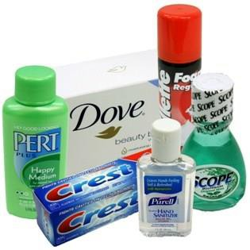

Help us collect hygiene items for our neighbors in need.

All donations will be delivered to 7hills Homeless Center on (Date) and will be put to good use immediately in helping those in our community.

Our goal is 100 hygiene items this month!

7hills is in need of the following items:

Deodorant (Men’s and Women’s)
  - Disposable Razors
  - Shampoo (full size bottles or trial/hotel size)
  - Shower Gel (full size bottles or trial/hotel size)
  - Bar Soap (Large or trial/hotel size)
  - Men’s Underwear (S, M, L)
  - Women’s Underwear (S, M, L)
  - Batteries (AA and AAA)

(Your Organization or Group’s Logo/Info Here)

Sample Flyer – Food Drive

First Annual Food Drive!
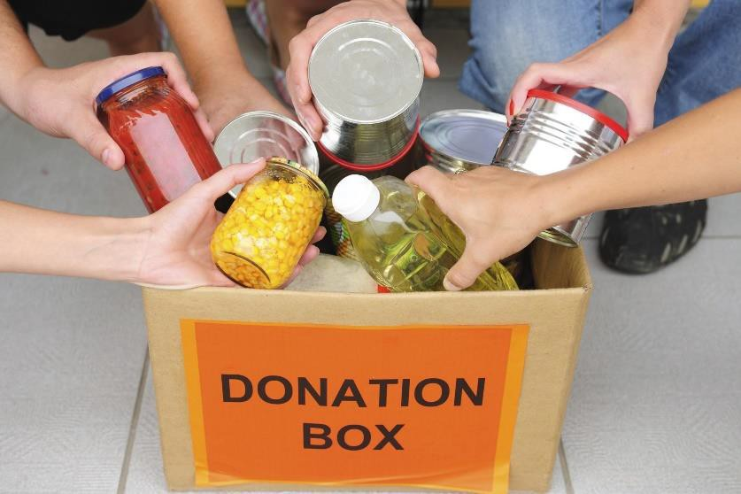

Help us collect food for our neighbors in need.

All donations will be delivered to 7hills Homeless Center on (Date) and will be put to good use immediately in feeding those who are hungry in the community.

7hills is in need of the following items:

- Pull-Top Canned Vegetables (Peas, Carrots, Green Beans)
- Pull-Top Canned Beans

- Pull-Top Canned Meats (Tuna, Chicken, Vienna Sausages)
- Canned Ravioli, Spaghettios, etc.

- Canned Chunky Soaps

- Protein/Granola Bars

- Spaghetti Sauce/Noodles
- Boxed Meals (Hamburger Helper, Tuna Helper, etc.)
- Macaroni and Cheese

- Saltine Crackers

- Ramen Noodles

- Sugar

- Creamer

- Coffee

(Your Organization or Group’s Logo/Info Here)

Sample Flyer – Winter Coat Drive

First Annual Coat Drive!
Help us collect coats for our neighbors in need.
All donations will be delivered to 7hills Homeless Center on (Date) and will be put to good use immediately in keeping our community members warm.

Our goal is (Number of Coats) to keep others warm!
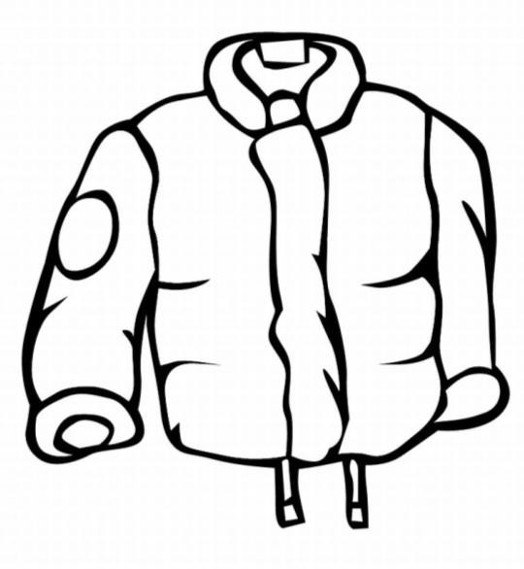

7hills is in need of the following items:
  - Male Adult coats
  - Female Adult coats
  - Winter Gloves
  - Winter Hats

(Your Organization or Group’s Logo/Info Here)

Sample Newsletter Article – Hygiene Drive

Hygiene Products Needed!

You can help homeless people move from homelessness to housing.

Now through (Date), we are collecting donations of hygiene products for 7hills Homeless Center. Your donations will help 7hills meet its mission to Fight Homelessness and Poverty with Education, and Hope and Opportunities!

We are collecting donations of:

Deodorant (Men’s and Women’s)

- Disposable Razors

- Shampoo (full size bottles or trial/hotel size)

- Shower Gel (full size bottles or trial/hotel size)

- Bar Soap (Large or trial/hotel size)

- Men’s Underwear (S, M, L)

- Women’s Underwear (S, M, L)

- Batteries (AA and AAA)

Bring your donations to our collection boxes located at: (Location). Our donation drive coordinator is (School/Office Contact) and can be reached at (School/Office Contact).
For more information on 7hills Homeless Center, please visit their website at 7hillscenter.org or call (479) 966-4644.

Sample Newsletter Article – Food Drive

Canned and Boxed Food Needed!

You can help homeless people move from homelessness to housing.

Now through (Date), we are collecting donations of canned and boxed, non-perishable food items for 7hills Homeless Center. Your donations will help 7hills meet its mission to Fight Homelessness and Poverty with Education, and Hope and Opportunities!
We are collecting donations of:

Pull-Top Canned Vegetables (Peas, Carrots, Green Beans)

- Pull-Top Canned Beans

- Pull-Top Canned Meats (Tuna, Chicken, Vienna Sausages)

- Canned Ravioli, Spaghettios, etc.

- Canned Chunky Soaps

- Protein/Granola Bars

- Spaghetti Sauce/Noodles

- Boxed Meals (Hamburger Helper, Tuna Helper, etc.)

- Macaroni and Cheese

- Saltine Crackers

- Ramen Noodles

- Sugar

- Creamer

- Coffee

Bring your donations to our collection boxes located at: (Location). Our donation drive coordinator is (School/Office Contact) and can be reached at (School/Office Contact).
For more information on 7hills Homeless Center, please visit their website at 7hillscenter.org or call (479) 966-4644.

Sample Newsletter Article – Clothing Drive

Gently Used or New Clothing Needed!

You can help homeless people move from homelessness to housing.

Now through (Date), we are collecting donations of new or gently used clothing for adults for 7hills Homeless Center. Your donations will help 7hills meet its mission to Fight Homelessness and Poverty with Education, and Hope and Opportunities!
We are collecting donations of:

Blue Jeans (Men’s and Women’s)

- T-Shirts (Men’s and Women’s)

- Socks (Ankle and Long)

- Belts

- Backpacks

- Men’s Underwear (S, M, L)

- Women’s Underwear (S, M, L)

- Light Jackets

- Rain Gear

- Winter Coats

- Winter Hats

- Winter Gloves

- Hand Warmers

Bring your donations to our collection boxes located at: (Location). Our donation drive coordinator is (School/Office Contact) and can be reached at (School/Office Contact).
For more information on 7hills Homeless Center, please visit their website at 7hillscenter.org or call (479) 966-4644.

Sample Financial Gift Form

Yes! I want to partner with 7hills Homeless Center! Below is my tax-deductible gift.

Please fill out the form below and fax/mail to:

7hills Homeless Center 1832 S. School Ave Fayetteville, AR 72701
Phone: 479-966-4644
Fax: 479-966-4644

My Gift: $25 $50 $75 $100 Other $

My Contact Information:

Name Address City/State/Zip Phone Email
Please check this box if you prefer to keep your gift anonymous.

Payment Options:

Enclosed is my check or money order made payable to “7hills Homeless Center” with the memo line marked “Day Center Essential Needs.”
I wish to donate by credit card. Below is my credit card information.

Visa MasterCard Expiration (mm/yy) Card number (16 digits) Card holder name Cardholder Signature
My Employer has a Matching Gift Program. Enclosed with my donation is my company’s form.
I want to be contacted regarding a future donation to the Day Center.

