Standard Form - QCD State of

Asset No.

REAL ESTATE PURCHASE AND SALE CONTRACT

- PARTIES: This Real Estate Purchase And Sale Contract (this Contract") is entered into by and between the Federal Deposit Insurance Corporation (the "FDIC"), [check one] _{I I} as Receiver for

in its corporate capacity ("Seller"), and

-, [check one] I I an individual I J a

("Purchaser").

- PROPERTY: That certain tract or parcel of land commonly known as

and described on Exhibit "A" attached hereto and incorporated herein for all purposes, which parcel of land is to be sold together with all buildings and other improvements situated thereon, all fixtures and other property affixed thereto, and all and singular the rights and appurtenances pertaining to the property, including any right, title and interest of Seller in and to adjacent streets, alleys or rights-of-way (collectively, the "Property").

- PURCHASE PRICE: The purchase price (the "Purchase Price") for which Seller agrees to sell and convey the Property to Purchaser, and which Purchaser agrees to pay to Seller, subject to the terms hereof, is the amount of______________________
-- AND N01100 DOLLARS ($ ), which

shall be paid by wired funds, cashier’s or certified check at Closing (hereinafter defined). Additionally, if any personal property is to be conveyed hereunder, as provided for in Section 32 hereof, Purchaser shall pay Seller at Closing the amount of$___________ for such personalty, over and above the Purchase Price.

4. EARNEST MONEY: Concurrently with the execution hereof, Purchaser has delivered to [check one] [ Seller or its
]

third party marketing contractor a cashier’s or certified check payable to Seller [ ] the Settlement Agent (as hereinafter defined in

Section 11) a cashier’s or certified check payable to the Settlement Agent in the amount of $ as earnest money

hereunder (the "Earnest Money"), equal to [check one] [ the full amount of the Purchase Price [ ] the greater of $2,000.00
]

or five percent (5%) of the Purchase Price [ ] percent ( %) of the Purchase Price. The

Earnest Money check shall immediately be presented for payment, and the Earnest Money will NOT bear interest at any time. If the sale hereunder is consummated in accordance with the terms hereof, the Earnest Money will be applied against the Purchase Price at Closing. In the event of default hereunder, the Earnest Money will either be retained by Seller or refunded to Purchaser in accordance with Section 16 hereof.

- SURVEY: Seller has no obligation to provide Purchaser with a survey of the Property. Purchaser may elect to purchase same at its own expense, which shall in no event delay Closing.

- TITLE COMMITMENT; TITLE POLICY: Seller has no obligation to provide Purchaser with a title commitment or an owner’s policy of title insurance covering the Property. Purchaser may elect to purchase same at its own expense from a title

FDIC Standard QCD Form Real Estate Purchase and Sale Contract - Page 1 fdicformresalescontractQCDrecorpO4O4 1 1_final.doc
Revised 04/04/11

company of its own choosing, which shall in no event delay Closing or cause Closing to occur other than as set forth in Section 11 of this Contract.

Purchaser has no right to raise any objection to, nor does Seller have any obligation to eliminate or modify, any easement, lien, imposition, encumbrance, restriction, condition, covenant, or any other matter with respect to the Property, whether of record or not, or whether evidenced by a title commitment, survey, or otherwise. Purchaser hereby acknowledges and agrees that all such matters are permitted encumbrances hereunder and that conveyance of the Property pursuant to this Contract will be subject thereto.

INSPECTION PERIOD [check one]: I ] There is no inspection period granted under this Contract.

₁ 1(a) Purchaser will have a period of days from and after the Effective Date (hereinafter defined) to examine the Property and to conduct at its sole cost and expense such physical tests, inspections, surveys, and other

investigations as are reasonably necessary for Purchaser to determine whether the Property is suitable for Purchaser’s intended use (the "Inspection Period"). Purchaser and Purchaser’s agents and representatives will have reasonable access to the Property during normal business hours prior to Closing for that purpose. Notwithstanding the foregoing, (i) Purchaser will give Seller reasonable notice of Purchaser’s intention to enter upon the Property; (ii) Purchaser must obtain written approval from Seller before Purchaser conducts any sampling, testing, or analysis of any media on or inspection of the Property, including, in Seller’s discretion, the execution of a property access agreement for those purposes; and (iii) Seller may require that a representative of Seller accompany Purchaser or its agents while they are on the Property. Any sampling, testing, or analysis of any media on or inspection of the Property performed or caused to be performed by Purchaser shall not unreasonably interfere with the use and occupancy of the Property by Seller or Seller’s tenants, if any. In the event that the transaction contemplated by this Contract does not close for any reason, Purchaser is obligated to restore the Property to its condition prior to Purchaser’s entry thereon. This obligation will survive termination of this Contract.

- copy of every report of every sampling, testing, analysis, and inspection conducted by Purchaser or on its behalf on the Property, including but not limited to any survey and any environmental report or environmental site assessment, will be delivered to Seller within five (5) days after such report is received by Purchaser. Purchaser shall and does hereby release, indemnify, and hold Seller harmless, and Purchaser shall defend Seller (with counsel acceptable to Seller), from and against any and all liabilities, claims, demands, causes of action, damages, and expenses (including attorneys’ fees) incident to, resulting from, or in any way arising out of Purchaser’s or its agents’ presence on the Property and any such sampling, testing, analysis, or inspection conducted by Purchaser on the Property. Such indemnity shall survive Closing or any termination of this Contract and shall not be merged therein.

- If Purchaser reasonably determines that the Property is unsuitable for Purchaser’s intended use, Purchaser may terminate this Contract by delivery of written notice to Seller prior to the expiration of the Inspection Period. In such event, the Earnest Money will be returned to Purchaser and thereafter neither party hereto will have any further rights or obligations under this Contract. If Purchaser does not terminate this Contract prior to the expiration of the Inspection Period, Purchaser will be obligated to close the transaction contemplated herein under the terms of this Contract and Purchaser’s failure to do so will entitle Seller to retain the Earnest Money as liquidated damages as provided in Section 16 hereof.

FDIC Standard QCD Form Real Estate Purchase and Sale Contract - Page 2 fdicformresalescontractQCD_recorp_0404 1 1_finaldoc

Revised 04/04/11

8. �CONVEYANCE OF TITLE: Seller will convey the Property to Purchaser by a quitclaim deed substantially in the form of Exhibit "B" attached hereto and incorporated herein for all purposes (provided, however, that if the state in which the Property is located does not recognize a conveyance by quitclaim deed, Seller will convey the Property to Purchaser by a deed without warranty in form and substance satisfactory to Seller in its sole and absolute discretion, in each such instance, the "Deed"), subject to any and all exceptions, easements, rights-of-way, covenants, conditions, restrictions, reservations, encroachments, protrusions, shortages in area, boundary disputes and discrepancies, matters which could be discovered or would be revealed by, respectively, an inspection or current survey of the Property, liens, encumbrances, impositions (monetary and otherwise), access limitations, licenses, leases, prescriptive rights, rights of parties in possession, rights of tenants, co-tenants, or other co-owners, and any and all other matters or conditions affecting the Property, whether known or unknown, recorded or unrecorded, as well as standby fees, real estate taxes, and assessments on or against the Property for the current year and prior and subsequent years and subsequent taxes and assessments for prior years becoming due by reason of a change in usage or ownership, or both, of the Property; and any and all zoning, building, and other laws, regulations, and ordinances of municipal and other governmental authorities affecting the Property (all of the foregoing being collectively referred to as the "Permitted Encumbrances"). Any personalty to be conveyed to Purchaser under Section 32 hereof shall be conveyed by a quitclaim bill of sale (the "Bill of Sale").

PROPERTY CONDITION:

- PURCHASER, BY ITS EXECUTION OF THIS CONTRACT, ACKNOWLEDGES THAT:

  - SELLER HAS NOT MADE, DOES NOT MAKE, AND SPECIFICALLY NEGATES AND DISCLAIMS, ANY REPRESENTATIONS, WARRANTIES, PROMISES, COVENANTS, AGREEMENTS, OR GUARANTIES OF ANY KIND OR CHARACTER WHATSOEVER, WHETHER EXPRESS OR IMPLIED, ORAL OR WRITTEN, PAST, PRESENT, OR FUTURE, OF, AS TO, CONCERNING, OR WITH RESPECT TO (A) THE VALUE, NATURE, QUALITY, OR CONDITION OF THE PROPERTY,

INCLUDING, WITHOUT LIMITATION, THE WATER, SOIL, AND GEOLOGY, (B) ANY INCOME TO BE DERIVED FROM THE PROPERTY, (C) THE SUITABILITY OF THE PROPERTY FOR ANY AND ALL ACTIVITIES AND USES WHICH PURCHASER MAY CONDUCT OR HOPE TO CONDUCT THEREON,

(D) THE COMPLIANCE OF OR BY THE PROPERTY OR ITS OPERATION WITH ANY LAWS, RULES, ORDINANCES, OR REGULATIONS OF ANY APPLICABLE GOVERNMENTAL AUTHORITY OR BODY, (E) THE TITLE, DESCRIPTION, POSSESSION, HABITABILITY, MERCHANTABILITY, MARKETABILITY, PROFITABILITY, OR FITNESS FOR PARTICULAR PURPOSE OF THE PROPERTY OR ANY PART THEREO, (F) THE MANNER OR QUALITY OF THE CONSTRUCTION OR MATERIALS, IF ANY, INCORPORATED INTO THE PROPERTY, (G) THE MANNER, QUALITY, STATE OF REPAIR, OR LACK OF REPAIR OF THE PROPERTY OR ANY PORTION THEREOF OR ANY

IMPROVEMENTS THERETO, (H) THE EXISTENCE, QUALITY, NATURE, ADEQUACY, OR PHYSICAL CONDITION OF ANY UTILITIES SERVING THE PROPERTY, OR (I) ANY OTHER MATTER WITH

RESPECT TO THE PROPERTY, AND SPECIFICALLY, THAT SELLER HAS NOT MADE, DOES NOT MAKE, AND SPECIFICALLY DISCLAIMS ANY REPRESENTATIONS REGARDING COMPLIANCE

FDIC Standard QCD Form Real Estate Purchase and Sale Contract - Page 3 fdicformresalescontractQCDrecorp_0404 I 1_final.doc
Revised 04/04/11

WITH ANY ENVIRONMENTAL PROTECTION, POLLUTION, OR LAND USE LAWS, RULES, REGULATIONS, ORDERS, OR REQUIREMENTS, INCLUDING, WITHOUT LIMITATION, THE DISPOSAL OR EXISTENCE, IN OR ON THE PROPERTY OR ANY PART THEREOF, OF ANY HAZARDOUS MATERIALS;

    - PURCHASER HAS FULLY INSPECTED THE PROPERTY AND THAT THE CONVEYANCE OF THE PROPERTY IS "AS IS" AND "WITH ALL FAULTS," AND SELLER HAS NO OBLIGATION TO ALTER, REPAIR, OR IMPROVE THE PROPERTY OR ANY PORTION THEREOF OR ANY IMPROVEMENTS THERETO; AND

    - NO WARRANTY HAS ARISEN THROUGH TRADE, CUSTOM, OR COURSE OF DEALING WITH SELLER.

  - ADDITIONALLY, PURCHASER HEREBY REPRESENTS TO SELLER THAT PURCHASER HAS MADE, WILL MAKE, OR HEREBY WAIVES: (A) ALL INSPECTIONS OF THE PROPERTY DEEMED

NECESSARY OR APPROPRIATE BY PURCHASER TO DETERMINE THE PROPERTY’S VALUE AND CONDITION, INCLUDING, WITHOUT LIMITATION, INSPECTIONS FOR THE PRESENCE OF ASBESTOS, PESTICIDE RESIDUES, UNDERGROUND STORAGE TANKS, HAZARDOUS WASTE, AND ANY OTHER HAZARDOUS MATERIALS, AND (B) ALL INVESTIGATIONS TO DETERMINE WHETHER ANY PORTION OF THE PROPERTY LIES WITHIN ANY FLOOD HAZARD AREA AS DETERMINED BY THE U. . ARMY CORPS OF ENGINEERS OR OTHER APPLICABLE AUTHORITY. PURCHASER’S INSPECTION OF THE PROPERTY OR WAIVER THEREOF WILL RELIEVE SELLER OF ANY LIABILITY TO PURCHASER AS RESULT OF

ANY ENVIRONMENTAL HAZARD ON OR TO THE PROPERTY AND PURCHASER HEREBY ACCEPTS ALL LIABILITY THEREFOR AS BETWEEN PURCHASER AND SELLER AND INDEMNIFIES AND HOLDS SELLER HARMLESS FROM AND AGAINST ANY AND ALL CLAIMS, LIABILITIES, DEMANDS, OR ACTIONS INCIDENT TO, RESULTING FROM, OR IN ANY WAY ARISING OUT OF SUCH HAZARD. THIS INDEMNITY SHALL SURVIVE CLOSING AND SHALL NOT BE MERGED THEREIN.

- BROKER’S FEE: By separate document, Seller has agreed to pay a real estate commission (the "Commission") to the real estate agent specified therein (the "Broker"), subject to the closing of the transaction contemplated by this Contract and payment of the full Purchase Price to Seller. The Broker may agree to pay a portion of the Commission to any other licensed real estate agent but Seller will bear no liability for payment of the Commission or any portion thereof to any agent other than the Broker. Purchaser hereby (i) acknowledges that Seller will bear no liability for payment of the Commission or any portion thereof to any agent other than the Broker, and (ii) indemnifies Seller from any claims which may be asserted against Seller by any real estate agent who has or claims to have been authorized by Purchaser to act on Purchaser’s behalf in the transaction contemplated by this Contract.

- CLOSING: The closing of the sale of the Property by Seller to Purchaser ("Closing") shall occur on the first business

day following the expiration of ()daysfrom and after [check the first box if there is no

FDIC Standard QCD Form Real Estate Purchase and Sale Contract - Page 4 fdicformresalescontract_QCD_recorp0404 1 1_final.doc
Revised 04/04/11

Inspection Period] [ J the Effective Date [ ] the expiration of the Inspection Period as set forth in Section 7(a) hereinabove (the "Closing Date"). The Closing shall occur at Seller’s offices or, at Seller’s option, at the offices of a title company or closing attorney designated by Seller in its sole discretion (in either event, the "Settlement Agent"). At Closing, among the other requirements set forth in this Contract, Purchaser shall deliver the Purchase Price to Seller in accordance with Section 3 hereinabove and, if applicable, the additional amount set forth in said Section 3 for the personalty to be conveyed hereunder, and Seller shall deliver the Deed and, if applicable under Section 32 hereof, the Bill of Sale, to Purchaser. If either party fails to close the sale under the terms of this Contract, the non-defaulting party will be entitled to exercise the remedies provided in Section 16 hereof. Any extension of the Closing Date must be in writing and executed by Purchaser and Seller in advance of the scheduled Closing Date. Notwithstanding the foregoing, Seller shall have the right, in its sole discretion, to extend the Closing
Date for a period of up to �( ) days as it may deem necessary or appropriate.

- POSSESSION: Possession of the Property in its condition existing on the Effective Date, ordinary wear and tear excepted, will be delivered to Purchaser at Closing, subject to the rights or claims of parties in possession or vendors thereto. Delivery of the Deed by Seller and acceptance of the Deed by Purchaser will evidence the assignment by Seller and assumption by Purchaser of all written or oral agreements for lease of the Property and contracts in effect as of the Closing Date. From and after Closing, Purchaser will defend, indemnify, and hold Seller harmless from and against all claims, demands, and actions arising under such leases or contracts.

- CLOSING COSTS: All expenses and costs incurred in connection with Purchaser’s purchase of the Property, except the Commission described in Section 10, if any, and the preparation of the Deed, will be paid by Purchaser. Such expenses and costs to be paid by Purchaser include, but are not limited to, documentary stamp, ad valorem and transfer taxes, and recording fees.

- PRORATIONS: At Closing, any and all utilities, rents, amounts owing under service contracts and leases, and all other items of income or expense related to the Property, will be prorated between Purchaser and Seller as of the Closing Date, Seller being charged and credited for all of same up to such date and Purchaser being charged and credited for all of same on and after such date. All such prorations are final and not adjustable. Notwithstanding the foregoing, Purchaser will be responsible for all unpaid taxes and assessments affecting the Property, whether known or unknown, current or delinquent, including, without limitation, any and all dues and assessments of home or condominium owners’ associations, and any additional taxes, assessments, interest, penalties, court costs, title costs, and attorney fees that may become due because of (i) the transfer of the Property, (ii) a subsequent change in the use of the Property, or (iii) the omission of assessments on improvements. There will be no proration for any of the items described in the immediately preceding sentence of this Section 14.

- CASUALTY LOSS: In the event of damage to or destruction of the Property by fire or other casualty prior to Closing, resulting in a loss exceeding the greater of $5,000.00 or twenty percent (20%) of the Purchase Price, Purchaser may, at its option, either (i) terminate this Contract by written notice thereof to Seller within five (5) days after Seller notifies Purchaser of the casualty and receive the immediate return of the Earnest Money, and thereafter neither party hereto will have any further rights or obligations under this Contract; or (ii) proceed to close the transaction contemplated herein in accordance with the terms hereof and receive the insurance proceeds payable as a result of such casualty (or, at Seller’s option, allow Purchaser at Closing a credit against the Purchase Price in the amount of such casualty loss).

FDIC Standard QCD Form Real Estate Purchase and Sale Contract - Page 5 fdicformresalescontractQCDrecorp 04041 1_final.doc

Revised 04/04/11

  - DEFAULT: If Purchaser fails to perform any of its obligations hereunder, Seller’s exclusive remedy for such default is

- termination of this Contract by written notice thereof to Purchaser, and (b) retention of the Earnest Money as liquidated damages hereunder. If Seller fails to perform any of its obligations hereunder, Purchaser’s exclusive remedy for such default is termination of this Contract by written notice thereof to Seller and liquidated damages as follows: (i) refund of the Earnest Money, and (ii) reimbursement by Seller of Purchaser’s documented out-of-pocket expenses, not to exceed $500.00. The liquidated damages specified in this Section are not penalties, but reasonable estimates of, respectively, the cost to Seller of holding the Property off of the market and the cost to Purchaser of the lost transaction. In no event shall Seller be liable to Purchaser for any other actual, punitive, speculative, or consequential damages, nor shall Purchaser be entitled to bring a claim to enforce specific performance of this Contract.

  - PROHIBITED PURCHASER: Purchaser acknowledges that certain persons are prohibited from purchasing assets from Seller and that under certain circumstances Seller will not sell assets to certain persons. Contemporaneously with the execution of this Contract, Purchaser has completed, executed, and delivered to Seller a Purchaser Eligibility Certification (the "PEC") in the form attached here to as Exhibit "C." Purchaser hereby represents and warrants to Seller that the completed PEC is true and correct, and acknowledges that Seller is relying on the truth and accuracy of the completed PEC. Any incorrect information on the PEC will constitute a default under this Contract by Purchaser. Accordingly, if Seller determines prior to Closing that any portion of Purchaser’s completed PEC is incorrect, Seller may terminate this Contract and retain the Earnest Money pursuant to Section 16 hereof, and may pursue any other sanctions provided by law.

  - CONFIDENTIALITY: Contemporaneously with the execution of this Contract, Purchaser has completed, executed, and delivered to Seller a Confidentiality Agreement (herein so called) in the form attached hereto as Exhibit "D." Any breach of the Confidentiality Agreement by Purchaser will constitute a default under this Contract by Purchaser, in which event Seller may terminate this Contract and retain the Earnest Money pursuant to Section 16 hereof, and may pursue any other sanctions provided by law.

  - ATTORNEYS’ FEES: In any legal proceeding brought under or with regard to this Contract, the prevailing party will be entitled to recover court costs and reasonable attorneys’ fees from the non-prevailing party; provided, however, that Seller’s liability, if any, for court costs and attorneys’ fees, shall be determined in accordance with the

Equal Access to Justice Act, codified at 28 U. .C. § 2412 (2006), to the extent applicable, as well as any other applicable federal law.

- AUTHORITY TO EXECUTE: Only an Attorney in Fact for the FDIC, acting in the capacity stated in Section 1 hereof, is authorized by the FDIC to execute this Contract.

- SURVIVAL: In addition to those certain provisions of this Contract expressly made to survive Closing or any termination of this Contract, Sections 9, 10, 12, 14, 23 and 27 of this Contract shall survive Closing and the delivery of the Deed and shall not be merged therein.

FDIC Standard QCD Form Real Estate Purchase and Sale Contract - Page 6 fdicformresalescontractQCDrecorp0404 I l_final.doc Revised 04/04/11

  - MODIFICATION: This Contract is the entire agreement between Seller and Purchaser concerning the sale of the Property and supersedes all prior agreements and understandings, if any, with regard thereto, and no modification hereof or subsequent agreement relative to the subject matter hereof shall be binding on either party unless reduced to writing and signed by the party to be bound.

  - GOVERNING LAW: The validity, construction, enforcement, interpretation, and performance of this Contract shall be governed by the laws of the United States of America, and to the extent that state law would apply under applicable federal law, the state in which the Property is located.

  - TIME: Time is of the essence in the performance of each party’s obligations under this Contract.

  - NOTICES: Any notice provided or required to be given under this Contract must be in writing and shall be served (and shall be deemed to have been served) by (a) depositing same in the United States mail, addressed to the party to be notified, postage prepaid and certified with return receipt requested; (b) delivering the same to such party or agent of such party, in person or by commercial courier; or (c) depositing the same into the custody of a nationally recognized overnight delivery service, addressed to the party to be notified. For purposes of notice, the addresses of the parties shall be as set forth in their respective signature blocks hereinbelow.

  - EFFECTIVE DATE: The date of execution of this Contract by the latter of Purchaser or Seller, as set forth in their respective signature blocks hereinbelow, shall be the "Effective Date" hereof for all purposes.

  - CONSTRUCTION: Unless stated otherwise, the words "day" or "days" refer to calendar days. Pronouns are used interchangeably herein to refer to masculine, feminine, or neuter antecedents. The parties hereby acknowledge that each party and its counsel have reviewed this Contract and had the opportunity to revise same, and each consequently agrees that the normal rule of construction to the effect that any ambiguities are to be resolved against the drafting party shall not be employed in the interpretation of this Contract.

  - INDIVIDUAL LIABILITY: The individual who purports to execute this Contract on behalf of a purchasing legal entity will nevertheless be bound under this Contract in his or her individual capacity unless, prior to Closing, the individual provides Seller with a copy of (a) the articles or agreement by which the purchasing legal entity was created, as filed, if applicable, with the proper state office or authority, (b) a resolution of that legal entity authorizing (i) the transaction contemplated herein, and (ii) such individual to bind such legal entity in such transaction.

- ASSIGNMENT: This Contract shall inure to the benefit of and be binding on the parties hereto and their respective heirs, legal representatives, successors, and assigns. Notwithstanding the foregoing, Purchaser shall not have the right to assign its interest in this Contract without the prior written consent of Seller, which consent may be granted or withheld in Seller’s sole and absolute discretion, and any such assignment to which Seller has not so consented shall be null and void and of no force or effect.

FDIC Standard QCD Form Real Estate Purchase and Sale Contract - Page 7 fdicforinresalescontractQCD_recorp0404 I lfinal.doc

Revised 04/04/I1

30. �STATE SPECIFIC ATTACHMENTS: The following attachments, if any, are attached hereto and incorporated herein for all purposes in order to conform this Contract to the laws of the state in which the Property is located:

_{F I} ATTACHMENT"!:"

- ATTACHMENT "2:"

_{F I} ATTACHMENT "3:"

  - _{I} ATTACHMENT "4:"

- DISCLOSURES REGARDING THE PROPERTY:

I I

F I

ATTACHMENT ":" Lead-Based Paint Disclosure. Required if improvements to the Property include a residential dwelling built prior to 1978.

ATTACHMENT":" Other Environmental Matters. Other environmental matters require disclosure prior to conveyance of the Property to Purchaser.

- PERSONAL PROPERTY; PERSONAL IDENTIFYING INFORMATION [check one]: _{F I} No personal property is included in the transaction contemplated by this Contract. _{I J} An inventory of the personal property included in the transaction contemplated by this Contract is set forth on Exhibit "E" attached hereto and made a part hereof for all purposes.

  - Regardless of whether or not any personal property is included in the transaction contemplated by this Contract, as indicated hereinabove, this Section 32 shall survive Closing and not be merged therein. For the purposes of this Section 32, "personal identifying information" or "P11" shall mean any piece of information which can potentially be used to uniquely identify, contact, or locate a particular person.

  - Notwithstanding anything to the contrary in this Contract or in any exhibit hereto, and to the extent that any furniture, fixtures, and equipment, including, without limitation, printers, fax machines, scanners, copiers, computer systems, servers, hardware and software, tapes, CD’s, disks, thumb drives, portable drives, hard disk drives, or any other portable electronic storage media/devices, and the electronic data stored therein or thereon, and all hard data, records, documents, and information, including, without limitation and with regard to each and all of the foregoing, personal identifying information or PIT, remain in, on, or about the Property at Closing, and whether or not apparently described in whole or in part on Exhibit "E" hereto, Purchaser hereby acknowledges and agrees that (i) any and all such hardware, software, tapes, CD’s, disks, thumb drives, portable drives, hard disk drives, and any other portable electronic storage media/devices and the electronic data stored therein or thereon and any hard data, records, documents, or information, including, without limitation and with regard to each and all of the foregoing, personal identifying information or P11 (all of the foregoing described in this Section 32.(b)(i) are hereinafter collectively referred to as the "Excluded Personalty"), are hereby expressly and unequivocally excluded from the

FDIC Standard QCD Form Real Estate Purchase and Sale Contract - Page 8 fdicformresalescontractQCDrecorp 04041 i_final.doc Revised 04/04/11

transaction contemplated by this Contract, and (ii) within ten (10) business days from and after Closing, Purchaser, at Seller’s sole cost and expense, shall effect the removal of the Excluded Personalty from the Property and delivery of same to Seller.

- If any software or systems necessary to or for the operation of any building located upon the Property, reside in or on any Excluded Personalty, then within ten (10) business days from and after Closing, Purchaser shall transfer that data to replacement portable electronic storage media/devices at Purchaser’s sole cost and expense, and immediately thereafter deliver all such Excluded Personalty to Seller.

- If at any time Purchaser discovers the presence of any Excluded Personalty which Seller or Purchaser has previously failed to remove from the Property, Purchaser shall promptly (i) notify Seller in writing of the existence of such Personal Property, and (ii) at Seller’s sole cost and expense, effect the removal of the discovered Excluded Personalty from the Property and delivery of same to Seller.

(e)Purchaser hereby acknowledges and agrees that any and all personal identifying information or PIT that remains in, on, or about the Property at Closing and thereafter is (i) the property of Seller, and Purchaser hereby agrees that it will not attempt to access or read or determine the content of any such personal identifying information or PIT, and (ii) confidential and governed by the Confidentiality Agreement described in Section 18 hereof. Notwithstanding anything to the contrary in the Confidentiality Agreement, the terms thereof shall not terminate and shall bind Purchaser as to any and all personal identifying information or P11 that remains in, on, or about the Property at Closing or thereafter.

[Signature pages follow.]

FDIC Standard QCD Form Real Estate Purchase and Sale Contract - Page 9 fdicformresalescontractQCD_recorp_04041 1_final.doc Revised 04/04/11

IN WITNESS WHEREOF, the parties have executed this Real Estate Purchase And Sale Contract to be effective as of the Effective Date.

PURCHASER [check applicable box]:

I I_�

Name:

[if an individual, sign on this first line, print name on second]

[print name of legal entity, including type of entity and state in which it was formed, e.g., Whiteacre, LLC, a New Jersey limited liability company]

By:

[entity’s representative signs here]

Print Name:

Title:

Date:

Tax ID Number:

Purchaser’s complete mailing address [whether individual or legal entity]:

[use street address only; a .O. Box is NOT acceptable]

Phone number:

Fax number:

[Seller’s signature page follows.]

FDIC Standard QCD Form Real Estate Purchase and Sale Contract - Page 10 fdicformre sale scontractQCD_recorp_0404 1 1_final.doc Revised 04/04/11

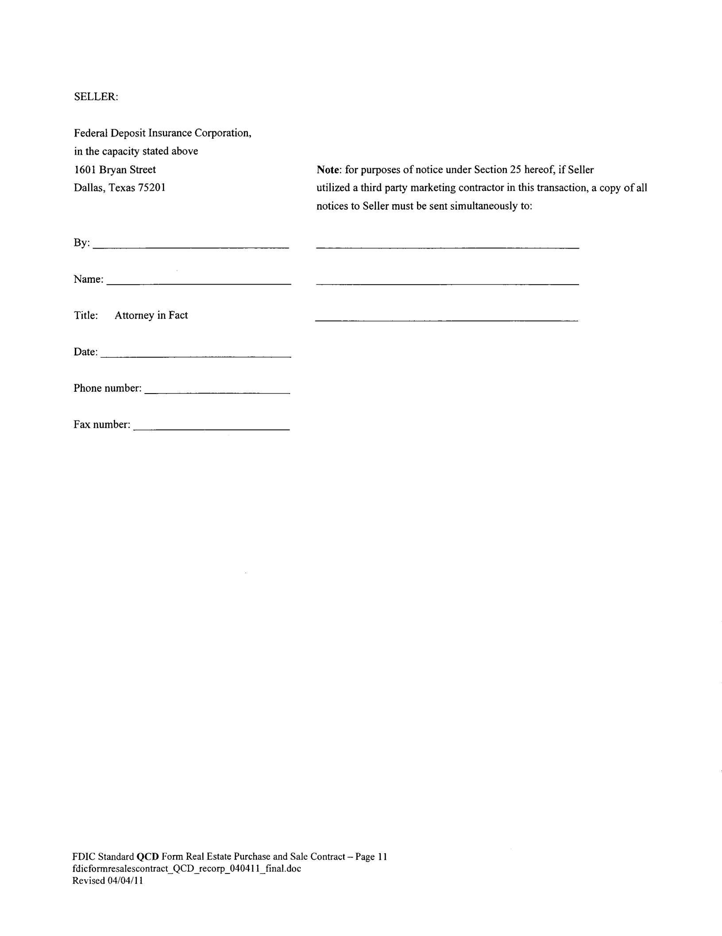
SELLER:

Federal Deposit Insurance Corporation,

in the capacity stated above

1601 Bryan Street Note: for purposes of notice under Section 25 hereof, if Seller

Dallas, Texas 75201 utilized a third party marketing contractor in this transaction, a copy of all

notices to Seller must be sent simultaneously to:

By:

Name:

Title: Attorney in Fact

Date:

Phone number:

Fax number:

FDIC Standard QCD Form Real Estate Purchase and Sale Contract - Page 11 fdicformresalescontract_QCD_recorp_0404 1 1_final.doc

Revised 04/04/11

EXHIBIT "A’

[Legal Description of the Property]
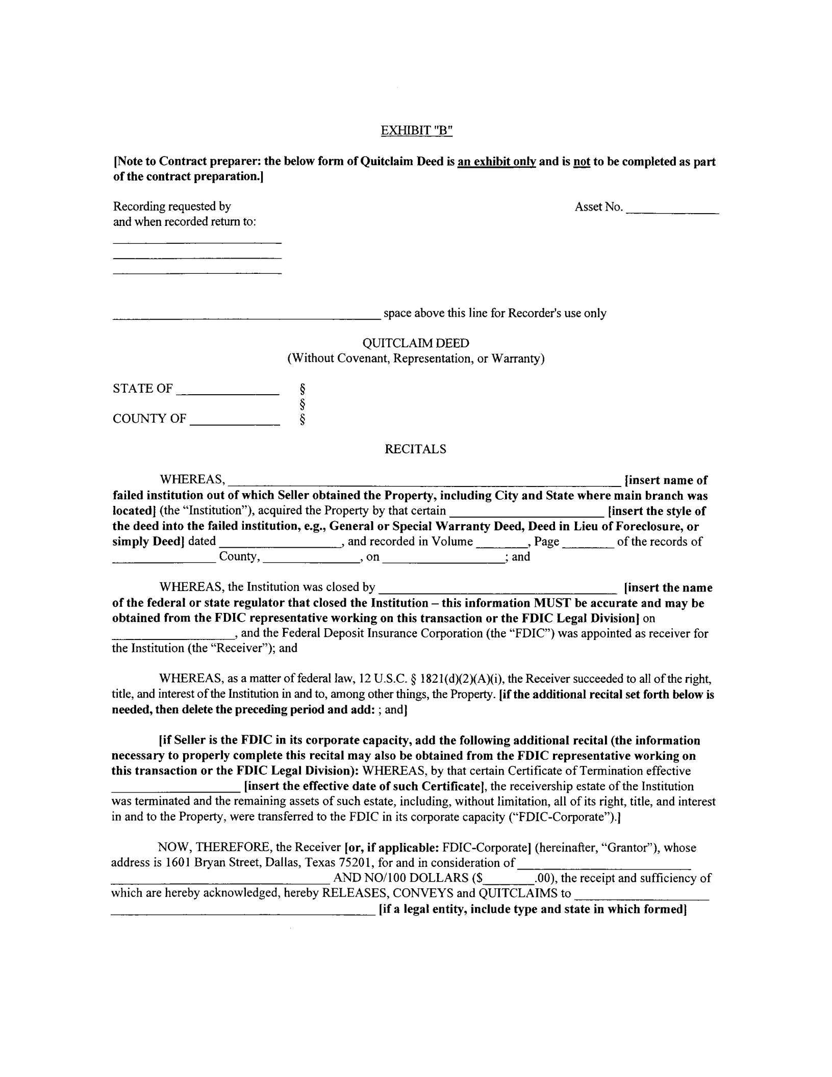
EXHIBIT "B"

[Note to Contract preparer: the below form of Quitclaim Deed is an exhibit only and is not to be completed as part of the contract preparation.]

Recording requested by
and when recorded return to:

Asset No.

space above this line for Recorder’s use only

QUITCLAIM DEED
(Without Covenant, Representation, or Warranty)

STATE OF

[EISJ1IK1

RECITALS

WHEREAS, [insert name of failed institution out of which Seller obtained the Property, including City and State where main branch was
located] (the "Institution"), acquired the Property by that certain [insert the style of
the deed into the failed institution, e.g., General or Special Warranty Deed, Deed in Lieu of Foreclosure, or

simply Deed]

dated

County,

and recorded in Volume , Page of the records of , on ; and

WHEREAS, the Institution was closed by

[insert the name

of the federal or state regulator that closed the Institution - this information MUST be accurate and may be obtained from the FDIC representative working on this transaction or the FDIC Legal Division] on

and the Federal Deposit Insurance Corporation (the "FDIC") was appointed as receiver for the Institution (the "Receiver"); and

WHEREAS, as a matter of federal law, 12 U. .C. § 182 1(d)(2XA)(i), the Receiver succeeded to all of the right, title, and interest of the Institution in and to, among other things, the Property. [if the additional recital set forth below is
needed, then delete the preceding period and add: ; and]

[if Seller is the FDIC in its corporate capacity, add the following additional recital (the information necessary to properly complete this recital may also be obtained from the FDIC representative working on this transaction or the FDIC Legal Division): WHEREAS, by that certain Certificate of Termination effective

[insert the effective date of such Certificate], the receivership estate of the Institution was terminated and the remaining assets of such estate, including, without limitation, all of its right, title, and interest in and to the Property, were transferred to the FDIC in its corporate capacity ("FDIC-Corporate").]

NOW, THEREFORE, the Receiver [or, if applicable: FDIC-Corporate] (hereinafter, "Grantor"), whose address is 1601 Bryan Street, Dallas, Texas 75201, for and in consideration of

AND NO/100 DOLLARS (S.00), the receipt and sufficiency of which are hereby acknowledged, hereby RELEASES, CONVEYS and QUITCLAIMS to

[if a legal entity, include type and state in which formed]

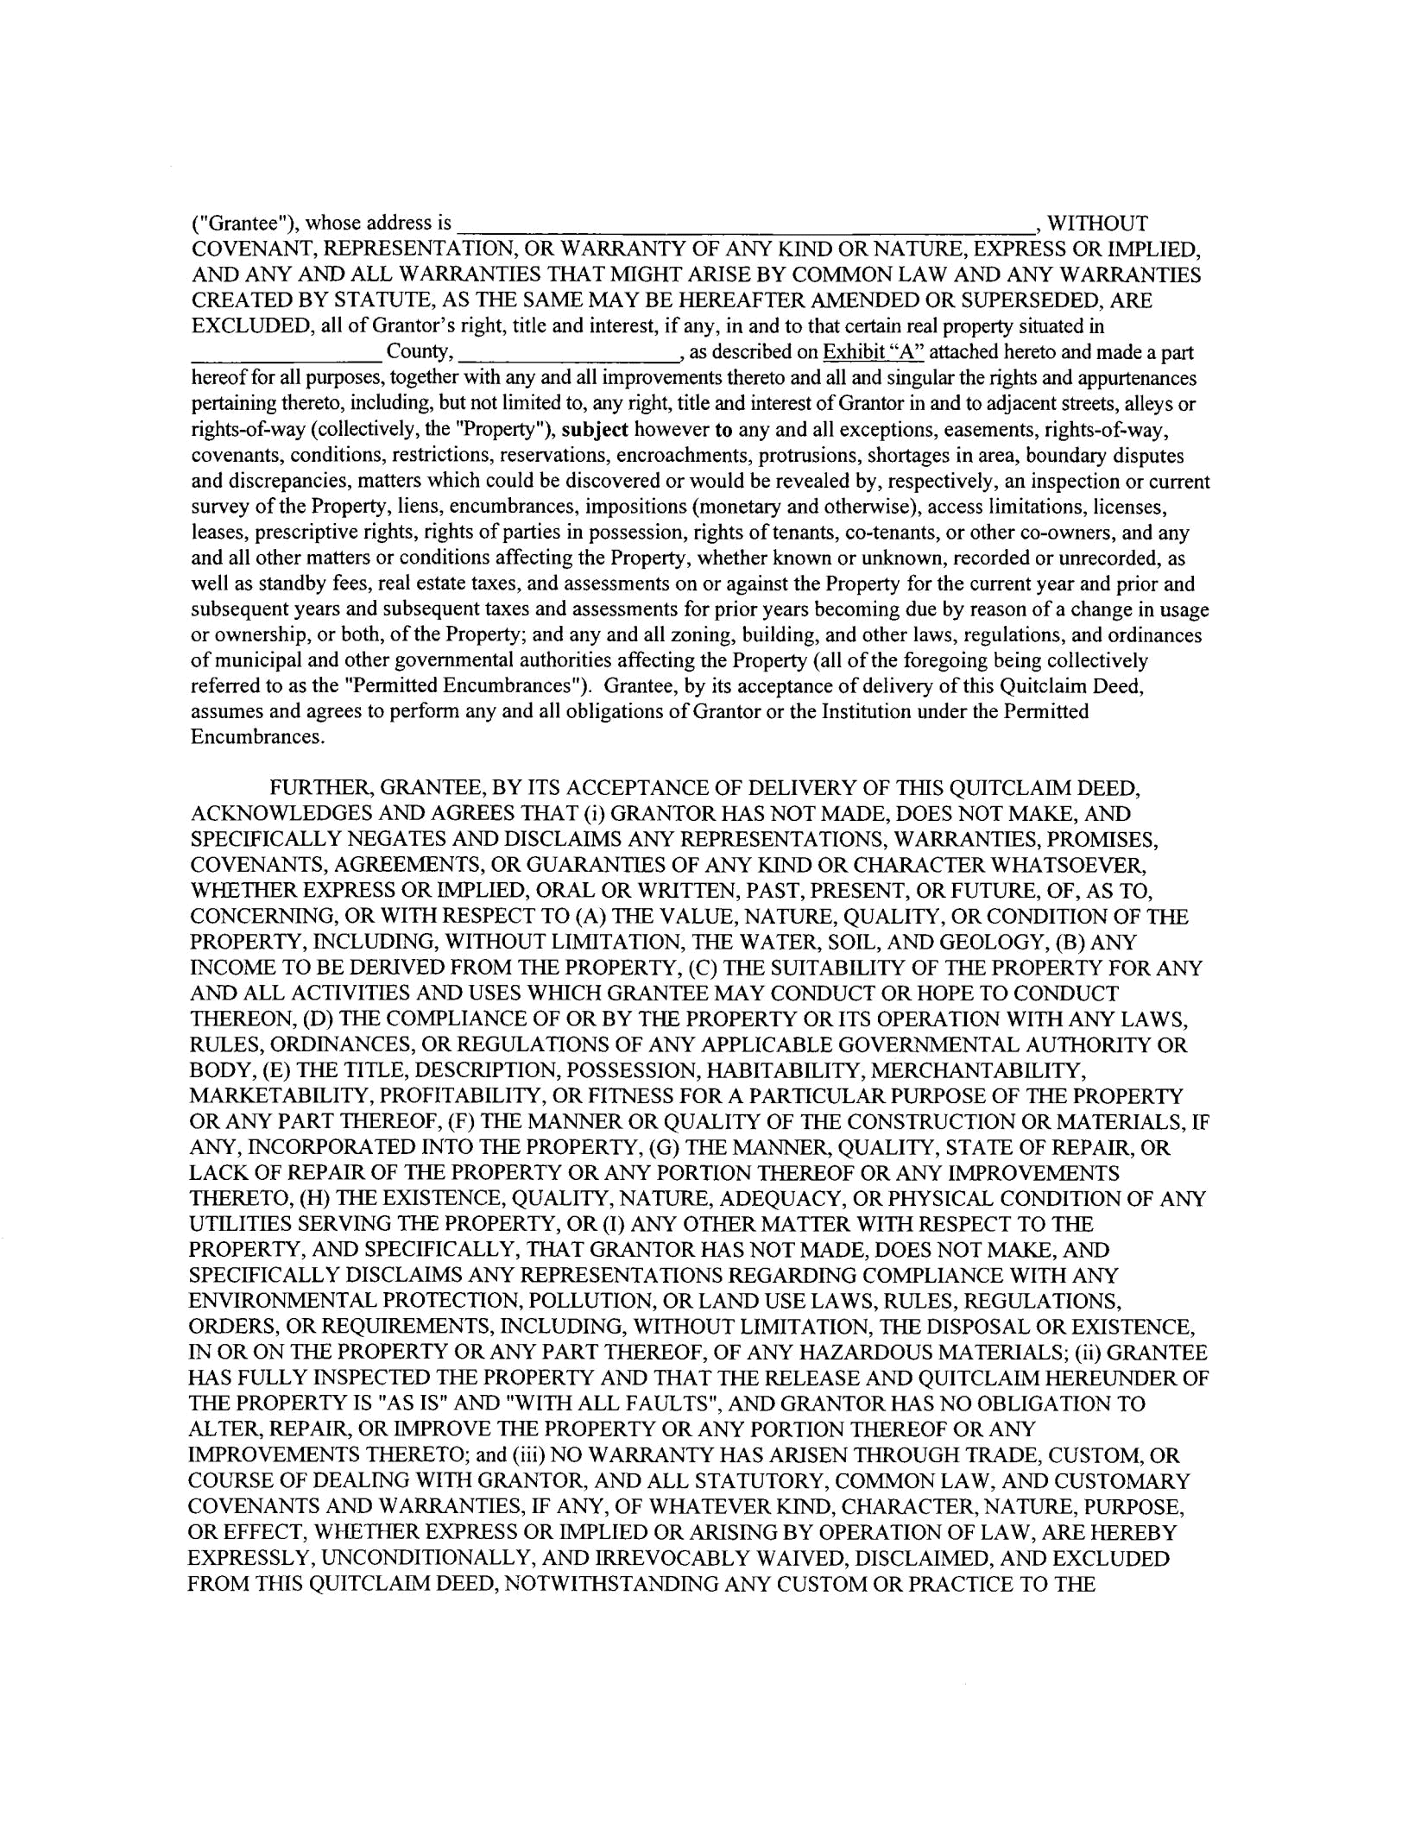
("Grantee"), whose address is � , WITHOUT COVENANT, REPRESENTATION, OR WARRANTY OF ANY KIND OR NATURE, EXPRESS OR IMPLIED, AND ANY AND ALL WARRANTIES THAT MIGHT ARISE BY COMMON LAW AND ANY WARRANTIES CREATED BY STATUTE, AS THE SAME MAY BE HEREAFTER AMENDED OR SUPERSEDED, ARE EXCLUDED, all of Grantor’s right, title and interest, if any, in and to that certain real property situated in
County, � , as described on Exhibit "A" attached hereto and made a part hereof for all purposes, together with any and all improvements thereto and all and singular the rights and appurtenances pertaining thereto, including, but not limited to, any right, title and interest of Grantor in and to adjacent streets, alleys or rights-of-way (collectively, the "Property’), subject however to any and all exceptions, easements, rights-of-way, covenants, conditions, restrictions, reservations, encroachments, protrusions, shortages in area, boundary disputes and discrepancies, matters which could be discovered or would be revealed by, respectively, an inspection or current survey of the Property, liens, encumbrances, impositions (monetary and otherwise), access limitations, licenses, leases, prescriptive rights, rights of parties in possession, rights of tenants, co-tenants, or other co-owners, and any and all other matters or conditions affecting the Property, whether known or unknown, recorded or unrecorded, as well as standby fees, real estate taxes, and assessments on or against the Property for the current year and prior and subsequent years and subsequent taxes and assessments for prior years becoming due by reason of a change in usage or ownership, or both, of the Property; and any and all zoning, building, and other laws, regulations, and ordinances of municipal and other governmental authorities affecting the Property (all of the foregoing being collectively referred to as the "Permitted Encumbrances"). Grantee, by its acceptance of delivery of this Quitclaim Deed, assumes and agrees to perform any and all obligations of Grantor or the Institution under the Permitted Encumbrances.

FURTHER, GRANTEE, BY ITS ACCEPTANCE OF DELIVERY OF THIS QUITCLAIM DEED, ACKNOWLEDGES AND AGREES THAT (i) GRANTOR HAS NOT MADE, DOES NOT MAKE, AND SPECIFICALLY NEGATES AND DISCLAIMS ANY REPRESENTATIONS, WARRANTIES, PROMISES, COVENANTS, AGREEMENTS, OR GUARANTIES OF ANY KIND OR CHARACTER WHATSOEVER, WHETHER EXPRESS OR IMPLIED, ORAL OR WRITTEN, PAST, PRESENT, OR FUTURE, OF, AS TO, CONCERNING, OR WITH RESPECT TO (A) THE VALUE, NATURE, QUALITY, OR CONDITION OF THE PROPERTY, INCLUDING, WITHOUT LIMITATION, THE WATER, SOIL, AND GEOLOGY, (B) ANY INCOME TO BE DERIVED FROM THE PROPERTY, (C) THE SUITABILITY OF THE PROPERTY FOR ANY AND ALL ACTIVITIES AND USES WHICH GRANTEE MAY CONDUCT OR HOPE TO CONDUCT THEREON, (D) THE COMPLIANCE OF OR BY THE PROPERTY OR ITS OPERATION WITH ANY LAWS, RULES, ORDINANCES, OR REGULATIONS OF ANY APPLICABLE GOVERNMENTAL AUTHORITY OR BODY, (E) THE TITLE, DESCRIPTION, POSSESSION, HABITABILITY, MERCHANTABILITY, MARKETABILITY, PROFITABILITY, OR FITNESS FOR PARTICULAR PURPOSE OF THE PROPERTY OR ANY PART THEREOF, (F) THE MANNER OR QUALITY OF THE CONSTRUCTION OR MATERIALS, IF ANY, INCORPORATED INTO THE PROPERTY, (G) THE MANNER, QUALITY, STATE OF REPAIR, OR LACK OF REPAIR OF THE PROPERTY OR ANY PORTION THEREOF OR ANY IMPROVEMENTS THERETO, (H) THE EXISTENCE, QUALITY, NATURE, ADEQUACY, OR PHYSICAL CONDITION OF ANY UTILITIES SERVING THE PROPERTY, OR (I) ANY OTHER MATTER WITH RESPECT TO THE PROPERTY, AND SPECIFICALLY, THAT GRANTOR HAS NOT MADE, DOES NOT MAKE, AND SPECIFICALLY DISCLAIMS ANY REPRESENTATIONS REGARDING COMPLIANCE WITH ANY ENVIRONMENTAL PROTECTION, POLLUTION, OR LAND USE LAWS, RULES, REGULATIONS, ORDERS, OR REQUIREMENTS, INCLUDING, WITHOUT LIMITATION, THE DISPOSAL OR EXISTENCE, IN OR ON THE PROPERTY OR ANY PART THEREOF, OF ANY HAZARDOUS MATERIALS; (ii) GRANTEE HAS FULLY INSPECTED THE PROPERTY AND THAT THE RELEASE AND QUITCLAIM HEREUNDER OF THE PROPERTY IS "AS IS" AND "WITH ALL FAULTS", AND GRANTOR HAS NO OBLIGATION TO ALTER, REPAIR, OR IMPROVE THE PROPERTY OR ANY PORTION THEREOF OR ANY IMPROVEMENTS THERETO; and (iii) NO WARRANTY HAS ARISEN THROUGH TRADE, CUSTOM, OR COURSE OF DEALING WITH GRANTOR, AND ALL STATUTORY, COMMON LAW, AND CUSTOMARY COVENANTS AND WARRANTIES, IF ANY, OF WHATEVER KIND, CHARACTER, NATURE, PURPOSE, OR EFFECT, WHETHER EXPRESS OR IMPLIED OR ARISING BY OPERATION OF LAW, ARE HEREBY EXPRESSLY, UNCONDITIONALLY, AND IRREVOCABLY WAIVED, DISCLAIMED, AND EXCLUDED FROM THIS QUITCLAIM DEED, NOTWITHSTANDING ANY CUSTOM OR PRACTICE TO THE
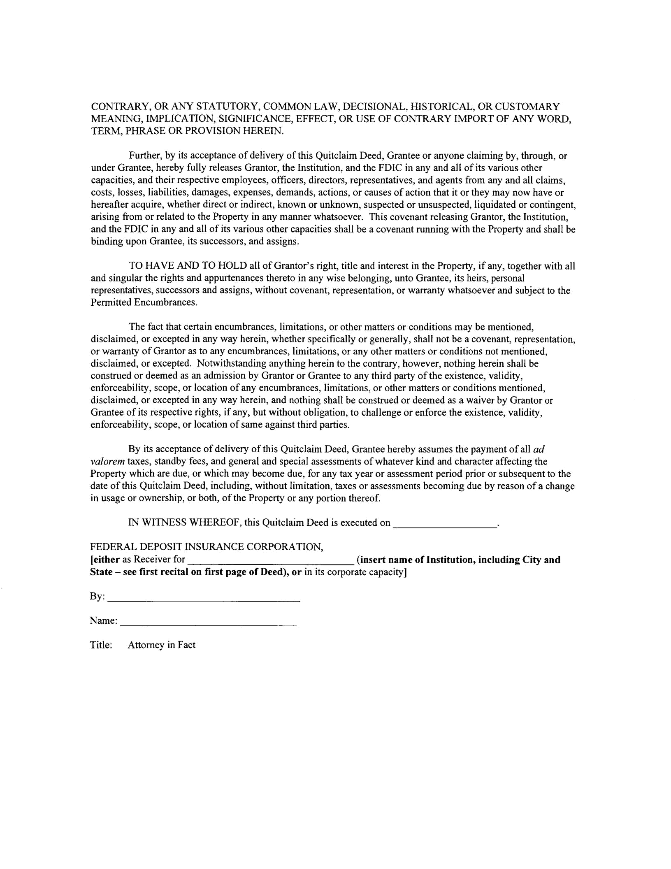
CONTRARY, OR ANY STATUTORY, COMMON LAW, DECISIONAL, HISTORICAL, OR CUSTOMARY MEANING, IMPLICATION, SIGNIFICANCE, EFFECT, OR USE OF CONTRARY IMPORT OF ANY WORD, TERM, PHRASE OR PROVISION HEREIN.

Further, by its acceptance of delivery of this Quitclaim Deed, Grantee or anyone claiming by, through, or under Grantee, hereby fully releases Grantor, the Institution, and the FDIC in any and all of its various other capacities, and their respective employees, officers, directors, representatives, and agents from any and all claims, costs, losses, liabilities, damages, expenses, demands, actions, or causes of action that it or they may now have or hereafter acquire, whether direct or indirect, known or unknown, suspected or unsuspected, liquidated or contingent, arising from or related to the Property in any manner whatsoever. This covenant releasing Grantor, the Institution, and the FDIC in any and all of its various other capacities shall be a covenant running with the Property and shall be binding upon Grantee, its successors, and assigns.

TO HAVE AND TO HOLD all of Grantor’s right, title and interest in the Property, if any, together with all and singular the rights and appurtenances thereto in any wise belonging, unto Grantee, its heirs, personal representatives, successors and assigns, without covenant, representation, or warranty whatsoever and subject to the Permitted Encumbrances.

The fact that certain encumbrances, limitations, or other matters or conditions may be mentioned, disclaimed, or excepted in any way herein, whether specifically or generally, shall not be a covenant, representation, or warranty of Grantor as to any encumbrances, limitations, or any other matters or conditions not mentioned, disclaimed, or excepted. Notwithstanding anything herein to the contrary, however, nothing herein shall be construed or deemed as an admission by Grantor or Grantee to any third party of the existence, validity, enforceability, scope, or location of any encumbrances, limitations, or other matters or conditions mentioned, disclaimed, or excepted in any way herein, and nothing shall be construed or deemed as a waiver by Grantor or Grantee of its respective rights, if any, but without obligation, to challenge or enforce the existence, validity, enforceability, scope, or location of same against third parties.

By its acceptance of delivery of this Quitclaim Deed, Grantee hereby assumes the payment of all ad valorem taxes, standby fees, and general and special assessments of whatever kind and character affecting the Property which are due, or which may become due, for any tax year or assessment period prior or subsequent to the date of this Quitclaim Deed, including, without limitation, taxes or assessments becoming due by reason of a change in usage or ownership, or both, of the Property or any portion thereof.

IN WITNESS WHEREOF, this Quitclaim Deed is executed on

FEDERAL DEPOSIT INSURANCE CORPORATION,

[either as Receiver for �(insert name of Institution, including City and State - see first recital on first page of Deed), or in its corporate capacity]

By:

Name:

Title: �Attorney in Fact
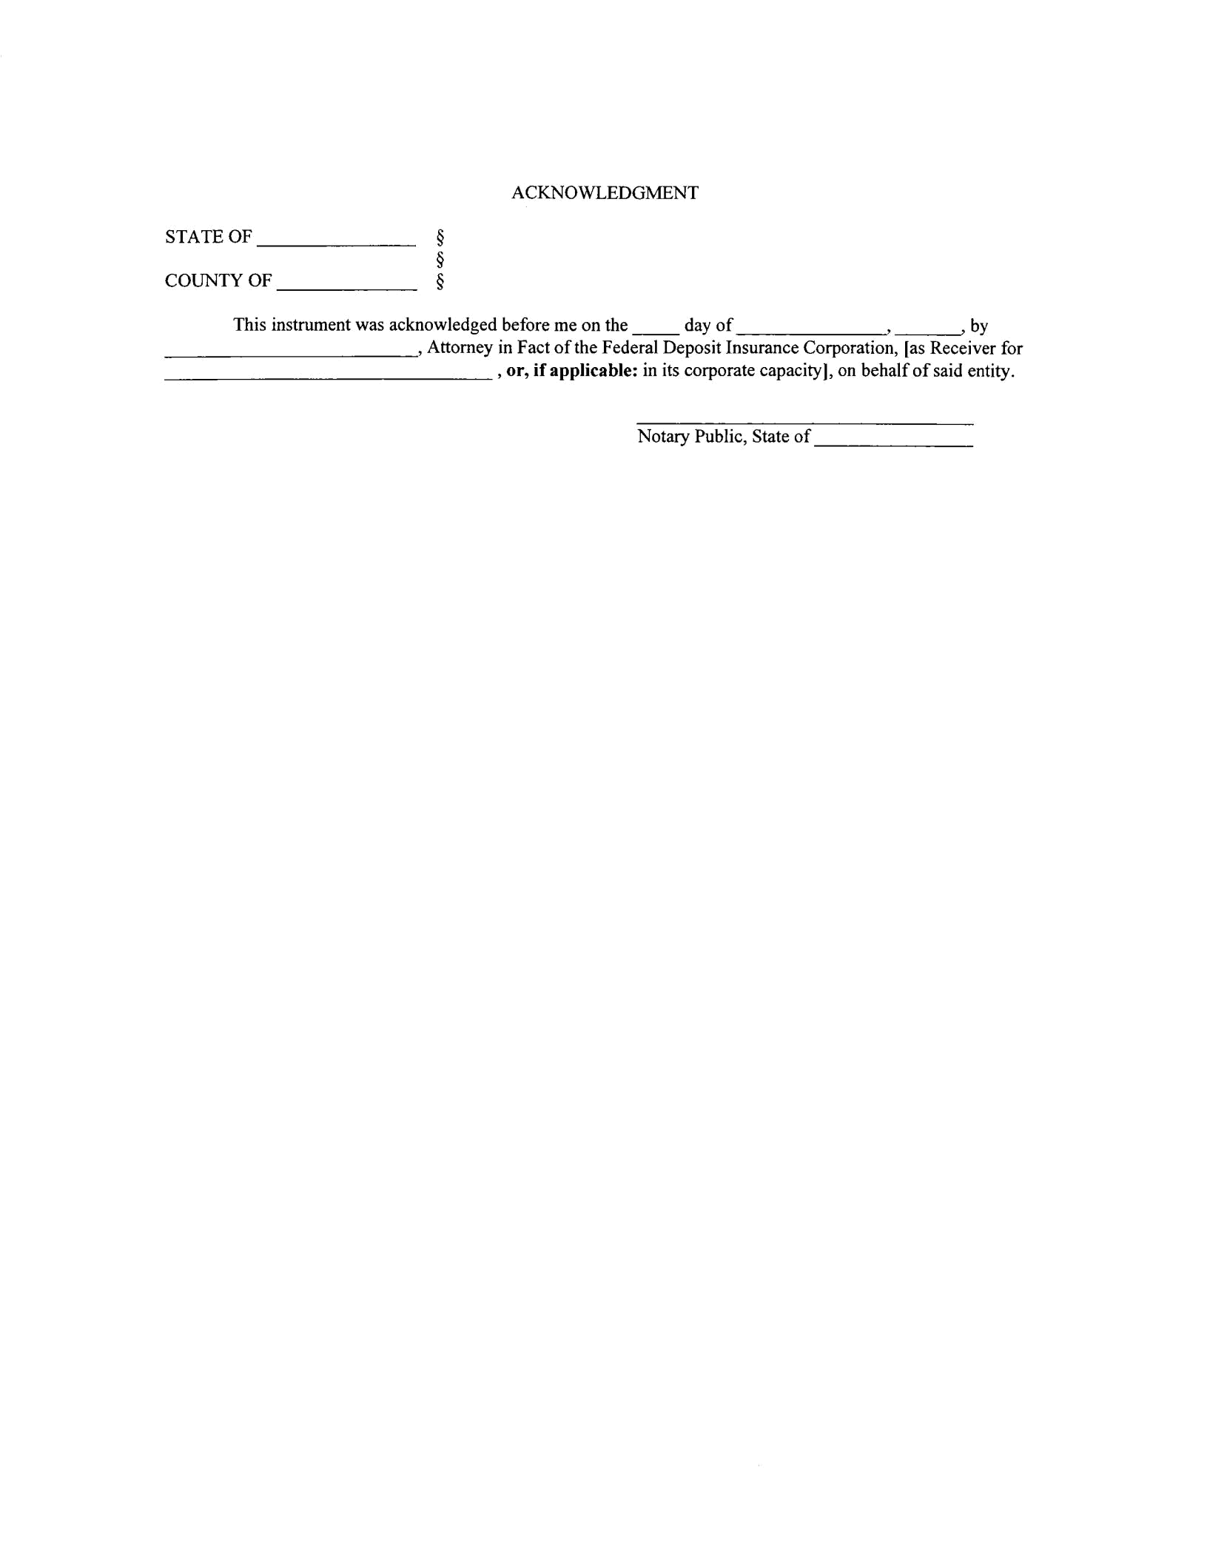
 | ACKNOWLEDGMENT
STATE OF | �
 | §
COUNTY OF | §
This instrument was acknowledged before me on the |  | day of �, | �by
Attorney in Fact of the Federal-Deposit Insurance Corporation, [as Receiver for or, if applicable: in its corporate capacity], on behalf of said entity.

Notary Public, State of
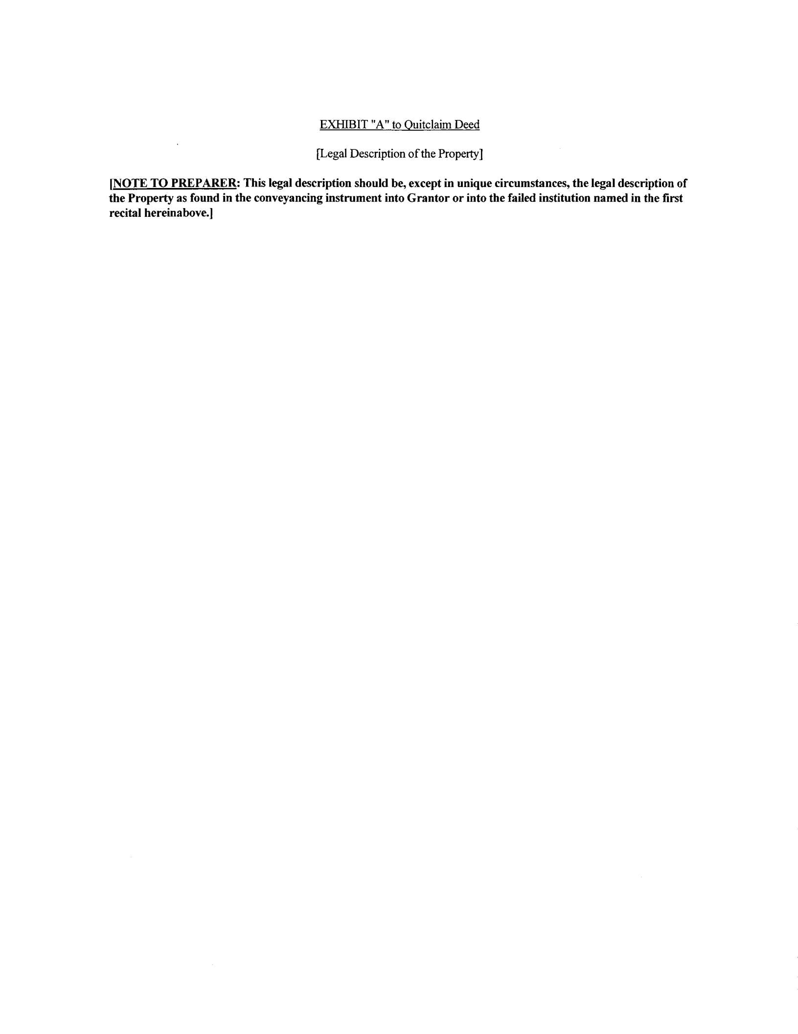
EXHIBIT ’A" to Quitclaim Deed

[Legal Description of the Property]

[NOTE TO PREPARER: This legal description should be, except in unique circumstances, the legal description of the Property as found in the conveyancing instrument into Grantor or into the failed institution named in the first recital hereinabove.]

EXHIBIT "C"

[Form of Purchaser Eligibility Certification]
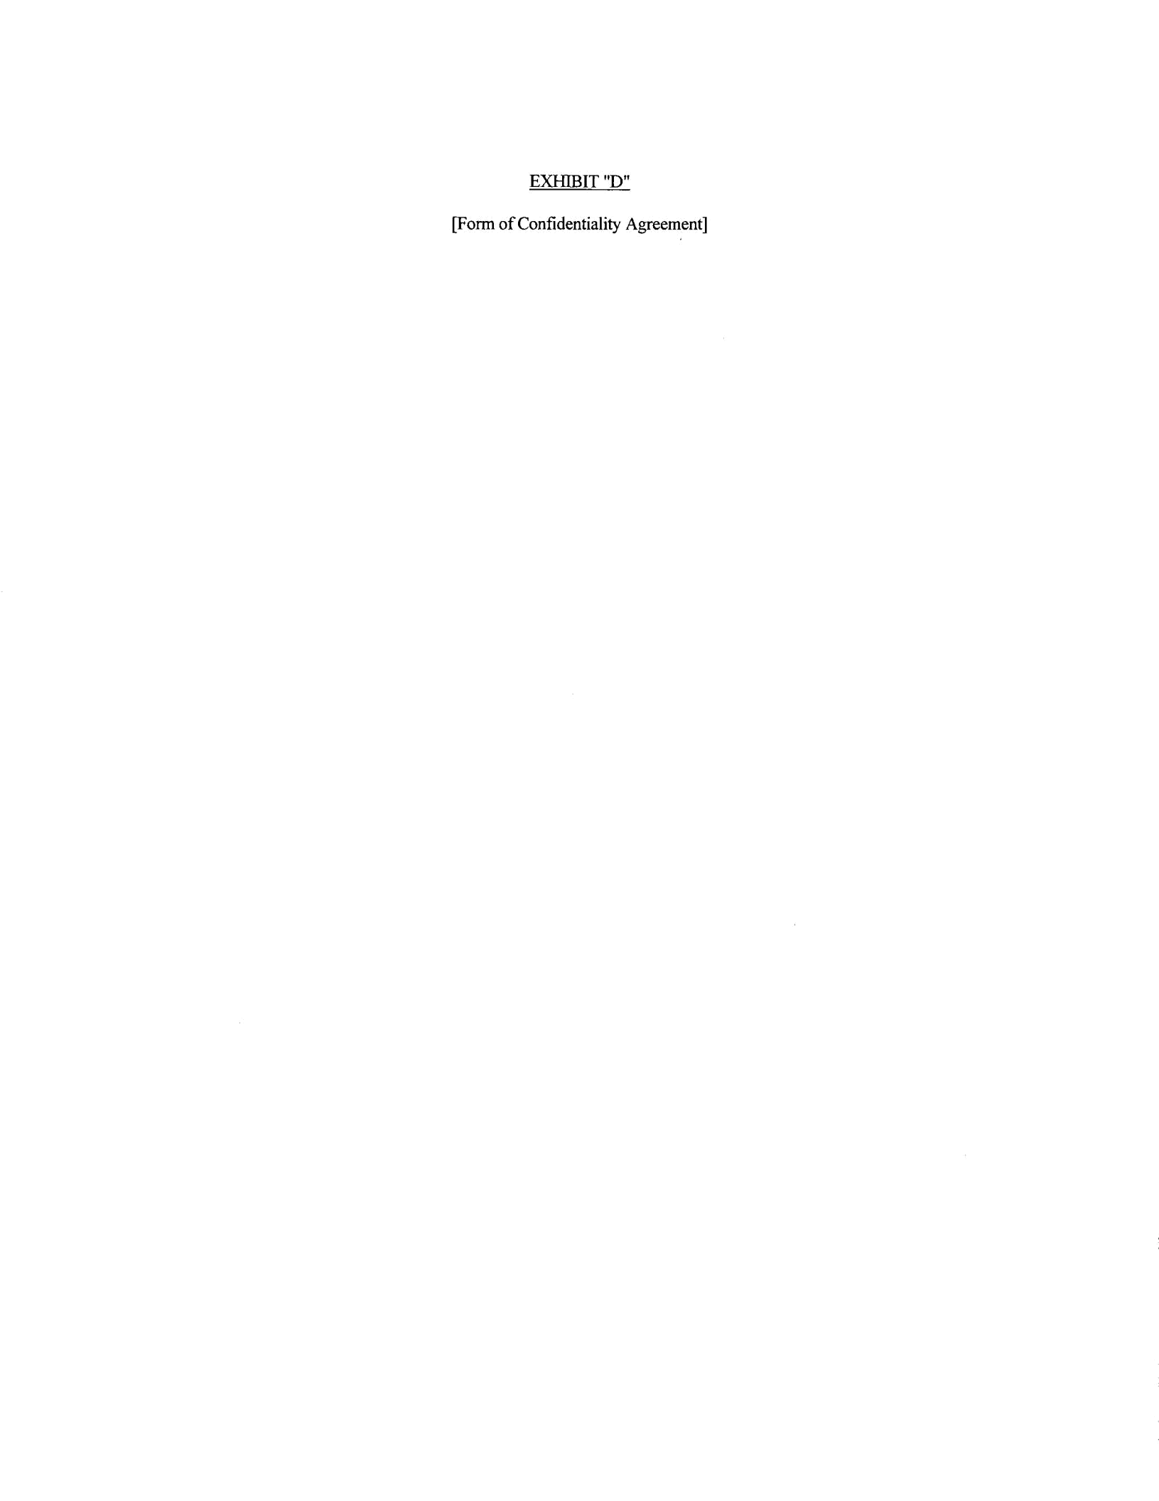
EXHIBIT "D"

[Form of Confidentiality Agreement]

EXHIBIT "E"

[Inventory of personalty to be conveyed]

