

Project Lessons-Learned Document

Project Name:

Update Number

Date (MM/DD/YYYY):

This document is to assist project teams to record the knowledge gained from the process of performing the Project. The purpose is to share and use the knowledge derived from experience to:

- Repeat desirable outcomes

- Avoid undesirable outcomes

- Update Organizational Knowledge Assets to Improve on Processes and Procedures

Use the document to list successes and failures for activities leading to key deliverables per the various stages of the VRA Project Life Cycle (PLC) with reference to the processes in following Project Management Knowledge Areas where applicable:

- Project Integration Management

- Project Scope Management

- Project Time Management

- Project Cost Management

- Project Quality Management

- Project Human Resource Management

- Project Communication Management

- Project Risk Management

- Project Procurement Management

- Project Stakeholder Management

Page 1 of 10
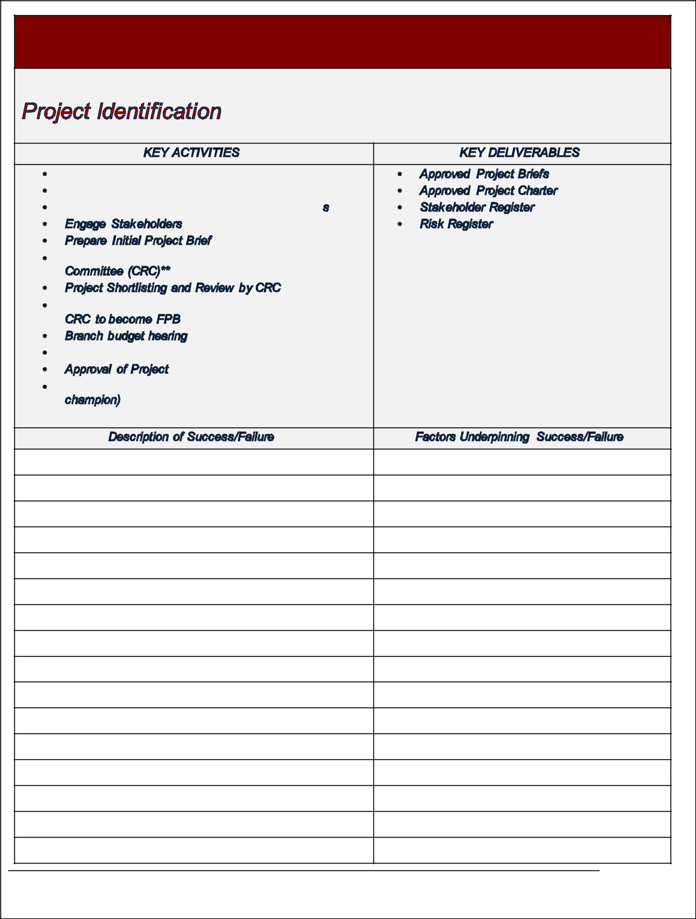

Page 2 of 10
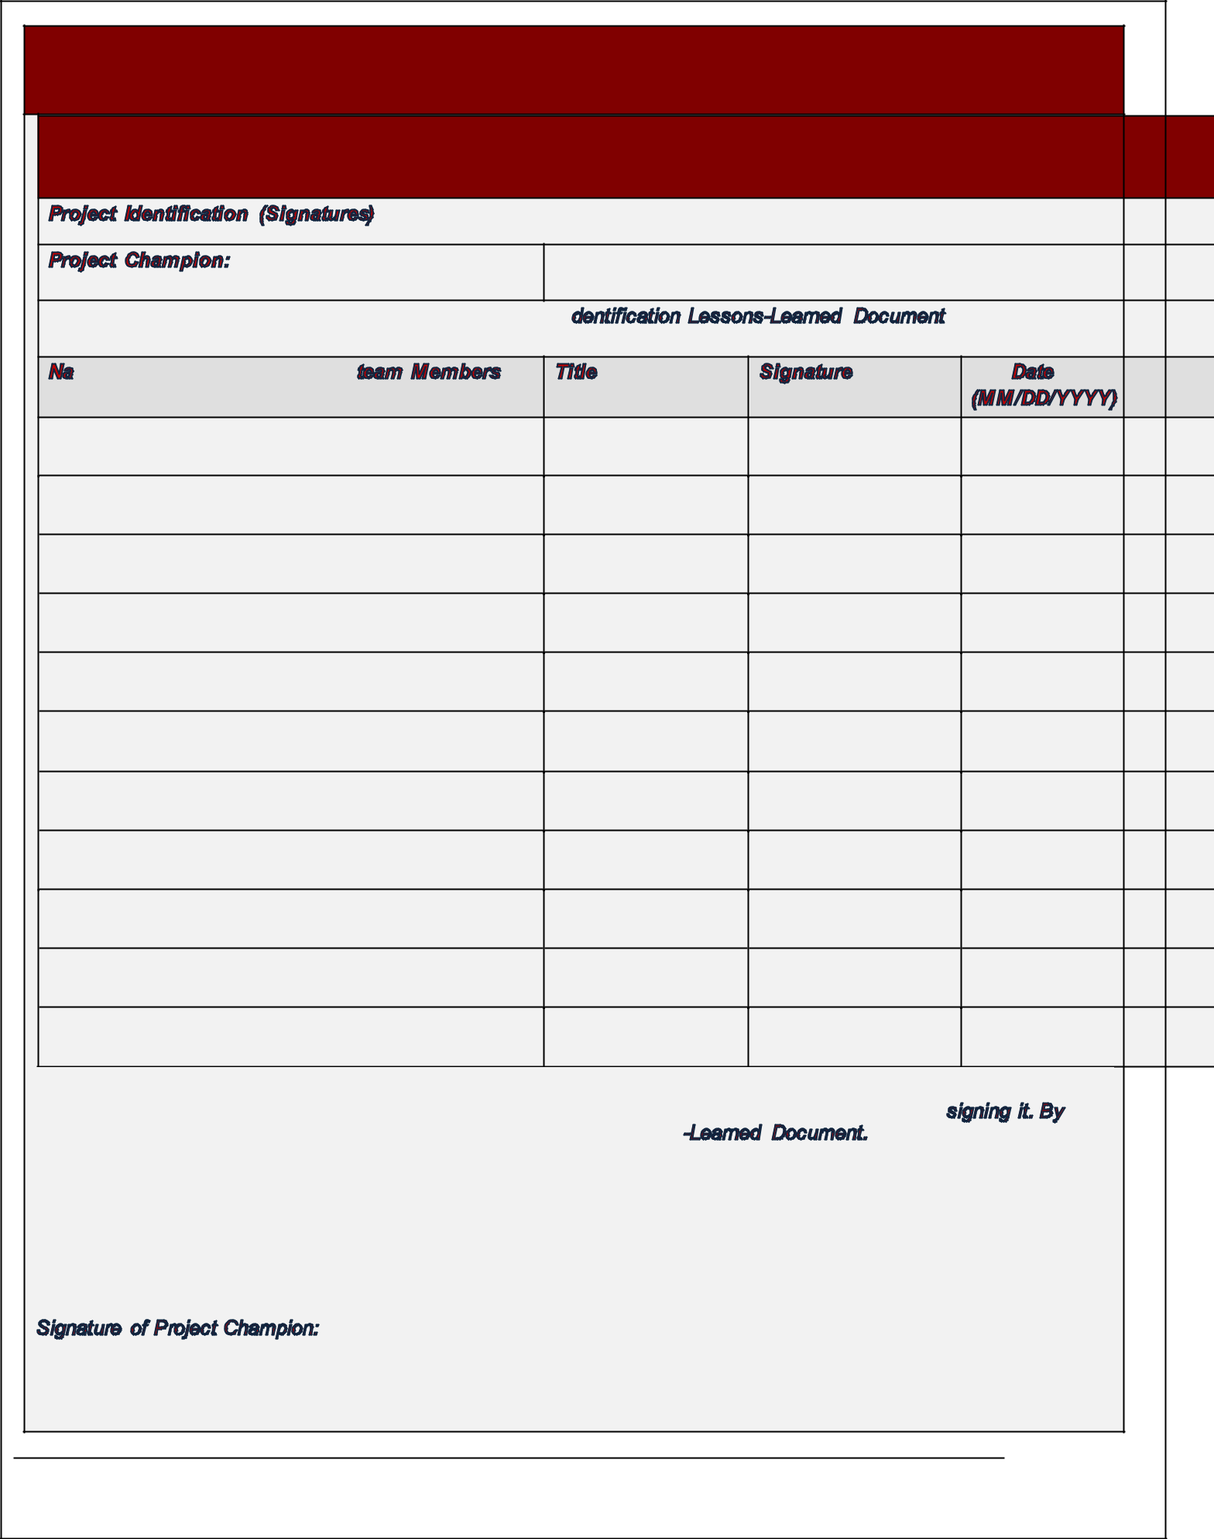

Page 3 of 10
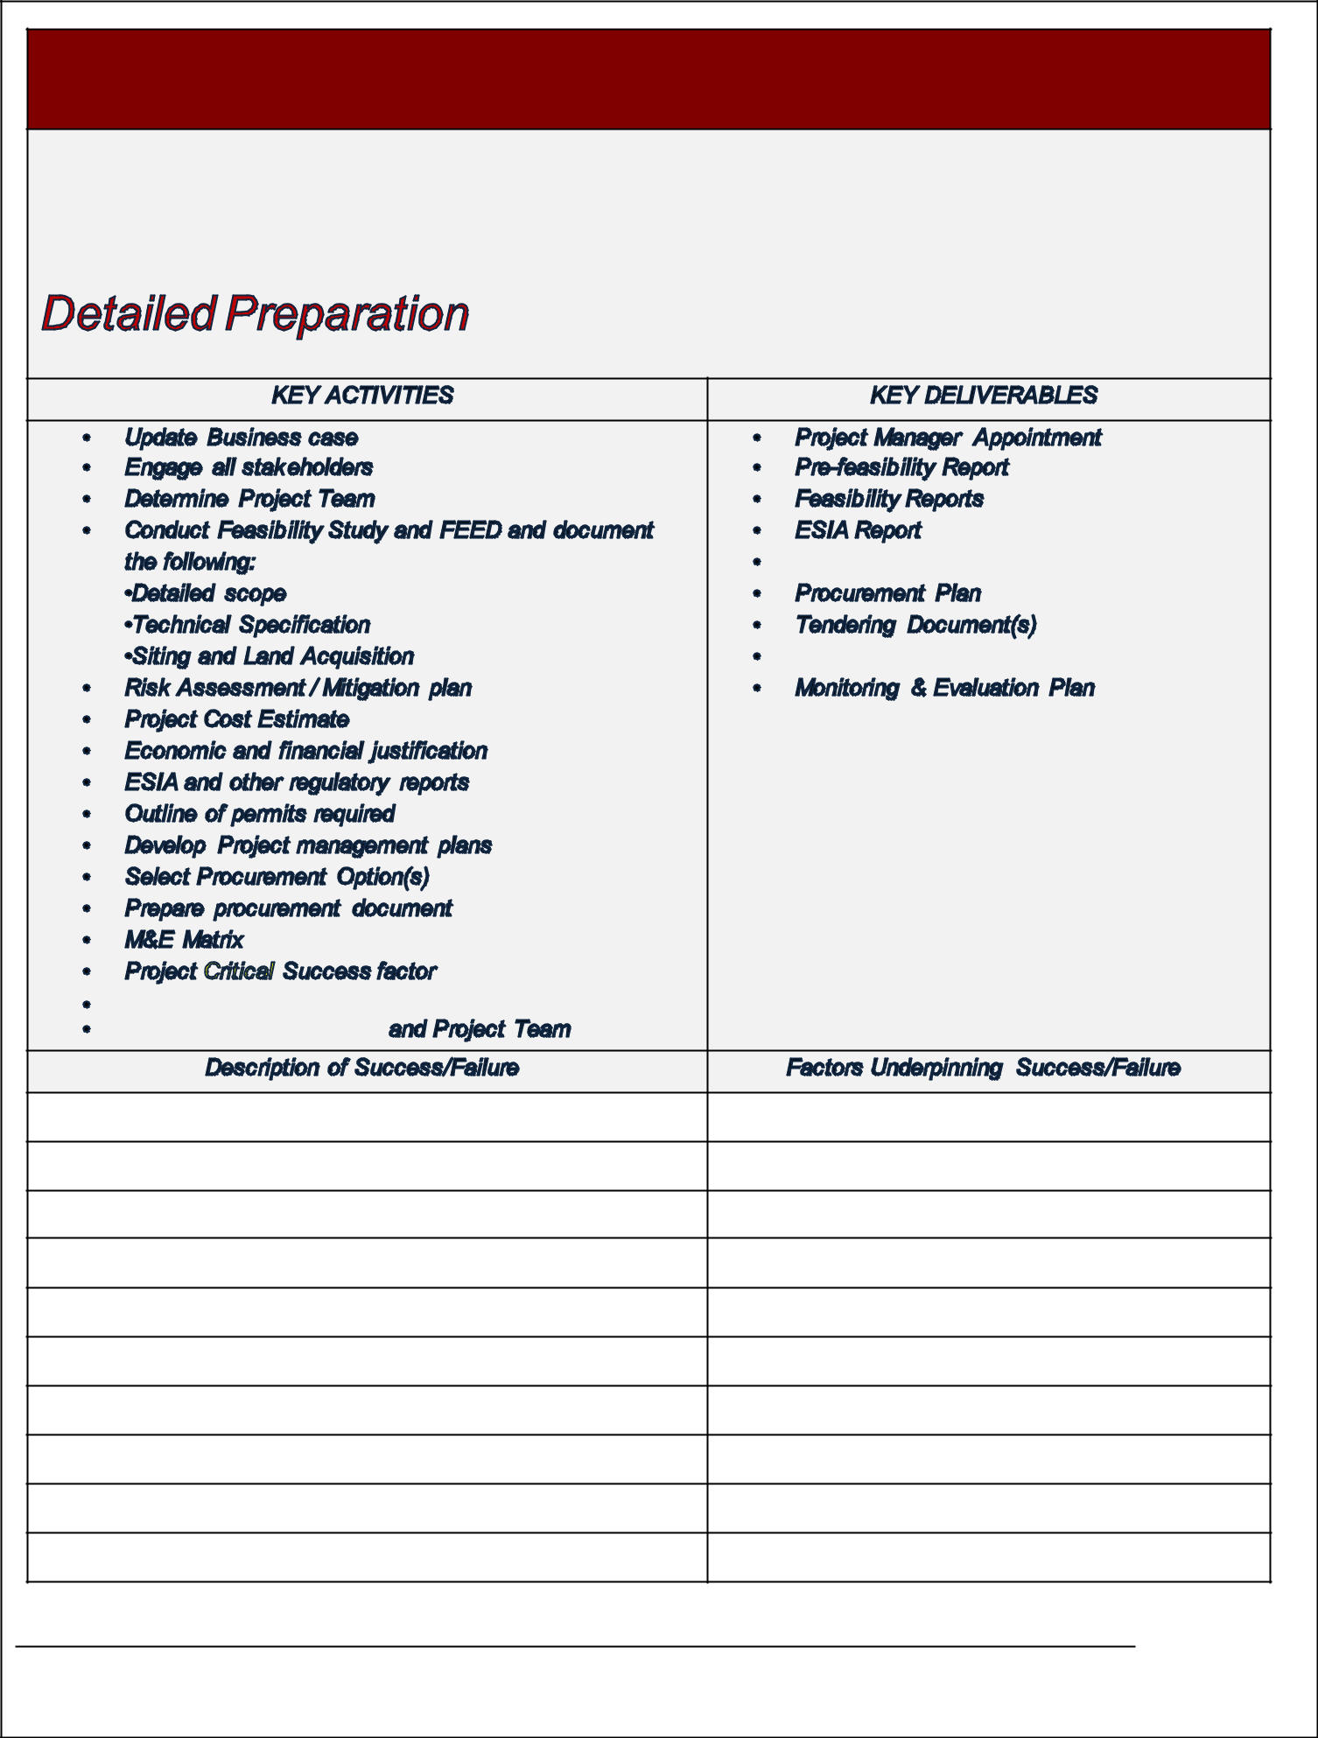

Page 4 of 10
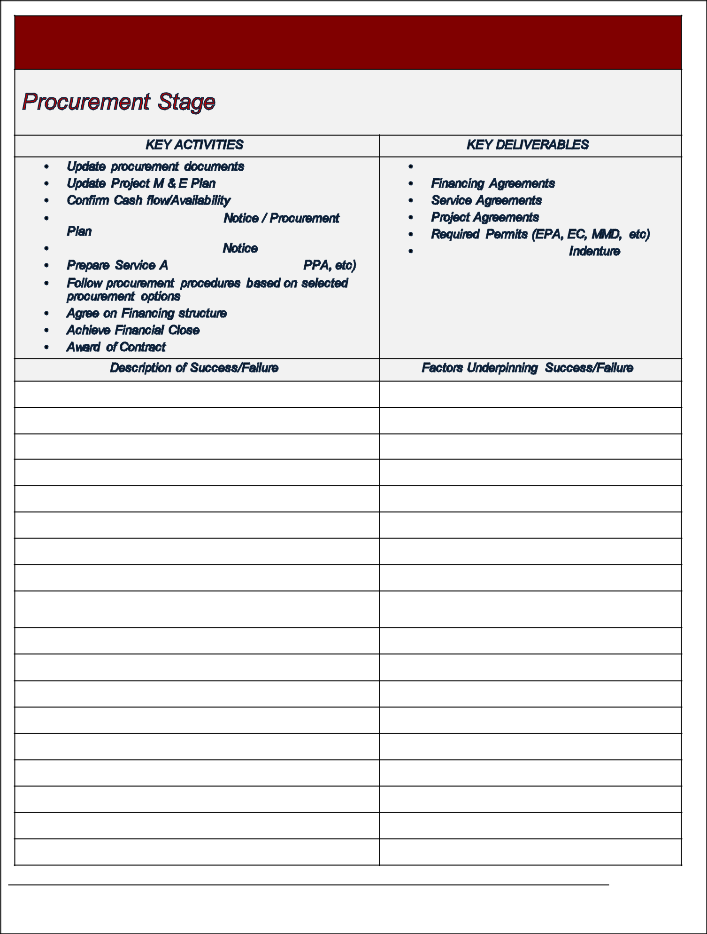

Page 5 of 10
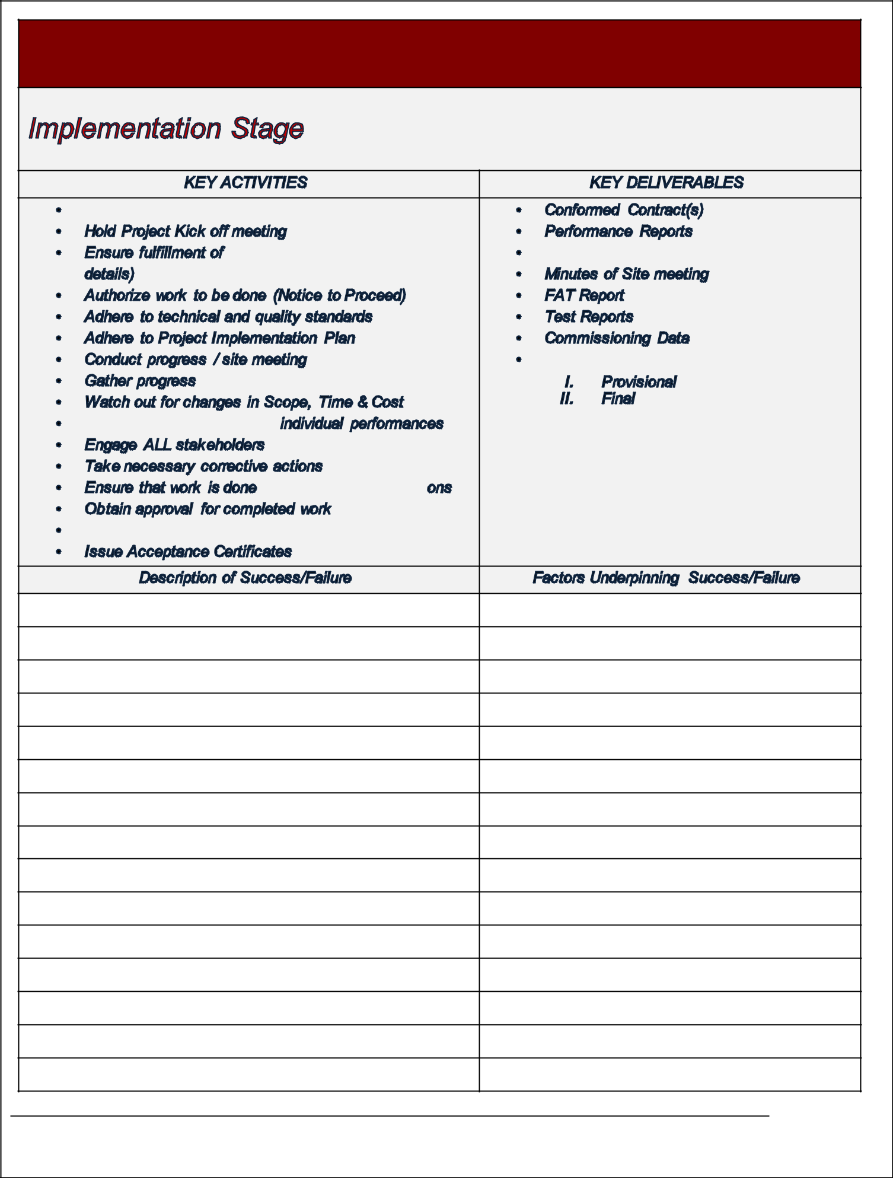

Page 6 of 10
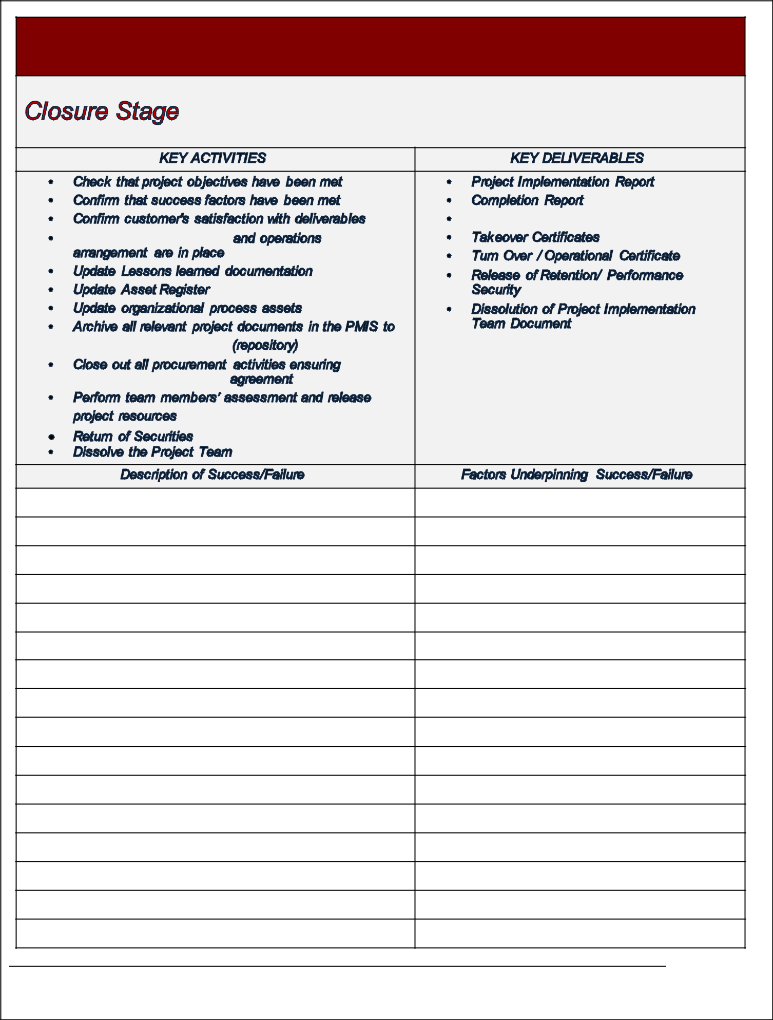

Page 7 of 10
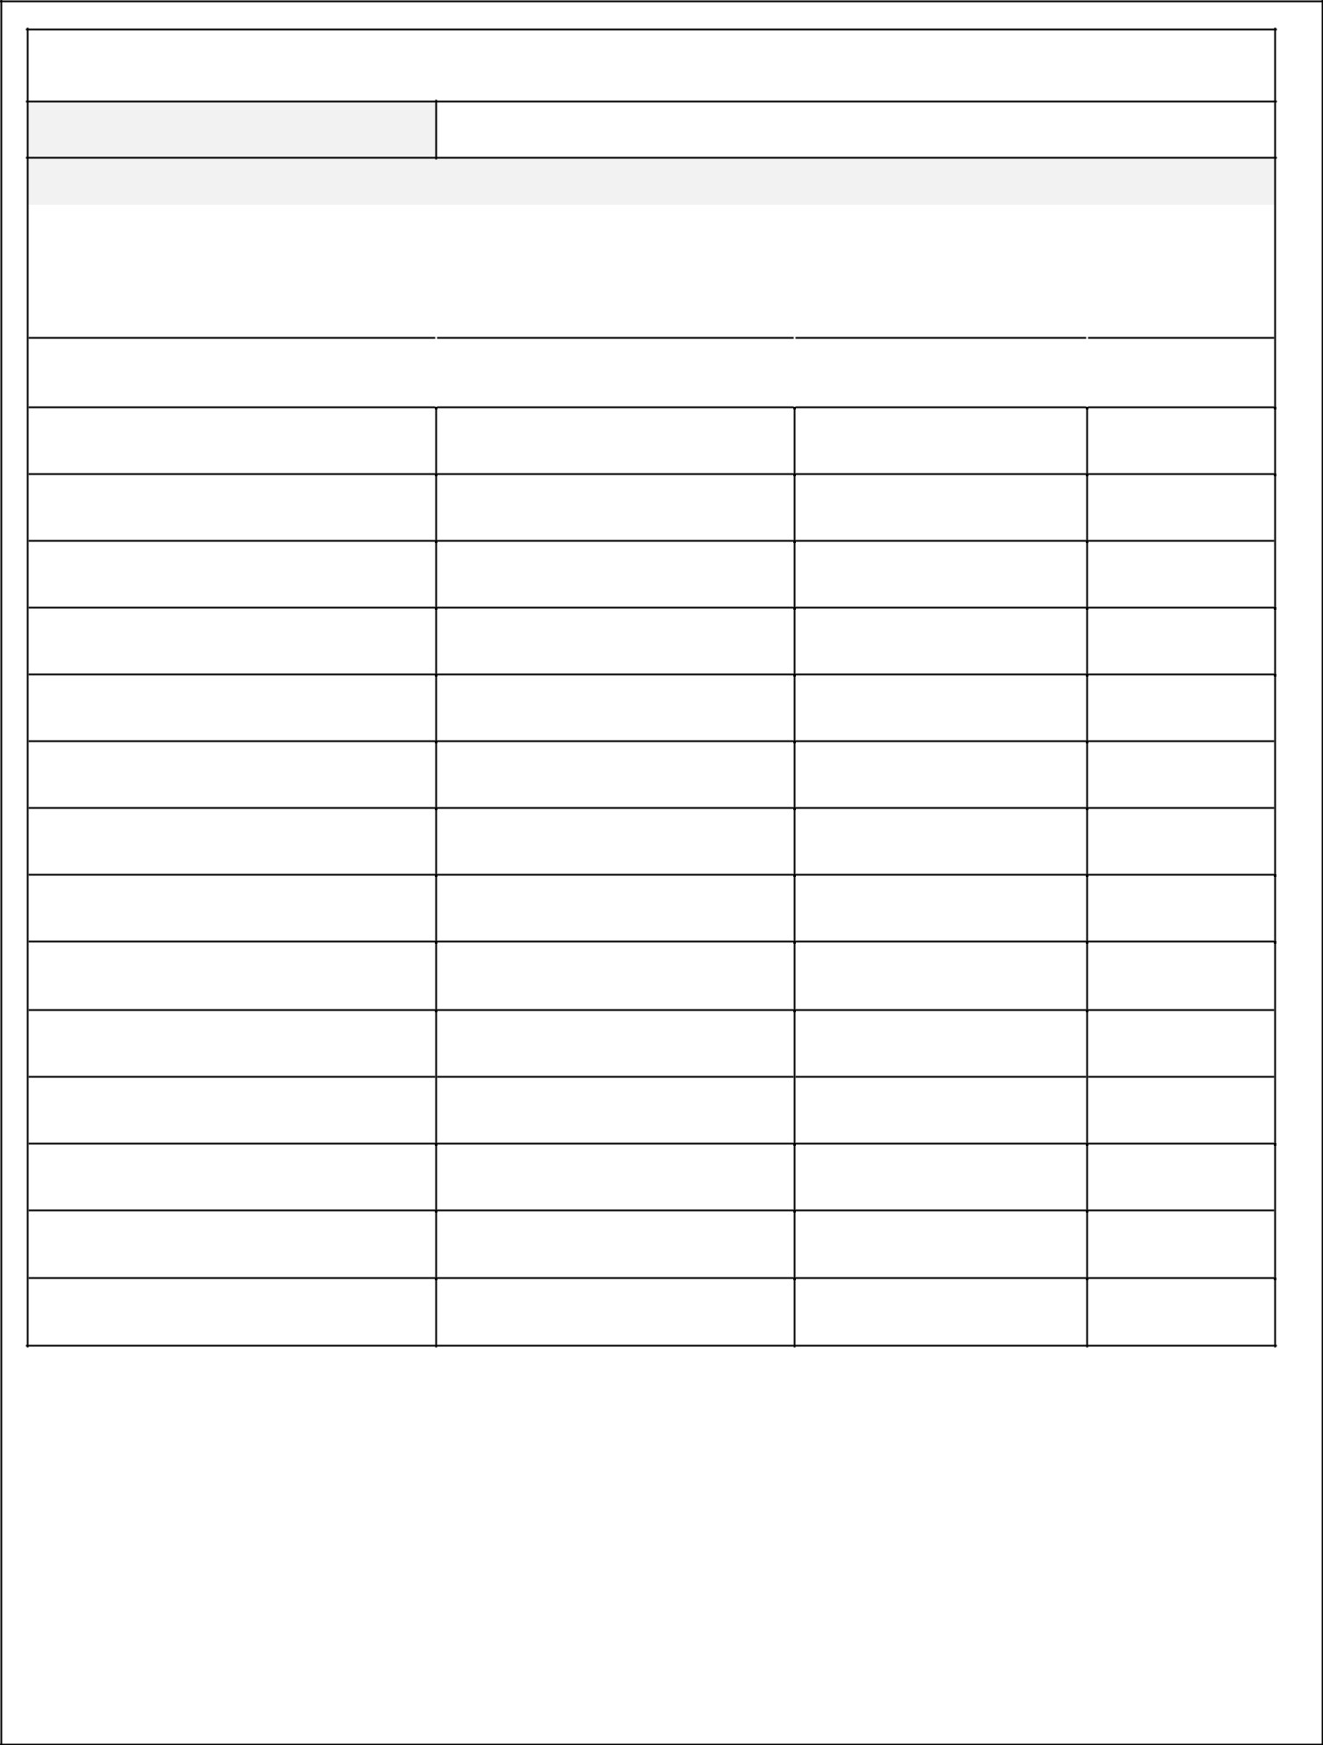
Project Team (Signatures)

Project Manager:

I have reviewed the information contained in this Project Lessons-Learned Document

 | Names of Key Members on the | Title | Signature |  | Date
 | Project team |  |  |  | (MM/DD/YYYY)

The signatures above indicate understanding of the purpose and content of this document by those signing it . By signing this document, you agree to this as the formal Project Lessons -Learned Document.

Signature of Project Manager:

Page 8 of 10
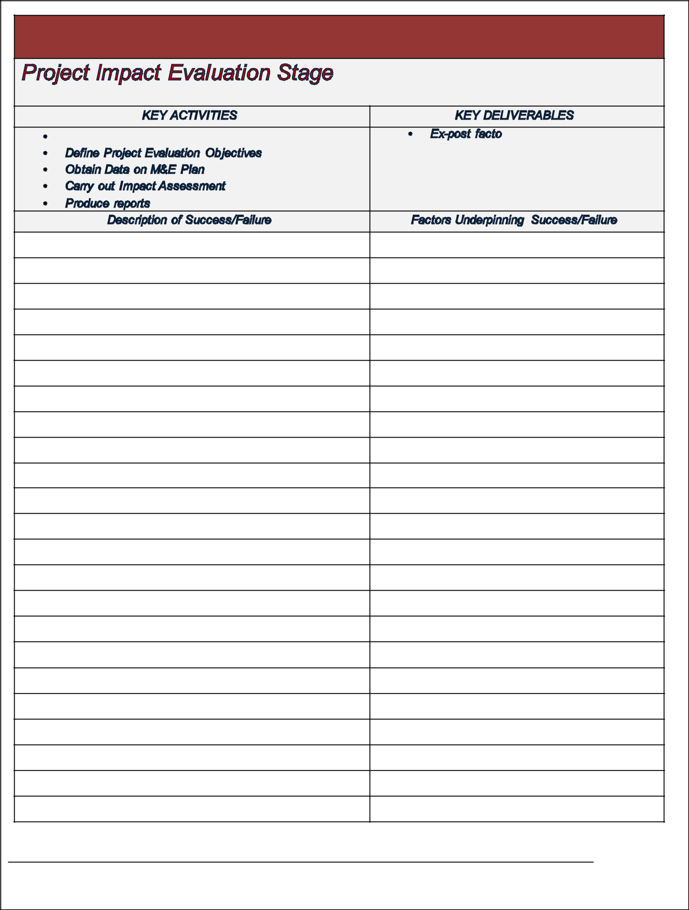

Page 9 of 10
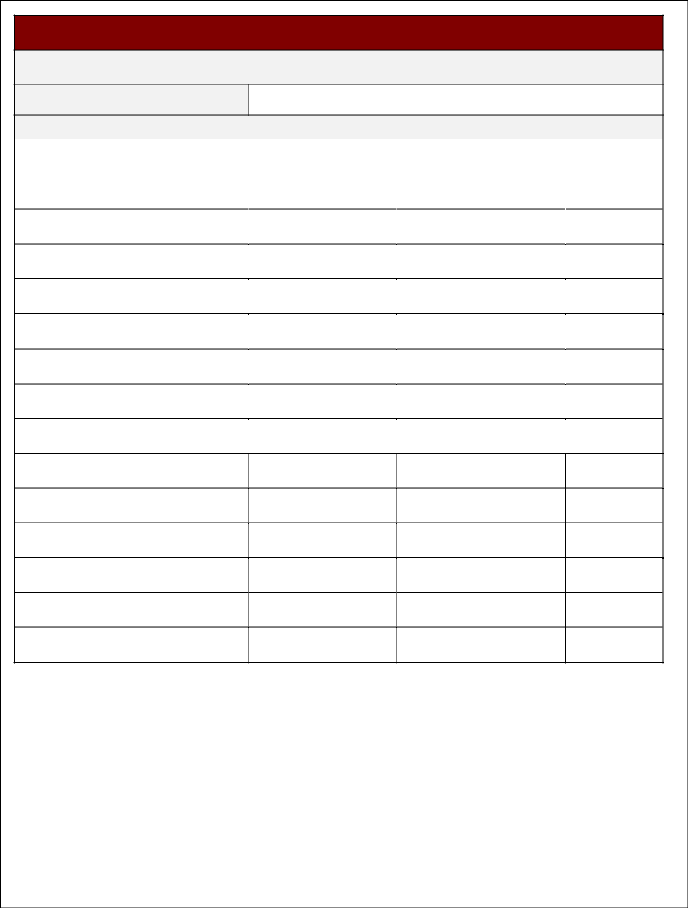
Project Impact Evaluation Team (Signatures)

Team Leader:

I have reviewed the information contained in this Project Impact Evaluation Lessons-Learned Document

 | Names of Project Impact Evaluation team | Title |  | Signature |  | Date
 | Members |  |  |  |  | (MM/DD/YYYY)

The signatures above indicate understanding of the purpose and content of this document by those signing it. By signing this document, they agree to this as the formal Project Lessons -Learned Document.

Signature of Team Leader:

Page 10 of 10

