

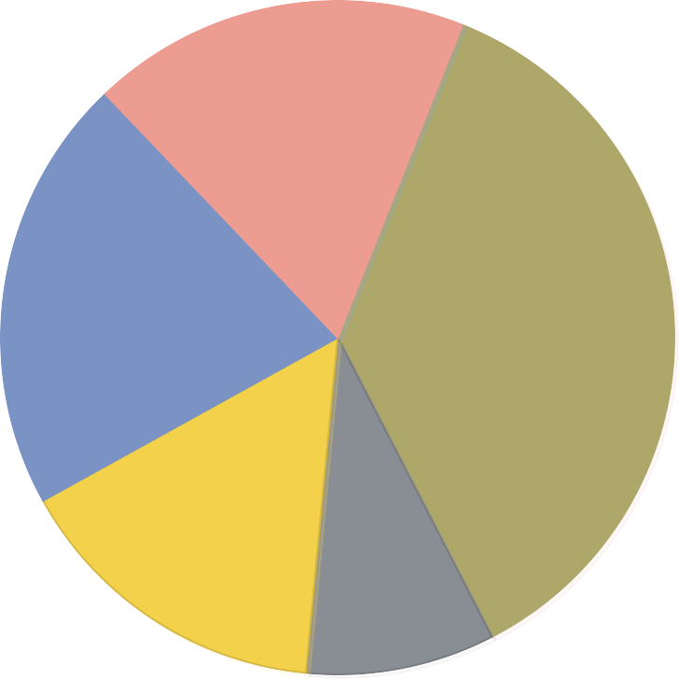

Home Appliances Sales Pie Chart

Others

Shaver

Hair Dryer Electric Kettle Rice cooker

20%

Extractor Hood

16%

Air Conditioner

8%

23%

40%

TV

Fridge

6%

10%

17%

10%

Company name/Author