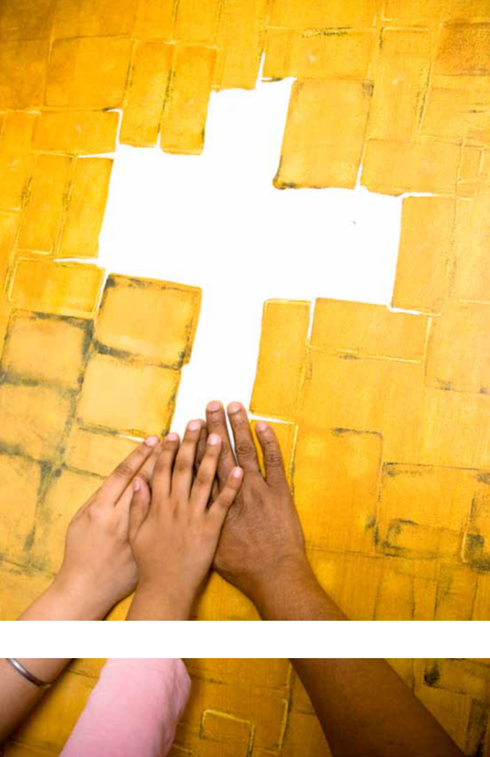
Prayer Journal
DOVE INternational | 2017

they raised their

voices together in

prayer to God.

Acts 4:24

Pray for the DOVE family around the world

Prayer Journal 1

To help you pray

Here are some tips for using the Prayer Journal to pray for the DOVE family including lead-ership teams, partner churches, fivefold ministers and missionaries.
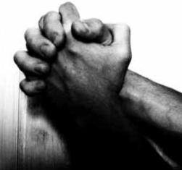

You can pray through the Prayer Journal from page one to the end, praying over a few churches or ministries each week. Read their praise reports and rejoice with them! Then read the prayer requests and agree for needs to be met and for the power of God to be released in their churches and ministries.

There is a listing of DOVE apostolic leaders and other leaders near the back of the Journal. You can pray over these leaders each week.

General guidelines for prayer

- Pray for a cleansing of your heart

“Create in me a clean heart, O God” (Psalm 51).

- Pray that we would grow in personal intimacy with Jesus

(John 17:3).

- Pray for souls to be saved and for laborers for the harvest and for new churches to be planted

(1 Peter 3:9, Matthew 9:37-38, Acts 14:23).

- Pray for spiritual mothers and fathers to be released

(1 Corinthians 4:15-17, Matthew 28:19-20).

- Pray that spiritual gifts will give a fresh release of the power of God (1 Peter 4:7-10, 1 Corinthians 2:4).
- Pray for those in authority (1 Timothy 2:1-4). Pray for small group leaders, senior elders and elders, and apostolic leadership.

- Pray for unity, reconciliation and restoration

(John 17:20-23). Pray for biblical relationships in families, churches and throughout the body of Christ.

2 DOVE International

DOVE International is a world-wide family of believers in Christ involved in churches and ministries located in six continents. We are di-verse in culture but share God-given vision, values, mission and commit-ment to start and nurture churches and

ministries.

God has called us to be people of prayer, to make disciples, to reach those who need to know Jesus and to advance the Kingdom of God. We stand together with the body of Christ to proclaim Jesus as Lord and bring glory to Him. Living the Kingdom— transforming our world.

For more information

visit www.dcfi.org.

©2017 DOVE International

11 Toll Gate Road, Lititz, PA 17543 USA

Phone: 717.627.1996 Email: info@dcfi.org www.dcfi.org

prayer journal
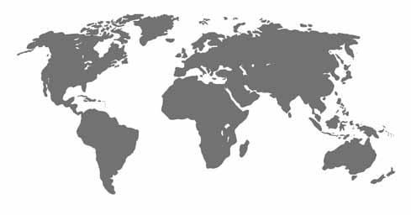

Contents

Africa 8

Asia/South Pacific 24

Canada 27

Caribbean 29

Europe 32

Latin America 33

USA 35

Apostolic Council 44

Ministries 46

Prayer Journal 3

“Ask me,

and I will make the

nations your inheritance,

the ends of the earth
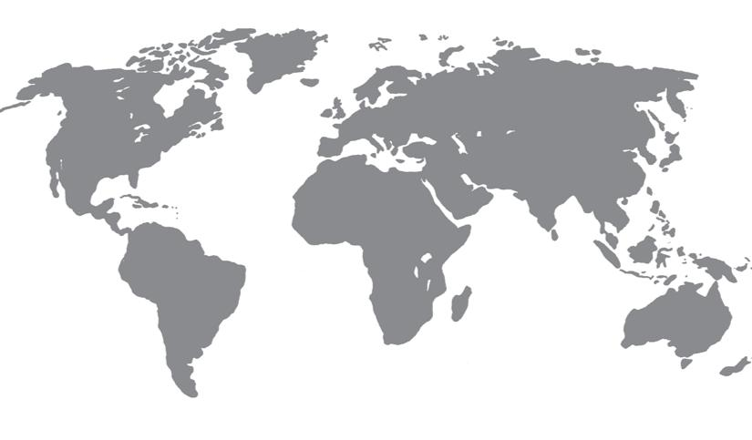
your possession”

(Psalm 2:8).

Barbados
Brazil
Bulgaria
Canada
Colombia
Congo | Netherlands
Guatemala | Netherlands
Guatemala | Peru
Haiti | Peru
Haiti | Philippines
India | Philippines
India | Rwanda
Ireland | Rwanda
Ireland | Scotland
Kenya | Scotland
Kenya | South Africa
Myanmar | South Africa
Myanmar | Uganda
 | USA

4 DOVE International



Our 2020 Challenge Continues

InOctober 1980, twenty-five believers met for their first Sunday morning meeting in a living room near Lititz, Pennsylvania USA. DOVE International was born. Obeying the Great Commission (Matt. 28:19-20) has been our focus ever since: prayer, leading people to faith in Christ, making disciples after the model of Jesus, and planting new small groups and churches. Sixteen years later in 1996, DOVE had grown to a family of eleven churches in four nations. And after another sixteen years (2012) we had grown to 200

churches.

But around that time, the growth seemed to reach a plateau. Very few new churches were being planted. The Lord spoke to our International Leadership Council from Psalm 2:8: “Ask me, and I will give you the nations for your inheritance.” So we began to ask the Lord in faith according to this

promise. We called it our 2020 Challenge: 1000 churches by 2020. Teams were sent into several nations to pray, and we began to train future leaders to plant new churches and take care of the believers who would come into the Kingdom of God.

Today, less than five years later, our DOVE family has more than doubled to over 400 churches in twenty nations. By God’s ongoing grace, we expect that the DOVE family will grow to at least 500 churches by the end of this year. That leaves just three years until 2020, but we believe that the Lord will answer our prayers and reward our obedience. Thank you for agreeing in prayer for 1,000 healthy churches in many nations by the end of 2020, and let us obey God together for this vision to be fulfilled.

Larry Kreider, DOVE International Director

Prayer Journal 5

Prayer Watch Vision

Prayer General Overseer: Nelson Martin

Our vision is to provide a prayer covering for the DOVE International family around the world every hour of every day of the week.

The Prayer Watch maps out the week with 42 time slots. Each time slot is four hours. When all time slots are assigned to Prayer Generals, we have 24/7 prayer coverage.

A Prayer General solicits volun-teers to pray weekly during a designated four-hour time slot. These Prayer War-riors commit to pray weekly for the DOVE family during a specific time slot allocated by a Prayer General.

The Prayer Journal is compiled annually with prayer requests from each DOVE partner church and regional apostolic leaders. The Journal is a tool used in praying for the DOVE family worldwide. The Prayer Journal is avail-able online and may be downloaded for your convenience.

A Prayer Update is sent by email with updated prayer requests. To receive these updates or for more information contact your church leadership or email: NelsonM@dcfi.org.

Join others to pray for the Kingdom of God to come here on earth! When we pray, we are confident He answers and His will is done on earth as it is in heaven. There are six vacancies on the Prayer Watch. Each partner church is encouraged to have a Prayer General.

Prayer Generals
  - Daniel Mbiti, Kenya Leah Tsisiche, Kenya

- Silverious Ingonga, Kenya Daniel Mbiti, Kenya

- Vacancy

- Medardo Serrano, USA

- Amos & Grace Mulwa, Kenya

- Hesbone & Violet Odindo, Kenya

- May Brechin, Scotland

- Elizabeth Apida, Kenya

- Rukundo Milton, Uganda

- Rukundo Milton, Uganda

11. Joina Munyanya, Kenya

- Vacancy

- Justo Llecllish, Peru Innes Begg, Barbados
- Samuel Odero, Kenya

- Radost Cacheva, Bulgaria

- Andrew Kakaulka, Uganda Charles & Alice Simiyu, Kenya

- Carol Preston, USA

- Elida Ochieng, Kenya

- David Musyoka, Kenya Mary Oketch, Kenya
- Bangirana Silver, Uganda

- Bangirana Silver, Uganda Binomugisha Roy, Uganda Twinamasiko Benon, Uganda

- James & Ann Mwendwa, Kenya

- Esther Wafula, Kenya

- Nyeko Alfred, Uganda Sellah Achieng, Kenya
- Vacancy

- Ginny Peng, Canada

- Judith Bartel Ondilo, Kenya

- Beldin Oulu, Kenya

- Nelson Martin, USA

- Vacancy

- Julius & Peninah Kithokoi, Kenya

6 DOVE International

- Vacancy

- Mark Okoth, Kenya Nkubana James Uganda
- Vacancy

- Cosmas Ngeso, Kenya

- Cosmas Ngeso, Kenya Alinaitwe Peter, Uganda Besigomwe Vererian, Uganda

- Tammy Hill, USA

- Giwumi Patrick, Uganda Linus Peace, Uganda Mazzi Sarah, Uganda Rwolekya Amnon, Uganda Jova Tumusiime, Uganda

- Vacancy

- Joseph & Jane Simiyu, Kenya

- Samson Otieno Omullo, Kenya

- Priska Anyango, Kenya

Prayer Watch Times

This diagram illustrates the times for each DOVE Prayer Watch. Each number represents a four- hour prayer slot. The numbers on the Prayer General list correspond with the wheel below.

To determine your local time for this chart visit www.timeanddate.com/ worldclock.
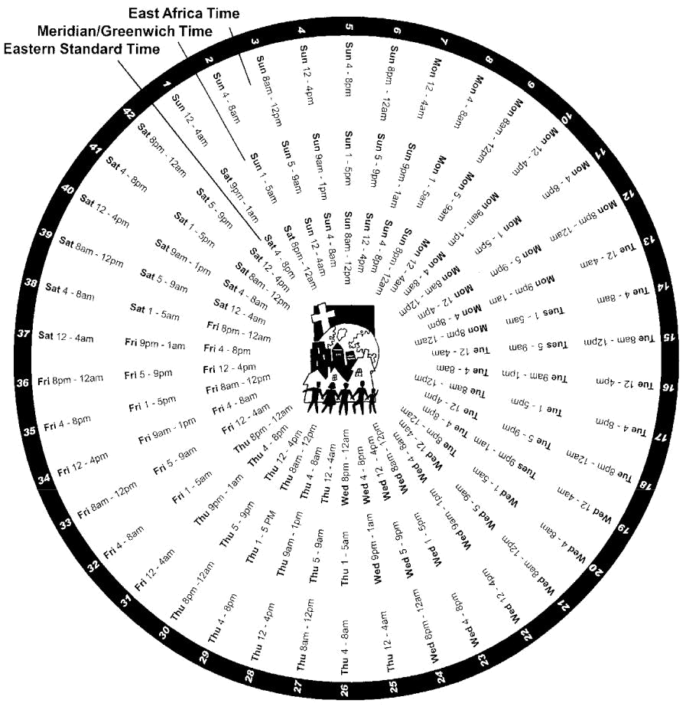



Prayer Journal 7

AFRICA

Ibrahim & Diane Omondi
Apostolic Team Leaders
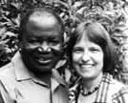

The Africa Apostolic team includes Hesbone & Violet Odindo and Ephraim & Jova Tumusiime. Pray for this team as

they give direction and provide oversight for the churches in the DOVE Africa family. Pray for strategic and godly partnerships for church planting. Pray for effective leadership training in every nation that will support healthy leaders, healthy churches and healthy growth. Pray with us for breakthrough in establishing a Prayer Center in Nairobi.

Africa Fivefold

Trans-Local Ministries

These trans-local (traveling) ministry gifts are recognized and commissioned to minister according to Holy Spirit’s anointing. They are available for ministry in cell groups or other church ministry.

Daniel Mbiti–Apostolic Ministry Rebecca Mbiti–Prophetic Ministry William Munyanya–Apostolic Ministry Samuel Odero – Teaching Ministry Hesbone Odindo–Apostolic Ministry Diane Omondi–Teaching Ministry Ibrahim Omondi–Apostolic Ministry Ephraim Tumusiime–Apostolic Ministry
Democratic Republic of

Congo

Apostolic Leader: Kitungano Ngoy assisted by Kyanga Mwesa and Kitonga Mutima

We thank God that leaders in DOVE DRC are very energetic in church planting. We are thankful for growth in 2016, and feel this is due to intensified prayers. Pray that we will continue strong in the Lord and reach our goals for church planting. Pray all of our churches will have a church building and also a project such as school, quarry, fish farming or dairy (which is a requirement of our national government).

Regional Apostolic Leaders:

Bunyakiri-Hombo Region:Musiwa Kitabingo Kamituga-Kitutu Region: Ilombe Mwendagilwa

Mwenga-Nord Region: Bulambo Kigabilo

Shabunda Region: Mkoma Mapendano Uvira Region: Ombeni Kungwe Pray for the churches of DOVE DRC and the pastors and evangelists who are serving, as follows:
DOVE Beroya Lulengwe:
Musombwa Kyalakanwa
DOVE Bion: Bahige Nabugala Elias
DOVE Butezi: Byemba Bituku Bosco
DOVE Bututa Mihowe:

Kitoga Mutima
DOVE Buchika:Kabonge Munyerere
DOVE Chirba:Jean Paul Biringingwa
DOVE Efeso Kenene:
Kyendaminwa Daniel
DOVE Goma: Kika Kazembe
DOVE Hombo:

Wabenga Chombo Penuel
DOVE Kabindula: Kungwe Obedi
DOVE Kagogo:Walaga Munyaga Yona
DOVE Kakalanga: Pascal Bazibuhe DOVE Kakemenge:

Mazambi Mungililwa

8 DOVE International

DOVE Kamituga /Kele:
Mutunda Kazamwali Albert

DOVE Katundu:Mwilomwigi Mizumbi
DOVE Kibesaio:

Wabenga Ilombe Abakuka

DOVE Kitutu City: Pastor Ayubu DOVE Kolo /Lugushwa:

Kabela Tabi
DOVE Lubumba: Kyuila Kasongo
DOVE Lugushwa Bwalala:
Daniel Bertin

DOVE Lupunge: Kamengele Menge
DOVE Makedonia:Tukini Mungwaere
DOVE Manji: Milelenge Yongolelo
DOVE Mapale:Kaseke Wilondja Roger
DOVE Mboko: Simbi Aluta
DOVE Mulolo: Nkoma Mapendano
DOVE Mumimba:Pastor Basilwango
DOVE Mungombe:Bulambo Kigabilo
DOVE Mwenga:
Itongwa Mazambi Rogatien

DOVE Philadelphia Kambeketi:
Musiwa Kitabingo
DOVE Reheboth:

Kitungano Ngoy Joseph
DOVE Sange:

Bashilwango Mwenyelwata
DOVE Smrma Kibanda:

Kika Watuta
DOVE Songo: Mbilizi Mushingilwa
DOVE Wakila: Mwamba Nsoka
Kenya

Hesbone & Violet Odindo
Apostolic Team Leaders

The Kenya Apostolic team includes William and Joina Munyanya, Samuel and Susan Odero, Ibrahim and Diane Omondi and Charles
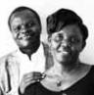
and Rose Wanyama. We are grateful for the support of DOVE Africa and DOVE International family of churches. We are praying for a greater revival this year. Pray our Father will provide leaders from within and without to support church planting.

Kenya: Kisumu Region

Hesbone & Violet Odindo
We give glory to God for ten years of fruitful ministry of Restoration Community Church (RCC) in this region. There is a desire among key leaders to pioneer church plants, so pray for wisdom and provision for all that will be needed. Pray for a release of five-fold ministers in the region.
RCC Ahero

Kennedy & Loice Nunda

Pray for a release of the gifts of the Spirit and fruit of the Spirit among us.
RCC Bethel
Joel & Margaret Randa

Pray we will reach the lost, disciple effectively and be fervent in prayer. Pray for evidence of kingdom transformation.
RCC Bondo

Joseph & Susan Obondo

Pray we will reach the lost, disciple effectively and be fervent in prayer. Pray for evidence of kingdom transformation.
RCC Chemelil

Jeremiah & Betty Otieno

Pray we will reach the lost, disciple effectively and be fervent in prayer. Pray for evidence of kingdom transformation.

Prayer Journal 9

RCC KADAWA
Fred & Susan Omanje

Pray the ladies conference we are hosting in August and the youth conference in December will be life -changing for all participants. Pray we will achieve the goal of reaching out to 500 young people this year.

RCC Kisumu:
Johnfred & Lydia Ojwang

We have witnessed numerical and spiritual growth and we thank God. Believers are more committed in prayer and fellowship. Praise God for provision for a place of worship where we can meet for fellowship anytime of the week. Pray for aan open door of finances to acquire the land where we currently worship, since the owner is willing to sell. Pray for a bigger tent to accommodate a growing number of members.

RCC Korwenje
RCC Korwenje: Loice Nunda

Pray for provision to facilitate the completion of our church building.
RCC: Magwar
Laban & Alberta Okinda

Pray for provision to facilitate the completion of our church building.

RCC Nyakach
Eric & Maureen Ogaja

Pray we will reach the lost, disciple effectively and be fervent in prayer. Pray for evidence of kingdom transformation.
RCC Samaria
Joseph & Peninah Meyo

Pray we will reach the lost, disciple effectively and be fervent in prayer. Pray for evidence of kingdom transformation.

Kenya: Kitale Region

William & Joina Munyanya
Apostolic Team Leaders

Pray for times of refreshing and revival in the Kitale churches. Pray the Lord will lift off the drudgery of life
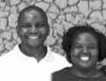
challenges from the pastors and bring all of us into a new level of joy, freedom and abundance. Pray God will bless the work of our hands: in homes, in business and in ministry. Pray the regional leadership team will be able to meet together more often and have clear strategies for church planting.

Baba Nyumbani
Amos & Milkah Kiprotich

Pray for funds to purchase church property. Pray for leaders and workers to rise up and shine in our church.

Bondeni DCF
Jackton & Janerose Chesing’ara

Pray for leaders and all the members to be filled with the fullness of God. Pray Bondeni will experience breakthrough
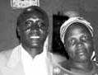
in terms of steadfast commitment and sound biblical teaching.
Chebukaka DCF
Charles & Alice Simiyu

Pray we will reach the lost, disciple effectively and be fervent in prayer. Pray for evidence of kingdom
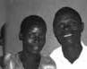
transformation.

Chesamis DCF
Dismas & Helen Wafula

Pray God will give a breakthrough in effective evangelism. Pray for financial provision for the pastor and his family.
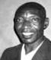

10 DOVE International

Cornerstone DCF
Phillip & Florence Nambutie

Pray for grace as our church works on the evangelism thrust. Pray for unity and revival in the members.

Daima DCF: Khungema-Mumias
Pius & Godliver Maskani

Pray for grace and financial provision as we expand structurally and numerically. We are building a permanent structure and have planted a new church.
Eluche DCF

This is a new church plant by Daima DCF church. Pray for spiritual and numerical growth.

Imani DCF
Joseph & Jane Simuyu

We thank God for the anointing of leadership and church planting vision on the pastor. Pray specifically for Joseph and Jane’s family. Pray for finances for school fees
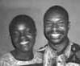
for four children in high school.

Kabuyefwe DCF
Martin Juma

Pray for leaders to arise for our church and help Pastor Martin in the work of ministry.
Kaibeiyo DCF
Benjamin & Susan Too

Pray we will reach the lost, disciple effectively and be fervent in prayer. Pray for evidence of kingdom transformation.
Kapsitwet DCF

Jackton & Janerose Chesing’ara

Pray we will reach the lost, disciple effectively and be fervent in prayer. Pray for evidence of kingdom transformation.
DOVE Kipsongo

Wilson & Rebecca Alemba

Pray for God’s provision to buy a church property and to construct a church structure.
Liavo DCF
Jocktan & Janerose Chesing’ara

Pray for leaders and all members to be filled with the fullness of God. Pray we will experience breakthrough in terms of steadfast commitment and effective leadership training.

Milele DCF
Vincent & Rose Wasike
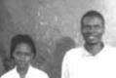

Pray for a Holy Spirit revival for our church and this area that will break

the strongholds of oppression and despair.

Muroki DCF
Mr. & Mrs. Francis Wanyonyi

Pray for revival in our church. Pray for Spirit-led intercession for the work of ministry, for church leaders and for the church in Mt. Elgon area.

Nang’eni DCF
Stanley & Colleta Masibo

Pray for healing for Colleta, who has been battling sickness a long time. Pray for encouragement for Stanley, Colleta and family. Pray for finances to construct a new church building.

Navakholo DCF
Boniface & Pauline Nyongesa

Pray for Holy Spirit revival in our church and community. Pray for God to raise up a strong leadership team that will be equipped to do ministry in the greater Bunyala region.

Nyortis DCF
William & Joina Munyanya

We thank God for allowing us to move to a new and better location. It is an exciting time! Pray for
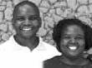
God’s favor and anointing as we go out to evangelize. Pray for true revival in our hearts and the fear of God in our lives. Pray for finances to buy bricks as we look forward to put up a permanent structure.

Prayer Journal 11

Sango DCF
Pius & Elizabeth Wanyonyi

Pray for pastor and his family to be encouraged in the Lord. Pray more people will be raised up for the work of ministry to stand together with the leaders.

Simatwet DCF
Martin & Ruth Shikuku

Pray for Martin and Ruth as they care for orphans at Johabeth Centre and administer the school at Simatwet. Thank God for blessing this ministry to the point that some orphan children have now been admitted in high school. Pray for meaningful partnerships and favor in the community.
Sinai DCFI Eshiasuna-Mumias

Benard & Christine Ndombera

Pray for provision for construction of a building and buying sound equipment.
Toroph DCF
Kennedy & Judith Kaula

Pray God will provide a strong leadership team. Pray for divine healing for Judith; she has had ongoing health challenges.
Waitaluk DCF

Leadership Team

Pray for grace and wisdom for the interim leadership team. Pray for clarity and God’s provision for a clear leader for our church.
Weyolola DCF

Alex & Beatrice Sabari

Pray for revival, strength and grace for our church. Pray the anointing for intercessory prayer will be released in greater measure.

Kenya: Nairobi Region

Apostolic Team
DOVE Gataka

Johnstone Ambati

We are grateful for our partnership with Living Stones Christian Fellowship (Canada) in this church plant. We rejoice in a newly-acquired sound system for Sunday

celebration. This year will be an exciting year for outreach and leadership training plans. Pray for an effectiveness in reaching the community and workers in children’s ministry. Pray for God’s favor.
DOVE Kathalani
Bendict & Elizabeth Muasa

Praise God for the new energy and focus. Praise God the leaders who completed the Foundation series training; the impact of leadership training is really great. Pray we will have more opportunities to share the gospel and resources to complete the church structure.
DOVE Kimua

Boniface & Margaret Mutunga

Praise God for leader’s training last year. It has encouraged the leaders to serve with confidence. Praise
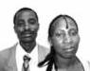
God for the two new church plants (Mithini and Potha). Pray for spiritual and numerical growth in all three congregations. Pray for sufficient rains to boost food production this year. Pray for resources to complete the church buildings at Mithini and Potha. Pastor Boniface is trusting God for a car this year. He has used a motorbike for 13 years and is experiencing side effects.
DOVE Mithini

Jacqueline Kimuyu

We are honored to serve God in this region and thank Him for His grace and presence. Pray God will continue to direct our steps and give us divine strategies for reaching many more people. Pray that those in the community who are bound by witchcraft and sin will be set free!
DOVE Kyasila

Julius & Penninah Kithokoi

We are rejoicing in the goodness of God in helping us grow deeper in faith. We also thank God for leaders
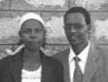

12 DOVE International

who received training and who now have greater enthusiasm for ministry. Pray for success in plans for constructing a new building.

DOVE Mutituni
Daniel & Jackline Mulinge

Praise God how far he has brought the church. Praise God for healing Jacqueline. Pray for the acquisition of land for our church. Pray for revival in our church.
DOVE Nairobi (Kawangware)

Ibrahim & Diane Omondi

Praise God for the revival in prayer and worship. Praise God for unity in the leadership and ministry team. Praise God for an awakening among the young people. Pray for greater unity in the leadership team. Pray for greater depth in our prayer and worship. Pray for wisdom, grace and provision as we consider James 1:27 ministry to widows, orphans and other needy situations. Pray for the long awaited sanctuary construction to be realized.

DOVE Potha
Justus Mbindyo

We thank God for the privilege of serving Him and of being part of the DOVE family. Pray with us to be able to have a permanent place for meeting as a church.
Generation Safi DCF

George & Peninah Ochieng

Praise God for the increase in membership. Many lives are getting saved and solid relationships are building. One young lady was recently delivered from alcoholism and we thank the Lord! Pray for the young generation to grow in love of the Lord and to serve him faithfully. Pray for the agreement with the managers of the venue we have spotted for our Sunday meeting place. Pray for divine direction and provision.
Joysprings Kianda DCF
Charles & Rose Wanyama

Praise God for space to build beside the school property. Thank God for renewed desire for holiness among
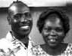
the young people, especially in regard to marriage. Pray for transition in our church leadership and steadfastness among people so we are not shaken by poverty or other challenges. Pray for creative and open minds among leaders. Pray our church planting vision will be revived. The Joysprings School has more students enrolled; pray we will be able to continue providing lunches.

Joysprings Matisi-Kitale
Jeremiah & Carolyne Matimikho

Praise God for the increase in membership and a spacious place of worship. Praise God for financial provision through fundraising to purchase land. Pray we will be able to raise the whole amount and begin construction. Pray the dream of owning a church compound be fulfilled.

Joysprings Sikhendu-Bungoma
Ken & Rose Simiyu

Pray the church and pastor’s family remain focused in serving God despite the hard times faced after the loss of Ken’s mother. Pray that God give courage and strength despite challenges, and truly build His church.

Joysprings-Tongaren, Bungoma
Ken & Rose Simiyu

Pray for the plans we have to plant another church in a nearby village this year. Pray for God’s favor and guidance.
Joysprings Wamwini-Kitale

James & Janet Osuru

The recent DOVE conference was an inspiration and helped us focus on serving the Lord. Pray we will experience revival this year and see many people come to faith in Christ.

Prayer Journal 13

Kenya: Ukambani Region

Daniel & Rebecca Mbiti
Apostolic Team Leaders

Thank God for successful adult and youth conferences which have impacted our region very positively. The unity among pastors is very encouraging! Pray
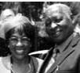
with us as we urgently desire to build a ministry center for the region. Pray for our annual conferences in August and December. Pray our theme this year will be a reality: “The presence of God will go with us this year and He will give us rest!”
DOVE Mikuyu

Timothy & Eunice Wambua

We thank God for grace He gave us in 2016 to put up God’s house on our own land as a church with electricity installed. Pray
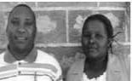
for us to be able to complete the house of God with all fittings, plastering, painting, etc.

DOVE KITHIA
Patrick & Agnes Nzivo

Pray for the grace and favor of God to overshadow us as we covet to see more of His power in our midst.
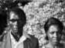

Fountain of Life Church Kyai Moto

Michael & Christine Kivuvo

We thank God for new believers in our midst and are positive many more are getting saved as we endeavor to spread the good news
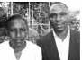
of the Kingdom of God. Pray we may be able to purchase our own land.
Ikumbini DCF
Bernard & Elizabeth Mutuku

Praise God we are connected to electrical power and had a successful fundraising to build the house of worship. We also
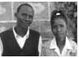
thank God for helping get a vehicle for

transport, as we always walked. Pray our congregation be motivated for God”s work.
Kitengela DCF
Francis & Faith Mwololo

Thank God for helping us build a house for pastor and his family through the generous donation of North Gate Church. Pray
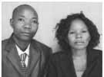
we will be able to build God’s house and connect electricity. Pray we experience God’s grace as we continue to spread the Good News.

Konza DCF
Jonathan & Cathrine Kiio

Praise God for giving His grace as he has increased our number so the place where we meet is too small and for

us we need more chairs! Pray for a larger place which can accommodate us and we may teach the believers effectively to be disciples of Jesus.

Kyanda DCF
Boniface & Joan Muema

Thank God how far He has brought us in just three years old and we have witnessed His grace. It is our sincere hope He who began good work
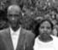
in us will see us strengthened for greater things. Pray for us to effectively expand His kingdom in our area. Pray that we will purchase our own land and build a house of worship with a good PA system for evangelism.

Machakos DCF
Samuel & Maryane Kyalo

Praise God for His i n c r e a s e d g r a c e i n church and ministry. He enabled us to continue

the construction work. We praise God for increase in the Church and the grace to win

14 DOVE International

souls. Pray with us for effective outreaches and more grace to increase even as God expands our territories.

Mbulutini DCF
James & Truphosa Mwendwa

Thank God for His goodness in 2016. We saw God take us through challenging times but continued to grow strong spiritually. Pray for
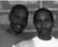
God to take us to a new level of glory in all areas of life. Pray for financial support for our school which we started as an influence to transform the community we serve.
Mbusyani Kitui DCF

Patrick & Anastasia Musyoka

We thank God for increasing our members such as should be saved. We also thank God for our youth who after attending annual
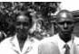
conference last December brought revival in the church which is now flooded with new converts. Pray with us to effectively disciple them for the work of ministry.
Mountain of God Minithanga

Benedict & Jane Muinde

We thank God for reviving the church, for increasing our number such as should be saved, and the fire of Pentecost through signs
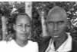
and wonders accompanying us as we move from house to house, setting the captives free. We thank God for helping us purchase a PA system. Pray for us to effectively reach the community with the gospel through signs and wonders.

Restoration of Life DCF
Moses & Judith Ndiva

Praise God for protection and healing the church. Pray for the congregation to be baptized with Holy Ghost with signs following and a release of all the gifts in
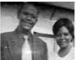
operation. Pray for the developments that have stalled for several years and that we may purchase a better sound system.
Restoration of Life Kibwezi
Benson & Paulina Mbungo

We thank God for transforming this land and bringing a harvest of crops in the area. There is new life in Kibwezi after planting this church. We thank God for saving elderly people from alcohol. Pray for us to be able to build a simple house for pastor as he travels far to minister, so he and his wife can minister more effectively.
Springs of Life Mutituni DCF
Jonah & Stella Maris Kisinga

T h a n k G o d f o r giving favor in the community as many souls are being saved. Pray we may impact
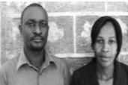
the community with the gospel of Jesus Christ with signs and wonders and that we may raise effective workers for ministry.
Vota DCF

Joshua & Jacklin Mulinge

Thank God for His grace when we saw many souls being saved and added to our congregation, until now we need to
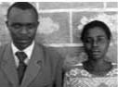
buy more chairs. Pray for us to be able to build a permanent house of worship and install electricity.

RWANDA

DOVE Christian Fellowship Rwanda

Levis Kagigi & Nyirarwaka Abiya-Apostolic Team Leader

Praise God for planting new churches, schools and community development projects. Pray He would
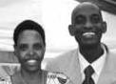
add more to us: strength for work, wisdom, new members and provision.

Prayer Journal 15

DOVE Busanza
Muhoza Nkunda Amon and Beatrice Namajana

Pray we will walk in the power of the Spirit of God in all we do, especially as leaders. Pray the number of followers of Christ will increase and the church will grow. Pray we will find land where we can build a church.
DOVE Gitega
Manyegezi Jackson and Nyiraneza Chantal

This year we are praying we would read the Bible daily as individuals and the entire church. Pray for unity so we would be a good example of Christ and His love. Pray we will be able to get a building for Sunday meetings since the one we have is being taken over by property developers.
DOVE Kanombe

Kawaya Elise and Deborah Nyiragazura

Pray the church may be zealous to seek those who have been lost to sin. Pray we may have the capacity to help orphan children. Pray for the progress of schools run by the church as well as increase in number. Pray our members who do not have jobs can find employment.
DOVE Kanyoni

Kayiranga Diogene and Mukakigeri Oliva

Pray that we may be able to serve the church well. We are praying for revival!
DOVE Kidugudu
Biramahire Leonidas and Mukashayaka Clementine

Pray our light may shine among our colleagues. Pray God shall send laborers to gather all the harvest to Jesus. Pray we may be able to assist orphaned children and the disabled.

DOVE Mugambazi
Thomas Nshimiyimana & Dorcus Nyirankundwa
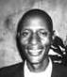
Pray God will bring more laborers and those who will serve in the church and Kingdom. Pray we will experience

revival. Pray that God may enable us to finish the work of building the church.
DOVE Muyumbu
Muyoboke Thomas and Nyantoresuzane

Pray for the increase of the believers. Pray for the construction of classrooms and churches. Pray for revival in our church.
DOVE Ndama

Ethiene Rwumbuguza & Monique Nyiransabimana

Pray God will enable us to evangelize and bring more people into His Kingdom. Pray we will be Christ-centered in all we do.
DOVE Ngoma

Deny Munyaneza and Mukakigeri Clotirida

We desire to know God more and follow Him more fully. Pray also that we may be able to roof our church building.
Dove Ntunga

Kagigi Levis and Nyirarwaka Abiya

Praise God we were able to buy land for the church. We will have our services at home until we are able to build. Pray we will walk in holiness and experience more of God’s presence. Pray we will be good shepherds for the flock of Christ.

Uganda

Ephraim & Jova Tumusiime
Apostolic Team Leaders

Thank God for Brian Sauder’s training for our key leaders. Thank God for the improvement in Jova’s heart condition. Pray for
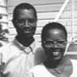
oneness in the Uganda Apostolic team that is comprised of: Davis Habaasa, Caleb Mwendwa, and Mark Ndyagasha. Pray for discernment in building relationships with churches desiring to partner. Pray for revival in DOVE Uganda. Pray that the Spirit of God will lead people to start more new congregations.

16 DOVE International

Antioch Worship Centre DOVE Church

Zena Driciru: Vurra

Thank God for the gift of healing in the ministry of our pastor. Pray for the gift of administration and favor of God. Pray that God will raise up a leadership team.
Apach DCF

Alfred & Rose Nyeko: Apach

Thank God for the open doors that He has made for the gospel in this region. Pray for the work that we have started in Barlonyo. Pray the Lord will raise up committed ministry leaders in Barlonyo. Pray for healing of the people that were traumatized by the Lord’s Resistance Army in the recent past. Pray for people to be interested in starting cell groups.

Arua Worship Center DOVE Church

Bob Linus & Peace Duma: Arua

Pray for our vision for reaching people in South Sudan. Pray the Lord will provide a means of transportation for outreach and a sound system. Pray the Lord will meet the needs of our widows and orphans.
Buduuda DCF
Sam & Margaret Kuloba: Mbale

Thank God for the people that have survived recent landslides. Pray God will protect this community from frequent landslides on the slopes of Mount Elgon. Pray the church will be a witness to many in this needy area. Pray for a public address system for this church.

Bugolobi DCF
Roy Binomugisha : Kiruhuura

Pray we will be led by the Spirit and that we will see more cells start. Pray against the religious spirit in this community. Pray that members will grow spiritually and be willing to witness to the lost.
Bujjuko Open Love
Community Church

Andrew & Janet Kawulira: Wakiso

Thank God for the people the Lord is saving in our community. Thank God for the cell group that is growing into a house church. Pray for
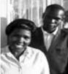
provision for the discipleship class for our leaders. Pray for the finances to buy land for our church. Pray for the provision for our pastor’s personal needs.
Bunamwaya DCF

Zakariya & Gorretti Male: Kampala

Thank God for the zeal in our youth group. Pray for the provision of school fees for the pastor’s children. Pray for new cell meetings to begin. Pray the Lord will use us to reach religious neighbors for Christ.
Bushika DCF
Simon & Florence Malele: Mbale

Thank God for our expansion as a church plant. Pray for protection against landslides as our church is high up in the mountains of Elgon. Pray for expanded vision for the cell church and for new believers to learn the ways of God. Pray we may be able to acquire a PA system.
Eden DCF

Dan & Agnes Nuwagaba:Kamwengye.

Thank God for favor in the community. Pray for increased prosperity in our community. Pray the Lord will save more people and people will desire the things of God. Pray people will join a cell group.
Enengo DCF
Benon & Justine Twinamasiko

Thank God for unity and agreement with other churches. Pray that signs, miracles and wonders will draw unbelievers to Jesus
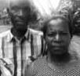
Christ. Pray our cell groups will increase in numbers.

Prayer Journal 17

DOVE Church Gamba
Davis & Grace Habaasa

Thank God for new believers, church member commitment and the primary school. Pray for cell groups to expand and be effective in prayer, evangelism and discipleship. Pray God will provide for building a church and school.

DOVE Church Kabada
Ronald Byaruhanga: Kiboga

Thank God for church leaders. Pray for the leaders to minister in the power of the Lord.
DOVE Church Kabanga
Ronald Byaruhanga: Kiboga

Pray the Lord will enable us to construct a permanent church building and a school. Pray the Lord will raise up effective leaders.
DOVE Church Ndegeya

David Kawuma: Kiboga

Pray the Lord will raise up leaders. Pray the Lord will provide land to build on and start a school. Pray for unity among members.
DOVE Church Kyempiri

Herbert Tumwebaze: Kyankwanzi

Pray for fire of evangelism to keep burning. Pray for cell group vision and leaders to emerge.
DOVE Church Kyomya

Jonathan Mukwaya

Pray the gospel will transform the hearts of people here. Pray the Lord will provide a faithful lady as a wife for our pastor.
DOVE Church Mabombwel

Betty Nsubuga

Pray members grow in knowledge of the Word of God. Pray God touches the hearts of people to yield to the gospel.

DOVE Church Malangata
Patrick & Annet Omwene: Wakiso

Praise the Lord for his protection during recent challenges. Pray people will yield to the gospel as we preach house to house.
DOVE Church Rakai
Kasamba Jackson: Rakai

Pray God gives us land on which to build our sanctuary. Pray God will provide for the orphans we care for. Pray we keep the vision of building the Kingdom of God.
Gilgil Worship Center

Bob Linus & Peace Duma: Arua

Pray for opportunity to start a Rehabilitation Training School and sponsorship for education for rehabilitated juveniles.
Kaberamaido DCF

Agabus & Margaret Ekwatu: Kaberamaido

Thank God for those He is saving from sin. Pray for the God’s favor and provision for several delopment projects including school reconstruction and a well.
Kaduku DCF

Irene Ochango Nandutu: Kiryandongo

Pray the Lord will pour out revival and cell group vision will increase. Pray for construction of a permanent building.

Kakaari DCF
Mark & Sedrass Ndyagasha: Rubirizi

Pray for resources to finish building a medical clinic and begin a nursery and primary school. Pray for healing of

pastor’s wife who has a heart condition.

Kalagala DCF
Charles Ngubili: Kyankwanzi

Pray the Lord will provide us with a plot to build upon. Pray that many will receive the gospel. Pray the Lord will provide leaders.
Kalungami DCF

Moses & Jenifer Batwala: Jinja

Thank God for the new place we have relocated to. Pray we have the Lord’s favor in this community. Pray for people in the area to be saved. Pray the Lord will provide finances to purchase a property and for provision for pastor’s ministry.

18 DOVE International

Kampala DCF
Philip & Susan Mugabi: Kampala City

Thank God the recent annual national DOVE youth conference was a success. Pray for more of the move of God. Pray we will plant another church in Kampala. Pray for favour and completion of our church building. Pray that husbands of many of the ladies in our church will be saved. Pray the Lord will raise up more missionaries. Pray the DOVE Uganda Leadership School will be rooted in our churches.
Kanyogoga DCF
Hellen Nuwagaba & Charles Aluku:Gulu

Pray for provision for pastor’s family. Pray the Lord will strengthen the church with His Word, signs, wonders and miracles.
Kateramo DCF

Dennis & Peace Kyamukaraata:

Rukungiri

Pray for expansion in our cell vision. Pray the Lord will provide for a building.
Katurikire DCF
Fred Byarufu: Kiryandongo

Thank God for a recent church plant. Pray the Lord will use the church to plant other churches. Pray for financial provision for the church and families. Pray that our school will get many children. Pray the youth will grow strong in the Lord.
Kiberenge DCF

Edward & Christine Byamukama:

Kiryandongo

Thank God for the church construction. Pray for ministry to witness to hard-hearted people in our community. Pray for transportation for our pastor to reach
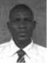
beyond our community with the gospel.

Kibungo DCF
Kesande Midiansi: Kabale

Pray the cell vision will expand. Pray God will save more of His people.
Kigarama DCF
Gift & Gereva Musinguzi: Kanungu

Thank God for land we have bought on which we have constructed our church building. Pray more people
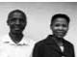
will be saved and added to our membership. Pray the pastor’s family will experience peace.

Kikandwa DCF
James Nkubana: Wakiso

Pray for unity among leaders and members.

Pray God will provide our own land.

Kinyomozi DCF
Joseph & Faith Bakoba: Kiryandongo

Pray for completion of our building. Pray the Word of God will spread. Pray members will commit to a cell group.

Kulu Worship Centre DOVE Church

Madelina Ejulu: Vurra

Pray for construction of our building. Pray we will overcome religious oppression. Pray for the provision of farm tools and equipment for our church project.

Kwera DCF
Fred Okudi: Dokolo

Pray Pastor Fred will be strong and encouraged as he travels a long distance from Kyembera DCF to minister and lead. Pray new believers will embrace our vision.
Kyanuuna DCF

Florence Mazzi: Kiboga

Thank God for an active youth group. Pray God will provide land and that more families will become part of our church.
Kyembera DCF

Dennis & Evis Odoch: Kiryandongo

Pray the Lord will provide transportation to travel to distant areas where we are building relationships. Pray we will reach out to the lost in our neighborhood. Pray for people to embrace our cell vision.

Prayer Journal 19

Mt Zion DCF
Alfred & Sarah Agenonga: Kiryandongo

Pray members will grow spiritually. Pray that the Lord will provide financially.
Mukyogo DCF
Peter Arinaitwe: Kabaale

Pray people will be saved and embrace the cell group vision. Pray God will perform miracles, signs and wonders.

Muyenga DCF
Silver & Peace Bangirana: Rubirizi

Thank God for this new church plant. Thank God for people that Jesus is saving. Pray God provides for our own plot of land and finances
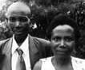
for rent for a place to meet.

Nakulabye DCF
Charles Muwanguzi: Kampala

Thank God for His protection of our pastor and for committed leaders. Thank God for fire manifested in members and outreaches. Pray we will purchase our own building. Pray for stable income for members.
Nalondo DCF
Halule Harriet: Mbale

Thank God for burnt brick for our building project. Pray God will provide funds for completion of this construction. Pray the Lord will bring unity. Pray the Lord will give us power in door to door evangelism. Pray that pastor Harriet will succeed at school as she goes for further
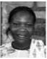
studies.

Namakweekwe DCF
Patrick & Evelyn Giumi: Mbale

Pray God provides finances to buy land and a sound system. Pray the Lord will provide finances to support our family and enable us to start income generating projects.
Nashimolo DCF

Paul and Agnes Shipanga: Mbale

Thank God for people getting saved. Pray the Lord will provide finances for a permanent building and a sound system.
Nfasha DCF
Godie Owomugabe: Kabaale

Thank God for His power of healing, miracles and wonders. Pray God provides for school buildings and teachers. Pray people have a heart for cell group vision.
Nkongoro DCF

Mrs. Allen Muganga: Ntungamo

Pray God will provide for reconstruction of our building destroyed by a storm. Pray the Lord will raise a strong leadership
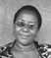
team. Pray more men will be touched by the gospel. Pray the Lord will enable us to start more cell groups and sister congregations. Pray the Lord will save the pastor’s children.

Nyakagando DCF
Caleb & Janet Mwendwa: Kiryandongo

Thank God for the youth who are active in the life of the church. Thank God for favor in the communities where
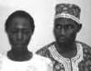
we are working. Pray for unity among the leadership. Pray for a sound system for evangelism. Pray the families of our pastors that need financial breakthrough. Pray for financial breakthrough for expansion of the gospel into northern Uganda.
Nyakahaama DCF

Partick Bwanakweeri: Kamwengye

Thank God for the protection of His church. Pray for desire to grow in the things of God. Pray God will provide for the
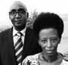
education of the pastor’s children. Pray that we will learn to meet in cell groups.
Nyakarongo DCF
Patrick Bakanyendaki: Masindi

Pray for an increased measure of faith for miracles. Pray for a plot to build a church building.

20 DOVE International

Nyarurambi DCF
Gilgori Mbisimirwa: Kamwengye

Pray against the spirit of confusion and for more salvations. Pray members will understand cell group vision.
Ocea Worship Center

Papy & Nicole Bisambela: Rhino Refugee Camp

Thank God for refugees being saved. Pray for a discipleship program for refugee youth who have dropped out of school. Pray for the vision of setting up a tailoring school for training refugees.

Oraba Worship Center
Sylivester & Esther Sunday: Maracha

Pray for land and shelter for worship. Pray against religious and tradition spirits in our area and for wisdom and strategy to evangelize Muslims. Pray we may start an elementary and adult literacy school. Pray for finances to start popcorn and sesame grinding machines for income generation.
Rubona DCF

Jackson & Hilda Byeiguru: Kamwengye

Thank God for new congregations starting in our region. Pray for more cells to start. Pray we will learn to witness effectively. Pray for unity and
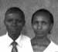
strength in the church.

Rwobuhura DCF
Godfrey Katakanya: Kiruhuura.

Thank God for unity we are experiencing. Pray the Lord will save more people from a religious spirit. Pray we will learn more about starting and leading cell groups. Pray we will plant new churches this year.
Simbiri Fellowship
Pastor Philip: Rhino Refuge Camp

Pray for the Lord’s protection over our lives. Pray the Lord will bring peace to South Sudan so that we may return home. Pray the Lord will meet all our needs.

Uluppi Worship Centre-DOVE Church

Richard Okaa: Vurra

Pray for people in the community to receive salvation. Pray for wisdom, leadership, support for the pastor and family. Pray that God will send a medical team to demonstrate the love of Jesus.
Wakiso DCF
Davis & Grace Habaasa: Wakiso

Thank God for growth and churches we have planted. Praise God for the new leaders being raised up and the DOVE
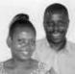
Uganda School of Ministry has become a reality for leaders to be trained. Pray for God’s wisdom to plant and oversee churches in central Uganda. Pray for the new secondary school to succeed. Pray for financial breakthrough for our pastors.
Zengebe DCF

Mbabazi : Nakasongora

Thank God members are growing strong in their walk with Jesus. Pray for us to start more cell groups. Pray we may cross the Nile and start churches in Busoga. Pray the Lord will redeem people who are living on the fish landing near our church from HIV/AIDS.

Prayer Journal 21

SOUTH AFRICA

Merle and Cheree Shenk
South Africa Apostolic Team Leaders

Merle and Cheree Shenk and Brian and Janet Sauder form the Apostolic Team.

Thank the Lord for sustaining us and the DOVE South Africa movement during changes in 2016. We have seen God’s provision and grace as many have changed roles and continue the work of the Kingdom. Pray for expansion, growth and churches to be planted and added. Pray for strategic partnerships within the DOVE family and for those who are asking God to connect to a family like DOVE. Pray for God’s grace as we believe for the work of the Lord to expand
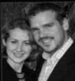
and deepen.

House of Praise
Nigel & Samantha Okkers: Cape Town

Pray for leaders to experience encouragement and joy as they serve and lead. Pray for a faithful and supportive team to form to assist in the work of ministry. Pray for faithful

disciples to grow from the youth outreaches and home groups. Pray for an abundance of grace and provision for every work. Pray for protection, growth, faith, and an activation in prayer as we follow the Lord’s direction.

Shiloh Community Church
Collin and Laura Bothma: Cape Town

Thank the Lord for the new facility. Pray for health, covering and provision for our family as we look to increased impact and outreach. Pray for financial provision as Colin’s season
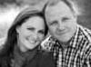
at his job is ending. Pray for marketplace discipleship groups to be effective and Kingdom values to be expressed in our church. Pray for growth and support in the work of ministry and more than enough financial provision.
DOVE Missions

Africa

Thank God for our missionaries who show God’s love to peoples of East Africa who are unreached with the gospel. Many serve in dangerous areas where being a Christian puts them at great risk. Pray for protection, provision, wisdom and courage for each one. Pray DOVE Africa churches will fully embrace and support these missionaries, and many others will answer the call to missions. Pray for greater unity among the missionary teams and pray that God will provide more workers for the harvest, especially for the schools and clinic.

Kennedy and Metrine Karuri
Reaching people through education and vocational training, Wajir, Kenya

Thank God for keeping us safe despite many security challenges. Pray the Somali people we are reaching would
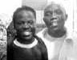
experience God’s love. They are very hostile toward others and even one another. Pray for good health in our family and for adequate support for the work of ministry.

Amos and Grace Mulwa
DMA Team Leaders of outreach to the Ilwana people, Garissa, Kenya

Thank God for a r e f r e s h i n g sabbatical. Thank God our daughter is now in high school. Praise God
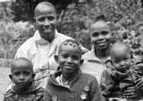
that Garisa has been calm and peaceful. Pray as we serve the communities, God’s love will transform their lives. We have had a water shortage in our area and we are trusting God to dig a well for water for home use.

22 DOVE International

Catherine Nanjala
Teacher at DOVE school, Garissa, Kenya

Praise God for good health and strength as I serve, despite many challenges. Pray we would have good relationships among the teaching staff and the community. Pray that new children in class will be able to catch up with school work. Pray for peace in Kenya as we prepare to

vote new leaders into office this year.

George and Doris Olwande
Teaching and Educational Outreach in Lamu Island, Kenya

We are so excited to serve here in Lamu and we thank God for good relationships of trust and openness that are developing with students and parents of our students. Pray
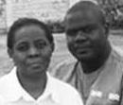
for another missionary teacher to join us, and pray we will be able to get a school building. We continue to have the school in our home, which is quite a challenge.
Joseph and Martha Onyango

Martha – Teacher at DOVE School, Garissa, Kenya
Joseph – Farm project and mission training
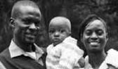
We are grateful to God as a family for his mercies which are new every morning.

Pray God will touch lives through Sports Ministry and Martha’s work at the School. Pray for financial breakthrough for our children’s education needs. Pray for good health and wisdom as we share with the local community. Pray that we will have an income-generating business that will help support us for mission work.
Leah Tsisiche
Teacher at DOVE School, Garissa, Kenya

I praise God for His faithfulness. Pray for the salvation of people in the community that they may know Christ and serve Him. Pray for me as I start my education degree at Kenyatta
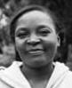

University, I need God’s grace and financial breakthrough.
Martin and Liz Tumusiime
Schools and Community Outreach, Arua, Uganda

Thank God for keeping us safe and strong in northern Uganda. Pray for grace as we face many needs. Pray for

sponsorships for children in the refugee schools, and His favor as we administer other schools that serve mostly an Islamic population. Pray for health in the harsh climate and protection. God is faithful!
Peter and Irene Wafula
Teaching, agricultural projects and youth outreach, Faza Island, Kenya

Praise God for blessing us with a baby boy! Pray for Irene’s quick recovery after undergoing a C.S. for delivery of our baby. Pray
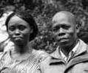
for Peter as he engages in community work in Lamu. Pray for divine protection. Our son in high school is in need of school fees and we are trusting God for intervention.

Prayer Journal 23

ASIA/

South PAcific

Asia

Apostolic Team
The DOVE International Apostolic Council serves as the apostolic team for Asia. Hesbone Odindo oversees the leaders of DOVE churches in Kakinada Region of India and Dominic Correlli oversees the leadership of DOVE churches in Visakhapatnam Region on the East Coast of India. Ibrahim and Diane Omondi give oversight to the leaders of Destiny Center in Mysore in southern India. Larry Kreider, Doug Lehman and Brian Sauder served as a team to train leaders in India last October. Pray for wisdom as others throughout India are being drawn into the DOVE family. Jeff Hoglen leads an apostolic team for DOVE Philippines, and Ram Lian oversees the work of DOVE in Myanmar.

Pray for wisdom for regional apostolic leaders to be raised up, and for divine appointments for Kingdom relationships in this region that will encourage church planting and Kingdom expansion.

India

Destiny Centre International
Philip & Kerina Omondi: Mysore

Pray with Philip Omondi and family as they trust God to move from ministry in India to Canada after leadership transition in 2017. Pray for the two churches which are now under
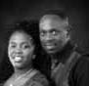
new leaders. Pray for wisdom, protection and provision over our ministry.
Destiny Center Bannimantap
Simon Ruwa: Mysore

Pray for grace to identify, train and release leaders in this one year old church plant.

Pray for us to identify and lease a suitable house to host our Sunday celebration and office.

Destiny Center Datagalli
Obed and Reeny Danso: Mysore

Pray for wisdom in appointing new leaders. Pray for Obed and Reeny to fully embrace their appointment as new senior elders, as Philip & Kerina transition to Canada.
Grace Harvest Church

Sammie and Grace Nalla:Visakhapatnam

Pray for our ministry of church planting, child care and charity. Pray God expands our boundaries to
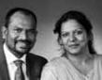
reach more people with the gospel and love of Christ. Pray for 20 pastors and their families who work in the mission field and lead churches. Pray for 9 girls in the Hope House. Pray for divine wisdom and direction for us to be anointed-servant leaders.

Home Fellowship Leaders-India:
Emmanuel & Jessi Kumar, Kakinada

Pray for our churches in remote places. Pray for the dedicated pastors who serve the Lord as leaders, their wives and children. Pray for

their protection as they are missionaries in their native lands and persecution has increased. Pray we reach the goal for 2020 vision. Efforts are under way towards new church plants through new leaders dedicated to the cause of Christ in the regions of Nalgonda District, Khammam District, Vizainagaram District and our headquarters at Kakinada city. Despite persecution, new doors are getting opened into the least evangelized part of the State of Odisha. We hope for new churches in that region. Pray for wisdom and direction as we seek the Lord for reaching India with good news of the Lord in expanding the Kingdom of God.

24 DOVE International

Myanmar

Ram & Novel Khaw Lian
Apostolic Team Leader:

Thank you for praying for us as we plant churches throughout the nation of Myanmar. Pray for our apostolic leader, Ram Lian to be completely healed
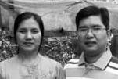
and refreshed during his present sabbatical. Pray for grace to complete our vision to plant churches and for our project to finish printing of The Biblical Foundation Series into the Myanmar language (Burmese). We thank God the first eight books are completed and there are only four more books to be printed in Burmese. Also pray for a great revival in Myanmar (Burma) churches.
Grace Family Chapel

Block 6 East Dagon, Yangon Bu Ling
Grace Family Chapel
Block 122 East Dagon, Yangon Thawng Thawng
Grace Family Chapel
Mandalay Myo, Mandalay Division Peng Lian
Grace Family Chapel
Rakhine State

Khin Hung

Christ Mission Church of Myanmar

Hlegu Myo, Yangon

Ning Ko

Christ Mission Church of Myanmar

Matupi, Southern Chin State Se Lian
Christ Mission Church of Myanmar

Ram Tim Village, Southern Chin State Ki Maung

Christ Mission Church of Myanmar

Kuep Na Village, Southern Chin State Kham Thang

Christ Mission Church of Myanmar

Pyin Oo Lwin, Mandalay Division Aung Can
Eagles Mission, Myanmar
Block 46 North Dagon, Yangon Naing Mana
Eagles Mission, Myanmar
Madainnu Village, Mindat Township Paing Kee
Eagles Mission, Myanmar
Gyauthut Myo, Magwe Division Thun Chain
Eagles Mission, Myanmar
Tachilek Myo, East Shan State Ling Thang
Eagles Mission, Myanmar
Kanpelet, Southern Chin State Phwe Kee
Agape Christian Church
Block 53 South Dagon, Yangon Bawi Ling
Agape Christian Church
Block 69 Dagon Seikkan, Yangon Bawi Ling
Life Christian Church
Hlaingtayar Myothit, Yangon Ral Luai
Beersheba Prayer Center
Hlegu Myo, Yangon

Pa Luai

New Life Evangelical Church
Block 71 South Dagon, Yangon Phway Bu
Hope Christian Church
Lashio Myo, Northern Shan State Ki Phwe
Center For Christ
Hmawbi, Yangon Division Aung Thein

Prayer Journal 25

Philippines
Jeff & Tonya Hoglen
Philippine Apostolic Team Leaders

Pray that each church in the network will be healthy and thriving with God’s presence. Pray for each church to catch hold of the multiplication
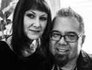
process as we seek to plant more churches in 2017. Pray the leaders of each DOVE church would put God’s desires before their own by living with a true kingdom mindset. Pray the pastors will maintain a focus on what they do daily, free from distractions. Pray we will find a new location for DOVE headquarters. Our previous building was in need of extensive repair. Pray for financial breakthrough for DOVE Philippines. We currently need a jeepney; (a vehicle to carry 18+ people) for the churches in Rizal to share; a Tricycle (motorcycle with side car) for outreach into more rural areas; and books for the DOVE Training Center Library.

God’s Gift Missionaries Int. Church

Eric Jose
Antipolo Hills Bless Church

Mike Gallo

God’s Gift Missionaries Int. Church, Binangonan, Rizal

Greg Narisma

God’s Gift Missionaries Int Church, Overlooking, Riza

Walter Dodoy
God’s Gift Missionaries Int.

Church, Overlooking, Rizal Eric Jose
Graceway Life Church

Cainta, Riza

Arthur Ornias
Lifestream Christian Ministry

Arenda TayTay Rizal

Bernard Flores

Open Arms Christian
Fellowship, Bon Bon Mindanao Jonathan Lumba

Reaching Out Christian Ministry, Presentacion, Bicol

Rodel Bueneventura

Rivers of Love Fellowship Cagayan de Oro, Mindanao

Loloy Badilla
ROCM TayTay Rizal Main

Buddy Gallo
ROCM Bicol

Glenn Pesimo
ROCM Brookside

Ariel Ello
ROCM Parugan Antipolo

Justin Pascual
ROCM Pinugay

Eddie Decina

Seeing the Dawn Christian Fellowship, Taytay, Rizal

Benjie Castillo

South Pacific

Steve Prokopchak
South Pacific Apostolic Team Leader

Pray for direction for this region of the world. We are asking for new, next-generation leaders to be raised up in the South
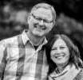
Pacific. We are believing for growth through reaching the lost and those desiring to connect with DOVE’s vision and values. We are asking the Lord for open doors and new church plants. We are excited about new missionaries, Dave and Alissa Smith, now in New Zealand and are beginning to realize a change in the Spirit in this region of the world.

26 DOVE International

CANADA

Brian & Janet Sauder
Canadian Apostolic Team Leaders

We are praying Isaiah 54:2 for all of DOVE Canada...individuals, leaders, churches, new churches. “Enlarge the place of your tent, stretch your tent curtains wide,
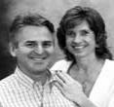
do not hold back; lengthen your cords, strengthen your stakes.” Ask God for lengtheners to be added to DOVE Canada at all levels. Pray for individuals to respond to the call to church planting and leadership. Pray for abundant financial provision.

Canadian Fivefold Trans-local Ministries

The following people are recognized to have traveling ministry gifts and are commissioned to minister according to the Holy Spirit’s anointing: Ed Peng, Ginny Peng, Lynn Ironside and Brian Sauder.
Emmaus Road
Ginny Peng: Kitchener, ON

We are a house church who desires to be a blessing and to be intentional in sharing the good news of the Kingdom of God.

Pray for us as we share the light and love of God in all our areas of influence. We are believing for a greater breakthrough to see signs and wonders following the good news being shared.

Harvest Family Community Church

Lynn Ironside: Georgina, ON

Stand with us as we pray that Harvest will grow – spiritually, physically and financially! May God’s Kingdom be revealed
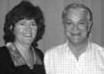
through our loving actions in our local community and beyond! 2017 is the year we claim our breakthrough for vibrancy in our church and our personal lives

Living Stones Christian Fellowship

Bern & Marion McLaughlan: Kingston, ON

We are partnering with DOVE Gataka in Nairobi, Kenya for church planting. Pray we hear the Lord’s voice in ways to
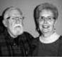
bless and encourage one another.

Muskoka Christian Fellowship

Deb Carter: Bracebridge, ON

We see ourselves as a ‘portable hospital’ unit that is praying for unity within the body of Christ. We
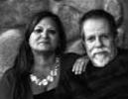
work alongside local churches, YWAM Muskoka, MIHOP, Healing Rooms and the First Nations church on Wahta reserve. We are involved in the arts community and multiple missions projects. We are praying how to engage the local “faith community” for Canada’s 150th birthday and bring light to events planned.
The Gathering
Philip & Lisa Wright: Woodstock, ON

P r a y f o r t h e m a n y, young, unwed mothers in our community. Pray g e n e r a t i o n a l f a m i l y
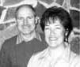
dysfunction will end and their babies will become strong, secure, responsible citizens. In 2016 there was a rash of suicides among youth in our county that made national headlines. Pray the “Spirit of Life” will put an end to the spirit of death, and this will be a year of celebration for families.

Youth Quest Ministries
Joanne Hicks: Woodstock, ON

Our prayer focus this year is Ephesians 6:10-18. Pray for Spirit-filled men and women to lead this generation into the

Promised Land; for our city, county,

Prayer Journal 27

province, country, and into the nations. Pray for intimacy with our Father, his strategies, his purposes, his provision, fulling seeking, hearing and obediently standing in His will.

DOVE Canada

Mission

Pray that DCM will develop into a vibrant Mission Center representing the Canadian DOVE churches. Pray for us as we prepare to launch our first short term mission in 2017. Pray that folk within the DOVE Canada churches and the Body of Christ here in Canada will desire to participate in missions and in supporting missionaries and church planters throughout the nations.
Bob and Kim Wahl

YWAM Muskoka,Ontario

The Wahl’s are active in seeing people walk in freedom and wholeness in God through discipleship training. Pray with them as their heart is to come
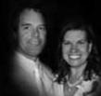
alongside God by staying in tune with Holy Spirit in identifying God’s plan and His destiny for them in the world. They desire to remain sensitive to Father God - saying and doing what He is leading them to do. Pray that God will provide a new home nearer to the YWAM base.
Mark and Jerri Jurgeneit

YWAM Muskoka, Ontario

Pray for vision, wisdom, and compassion as we provide leadership to the students and as they reveal God’s call on their hearts to build relationally. Pray for continued
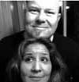
provision in areas of physical, emotional, financial and spiritual needs as the new YWAM base undergoes extensive renovations to enhance ministry. Pray for God to move mightily within the DTS students as they grow in their capacity to
reveal Christ’s love; ministering throughout nations, in regions, with high numbers of unsaved adults, youth and children.
Mark Sarrasin

Quebec House of Prayer

Pray for vision and wisdom, and continued provision and strength - physical, emotional, financial and spiritual, as Mark serves
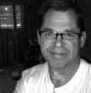
at Quebec House Of Prayer and gives leadership to a new church plant in his community. Pray for the revelations of God’s purposes to bring Mark to new levels of ministry in Quebec. QHOP now often see 40-50 people in the prayer room. From humble beginnings and the prayers of faith, they go forward believing God answers prayer.

28 DOVE International

Caribbean

Steve & Mary Prokopchak
Caribbean Apostolic Team Leaders

We praise God for faith-filled leaders in the Caribbean. Pray for next generation believers who will incorporate effective community outreach. Pray for Impact World
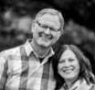
Tour outreaches taking place in numerous Caribbean nations and seeing many come to Christ. Pray for a connection to apostolic leaders and men and women of peace in nations of the Caribbean. We are asking our Father for those connections in Cuba and Guyana. Ask God for the multiplication of leaders, small group leaders, missionaries and church planters. Pray for finances to support an increase in vision and for those Haitian churches that incorporate primary schools. Pray for the national gathering of leaders in Haiti on April 11.

BARBADOS

Home Way Ministries
Andrew & Vicki Shepherd: Christ Church

Pray for an outpouring of Holy Spirit upon the elder team and this partner church.
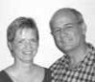

The Living Room
Steve & Shelly Moore: Christ Church

Pray that God’s vision will be implemented and fulfilled through every member. Pray that God would give us His passion and strategies
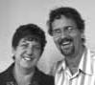
as we seek to disciple communities in Barbados through the development of small groups, as well as, be able to touch lives regionally and internationally with the Gospel. Pray for His abundant provision to do all that He has called us to do.
Haiti

Haiti Mission-DOVE
Miguel & Crysla Riseme
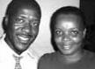

Pray for provision for teacher salaries for our school. Pray people will

grow in strength and power of Holy Spirit.

Church of God-DOVE Rousseau
Miguel & Crysla Riseme

Pray for leaders to be trained and released to lead our church. Pray for the leaders of Haiti Mission as they travel to give leadership.

Temple of the Bible Church DOVE

Precol & Amante Charles: Mountrouis

Thank God for money received to buy rice and beans following hurricane. Pray for financial provision
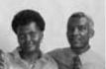
to finish construction of the school and for student benches. Pray for youth to be connected to Christ with all their heart.

Temple of the Bible DOVE-Colline

Chiley Darelus: Colline

Thank God for money received for rice and beans to give to the community. Pray for the launch of a school and more student benches.

Pistos-Disciples for Christ
Gesner Fedelus: Montrouis

Thank God for money to buy rice and beans following Hurricane Matthew. Pray for God’s provision for teacher salaries and student lunches
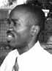
for the school. Pray for the launch of a vocational school with classes in sewing, computer, mechanics and Bible.

Prayer Journal 29

Pray for leaders to be trained and raised up to serve in these churches. Pray for Bibles for teaching members to be disciples:

Pistos Church-Bwadom Pistos Church-Plaine Olive Pistos Church-Savanne A Roche Pistos Church-Tikouyo Pistos Church-Tipalmiste

Eglise Baptise de Calvaire
Jacquelyn Sa Jous: Gonaives

Thank God for the help after the passage of Hurricane Matthew. Pray for us to grow in the Spirit and an open a door to buy land.
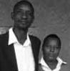
Eglise Baptiste Confraternite
Vernisier Luckenson: Gonaives Brunette

Praise God for money received to help after Hurricane Matthew. Pray for us to grow in the Spirit and an open door to buy land

Eglise Baptiste DOVE de Troiponts

Eugene Wesner: Gonaives Pont Gaudin

Thank God for your help after destruction of Hurricane Matthew. Pray for a way to repair the floor of our building that was destroyed.
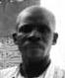
Eglise Baptiste Smyne
Jean Philippe: Gonaives

Praise God for money to help after hurricane damage. Pray for members to be filled with Holy Spirit. Pray God will open a door for construction of a building.
Eglise Chretienne

Homere Blanca: Gros Morne
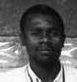

Pray for an outpouring of the Holy Spirit upon the elder team and this partner church.

Eglise Chretienne Indepentant
Jacques Gedeon: Buyeonais Yobe
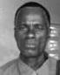

Thank God for money to help members after the hurricane. Pray for cell group members to grow in the Holy Spirit.
Eglise de Dieu En Christ
Ronald Isnadin: Colm ini St Marc

Thank God for money given to help during the recovery of Hurricane Matthew. Pray we will be able to open a
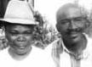
new school in our community.

Eglise de Dieu Primitive En Christ

Temporary Leadership: Gonaives Pradvil

Thank God for help after hurricane damage. Pray for grace and comfort as pastor Frankel passed away in January following a heart condition. Pray for Holy Spirit to guide in identifying a new leader.
Eglise de Dieu Reformee
Cantave Olius Listin: Lian Court

Thank God for money received to buy rice and beans after hurricane destruction. Pray for cell groups to increase and members to be filled with the Holy Spirit. Pray for the completion of construction of our building.
Eglise Evangelique de Salut
Devert & Guerline Jacky:Gonaives Pradvil
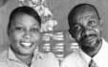

Thank God for financial assistance following Hurrican Matthew. Pray
for more student benches for our school.

Church de Dieu de la Fraternite
Roger Dormilus: Marchanel Dessalines

Praise God for help to purchase rice and beans. Pray for our cell groups to multiply and construction of a building to
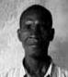
worship God.

Eglise de Dieu Primitive
Jonas & Ri Guerna Joseph: Gonaives

Praise God for money to buy rice and beans to help after Hurricane Matthew. Pray for God’s provision for salary for
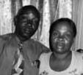
seven teachers in our school.

30 DOVE International

Eglise Pentecostale
Charles Amanata: St Marc

Thank God for help to buy rice and food.

Pray for God to open a door to complete

construction of our building.

Eglise de Dieu de la Prophetic
Thompson Emmanuel: Lacroix Perisse

Pray for an outpouring of Holy Spirit upon

the elder team and this partner church

Eglise Redempter
Cenopard Dieunes: Gonaives

Thanks for your help to
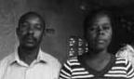
buy food after the hurricane

damage. Pray for us to

purchase land for the church.

Eglise de Dieu Primitive
Jeantilus Nagre: Grande Desdune

Thank God for money to buy
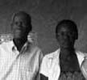
rice and beans for people in our

community after hurricane damage.

Pray for God to open a way to start

construction of a building.

Eglise de Gros Morne
Mathurin Tanis: Gros Morne

Pray for an outpouring of Holy Spirit
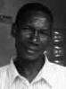
upon the elder team and this partner

church.

Prayer Journal 31

Europe

Ron Myer
Europe Apostolic Team Leader

The Apostolic team includes Peter Bunton and Larry Kreider. There are churches in Bulgaria, Ireland, Scotland and The Netherlands, as
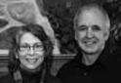
well as a ministry in Germany. There is a growing sense of working together to expand the Kingdom in the nations of Europe. Pray specifically for divine connections with church planters, apostolic leaders, and leaders of churches the Lord is calling to be part of DOVE Europe. Pray that salvations would lead to church planting and for divine connections to be formed throughout Europe as the DOVE family continues to grow and expand.

Bulgaria

Tihomir & Dimka Tenevi
Bulgaria Apostolic Leaders

Pray for more leaders to be trained and for new churches to be started across our nation. Pray for finances for apostolic ministry.
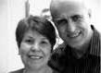
DOVE Christian Fellowship

Bulgaria - Sliven

Danail & Nora Tanev: Sliven

Thank God for 2016! It was a year full of God’s grace, saved people, and changed lives. Pray for the beginning of April as we will launch thirteen new and innovative small

groups mostly led by new leaders. May we see lots of growth, fruit, and saved people! Pray for God’s guidance in how to reach the lost in our city and nation. Pray for the manifestation of the gifts of the Spirit, miracles and wonders; and for divine strategies on how to expand His Kingdom in Bulgaria.

DOVE Christian Fellowship - Lozarevo

Dimka Tenevi: Lozarevo

We thank God for His guidance and support the past year; and for trust being built between people in small groups. God kept us from natural disasters, because the village where we live is vulnerable to flooding and snowstorms. We also prayed for twins born premature; doctors did not give any hope of life for one, but they both are alive and very well. Pray for everyone to be emotionally healthy and free from hopelessness and strengthened in faith. Pray for members to not be subservient to dejection and passivity. Pray for people to build good relationships. Pray for God to guide us and give us strategy to reach the unsaved.

DOVE Christian Fellowship Sofia

Plamen & Maya Kolevi

Pray for the churches in Sofia, Velingrad, Sandanski and Razlog to multiply. Pray with us to break off the bad spiritual
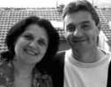
atmosphere in each of these cities. Pray for the development of God’s kingdom through Discovery Bible Groups. Pray for financial provisions that cover the needs for expansion of the Kingdom.

Ireland

Grassroots Church Planting Ministries

James & Rachel Krechnyak: Dublin

Pray for Ireland, that the spirit of oppression and depression would be broken, and God would heal

the broken hearted and see him as their forever Father! Pray for James and Rachel and their three kids as they pack to move to Oregon, USA for the unforeseen future.

32 DOVE International

Pray for a safe trip and a good transition, for our children especially for the teenagers and one pre-teen. Pray that they won’t miss their friends too much and they will make new friends. Pray for the sale of our house and a new place to live. Life Church Carlow is meeting as a house church, and discovering more on how to reach the community and the role it plays there. It is being led by local leadership. Pray for God’s presence to transform people’s lives.

Scotland

Living Waters Community Church
Nick & Liz Wilson: Peterhead

John Buchan, who birthed LWCC thirteen years ago, was called home December 2015. While it has been a challenging year, we as a body have stood
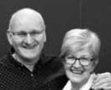
together. The Lord raised up Nick Wilson as the new Senior Elder. Pray that we move forward with confidence in 2017 knowing that God has called us to serve. Pray the new leadership team and congregation will be knit together and hear God as we move forward. Pray for an effective strategy in outreach, especially for new souls to be saved as we plan events and look to reach out into our community.

The Netherlands

The Living
Dirk & Hanneke Develing: Apeldoorn, Netherlands
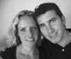
Pray this church is effective in reaching the lost, making disciples and in prayer. Pray for kingdom

transformation.
Latin America

Craig & Tracie Nanna
Latin America Apostolic Team Leader

The apostolic team includes, Tom Barnett, Duane Britton, Larry Kreider and Chad Miller. Craig Nanna gives
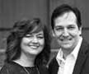
oversight to leadership in Peru, Duane Britton gives oversight to leadership in Guatemala, Chad Miller gives oversight to leadership in Brazil and Tom Barnett gives oversight to leadership in Colombia. Pray for apostolic leaders who share our spiritual DNA to be called to join our vision of expanding the Kingdom of God in other regions of Latin America. Also pray for the building momentum of evangelism, expansion, and church planting in these nations.

Brazil

Comunidade Cristã DOVE
Victor & Vânia Gomes: Fortaleza

Pray with the leadership team about new vision for ministry. Pray for clear direction for their future from God. Pray for new leaders
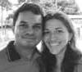
to be raised up to serve alongside Victor and Vania.

Colombia

Herederos del Reino
Leonel & Alba Vallejo: Armenia

Pray for leaders to help plant another church in the city of Armenia, Pray for wisdom for apostolic
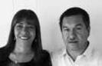
leaders and unity for the work of DOVE in Colombia. Pray for financial provision and a reliable car for Leonel and Alba.

Prayer Journal 33

Herederos del Reino-Bogota
Yuri & Dunia Camacho Bogota

Pray for laborers to help establish this new church plant. Pray for establishment of new cell groups. Pray for finances for a building for a meeting place. Pray for
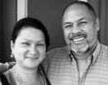
missionaries to help with evangelism and to serve the practical needs in the areas we are reaching out.

DOVE Calarca, Colombia
Juan Pablo & Adriana Munoz: Calarcá

Pray for protection from schemes of the enemy for our leaders and their children. Pray for ministry to youth, children and women. Pray for the finances and volunteers for
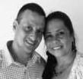
this outreach. Pray for our vision to raise up missionaries and finances to fulfill the call to missions. Pray for the youth mission team in Guatemala in June and our new ministry to people living in the Amazon region. Pray for healing for our church members. Pray for intercessors to be raised up to pray for Colombia.

Iglesia Cristiana Libertad
Carlos & Selene Alfonso: Bogota

We have just begun partnering with DOVE. Pray for growth in our church and for a building in Bogata where we may establish ministry to children, single mothers and leadership
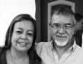
training. Pray for our family to realize the call of God to serve Him and for God to open doors for ministry in businesses, work places and personal encounters. Pray for the restoration of families in our church and financial resources for ministry projects.

Guatemala

Ministerios Cristianos Luz Y Vida
Julio & Jodi Rodriguez: San Lucas
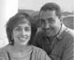

Pray for leaders of student centers and churches, Getsemani School, and Mission House to be filled with

wisdom, health, strength and protection. Pray they have a persevering faith to share about Christ. Pray students will receive the gospel message and grow up in their salvation. Pray for discipleship and growth of leaders in our School of Servants. Pray for discipleship in a new city area we reach with the gospel.

Pray the leaders of these churches will grow in faith and strength of the Lord as the gospel message is given in their community.

Panimache
Francisco Sis Morales: San Andres Semetabaj, Solola
Aguacate
Fredy Matias: Ciudad
San Bartolome

Nery Martinez: Milpas Altas, Sacatepequez

Santa Maria
Carlos Solis Farfan:Cauque, Sacatepequez

Sumpango
Luis Solis Farfan: Sacatepequez

Peru

Heroes 21
Justo & Loren Llecllish: Lima

We plan to consolidate a micro- church in the north of the city of Lima and another in the south of the

city; along with other new groups in other districts of Lima. Pray for more leaders needed to carry out this plan. Pray we put into place a system to support the new groups and micro-churches. Pray for divine guidance to plant more micro-churches in other countries such as Colombia and the U.S.

34 DOVE International

USA

Ron & Bonnie Myer
USA Apostolic Team Leaders

The USA team includes Tracie Nanna and Steve & Mary Prokopchak. The Team is fully expecting things that have been in prayer stages to be released.
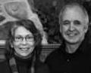
While we have been blessed with all the Lord has done last year we are engaging in the implementation of some new ventures. Pray our ideas and concepts would take root and bear fruit in 2017. Pray people would individually be involved in sharing their faith as well as revitalization of the value of small group ministry, discipleship and church planting for all churches. Pray for salvations, increase of the presence of the Lord in all we do, and for a prospering of all things as we look to Holy Spirit for direction and wisdom throughout this year.

Fivefold Trans-Local Ministries
These trans-local or traveling ministers are recognized and commissioned to minister according to the Holy Spirit’s anointing and are available for ministry in small groups and in other church ministry:

Wanda Alger Prophetic

Duane Britton Apostolic/Teaching

Peter Bunton Apostolic/Teaching

Calvin Greiner Prophetic/Intercession

John & Kim Henry Prophetic/Evangelistic

Erin Herndon Prophetic

Charlie Kline Evangelistic

Larry Kreider Apostolic/Teaching

Marvin Lyons Evangelistic

Nelson Martin Apostolic

Wallace Mitchel Teaching

Ron Myer Apostolic/Prophetic

Craig Nanna Apostolic/Prophetic

Tracie Nanna Teaching/Prophetic

Steve Prokopchak Apostolic/Teaching

Al Rainbow Teaching

David Redish Teaching/Prophetic

Brian Sauder Apostolic/Prophetic

Marty Smith Prophetic/Intercession

Youth Resources
Youth Team: Chad Miller–Leader,

Jeff Burkholder, Shawn and Sheila

Hurst, Rodney and Mosel Royer, Stephanie Sauder and Kristy Yoder

Praise God for the excitement for youth ministry throughout the DOVE family. Pray Holy Spirit continues to fan the flame so we can move into a season of revival. Pray for annual Evangelism Mission Training, June 16-20.

Partner Churches Abundant Harvest Church

Matthew & Bethany Zang: Duncannon, PA

Pray for spiritual, numerical and financial growth. Pray for favor and provision to move into a building project. Pray for unity in the body
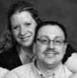
and the comfort of the Holy Spirit to be ever increasing among us.
True Life Fellowship
Brian & Deborah Peters: Marysville, PA

Pray for an outpouring of Holy Spirit upon the elder team and this partner church.
Agape Community Fellowship
Gene & Tisha Miller: Marysville, OH

Pray for Kingdom break-through in our churches, the unchurched, restoration of families, marriages, freedom

from addictions and binding the spirit of suicide. We are making significant shifts in the way we evangelize and disciple. Pray for an increasing deep, passionate hunger for Jesus and life transformation. Pray for financial breakthrough, corporately as well as individually, provision for Agape and the Hope Center in fulfilling God’s mission.

Prayer Journal 35

Bethel Church
Joey & Renee Bozard: Orangeburg, SC

Pray the vision of Bethel to (LOVE, LIBERATE, LEAD, and LAUNCH) be successfully carried out this year! We pray for a continued presence of
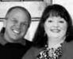
Holy Spirit in all of our services and a re-ignited passion for the lost of our region. Pray also for our Encounter Retreats – that many will be transformed by the power and presence of God!

Breath of God Christian Fellowship

Dianne & Joe Welsh: Aberdeen, MD

Pray for an outpouring of Holy Spirit upon the elder team and this partner church.
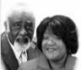

Bridge To Life
Chris & Becky Valente: Johnstown, PA

Pray for an outpouring of Holy Spirit upon the elder team and this partner church.

Broadlands Community Church

Wallace & Linda Mitchell: Ashburn, VA

Pray for an outpouring of Holy Spirit upon the elder team and this partner church.


Calvary Worship Center

Bob & Jennifer Handley: Holden, MA

Pray for an outpouring of Holy Spirit upon the Elder team and this partner church.
Christian Outreach Fellowship
Laurie Brunz: Sioux Falls, SD

Pray for a structure that fits who we are and what God is calling us to do in our city. Pray for the Lord to melt our hearts for each other and the Lord. Pray our house church will be more meaningful in ministry and relationships. Pray for us and many others we want to reach.

Centro de Formacion la Gran Commision

Medardo & Maritza Serrano: Burke, VA

Pray for an outpouring of Holy Spirit upon the elder team and this partner church”
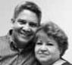

Christian Life Church
Ted & Jana Walker: Sherwood, AR


Pray for an outpouring of Holy Spirit upon the elder team and this partner church.

Crossroads Community Church

Bobby & Wanda Alger: Winchester, VA

We have been blessed by numerical growth, increased spiritual hunger, and greater engagement in

the community. Pray for finances needed to add to our pastoral staff. Pray the growing young adult ministry would be ignited with fresh fire from the Lord. Pray for leadership as we expand our understanding and implementation of five -fold gifts. Pray for wisdom in decisions regarding a possible second service or larger facility. Pray for our vision to increase prayer altars across our community in the marketplace, educational venues, and neighborhoods. Pray for Bobby as he develops healthy systems to sustain our growth.

Desert Streams Church
Gil & Nanci Miller: Bend, OR

Pray for an outpouring of Holy Spirit upon the elder team and this partner church.
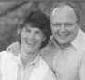

DOVE Christian Fellowship - Elizabethtown

Tom & Nancy Barnett:Elizabethtown, PA

Pray for a permanent building to expand our ministry. Pray for volunteers for children’s workers,
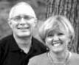

36 DOVE International

worship leaders, musicians, and cell leaders. Pray for evangelism in our region and uinity within the Body of Christ in the Elizabethtown area.

DOVE Christian Fellowship Lebanon

Dan & Jenn Vogel: Lebanon, PA
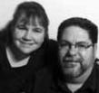

Our theme for the year is, “Keep Moving Forward!” We are asking God to give us fresh vision in how to move forward in what He has called us to do as a church. Pray
that God will give us open doors and opportunities to minister the life of Christ.
DOVE Westgate Church
Deryl & Mim Hurst: Ephrata, PA

Pray we would experience God’s manifest presence in ways that would be transformative and empowering the lives of people and usher in revival. Pray God would raise up an Associate
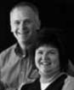
Pastor. Pray for wisdom for possible facility improvement/expansion. Pray for direction and favor as we recast and reformat Small Group Leaders meetings. Pray the “Power & Love” Conference, April 19-22, we are co-sponsoring would have a profound impact on our region.
DOVE Church Wilmington

Steve & Trudi Fricke: Wilmington, OH

This year we have felt an amazing expectation of God’s advancement. We believe He has prepared us and paved the way for growth and impact
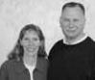
We believe this will be the year of the dance, meaning our lives become our dance for Him as we proclaim His everlasting goodness. Pray as we prepare to move into a new facility, the remodeling will go smoothly and our current building sells at just the right time.

DOVE Rivers of Life Fellowship
Rick & Sue Patterson: Refton, PA
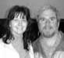

Pray we would see a release of the operation of the Spirit and truth. Pray
we would become people with a testimony that our steps are ordered by the Lord!
ELANCO DOVE Fellowship
Craig & Denise Sensenig: Terre Hill, PA

Pray EDF would increase in understanding the ways of God’s kingdom and we would allow Holy Spirit to guide us.
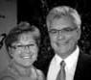
Pray people will receive the baptism of the Holy Spirit and focus on living a life of worship in all areas of life. Ask God to send awakening, life, and kingdom builders into Terre Hill region. Pray we would love God, each other and the lost people we meet.

Freedom Lighthouse Ministries
James & Kelli Martin: Fort Loudon, PA

Pray we would have an increased passion for the Lord and a greater confidence to walk in all

that He has for us. Pray we would better understand our callings and have wisdom to walk this out in the body and in the community. Pray for leadership to disciple others that would multiply and see the Kingdom of the Lord expand. Pray we would have an increased desire to reach the lost and to go into missions.

Grace & Peace Fellowship
Joel & Jenn Deeter: Gales Ferry, CT

Pray for an outpouring of Holy Spirit upon the elder team and this partner church.


House to Home Christian Fellowship

John & Kimberly Henry: Fontana, CA

Thank the Lord for a very successful Resonance Art and Healing Festival we sponsored last year. We are praying for
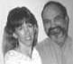
an increase this year. Pray the Lord blesses with outpouring of His Spirit as we create a festival atmosphere designed to worship Him and draw the lost to Him.

Prayer Journal 37

Pray we grow in anointing to use arts for evangelism. Pray we raise up a generation of youth who love Him, serve Him and multiply in house cell/church vision and move in signs and wonders.
Identity Church
Dean & Lori Landis: Willow Street, PA

Pray for us as we navigate through transition of being a Bible study to a micro church. Pray for Holy Spirit direction as we identity and establish a leadership team. Pray
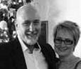
we will impact our community through the gifts, abilities and dreams of each individual and be good stewards of our part. Pray each individual will see personal growth, experience new levels of freedom and encounter the love of our Father.
Iglesia Nueva Generacion

Asael & Yudelka Baez: Holden, MA

Pray for 30 new souls to be saved and added to our church. Pray for everyone within the church to know God’s call on their lives. Pray for God’s people to grow in strong marriages. Pray for a building to serve as a place to meet

Ignited Generation
Gary & Bonnie Reiff: Nottingham, NH

Thank God for strengthening our body and relationships. Many families faced difficult obstacles and trials but were strengthened by the Lord and the church body. Many young people are growing in Christ

and reaching out to peers who are not yet believers. Pray for growth and expansion through our gatherings. Pray for blessing on relationships with those who are yet to know the Lord. Pray for strategy to pass the baton of leadership to the next generation and help them identify and use their gifts.
Indian Lake Fellowship
Lee & Teresa DeMatos: Worcester, MA

Pray for an outpouring of Holy Spirit upon the elder team and this partner church.


Kansas City Renewal Fellowship

Sharon & Jim Allen: Kansas City, MO

Praise God for the unity and maturity in the network of churches. We thank the Holy Spirit for those that received
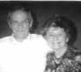
deliverance and healing this year and for healthy leaders. We pray to the Father for those that need to repent, refresh, and reform. We pray for new house churches to be planted this year and multiplication of those already up and running. Pray for continued maturity, spiritually, emotionally and in the love of the Lord!!

Koinonia House
Jessi & Todd Clemmer: Pottstown, PA
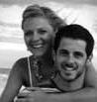

Pray for an outpouring of Holy Spirit upon the elder team and this partner church.

Lighthouse Christian Center
Bob & Barbara Olmstead: Feeding Hills, MA

Pray our Father will give us clarity of vision and mission; and show us what He is doing. May we respond practically and cooperate with Him. Pray compassion for people will expand within us that the lost come to Him and His Kingdom increase regionally and manifest substantially within each of us. Pray we increase in our awareness of the fullness of Holy Spirit within us and give us grace to risk in obedience to Him.

Living Stones Christian Fellowship

Jan Heller, Interim Sr Elder: Newmanstown, PA

Pray for wisdom. At this time we do not have a Senior Elder and are in the process of seeking the Lord as to the future use of our building which we have used for seven

38 DOVE International

years. Pray people will come to know the love of Jesus as we reach out to our community and serve a meal at our building

each Friday.

New Life in Jesus Fellowship
Lloyd & Sue Reiff: Rawlinsville, PA

Pray for continued growth as a family of believers. Pray for wisdom and direction for God’s next step for us in expanding the Kingdom of God.

New Life Family Center
David & Connie Dienner: New Holland, PA

Pray for God to send laborers and leaders. Pray for cell groups to multipy, as new leaders are raised up. Ask God to show His goodness to us and our community
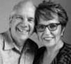
Newport DOVE
Allen & Julie Dise: Elm, PA

Pray that through our new core values, vision and strategy, God would work in mighty ways for our church to be more outward focused.
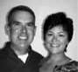
Pray for many salvations and baptisms! Pray our small groups, children’s ministry and teen ministry would be vibrant and flourishing. Pray that prayer will be a more integral part of church life.

North Gate DOVE Christian Fellowship

Ron & Martha Good: Hamburg, PA

Pray for new leaders in every sphere of ministry. Pray for revival in our region. Pray for fruitfulness during our outreaches throughout the year.
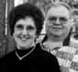
Oasis Fellowship

Chris & Jenn Leiby: Akron, PA

Pray we continue our vision ‘Equipping One Another To Pursue the Plan and Purpose of God.’ Pray for outreach opportunities and
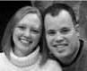
growth as we expand our impact on the Akron/Ephrata communities. Praise God
for the release of Tonya and Jeremiah for the launch of The Overflow, as a house church.
ONE Family Church

Jason & Whitney McGee: Shrewsbury, MA

Pray for an outpouring of Holy Spirit upon the elder team and this partner church
Overflow Community Church
Doug & Jen Lehman: Chambersburg, PA

Pray we focus on God’s plan and for us. We sense very clearly that we are to focus on “Preferring One Another.” As we prefer one
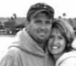
another our evangelism anointing will increase, seeing many new disciples come into the Kingdom. We had a prophetic word in 2016 of a physical location which would become a “base of operations” Pray for that to become reality!

Perry Hall Family Worship Center

Dominic & Lisa Correlli: Perry Hall, MD

Pray for an outpouring of Holy Spirit upon the elder team and this partner church.
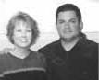

Restorer of Broken Bridges
Richard & Elizabeth Gonzales: Wocester, MA

Pray for a building to serve as a homeless day center and as an emergency shelter. Pray for more laborers to serve as leaders and for leaders to be filled with Holy Spirit.
Rivers Of Healing

Christine & Jean Paul Raymond:

Auburn, MA

Pray for an outpouring of Holy Spirit upon the elder team and this partner church.
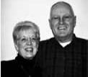

Prayer Journal 39

Sacred Journey
Ruth Ann Bunton, Lititz, PA
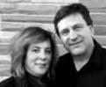

Pray for an outpouring of Holy Spirit upon the elder team and this partner church.
Shepherd’s Gate Fellowship

Tim & Janet Chase: Bend, OR

Pray for an outpouring of Holy Spirit upon the elder team and this partner church
Shift
Kim & Brian Zimmerman: Lititz, PA

Pray God will give us the spirit of wisdom and revelation in the knowledge of Him, that we would be strengthened in our inner man, that Christ would dwell in our
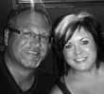
hearts, being rooted and grounded in love. Pray we would know the exceeding greatness of His power and be filled with the fullness of Him. Pray we walk worthy of the calling to which we have been called and everything we do would represent the Kingdom of God and bear good fruit.
The Brook

Wayne & Tina Inscore: Red Lion, PA

God is calling us into a greater revelation of who He is and who we are in Him and to draw others to do the same. Pray we grow in
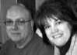
our awareness of His presence in our lives in such a manner that it changes us, our friends, our neighbors and our communities.

The CROSSing
David & Sandra Redish: Lexington, KY

Pray for an outpouring of Holy Spirit upon the elder team and this partner church.
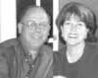

The Fireplace Christian Fellowship

Bryan & Rachel Stevenson: Myerstown,PA

Praise God for His faithfulness: ‘Recovery Through Christ’ has been solid after the launch of

this specialized cell group; new believers have called The Fireplace home; and spiritual parents are walking with them. Pray for incoming Elders. Pray for leaders to follow God’s design for The Fireplace!
The Gathering
Chad & Chris Miller: Lititz, PA

Pray for us as we transition to new leadership over the next year as Chad and Chris plan to follow God’s calling to California in 2018.
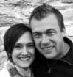

The Hive Micro Church Network

Tim & Angie Wenger: Sheridan, OR

The Hive Communities.
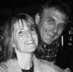

Green Tree Church: John and Gizelle Marr The Spring Church:
Andrew and Shelly Wenger

Pray for The Hive Communities as we take steps towards planting another church, hopefully launching in September. Pray as we initiate sending 2 long-term teams, comprised of our members to locations that are considered “unreached” by the gospel. Pray for The Mandate Discipleship School to continue to develop as a training school for kingdom leaders.

40 DOVE International

TransformChurch
Craig & Tracie Nanna: Reading, PA

As an urban church, we are believing God for greater ways to not only be a church in the city, but to be a church for the city. The
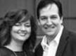
fires of evangelism and discipleship are burning within us, knowing that “the future of our church is out there!” Pray with us as we expand our Sunday Church into the Reading IMAX, making room for many to come into the Kingdom.
WINGS Christian Fellowship

Mike & Heather Sabin: Dayton, OH

Pray our church family continues to reach our community with the truth and love. Pray we bring in the harvest of souls.

DOVE Mission International

Pray for DMI staff Peter Bunton, director, and Nancy Leatherman, assistant. The DMI Leadership Team includes Peter Bunton, Tom Barnett, Allen Dise, Wes Dudley, Janet Sauder, Cheree Shenk and Josie Wilson.

Pray for people to be called to serve as long-term missionaries. We rejoice as new workers were given assignments. Pray for young people to be trained at EMT camp June 16-20. Extended outreach teams will serve in Guatemala and St. Vincent and the Grenadines.

Peter and Ruth Ann Bunton
Director, DMI-USA

Pray for protection and safety for Peter in his travels, for wisdom in leadership and decision making and for provision
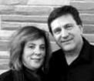
for ministry needs. Pray for study and writing times as Peter continues his PhD studies.

Shannon Graybill
Muizenberg Outreach, South Africa

Shannon serves with YWAM in Muizenberg, South Africa on the leadership team of the Discipleship Training
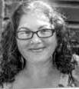
School. Pray for wisdom in leadership as she trains young people from many nations to be leaders and influencers. Pray for Shannon as she faces challenges in renewing her residence permit for South Africa.

Prayer Journal 41

Dan and Regina Bumstead
Love’s Door, Zambia

Dan and Regina work in a deep African village setting, catalysing indigenous church movements and raising up orphans for Kingdom advancement. Pray for funding for another orphan home; for African
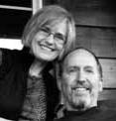
leaders to lead this work; for long term partners; for one-year interns; for another year of grace and health.

Daniel and Katrina Harper
Fragrance and Fire

Daniel and Katrina feel called to begin their life together as a married couple in the Himalayas with the YWAM team they’ve been with. Pray they receive the right visas and find a suitable
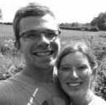
home. Pray they would have a deeper desire for the people of the nation to encounter Jesus. Pray they find joy in the process of settling down and language learning.

Clarissa Kline
Australia Outreach

Clarissa now leads the Compassion Discipleship Training School (DTS) in Youth With A Mission (YWAM) Perth. The heart of the DTS is to disciple young people in the midst of reaching the poor and

needy through healthcare and community development. God has spoken to her that this would be a year of new beginnings – one of greater challenge and trust in the Lord. Pray for God’s strength and grace in this next year.
Joetta Keefer

Hands of Hope Ministry, Philadelphia, PA

Joetta ministers to the homeless and poor in Philadelphia. Pray for women’s shelters and ministries to be opened. Many homeless are confused in understanding of the
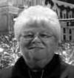

Gospel. Pray Jesus removes their blindness to understand the truth about Jesus being their Savior. Pray for Joetta’s protection.
Bill and Val Landis

Caribbean Youth Mission, Barbados

Bill and Val relocated to Barbados to relaunch a YWAM center and to serve with a regional team of YWAM Caribbean. They are developing a discipling community through DTS.
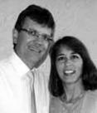
Pray for long-term staff and short-term volunteers to serve in campus operations (maintenance, kitchen, office). Pray for March 2017 DTS students. Pray for local partners for the Caribbean Prayer Rooms and Youth Village. Pray for volunteers and finances for 2018 Impact World evangelistic campaign in Barbados.

David and Alissa Smith Hope to the Pacific, New Zealand

D a v e a n d
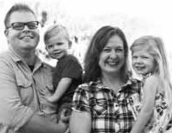
A l i s s a a r e

c o m m i t t e d t o s e e i n g p e o p l e s o f New Zealand, P a c i f i c

Islanders, and those that cross these nations to find hope, life, healing and empowerment through Jesus Christ. They work alongside YWAM Tauranga Projects and YWAM Marine Reach New Zealand to serve the community in Tauranga. They are also looking to assess the water needs in the remote Pacific Islands to provide safe drinking water.
John and Marty Smith

Port Orange, FL and Western Kenya

Pray for divine provision for the Widows’ Farm Enterprises (WFE),
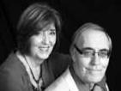
- local government-approved community-

42 DOVE International

based organization, which supports widows and orphans in Kisumu, Kenya. WFE provides food to destitute widows, operates a credit union to provide finances to establish microfinance businesses and sponsors a hospital fund and medical/eye clinics. We also have ongoing sponsorship for building houses and providing clothing, mattresses, mosquito nets and other basic necessities. Pray for skillful and Godly wisdom, for John’s eyesight, and health and safety while in the mission field.

Joel and Marion Smucker
South Africa Outreach, South Africa

Joel and Marion lead a ministry for youth of Cape Town. Pray the youth to be on fire for Jesus, to be Spirit-filled, and spread the message of the Gospel. Pray for creative strategies to reach and mentor youth when involved in drugs or
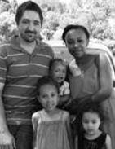
gangs. Pray for a youth/community center dedicated to showing God’s love through the Gospel, performing arts, mentorship, skills training, tutoring, or whatever God’s heart is for the community.
Justin and Rawan Shrum
The Justice Project, Germany

Our outreach center continues to develop and grow in its capacity to reach more women. The safe house is nearly full with those who have left forced
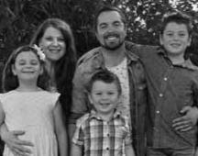
prostitution and are now on the road to recovery! Pray that God would continue to grow our staff with solid, dedicated laborers as we expand each aspect of what we offer to those in need.
Creative Access Nations
North Africa

R & M, DMI workers, work among the unreached people of North Africa. They live intentionally among Muslims and operate a business as a means to be a light. Pray for them and their witness in their community. Pray for hearts to be softened and opened to the Gospel.

DOVE Medical Missions

Gregory Fritz
DMI Medical Missions exists to promote and help organize medical and other service mission teams where needed throughout the world in order to compassionately serve and
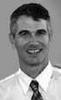
help draw all mankind to Jesus. Greg Fritz, the new coordinator, hopes to build on the foundation laid by Dr. Scott and Karen Jackson. 2017 should be a re-launch year as the program’s strengths and potential are assessed and new teams are formed. Pray we will find sustainable ways to serve DMI linked servants and our global community.

Prayer Journal 43

InternationaL Apostolic Council

Pray for the International Apostolic Council to have wisdom, discernment and grace to encourage, equip and strengthen the servant leaders in the DOVE family worldwide. Pray for safety for each of them and their families as they travel to many nations serving the DOVE family and the body of Christ. Pray they would have the Lord’s wisdom as they respond to the Lord’s invitation to join Him in the 2020 Challenge of trusting God for the DOVE family to grow to 1,000 churches by the year 2020. Pray for new apostolic leaders with the same spiritual DNA that God has given us to join the DOVE global family

Larry and LaVerne Kreider
International Director

Pray for Larry and LaVerne Kreider as they lead the DOVE International Apostolic Council and minister to leaders in many nations. Pray for much grace for Larry and LaVerne to travel and minister throughout
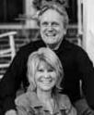
the world, and pray for an abundance of finances for the expanding work of the DOVE International family throughout the nations. Pray for younger leaders to be called, mentored, trained and released to take new roles of leadership in the DOVE family. Pray for wisdom as they oversee and serve various church leaders in Asia, Europe and the USA and many other nations.

Ron and Bonnie Myer
Assistant International Director

Pray for Ron and Bonnie as they give leadership to the USA Apostolic Council and travel to various churches
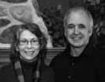
throughout the nation inspiring Kingdom expansion. Ron also provides leadership to the DOVE Europe Apostolic Team, works with Jeff Hoglen, the apostolic leader for the Philippines, and currently serves as the Director of Operations for the DOVE International offices. Pray for a fresh release of the anointing of the Lord as they travel and minister both nationally and internationally calling the church to rise to her full potential.

Peter and Ruth Ann Bunton
Pray for Peter as director o f D O V E M i s s i o n International. Peter prepares new long-term missionaries and helps
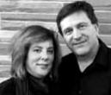
provide supportive services for those on the mission field. He develops short-term mission outreach teams, and is an instructor in churches, training schools and a local seminary. Peter is working on advancing his academic training and is a member of the DOVE Europe Apostolic team. Ruth Ann is a trained spiritual director and is an adviser and teacher for a ministry in Europe. She is leader of Sacred Journey, a house church in Lititz.

Chad and Chris Miller
Pray for Chad as he provides oversight to ministries in DOVE Latin America region. He is director of DOVE USA youth. Chad and Chris lead
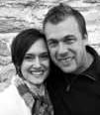
The Gathering, Lititz, PA. They oversee the church they founded Comunidade Crista DOVE, Forteleza, Brazil. Pray for grace

44 DOVE International

and wisdom as they travel and train the next generation of leaders.
Hesbone and Violet Odindo
Pray for Hesbone and Violet as they provide oversight and direction for DOVE Kenya, the ten RCC Churches in Kisumu region and serve on the DOVE Africa
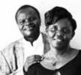
Apostolic Council.They also oversee churches in Kakinada, India. Pray for God’s grace for the many responsibilities they carry and for wisdom and protection. Pray for the grace to minister effectively in a variety of community development projects.

Ibrahim and Diane Omondi
Pray for Ibrahim and Diane as they lead the DOVE Africa Apostolic Council and minister in DOVE Nairobi. Along with travel to DOVE churches in four African
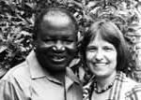
nations, they focus on leadership training and Bible teaching for church leaders. They also give direction to many development projects aimed at helping believers and the church rise to a position of economic stability. Pray for wisdom from the Lord and provision for these projects. Pray for divine partnerships both within the DOVE family and throughout the Kingdom of our Lord. Pray for God dreams and God strategies in church planting and development projects. Pray also for the establishing of a prayer center and conference facility in Nairobi.

Steve and Mary Prokopchak
Pray for Steve and Mary as they lead the Caribbean Region and the South Pacific Region. They also serve on the USA Apostolic Council and oversee various USA churches.
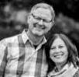
Pray for signs following wherever the Holy Spirit takes them; nationally and internationally. Pray for grace and safety

to travel throughout the year and that they will be a blessing to the leaders they serve.
Brian and Janet Sauder
Pray for Brian and Janet as they lead the DOVE Canada Apostolic Council and serve on the South Africa Apostolic Team.
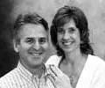
They oversee churches in Canada and the USA. Brian leads the DOVE Leadership Training Schools and oversees numerous training venues in the DOVE family. Brian teaches and ministers prophetically and Janet is passionate about world missions and reaching youth.

Prayer Journal 45

ministries

DOVE Stewardship Team
Earl Shirk–Chairman

Ron Myer–Treasurer

David Breckbill, Rob Kurtz, Bob Kreider

Spiritual Advisors
Keith Yoder, Tony Fitzgerald,

Marilyn Fitzgerald

DOVE Administrative Resources

Hank Rogers,Denise Sensenig,

Trina Beachy and Faith Snavely

DOVE Mission International

Peter Bunton–Director

Nancy Leatherman–Assistant

Team Members–Tom Barnett,

Allen Dise, Wes Dudley Janet Sauder,

Cheree Shenk and Josie Wilson

DOVE Training
Brian Sauder–Director

DOVE Leadership and Ministry
School

Hopewell school location

Live Webcast

House to House Publications
Sarah Sauder, Lou Ann Good,

Diane Omondi

Koinonia Connection Ministry
Hubie Harmon–Operations Director

Nelson Martin–Chairman

Ray Martin

RCTV Productions, Inc.

Don Barley–Director

Brad Sauder–President

Board: Brad Sauder–Chairman

Nelson Martin–Secretary

Brian Sauder–Treasurer

Fred Esbenshade

46 DOVE International

prayer notes

_________________________________________________________________________

_________________________________________________________________________

_________________________________________________________________________

_________________________________________________________________________

_________________________________________________________________________

_________________________________________________________________________

_________________________________________________________________________

_________________________________________________________________________

_________________________________________________________________________

_________________________________________________________________________

_________________________________________________________________________

_________________________________________________________________________

_________________________________________________________________________

_________________________________________________________________________

_________________________________________________________________________

_________________________________________________________________________

_________________________________________________________________________

_________________________________________________________________________

_________________________________________________________________________

_________________________________________________________________________

_________________________________________________________________________

_________________________________________________________________________

_________________________________________________________________________

Prayer Journal 47

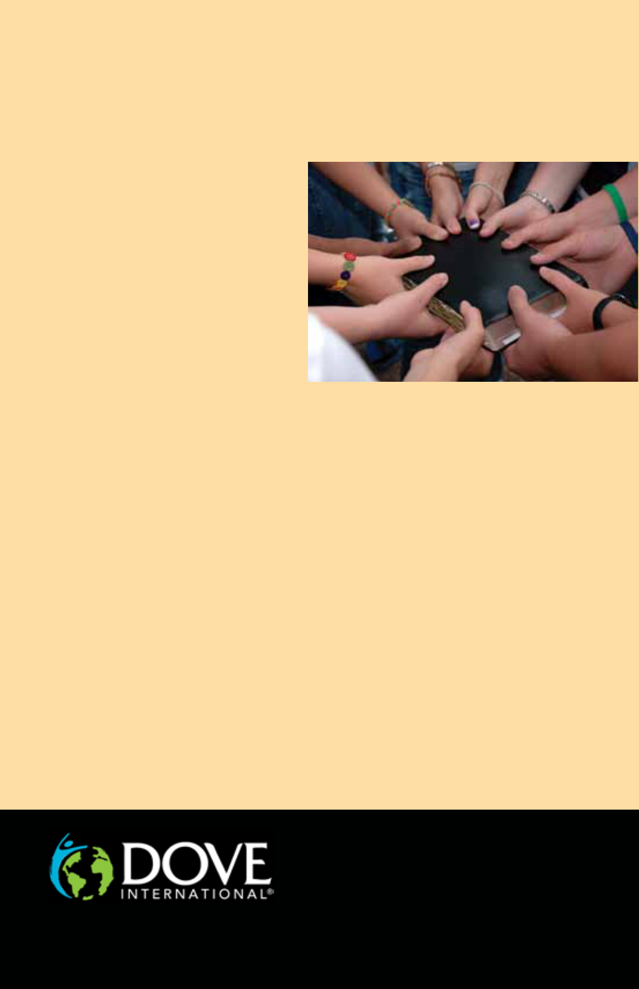
You are invited to pray for the DOVE International family!

This Prayer Journal is a guide for anyone to use when praying for partner churches, councils and ministries. Prayer is a core value to extending God’s Kingdom. The journal can also be downloaded.

The DOVE Prayer Watch The Prayer Watch helps cover

the DOVE family every hour of every day of the week. It is organized by Prayer Generals enlisting to pray during a four-hour slot each week. The generals recruit others to help them cover their slot to give 24/7 prayer coverage.

Prayer Generals

A Prayer General covers a four-hour time slot each week. Their willingness to find prayer warriors is essential for the Watch to be complete. Each partner church is encouraged to have at least one Prayer General. Check this journal for open slots and a list of Generals who faithfully serve.

For more details and to sign up

For details or to join the Prayer Watch team contact Nelson Martin at: NelsonM@dcfi.org.

11 Toll Gate Road, Lititz, PA 17543 USA Phone: 717.627.1996 Email: info@dcfi.org www.dcfi.org

48 DOVE International

