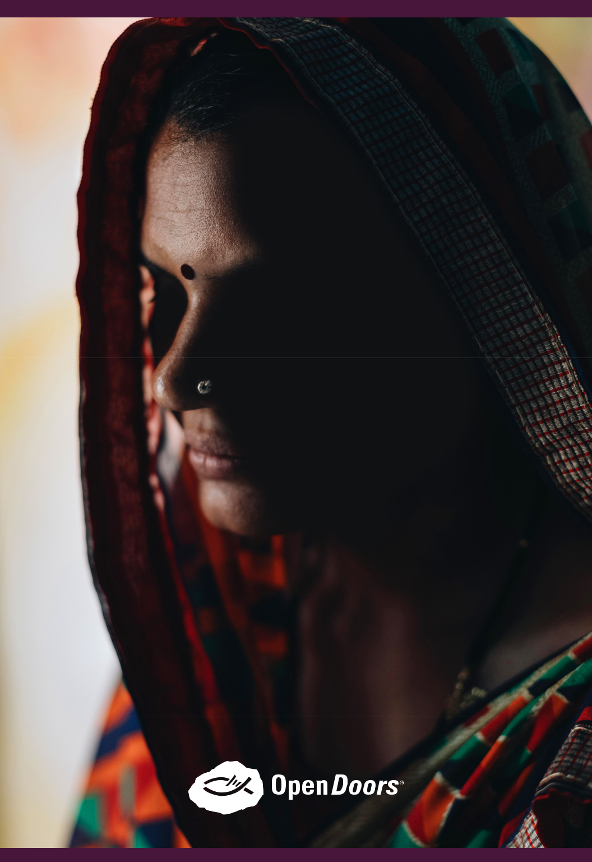

India Prayer
Journal
Dear Friend,

Brother Andrew often said, “No door is closed to prayer” and it’s true. When we pray, our geography changes.

Through prayer, we can travel the world to encourage persecuted believers in places like India, Pakistan and even North Korea— a country closed to Christianity, but powerless to incoming prayers.

Prayer opens the world up to us.

In this special India Prayer Journal, you’ll read about the unmistakable power of prayer in the lives of our brothers and sisters in Christ who suffer for their faith. From Manorama, a woman who’s often threatened by villagers for doing ministry among Hindus, to Anjana, a young woman who chose to follow Jesus—even though her whole family remains Hindu.

These testimonies, and the others you’ll find throughout the journal, reveal the growing intensity of Christian persecution in India, but they also show the resilience of believers to seek God in prayer, trust in His promises and move forward in unrelenting faith.

Through this journal, we invite you to stand with your persecuted family in India through prayer…

Because we know that the God who parted the Red Sea, rescued Paul from shipwreck and shook the prison doors open for Peter is the same God who eagerly desires to work on our behalf for His glory!

Thank you for partnering with us—and for believing this work matters deeply for the Kingdom. It’s an honor to stand with you on behalf of our brothers and sisters in Christ in India and all around the world.
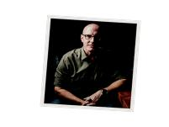

Blessings to you,

David


Dr. David Curry

President/CEO

- Open Doors USA / India Prayer Journal

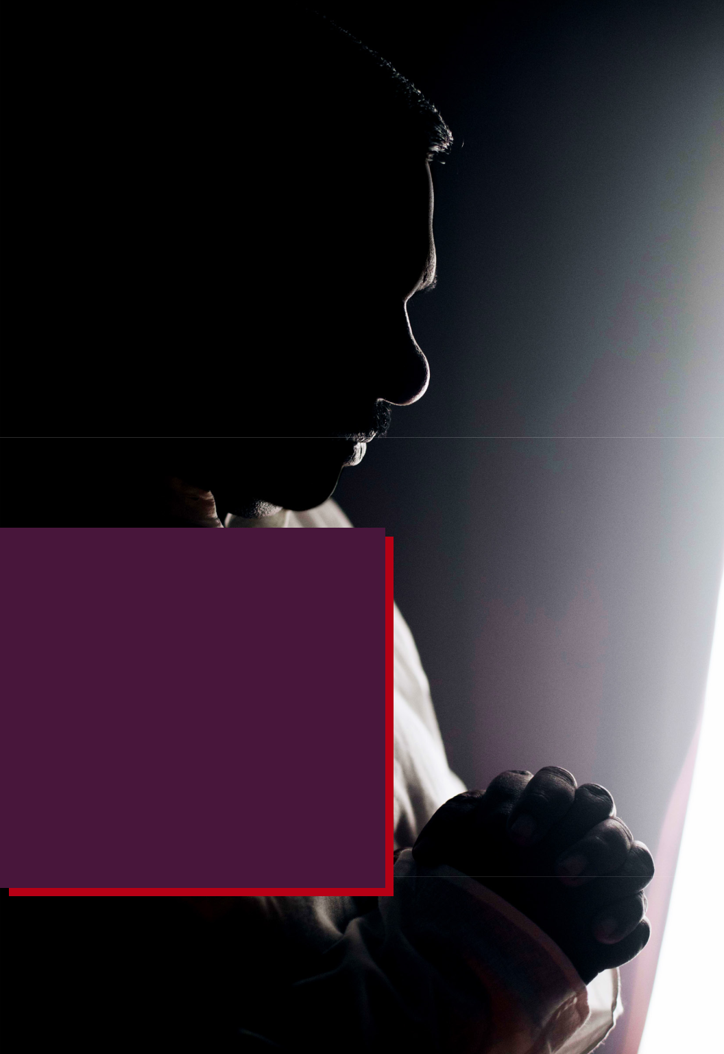

“The more we are washed with persecution, the cleaner we become.”

—Subhash, a believer from India

Open Doors USA / India Prayer Journal 2

Praying for—and with—believers in India

When praying for people or places in other parts of the world, it’s often challenging to truly feel “connected.” After all, most of us have never walked through villages in India or had the chance to get to know the people who call these areas home.
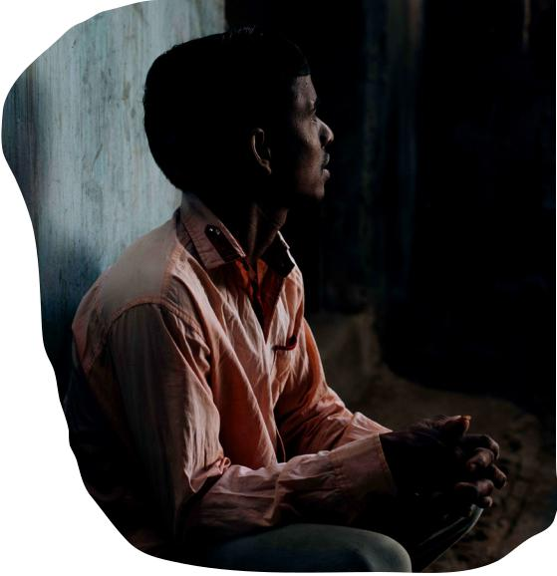

So before you begin this journey of

prayer with your brothers and sisters

in India, we want to give you a quick

introduction to the country and its people.

The Early Church in India

According to the oldest tradition, the Apostle Thomas

came to India in the 1st century A.D. and established the first churches in the country—mainly in Kerala. It is assumed that the initial converts were largely Jewish proselytes among the Cochin Jews who are believed to have arrived in India around 562 B.C., after the destruction of the First Temple in Jerusalem.

Notes on Government

From 1920 onwards, nationalist leader Mahatma Gandhi led non-violent protests against British colonial rule which eventually led to independence in 1947. That same year, areas with Muslim majority split off to form Pakistan as a separate nation. In 1971, war over East Pakistan led to the creation of Bangladesh.

Traditionally, Hinduism and Buddhism—both of them stem from India— used to be regarded as peaceful, but since the 1990s, some expressions of Hinduism have taken on a much more violent character. The tolerance for dissent, minorities, or religious and cultural diversity has dwindled.

- Open Doors USA / India Prayer Journal

The Rise of Persecution

Today, persecution in India is often violent—mainly due to the rise in radical Hinduism. Those who follow Jesus in India face constant pressure to turn to traditional Hindu beliefs.

India is #10 on the 2019 World Watch List

Since the current ruling party took power in 2014, persecution incidents have increased. As a result, Christians have been targeted by Hindu nationalist extremists more and more each year. The view of the nationalists is that to be Indian is to be Hindu, so any other faith—including Christianity—is considered non-Indian.

The Kingdom at Work

And yet, within this setting, God is doing an amazing work. In the face

of trials and persecution, the gospel is spreading, the church is growing and individual believers are risking their lives to further the Kingdom.

This is the context in which Indian Christians live and work, play and worship. And through the gift of prayer, you can stand with them in their faith. We invite you to meet a few of these brave believers in the days ahead through this journal— and we encourage you to remember them in your prayers and to share their stories with others.
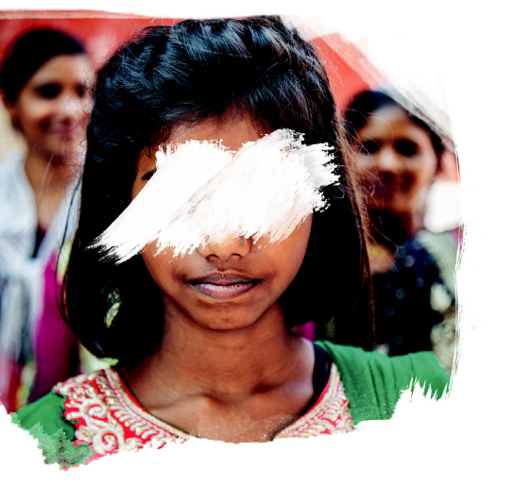

Because, even though India might

feel far away, we are part of the

same Body. We are One Church.

One Family.

Open Doors USA / India Prayer Journal 4



INDIA PRAYER JOURNAL

MEET MANORAMA

Manorama is a follower of Jesus with a passion to reach the Hindus in her village, but this mission has caused Manorama to face severe persecution in her community. People in her village often criticize her—and discriminate against her family because of their Christian faith. Recently, the Hindus in her village have been discussing ways to expel her from the community. But her heart is strong and her faith is steady—even in the midst of suffering.

A Prayer From Manorama

Dear God, I thank You for giving us this day. I pray for the persecuted believers all over the country. I also pray for the diseased, afflicted, widow and destitute. I ask that You would take care of Your people in pain. My prayer is also for the youth—both boys and girls—that they might know You and love You. I pray for the servants of God who work for the extension of His Kingdom and especially those who support us and pray for us. Be with them and bless them. Please also bless my family and the believers in my church. In Jesus’ name, amen.

Prayer

This is the confidence we have in approaching God: that if we ask anything according to His will, He hears us. —1 John 5:14

- Open Doors USA / India Prayer Journal


INDIA PRAYER JOURNAL

MEET MAMATA

Mamata lives in a very remote village in Central India. In her childhood she never heard about God or understood the hope of His promises. When she did hear the gospel, she gave her life to Christ. However, she didn’t read the Bible and rarely prayed. Recently, she realized how far she had drifted from the Lord. Today, Mamata has started reading her Bible. And even though she suffers for her faith, she’s growing in the Lord.

A Prayer From Mamata

Lord, I pray for my husband—that he will fear You only and nothing else. Help him to trust You and live for Your glory. Please help us to always praise You and to hold fast to our faith for eternal life. Lord, please let Your wisdom rest in me because I am studying now, help me to study

well. I pray that the ministry will be strengthened through my husband and I as we labor for You.

Prayer

Look to the Lord and His strength; seek His face always.

—1 Chronicles 16:11

Open Doors USA / India Prayer Journal 6

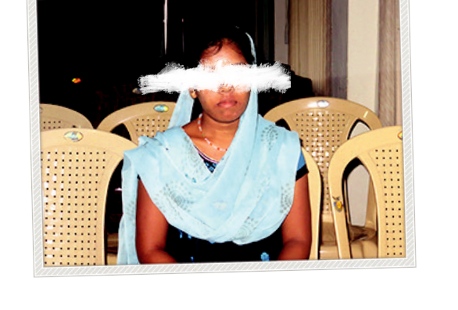
INDIA PRAYER JOURNAL

MEET ANJANA

Anjana is a student and the only Christian convert in her family—her parents are both Hindu. Anjana faced many struggles when she first became a Christian. This is typical for Hindu Background Believers. The pressure to return to their national faith is strong—both from family and society. However, Anjana recently married a Christian, and they plan to pursue Christian ministry together.

A Prayer From Anjana

God, I thank You for all the believers in my church who encourage me and support me in my faith. I pray for all my family members—that they may all come to faith. I pray for my husband that he might grow in You and might be able to do the ministry effectively. You know all my needs, Lord, and I pray that You provide me things that I require. I also pray for all families and for all churches who are in persecution—I pray that You visit them and also bless them. Amen.

Prayer

And pray in the Spirit on all occasions with all kinds of prayers and requests.

With this in mind, be alert and always keep on praying for all the Lord’s people.

—Ephesians 6:18

- Open Doors USA / India Prayer Journal

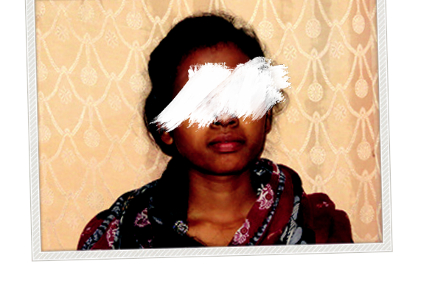
INDIA PRAYER JOURNAL

MEET JYOTI

Jyoti was born into a Christian family. When she was just 6 years old,

her family faced intense persecution from the villagers who pressured them to leave their Christian faith. When she turned 19, Jyoti realized that the Lord was calling her into ministry and she decided to enroll in Bible college. Today, Jyoti is studying theology and returns to her village to do ministry during her college breaks.

A Prayer From Jyoti

Lord, I pray for my state—that the staunch Hindus and tribals come to know about Your love and believe in You. I pray for the youth team in my church. It is my heart’s desire, Lord, that every person in our village comes to know You. I also pray for the safety of girls in our village as they are often abused. I finally pray that I remain strengthened in my faith and always walk in Your ways.

Prayer

Do not conform to the pattern of this world, but be transformed by the renewing of your mind. Then you will be able to test and approve what God’s will is—His good, pleasing and perfect will.

—Romans 12:2

Open Doors USA / India Prayer Journal 8

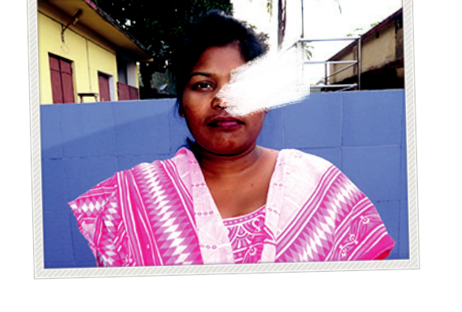
INDIA PRAYER JOURNAL

MEET SAVITA

Savita came to know Jesus almost 17 years ago. She’s a nurse, a Sunday school teacher and she’s also involved in worship at her church. Christians in her village often suffer discrimination, but Savita loves

to step in and pray for others who are hurting. She also loves to share the gospel, but often faces persecution for sharing Jesus with others.

A Prayer From Savita

Lord, I pray to You for my church people—that they might grow in You. I pray for the people who suffer persecution that they might be able to stand strong in their faith. I pray that You would help me pray with dedication. And please bless all the ministerial work I am doing; may it be fruitful. I pray that You guide me and give me wisdom.

Prayer

I call on You, my God, for You will answer me; turn Your ear to me and hear my prayer.

—Psalm 17:6

- Open Doors USA / India Prayer Journal

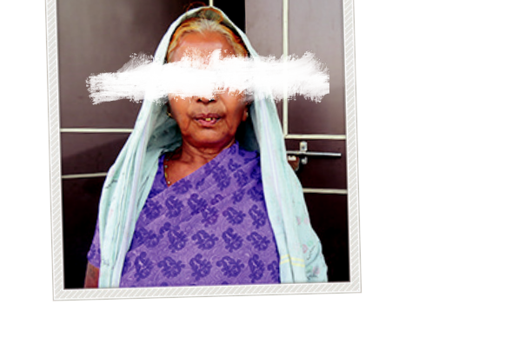
INDIA PRAYER JOURNAL

MEET RAMKALI

Ramkali comes from a Hindu family. Seven years ago, she was very sick, but God healed her through prayer. After this, her aunt and uncle led her to Jesus. However, after she proclaimed Jesus as Lord of her life, she faced many problems in her community. The people in the village stopped communicating with her—and her family. Her mother-in-law recently passed away and none of the villagers came to comfort her. There were only a small number of Christians who came and helped with the funeral.

A Prayer From Ramkali

Dear Lord, I thank You for this day. I thank You for saving me and for healing me. I pray that You would protect me and my family in Your blood. Lord, I also pray for the salvation of the people my village. We face many trials, Lord. Please help us and be with us in all of our tough times.

Prayer

Be joyful in hope, patient in affliction, faithful in prayer.

—Romans 12:12

Open Doors USA / India Prayer Journal 10

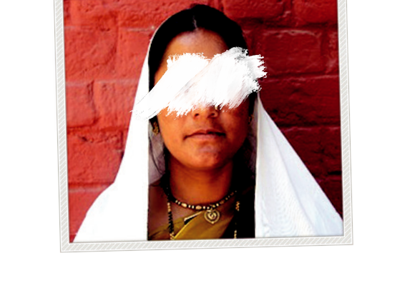
INDIA PRAYER JOURNAL

MEET MAMTA

Mamta decided to follow Jesus four years ago. Since then, she has had family members oppose her—telling her to leave her Christian faith and return to Hinduism. Hindu extremists also placed her name on a list and presented it to a senior government official—accusing Mamta of converting other Hindus to Christianity.

A Prayer From Mamta

Oh God, who is sitting in the heaven, I give thanks to You. You are among us. Please remove all the difficulties of our neighbors who live in darkness— they don’t know You, Lord. They are perishing. Lord, have mercy on them.

I also commit my own family into Your hands. Mold us in the way You desire. Please help all the churches and the pastors so that they might

be able to preach the gospel. Please help me also. Forgive my sins, Lord.

All my children are given by You, keep them safe under Your wings.

Thank you for listening to my prayers. In Jesus’ name, amen.

Prayer

“But to you who are listening I say: Love your enemies, do good to those who hate you, bless those who curse you, pray for those who mistreat you.”
—Luke 6:27-28

- Open Doors USA / India Prayer Journal

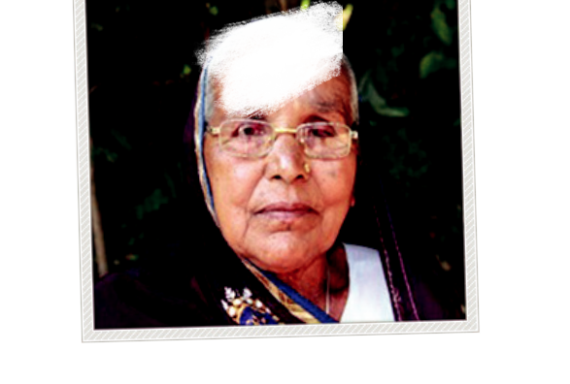
INDIA PRAYER JOURNAL

MEET PREMBATI

Prembati has been a Christian for one year. However, her son has

been a Christian for a long time and is helping Prembati grow in her faith. Prembati’s family members are outcasts in their village because of their belief in Jesus. Lately, the others in the village have threatened Prembati—telling her that the consequences will be dire if they don’t leave Christianity.

A Prayer From Prembati

Dear God, thank You. I come to Your feet this moment—hear my prayers. I need a job to sustain my family, please provide a good job for me. Please help us to grow stronger and more faithful in You. I pray for all Your servants who are toiling for Your ministry—please give them Your grace

and bless them. Please take care of me in the coming days and please hear my prayers. I pray for health and for grace that I might be able to be faithful. Please help me read the Bible daily and also obey it. Give me wisdom so that I might be able to be faithful till my last breath. Thanks for all Your blessings. In Jesus’ name, amen.

Prayer

The end of all things is near. Therefore be alert and of sober mind so that you may pray. —1 Peter 4:7

Open Doors USA / India Prayer Journal 12

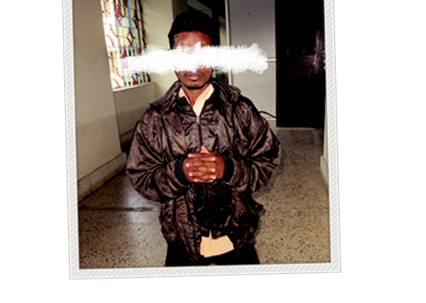
INDIA PRAYER JOURNAL

MEET ANJAN

Anjan comes from a very remote village in Odisha. When the local pastor told him about Jesus, Anjan ignored him. Anjan found it difficult to believe in a God who was invisible—especially since his religion worshipped idols that were visible. However, after reading more from the Bible, God began to soften Anjan’s heart and he gave his life to Christ. Today, he’s involved in his church and loves to share the gospel with others.

A Prayer From Anjan

Lord, I thank You for helping me know You. I pray for my village, because people do not want to acknowledge You. I pray that they would see You soon. Please help me serve You. I have shared about You to my neighbors. I pray that they would come to faith soon. I also pray for my country— that Your name would rise and many people would find salvation in You.

Prayer

Very early in the morning, while it was still dark, Jesus got up, left the house and went off to a solitary place, where He prayed.
—Mark 1:35

- Open Doors USA / India Prayer Journal

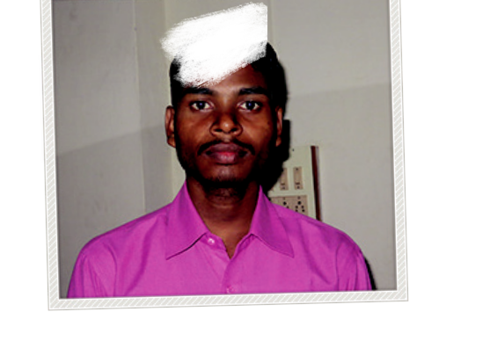
INDIA PRAYER JOURNAL

MEET KARAN

Karan is the only Christian in his family. The rest of his family members are devout Hindus—and his father is the village chief. In Karan’s village, it’s a disgrace that the chief’s son is not a Hindu, but a Christian.

A Prayer From Karan

Dear Lord, I pray for my studies. Please help me concentrate and give my best. I pray for my family—please bless them and help them to know You. Lord, I pray for a suitable job for me so that I can help my family. I also want to learn more about the Bible. Please provide an opportunity for me to get more Bible training.

Prayer

Then they cried out to the Lord in their trouble, and He brought them out of their distress. He stilled the storm to a whisper; the waves of the sea were hushed. They were glad when it grew calm, and He guided them to their desired heaven.

—Psalm 107:28–30

Open Doors USA / India Prayer Journal 14

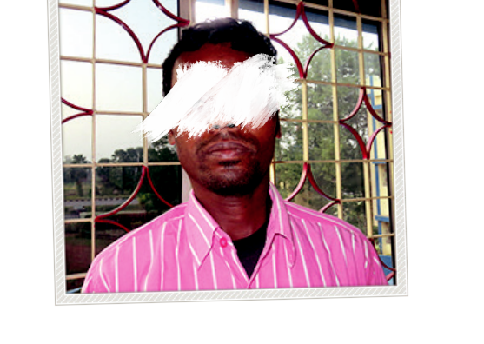
INDIA PRAYER JOURNAL

MEET TOFARI

Tofari came to faith while he was studying at a Christian institution, but his family worships many idols due to their Hindu faith. His heart cries out for his family and the people in his village to know God. Tofari has shared the gospel with his family, but so far they have refused to believe.

A Prayer From Tofari

Jesus, I come to You. I pray for my state and my country. I pray for a revival that people would know You and find life in You. I pray for the sick and the ill— provide them health, Lord. I also pray for all Christian organizations and all denominations, lead them in Your direction—help all of us grow

and find strength in You. Bless the pastors and Christian workers, help them stand firm. Amen.

Prayer

I will not fear though tens of thousands assail me on every side.

—Psalm 3:6

- Open Doors USA / India Prayer Journal

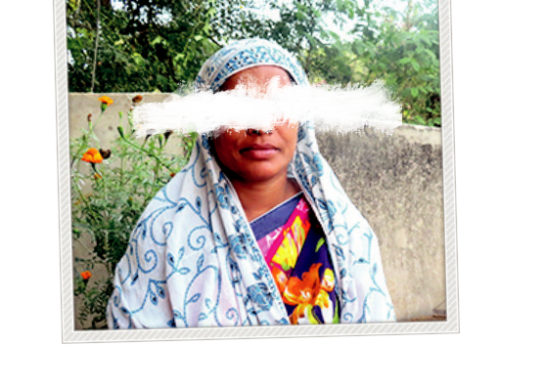
INDIA PRAYER JOURNAL

MEET SABANA

Sabana came to faith in Christ in 2001 after her husband was healed through the power of prayer. Sabana lives in a predominantly Hindu village and faces regular opposition—both from the people in the village and Hindu extremists who constantly threaten her for being a Christian.

A Prayer From Sabana

Lord, I thank You for this day. I pray that You would protect my family as they face many trials from the villagers—and reach my village with the gospel.

Prayer

“Call to Me and I will answer you and tell you great and unsearchable things you do not know.”

—Jeremiah 33:3

Open Doors USA / India Prayer Journal 16

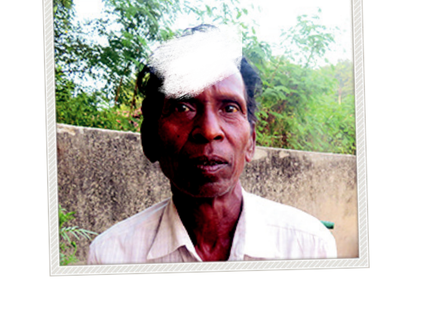
INDIA PRAYER JOURNAL

MEET MANKU

Manku and his family came to Christ when his wife was delivered from an evil spirit through prayer. After he and his family came to faith, the villagers opposed them and beat him. The whole family was socially ostracized. Manku was also denied any work in the village. He has always depended on daily labor for earning a living, and now no one gives him work because of his Christian faith. Life is difficult for him, but he remains strong in his faith, along with his family.

A Prayer From Manku

Lord, I pray for the protection of my family—we face constant opposition in my village. I pray that You would preserve us from all harm that might come upon us. Help us to continue with our faith. I pray for the salvation of my village. Please help all the people in our village to know Your faith. I also pray that You would help us with our livelihood—help me to earn well for my family. In Jesus’ name, amen.

Prayer

Elijah was a human being, even as we are. He prayed earnestly that it would not rain, and it did not rain on the land for three and a half years.

—James 5:17

- Open Doors USA / India Prayer Journal

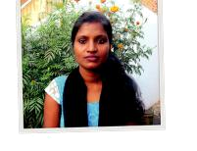

INDIA PRAYER JOURNAL

MEET YENU

Yenu lives with her two younger sisters. Due to an illness, her mother recently died—and Yenu lost her father years ago. When her mother died, no one from the village came to help or even attend the funeral—even though they knew the family was very poor. Since her mother’s passing, it’s been very difficult for the family to survive. Yenu is currently looking for a job to help support her sisters.

A Prayer From Yenu

Lord, I come to You. I pray for my family. Please provide for our livelihood, Lord. I pray that You would provide a suitable job for me so that I might be able to provide for my family. I pray for the perishing souls in my village. Please reveal Yourself to them that they might know Your truth and find salvation in You. In Jesus’ name, amen.

Prayer

But the fruit of the Spirit is love, joy, peace, forbearance, kindness, goodness, faithfulness, gentleness and self-control. Against such things there is no law.
—Galatians 5:22-23

Open Doors USA / India Prayer Journal 18

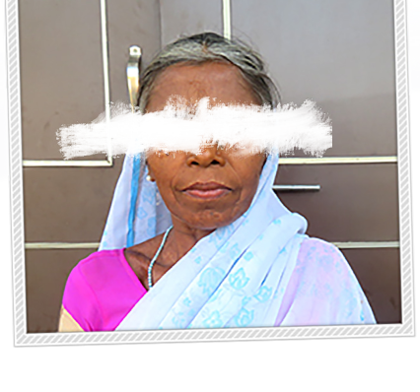
INDIA PRAYER JOURNAL

MEET SHANTI

Shanti trusted Jesus as her Lord in 2017. She was suffering from a mental issue, but God healed her and she decided to believe in the gospel. However, the moment she placed her faith in Jesus, suffering and opposition arose within her family. She was beaten by her son-in-law and thrown out of her home. Her community also threatens her and tells her to renounce her Christian faith or be expelled from the village.

A Prayer From Shanti

Lord, thank You for this life and for revealing Your salvation to me. I pray that You would save my daughter and also my son-in-law. Lord, I pray that you would provide a good place to live for me. I am struggling to find a home, but I trust You, Lord. Please help me stand strong in You. In Jesus’ name, amen.

Prayer

But in your hearts revere Christ as Lord. Always be prepared to give an answer to everyone who asks you to give the reason for the hope that you have.

—1 Peter 3:15

- Open Doors USA / India Prayer Journal

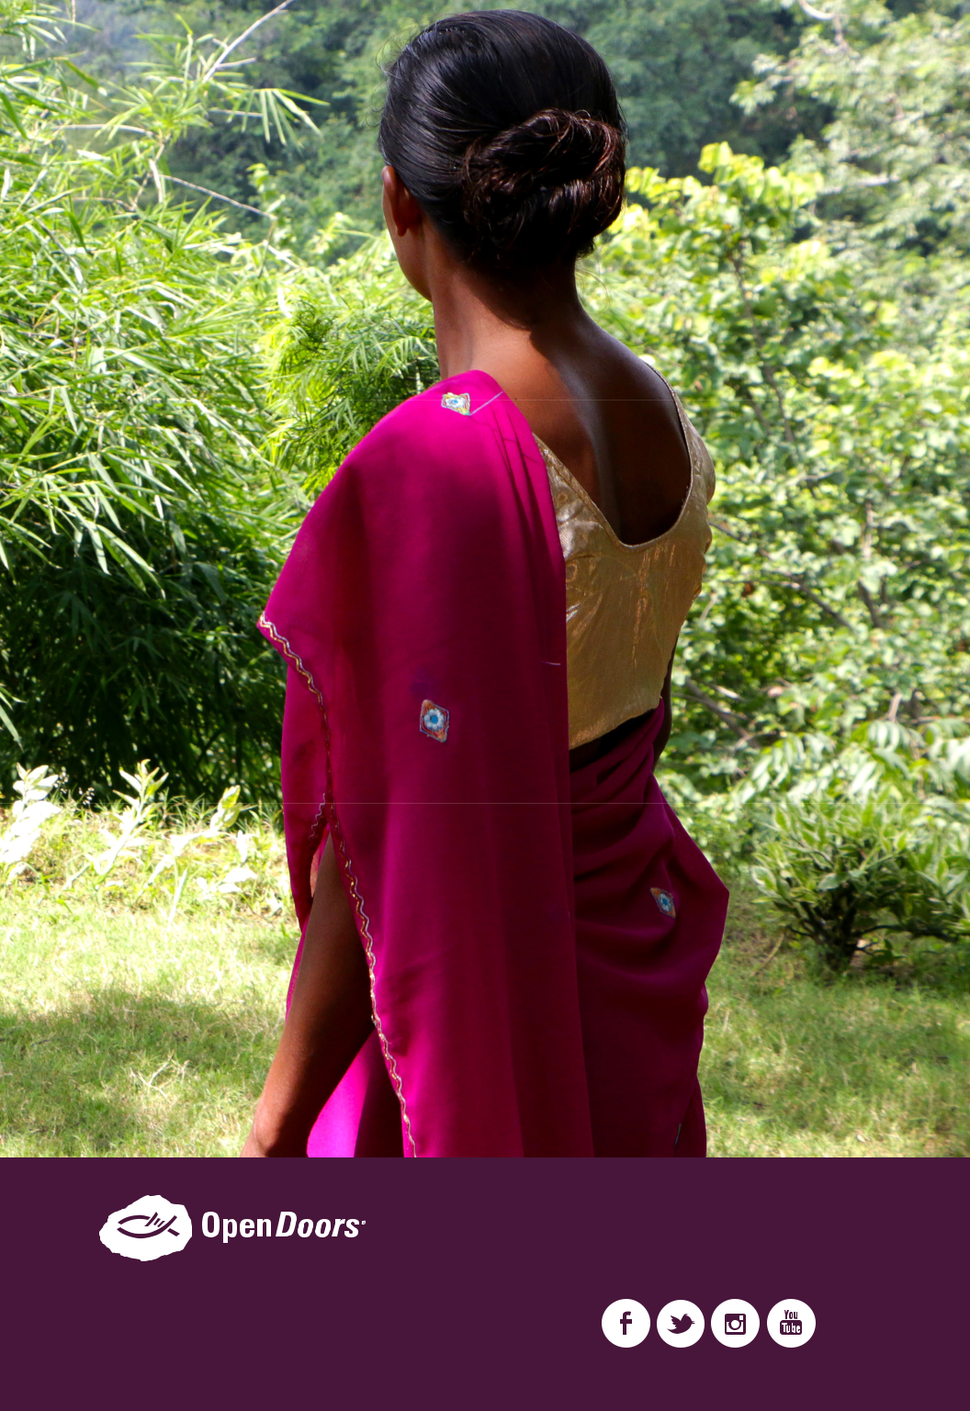

OpenDoorsUSA.org

One Family. One Church.

888-5-BIBLE-5 (888-524-2535)
info@odusa.org

