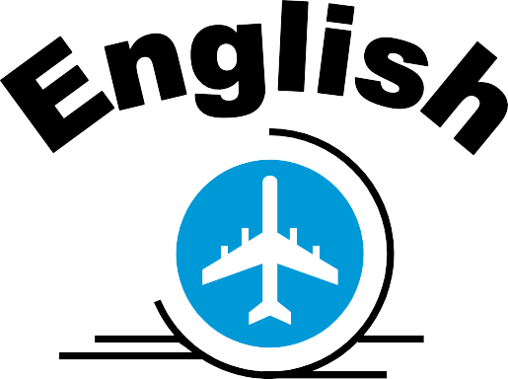



Rules:

1. Mistakes are okay!
2. Try to speak.
3. Ask questions.

**“I want to learn more and more!!”**

Rules:

1. Mistakes are okay!
2. Try to speak.
3. Ask questions.

**“I want to learn more and more!!”**

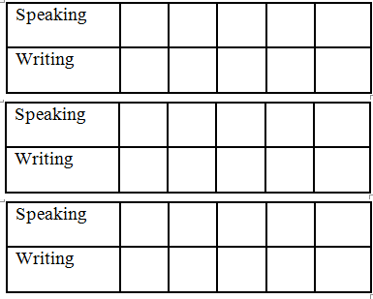

Hobby: _____________________

Hobby: _____________________

Visas

Name

Class

Birthday:

Club:

Visas

Name

Class

Birthday:

Club: