Trustworthy Friends Passport Template

Print the first page and then print the second page on the reverse side of the first. Repeat this process with the third and fourth pages. Cut out the white borders and cut each page in half.

Assemble the resulting pages into the correct page order and fold in half. Staple along the fold.

© 2012, **DiscipleLand**. Permission granted to reproduce for class use.

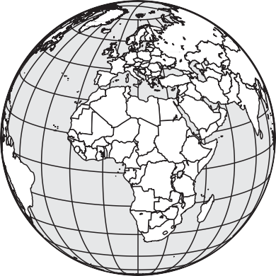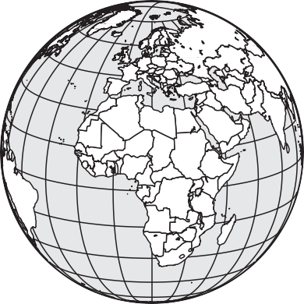

Country

Date visited _ _ _ _ _ _ _ _ _ _ _ _ _ _ _ _ _ _ _ _ _ _ _ _ _ _ _ _ _ _ _ _ _ _ _ _ _ _ _ _ _ _ _ _ _

Country

Date visited _ _ _ _ _ _ _ _ _ _ _ _ _ _ _ _ _ _ _ _ _ _ _ _ _ _ _ _ _ _ _ _ _ _ _ _ _ _ _ _ _ _ _ _ _

6

7

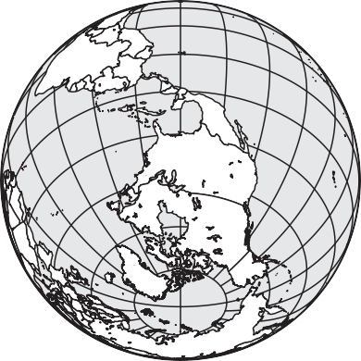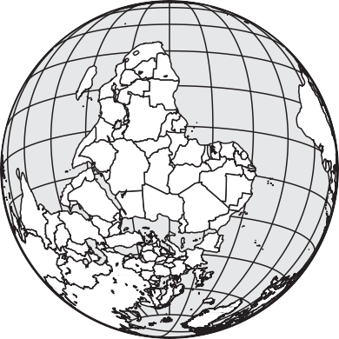

**CITIZEN OF HEAVEN**

NAME _ _ _ _ _ _ _ _ _ _ _ _ _ _ _ _ _ _ _ _ _ _ _ _ _ _ _ _ _ _ _ _ _ _ _ _ _ _ _ _ _ _ _ _ _ _ _ _ _ _ _

**Dictionary**

How do you say “hello” in…

Mexico _ _ _ _ _ _ _ _ _ _ _ _ _ _ _ _ _ _ _ _ _ _ _ _ _ _ _ _ _ _ _ _ _ _ _ _ _ _ _ _ _ _ _ _ _ _ _ _ _ _

Bolivia _ _ _ _ _ _ _ _ _ _ _ _ _ _ _ _ _ _ _ _ _ _ _ _ _ _ _ _ _ _ _ _ _ _ _ _ _ _ _ _ _ _ _ _ _ _ _ _ _ _

“WORLD” COUNTRY _ _ _ _ _ _ _ _ _ _ _ _ _ _ _ _ _ _ _ _ _ _ _ _ _ _ _ _ _ _ _ _ _ _ _ _ _ _ _

Haiti _ _ _ _ _ _ _ _ _ _ _ _ _ _ _ _ _ _ _ _ _ _ _ _ _ _ _ _ _ _ _ _ _ _ _ _ _ _ _ _ _ _ _ _ _ _ _ _ _ _ _ _

BIRTHDAY _ _ _ _ _ _ _ _ _ _ _ _ _ _ _ _ _ _ _ _ _ _ _ _ _ _ _ _ _ _ _ _ _ _ _ _ _ _ _ _ _ _ _ _ _ _ _

Rwanda _ _ _ _ _ _ _ _ _ _ _ _ _ _ _ _ _ _ _ _ _ _ _ _ _ _ _ _ _ _ _ _ _ _ _ _ _ _ _ _ _ _ _ _ _ _ _ _ _

BIRTHPLACE _ _ _ _ _ _ _ _ _ _ _ _ _ _ _ _ _ _ _ _ _ _ _ _ _ _ _ _ _ _ _ _ _ _ _ _ _ _ _ _ _ _ _ _ _ _

Ghana _ _ _ _ _ _ _ _ _ _ _ _ _ _ _ _ _ _ _ _ _ _ _ _ _ _ _ _ _ _ _ _ _ _ _ _ _ _ _ _ _ _ _ _ _ _ _ _ _ _

Egypt _ _ _ _ _ _ _ _ _ _ _ _ _ _ _ _ _ _ _ _ _ _ _ _ _ _ _ _ _ _ _ _ _ _ _ _ _ _ _ _ _ _ _ _ _ _ _ _ _ _ _

HEIGHT _ _ _ _ _ _ _ _ _ _ _ _ _ _ _ _ _ _ _ _ _ _ _ _ _ _ _ _ _ _ _ _ _ _ _ _ _ _ _ _ _ _ _ _ _ _ _ _ _

Russia _ _ _ _ _ _ _ _ _ _ _ _ _ _ _ _ _ _ _ _ _ _ _ _ _ _ _ _ _ _ _ _ _ _ _ _ _ _ _ _ _ _ _ _ _ _ _ _ _ _ _

WEIGHT _ _ _ _ _ _ _ _ _ _ _ _ _ _ _ _ _ _ _ _ _ _ _ _ _ _ _ _ _ _ _ _ _ _ _ _ _ _ _ _ _ _ _ _ _ _ _ _ _

India _ _ _ _ _ _ _ _ _ _ _ _ _ _ _ _ _ _ _ _ _ _ _ _ _ _ _ _ _ _ _ _ _ _ _ _ _ _ _ _ _ _ _ _ _ _ _ _ _ _ _ _

EYE COLOR _ _ _ _ _ _ _ _ _ _ _ _ _ _ _ _ _ _ _ _ _ _ _ _ _ _ _ _ _ _ _ _ _ _ _ _ _ _ _ _ _ _ _ _ _ _

Thailand _ _ _ _ _ _ _ _ _ _ _ _ _ _ _ _ _ _ _ _ _ _ _ _ _ _ _ _ _ _ _ _ _ _ _ _ _ _ _ _ _ _ _ _ _ _ _ _ _

13

HAIR COLOR _ _ _ _ _ _ _ _ _ _ _ _ _ _ _ _ _ _ _ _ _ _ _ _ _ _ _ _ _ _ _ _ _ _ _ _ _ _ _ _ _ _ _ _ _

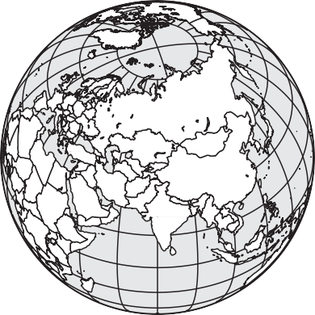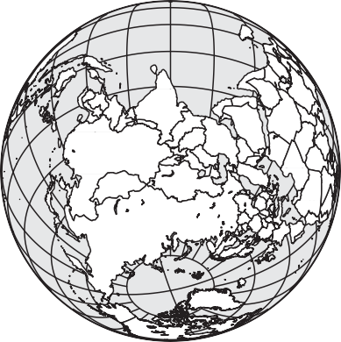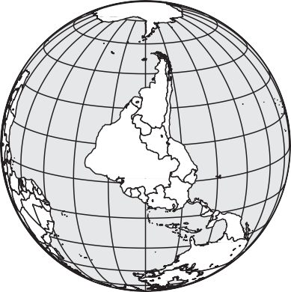

Country

Date visited _ _ _ _ _ _ _ _ _ _ _ _ _ _ _ _ _ _ _ _ _ _ _ _ _ _ _ _ _ _ _ _ _ _ _ _ _ _ _ _ _ _ _ _ _

**PASSPORT**

The holder of this passport, ,

is granted all rights, privileges, and duties as a full citizen of Christ’s Kingdom. He/she is commissioned with Jesus’ authority to go everywhere to tell the Good News to everyone, making disciples of all the nations.

12

1

draw or place your photo here

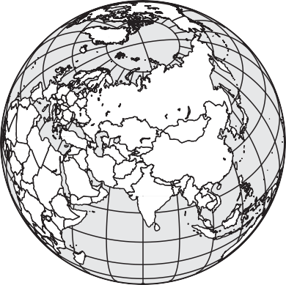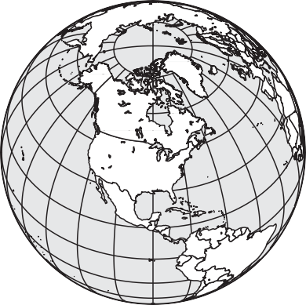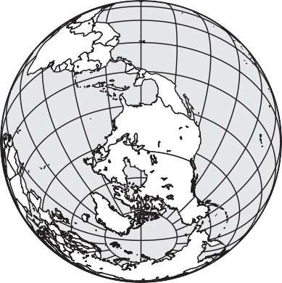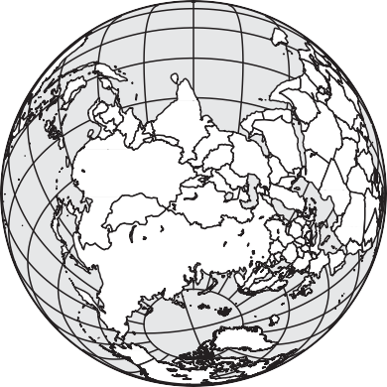

Country

Date visited _ _ _ _ _ _ _ _ _ _ _ _ _ _ _ _ _ _ _ _ _ _ _ _ _ _ _ _ _ _ _ _ _ _ _ _ _ _ _ _ _ _ _ _ _

Country

Date visited _ _ _ _ _ _ _ _ _ _ _ _ _ _ _ _ _ _ _ _ _ _ _ _ _ _ _ _ _ _ _ _ _ _ _ _ _ _ _ _ _ _ _ _ _

2

11