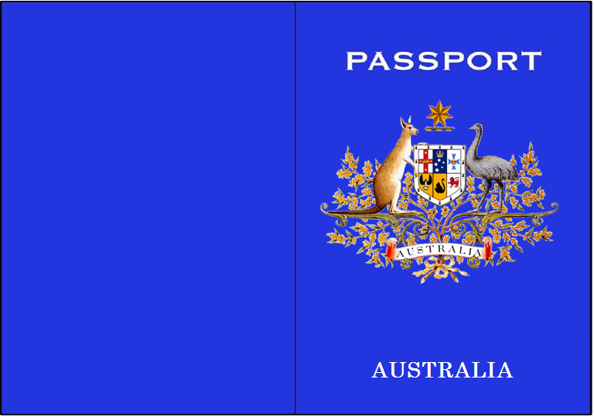

**PHOTO**

**Passport**

**Surname:**

**Given Name:**

**Nationality:**

**Gender:**

**Date of Birth:**

**>>>>239>>>>>>>>>>>>>>>>>>>>>>>>>>>>>>>>>>>>>>>WG29110800734459Y4>>>>>>>>>>>>>>>>>>>>>>**

1

2

3

4

5

6

7

8

9