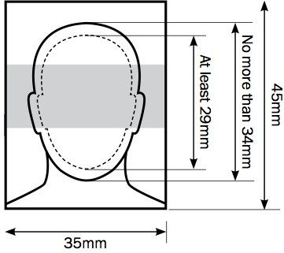

**THAILAND VISA PHOTO REQUIREMENT**

-

Photos must be professionally printed and 45 millimetres (mm) high by 35mm wide

in colour on plain white photographic paper taken against a plain cream or white background identical

taken within the last month clear and in focus

without any tears or creases

unmarked on both sides (unless a photo needs to be countersigned) unaltered by computer software

-

-

-

-

-

-

-

-

**The image of you**

Your photos must show a close-up of your full head and shoulders. It must be only of you with no other objects or people.

The image of you - from the crown of your head to your chin - must be between 29mm and 34mm high (see example below).

**Your photos may be rejected unless they show you:**

facing forward and looking straight at the camera with a neutral expression and your mouth closed without anything covering the face

in clear contrast to the background

without a head covering (unless it’s worn for religious or medical reasons)

with eyes open, visible and free from reflection or glare from glasses with your eyes not covered by sunglasses, tinted glasses, glasses frames or hair

without any ‘red eye’

without any shadows in the picture

•

•

•

•

•

•

•

•

•

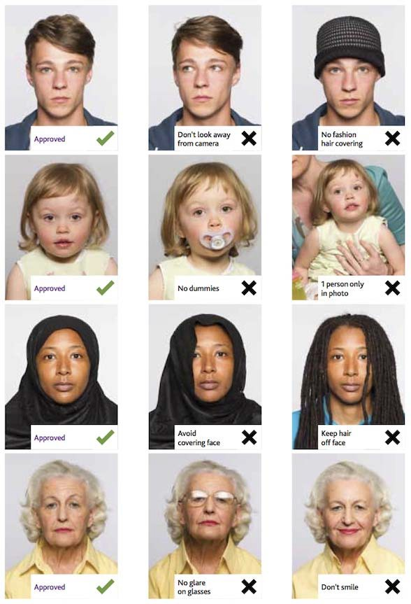

**Photos of children**

Children must be on their own in the picture. Babies must not be holding toys or using dummies.

Children under 6 don’t have to be looking directly at the camera or have a neutral expression.

Children under 1 don’t have to have their eyes open. If their head is supported by a hand, the hand mustn’t be visible in the photo.

**Photo Examples**