

**Passport Photo Guidance**

Passport photos are a vital part of your application. If the photos you supply are not suitable, your passport will be delayed. Please follow the instructions below carefully so you can get it right first time.

Photo style

The photo must be of the applicant:

Photo quality must

•

be taken against a plain cream or plain light- grey background

be printed to a high quality, such as photos printed by a booth or studio (photographs printed at home are unlikely to be of a high enough quality)

be clear and in sharp focus be taken within the last month

be in colour on plain white photographic paper

not be torn, creased, or marked, and

not have any writing on the front or back

– except when one of the photos needs to be certified.

•

facing forward and looking straight at the camera

in close-up of their face, head and shoulders with a recommended head height (the distance between the bottom of the chin and the crown of the head) of between 29 and 34 millimetres

with a neutral expression and with the mouth closed (no smiling, frowning or

raised eyebrows)

with their eyes open and clearly visible (no sunglasses or tinted glasses and no hair across the eyes)

free from reflection or glare on glasses, and frames must not cover eyes (we recommend that, if possible, glasses are removed for the photo)

showing their full head, without any head covering, unless they wear one for religious beliefs or medical reasons

with no other objects or people in the photo (this also applies to a photo of a baby or young child and babies should not have toys or a dummy in the photo)

without shadows on the picture

without anything covering the face – nothing should cover the outline of the eyes, nose or mouth, and

not showing any ‘red-eye’.

•

•

•

•

•

•

•

•

•

Children

Children aged five and under do not need to have a neutral expression or to look directly at the camera. Babies under one don’t need to have their eyes open. If the baby’s head needs to be supported, the supporting hand must not be seen. All other photograph standards must be met.

•

•

•

•

•

•

Photo size must

* be 45 millimetres high x 35 millimetres wide, the standard size used in photo booths in the UK (if you are outside the UK not all photo booths use this standard size), and
* not be trimmed or cut down from a larger photograph to the size of a standard passport photograph.

35mm

45mm

No more than 34mm

At least 29mm

**Tip**: Place your photos in this guide to help check they are the correct size

before sending

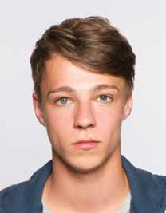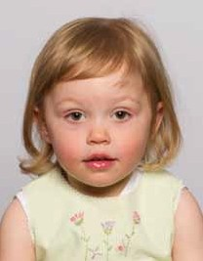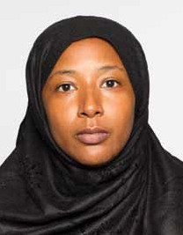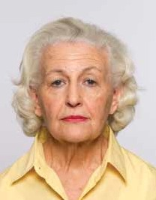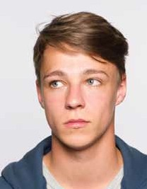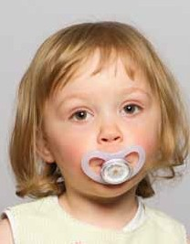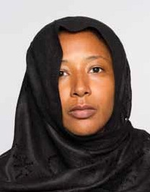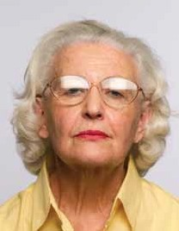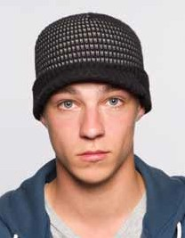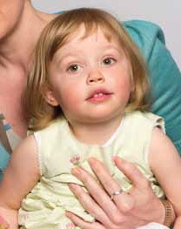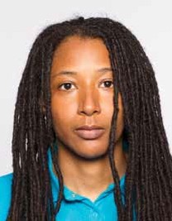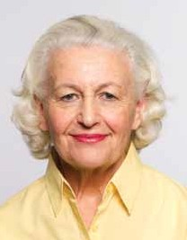

Dont look away from camera

No fashion hair covering

Approved

1 person only in photo

Approved

No dummies

Avoid covering face

Keep hair off face

Approved

No glare on glasses

Approved

Don't smile