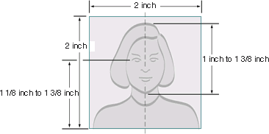

PASSPORT PHOTO REGULATIONS

***To process your application, you are required to provide a recent passport – style photograph(s). Many embassies are very particular regarding the quality of photos provided. A bad quality photo can and will delay your visa application.***

•

•

•

•

Make sure the photo presents the full head from the top of the hair to the bottom of the chin Center the head with the frame

The person in the photo should have a neutral expression and be facing the camera

Photo must be recent – taken within the last six months

**Paper Photo Head Size Template**

•

* Photo must be 2 inches by 2 inches
* The height of the head (top of hair to bottom of chin) should measure 1 inch to 1 3/8 inches (25 mm - 35 mm)
* Make sure the eye height is between 1 1/8 inches to 1 3/8 inches (28 mm – 35 mm) from the bottom of the photo

**Well Composed Photo Composition Examples**