PASSPORT PHOTOGRAPH GUIDELINES

SIZE
Two identical photographs must be submitted, no more than six months old, to ensure an up to date likeness. They should be 45 – 50 mm in height and 35 – 38 mm in width. They should show a close up of your face and the top of your shoulders so that your face takes up between 70% - 80% of the frame.
PHOTOGRAPH CHECK
(A.) Minimum photograph size 35mm x 45mm (B.) Maximum photograph size 38mm x 50mm
To check the facial dimensions place the photograph under the plastic template below.
3. Check that your head height (top of your crown through the hairline) falls between
lines D and E.
B
A D
E
- Place your photograph under the plastic template.

- Exactly align the base of the chin with line C.
max 36mm min 32mm

POSE

The head should be centred in the image. A frontal pose looking directly at the camera and showing full face must be used and should be taken against a plain white, cream or light grey background. There should be a marked contrast between your facial features and the background of the photographs. Rotation or tilting of the head either in an up/down or left/right direction must be avoided.
C

EXPRESSION
The expression should be neutral with both eyes open and mouth closed. There should be no hair covering the eyes. Contrived expressions such as raised eyebrows, squinting or frowning are not acceptable.
IMPORTANT NOTICE
PHOTOGRAPHS WHICH DO NOT MEET THE ABOVE STANDARDS
WILL NOT BE ACCEPTED AND THIS WILL DELAY THE ISSUE OF YOUR PASSPORT.
GLASSES. HEAD COVERS AND CLOTHING

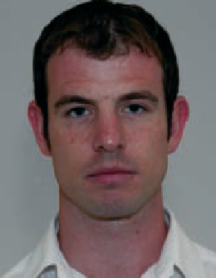
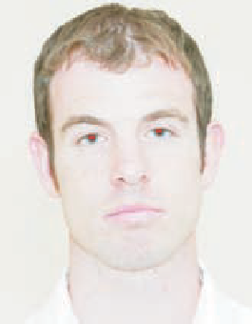
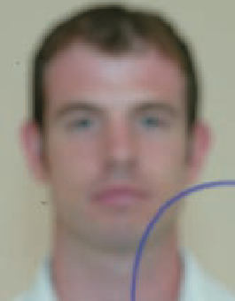
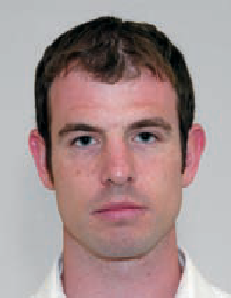
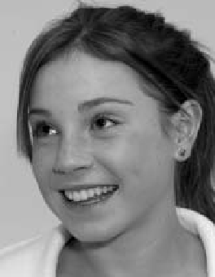
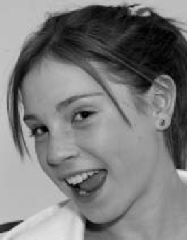
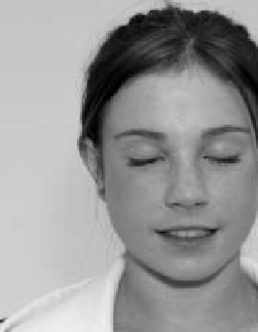
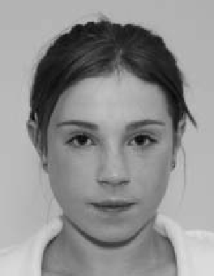
If glasses are worn they should be of clear glass so that the eyes are clearly visible. Only head coverings worn for religious reasons are permitted. Uniforms, civil or military, (e.g. showing epaulettes, insignia) should not be worn. Your facial features from bottom of chin to
1a
Image too dark.
1b
Image too bright. Red eye.
1c
Image blurred. Ink marks.
1d
Image correctly lit. In focus, no marks.

2a
Head and eyes facing away.
2b
Mouth open. Head tilted.
2c
Eyes closed. Image not centred.
2d
Neutral expression, centred. Looking at camera.
top of forehead and both edges of your face must be clearly shown.

INFANTS
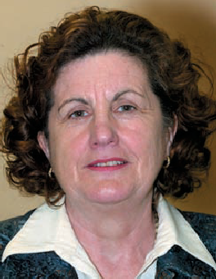
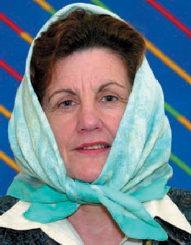
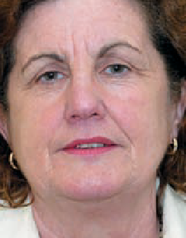
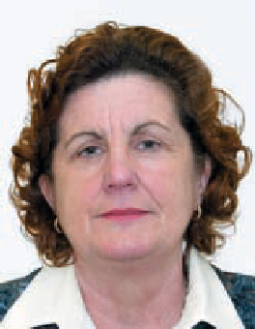
Infants or very small children who are unable to support themselves should be photographed lying down. Hands, arms, etc. used to support the child should not be visible.
3a
Shadow behind head.
3b
Head covering. Background not plain.
3c
Too close. Part of image outside frame.
3d
Plain background, full image in frame, head not covered.

LIGHTING & FOCUS

The photograph must be in sharp focus and correctly exposed. There should be no shadows or glare on the image or background. The photograph must have a good colour balance and natural flesh tones, and no ‘Red Eye’.

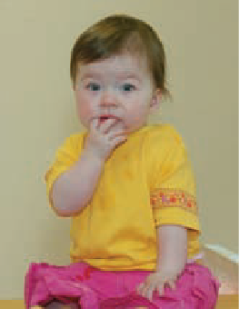
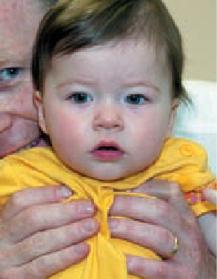
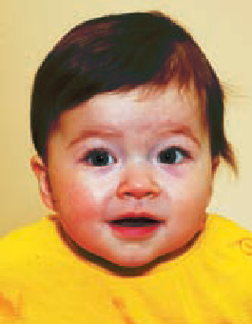
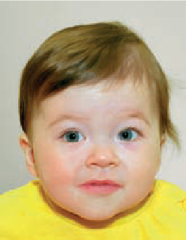
PHOTOGRAPH QUALITY
4a
Too far away.
4b
Hands in foreground. Face in background.
4c
Unnatural skin tones.
4d
Natural skin tone, correct size in frame, no hands.

Your photograph will be digitally printed onto the passport in black and white. We would recommend that black and white photographs are submitted, though colour is also acceptable. Photos submitted must be printed on high quality paper, at a high resolution and with no ink marks or creases. If a digital camera is used, photographs must be printed on photo-quality paper. Reverse of photograph must be white and unglazed.

FURTHER INFORMATION

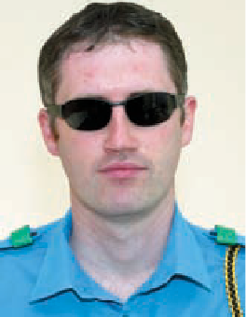
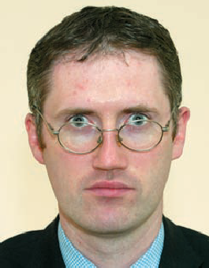
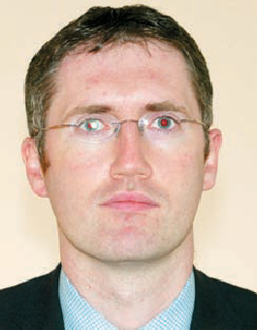
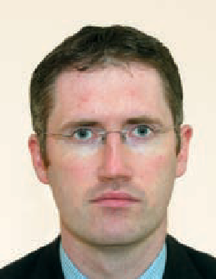
For further passport information visit our website at:
5a
Dark glasses, uniform.
5b
Frames across eyes.
5c
Reflection on lens.
5d
Good.

www.passport.ie

PERSONS WITH DISABILITIES WHO CANNOT COMPLY WITH ANY OF THE ABOVE REQUIREMENTS SHOULD CONTACT THE PASSPORT OFFICE FOR FURTHER ADVICE.
(08/06)

