Passport photo guidelines

Finland introduced new requirements for passport photos on 21 August 2006. The new requirements are based on the standards set by the International Civil Aviation Organization, an agency of the United Nations. The aim of these requirements is to standardise passport photos and improve the verification of passport holders’ identities. The revised requirements support the new biometric passports in particular, because the digital facial image stored on the passport chip will be used later in automatic face recognition.

The photos attached to passport applications must conform to the requirements described here.

This booklet is also available in HTML format at http://www.police.fi/passport/photoguidelines.

The guidelines are divided into six categories:

General characteristics: Photo dimensions and other general guidelines. (p. 2) | Background: Requirements for the photo background and children's passport photos. (p. 5)
Position: Guidelines on the position of the subject. (p. 3) | Lighting: Position and intensity of lighting. (p. 6)
Expressions and accessories: Guidelines on facial expressions, glasses and head coverings. (p. 4) | Technical characteristics: Requirements for the print quality and other technical characteristics of the photo. (p. 7)

A list of frequently asked questions can be found at the end of this document.

General characteristics

This page describes the requirements for the dimensions and other general characteristics of the standard passport photo.
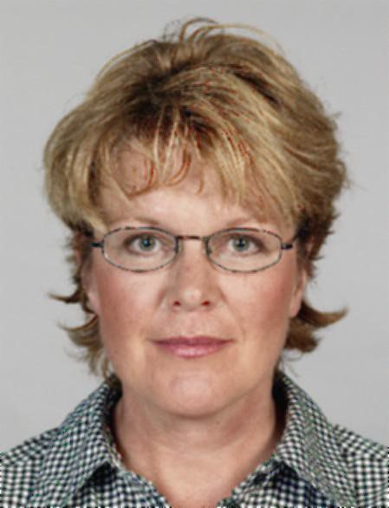

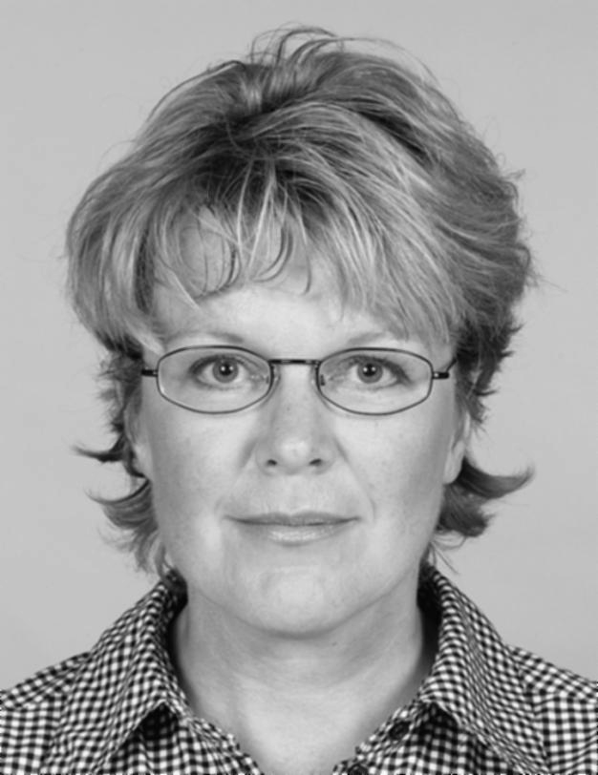

correct 2) correct

  - Both monochrome and colour photos are acceptable.
  - The photo attached to a passport application must not be older than six (6) months.

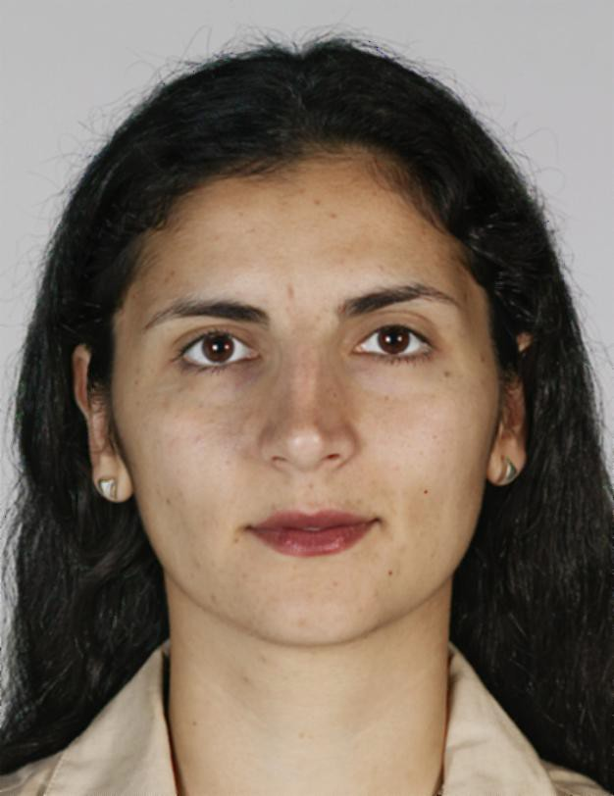

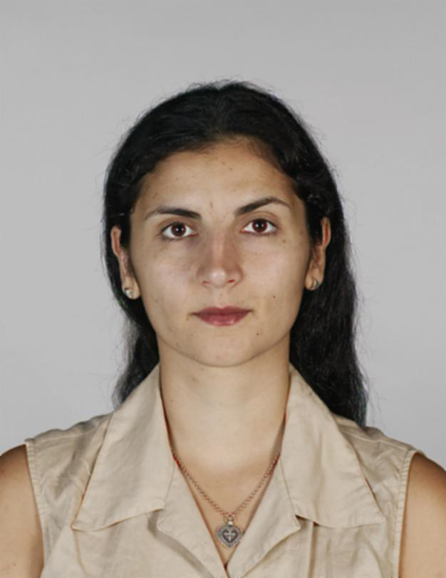

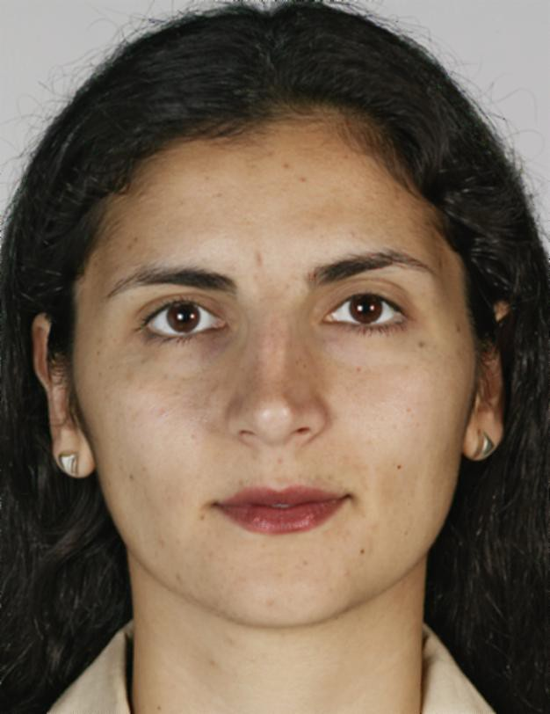

3) correct 4) incorrect:
too far away

incorrect:
too close
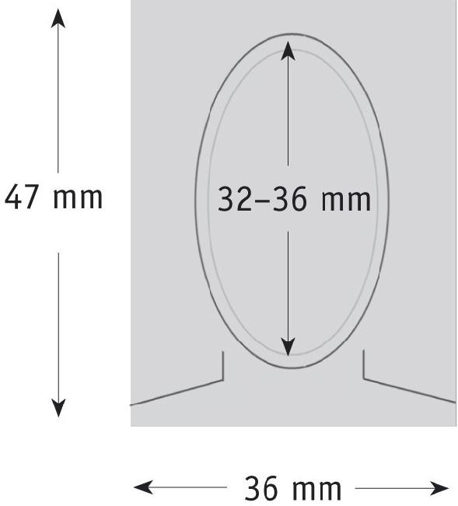

  - The photo must be 47mm high and 36mm wide. The distance between the top of the head without hair and the bottom of the chin must be 32-36mm in the photo.
  - For children younger than 11 years old, a photo with a smaller head size is acceptable if blurring or other distortion cannot otherwise be avoided. In such photos, the height of the head must still be at least 25mm.
  - If the subject has a large volume of hair, it is essential to make sure that in the photo the distance between the bottom of the chin and the top of the head corresponds to the values given above.

Position of the subject

This page describes the requirements for the position of the subject. The photo must show a full front view of the subject’s face with the head centred and both the face and the shoulders turned straight towards the camera.
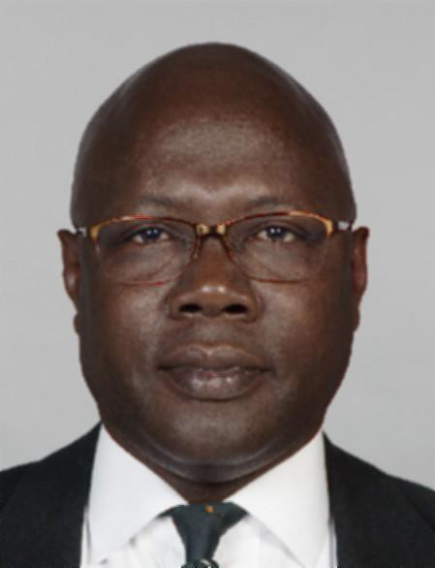

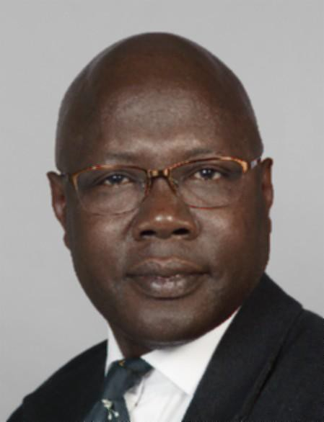

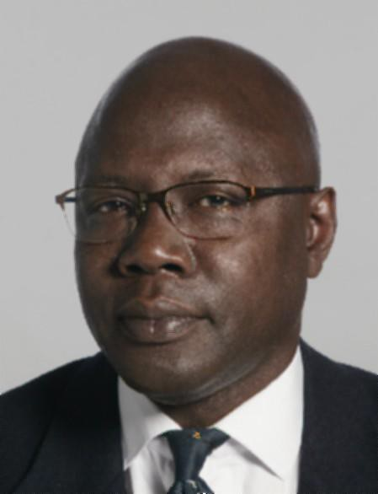

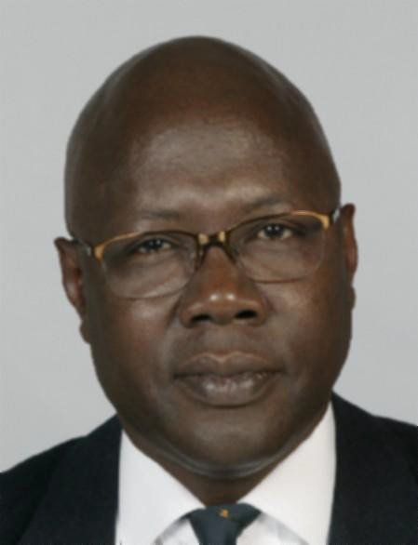

1) correct 2) incorrect:
shoulders askew

incorrect:
head sideways

incorrect:
head tilted

  - The head must be straight and in the middle of the photo.
  - Both the head and the shoulders must be turned straight towards the camera. Portrait-style photos where the subject looks over one shoulder are not acceptable.
  - The photo must be taken straight from the front, not from higher up, lower down or from the side.
  - The subject must look straight at the camera.

Expressions and accessories

This page describes the requirements for facial expressions, head coverings and glasses. The main principle is that the photo must show the subject’s full face, with eyes open and clearly visible.
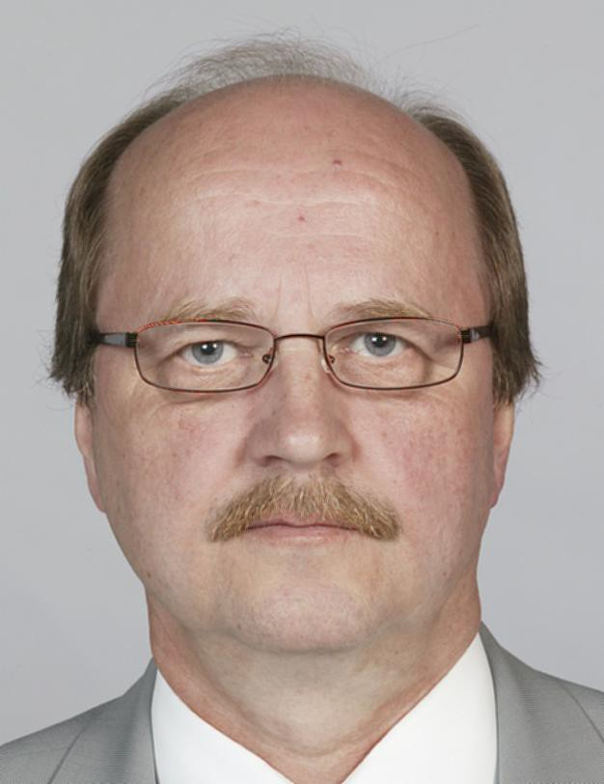

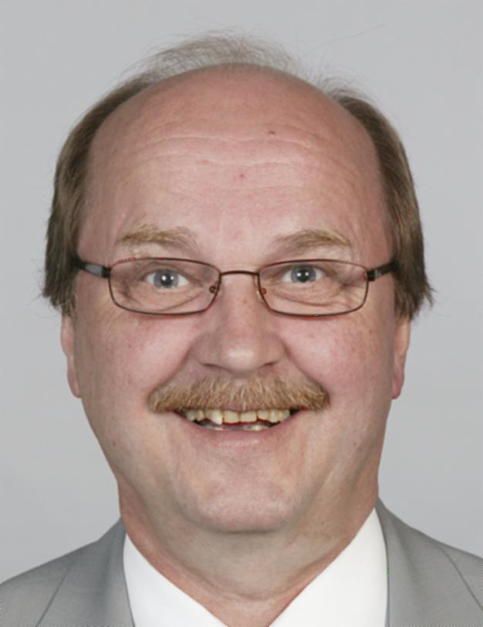

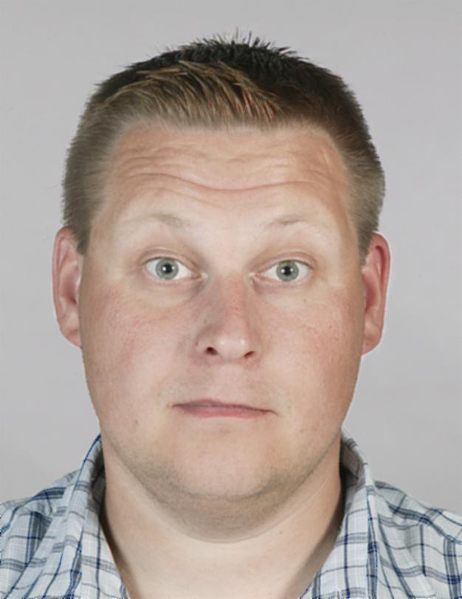

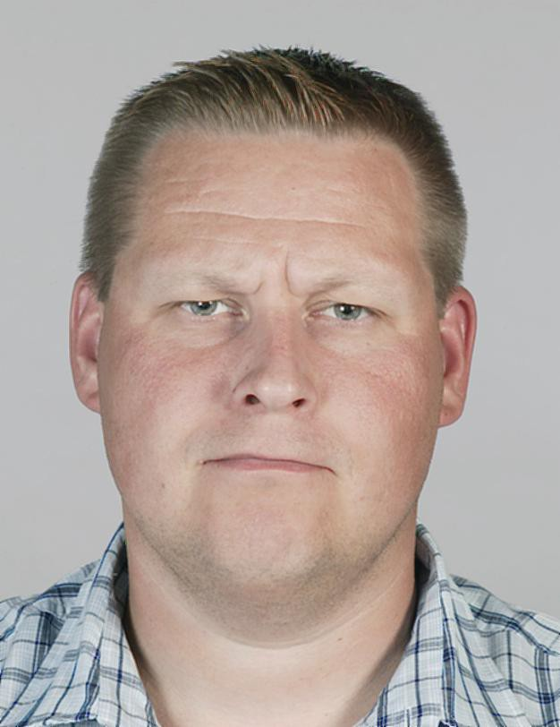

1) correct 2) incorrect:
mouth open

incorrect:
raised eyebrows

incorrect:
squinting

  - The expression must be neutral.
  - The mouth must be closed.
  - The eyes must be open and clearly visible.

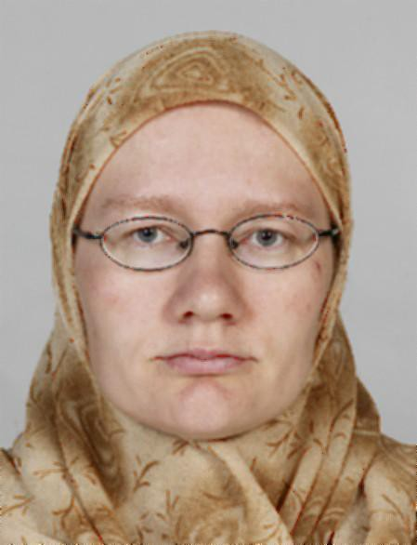

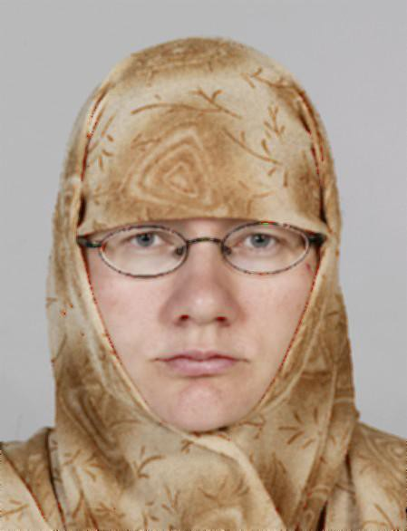

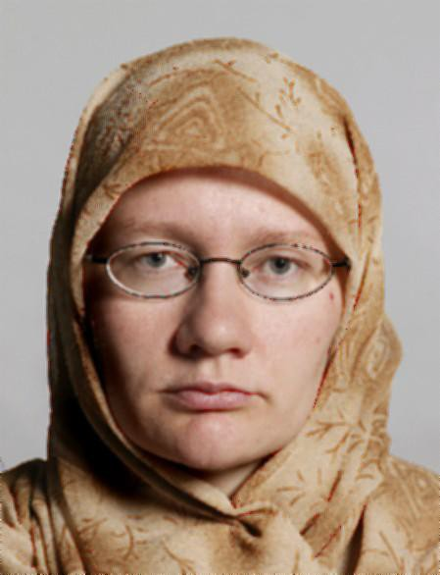

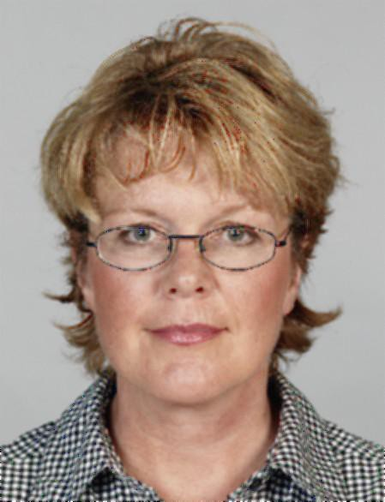

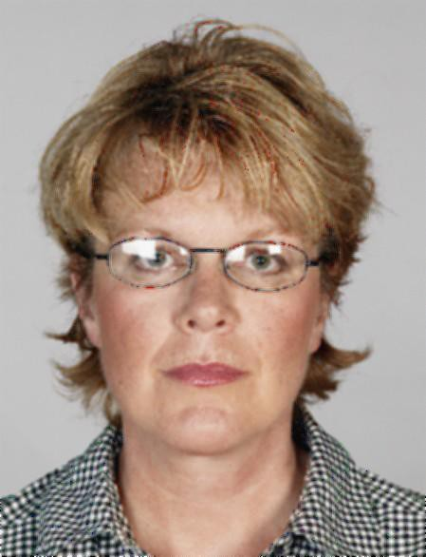

- correct 6) incorrect: forehead covered
- incorrect: shadows across face
- incorrect: frames covering eyes
- incorrect: reflections on glasses

  - The photo must show the subject’s full face; e.g. garments or hair must not cover any part of the face. Particularly eyes must be clearly visible. Sample picture 8 shows the frames partially covering the eyes, and in sample picture 9, the eyes are concealed by the light reflected from the glasses. Glasses can always be removed for the photo.
  - Tinted glasses and eye patches are allowed only for medical reasons.

Background

This page describes the requirements for the photo background and children's passport photos.
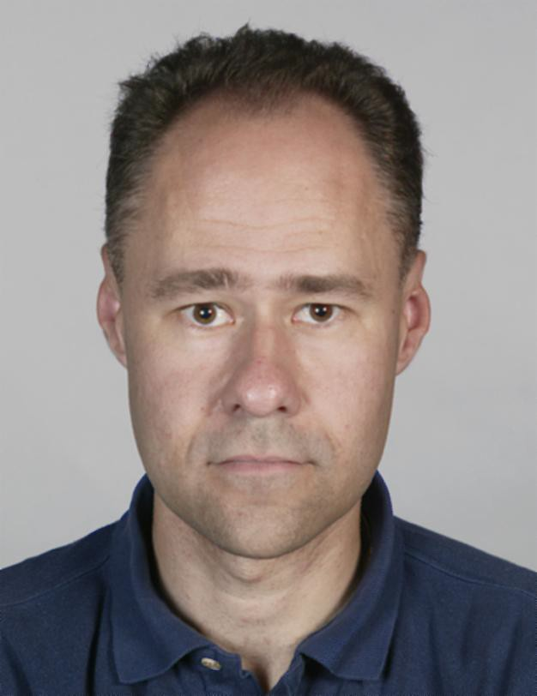

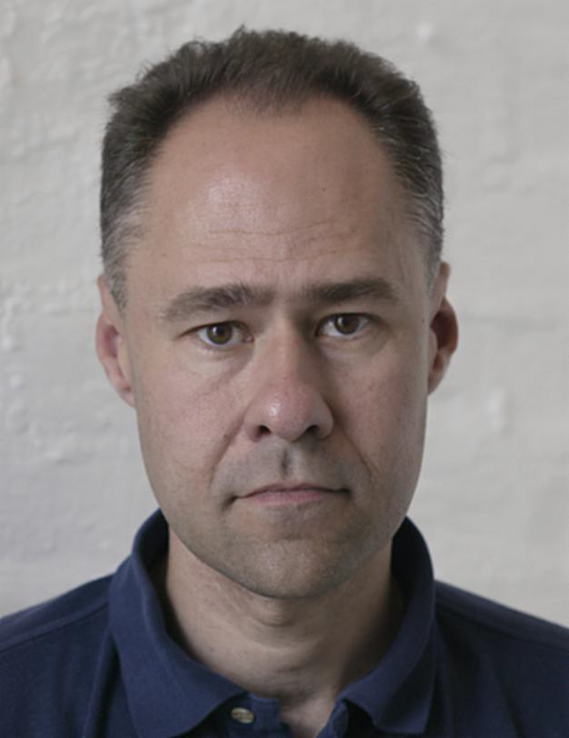

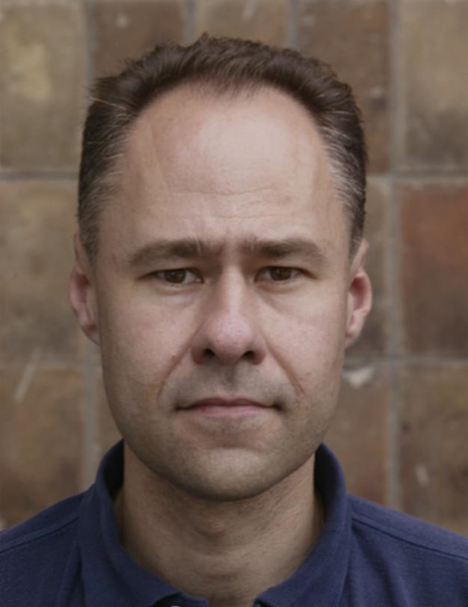

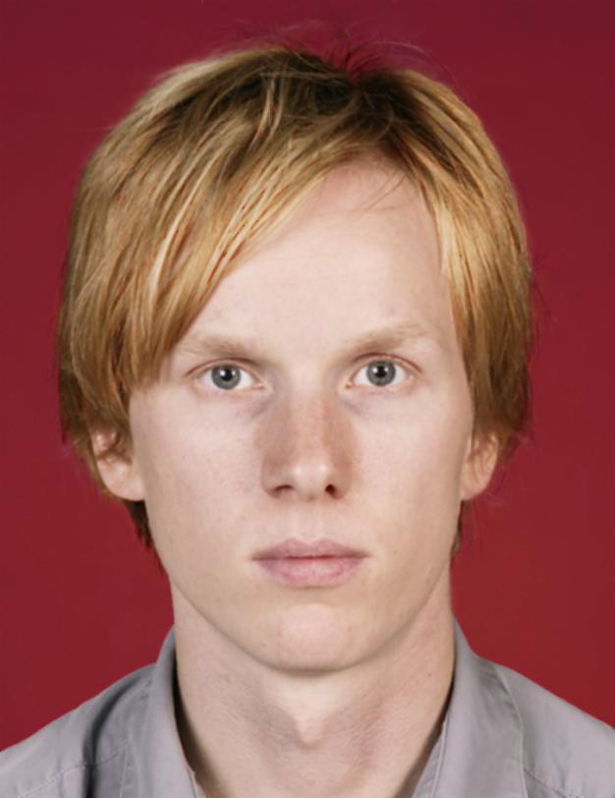

1) correct 2) incorrect:
- incorrect:
- incorrect:

uneven background
busy background dark background

  - The photo must be taken against a plain background.
  - The colour of the background must be neutral and light.
  - There must be no shadows in the background.
  - The face must be clearly distinguishable against the background.

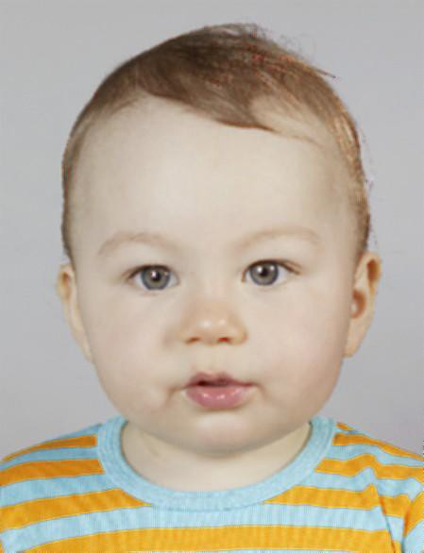

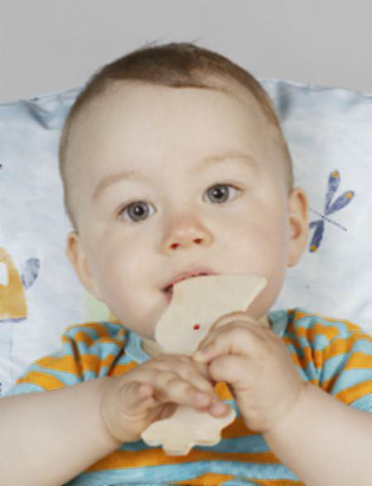

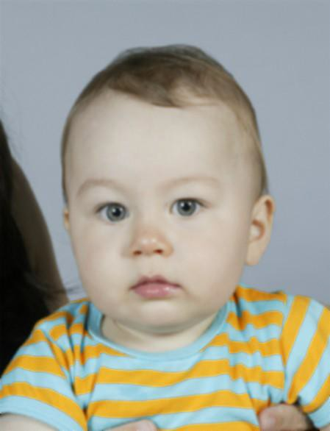

correct 6) incorrect:
toy, pillow visible
- incorrect: shows another person

  - Other people or objects must not be visible in the photo. A small child may be supported, but no part of the supporter is to be visible.
  - For children younger than 11 years old, a photo with a smaller head size is acceptable, if blurring or other distortion cannot otherwise be avoided. In such photos, the height of the head must still be at least 25mm.

Lighting

This page describes the requirements for the position and intensity of lighting.
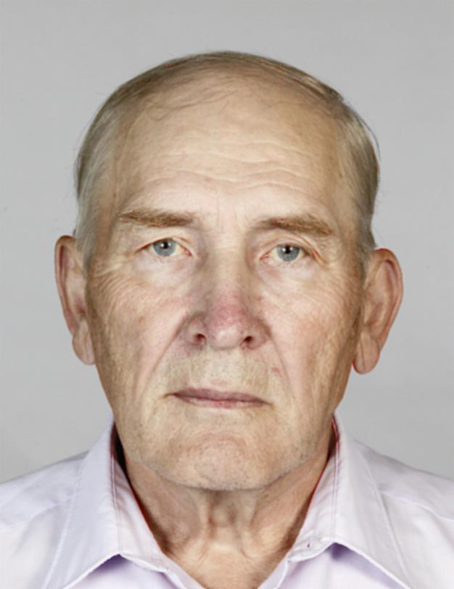

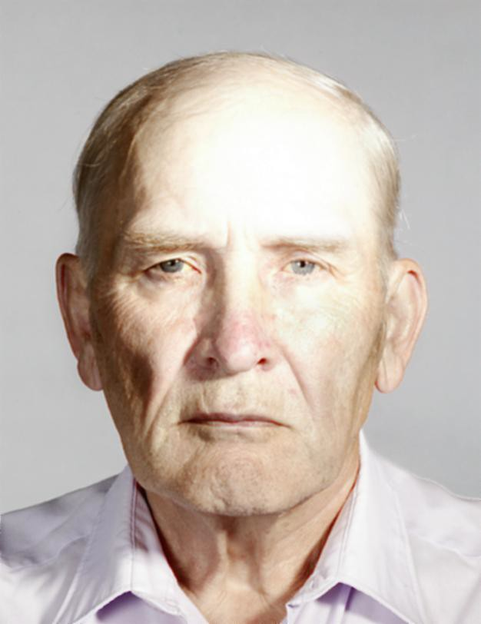

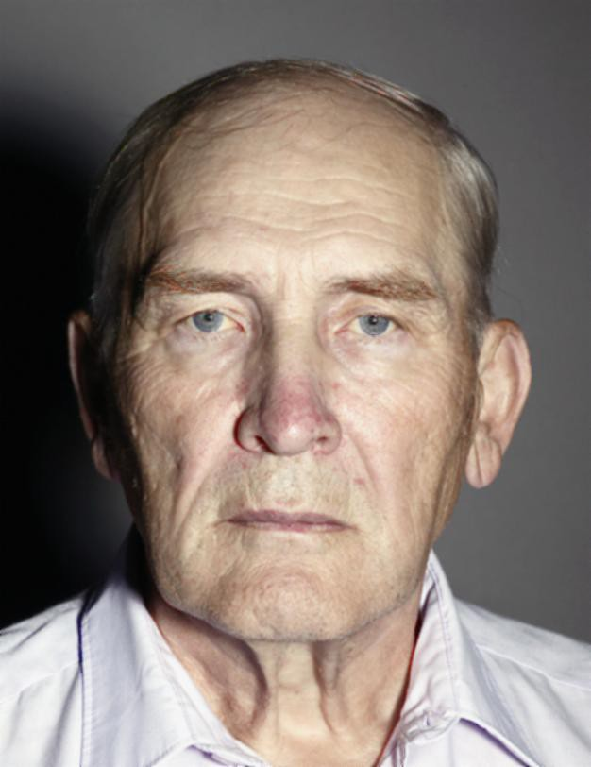

1) correct 2) incorrect: hot spot on the forehead
- incorrect: directional light, shadow

  - The lighting must be uniform: the face and the background must be free of shadows and hot spots.
  - The red-eye effect must be prevented.
  - The colour of the lighting must be natural, not bluish or reddish, for example.

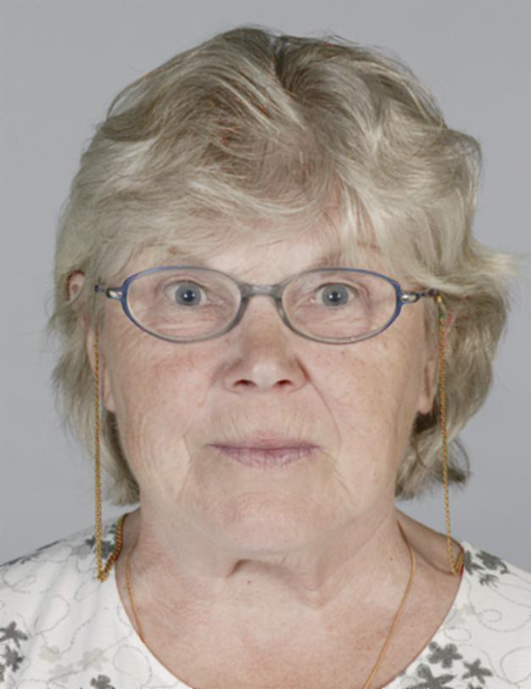

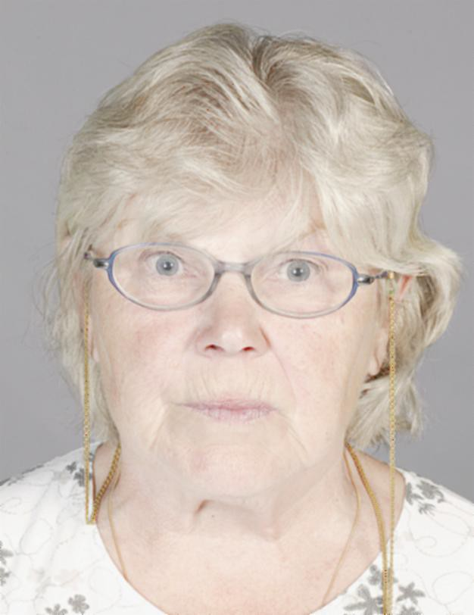

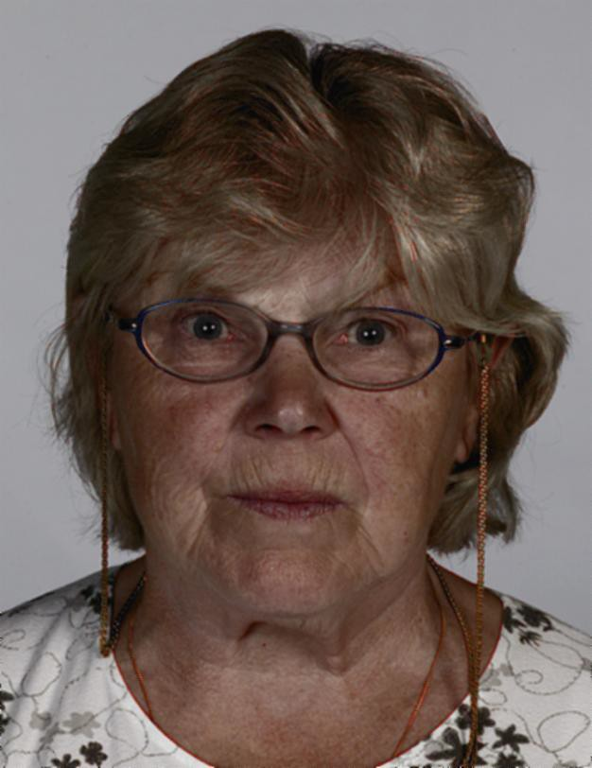

correct 5) incorrect:
overexposed

incorrect:
underexposed

  - The photo must not be over- or under-exposed.

Technical characteristics of the photo

This page describes the requirements for the print quality and other technical characteristics of the photo.
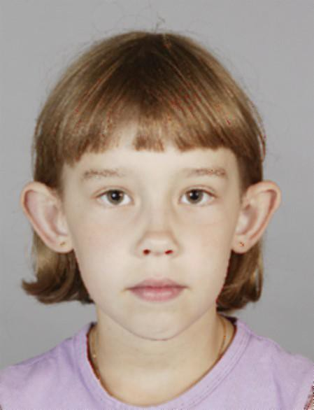

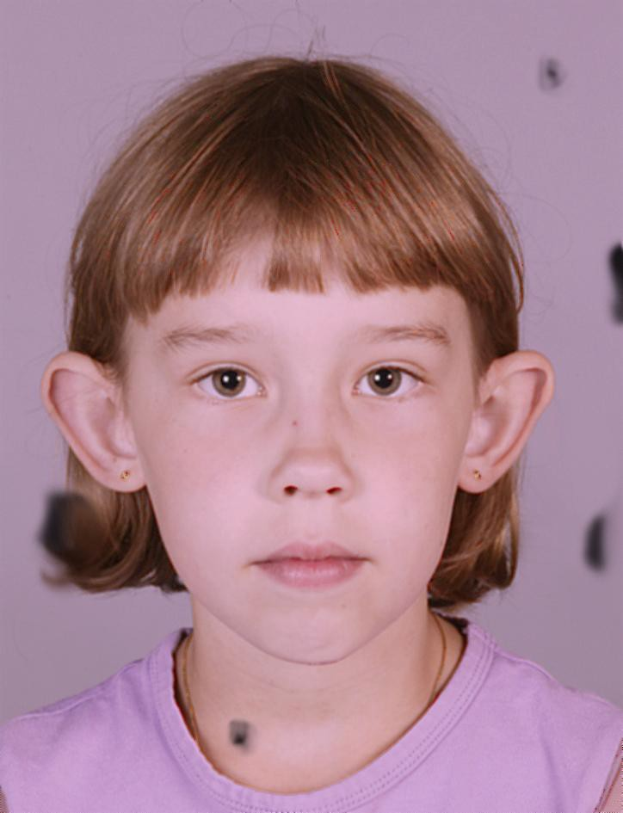

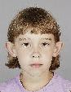

1) correct 2) incorrect: unnatural colour, stains

incorrect:
grainy

  - The photo must be printed on high-quality photograph paper.
  - The photo must be sharp and in focus; it must not be blurred or grainy.
  - The photo must be clean: no scratches, stains or creases are allowed.
  - No manipulation or retouch of the photo is allowed.

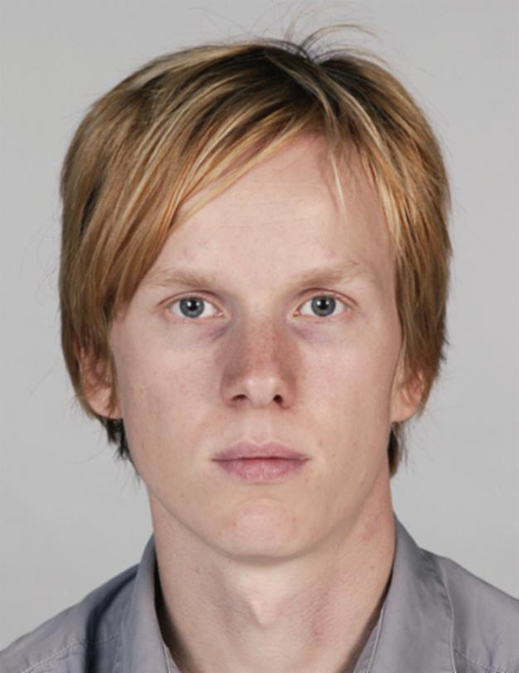

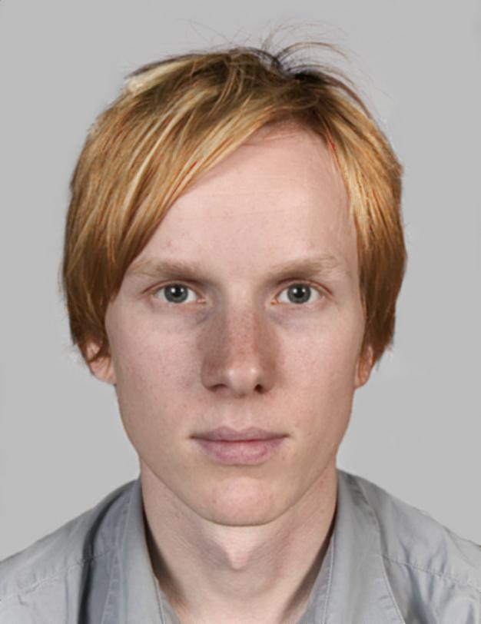

correct 5) incorrect:
optical distortion

  - Optical and other distortions of the dimensions of the face that impede visual or automatic identification are not allowed.

Frequently asked questions

Does the passport photo have to be exactly 36mm x 47mm in size?

The minimum size requirement is 36mm x 47mm, and photos which do not comply with this requirement cannot be accepted. Photographic studios have various tools for cutting out driving licence sized photos (35mm x 45mm), but unfortunately this size is too small. The photo area (i.e. the photo background) may be bigger as long as the head in the photo is of the right size. Extra space around the head only makes it easier to scan the photo. In fact, it can often be useful to leave the edges of the photo intact.

What is the required width of the face in the photo?

There is no separate requirement for face width, only for height. If the face height fulfils the requirements, there is no need to pay attention to face width.

Is it necessary to leave extra space above the head in the photo?

There is no separate mention of this in the passport photo guidelines but this is apparent from the current standards. First of all, the head must be in the middle of the photo as stated in the passport photo guidelines. The maximum head size in the photo is 36 mm and the minimum height of the photo 47 mm; thus, there is at least a total of 11 mm of space below and above the head (without hair). This means that in principle there should be about 5.5 mm of space above the head. Typically, the head in the photo is, however, a little closer to the top of the photo than to the bottom of the photo, and it is acceptable that these measures vary slightly. As far as scanning is concerned, it is enough that the distance between the top of the head and the top of the photo is 3-4 mm. The same applies to the distance between the bottom of the chin and the bottom of the photo.
It is worth bearing in mind that hair is not included when estimating the space above the head. The distance is measured between the top of the photo and the top of the head without hair. However, hair may cover the space between the top of the head and the top of the photo, so in that sense no empty space above the head is required.

Are there tools for measuring photos?

The template below can be used for measuring passport photos. It can be printed on a transparency. There are four figures side by side in the template: 1) the minimum and maximum size of the head of an adult, 2) the minimum and maximum size of the head of an under 11-year-old, 3) the minimum size of a passport photo, and 4) the maximum size of a passport photo. A photo can be measured by putting the transparency on it. Before using the template, it is worth ensuring that it has been printed out in the right size.

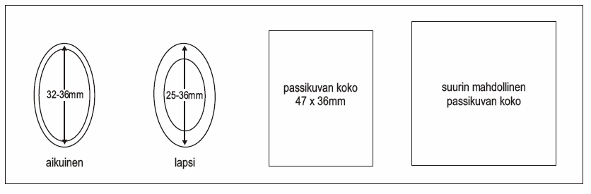

A passport photo cutter rounds the corners of the photo. Is this acceptable?

If the size of the photo exceeds the minimum requirement (36mm x 47mm), rounding does not usually cause any problems. If the photo is exactly 36mm x 47mm in size, rounding must be performed moderately. Losing a few square millimetres of the photo surface does not cause any problems. However, a greater rounding may result in shadows on the photo stored on the passport chip, and thus disturb automatic face recognition.

The person to be photographed has a large volume of hair. Does the photo have to show all the hair?

No, it does not, and the same applies to long beards. What is essential is the height of the head in the photo; it must be 32mm to 36mm without hair (for children under 11 years of age, 25mm to 36mm). The height of the head is measured from the bottom of the chin to the top of the head. If the person’s hair or beard obscures the outline of the head, the position of the chin and top of the head must be estimated.

Is it permissible to wear a wig in a passport photo?

A wig can be worn if the person wears it daily, for example for medical reasons. The same rules apply to a wig as to real hair. Thus, the wig must not cover the face and, most importantly, the eyes.

Can I wear heavy makeup or large pieces of jewellery in the passport photo?

It is impossible to provide comprehensive guidelines on makeup. What is important is that the person concerned can be clearly identified from the photo. This can only be judged on a case- by-case basis.

Eyeglasses cause reflections that cannot be removed. What should I do?

We advise removing your glasses when having your photo taken.

The person to be photographed is not able to hold his/her head in an upright position due to an illness or an injury. How should a passport photo of him/her be taken?

The photo requirements can be relaxed on medical grounds. In this case, we ask that as good an image as possible is captured so that the person can be identified from the photo.

Do both ears have to show in the photo?

The subject in the photo must be looking straight into the camera. Sometimes the visibility of ears can help to assure that the subject is looking straight ahead but we cannot insist that both ears are equally visible, as it may be that one ear is further back or smaller than the other.

The guidelines specify that the photo must be printed on high-quality photograph paper. What does this mean?

There are several types of high-quality paper on the market that are specifically designed for printing photographs on an inkjet printer. High-quality photograph paper is more compact

(dense) and thicker than normal printer paper. If the paper is porous or uneven, the sharpness of the photo will be compromised. The paper does not have to be photograph paper; what matters is that it fulfils the specified requirements.

When the photo was scanned, damp looking patches appeared in it, although the patches are not visible in the original photo. What causes this?

Patches appear in certain photograph papers when they are subjected to mechanical pressure. This problem is easily solved. If patches appear, a thin piece of cardboard (of about the same thickness as the leaflet on passport photo requirements) or something similar should be placed between the photo and the scanner; this helps to spread the weight of the scanner’s lid over the glass and to prevent the lid from pressing the photo too hard.

Which is better, a matt or a glossy finish?

Both are equally acceptable.

What kind of background is the best?

The best background colour is relatively light grey. Problems usually arise if the shirt or the skin of the subject happens to be equally light or dark as the background, because it will then not be possible to tell them apart in a monochrome photo. If the original photo is in colour, it will be stored on the passport chip in colour, but on the passport’s photo page all photos will appear in monochrome. We do not recommend a completely white background. The best background is one that makes both the face and the subject’s clothing stand out clearly.

