

Humble ISD
Professional
Development Plan

2014-2017

Based on work of the Professional Development Task Force from September 2010 to May 2011 and the Professional Development Advisory Committee from 2014-2016.

Approved August 2014
Revised January 2016

Revised March 2016
Humble ISD
Professional Development Plan

Table of Contents

Introduction 5

District Vision Statement 5

District Mission Statement 5

District Goals 5

Professional Development Mission Statement 5

Professional Development Belief Statements 5

HISD Definition of Professional Development 5

Learning Designs for Results Driven Professional Development 6

Levels of Professional Learning 7

Theoretical Basis of Professional Learning 7

School Board Policy Governing Professional Learning 8

Professional Development Requirements for All Employees 8

Professional Development Requirements for Teachers 8

Professional Development as a Component of Annual Teacher Appraisal 8

Teacher Curriculum Professional Development Cycle for Content Areas 9

Professional Development Requirements for New to District Teachers 10

Professional Learning Communities (PLC) 10

Expected Characteristics of Professional Development Communities 10

Professional Development Advisory Committee 11

Long-Term District Professional Development Initiatives 11

Professional Development Plan Components and Format 12

Professional Development Department Roles and Responsibilities 12

Humble ISD Professional Development Presenter Academy 15

Required Planning, Monitoring and Evaluation of Professional Learning 16

Needs Assessment for Professional Development Planning 16

Planning for Professional Development 17

Funding for Professional Development 17

Campus/Department Supervisor Responsibilities 17

Approval Process for Campus/Department Professional Development 18

Assigning Credit to Professional Development Sessions 18

Implementation of Teacher Professional Development 20

Tools for Monitoring the Taught Curriculum 20

Rev. 4/1/2016 1 | P a g e
Humble ISD
Professional Development Plan

Evaluation of Professional Development 20

Professional Development Plan for Technology Integration 21

Essential Conditions 21

Stages of Technology Integration Supported by Professional Development 21

Professional Development for Principals 22

Professional Development for Teachers, ALTS, Librarians or Media Specialists 22

The Technology Integration Matrix Table of Teacher and Instructional Settings Descriptors 22

Rigorous and Relevant Learning 27

Atomic Learning 29

Continuum of Development by Department 29

Appendices 30

Appendix 1: Learning Forward Standards for Professional Learning 31

Appendix 2: CMSi Characteristics of a Comprehensive Professional Learning Plan 32

Appendix 3: HISD Professional Development Session Evaluation 33

Appendix 4: Planning Framework 34

Appendix 5: Evaluation Framework 35

Appendix 6: Professional Development Continuum by Department 36

Appendix 7: District Level Professional Development Initiatives, 2013-2016 57

Appendix 8: Example of Professional Development Plan from TOP Evaluation System 60

Appendix 9: Lead4Ward Webinar Schedule 69

Appendix 10: Example of Department Professional Development Planning Memo 70

Appendix 11: Professional Development Advisory Committee Charter 76

Purpose of the Professional Development Advisory Committee 77

Long-Term District Professional Development Initiatives 77

Executive Summary 78

Project Overview 78

Advisory Committee Organization Plans 79

Rev. 4/1/2016 2 | P a g e

Humble ISD
Professional Development Plan

Professional Development Advisory Committee Members 2014-2018

Member Name | Position
Janice Johnson | Elementary Teacher – Woodland Hills
Kathryn Young | Elementary Teacher – Woodland Hills
Shelly Cooper | Elementary Teacher – Maplebrook
Bridget Mullin | Elementary Teacher –Atascocita Elementary
Stephanie Romero | Middle School Teacher – Riverwood
Deborah Badeaux | Middle School Teacher – Woodcreek
Precious Rogers | Middle School Teacher - Timberwood
Kelly Dent | High School Teacher – Humble
Nancy Cozad | High School Teacher – Kingwood
Louis Goudeau | High School Teacher – Kingwood
Stephanie Coronado | Principal – Lakeshore Elementary
Denise Weatherford | Assistant Principal – Riverwood Middle
 | School
Steven Steinke (2014-2015) | Assistant Principal – Atascocita Middle School
Eddie Palomarez | Assistant Principal – Summer Creek High
 | School
Buford Jones | Assistant Principal – Summer Creek High
 | School
Bonnie Godinich | Assistant Principal – Deerwood Elementary
Betsy Ullrich | Educational Support Services
Debbie Hebert | Educational Support Services
David Hays | Educational Support Services
Matt Smith | Coordinator of Affective Education
Dr. Marley Morris | Director of Career and Technical Education
Melissa Christensen | Coordinator of Elementary Math
Debbie Perez | Coordinator of Secondary ELAR
Dr. Stephanie Hattan | Coordinator of Digital Learning
Kim Bales | Digital Learning Specialist
Kelly Gabrisch | Director of Human Resources
Thomas Price | Chief Academic Officer/Deputy
 | Superintendent
Dr. Robin Perez | Assistant Superintendent of Curriculum and
 | Instruction
Rick Gardner | Assistant Superintendent of Human
 | Resources
Arthur Allen | Director of Technology
Glenda Holder | Director of Professional Development
Melissa Leigh | Coordinator of Professional Development
Sally Wagner | Specialist for AVID and Professional
 | Development

Rev. 4/1/2016 3 | P a g e

Humble ISD
Professional Development Plan

Professional Development Advisory Committee Meeting Dates


2014-2015 Meeting Dates
 | Date | Time | Location
 | January 28th, 2015 | 4:30 to 6:30 | ISC, 1005
 | March 25th,2015 | 4:30 to 6:30 | ISC, 1005
 | 2015- 2016 Meeting Dates
 | Date | Time | Location
 | September 2, 2015 | 4:30 to 6:30 | ISC, 1005
 | October 14, 2015 | 4:30 to 6:30 | ISC, 1005
 | November 18, 2015 | 4:30 to 6:30 | ISC, 1005
 | February 3, 2016 | 4:30 to 6:30 | ISC, 1005
 | April 4, 2016 | 4:30 to 6:30 | ISC, 1005
 | June 8, 2016 | 4:30 to 6:30 | ISC, 1005
 | 2016-2017 Meeting Dates
 | Date | Time | Location
 | September 7 , 2016 | 4:30 – 6:30 | ISC, 1005
 | October 19, 2016 | 4:30 – 6:30 | ISC, 1005
 | December 12 2016 | 4:30 – 6:30 | ISC, 1005
 | February 1, 2017 | 4:30 – 6:30 | ISC, 1005
 | April 5, 2017 | 4:40 – 6:30 | ISC, 1005
 | June 7, 2017 | 4:30 – 6:30 | ISC, 1005

Additional meetings may be required depending on the scope of committee work and changes in deadlines.

Rev. 4/1/2016 4 | P a g e

Humble ISD
Professional Development Plan

Introduction

This document contains the Humble Independent School District Professional Development Plan including information about HISD’s philosophy, the definition of professional learning, and the rationale for all employees to be lifelong learners.

District Vision Statement

We envision schools where students and staff are enthusiastically engaged in development within local and virtual environments. We see schools that encourage collaboration and cultivate a sense of belonging. We see development standards that are rigorous and relevant. We see development standards that inspire creativity and problem solving. Ultimately, we see schools that prepare students for many paths and that empower them with skills to successfully live in a rapidly changing world.

District Mission Statement

The HISD Mission, in partnership with families and community, is to develop each child intellectually, artistically, emotionally, physically, and socially so that all students are lifelong learners, complex thinkers, responsible global citizens and effective communicators.


District Goals
- Student Achievement: Prepare students to be college and career ready

- Service: Provide quality service to internal and external customers

- People: Provide a quality work environment so every employee can perform at the highest level
- Finance: Create efficiencies at all levels of the organization

Professional Development Mission Statement

The Professional Development Department facilitates and supports differentiated blended, professional development which is results oriented, on-going, job-embedded, and data-driven and designed to advance student learning.

Professional Development Belief Statements
In HISD we believe that professional development:

- Improves student outcomes and must be driven by data on student achievement;
- Is research-based, job-embedded and on-going;
- Builds a shared vision that supports collaboration and collegiality;
- Builds capacity for all employees;
- Includes resources to support ongoing work;
- Is meaningful and relevant to the learner;
- Should be offered by various modes of delivery (face-to-face, blended, on-line)
- Must be grounded in inquiry, reflection, action and evaluation;
- Must be aligned and evaluated against district mission and goals;
- Results Oriented

HISD Definition of Professional Development

Humble ISD defines professional development as an ongoing course of study that changes the participant behavior in a way that produces a demonstrable and measurable effect on student learning. The HISD Professional Development Plan is built on the expectation that all supervisors are professional developers of the employees they supervise and all employees will continually seek opportunities to grow professionally to improve performance. The basis of professional development in HISD is founded on the Standards of

Rev. 4/1/2016 5 | P a g e

Humble ISD
Professional Development Plan

Professional Development from Learning Forward (formerly the National Staff Development Council) as listed in Appendix 1¹.

Humble ISD utilizes learning designs that include outcomes aligned with performance standards and student learning outcomes; active engagement; reflection; metacognition; and ongoing support.

Learning Designs for Results Driven Professional Development
The learning designs of professional development in HISD are as follows:

- Blended Professional Development or Flipped Professional Learning: using face to face, digital products or processes, and virtual interaction for ongoing learning;

- Professional Development Communities: a shared vision for running a school in which everyone can make a contribution, and staff are encouraged to collectively undertake activities and reflection in order to constantly improve their students’ performance;

- Job embedded: a learn-try-evaluate cycle that repeats over time, active teacher involvement and immediate implementation;
- Seminars: events with a central theme, utilizing expert consultants and group participation;

- Workshops: introductory sessions to build awareness, provide basic information, and allow participants to determine future areas of concentration;

- Independent Study: a designated course of study completed independently, including checkpoint evaluation of progress and an end assessment of accomplishment;

- Book Studies: the reading of agreed upon book(s) that may offer insight into the improvement of education (or an aspect of); provide an opportunity to compare those practices that have improved organizations, businesses, and projects; provide an opportunity to keep abreast of the latest innovations that would improve schools and our educational system; and the discussion of the content of the book(s) in regularly scheduled sessions;

- Summer Institutes: events scheduled over (one or more days), offering a menu of sessions revolving around integrated themes, with expert presentations and opportunities for collegial discussion and planning;

- Conferences: local, state or national experiences selected to broaden knowledge and to assess adaptability of outside programs;

- Trainer of Trainers: a strand of concentrated study with a commitment to provide professional development for the District in the area of concentration;

- Pilot Participation: establishment of core teams of teachers and administrators at given sites to implement specific programs or strategies;

- Instructional Coaching: a strand of concentrated study plus a collegial support component that may include modeling, observations, collegial conversations, and reflection;

- Team Development: the training of a group of individuals in a core concept with the responsibility to assist implementation of the concept at the local site level;

- College/University Coursework: a designated course of study for which District or university credit is offered;

- Faculty/Grade level/Department Meetings: held for the purpose of formal study groups or teacher as a researcher of curriculum, instruction, technology and assessment design groups, or interdisciplinary planning or sharing of artifacts or analysis of student work.

Humble ISD offers a range of learning environments to provide high-quality learning designs;
- Online
- In-person

- Blended

- Learning Forward Standard: Professional learning that increases educator effectiveness and results for all students integrates theories, research, and models of human learning to achieve its intended outcomes.

Rev. 4/1/2016 6 | P a g e

Humble ISD
Professional Development Plan

Although valuable for other purposes, the following do not align with Humble ISD definition of professional development:
- Meetings that do not include a learning outcome or goal aligned to the Humble ISD Strategic Plan;

- Practices, performances or events that are not organized with a clear learning goal aligned to the Humble ISD Strategic Plan.

Levels of Professional Learning

In HISD, three levels of professional development opportunities are available for employees to determine which learning design will be best to meet the identified needs:

- District level professional development focused on increasing the effectiveness of employees through learning opportunities that lead to the achievement of HISD goals;

o Established need and urgency

o Clear, consistent and shared vision and goals o Experience with previous change efforts

o Culture for risk-taking and learning

- Campus or department level professional development to provide specific opportunities for school and department goals that are aligned with HISD goals; Established need and urgency

o Established need and urgency

o Clear, consistent and shared vision and goals o Experience with previous change efforts

o Culture for risk-taking and learning

- Individual professional level to meet each employee’s goals aligned with HISD goals.
- Learning preference

- Experiences inside and outside of education o Personal background and beliefs

o Previous experiences with the content

o initial level of understanding and use of the content o perceived need, urgency, value and purpose

o experience with the different learning designs

Theoretical Basis of Professional Learning

All professional development offered in HISD is based on adult theory which recognizes that adult learners, like student learners, have unique needs that must be considered and addressed. Speck (1996) emphasizes that the following aspects points of adult learning theory should be considered when professional development is designed:

- Adults will commit to development when the goals and objectives are considered realistic and important to them;

- Application in the 'real world' is important and relevant to the adult learner's personal and professional needs;

- Professional development needs to provide adult participants some control over the what, who, how, why, when, and where of their learning;

- Adult learners need direct, concrete experiences in which they apply the development in real work;

- Adults need to receive feedback on how they are doing and the results of their efforts. Opportunities must be built into professional development activities that allow the learner to practice the development and receive structured, helpful feedback;

- Adult learners come to development with a wide range of previous experiences, knowledge, self-direction, interests, and competencies. This diversity must be accommodated in professional development planning and implementation;

Rev. 4/1/2016 7 | P a g e

Humble ISD
Professional Development Plan

- Transfer of learning for adults is not automatic and must be facilitated. Coaching and other kinds of follow-up support are needed to help adult learners transfer learning into daily practice so that it is sustained." (pp. 36-37)²

School Board Policy Governing Professional Learning

HISD School Board Policy DMA (Legal) and (Local) outlines the mandated areas of professional development. Policy DMD (Local) outlines the parameters for professional meetings and conferences. Policy EG (Local) describes expectations for teacher professional development in curriculum and instruction. This expectation for teacher professional development supports the alignment of the written, taught and the tested curriculum. Board Policy BQA (Local) requires that the District Planning Committee serve in an advisory role except that the committee must approve professional development of a District-wide nature. DMA (local) policy sets the purpose for all professional learning in Humble ISD to be connected to district goals and result in improved student learning. Additionally, the policy defines the role of the professional development department. More specifically DMA (Local) sets expectations for the following areas:

- A mandatory induction program for new to district teachers;
- The number of professional development hours each employee group will earn in a school year;
- The role of the professional development advisory committee;
- Requirement for supervisors to monitor employee professional learning and
- Requirement for employees to maintain an electronic portfolio (Eduphoria).

Professional Development Requirements for All Employees

All HISD employees are expected to model lifelong learning through active participation and application of professional development. Professional development at the District level is determined by district initiatives along with state and federal guidelines. Campus/department professional development is based on alignment with the District mission and goals, campus/department needs and on improving instructional/operational practices.

Professional Development Requirements for Teachers

As the largest group of employees in HISD, teachers play a critical role in the academic success of each student. Because of this responsibility, specific professional development requirements have been established to ensure that the District maximizes resources to support teacher professional learning.

Professional Development as a Component of Annual Teacher Appraisal

As a component of the Humble ISD board approved teacher appraisal system, teachers are required to work closely with their supervisors to identify annual professional development targets aligned with the District mission and goals and focused on increasing student achievement. These Professional Development Plans are reviewed first and second semester as well as at the end of each school year. Teachers complete a self-assessment in May that is used in planning individual professional development for the next school year.

The professional development plan may incorporate all forms of professional development, not just the traditionally provided courses offered by outside entities or to whole staff. Professional development could include working within professional learning communities (PLCs), with an instructional coach, a department chair or another teacher on particular practices identified as improvement goals. It could also include self-directed professional development that seeks literature, online videos or modules that address particular practices that the teacher identified as improvement goals.

Each campus annually conducts orientation sessions with information describing the appraisal system no later than the final day of the first three weeks of school and at least two weeks before the teacher’s first observation. Summative conferences focus on the Evaluation, Professional Development Plan, and other related data sources.

- From the North Central Regional Educational Laboratory

Rev. 4/1/2016 8 | P a g e

Humble ISD
Professional Development Plan

Teacher Curriculum Professional Development Cycle for Content Areas

In addition to legally mandated requirements and District initiatives, a foundational component of teacher professional development is the written curriculum. Teachers are expected to possess a deep understanding of the written curriculum so that they can implement the curriculum with fidelity.

Humble ISD’s curriculum writing process is designed to promote higher student achievement by engaging District staff in the study and implementation of best practices in teaching and learning. The curriculum writing teams consist of campus and District staff members who work collaboratively to develop, implement, and evaluate the written curriculum. The following process components for curriculum writing foster thoughtful planning to continually improve the written taught and assessed curriculum. A component of the curriculum development process includes professional development requirements for teachers during implementation as follows:

Implementation and Monitoring Phase

HISD is committed to a guaranteed and viable curriculum for all students. This commitment includes district, campus, and employee level expectations as follows:

- Implement the curriculum district wide;
- Provide professional development in curriculum and instruction;
- Provide users access to curriculum via curriculum management system;

Monitor implementation of the curriculum through classroom observations and student data. The information included in the table below provides an overview of the professional development provided during the implementation of revised the written curriculum:

 | Time |  | Training |  | Target Audience
 |  |  | Trends and issues in the content |  | Potential members of the framework task
 |  |  | Trends and issues in the content |  | force
 | Year Prior to Framework |  |  |  | force
 | Year Prior to Framework |  | Development of a framework |  | Members of the framework task force
 | *Summer Prior to Pilot |  |  |  | Teacher and administrative representatives
 | *Summer Prior to Pilot |  | Delivery of the new framework |  | from each campus, grade level/course (Train-
 | *Completed as needed when |  | Delivery of the new framework |  | from each campus, grade level/course (Train-
 | *Completed as needed when |  |  |  | the-Trainer Model)
 | implementing new |  |  |  | the-Trainer Model)
 | courses/programs/or using |  | Steps to selecting textbooks/ |  | Members of the curriculum writing team
 | instructional materials |  | supplementary materials |  | Members of the curriculum writing team
 | Summer Prior to |  |  |  | Administrators and representative teachers
 | Implementation of New |  | Delivery of the new framework |  | from each grade/course level in schools
 | Course |  |  |  | (Train-the- Trainer Model)
 | *Done as needed when |  | Steps to selecting textbooks/
 | implementing new |  | supplementary materials |  | Members of the Curriculum Writing Team
 | courses/programs/or using |  | *Done as needed for new |  | Members of the Curriculum Writing Team
 | instructional materials |  | courses/programs/adoptions
 |  |  |  |  | Representative teachers, ALTs, and
 | Summer Prior to |  | Delivery of the new framework |  | administrators from each grade/course
 | Summer Prior to |  |  |  | level in schools (Train-the- Trainer Model)
 | Implementation and |  |  |  | level in schools (Train-the- Trainer Model)
 | During First Year of |  | Identification and use of strategies that |  | Representative teachers a n d A L T s from
 | Implementation |  | Identification and use of strategies that |  | each grade/course level in schools (Train-the-
 | Implementation |  | support the new/revised curriculum |  | each grade/course level in schools (Train-the-
 |  |  | support the new/revised curriculum |  | Trainer Model)
 |  |  | Sessions based on data and updates to |  | Representative teachers and ALTs from each
 | Monitoring Years |  | Sessions based on data and updates to |  | grade/course level in schools (Train-The-
 | Monitoring Years |  | curriculum |  | grade/course level in schools (Train-The-
 |  |  | curriculum |  | Trainer Model)

Rev. 4/1/2016 9 | P a g e

Humble ISD
Professional Development Plan

Professional Development Requirements for New to District Teachers

The following sequence of concepts is recommended for teachers who are new to within the first three years of employment. Specific courses that meet these concept requirements will be determined between the appraiser and the employee on the basis of individual needs.

 | Year 1 |  |  | Year 1 |  | Year 2 |  |  | Year 3
 |  |  |  | Either after school, in the summer, or
 | New Teacher Orientation |  |  | on Saturdays – 40 hours (Includes New |  | 40 total hours |  |  | 40 total hours
 | New Teacher Orientation |  |  | Teacher Orientation) |  | 40 total hours |  |  | 40 total hours
 | Classroom Management |  |  | Classroom Management |  | Classroom Management |  |  | Classroom Management
 |  |  |  | Classroom Management |  | and the Whole Child (such |  |  | and the Whole Child (such
 | and the Whole Child (such |  |  | and the Whole Child (such
 |  |  |  | and the Whole Child (such |  | as Making Connections to |  |  | as Making Connections:
 | as Making Connections |  |  | as Response to
 |  |  |  | as Response to |  | Opportunity, Freedom, and |  |  | Building Community in the
101) |  |  |  | Intervention)
 |  |  |  | Intervention) |  | Self-Respect) |  |  | Classroom)
 | Instructional Technology |  |  | Instructional Technology – |  | Instructional Technology – |  |  | Technology in the
 | Overview |  |  | Mobile, Web Design |  | Advanced applications |  |  | Classroom
 | Content -Lesson Design in |  |  | Courses that support
 | the Classroom, use of |  |  | Courses that support |  |  |  |  | Content Area Training
 |  |  |  | Writing Across the |  | Differentiation
 | curriculum management |  |  | Writing Across the
 |  |  |  | Curriculum
 | system, assessments |  |  | Curriculum
 | Gradebook/Grading |  |  | Questioning for Rigor |  | Sheltered Instruction Part 1 |  |  | Sheltered Instruction Part 2
 | Practices
 |  |  |  | Special Education/504
 |  |  |  |  |  |  |  |  | Continued focus on building
 | The Whole Child (such as |  |  | Parent Conferences and |  |  |  |  | relationships with students,
 |  |  |  | establishing positive |  | Boys In Crisis |  |  | parents and community via
 | Understanding Poverty) |  |  | establishing positive
 |  |  |  | relationships with parents |  |  |  |  | additional training with
 |  |  |  |  |  |  |  |  | Ruby Payne’s group
 | Courses that support |  |  | Instructional Strategies – |  | Formative Assessment |  |  | Instructional Strategies
 |  |  |  | Instructional Strategies – |  | Instructional Strategies
 | Questioning for Rigor |  |  | District Specified |  |  |  |  | District Specified
 |  |  |  | District Specified |  | District Specified
 |  |  |  | Professional Learning |  | Content Area Training |  |  | Content Area Training
 |  |  |  | Communities

Professional Learning Communities (PLC)

Learning Forward Standard: Professional learning that increases educator effectiveness and results for all students occurs within learning communities committed to continuous improvement, collective responsibility, and goal alignment.

Humble ISD has invested in Professional Learning Communities (PLC) at the District, campus and departmental levels. This investment is based on the beliefs embodied in the District mission and goals. It is expected that a PLC be composed of collaborative teams whose members work interdependently to achieve common goals linked to the purpose of learning for each student.

Expected Characteristics of Professional Development Communities
The expected characteristics of professional development communities in HISD are as follows:
- Shared mission and goals;
- Collaborative teams focused on learning;

- Collective inquiry into best practice instruction;
- Action and results orientation;
- Commitment to continuous improvement.

Rev. 4/1/2016 10 | P a g e

Humble ISD
Professional Development Plan

Professional Development Advisory Committee

The District maintains a Professional Development Advisory Committee composed of representatives from various departments, campuses and programs that serve in an advisory capacity to the Leadership Forum. Membership on the Professional Development Advisory Committee will include representatives from the following:

- 2 Teacher representatives from high schools
- 2 Teacher representatives from middle schools
- 2 Teacher representatives from elementary schools
- 2 Employee representatives from operational departments
- 2 Employee representatives from the Special Education Department

- 2 Employee representatives from Curriculum and Instruction Division
- 2 Employee Representatives from Technology Department

The above representatives serve a staggered two-year term and are nominated by their supervisors. Standing members of the Professional Development Advisory Committee include:

- Chief Academic Officer/Deputy Superintendent
- Assistant Superintendent of Curriculum and Instruction or designee

- Assistant Superintendent of Human Resources or designee
- Chief Technology Officer or designee
- Facilitator: Director of Professional Development
- Secretary: Coordinator of Professional development

The Professional Development Advisory Committee will meet a minimum of twice annually to review evaluation data of student performance, professional development evaluations, program evaluations, and other performance data to determine specific professional development needs within the context of the District Professional Development Plan. Recommendations from the Professional Development Advisory Committee are presented to the Leadership Forum no later than November of each year to be included in the budgeting/planning process for the coming school year.

Long-Term District Professional Development Initiatives

The Professional Development Department in collaboration with the Leadership Forum supports the following long-term professional development initiatives in Humble ISD:

- Closing the Leadership Gap: The International Center for Leadership in Education (ICLE)
- Closing the Relationship Gap: Ruby Payne
- Closing the Achievement Gap: Lead4ward

These long-term professional development initiatives provide sessions on reflective leadership and coaching, understanding students in poverty with researched-based strategies, and using data to make decisions regarding teaching and learning.

Professional development for all staff is differentiated based on needs and experience and organized into the following organizational structure:

Rev. 4/1/2016 11 | P a g e

Humble ISD
Professional Development Plan
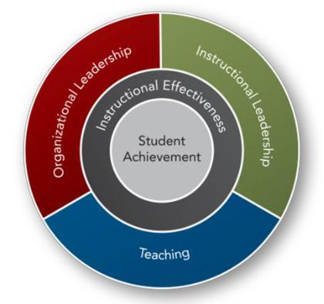

This graphic shows the relationship between student achievement and areas of district support

Daggett System for Effective Instruction

- Organizational Leadership: provides ongoing professional development support to maximize organizational efficiency and effectiveness.

- Instructional Leadership: provides ongoing professional development support to district and campus leaders to ensure the highest levels of student achievement.

- Teaching: provides ongoing professional development for curriculum, teaching and assessment to ensure the highest levels of student achievement.

The organizational structure of the Professional Development Plan also reflects the career cycle of all employees. Professional development career cycles in future years will reflect specific expectations for all employees along the following career stages as follows:

- Beginning: reflects the career cycle of an employee who is new to the particular assignment

- Developing: reflects the career cycle of an employee who has gained specific experience in the current assignment and possesses deepening skills

- Meeting: reflects the career cycle of an employee who has gained a deeper level of experience in the current assignment and possesses specific skills

- Expert: reflects the career cycle of an employee who has gained the highest level of experience in the current assignment, possesses specific skills, and is viewed by colleagues and supervisors as a leader in the particular field of work

Professional Development Plan Components and Format

The time span of the professional development plan is three years, with annual review and adjustment as needed to address emerging needs or other changes impacting priorities for these services. Each current/immediate year’s plan will contain explicit and complete information for each group of employees. The future three years will contain a general informational framework that will be developed in detail as data and other feedback lead to specific contents and contexts for the professional development offerings. As a year of development is completed, the subsequent plans will be modified as needed and the third year projected and added to the plan. The plan is based on Curriculum Management Audit criteria, research-based best practices in adult development theory, and national standards for professional learning [Refer to Appendix 2 for details of the CMSi criteria].

Professional Development Department Roles and Responsibilities

The Professional Development Department supports and facilitates professional development sessions throughout the district. The specific roles of the department are as follows:

- Support all district, campus, and department based professional development to ensure alignment with HISD mission and goals;
- Coordinate resources within the organization through collaboration;
- Assist individuals seeking support for their own identified professional or personal growth activities;

Rev. 4/1/2016 12 | P a g e
Humble ISD
Professional Development Plan

- Guide implementation of all Humble ISD District Wide Professional Development Initiatives;

- Facilitate the development and implementation of Humble ISD Professional Development Presenter Institute;
- Assist in identification of appropriate resources for planned professional development opportunities;
- Publish a calendar of scheduled professional development activities;

- Use social media, email, web-site and other communication avenues to inform employees of development opportunities;

- Collect and synthesize data on effectiveness of professional development offered throughout the district;
- Long range planning for district, school, and department development plans;
- Facilitate Professional Development Planning Framework with district, campus and departments; and

- Facilitate use of the Evaluation Framework for Professional Development in Humble ISD with district, campus and departments.

Central Coordination and Tracking of Professional Learning

All professional development is centrally approved and coordinated through the Professional Development Department. A clearinghouse system is a central component of the service management and includes:

- The planning and approval of all district and campus/department professional learning;

- The planning process is designed and implemented by the Professional Development Department and involves the Leadership Forum, the Professional Development Advisory Committee, administrative staff, teachers and other stakeholders in plan development, draft, feedback, solicitation, and final determination of annual plan content.

- The design and implementation of the professional development plan will be responsive to other plans such as district or school improvement plans, the district’s curriculum management plan, the district’s technology plan and any plans driving the functions of support services across HISD.

- Determination of professional development program effectiveness will be guided by a specific evaluation process that incorporates multiple data sources and compiles the data annually.

Professional Development Tracking System

Eduphoria! Workshop is a professional development management system that allows employees to enroll in Humble ISD professional development, submit out-of-district courses for credit, and track their own professional development in one centralized location. The Professional Development Department utilizes Workshop to:

- Standardize groups and categories in a concise manner to assist employee in their searches for professional development offerings;

- Train professional development instructors/facilitators to use the system and follow the district standards;
- Follow a naming standard for all courses;

- Standardize course creation components to ensure alignment with district goals and required course description indicators;

- Provide the required end of course evaluation feature;
- Standardize the process for tracking job embedded professional development; and

- Utilize reports and other data sources from Eduphoria to track professional development in Humble ISD.

Explanation of Professional Development Credit

Humble ISD employees are required to earn 40 professional development hours each year which equals 200 professional development hours every five years. Educators with a standard certificate are subject to mandatory professional development requirements and must provide evidence to the Texas Education Agency every 5 years.

Rev. 4/1/2016 13 | P a g e

 |  |  |  |  |  |  |  |  |  | Humble ISD
 |  |  |  |  |  |  | Professional Development Plan
 |  |  |  |  |  |  | Maximum Hours Allowed |  |  | Maximum Hours
 | Type of Activity |  |  | Documentations and |  |  | Maximum Hours Allowed |  |  | Allowed
 | Type of Activity |  |  | Documentations and |  |  | Renewal of Standard
 | Type of Activity |  |  | Permissions |  |  | Renewal of Standard |  |  | Lifetime Provisional
 |  |  |  | Permissions |  |  | Certificate |  |  | Lifetime Provisional
 |  |  |  |  |  |  | Certificate |  |  | Certificate Holders
 |  |  |  |  |  |  | (obtained after Sept. 1, 1999) |  |  | Certificate Holders
 | Attending a professional
 | development workshop or in- |  |  | Certificate |  |  | No limit |  |  | No Limit
 | service
 | Presenting for district or |  |  |  |  |  | 15 hours each five year cycle
 |  |  |  |  |  |  | can be applied to required
 | professional conferences
 |  |  |  | Agenda and Certificate |  |  | certificate renewal hours |  |  | No Limit
 | (three hours of credit for one
 |  |  |  |  |  |  | No limit on the number of
 | hour of presenting)
 |  |  |  |  |  |  | hours for District Credit
 | Developing Curriculum |  |  | Assistant Superintendent of
 | Developing Instructional |  |  | Curriculum and Instruction or |  |  | No Limit |  |  | No Limit
 |  |  |  | designee; completed
 | Materials
 |  |  |  | documents
 |  |  |  |  |  |  | 45 hours each five year cycle
 | Participating as a District |  |  | Approval of immediate |  |  | can be applied to required |  |  | 72 hours each five year
 |  |  |  |  |  |  | certificate renewal hours
 | Designated Mentor |  |  | supervisor |  |  |  |  |  | cycle
 |  |  |  |  |  |  | No limit on the number of
 |  |  |  |  |  |  | hours for District Credit
 |  |  |  | Approval of Assistant |  |  | 30 hours each five year cycle
 | Participating in Independent |  |  |  |  |  | can be applied to required
 |  |  |  | Superintendent and Director of |  |  |  |  |  | 48 hours each five year
 | Study (i.e. book study, |  |  |  |  |  | certificate renewal hours
 |  |  |  | Professional Development; |  |  |  |  |  | cycle
 | independent research, etc...) |  |  |  |  |  | No limit on the number of
 |  |  |  | Professional
 |  |  |  |  |  |  | hours for District Credit
 | Earning College Credit
 | 1 college hour = 15 hours of |  |  | Principal Approval |  |  | No Limit |  |  | No Limit
 | professional development |  |  | Official Transcript to HR
 | credit
 | Participating in national
 | board certification |  |  |  |  |  | 90 Continuing Professional |  |  | 90 Continuing
 | Conducting Educational |  |  | District Approval |  |  |  |  |  | Professional Education
 |  |  |  |  |  |  | Education (CPE) hours each
 | research under the direction |  |  |  |  |  |  |  |  | (CPE) hours each five
 |  |  |  |  |  |  | five year cycle
 | of the university in |  |  |  |  |  |  |  |  | year cycle
 | attendance
 | District
 | Flipped Professional |  |  | Courses available in Eduphoria! |  |  | No Limit |  |  | No Limit
 | Development
 | Participating on a district or
 | campus instructional |  |  | Principal , Curriculum
 | committee |  |  | Coordinator, Director of
 | (i.e. DDMC, SBDM, grading, |  |  | Curriculum and Instruction, |  |  | No Limit |  |  | No Limit
 | textbook, advisory, etc…) |  |  | Director of Professional
 | Active Participation in |  |  | Development
 | Cadre

Rev. 4/1/2016 14 | P a g e

Humble ISD
Professional Development Plan

Humble ISD Professional Development Presenter Academy

The Professional Development Presenter Institute will focus on developing staff in researched based adult development strategies, planning and delivery of effective presentations, working with a co-presenter, verbal nonverbal communications, engagement, development and application of new development by attendees. The primary goal of this institute is to develop quality professional development presenters to further impact development for employees thus advancing student learning. Professional development surveys will be used in determining effectiveness of presenters and refinement of the Professional Development Presenter Academy offerings. Staff members will be able to apply to become a member through the Professional Development Department via an application process beginning Spring of 2016.

Course Sequence and Professional Development Badges

The awarding of badges is not new; the military and Scout programs having been using them for years. Those programs were successful because they both allowed members to earn some together as a team, and others based on their own interest and needs.

The Humble ISD Presenter’s Academy will offer employees the opportunity to hone their presentation skills using whole group learning opportunities, Atomic Learning online courses, and … of choice

Badges

- Design Doyen
- Modality Maven
- Visual Virtuoso
- Audience Ace
- Adult Learner Expert

- Humble ISD Master Presenter

Design Doyen

To receive the Design Doyen badge participants will attend a 1 hour PD focused on creating effective trainings. Participants will learn Rich Allen’s Train Smart method that includes how to engage an audience, framing the training, how to involve participants in the material, debriefing, and reflecting so that participants can embed their learning. Participants will also be training in how to read their survey’s in Eduphoria and how to use feedback to drive their next presentation.

Modality Maven

To earn the Modality Maven badge academy participants will attend a 2 hour PD exploring learning designs for professional development. Participants will explore the answers to the following questions: When is a face to face training necessary? Would an eCourse be just as effective? Is this material better shared in small groups, or is a large group okay?

This course will also cover the basics of setting up technology at the ISC, trouble-shooting common hiccups, and who to call for help. In addition, participants will learn the process of creating an eCourse. Participants already knowledgeable in creating eCourses are not required to stay for this portion of the training. Participants will then have time to create their own eCourse (real or for fun). Badges will be awarded based on the completion of a 2 minute eCourse.

Visual Virtuoso

To earn the Visual Virtuoso badge academy participants will use Atomic Learning. They will watch Effective PD Design focusing on what’s the point, color, text, making text clear and concise. After completing the assigned courses participants will use their new learning to create a visual presentation about themselves. Badges will be award by PD based on completion of the AL courses and the participant’s presentation.

Rev. 4/1/2016 15 | P a g e

Humble ISD
Professional Development Plan

Audience Ace

To earn the Audience Ace badge academy participants will need to attend a minimum of three 1 hour trainings that will focus on:

- Understanding and Managing Your Audience (required for all)
- Handling Hecklers and Interruptions, Using Positive Language, Managing Resources

- Pacing and giving clear/concise instructions
- Working with a Co-Presenter and rapport building
- Verbal and Non Verbal Communication
- Culturally Relevant Presentations

Adult Learner Expert

Professional learning practices for working with adult learners. Learning outcomes will focus on the application of brain research to support adult learners, how adult learners are different than students, what is important to adult learners. Finally, presenter academy participants will develop or grow cognitive coaching skills to help ensure quality interactions with adult learners.

Humble ISD Master Presenter

To earn the Humble ISD Master Teacher badge participants must have first completed the requirements of the other 5 badges. They will then invite a member of PD to visit a training of their choice. Afterwards, PD will meet with the participant to discuss the training’s successes and possible coaching questions. PD will award final approval for badge.

Required Planning, Monitoring and Evaluation of Professional Learning³
It is expected that all supervisors actively support their employees in their professional growth activities through the collaborative development of annual growth targets, the ongoing monitoring of performance and annual appraisal. All professional development sessions in HISD are required to follow a consistent process for planning and evaluation. These requirements are in place to ensure that all professional development is of the highest quality and has a lasting impact on employee performance and ultimately results in improved student achievement.
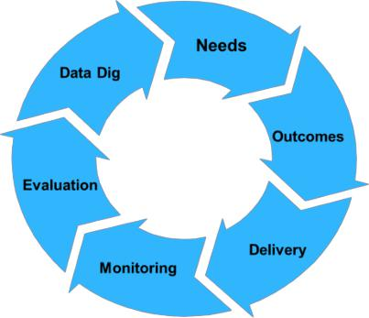

Diagram of the Planning Process for Professional Learning

Needs Assessment for Professional Development Planning

Assessment of professional development needs across the district will include, at a minimum, the following informational feedback sources:

- Clarification of district expectations for effective organizational leadership, instructional leadership, teaching that support educators in attainment of student development success; and

- Learning Forward Standard: Professional learning that increases educator effectiveness and results for all students;

Uses a variety of sources and types of students, educator and system data to plan, assess, and evaluate professional learning; Applies research on change and sustains support for implementation of professional learning for long-term change; and Aligns its outcomes with educator performance and student curriculum standards.

Rev. 4/1/2016 16 | P a g e

Humble ISD
Professional Development Plan

- Identification of professional development needs and offerings will be based on consideration of data/feedback from:

  - A range of data sources that provide information about student performance; universal screeners, local, state and national assessment data;
  - District mission and goals;
  - Evaluative feedback on prior offerings;
  - Employee performance appraisals;
  - Self-assessment of job-specific and broader development needs;
  - Information regarding innovation efforts and introduction of new expectations;
  - Legal and regulatory requirements;
  - Collaborative Instructional Rounds and the Classroom Visitation Tool.

Planning for Professional Development

Of all of the professional development decisions made, none is more important than the linkage of efforts to district change. To justify time, energy, and money invested, professional development activities offered in Humble ISD are research based, proven in practice, and relevant to the district, campus, and department goals. Each participant will understand the development outcomes and the relevance to other practices, strategies, policies or procedures that are currently in use or will be in use.

Employing a backwards design model, the Humble ISD Professional Development Plan includes a planning framework to guide all campuses and departments in planning quality professional development or all employees. By utilizing the planning framework a common language and planning sequence will be employed ensuring that a standard process is in place. The process includes these concepts:

- Planning for professional development will begin with the end goals for student achievement based on a needs assessment.

- New practices or strategies are matched to the desired student achievement result. Careful consideration is given during the planning process for on-going support from district and campus personnel as the new development strengthens and becomes sustainable.

- Professional development activities build on the knowledge base needed to ensure success with new learning.

- Design of the professional development activities match the best delivery approach with the intended audience and the new skills that will be a result of the development activity.

[Appendix 4 includes the Humble ISD PD Planning Framework.]

Funding for Professional Development

Many numerous funding sources are available for professional development in Humble ISD. The most commonly used sources include district funds, state compensation funds, federal funds, state Title allotments, various grants, community partnerships, fundraising and campus budgets. During professional development planning, funding sources are identified and evaluation criteria are determined. All professional development is monitored for ongoing support and impact on student learning so that full utilization of funds allotted are realized.

Campus/Department Supervisor Responsibilities⁴
The supervisor of each campus or department, with employee input, is responsible for facilitation of the District Professional Development Plan. By using the PD Planning Framework, each campus or department will identify and examine annual professional development needs, propose strategies, and design development opportunities. This annual evaluation requirement enables each supervisor and advisory committee to carefully examine strengths/weaknesses and propose innovative solutions, aligned with district mission and

- Learning Forward Standard: Professional learning that increases educator effectiveness and results for all students requires skillful leaders who develop capacity, advocate and create support system for professional learning.

Rev. 4/1/2016 17 | P a g e

Humble ISD
Professional Development Plan

goals, to support employee growth. The supervisor is responsible for overseeing the planning and review process for all employees. The planning process is to be completed by an ad hoc group formed of employees representing the identified target group; campuses should utilize a sub-committee of the campus-based planning team to fulfill this responsibility. The supervisor is responsible for development, implementation, and evaluation of specific plans. The supervisor also is responsible for submitting site professional development plans, for final approval, embedded within the campus or department improvement plan.

Approval Process for Campus/Department Professional Development

All professional development offered within HISD must be focused and closely aligned with the district mission and goals. The Professional Development Department supports the district, campuses/departments and individual employees through the approval, tracking and evaluation of all employee professional learning.

Campuses or departments that wish to hold professional development beyond the scope of current district initiatives must submit the Professional Development course description for approval and adhere to the following procedure:

- When a need is identified, a campus or department administrator, in consultation with the leadership team, should carefully review the district mission and goals to determine how addressing the identified need will support the district direction.

- Once the supporting mission and goals are identified the administrator should gather all available data and develop a complete course description of the need.

- Utilizing research, the administrator should then explore potential options to address the identified need and develop a brief description of the professional development session, including duration, number of employees involved, and the cost and identified funding source.

- The administrator will identify a minimum of two measurable, time-bound outcomes resulting from HISD employees participating in the professional development session. These outcomes must be included in each course description.

- The administrator will explain how application of the new skill will be supported and monitored within each course description.

- Finally, all district goals that the session aligns with will by indicated by placing a check next to the appropriate goal.

- The course description will be submitted to the supervising district leader for review via Eduphoria!. The course will not move through the approval process unless the required information is included in the description and the aligned district goals are noted.

- If approved by the supervising district leader, the course description and goals will then be submitted to the Professional Development Department via Eduphoria! for final review.

Assigning Credit to Professional Development Sessions

Credits are assigned to each professional development sessions in Eduphoria by the course creator. The following credit types will be utilized in Humble ISD.

 | Credit Type | When to use….. |  |  |  |  | Approval Process
 | GT | When assigning GT credit to a session portions of |  |  |  |  | GT Coordinator
 |  | the entire session need to give participants time
 |  | to reflect on the new learning and how it can be
 |  | used to increase the depth and complexity of
 |  | content for all gifted students the teacher serves.
 |  | For further information on assigning GT credit
 |  | please contact the district GT Coordinator.
 | Bilingual | When | assigning | credit | for | professional | Bilingual/ELS and LOTE
 |  | development that focuses on second language |  |  |  |  | Director
 |  | acquisition of English language learning students
 |  | or non-limited |  | English | proficient students

Rev. 4/1/2016 18 | P a g e

 |  |  |  |  |  |  | Humble ISD
 |  |  |  |  |  |  | Professional Development Plan
Credit Type | When to use….. |  |  |  |  |  | Approval Process
 | participating in a Dual language program model.
 | Methodologies |  | for | bilingual |  | professional
 | development shall be research based and address
 | native language as well as English acquisition in
 | grades PreK – 5th. This may include instructional
 | best practices for language transfer.
ESL | When | assigning |  | credit | for | professional | Bilingual/ESL and LOTE
 | development that focuses on second language |  |  |  |  |  | Director
 | acquisition of English language learning students.
 | Methodologies for ESL professional development
 | shall be research based and address the
 | acquisition of the English language. This may
 | include sheltered instruction, LEP assessment and
 | program placement/compliance in instruction and
 | program design.
LOTE | When | assigning |  | credit | for | professional | Bilingual/ESL and LOTE
 | development that focuses on second language |  |  |  |  |  | Director
 | acquisition of a language other than English.
 | Methodologies for LOTE professional development
 | shall be research based and be aligned with the
 | ACTFL standards.
Technology | When | assigning |  | credit | for | professional | No Approval Process
 | development that focuses on Technology where
 | the emphasis is on learning a new technology
 | application or using technology as a strategy to
 | increase student learning. It is important to use
 | this credit to capture all sessions where
 | technology strategies or applications are being
 | taught.
SBEC | SBEC credit should be assigned in addition to |  |  |  |  |  | No approval process
 | on/off contract credit so that all professional
 | learning is captured with this credit type. This is
 | not an appropriate credit to attach to meetings
 | where professional learning is not occurring.
Meeting | Meeting credit should be assigned to all |  |  |  |  |  | No approval process
 | department, faculty, and committee meetings in
 | which the entire focus is operations or
 | information sharing.
Off – Contract | Off- Contract credit is assigned to any session |  |  |  |  |  | No approval process
 | that occurs outside the regular workday for the
 | staff attending or after regular contract days.
On – Contract | On-Contract credit is assigned when the |  |  |  |  |  | No approval process
 | professional development session occurs during
 | the regular workday for the staff designated to
 | attend or during the contract period of each
 | school year.
Custom Credit | Custom credit can be awarded for a variety of |  |  |  |  |  | No approval process
 | situations: |  |  |  |  |  | Use published Humble ISD
 | Part of the session occurs before/after the regular |  |  |  |  |  | work calendar days to
 | workday hours for the staff attending while a |  |  |  |  |  | guide you with awarding
 | portion of the session occurs during regular |  |  |  |  |  | custom credit
 | workday hours. Please contact the professional
 | development office for guidance if you feel it is
 | necessary to assign custom credit.

Rev. 4/1/2016 19 | P a g e

Humble ISD
Professional Development Plan

Implementation of Teacher Professional Development

All campus instructional leaders are expected to monitor the delivery of the curriculum and be able to determine the concepts or skills being taught, the context within which it is being taught, and the cognitive level at which students are expected to demonstrate their development using collaborative instructional rounds. They are also expected to be able to determine if all of the aspects observed match the district curriculum. Instructional leaders are also expected to conference with and provide feedback to teachers about their teaching through both reflective questions and dialogue in an effort to improve the delivery of the district curriculum.

The curriculum is monitored by the campus and district level teams through the Collaborative Instructional Rounds process as well as formal observations. The campus principal is the instructional leader responsible for monitoring the implementation of the district curriculum. The classroom visitations will include quick “snapshots” of the daily implementation of the curriculum and instructional strategies.

Tools for Monitoring the Taught Curriculum
The taught curriculum is to be monitored by the campus administrative team using any of the following tools:
- Analysis of student assessment data
- Observations of teachers
- Interviews and conferences with individual teachers and/or teams
- Meetings with district curriculum/instruction personnel
- Review of lesson plans and instructional units
- Classroom Visitation Tool

Evaluation of Professional Development⁵
In order for HISD employees to receive credit for professional development completed within the District, an evaluation survey of the professional development session must be completed through Eduphoria!. The evaluation results of all professional development sessions are used as a measure for ongoing improvement. See Appendix 5 for HISD Professional Development Session Evaluation

Professional Development sessions, programs, and initiatives will also be evaluated by the following factors:

- Participants Reactions – The perceptions of the professional development delivery and attitudes towards the professional development initiative;

- Participants Development– the knowledge of the professional development content;

- Organizational Support and Change – Active advocating, leadership understanding, time for learning, effective communication of expectations for new learning, alignment with district goals, financial support for ongoing development and effective atmosphere for learning;

- Participants Use of the new Knowledge and Skills – Participant implementation of development expectations;

- Students Development Outcomes – Student attitudes, engagement, effort, motivation, support and self-efficacy, improved student achievement ; and

- Demonstrating Capacity of Development- Coaching, Collaborative Instructional Reviews, Alts and Administrators communicate content expertise, common language, adapting implementation based on feedback, Professional Development Community time devoted to deeper learning, Facilitation of collaboration, Support of the initiative and delivery of content to new participants.

- Refer to Appendix 5, page 28 for the Evaluation Framework for Professional Development

Rev. 4/1/2016 20 | P a g e

Humble ISD
Professional Development Plan

Professional Development Plan for Technology Integration

Essential Conditions

The International Society Technology Education published 14 essential conditions critical for quality technology integration and the leverage of technology for learning. The Digital Learning Department will use this list of conditions as a guide for the best way to improve the innovation of technology integration and bring forth the district’s vision for technology integration. These conditions include:
- Shared Vision

- Empowered Leaders

- Implementation Planning

- Consistent and Adequate Funding

- Equitable Access

- Skilled Personnel

- Ongoing Professional Learning

- Technical Support

- Curriculum Framework

- Student-Centered Learning

- Assessment and Evaluation

- Engaged Communities

- Support Policies

- Supportive External Context

Stages of Technology Integration Supported by Professional Development

The Florida Center for Instructional Technology at the University of South Florida College of Education, the descriptors in the Technology Integration Matrix suggests the following stages of technology integration. Professional development will focus on moving teachers toward the final stage. Learning designs will include, online, blended and job embedded opportunities for learning that will be based on the learning needs of adult learners.
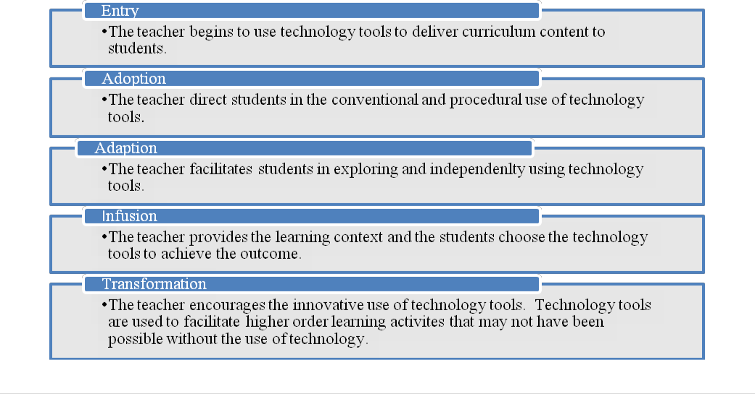

Rev. 4/1/2016 21 | P a g e

Humble ISD
Professional Development Plan

Professional Development for Principals

The International Society of Technology Education published standards for educational leaders with the focus of leading the integration of technology in the schools. These standards will be the basis for professional development for the district leaders. The ISTE Administrator standards are a guide for educators to use to support technology and will be a focus of administrator professional development. These include: Visionary Leadership, Digital Age Learning Culture, Excellence in Professional Practice, Systemic Improvement, and Digital Citizenship.

Professional Development for Teachers, ALTS, Librarians or Media Specialists

Teacher professional development will focus on the International Society of Technology Education published standards for teachers and form the basis of professional development for our teachers. These standards are organized into the following categories:
- Facilitate and inspire student learning and creativity

- Design and develop digital age learning experiences and assessments

- Model digital age work and learning

- Promote and model digital citizenship and responsibility

- Engage in Professional growth and leadership

In addition, the improve the Technology Integration Matrix (TIM) for curriculum, learning environments, teachers and students will guide professional development so that as Humble ISD teachers design, deliver and assess learning technology is used as a tool to increase rigor, relevance and learner engagement.

The Technology Integration Matrix Table of Teacher and Instructional Settings Descriptors

Adapted from the Florida Center for Instructional Technology at the University of South Florida College of Education, the descriptors in the Technology Integration Matrix (TIM) contain resources that detail student activity, instructional settings, and tables of summary indicators. Evidence of technology integration will be gathered via formal and informal classroom observations or analysis of lesson plans conducted by campus and district leadership in addition to pre and post self-reflection by teachers. These results will assist in evaluating and then revising professional development to better meet the needs of district personnel.

Rev. 4/1/2016 22 | P a g e

Humble ISD
Professional Development Plan
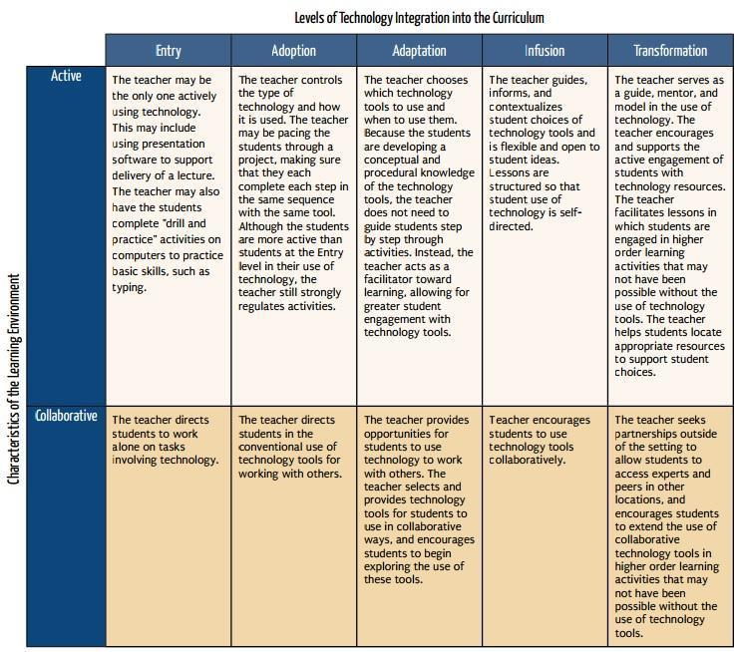

Rev. 4/1/2016 23 | P a g e

Humble ISD
Professional Development Plan
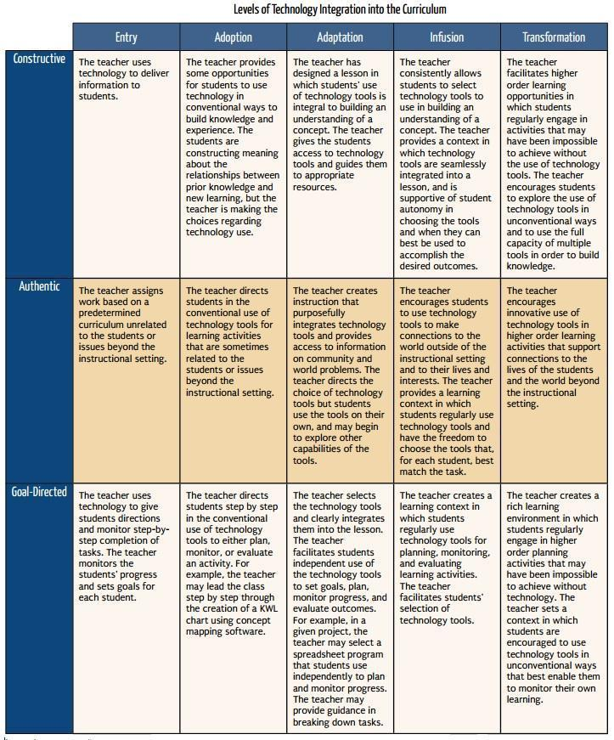

Rev. 4/1/2016 24 | P a g e

Humble ISD
Professional Development Plan

Instructional Setting Descriptors
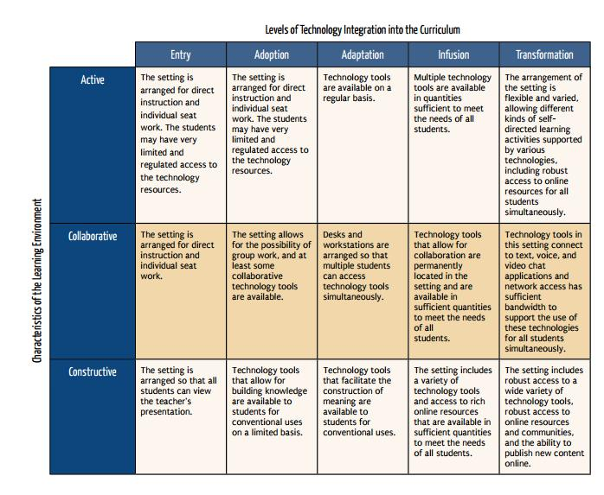

Rev. 4/1/2016 25 | P a g e

Humble ISD
Professional Development Plan
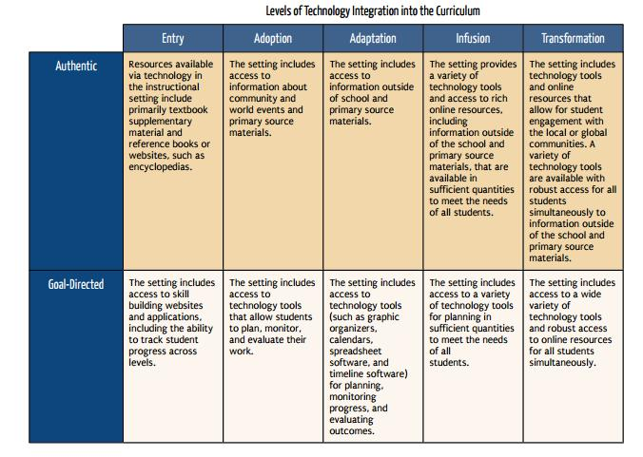

Rev. 4/1/2016 26 | P a g e

 |  |  |  |  |  |  |  |  |  |  |  |  |  | Humble ISD
 |  |  |  |  |  |  |  |  |  |  |  | Professional Development Plan
 | Rigorous and Relevant Learning
 |  |  |  |  | Rigorous and Relevant Learning for ALL Students
 |  | Technology Professional Development Plan for Integration of Technology into Instruction
 |  |  |  | Audience |  |  | 2015-2016 |  |  |  | 2016-2017 |  |  | 2017-2018
 |  |  |  |  |  |  | Professional Development for
 |  |  |  | Curriculum and |  |  | supporting technology integration
 |  |  |  | Curriculum and |  |  | aligned to the CIR rubrics to increase |  |  |  | Supporting PLCs – Using the CIR |  |  | Integration of technology to
 |  |  |  | Instruction : |  |  |  |  |  |  | Supporting PLCs – Using the CIR |  |  | Integration of technology to
 |  |  |  | Instruction : |  |  | R/R |  |  |  | Supporting PLCs – Using the CIR |  |  | Integration of technology to
 |  |  |  | Directors, |  |  |  |  |  |  | rubrics in planning incorporating |  |  | increase rigor and relevance to
 |  |  |  | Directors, |  | • |  | Includes onsite PD and Coaching. |  |  | rubrics in planning incorporating |  |  | increase rigor and relevance to
 |  |  |  | Coordinators, |  |  |  |  |  |  | tech resources as one of a selected |  |  | build Quad D lessons that are
 |  |  |  | Coordinators, |  | • |  | Focused on district identified Tech |  |  | tech resources as one of a selected |  |  | build Quad D lessons that are
 |  |  |  | Specialists and |  |  |  |  |  |  | few instructional strategies |  |  | cross-curricular
 |  |  |  | Specialists and |  |  |  | Tools |  |  | few instructional strategies |  |  | cross-curricular
 |  |  |  | Facilitators
 |  |  |  | Facilitators |  |  | Incorporate tech resources as a strategy
 |  |  |  |  |  |  | into the RR training (October 2015)
 |  |  |  |  |  |  | Professional Development for
 |  |  |  |  |  |  | supporting technology integration
 |  |  |  |  |  |  | aligned to the CIR rubrics to increase |  |  |  | Supporting PLCs – Using the CIR |  |  | Integration of technology to
 |  |  |  |  |  |  | R/R |  |  |  | Supporting PLCs – Using the CIR |  |  | Integration of technology to
 |  |  |  |  |  |  |  |  |  |  | rubrics in planning incorporating |  |  | increase rigor and relevance to
 |  |  |  | ALTs |  | • |  | Includes onsite PD and Coaching. |  |  | rubrics in planning incorporating |  |  | increase rigor and relevance to
 |  |  |  | ALTs |  |  |  |  |  |  | tech resources as one of a selected |  |  | build Quad D lessons that are
 |  |  |  |  |  | • Focused on district identified Tech |  |  |  |  | tech resources as one of a selected |  |  | build Quad D lessons that are
 |  |  |  |  |  |  |  |  |  |  | few instructional strategies |  |  | cross-curricular
 |  |  |  |  |  |  |  | Tools |  |  | few instructional strategies |  |  | cross-curricular
 |  |  |  |  |  |  | Incorporate tech resources as a strategy
 | Rigorous and Relevant |  |  |  |  |  | into the RR training (Aug 2015)
 | Instruction |  |  |  |  |  | PD for a select group of lead teachers
 |  |  |  |  |  |  | “Technology as one instructional
 |  |  |  |  |  |  | strategy for increasing Rigor and |  |  |  | Supporting PLCs – Using the CIR |  |  | Integration of technology to
 |  |  |  |  |  |  | Relevance of ALL student tasks” |  |  |  | Supporting PLCs – Using the CIR |  |  | Integration of technology to
 |  |  |  |  |  |  |  |  |  |  | rubrics in planning incorporating |  |  | increase rigor and relevance to
 |  |  |  | Teachers |  | • |  | Includes onsite PD and Coaching. |  |  | rubrics in planning incorporating |  |  | increase rigor and relevance to
 |  |  |  | Teachers |  |  |  |  |  |  | tech resources as one of a selected |  |  | build Quad D lessons that are
 |  |  |  |  |  | • Focused on district identified |  |  |  |  | tech resources as one of a selected |  |  | build Quad D lessons that are
 |  |  |  |  |  |  |  |  |  |  | few instructional strategies |  |  | cross-curricular
 |  |  |  |  |  | • |  | Tech Tools |  |  | few instructional strategies |  |  | cross-curricular
 |  |  |  |  |  |  | Incorporate tech resources as a strategy
 |  |  |  |  |  |  | into the RR training (July 2015)
 |  |  |  |  |  |  | Incorporating and supporting technology
 |  |  |  |  |  |  | as a tool for Communication, PR, and
 |  |  |  |  |  |  | Branding |  |  |  | Digital Leadership in Humble
 |  |  |  |  |  |  | Administrators will use technology to |  |  |  | Digital Leadership in Humble
 |  |  |  |  |  |  |  |  |  |  | Ongoing PD for incorporating and |  |  | Establishing Professional
 |  |  |  |  |  |  | share the PD story including CIR work. |  |  |  | Ongoing PD for incorporating and |  |  | Establishing Professional
 | Digital Leadership |  |  | Campus Leaders |  |  |  |  |  |  | supporting technology as a tool |  |  | Learning Networks,
 | Digital Leadership |  |  | Campus Leaders |  | • |  | Includes onsite PD and Coaching. |  |  | supporting technology as a tool |  |  | Learning Networks,
 |  |  |  |  |  |  |  |  |  |  | for Student Learning and Positive |  |  | Opportunities
 |  |  |  |  |  | • Focused on district identified Tech |  |  |  |  | for Student Learning and Positive |  |  | Opportunities
 |  |  |  |  |  |  |  |  |  |  | School Learning Environment
 |  |  |  |  |  |  |  | Tools. Examples include: |  |  | School Learning Environment
 |  |  |  |  |  |  |  | - | Twitter
 |  |  |  |  |  |  |  | - | Facebook

Rev. 4/1/2016 27 | P a g e

 |  |  |  |  |  |  |  |  |  |  |  |  | Humble ISD
 |  |  |  |  |  |  |  |  |  |  | Professional Development Plan
 |  |  |  |  | Rigorous and Relevant Learning for ALL Students
 |  | Technology Professional Development Plan for Integration of Technology into Instruction
 |  |  |  | Audience |  |  | 2015-2016 |  |  | 2016-2017 |  |  | 2017-2018
 |  |  |  |  |  | - |  | Blogging
 |  |  |  |  |  | - |  | LinkedIn
 |  |  |  |  |  | - |  | Pinterest
 |  |  |  |  |  |  | Incorporating and supporting technology
 |  |  |  |  |  |  | as a tool for Communication, PR, and
 |  |  |  |  |  |  | Branding
 |  |  |  |  |  |  | District Leaders will use technology to
 |  |  |  |  |  |  | describe district work. |  |  | Digital Leadership in Humble
 |  |  |  |  |  | • Includes onsite PD and Coaching. |  |  |  | Ongoing PD for incorporating and |  |  | Establishing Professional
 | Digital Leadership |  |  | District Leaders |  | • Focused on district identified Tech |  |  |  | supporting technology as a tool |  |  | Learning Networks,
 |  |  |  |  |  |  | Tools. Examples include: |  |  | for Student Learning and Positive |  |  | Opportunities
 |  |  |  |  |  | - |  | Twitter |  | School Learning Environment
 |  |  |  |  |  | - |  | Facebook
 |  |  |  |  |  | - |  | Blogging
 |  |  |  |  |  | - |  | LinkedIn
 |  |  |  |  |  | - |  | Pinterest
 | Curriculum Technology |  |  | Coordinators, |  |  | Technology Integration in Today’s |  |  | Assessing the Use of Technology |  |  | Assessing the Use of
 | Curriculum Technology |  |  | Directors, |  |  | Classroom – what does this look like |  |  | Assessing the Use of Technology |  |  | Assessing the Use of
 | Integration |  |  | Directors, |  |  |  |  |  | in the Curriculum |  |  | Technology in the Curriculum
 | Integration |  |  | Specialists |  |  | and sound like? |  |  | in the Curriculum |  |  | Technology in the Curriculum

Note: This professional development plan was developed in partnership with ICLE. All professional development offerings will be based on adult learning theories and reflect the planning, delivery and evaluation systems outlined in the professional development plan.

Rev. 4/1/2016 28 | P a g e

Humble ISD
Professional Development Plan

Atomic Learning

Atomic Learning is an online professional development tool geared towards providing a wide array of online training in more than 250 commonly used software applications such as Microsoft Office tools and Google Docs and Apps for Education that is available 24 hours a day, 7 days a week. This platform allows employees of Humble ISD to access professional development that is specific to their unique needs at times that fit their personal and professional lives as part of a 21st century skills professional development program.

The online professional development modules are often used in the areas of:
- School Leadership/Administration
- Curriculum/Staff Development
- Technology Directors
- Help Desk Staff
- Librarians & Media Specialists
- Educators, Classroom Integrationists, & Instructional Coaches
- Special Education
- Classified Staff
- Students
- Families of Students

Continuum of Development by Department⁶
The continuum of development by departments is a living document which will continue to evolve with significant input from campuses and departments. As the Professional Development Department creates more integrated systems professional development across the district will be aligned to district goals and objectives.

- Refer to Appendix 6, page for the Continuum of Development by Department

Rev. 4/1/2016 29 | P a g e

Humble ISD
Professional Development Plan

Appendices

Rev. 4/1/2016 30 | P a g e

Humble ISD
Professional Development Plan

Appendix 1: Learning Forward Standards for Professional Learning

- Learning Communities: Professional learning that increases educator effectiveness and results for all students occurs within learning communities committed to continuous improvement, collective responsibility, and goal alignment.

- Leadership: Professional learning that increases educator effectiveness and results for all students requires skillful leaders who develop capacity, advocate, and create support systems for professional learning.

- Resources: Professional development that increases educator effectiveness and results for all students requires prioritizing, monitoring, and coordinating resources for educator learning.

- Data: Professional learning that increases educator effectiveness and results for all students uses a variety of sources and types of student, educator, and system data to plan, assess, and evaluate professional learning.

- Learning Designs: Professional learning that increases educator effectiveness and results for all students integrates theories, research, and models of human learning to achieve its intended outcomes.

- Implementation: Professional learning that increases educator effectiveness and results for all students applies research on change and sustains support for implementation of professional learning for long term change.

- Outcomes: Professional learning that increases educator effectiveness and results for all students aligns its outcomes with educator performance and student curriculum standards.

Rev. 4/1/2016 31 | P a g e

 |  |  | Humble ISD
 | Professional Development Plan
Appendix 2: CMSi Characteristics of a Comprehensive Professional Learning Plan
 | Characteristics | Adequate |  | Inadequat
 | Characteristics | Adequate |  | e
Policy
1. | Has policy that directs staff development efforts. | X
2. | Fosters an expectation for professional growth. | X
3. | Is for all employees. | x
Planning and Design
4. | Is based on a careful analysis of data and is data-driven. | X
5. | Provides for system-wide coordination and has a clearinghouse function in place. | X
6. | Provides the necessary funding to carry out professional learning goals. | X
7. | Has a current plan that provides a framework for integrating innovations related to | X
 | mission. | X
8. | Has a professional learning mission in place. | X
9. | Is built using a long-range planning approach. | X
10. | Provides for organizational, unit, and individual learning in a systemic manner. | X
11. | Focuses on organizational change—staff learning efforts are aligned to district goals. | X
Delivery
12. | Is based on proven research-based approaches that have been shown to increase | X
 | productivity. | X
13. | Provides for three phases of the change process: initiation, implementation, and | X
 | institutionalization. (this requires the most long-term work to achieve) | X
14. | Is based on human learning and adult learning. | X
15. | Uses a variety of professional learning approaches. | X
16. | Provides for follow-up and on-the-job application necessary to ensure improvement. | X
17. | Expects each supervisor to be a staff developer of staff supervised. | X
Evaluation
18. | Requires an evaluation of process that is ongoing, includes multiple sources of
 | information, focuses on all levels of the organization, and is based on actual change in | X
 | behavior.

In 2011 a Curriculum Audit conducted by the International Curriculum Audit Center-Phi Delta Kappa International, at that time Humble ISD met 27% of the CMSI criteria.

An auditor of the Curriculum Management Systems Inc., under the direction of the International Curriculum Audit Center, Phi Delta Kappa International, examined the current Humble Independent School District Professional Development Plan created in response to the audit that was conducted in 2011. The auditor found the Humble Independent School District Professional Development Plan met 100% of the CMSi criteria when reviewed June 2014.

Rev. 4/1/2016 32 | P a g e

Humble ISD
Professional Development Plan

Appendix 3: HISD Professional Development Session Evaluation

The following online evaluation survey is posted in Workshop and must be completed to receive professional development credit.

The Humble Independent School District is committed to the improvement of professional development for each employee. Each professional development session offered in HISD is followed with participants' completion of the online evaluation form. Results of the Likert Scale are analyzed for improvement measures.
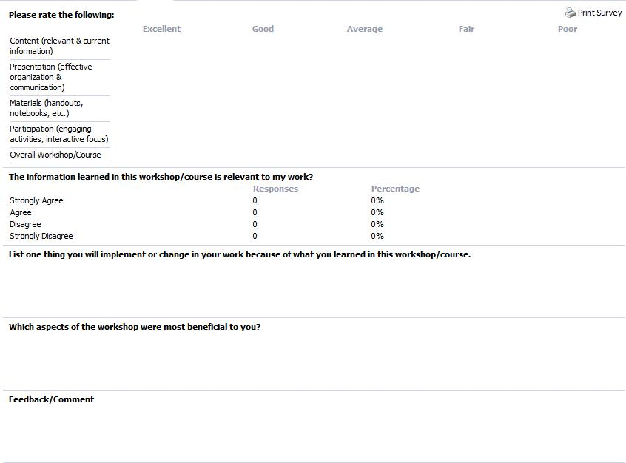

Rev. 4/1/2016 33 | P a g e

Humble ISD
Professional Development Plan

Appendix 4: Planning Framework
 |  |  |  |  | How will
Step or Process | Definition of Step | Questions to Guide | Data or Suggestions to Consider | Materials | you
 |  |  |  |  | measure?
Needs | “Beginning with the end in | What are the intended effects on student learning? | standardized test scores | Student and campus
Needs | mind” | What specific change in student achievement do you | state assessments sub-group data, | data
Assessment and | Backwards Design | want to see as a result of this training? | unit assessments, discipline data, | District Goals
Desired |  |  | classroom observations, curriculum | Campus Goals
Outcomes |  |  | instructional rounds, classroom
 |  |  | assessments,
 | Key Question: | What instructional practice is most likely to produce the | Use publications that experts have | Research
 | What instructional | desired results? | reviewed and are judged to be | Learning List
New Practices or | approaches will produce the | How do we know that these particular practices and | sufficiently rigorous to yield | Alignment with District
Strategies to | desired result? | policies produce the same results that hope to achieve? | trustworthy results. | and Campus Goals
Implement |  | What is the evidence for various approaches? | Engage participants in goal setting,
 |  |  | planning activities and strategies
 | “Many valuable | What will be our feedback system to teachers? | Leadership- visible and sustained | Time
 | improvement efforts fail | How frequent will the feedback be given? | support | Financial needs
 | because of lack of active | How will this development be assessed? | Leadership focus work, participation | Supplies, Resources
 | participation and clear | How frequent will classroom observations | in training, encouragement and | Schedule
Needed District | support from school leaders” | be done? | recognition of efforts | Support Structures
Support | Guskey | What is the monitoring structure at the district and | Providing time and resources | Technology
 |  | building level? | Incorporate the results of | Align with District and
 |  | What resources are needed? Materials? Technology? | professional development in PL | Campus Goals
 |  | What time is needed? | plans and evaluations
 |  | What funding will be used?
 | This drives the what and the | What knowledge and skills are required to implement | Build on knowledge base | Agenda
 | why of the learning | this professional learning? | Promote curiosity and disciplined | Data
Educator |  | What must educators know and be able to do to | inquiry | Change process
Knowledge and |  | successfully implement and bring about the sought after | Theoretical research rationale | Adult development
Skills |  | improvements in student learning? | Build on the principles of adult | resources
 |  | How will we help staff understand the need for the | development and change
 |  | change?
 | Design of the Professional | What set of experiences will best enable participants to | Seminars, workshops, collaborative | Definitions of types of
 | Learning | acquire the needed knowledge and skills? | planning, structured opportunities | professional
Optimal | What works depends on |  | for practice with feedback, follow- | development
Professional | where, when and with whom |  | up coaching, action research | Funding Sources
Development |  |  | projects, organized study groups,
Development |  |  | collegial exchanges, professional
Activities |  |  | collegial exchanges, professional
Activities |  |  | development communities, online
 |  |  | services
Adapted from “Planning Professional Learning” by Thomas Guskey, Education Leadership, May 2014 (Vol.71 #8, p. 10-16)

Rev. 4/1/2016 34 | P a g e

Humble ISD
Professional Development Plan

Appendix 5: Evaluation Framework

Evaluation Framework for Professional Development in Humble ISD
 |  | Evaluation Level |  | What Questions are |  | What is measured or assessed? |  | Tools and Measures |  | Data Gathering |  | How will the information be
 |  |  |  | addressed? |  |  |  |  |  | Roles and |  | used?
 |  |  |  |  |  |  |  |  |  | Responsibilities
 |  |  |  | Did they like it? |  | Perceptions of the Professional |  | Workshops/Meeting feedback |  | Participants
 |  |  |  | Was their time well |  | Development delivery? Attitudes |  | tool |  | Participants |  | Improve program design and
 |  | Participants’ Reactions |  | Was their time well |  | Development delivery? Attitudes |  | tool |  | District and School |  | Improve program design and
 |  | Participants’ Reactions |  | spent? Did material |  | towards the professional |  | Coaching feedback tool |  | District and School |  | delivery
 |  |  |  | spent? Did material |  | towards the professional |  | Coaching feedback tool |  | Personnel |  | delivery
 |  |  |  | make sense? |  | development initiative? |  | Small group feedback |  | Personnel
 |  |  |  |  |  |  |  | Survey
 |  |  |  | Did participants |  | Knowledge of the professional |  | Self-Assessments |  | Participants |  | To improve program content,
 |  | Participants’ Learning |  | acquire the intended |  | Knowledge of the professional |  | Implementation Rubric |  | District and School |  | To improve program content,
 |  | Participants’ Learning |  | acquire the intended |  | development content |  | Implementation Rubric |  | District and School |  | format and organization
 |  |  |  | knowledge and skills? |  | development content |  | Collaborative Instructional |  | Personnel |  | format and organization
 |  |  |  |  |  |  |  | Rounds
 |  |  |  |  |  | Time Allocation , Effective |  |  |  |  |  | To document and improve
 |  |  |  |  |  | communication of expectations for |  |  |  |  |  | To document and improve
 |  |  |  | Was it advocated for |  | communication of expectations for |  |  |  |  |  | organization support and
 |  |  |  | Was it advocated for |  | all employees involved |  |  |  |  |  | organization support and
 |  |  |  | facilitated and |  | all employees involved |  | Organizational Support |  | Participants |  | understanding of change
 |  | Organization Support |  | facilitated and |  | Overtly aligned with district and |  | Organizational Support |  | Participants |  | understanding of change
 |  | Organization Support |  | supported? Was the |  | Overtly aligned with district and |  | Change and Building Capacity |  | District and School |  | process. This will guided an
 |  | and Change |  | supported? Was the |  | school goals, Budget funding |  | Change and Building Capacity |  | District and School |  | process. This will guided an
 |  | and Change |  | support public and |  | school goals, Budget funding |  | Survey |  | Personnel |  | inform future preparations for
 |  |  |  | support public and |  | Improvement/change process |  | Survey |  | Personnel |  | inform future preparations for
 |  |  |  | overt? |  | Improvement/change process |  |  |  |  |  | Capacity building
 |  |  |  | overt? |  | noted, Effective atmosphere for |  |  |  |  |  | Capacity building
 |  |  |  |  |  | noted, Effective atmosphere for |  |  |  |  |  | implementations
 |  |  |  |  |  | development(risk-taking) |  |  |  |  |  | implementations
 |  |  |  |  |  |  |  | CIR
 |  | Participants use of |  | Did participants |  | Teacher Demonstration |  | Embedded Coaching Feedback |  | Teacher’s school |  | To document and improve the
 |  | new Knowledge and |  | effectively apply new |  | Classroom Quality of |  | Self-Assessment |  | Teacher’s school |  | implementation of program
 |  | new Knowledge and |  | effectively apply new |  | Classroom Quality of |  | Self-Assessment |  | administrators |  | implementation of program
 |  | Skills |  | knowledge and skills? |  | Implementation (content specific |  | Reflective Journals |  | administrators |  | content
 |  |  |  |  |  |  |  | Lesson Study Videos
 |  |  |  |  |  |  |  | Student Survey
 |  |  |  | What was the impact |  | Students Attitudes: engagement, |  | Classroom data – student work |  |  |  | To demonstrate the impact of
 |  | Student Development |  | on student |  | motivation, effort, supported, self- |  | Classroom Formative |  | District and School |  | the professional development
 |  | Outcomes |  | achievement and |  | efficacy |  | assessments |  | Personnel |  | and to inform future
 |  |  |  | student attitudes? |  | Student Achievement |  | Benchmark data and |  |  |  | implementation needs
 |  |  |  |  |  |  |  | standardized test data
 |  |  |  |  |  | Coaching and Observations
 |  |  |  | Is there evidence that |  | ALT and Administrators can clearly
 |  |  |  | Is there evidence that |  | communicate the content expertise,
 |  | Demonstrating |  | administrators and |  | communicate the content expertise, |  | Faculty Survey
 |  | Demonstrating |  | administrators and |  | Common Language, Adapting |  | Faculty Survey
 |  | Capacity - |  | teacher leaders have |  | Common Language, Adapting |  | Follow – up work |  | District and School |  | To document and improve
 |  | Capacity - |  | teacher leaders have |  | implementation based on feedback, |  | Follow – up work |  | District and School |  | To document and improve
 |  | sustainability of |  | the ability to |  | implementation based on feedback, |  | Organizational support, change |  | Personnel |  | sustainability efforts
 |  | sustainability of |  | the ability to |  | Monitoring implementation |  | Organizational support, change |  | Personnel |  | sustainability efforts
 |  | development |  | successfully replicate |  | Monitoring implementation |  | and building capacity survey
 |  | development |  | successfully replicate |  | Facilitating collaboration, |  | and building capacity survey
 |  |  |  | the content to others? |  | Facilitating collaboration,
 |  |  |  | the content to others? |  | Deliver content to new participants

Rev. 4/1/2016 35 | P a g e

Humble ISD
Professional Development Plan

Appendix 6: Professional Development Continuum by Department

 |  |  |  |  |  |  | Developing |  |  | Meeting |  |  | Expert
 |  |  |  |  |  |  | Developing |  |  | Meeting |  |  | Employee has gained the highest
 | Development |  |  | New to assignment / Beginning |  |  | Employee has gained specific |  |  | Employee has gained a deeper |  |  | Employee has gained the highest
 | Development |  |  | New to assignment / Beginning |  |  | Employee has gained specific |  |  | Employee has gained a deeper |  |  | level of experience, possesses
 | Continuum |  |  | New to the particular assignment. |  |  | experience and possesses |  |  | level of experience and possesses |  |  | level of experience, possesses
 | Continuum |  |  | New to the particular assignment. |  |  | experience and possesses |  |  | level of experience and possesses |  |  | specific skills, and is viewed as a
 |  |  |  |  |  |  | deepening skills. |  |  | specific skills. |  |  | specific skills, and is viewed as a
 |  |  |  |  |  |  | deepening skills. |  |  | specific skills. |  |  | leader in a particular field.
 |  |  |  | Employee Handbook |  |  | Employee Handbook |  |  | Employee Handbook |  |  | Employee Handbook
 |  |  |  | Employee Health Training |  |  | Employee Health Training |  |  | Employee Health Training |  |  | Employee Health Training
 | Annual Compliance |  |  | Harassment in Schools |  |  | Harassment in Schools |  |  | Harassment in Schools |  |  | Harassment in Schools
 | Training |  |  | Keeping Students Safe |  |  | Keeping Students Safe |  |  | Keeping Students Safe |  |  | Keeping Students Safe
 |  |  |  | Legal Issues (FERPA) |  |  | Legal Issues (FERPA) |  |  | Legal Issues (FERPA) |  |  | Legal Issues (FERPA)
 |  |  |  | Responsible Use Policy |  |  | Responsible Use Policy |  |  | Responsible Use Policy |  |  | Responsible Use Policy
 |  |  |  | Understanding Poverty |  |  | Hear Our Cry: Boys in Crisis
 | District Focus Courses |  |  | Learner Engagement: Questioning |  |  | Super Eight: Essential Practices for |  |  | Offerings will be based on district |  |  | Offerings will be based on district
 | (All instructional and |  |  | Strategies to Increase Rigor |  |  | Teaching the Writer |  |  | goals, identified needs, evaluation |  |  | goals, identified needs, evaluation
 | instructional support |  |  |  |  |  |  |  |  | of current professional offerings |  |  | of current professional offerings
 |  |  |  |  |  |  | Offerings will be based on district |  |  | of current professional offerings |  |  | of current professional offerings
 | staff) |  |  |  |  |  | Offerings will be based on district |  |  | and program evaluation outcomes. |  |  | and program evaluation outcomes.
 |  |  |  | Writing Across the Curriculum |  |  | goals, identified needs, evaluation |  |  | and program evaluation outcomes. |  |  | and program evaluation outcomes.
 |  |  |  |  |  |  | of current professional offerings
 |  |  |  |  |  |  | and program evaluation outcomes.
 |  |  |  |  |  |  | Offerings will be based on district |  |  | Offerings will be based on district |  |  | Offerings will be based on district
 | Campus Administrators |  |  | Region IV Induction/Support |  |  | goals, identified needs, evaluation |  |  | goals, identified needs, evaluation |  |  | goals, identified needs, evaluation
 | – New |  |  | Program |  |  | of current professional offerings |  |  | of current professional offerings |  |  | of current professional offerings
 |  |  |  |  |  |  | and program evaluation outcomes. |  |  | and program evaluation outcomes. |  |  | and program evaluation outcomes.
 |  |  |  | Professional Learning |  |  | Offerings will be based on district |  |  | Offerings will be based on district |  |  | Offerings will be based on district
 |  |  |  | Communities / Smaller Learning |  |  | Offerings will be based on district |  |  | Offerings will be based on district |  |  | Offerings will be based on district
 |  |  |  |  |  |  | goals, identified needs, evaluation |  |  | goals, identified needs, evaluation |  |  | goals, identified needs, evaluation
 | Campus Administrators |  |  | Communities |  |  | goals, identified needs, evaluation |  |  | goals, identified needs, evaluation |  |  | goals, identified needs, evaluation
 |  |  |  |  |  |  | of current professional offerings |  |  | of current professional offerings |  |  | of current professional offerings
 |  |  |  | Data-Driven Decision Making |  |  | and program evaluation outcomes. |  |  | and program evaluation outcomes. |  |  | and program evaluation outcomes.

Rev. 4/1/2016 36 | P a g e

Humble ISD
Professional Development Plan
 |  |  |  |  |  |  | Developing |  |  | Meeting |  |  | Expert
 |  |  |  |  |  |  | Developing |  |  | Meeting |  |  | Employee has gained the highest
 | Development |  |  | New to assignment / Beginning |  |  | Employee has gained specific |  |  | Employee has gained a deeper |  |  | Employee has gained the highest
 | Development |  |  | New to assignment / Beginning |  |  | Employee has gained specific |  |  | Employee has gained a deeper |  |  | level of experience, possesses
 | Continuum |  |  | New to the particular assignment. |  |  | experience and possesses |  |  | level of experience and possesses |  |  | level of experience, possesses
 | Continuum |  |  | New to the particular assignment. |  |  | experience and possesses |  |  | level of experience and possesses |  |  | specific skills, and is viewed as a
 |  |  |  |  |  |  | deepening skills. |  |  | specific skills. |  |  | specific skills, and is viewed as a
 |  |  |  |  |  |  | deepening skills. |  |  | specific skills. |  |  | leader in a particular field.
 |  |  |  | TOP Review – Teacher Appraisal
 |  |  |  | System
 | Campus Administrators
 | (cont.) |  |  | Discipline Training
 |  |  |  | Bullying & Harassment
 |  |  |  | 504 Annual Update:
 |  |  |  | Administrators & Campus 504 |  |  | 504 Best Practices
 |  |  |  | Coordinators
 |  |  |  | ARD Decision Making for |  |  | Adaptive Behavior Snapshot for
 |  |  |  | Assessment: Train the Trainer
 |  |  |  |  |  |  | Admin: Level Systems K-8
 |  |  |  | (Part 1)
 |  |  |  | ARD Decision Making for |  |  | Adaptive Behavior Snapshot for
 |  |  |  | Assessment: Train the Trainer
 |  |  |  |  |  |  | Admin: STAGES/PASS 9-12
 |  |  |  | (Part 2)
 | Campus Administrators |  |  |  |  |  |  |  |  | Offerings will be based on district |  |  | Offerings will be based on district
 |  |  |  | Dyslexia |  |  | Substantial Limitation |  |  | Offerings will be based on district |  |  | Offerings will be based on district
 |  |  |  |  |  |  |  |  |  | goals, identified needs, evaluation |  |  | goals, identified needs, evaluation
 | Special Education / 504 |  |  |  |  |  |  |  |  | goals, identified needs, evaluation |  |  | goals, identified needs, evaluation
 |  |  |  |  |  |  |  |  |  | of current professional offerings |  |  | of current professional offerings
 |  |  |  |  |  |  | Accommodations |  |  | and program evaluation outcomes. |  |  | and program evaluation outcomes.
 |  |  |  | Offerings will be based on district |  |  | Managing the Workload
 |  |  |  | goals, identified needs, evaluation
 |  |  |  | of current professional offerings |  |  | Best Practices
 |  |  |  | and program evaluation outcomes.
 |  |  |  |  |  |  | OT / PT & Sensory
 |  |  |  |  |  |  | Offerings will be based on district |  |  | Offerings will be based on district |  |  | Offerings will be based on district
 | Child Nutrition – All |  |  | Civil Rights and Annual Required |  |  | goals, identified needs, evaluation |  |  | goals, identified needs, evaluation |  |  | goals, identified needs, evaluation
 | Employees |  |  | Training |  |  | of current professional offerings |  |  | of current professional offerings |  |  | of current professional offerings
 |  |  |  |  |  |  | and program evaluation outcomes. |  |  | and program evaluation outcomes. |  |  | and program evaluation outcomes.
 |  |  |  | Offerings will be based on district |  |  | Offerings will be based on district |  |  | Offerings will be based on district
 |  |  |  | Offerings will be based on district |  |  | goals, identified needs, evaluation |  |  | Offerings will be based on district
 | Child Nutrition – |  |  | goals, identified needs, evaluation |  |  | goals, identified needs, evaluation |  |  | goals, identified needs, evaluation
 |  |  |  | goals, identified needs, evaluation |  |  | of current professional offerings |  |  | goals, identified needs, evaluation |  |  | TDA / Region IV Yearly Update
 | Administrators |  |  | of current professional offerings |  |  | of current professional offerings |  |  | of current professional offerings
 |  |  |  | of current professional offerings |  |  | and program evaluation outcomes. |  |  | of current professional offerings
 |  |  |  | and program evaluation outcomes. |  |  | and program evaluation outcomes. |  |  | and program evaluation outcomes.

Rev. 4/1/2016 37 | P a g e

Humble ISD
Professional Development Plan
 |  |  |  |  |  |  | Developing |  |  | Meeting |  |  | Expert
 |  |  |  |  |  |  | Developing |  |  | Meeting |  |  | Employee has gained the highest
 | Development |  |  | New to assignment / Beginning |  |  | Employee has gained specific |  |  | Employee has gained a deeper |  |  | Employee has gained the highest
 | Development |  |  | New to assignment / Beginning |  |  | Employee has gained specific |  |  | Employee has gained a deeper |  |  | level of experience, possesses
 | Continuum |  |  | New to the particular assignment. |  |  | experience and possesses |  |  | level of experience and possesses |  |  | level of experience, possesses
 | Continuum |  |  | New to the particular assignment. |  |  | experience and possesses |  |  | level of experience and possesses |  |  | specific skills, and is viewed as a
 |  |  |  |  |  |  | deepening skills. |  |  | specific skills. |  |  | specific skills, and is viewed as a
 |  |  |  |  |  |  | deepening skills. |  |  | specific skills. |  |  | leader in a particular field.
 |  |  |  |  |  |  |  |  |  | Offerings will be based on district |  |  | Offerings will be based on district
 |  |  |  |  |  |  |  |  |  | Offerings will be based on district |  |  | goals, identified needs, evaluation
 | Child Nutrition – CNS |  |  |  |  |  |  |  |  | goals, identified needs, evaluation |  |  | goals, identified needs, evaluation
 |  |  |  | New Cashier Training |  |  | Advanced Cashier Training |  |  | goals, identified needs, evaluation |  |  | of current professional offerings
 | Cashiers |  |  |  |  |  |  |  |  | of current professional offerings |  |  | of current professional offerings
 |  |  |  |  |  |  |  |  |  | of current professional offerings |  |  | and program evaluation outcomes.
 |  |  |  |  |  |  |  |  |  | and program evaluation outcomes. |  |  | and program evaluation outcomes.
 |  |  |  |  |  |  | HACCP / Safety |  |  | Ordering and Inventory Control |  |  | Nutrikids Software / Food Allergies
 |  |  |  |  |  |  |  |  |  | CNS Finance |  |  | Policies & Procedures
 |  |  |  |  |  |  |  |  |  | Employee Management |  |  | CNS Website
 |  |  |  |  |  |  |  |  |  | Technology |  |  | Intern Manager Training Practicum
 |  |  |  |  |  |  |  |  |  |  |  |  | (in school kitchens) 80 hours
 | Child Nutrition – Intern |  |  | Offerings will be based on district
 |  |  |  | goals, identified needs, evaluation |  |  | Offerings will be based on district
 | Manager |  |  | goals, identified needs, evaluation |  |  | Offerings will be based on district |  |  | Kronos / Exception Reporting
 |  |  |  | of current professional offerings |  |  | goals, identified needs, evaluation
 |  |  |  | and program evaluation outcomes. |  |  | of current professional offerings
 |  |  |  | and program evaluation outcomes. |  |  | of current professional offerings |  |  | Writing Work Schedules /
 |  |  |  |  |  |  | and program evaluation outcomes.
 |  |  |  |  |  |  | and program evaluation outcomes. |  |  | Production |  |  | Offerings will be based on district
 |  |  |  |  |  |  |  |  |  | Equipment |  |  | goals, identified needs, evaluation
 |  |  |  |  |  |  |  |  |  |  |  |  | of current professional offerings
 |  |  |  |  |  |  |  |  |  |  |  |  | and program evaluation outcomes.
 |  |  |  |  |  |  |  |  |  | Banking and Recording |  |  | and program evaluation outcomes.
 |  |  |  |  |  |  |  |  |  | Free & Reduced Applications
 |  |  |  | New Employee Training |  |  | Safety & Sanitation |  |  | Offerings will be based on district |  |  | Offerings will be based on district
 | Child Nutrition – |  |  |  |  |  |  |  |  | goals, identified needs, evaluation |  |  | goals, identified needs, evaluation
 | Kitchen Staff |  |  | Safety & Sanitation |  |  | Meal Patterns |  |  | of current professional offerings |  |  | of current professional offerings
 |  |  |  |  |  |  |  |  |  | and program evaluation outcomes. |  |  | and program evaluation outcomes.
 |  |  |  | Offerings will be based on district |  |  | Food Production Records |  |  | Offerings will be based on district |  |  | Offerings will be based on district
 | Child Nutrition – |  |  | goals, identified needs, evaluation |  |  |  |  |  | goals, identified needs, evaluation |  |  | goals, identified needs, evaluation
 | Specialist III |  |  | of current professional offerings |  |  | HACCP / Safety |  |  | of current professional offerings |  |  | of current professional offerings
 |  |  |  | and program evaluation outcomes. |  |  |  |  |  | and program evaluation outcomes. |  |  | and program evaluation outcomes.

Rev. 4/1/2016 38 | P a g e

Humble ISD
Professional Development Plan
 |  |  |  |  |  |  | Developing |  |  | Meeting |  |  | Expert
 |  |  |  |  |  |  | Developing |  |  | Meeting |  |  | Employee has gained the highest
 | Development |  |  | New to assignment / Beginning |  |  | Employee has gained specific |  |  | Employee has gained a deeper |  |  | Employee has gained the highest
 | Development |  |  | New to assignment / Beginning |  |  | Employee has gained specific |  |  | Employee has gained a deeper |  |  | level of experience, possesses
 | Continuum |  |  | New to the particular assignment. |  |  | experience and possesses |  |  | level of experience and possesses |  |  | level of experience, possesses
 | Continuum |  |  | New to the particular assignment. |  |  | experience and possesses |  |  | level of experience and possesses |  |  | specific skills, and is viewed as a
 |  |  |  |  |  |  | deepening skills. |  |  | specific skills. |  |  | specific skills, and is viewed as a
 |  |  |  |  |  |  | deepening skills. |  |  | specific skills. |  |  | leader in a particular field.
 | Child Nutrition – |  |  |  |  |  | Reimbursable Meals
 | Specialist III (cont.)
 |  |  |  |  |  |  | On-Site Training
 |  |  |  | Basic Eduphoria Training for New
 |  |  |  | Employees – Account set up and
 |  |  |  | profile update
 |  |  |  | Eduphoria Workshop - Creating
 |  |  |  | Courses
 |  |  |  | Aware and Forethought for
 |  |  |  | Teachers
 |  |  |  |  |  |  | Offerings will be based on district goals, identified needs, evaluation of current professional offerings and
 | Eduphoria! |  |  | Aware and Forethought for
 |  |  |  |  |  |  |  |  |  | program evaluation outcomes.
 |  |  |  | Campus and District Leaders
 |  |  |  | Facilities and Events for District/
 |  |  |  | Campus Leaders and Office
 |  |  |  | Professionals
 |  |  |  | Eduphoria! Workshop
 |  |  |  | Creating Courses for
 |  |  |  | Campus/District Leaders and
 |  |  |  | Office Professionals
 |  |  |  |  |  |  | Offerings will be based on district
 |  |  |  | Foundations of Reading |  |  | goals, identified needs, evaluation
 |  |  |  |  |  |  | of current professional offerings
 |  |  |  |  |  |  | and program evaluation outcomes.
 |  |  |  | Words Their Way |  |  | Expository Writing (3-5) |  |  | Offerings will be based on district |  |  | Offerings will be based on district
 | English / Language Arts |  |  |  |  |  |  |  |  | goals, identified needs, evaluation |  |  | goals, identified needs, evaluation
 |  |  |  | I Station training for all teachers K- |  |  | Handwriting Without Tears, Part 2 |  |  | goals, identified needs, evaluation |  |  | goals, identified needs, evaluation
 | (ELAR) |  |  |  |  |  |  |  |  | of current professional offerings |  |  | of current professional offerings
 |  |  | 12 |  |  |  | (K-2) |  |  | of current professional offerings |  |  | of current professional offerings
 | Elementary |  |  |  |  |  |  |  |  | and program evaluation outcomes. |  |  | and program evaluation outcomes.
 |  |  |  | Handwriting Without Tears, Part 1 |  |  | Interactive Writing: How Language |  |  | and program evaluation outcomes. |  |  | and program evaluation outcomes.
 |  |  |  | (K-2) |  |  | and Literacy Come Together (K-1)
 |  |  |  | Spelling / Phonics/ Vocabulary |  |  | Spelling / Phonics/ Vocabulary
 |  |  |  | Instruction,
 |  |  |  |  |  |  | Instruction, Part 2
 |  |  |  | Part 1

Rev. 4/1/2016 39 | P a g e

Humble ISD
Professional Development Plan
 |  |  |  |  |  |  | Developing |  |  | Meeting |  |  | Expert
 |  |  |  |  |  |  | Developing |  |  | Meeting |  |  | Employee has gained the highest
 | Development |  |  | New to assignment / Beginning |  |  | Employee has gained specific |  |  | Employee has gained a deeper |  |  | Employee has gained the highest
 | Development |  |  | New to assignment / Beginning |  |  | Employee has gained specific |  |  | Employee has gained a deeper |  |  | level of experience, possesses
 | Continuum |  |  | New to the particular assignment. |  |  | experience and possesses |  |  | level of experience and possesses |  |  | level of experience, possesses
 | Continuum |  |  | New to the particular assignment. |  |  | experience and possesses |  |  | level of experience and possesses |  |  | specific skills, and is viewed as a
 |  |  |  |  |  |  | deepening skills. |  |  | specific skills. |  |  | specific skills, and is viewed as a
 |  |  |  |  |  |  | deepening skills. |  |  | specific skills. |  |  | leader in a particular field.
 |  |  |  |  |  |  | Offerings will be based on district
 | (Cont.) |  |  | Writing Workshop |  |  | goals, identified needs, evaluation
 |  |  |  |  |  |  | of current professional offerings
 |  |  |  |  |  |  | and program evaluation outcomes.
 |  |  |  | Foundations of Reading |  |  | Foundations of Writing |  |  | Foundations of Assessment & Data
 | English / Language Arts |  |  |  |  |  |  |  |  | Analysis |  |  | Offerings will be based on district
 |  |  |  |  |  |  |  |  |  |  |  |  | goals, identified needs, evaluation
 | (ELAR) |  |  |  |  |  | Offerings will be based on district |  |  | Offerings will be based on district |  |  | goals, identified needs, evaluation
 |  |  |  | Essential Practices for Teaching |  |  | goals, identified needs, evaluation of |  |  | goals, identified needs, evaluation |  |  | of current professional offerings
 | Secondary |  |  |  |  |  | goals, identified needs, evaluation of |  |  | goals, identified needs, evaluation |  |  | of current professional offerings
 |  |  |  | the Writer |  |  | current professional offerings and |  |  | of current professional offerings |  |  | and program evaluation outcomes.
 |  |  |  |  |  |  | program evaluation outcomes. |  |  | and program evaluation outcomes.
 |  |  |  | English Language Proficiency |  |  | Sheltered Instruction (SIOP) |  |  | Annual Update |  |  | Annual Update
 |  |  |  | Standards (ELPS)
 | ESL / Bilingual |  |  | TELPAS |  |  | Annual Update |  |  | Annual Update |  |  | Annual Update
 |  |  |  | Best Practices in Bilingual/Dual |  |  | Annual Update |  |  | Annual Update |  |  | Annual Update
 |  |  |  | Language
 | Gifted & Talented |  |  | Initial Training |  |  | Annual Update |  |  | Annual Update |  |  | Annual Update
 |  |  |  | 30 hours |  |  | 6 hours |  |  | 6 hours |  |  | 6 hours
 |  |  |  |  |  |  |  |  |  | Offerings will be based on district |  |  | Offerings will be based on district
 | Instructional |  |  | Technology Course Offerings will be added when the Technology Plan is |  |  |  |  |  | goals, identified needs, evaluation |  |  | goals, identified needs, evaluation
 | Technology |  |  | completed and aligned with the Professional Development Plan |  |  |  |  |  | of current professional offerings |  |  | of current professional offerings
 |  |  |  |  |  |  |  |  |  | and program evaluation outcomes. |  |  | and program evaluation outcomes.
 |  |  |  |  |  |  | Elementary Math Efficiency in |  |  | Developing Mathematical Ideas: A
 |  |  |  | Foundations of Elementary Math |  |  | Strategies (Prerequisite: |  |  | System of Tens (Prerequisite:
 |  |  |  |  |  |  | Foundations of Elem. Math) |  |  | Foundations of Elem. Math)
 |  |  |  |  |  |  | Elementary Math Journals |  |  |  |  |  | Offerings will be based on district
 | Math |  |  | Offerings will be based on district |  |  |  |  |  | Offerings will be based on district |  |  | goals, identified needs, evaluation
 | Elementary |  |  | Offerings will be based on district |  |  | Formative Assessment & |  |  | Offerings will be based on district |  |  | of current professional offerings
 |  |  |  | goals, identified needs, evaluation |  |  |  |  |  | goals, identified needs, evaluation |  |  | of current professional offerings
 |  |  |  | goals, identified needs, evaluation |  |  | Implications in the Elem. Math |  |  | goals, identified needs, evaluation |  |  | and program evaluation outcomes.
 |  |  |  | of current professional offerings |  |  |  |  |  | of current professional offerings |  |  | and program evaluation outcomes.
 |  |  |  | of current professional offerings |  |  | Classroom |  |  | of current professional offerings
 |  |  |  | and program evaluation outcomes. |  |  |  |  |  | and program evaluation outcomes.
 |  |  |  | and program evaluation outcomes. |  |  | Understanding Elementary Math |  |  | and program evaluation outcomes.
 |  |  |  |  |  |  | Standards

Rev. 4/1/2016 40 | P a g e

Humble ISD
Professional Development Plan
 |  |  |  |  |  |  | Developing |  |  | Meeting |  |  | Expert
 |  |  |  |  |  |  | Developing |  |  | Meeting |  |  | Employee has gained the highest
 | Development |  |  | New to assignment / Beginning |  |  | Employee has gained specific |  |  | Employee has gained a deeper |  |  | Employee has gained the highest
 | Development |  |  | New to assignment / Beginning |  |  | Employee has gained specific |  |  | Employee has gained a deeper |  |  | level of experience, possesses
 | Continuum |  |  | New to the particular assignment. |  |  | experience and possesses |  |  | level of experience and possesses |  |  | level of experience, possesses
 | Continuum |  |  | New to the particular assignment. |  |  | experience and possesses |  |  | level of experience and possesses |  |  | specific skills, and is viewed as a
 |  |  |  |  |  |  | deepening skills. |  |  | specific skills. |  |  | specific skills, and is viewed as a
 |  |  |  |  |  |  | deepening skills. |  |  | specific skills. |  |  | leader in a particular field.
 |  |  |  | Foundations of Algebra |  |  | Lake Houston Regional
 |  |  |  |  |  |  | Mathematics Collaborative
 |  |  |  | Foundations of Algebra II |  |  |  |  |  | Offerings will be based on district |  |  | Offerings will be based on district
 | Math |  |  |  |  |  | Offerings will be based on district |  |  | goals, identified needs, evaluation |  |  | goals, identified needs, evaluation
 | Secondary |  |  | Foundations of Geometry |  |  | goals, identified needs, evaluation |  |  | of current professional offerings |  |  | of current professional offerings
 |  |  |  |  |  |  | of current professional offerings |  |  | and program evaluation outcomes. |  |  | and program evaluation outcomes.
 |  |  |  |  |  |  | and program evaluation outcomes.
 |  |  |  | Foundations of Middle School |  |  | and program evaluation outcomes.
 |  |  |  | Math
 |  |  |  | Annual 504 Update
 |  |  |  | Hear My Cry: Boys in Crisis
 |  |  |  | New Nurse Orientation
 |  |  |  | Clinical Competencies (Required
 |  |  |  | every 2 years) |  |  | Offerings will be based on district |  |  | Offerings will be based on district |  |  | Offerings will be based on district
 | Nurses |  |  | CPR / AED Certification |  |  | goals, identified needs, evaluation |  |  | goals, identified needs, evaluation |  |  | goals, identified needs, evaluation
 |  |  |  | (Required every 2 years) |  |  | of current professional offerings |  |  | of current professional offerings |  |  | of current professional offerings
 |  |  |  |  |  |  | and program evaluation outcomes. |  |  | and program evaluation outcomes. |  |  | and program evaluation outcomes.
 |  |  |  | Diabetes Risk Assessment |  |  | and program evaluation outcomes. |  |  | and program evaluation outcomes. |  |  | and program evaluation outcomes.
 |  |  |  | (Required every 5 years)
 |  |  |  | Hearing Screening Certification
 |  |  |  | (Required every 5 years)
 |  |  |  | Spinal Screening Certification
 |  |  |  | (Required every 5 years)
 |  |  |  | Vision Screening Certification
 |  |  |  | (Required every 5 years)
 | Office Professional – |  |  | Understanding Poverty |  |  | Payroll: Kronos |  |  | Offerings will be based on district |  |  | Offerings will be based on district
 |  |  |  |  |  |  |  |  |  | goals, identified needs, evaluation |  |  | goals, identified needs, evaluation
 | Elementary Principal |  |  | Hear My Cry: Boys in Crisis |  |  | Payroll: Munis – Supplemental Pay |  |  | goals, identified needs, evaluation |  |  | goals, identified needs, evaluation
 |  |  |  |  |  |  |  |  |  | of current professional offerings |  |  | of current professional offerings
 | Secretary |  |  |  |  |  |  |  |  | of current professional offerings |  |  | of current professional offerings
 |  |  |  | Dealing with Difficult People |  |  | Office: Word |  |  | and program evaluation outcomes. |  |  | and program evaluation outcomes.

Rev. 4/1/2016 41 | P a g e

Humble ISD
Professional Development Plan
 |  |  |  |  |  |  | Developing |  |  | Meeting |  |  | Expert
 |  |  |  |  |  |  | Developing |  |  | Meeting |  |  | Employee has gained the highest
 | Development |  |  | New to assignment / Beginning |  |  | Employee has gained specific |  |  | Employee has gained a deeper |  |  | Employee has gained the highest
 | Development |  |  | New to assignment / Beginning |  |  | Employee has gained specific |  |  | Employee has gained a deeper |  |  | level of experience, possesses
 | Continuum |  |  | New to the particular assignment. |  |  | experience and possesses |  |  | level of experience and possesses |  |  | level of experience, possesses
 | Continuum |  |  | New to the particular assignment. |  |  | experience and possesses |  |  | level of experience and possesses |  |  | specific skills, and is viewed as a
 |  |  |  |  |  |  | deepening skills. |  |  | specific skills. |  |  | specific skills, and is viewed as a
 |  |  |  |  |  |  | deepening skills. |  |  | specific skills. |  |  | leader in a particular field.
 |  |  |  | Customer Service |  |  | Office: Excel
 |  |  |  | Raptor: Screening Visitors |  |  | Office: Access
 |  |  |  | Purchasing: Munis & Requisitions |  |  | Office: PowerPoint
 |  |  |  | Purchasing: Munis & Vendors |  |  | Office: Publisher
 |  |  |  | Purchasing: Munis & Contract |  |  | SchoolWires: Website Building &
 |  |  |  |  |  |  | Maintenance
 |  |  |  | Purchasing: P-Card
 |  |  |  | eSchool: Student Center
 |  |  |  | Budget: Munis & Budget Codes
 |  |  |  | Budget: Munis & Transfers
 | Office Professional –
 |  |  |  | Budget: Munis & Reports
 | Elementary Principal
 | Secretary
 |  |  |  | AESOP: Sub System
 | (cont.)
 |  |  |  |  |  |  | Offerings will be based on district
 |  |  |  | AESOP: Leaves & Absences |  |  | Offerings will be based on district
 |  |  |  |  |  |  | goals, identified needs, evaluation
 |  |  |  | Accounts: Munis & Receiving a PO |  |  | of current professional offerings
 |  |  |  |  |  |  | and program evaluation outcomes.
 |  |  |  | Accounts: Check Request
 |  |  |  | Accounts: Late Submittal Form
 |  |  |  | Accounts: Closing POs
 |  |  |  | Accounts: Travel / Field Trip
 |  |  |  | Procedures
 |  |  |  | SchoolDude: Maintenance Work
 |  |  |  | Orders
 |  |  |  | SchoolDude: Extended Air Requests

Rev. 4/1/2016 42 | P a g e

Humble ISD
Professional Development Plan
 |  |  |  |  |  |  | Developing |  |  | Meeting |  |  | Expert
 |  |  |  |  |  |  | Developing |  |  | Meeting |  |  | Employee has gained the highest
 | Development |  |  | New to assignment / Beginning |  |  | Employee has gained specific |  |  | Employee has gained a deeper |  |  | Employee has gained the highest
 | Development |  |  | New to assignment / Beginning |  |  | Employee has gained specific |  |  | Employee has gained a deeper |  |  | level of experience, possesses
 | Continuum |  |  | New to the particular assignment. |  |  | experience and possesses |  |  | level of experience and possesses |  |  | level of experience, possesses
 | Continuum |  |  | New to the particular assignment. |  |  | experience and possesses |  |  | level of experience and possesses |  |  | specific skills, and is viewed as a
 |  |  |  |  |  |  | deepening skills. |  |  | specific skills. |  |  | specific skills, and is viewed as a
 |  |  |  |  |  |  | deepening skills. |  |  | specific skills. |  |  | leader in a particular field.
 |  |  |  | Understanding Poverty
 | Police Department - All
 |  |  |  | Hear My Cry: Boys in Crisis
 |  |  |  | 1999 Personnel Orientation by
 |  |  |  | Department |  |  | 3311 ALERRT
 |  |  |  | Hours vary
 |  |  |  | 3722 Peace Officer Field Training |  |  | 2070 Accident Investigations
 | Police Department – |  |  |  |  |  |  |  |  | Offerings will be based on district |  |  | Offerings will be based on district
 |  |  |  |  |  |  | Bullying and Its Effects on our |  |  | goals, identified needs, evaluation |  |  | goals, identified needs, evaluation
 | Novice Police Officer |  |  |  |  |  |  |  |  | goals, identified needs, evaluation |  |  | goals, identified needs, evaluation
 |  |  |  | 3270 Human Trafficking |  |  | Youth |  |  | of current professional offerings |  |  | of current professional offerings
 |  |  |  |  |  |  | 4 to 8 hours |  |  | and program evaluation outcomes. |  |  | and program evaluation outcomes.
 |  |  |  | Report Writing |  |  | Offerings will be based on district
 |  |  |  |  |  |  | goals, identified needs, evaluation
 |  |  |  | 3183 83rd Legislative Session Legal |  |  | of current professional offerings
 |  |  |  | Update |  |  | and program evaluation outcomes.
 |  |  |  | 3939 Cultural Diversity |  |  | 2105 Child Abuse Prevention and
 |  |  |  |  |  |  | Investigation
 |  |  |  |  |  |  | 2106 Crime Scene Investigation
 |  |  |  |  |  |  | 2107 Use of Force
 | Police Department – |  |  |  |  |  | 2108 Arrest, Search, and Seizure |  |  | Offerings will be based on district |  |  | Offerings will be based on district
 |  |  |  | Offerings will be based on district |  |  |  |  |  | goals, identified needs, evaluation |  |  | goals, identified needs, evaluation
 | Intermediate Police |  |  | Offerings will be based on district |  |  |  |  |  | goals, identified needs, evaluation |  |  | goals, identified needs, evaluation
 |  |  |  | goals, identified needs, evaluation |  |  |  |  |  | of current professional offerings |  |  | of current professional offerings
 | Officer |  |  | goals, identified needs, evaluation |  |  | 2109 Spanish for Law Enforcement |  |  | of current professional offerings |  |  | of current professional offerings
 |  |  |  | of current professional offerings |  |  |  |  |  | and program evaluation outcomes. |  |  | and program evaluation outcomes.
 |  |  |  | and program evaluation outcomes.
 |  |  |  | and program evaluation outcomes. |  |  | 3277 Identity Crimes
 |  |  |  |  |  |  | 4 hours
 |  |  |  |  |  |  | 3255 Asset Forfeiture
 |  |  |  |  |  |  | 3256 Racial Profiling

Rev. 4/1/2016 43 | P a g e

Humble ISD
Professional Development Plan
 |  |  |  |  |  |  | Developing |  |  | Meeting |  |  | Expert
 |  |  |  |  |  |  | Developing |  |  | Meeting |  |  | Employee has gained the highest
 | Development |  |  | New to assignment / Beginning |  |  | Employee has gained specific |  |  | Employee has gained a deeper |  |  | Employee has gained the highest
 | Development |  |  | New to assignment / Beginning |  |  | Employee has gained specific |  |  | Employee has gained a deeper |  |  | level of experience, possesses
 | Continuum |  |  | New to the particular assignment. |  |  | experience and possesses |  |  | level of experience and possesses |  |  | level of experience, possesses
 | Continuum |  |  | New to the particular assignment. |  |  | experience and possesses |  |  | level of experience and possesses |  |  | specific skills, and is viewed as a
 |  |  |  |  |  |  | deepening skills. |  |  | specific skills. |  |  | specific skills, and is viewed as a
 |  |  |  |  |  |  | deepening skills. |  |  | specific skills. |  |  | leader in a particular field.
 |  |  |  |  |  |  | 3270 Human Trafficking |  |  | 3271 Advanced Human Trafficking
 | Police Department –
 |  |  |  |  |  |  | 3841 Crisis Intervention Training |  |  | Offerings will be based on district
 | Intermediate Police |  |  |  |  |  |  |  |  | Offerings will be based on district
 |  |  |  |  |  |  | 8 hours |  |  | Offerings will be based on district
 |  |  |  |  |  |  |  |  |  | goals, identified needs, evaluation
 | Officer |  |  |  |  |  |  |  |  | goals, identified needs, evaluation
 | (cont.) |  |  |  |  |  | 3232 Special Investigative Topics |  |  | of current professional offerings
 |  |  |  |  |  |  |  |  |  | and program evaluation outcomes.
 |  |  |  | Policies and Procedures |  |  | 3859 Campus Based Emergency |  |  | 3840 CIT – Train the Trainer
 |  |  |  | 16 hours |  |  | Training (General)
 |  |  |  | TCIC / NCIC for Less than Full |  |  | 6045 Campus Based Training – |  |  | Offerings will be based on district
 |  |  |  | Access Operators |  |  | Clery Act |  |  | goals, identified needs, evaluation
 |  |  |  |  |  |  | 2090 Delinquency Prevention |  |  | of current professional offerings
 |  |  |  |  |  |  |  |  |  | and program evaluation outcomes.
 |  |  |  |  |  |  | 3615 Children at Risk |  |  | 3601 Recognition of Child Abuse or
 |  |  |  |  |  |  |  |  |  | Neglect
 |  |  |  |  |  |  | 53267 Children with Disabilities |  |  | 27015 Policing the Mentally Ill |  |  | Offerings will be based on district
 |  |  |  |  |  |  | TMPA |  |  |  |  |  | Offerings will be based on district
 | Police Department – |  |  |  |  |  |  |  |  |  |  |  | goals, identified needs, evaluation
 |  |  |  | Offerings will be based on district |  |  | 3340 Crowd Control |  |  |  |  |  | of current professional offerings
 | Intermediate / Adv / |  |  | Offerings will be based on district |  |  |  |  |  |  |  |  | and program evaluation outcomes.
 |  |  |  | goals, identified needs, evaluation |  |  |  |  |  |  |  |  | and program evaluation outcomes.
 | Master Officer |  |  | goals, identified needs, evaluation
 |  |  |  | of current professional offerings |  |  | Cyber Bullying
 |  |  |  | and program evaluation outcomes. |  |  |  |  |  | Offerings will be based on district
 |  |  |  |  |  |  | 3920 Ethics in Law Enforcement |  |  | goals, identified needs, evaluation
 |  |  |  |  |  |  |  |  |  | of current professional offerings
 |  |  |  |  |  |  | 2091 Family Code – Juvenile Law |  |  | and program evaluation outcomes.
 |  |  |  |  |  |  | Improper Communication
 |  |  |  |  |  |  | between Students and ISD
 |  |  |  |  |  |  | Employees
 |  |  |  | 66100 Incident Command |  |  | 66200 Incident Command |  |  | 66700 Incident Command |  |  | 66800 Incident Command
 |  |  |  | Simulation |  |  | Simulation |  |  | Simulation |  |  | Simulation
 |  |  |  | Offerings will be based on district |  |  | Kray Maga |  |  | Offerings will be based on district |  |  | Offerings will be based on district
 |  |  |  | goals, identified needs, evaluation |  |  |  |  |  | goals, identified needs, evaluation |  |  | goals, identified needs, evaluation

Rev. 4/1/2016 44 | P a g e

Humble ISD
Professional Development Plan
 |  |  |  |  |  |  | Developing |  |  | Meeting |  |  | Expert
 |  |  |  |  |  |  | Developing |  |  | Meeting |  |  | Employee has gained the highest
 | Development |  |  | New to assignment / Beginning |  |  | Employee has gained specific |  |  | Employee has gained a deeper |  |  | Employee has gained the highest
 | Development |  |  | New to assignment / Beginning |  |  | Employee has gained specific |  |  | Employee has gained a deeper |  |  | level of experience, possesses
 | Continuum |  |  | New to the particular assignment. |  |  | experience and possesses |  |  | level of experience and possesses |  |  | level of experience, possesses
 | Continuum |  |  | New to the particular assignment. |  |  | experience and possesses |  |  | level of experience and possesses |  |  | specific skills, and is viewed as a
 |  |  |  |  |  |  | deepening skills. |  |  | specific skills. |  |  | specific skills, and is viewed as a
 |  |  |  |  |  |  | deepening skills. |  |  | specific skills. |  |  | leader in a particular field.
 |  |  |  | of current professional offerings |  |  | 3922 Missing / Run Away Children |  |  | of current professional offerings |  |  | of current professional offerings
 |  |  |  | and program evaluation outcomes. |  |  |  |  |  | and program evaluation outcomes. |  |  | and program evaluation outcomes.
 |  |  |  |  |  |  | 3922 Off Duty Encounters |  |  | 2047 Officer Survival / Weapon
 |  |  |  |  |  |  |  |  |  | Retention
 | Police Department –
 | Intermediate / Adv / |  |  |  |  |  | School Crossing Guard Training
 | Master Officer
 | (cont.) |  |  |  |  |  |  |  |  | Offerings will be based on district
 |  |  |  |  |  |  | Sexting |  |  | Offerings will be based on district
 |  |  |  |  |  |  |  |  |  | goals, identified needs, evaluation
 |  |  |  |  |  |  | 3283 Street Gangs |  |  | of current professional offerings
 |  |  |  |  |  |  |  |  |  | and program evaluation outcomes.
 |  |  |  |  |  |  | 38710 Student Behaviors
 |  |  |  | 3720 Telecommunications |  |  | 3619 Amber Alert Training
 | Police Department – |  |  | Operator Field Training |  |  |  |  |  | Offerings will be based on district |  |  | Offerings will be based on district
 |  |  |  |  |  |  |  |  |  | goals, identified needs, evaluation |  |  | goals, identified needs, evaluation
 | Basic |  |  | 2120 Crisis Communication |  |  | Offerings will be based on district |  |  | goals, identified needs, evaluation |  |  | goals, identified needs, evaluation
 |  |  |  |  |  |  | Offerings will be based on district |  |  | of current professional offerings |  |  | of current professional offerings
 |  |  |  |  |  |  | goals, identified needs, evaluation |  |  | of current professional offerings |  |  | of current professional offerings
 | Telecommunicator |  |  | 3812 TDD/TYY within the last 6 |  |  | goals, identified needs, evaluation |  |  | of current professional offerings |  |  | of current professional offerings
 |  |  |  |  |  |  | of current professional offerings |  |  | and program evaluation outcomes. |  |  | and program evaluation outcomes.
 |  |  |  | months |  |  | and program evaluation outcomes.
 |  |  |  | Istation – Universal Screener
 |  |  |  | Beginning, Middle and End of the |  |  | Istation – Universal Screener
 |  |  |  | Year |  |  | Istation – Universal Screener
 |  |  |  |  |  |  | Beginning, Middle and End of the
 |  |  |  | Training for all K-2 teachers across |  |  | Beginning, Middle and End of the
 |  |  |  |  |  |  | Year Training for all K-8 teachers
 |  |  |  | the district and the pilot schools |  |  | Year Training for all K-8 teachers
 |  |  |  |  |  |  | across the district
 |  |  |  | 3,4,5,6,7,and 8 teachers |  |  | across the district
 |  |  |  |  |  |  |  |  |  | Offerings will be based on district goals, identified needs, evaluation of
 | RTI |  |  | RTI Handbook and Processes – |  |  |  |  |  | current professional offerings and program evaluation outcomes.
 |  |  |  |  |  |  | RTI Handbook and Processes –
 |  |  |  | training for all campuses and |  |  | training for all campuses and
 |  |  |  | district personnel involved in the |  |  | district personnel involved
 |  |  |  | pilot program for RTI |  |  | RTI Data Meetings held according
 |  |  |  |  |  |  | to schedule.
 |  |  |  |  |  |  | Universal Screener Data Training
 |  |  |  | RTI Meeting Training for pilot |  |  | Universal Screener Data Training
 |  |  |  | campuses |  |  | at the Beginning, Middle and End

Rev. 4/1/2016 45 | P a g e

Humble ISD
Professional Development Plan
 |  |  |  |  |  |  | Developing |  |  | Meeting |  |  | Expert
 |  |  |  |  |  |  | Developing |  |  | Meeting |  |  | Employee has gained the highest
 | Development |  |  | New to assignment / Beginning |  |  | Employee has gained specific |  |  | Employee has gained a deeper |  |  | Employee has gained the highest
 | Development |  |  | New to assignment / Beginning |  |  | Employee has gained specific |  |  | Employee has gained a deeper |  |  | level of experience, possesses
 | Continuum |  |  | New to the particular assignment. |  |  | experience and possesses |  |  | level of experience and possesses |  |  | level of experience, possesses
 | Continuum |  |  | New to the particular assignment. |  |  | experience and possesses |  |  | level of experience and possesses |  |  | specific skills, and is viewed as a
 |  |  |  |  |  |  | deepening skills. |  |  | specific skills. |  |  | specific skills, and is viewed as a
 |  |  |  |  |  |  | deepening skills. |  |  | specific skills. |  |  | leader in a particular field.
 |  |  |  | Universal Screener Data Training |  |  | of the year for all K-8 RTI training
 | RTI (cont.) |  |  | at the Beginning, Middle and End |  |  | teams
 |  |  |  | of the year for all Pilot campuses
 |  |  |  | and Elementary K-2
 |  |  |  | Offerings will be based on district |  |  |  |  |  |  |  |  | Offerings will be based on district
 | Science |  |  | goals, identified needs, evaluation |  |  | Foundations of Science Tier II |  |  | Rice Elementary Model Science |  |  | goals, identified needs, evaluation of
 | Elementary |  |  | of current professional offerings |  |  |  |  |  | Lab (by Application only) |  |  | current professional offerings and
 |  |  |  | and program evaluation outcomes. |  |  |  |  |  |  |  |  | program evaluation outcomes.
 |  |  |  | Secondary Science Safety Training |  |  | Foundations of Biology
 |  |  |  | AVID Path Training – Science |  |  | Lake Houston Regional Science
 |  |  |  |  |  |  | Collaborative |  |  | Offerings will be based on district |  |  | Offerings will be based on district
 | Science |  |  |  |  |  |  |  |  | goals, identified needs, evaluation |  |  | goals, identified needs, evaluation
 |  |  |  |  |  |  | Offerings will be based on district |  |  | of current professional offerings |  |  | of current professional offerings
 | Secondary |  |  |  |  |  | Offerings will be based on district |  |  | of current professional offerings |  |  | of current professional offerings
 |  |  |  |  |  |  | Offerings will be based on district |  |  | and program evaluation |  |  | and program evaluation
 |  |  |  | Foundations of Secondary Science |  |  | goals, identified needs, evaluation |  |  | and program evaluation |  |  | and program evaluation
 |  |  |  |  |  |  | goals, identified needs, evaluation |  |  | outcomes. |  |  | outcomes.
 |  |  |  |  |  |  | of current professional offerings |  |  | outcomes. |  |  | outcomes.
 |  |  |  | Tier I |  |  | of current professional offerings
 |  |  |  |  |  |  | and program evaluation
 |  |  |  |  |  |  | outcomes.
 |  |  |  | Foundations of Elementary Social |  |  | Offerings will be based on district |  |  | Offerings will be based on district |  |  | Offerings will be based on district
 |  |  |  | Studies (K-2) |  |  | Offerings will be based on district |  |  | Offerings will be based on district |  |  | Offerings will be based on district
 | Social Studies |  |  |  |  |  | goals, identified needs, evaluation |  |  | goals, identified needs, evaluation |  |  | goals, identified needs, evaluation
 |  |  |  | 12 hours |  |  | goals, identified needs, evaluation |  |  | goals, identified needs, evaluation |  |  | goals, identified needs, evaluation
 | Elementary |  |  |  |  |  | of current professional offerings |  |  | of current professional offerings |  |  | of current professional offerings
 |  |  |  | Foundations of Elementary Social |  |  | of current professional offerings |  |  | of current professional offerings |  |  | of current professional offerings
 |  |  |  |  |  |  | and program evaluation outcomes. |  |  | and program evaluation outcomes. |  |  | and program evaluation outcomes.
 |  |  |  | Studies (3-5) |  |  | and program evaluation outcomes. |  |  | and program evaluation outcomes. |  |  | and program evaluation outcomes.
 |  |  |  | Foundations of Middle School
 |  |  |  | Social Studies
 |  |  |  |  |  |  | Offerings will be based on district |  |  | Offerings will be based on district |  |  | Offerings will be based on district
 |  |  |  | Foundations of 8th Grade U.S. |  |  | Offerings will be based on district |  |  | Offerings will be based on district |  |  | Offerings will be based on district
 |  |  |  |  |  |  | goals, identified needs, evaluation |  |  | goals, identified needs, evaluation |  |  | Offerings will be based on district
 | Social Studies |  |  |  |  |  | goals, identified needs, evaluation |  |  | goals, identified needs, evaluation |  |  | goals, identified needs, evaluation
 |  |  |  | History |  |  | of current professional offerings |  |  | of current professional offerings |  |  | goals, identified needs, evaluation
 | Secondary |  |  |  |  |  | of current professional offerings |  |  | of current professional offerings |  |  | of current professional offerings
 |  |  |  |  |  |  | and program evaluation |  |  | and program evaluation |  |  | of current professional offerings
 |  |  |  |  |  |  | and program evaluation |  |  | and program evaluation |  |  | and program evaluation
 |  |  |  |  |  |  | outcomes. |  |  | outcomes. |  |  | and program evaluation
 |  |  |  | Foundations of High School U.S. |  |  | outcomes. |  |  | outcomes. |  |  | outcomes.
 |  |  |  | History

Rev. 4/1/2016 46 | P a g e

Humble ISD
Professional Development Plan
 |  |  |  |  |  |  | Developing |  |  | Meeting |  |  | Expert
 |  |  |  |  |  |  | Developing |  |  | Meeting |  |  | Employee has gained the highest
 | Development |  |  | New to assignment / Beginning |  |  | Employee has gained specific |  |  | Employee has gained a deeper |  |  | Employee has gained the highest
 | Development |  |  | New to assignment / Beginning |  |  | Employee has gained specific |  |  | Employee has gained a deeper |  |  | level of experience, possesses
 | Continuum |  |  | New to the particular assignment. |  |  | experience and possesses |  |  | level of experience and possesses |  |  | level of experience, possesses
 | Continuum |  |  | New to the particular assignment. |  |  | experience and possesses |  |  | level of experience and possesses |  |  | specific skills, and is viewed as a
 |  |  |  |  |  |  | deepening skills. |  |  | specific skills. |  |  | specific skills, and is viewed as a
 |  |  |  |  |  |  | deepening skills. |  |  | specific skills. |  |  | leader in a particular field.
 |  |  |  | 504 Basics (New counselors only) |  |  | Accessible Instructional Materials
 |  |  |  | 504 Annual Update (Required on |  |  | Listening to Learn and Learning to
 |  |  |  | each campus) |  |  | Listen
 |  |  |  | Assistive Technology Basics |  |  | ESY Consideration
 |  |  |  | Dyslexia |  |  | Accommodations |  |  | Offerings will be based on district |  |  | Offerings will be based on district
 |  |  |  |  |  |  |  |  |  | goals, identified needs, evaluation |  |  | goals, identified needs, evaluation
 | Special Education / 504 |  |  | Understanding the Career |  |  | 504 / RtI Best Practices |  |  | goals, identified needs, evaluation |  |  | goals, identified needs, evaluation
 |  |  |  |  |  |  |  |  |  | of current professional offerings |  |  | of current professional offerings
 |  |  |  | Continuum |  |  |  |  |  | of current professional offerings |  |  | of current professional offerings
 |  |  |  |  |  |  |  |  |  | and program evaluation outcomes. |  |  | and program evaluation outcomes.
 |  |  |  | Legal Issues in 504 & SpEd |  |  | Managing the Workload |  |  | and program evaluation outcomes. |  |  | and program evaluation outcomes.
 |  |  |  | Transitioning 504 Students & |  |  | OT/PT & Sensory
 |  |  |  | Records
 |  |  |  | Offerings will be based on district
 |  |  |  | goals, identified needs, evaluation |  |  | Substantial Limitation
 |  |  |  | of current professional offerings
 |  |  |  | and program evaluation outcomes.
 |  |  |  | Level System Overview: K-8 |  |  | STAGES for the Resource Setting
 |  |  |  | STAGES for the High School AB |  |  | Adaptive Behavior Snapshot for
 |  |  |  |  |  |  | Administrators at AB Cluster Sites
 |  |  |  | Setting
 |  |  |  |  |  |  | (K-8)
 | Special Education – |  |  | Alternative Level System – |  |  | Adaptive Behavior Snapshot for |  |  | Offerings will be based on district |  |  | Offerings will be based on district
 | Adaptive Behavior |  |  |  |  |  | Administrators (STAGES/PASS High |  |  | goals, identified needs, evaluation |  |  | goals, identified needs, evaluation
 |  |  |  | Cambridge |  |  |  |  |  | goals, identified needs, evaluation |  |  | goals, identified needs, evaluation
 |  |  |  |  |  |  | School AB Setting) |  |  | of current professional offerings |  |  | of current professional offerings
 |  |  |  | STAGES for Lower Cognitive – |  |  | Self-Determination: |  |  | and program evaluation outcomes. |  |  | and program evaluation outcomes.
 |  |  |  |  |  |  | Transition/Visual Tools/Agency
 |  |  |  | Cambridge
 |  |  |  |  |  |  | Coordination
 |  |  |  |  |  |  | Technology: Snapshot of
 |  |  |  | Level System Data Collection |  |  | Resources for AB (iPad, Kurzweil,
 |  |  |  | Interpretation/Interventions K-8 |  |  | Start to Finish, Video Role
 |  |  |  |  |  |  | Modeling, AIM)

Rev. 4/1/2016 47 | P a g e

Humble ISD
Professional Development Plan
 |  |  |  |  |  |  | Developing |  |  | Meeting |  |  | Expert
 |  |  |  |  |  |  | Developing |  |  | Meeting |  |  | Employee has gained the highest
 | Development |  |  | New to assignment / Beginning |  |  | Employee has gained specific |  |  | Employee has gained a deeper |  |  | Employee has gained the highest
 | Development |  |  | New to assignment / Beginning |  |  | Employee has gained specific |  |  | Employee has gained a deeper |  |  | level of experience, possesses
 | Continuum |  |  | New to the particular assignment. |  |  | experience and possesses |  |  | level of experience and possesses |  |  | level of experience, possesses
 | Continuum |  |  | New to the particular assignment. |  |  | experience and possesses |  |  | level of experience and possesses |  |  | specific skills, and is viewed as a
 |  |  |  |  |  |  | deepening skills. |  |  | specific skills. |  |  | specific skills, and is viewed as a
 |  |  |  |  |  |  | deepening skills. |  |  | specific skills. |  |  | leader in a particular field.
 |  |  |  | Level System – Classroom Set-Up |  |  | UDL & Differentiation
 |  |  |  | Why Try: Overview, Scope &
 |  |  |  | Sequence, Red Bag Activities,
 |  |  |  | Team Collaboration |  |  | Offerings will be based on district
 |  |  |  | Incredible Years |  |  | goals, identified needs, evaluation
 | Special Education – |  |  |  |  |  | of current professional offerings
 |  |  |  |  |  |  | and program evaluation outcomes.
 | Adaptive Behavior |  |  | Why Try: Hands On Activities, |  |  | and program evaluation outcomes.
 | (cont.)
 |  |  |  | Team Collaboration
 |  |  |  | Social Skills: A Snapshot of |  |  | Social Skills for Parents: Overview,
 |  |  |  | Supplemental Resources |  |  | Make & Take
 |  |  |  | BIP/FIE/Behavior Goals
 |  |  |  |  |  |  | Offerings will be based on district
 |  |  |  | Understanding the FIE (C/R) |  |  | goals, identified needs, evaluation
 |  |  |  |  |  |  | of current professional offerings
 |  |  |  |  |  |  | and program evaluation outcomes.
 |  |  |  | PASS |  |  | and program evaluation outcomes.
 |  |  |  | Non-Violent Crisis Prevention |  |  | Non-Violent Crisis Prevention
 |  |  |  | Intervention (CPI) – Full |  |  | Intervention (CPI) – Refresher
 |  |  |  | Certification |  |  | Course
 |  |  |  | Time to Enrich Social Skills Training |  |  | Elementary Applied Skills Jam
 |  |  |  | Hours vary |  |  | 5 sessions per year
 |  |  |  |  |  |  | Secondary Applied Skills Jam |  |  | Offerings will be based on district |  |  | Offerings will be based on district
 | Special Education – |  |  | Applied Skills Boot Camp |  |  |  |  |  | goals, identified needs, evaluation |  |  | goals, identified needs, evaluation
 |  |  |  |  |  |  | 5 sessions per year |  |  | goals, identified needs, evaluation |  |  | goals, identified needs, evaluation
 | Applied Skills |  |  |  |  |  |  |  |  | of current professional offerings |  |  | of current professional offerings
 |  |  |  |  |  |  | Offerings will be based on district |  |  | and program evaluation outcomes. |  |  | and program evaluation outcomes.
 |  |  |  | SRA Corrective Reading for New |  |  | goals, identified needs, evaluation of
 |  |  |  | Applied Skills Teachers |  |  | current professional offerings and
 |  |  |  |  |  |  | program evaluation outcomes.

Rev. 4/1/2016 48 | P a g e

Humble ISD
Professional Development Plan
 |  |  |  |  |  |  | Developing |  |  | Meeting |  |  | Expert
 |  |  |  |  |  |  | Developing |  |  | Meeting |  |  | Employee has gained the highest
 | Development |  |  | New to assignment / Beginning |  |  | Employee has gained specific |  |  | Employee has gained a deeper |  |  | Employee has gained the highest
 | Development |  |  | New to assignment / Beginning |  |  | Employee has gained specific |  |  | Employee has gained a deeper |  |  | level of experience, possesses
 | Continuum |  |  | New to the particular assignment. |  |  | experience and possesses |  |  | level of experience and possesses |  |  | level of experience, possesses
 | Continuum |  |  | New to the particular assignment. |  |  | experience and possesses |  |  | level of experience and possesses |  |  | specific skills, and is viewed as a
 |  |  |  |  |  |  | deepening skills. |  |  | specific skills. |  |  | specific skills, and is viewed as a
 |  |  |  |  |  |  | deepening skills. |  |  | specific skills. |  |  | leader in a particular field.
 |  |  |  | AT Basics 100 |  |  | Caroline Musselwhite Series:
 |  |  |  |  |  |  | Singing to Learn
 |  |  |  | Considering AT in the Scope of |  |  | Caroline Musselwhite Series:
 |  |  |  | Student Assessment |  |  | Writing Tips
 |  |  |  | Communication Across the Day |  |  | Caroline Musselwhite Series:
 |  |  |  |  |  |  | Group Activities
 |  |  |  | Caroline Musselwhite Series: Can |  |  | Caroline Musselwhite Series:
 |  |  |  | We Chat? |  |  | Poetry Power
 |  |  |  | AT Tools for PPCD |  |  | Caroline Musselwhite Series:
 |  |  |  |  |  |  | Reading Aloud
 |  |  |  |  |  |  |  |  |  | Offerings will be based on district |  |  | Offerings will be based on district
 |  |  |  | AT Tools for Life Skills – |  |  | Caroline Musselwhite Series: AAC |  |  | Offerings will be based on district |  |  | Offerings will be based on district
 |  |  |  |  |  |  |  |  |  | goals, identified needs, evaluation |  |  | goals, identified needs, evaluation
 |  |  |  | Elementary |  |  | Topic Setting |  |  | goals, identified needs, evaluation |  |  | goals, identified needs, evaluation
 |  |  |  |  |  |  |  |  |  | of current professional offerings |  |  | of current professional offerings
 |  |  |  |  |  |  | AT Tech Tubs for Computer Labs – |  |  | and program evaluation outcomes. |  |  | and program evaluation outcomes.
 |  |  |  | AT Tools for Life Skills – Secondary |  |  | must attend prior to checking out
 |  |  |  |  |  |  | each Tech Tub
 | Special Education – |  |  | Broadmaker Intro |  |  | Broadmaker Intermediate
 | Assistive Technology
 |  |  |  | Kurzweil Intro |  |  | Kurzweil Intermediate
 |  |  |  | Clicker 5 Intro |  |  | Clicker 5 Intermediate
 |  |  |  | AT Supports for Writing for OT |  |  | Accessible Instructional Materials
 |  |  |  | Video Role Modeling (Theory) |  |  |  |  |  | Video Role Modeling (Technical |  |  | Offerings will be based on district
 |  |  |  | Required for LS, SCD, SPEAK, SS, |  |  | Video Role Modeling (Theory) |  |  | Aspects) |  |  | goals, identified needs, evaluation of
 |  |  |  | PPCD, AB, HB, Voc. Coaches, |  |  | Recommended for OT, Speech |  |  | Recommended for LS, SCD, SPEAK, |  |  | current professional offerings and
 |  |  |  | Interventionists, Paras |  |  |  |  |  | SS, PPCD, AB, HB, OT, Speech |  |  | program evaluation outcomes.
 |  |  |  | Offerings will be based on district |  |  | PODD |  |  | Offerings will be based on district |  |  | Offerings will be based on district
 |  |  |  | goals, identified needs, evaluation |  |  |  |  |  | goals, identified needs, evaluation |  |  | goals, identified needs, evaluation
 |  |  |  | goals, identified needs, evaluation |  |  | Communication Apps for Mobile |  |  | goals, identified needs, evaluation |  |  | goals, identified needs, evaluation
 |  |  |  | of current professional offerings |  |  |  |  |  | of current professional offerings |  |  | of current professional offerings
 |  |  |  | of current professional offerings |  |  | Devices; Focus on Proloquo2 |  |  | of current professional offerings |  |  | of current professional offerings
 |  |  |  | and program evaluation outcomes. |  |  |  |  |  | and program evaluation outcomes. |  |  | and program evaluation outcomes.
 |  |  |  | and program evaluation outcomes. |  |  | and/or SonoFlex |  |  | and program evaluation outcomes. |  |  | and program evaluation outcomes.

Rev. 4/1/2016 49 | P a g e

Humble ISD
Professional Development Plan
 |  |  |  |  |  |  | Developing |  |  | Meeting |  |  | Expert
 |  |  |  |  |  |  | Developing |  |  | Meeting |  |  | Employee has gained the highest
 | Development |  |  | New to assignment / Beginning |  |  | Employee has gained specific |  |  | Employee has gained a deeper |  |  | Employee has gained the highest
 | Development |  |  | New to assignment / Beginning |  |  | Employee has gained specific |  |  | Employee has gained a deeper |  |  | level of experience, possesses
 | Continuum |  |  | New to the particular assignment. |  |  | experience and possesses |  |  | level of experience and possesses |  |  | level of experience, possesses
 | Continuum |  |  | New to the particular assignment. |  |  | experience and possesses |  |  | level of experience and possesses |  |  | specific skills, and is viewed as a
 |  |  |  |  |  |  | deepening skills. |  |  | specific skills. |  |  | specific skills, and is viewed as a
 |  |  |  |  |  |  | deepening skills. |  |  | specific skills. |  |  | leader in a particular field.
 | Special Education – |  |  |  |  |  | DynaVox
 | Assistive Technology
 | (cont.) |  |  |  |  |  | CoWriter
 |  |  |  | Signing Exact English
 |  |  |  | Interpreting Testing
 |  |  |  | Ethics
 |  |  |  |  |  |  | Offerings will be based on district |  |  | Offerings will be based on district |  |  | Offerings will be based on district
 | Special Education – |  |  | Situational Interpreting |  |  | goals, identified needs, evaluation |  |  | goals, identified needs, evaluation |  |  | goals, identified needs, evaluation
 | Deaf Ed Interpreters |  |  |  |  |  | of current professional offerings |  |  | of current professional offerings |  |  | of current professional offerings
 |  |  |  |  |  |  | and program evaluation outcomes. |  |  | and program evaluation outcomes. |  |  | and program evaluation outcomes.
 |  |  |  | Teaming |  |  | and program evaluation outcomes. |  |  | and program evaluation outcomes. |  |  | and program evaluation outcomes.
 |  |  |  | Proper Use of Down Time
 |  |  |  | Ethics/Vocabulary Building
 |  |  |  |  |  |  | Offerings will be based on district |  |  | Offerings will be based on district |  |  | Offerings will be based on district
 | Special Education – |  |  | Region IV Specific Offerings |  |  | goals, identified needs, evaluation of |  |  | goals, identified needs, evaluation |  |  | goals, identified needs, evaluation of
 | Deaf Ed Teachers |  |  |  |  |  | current professional offerings and |  |  | of current professional offerings |  |  | current professional offerings and
 |  |  |  |  |  |  | program evaluation outcomes. |  |  | and program evaluation outcomes. |  |  | program evaluation outcomes.
 |  |  |  | ARD Decision Making for
 | Special Education – |  |  | Assessment: Train the Trainers |  |  | Offerings will be based on district |  |  | Offerings will be based on district |  |  | Offerings will be based on district
 | Diags, LSSPs, SpEd |  |  | (Part 1) |  |  | goals, identified needs, evaluation of |  |  | goals, identified needs, evaluation |  |  | goals, identified needs, evaluation
 | ALTs, Campus Teams, |  |  | ARD Decision Making for |  |  | current professional offerings and |  |  | of current professional offerings |  |  | of current professional offerings
 | Administrators |  |  | Assessment: Train the Trainers |  |  | program evaluation outcomes. |  |  | and program evaluation outcomes. |  |  | and program evaluation outcomes.
 |  |  |  | (Part 2)
 |  |  |  |  |  |  | Non-Violent Crisis Prevention |  |  | Offerings will be based on district |  |  | Offerings will be based on district
 | Special Education – |  |  | DPS Meeting for Diags & LSSPs |  |  | Intervention (CPI) |  |  | goals, identified needs, evaluation |  |  | goals, identified needs, evaluation
 | Diags & LSSPs |  |  |  |  |  | (Refresher course) |  |  | of current professional offerings |  |  | of current professional offerings
 |  |  |  |  |  |  | (Full certification) |  |  | and program evaluation outcomes. |  |  | and program evaluation outcomes.

Rev. 4/1/2016 50 | P a g e

Humble ISD
Professional Development Plan
 |  |  |  |  |  |  | Developing |  |  | Meeting |  |  | Expert
 |  |  |  |  |  |  | Developing |  |  | Meeting |  |  | Employee has gained the highest
 | Development |  |  | New to assignment / Beginning |  |  | Employee has gained specific |  |  | Employee has gained a deeper |  |  | Employee has gained the highest
 | Development |  |  | New to assignment / Beginning |  |  | Employee has gained specific |  |  | Employee has gained a deeper |  |  | level of experience, possesses
 | Continuum |  |  | New to the particular assignment. |  |  | experience and possesses |  |  | level of experience and possesses |  |  | level of experience, possesses
 | Continuum |  |  | New to the particular assignment. |  |  | experience and possesses |  |  | level of experience and possesses |  |  | specific skills, and is viewed as a
 |  |  |  |  |  |  | deepening skills. |  |  | specific skills. |  |  | specific skills, and is viewed as a
 |  |  |  |  |  |  | deepening skills. |  |  | specific skills. |  |  | leader in a particular field.
 |  |  |  | Secondary DPS Meeting for Diags |  |  | Offerings will be based on district
 |  |  |  | & LSSPs |  |  | Offerings will be based on district
 |  |  |  |  |  |  | goals, identified needs, evaluation of
 |  |  |  |  |  |  | current professional offerings and
 |  |  |  | New Hire Meeting |  |  | program evaluation outcomes.
 |  |  |  | eSped Training for New Diags & |  |  | eSped Refresher for Diags & LSSPs
 |  |  |  | LSSPs
 |  |  |  |  |  |  | 6 hours
 |  |  |  | 12 hours
 |  |  |  | Learning Disability Data Review |  |  | Offerings will be based on district
 |  |  |  | Team for Diags & LSSPs |  |  | Offerings will be based on district
 |  |  |  |  |  |  | goals, identified needs, evaluation of
 |  |  |  | LSSP Supervision (for LSSP Interns |  |  | current professional offerings and
 |  |  |  |  |  |  | program evaluation outcomes.
 |  |  |  | only) |  |  | program evaluation outcomes.
 | Special Education –
 | Diags & LSSPs |  |  | Specific Learning Disability |  |  | Specific Learning Disability
 | (cont.) |  |  |  |  |  | Identification & Report Writing
 |  |  |  | Identification & Report Writing
 |  |  |  |  |  |  | (Recommended for returning
 |  |  |  | (Required for New Diags & LSSPs)
 |  |  |  |  |  |  | Diags & LSSPs)
 |  |  |  |  |  |  | Offerings will be based on district
 |  |  |  | Legal Issues in SpEd & 504 |  |  | goals, identified needs, evaluation
 |  |  |  |  |  |  | of current professional offerings
 |  |  |  |  |  |  | and program evaluation outcomes.
 |  |  |  | CTOPP-2, GORT-5, TWS-2, TOWRE- |  |  | CTOPP-2, GORT-5, TWS-2,
 |  |  |  |  |  |  | TOWRE-2
 |  |  | 2
 |  |  |  |  |  |  | (Recommended for returning
 |  |  |  | (Required for new dyslexia
 |  |  |  |  |  |  | dyslexia specialists, diags, &
 |  |  |  | specialists.)
 |  |  |  |  |  |  | LSSPs.)
 |  |  |  |  |  |  | Offerings will be based on district
 |  |  |  | Ethics for LSSPs |  |  | goals, identified needs, evaluation of
 |  |  |  |  |  |  | current professional offerings and
 |  |  |  |  |  |  | program evaluation outcomes.
 | Special Education – |  |  |  |  |  | Offerings will be based on district |  |  | Offerings will be based on district |  |  | Offerings will be based on district
 |  |  |  | Surrogate Parent Training |  |  | goals, identified needs, evaluation |  |  | goals, identified needs, evaluation |  |  | goals, identified needs, evaluation of
 | Foster Parents and |  |  |  |  |  | goals, identified needs, evaluation |  |  | goals, identified needs, evaluation |  |  | goals, identified needs, evaluation of
 |  |  |  | Hours vary |  |  | of current professional offerings |  |  | of current professional offerings |  |  | current professional offerings and
 | Surrogate Parents |  |  |  |  |  | of current professional offerings |  |  | of current professional offerings |  |  | current professional offerings and
 |  |  |  |  |  |  | and program evaluation outcomes. |  |  | and program evaluation outcomes. |  |  | program evaluation outcomes.

Rev. 4/1/2016 51 | P a g e

Humble ISD
Professional Development Plan
 |  |  |  |  |  |  | Developing |  |  | Meeting |  |  | Expert
 |  |  |  |  |  |  | Developing |  |  | Meeting |  |  | Employee has gained the highest
 | Development |  |  | New to assignment / Beginning |  |  | Employee has gained specific |  |  | Employee has gained a deeper |  |  | Employee has gained the highest
 | Development |  |  | New to assignment / Beginning |  |  | Employee has gained specific |  |  | Employee has gained a deeper |  |  | level of experience, possesses
 | Continuum |  |  | New to the particular assignment. |  |  | experience and possesses |  |  | level of experience and possesses |  |  | level of experience, possesses
 | Continuum |  |  | New to the particular assignment. |  |  | experience and possesses |  |  | level of experience and possesses |  |  | specific skills, and is viewed as a
 |  |  |  |  |  |  | deepening skills. |  |  | specific skills. |  |  | specific skills, and is viewed as a
 |  |  |  |  |  |  | deepening skills. |  |  | specific skills. |  |  | leader in a particular field.
 |  |  |  | Homebound Teachers JAM |  |  | Offerings will be based on district |  |  | Offerings will be based on district |  |  | Offerings will be based on district
 | Special Education – |  |  | 2 sessions per year |  |  | goals, identified needs, evaluation of |  |  | goals, identified needs, evaluation |  |  | goals, identified needs, evaluation of
 | Homebound Teachers |  |  | Homebound Teachers JAM |  |  | current professional offerings and |  |  | of current professional offerings |  |  | current professional offerings and
 |  |  |  | 8 sessions per year |  |  | program evaluation outcomes. |  |  | and program evaluation outcomes. |  |  | program evaluation outcomes.
 |  |  |  |  |  |  |  |  |  | Offerings will be based on district |  |  | Offerings will be based on district
 | Special Education – Life |  |  | Life Skills Boot Camp |  |  | Life Skills JAM |  |  | goals, identified needs, evaluation |  |  | goals, identified needs, evaluation of
 | Skills |  |  |  |  |  | 4 sessions per year |  |  | of current professional offerings |  |  | current professional offerings and
 |  |  |  |  |  |  |  |  |  | and program evaluation outcomes. |  |  | program evaluation outcomes.
 |  |  |  | Developing Foundational Skills |  |  | Sensory Solutions in the Classroom |  |  | Offerings will be based on district |  |  | Offerings will be based on district
 |  |  |  | (Fine Motor/Visual Motor) |  |  |  |  |  | Offerings will be based on district |  |  | Offerings will be based on district
 | Special Education – |  |  |  |  |  |  |  |  | goals, identified needs, evaluation |  |  | goals, identified needs, evaluation of
 |  |  |  |  |  |  | How to Design an Effective |  |  | goals, identified needs, evaluation |  |  | goals, identified needs, evaluation of
 | Occupational Therapy |  |  | Teaching Handwriting with a |  |  |  |  |  | of current professional offerings |  |  | current professional offerings and
 |  |  |  |  |  |  | Sensory Diet |  |  | of current professional offerings |  |  | current professional offerings and
 |  |  |  | Multi-Sensory HWT Approach |  |  |  |  |  | and program evaluation outcomes. |  |  | program evaluation outcomes.
 |  |  |  |  |  |  | Hours vary |  |  | and program evaluation outcomes. |  |  | program evaluation outcomes.
 |  |  |  | eSped for SLPs
 |  |  |  | The ARD Process for SLPs
 |  |  |  | Educationally Relevant Assessment
 |  |  |  | for SLPs
 |  |  |  | Miscellaneous Procedures for SLPs
 |  |  |  | PLAAFP Writing for SLPs
 |  |  |  |  |  |  | Offerings will be based on district |  |  | Offerings will be based on district |  |  | Offerings will be based on district
 | Special Education – |  |  | IEP Writing for SLPs |  |  | goals, identified needs, evaluation |  |  | goals, identified needs, evaluation |  |  | goals, identified needs, evaluation
 | Speech Pathologists |  |  |  |  |  | of current professional offerings |  |  | of current professional offerings |  |  | of current professional offerings
 |  |  |  | TSHA SLP – Assistant Guide: Roles |  |  | and program evaluation outcomes. |  |  | and program evaluation outcomes. |  |  | and program evaluation outcomes.
 |  |  |  | & Responsibilities for SLP
 |  |  |  | Supervisors
 |  |  |  | RtI for SLPs – Speech Lab
 |  |  |  | Multicultural Issues in Speech-
 |  |  |  | Language Pathology
 |  |  |  | TSHA SLP – Assistant Guide: Roles
 |  |  |  | & Responsibilities for SLP
 |  |  |  | Assistants

Rev. 4/1/2016 52 | P a g e

Humble ISD
Professional Development Plan
 |  |  |  |  |  |  | Developing |  |  | Meeting |  |  | Expert
 |  |  |  |  |  |  | Developing |  |  | Meeting |  |  | Employee has gained the highest
 | Development |  |  | New to assignment / Beginning |  |  | Employee has gained specific |  |  | Employee has gained a deeper |  |  | Employee has gained the highest
 | Development |  |  | New to assignment / Beginning |  |  | Employee has gained specific |  |  | Employee has gained a deeper |  |  | level of experience, possesses
 | Continuum |  |  | New to the particular assignment. |  |  | experience and possesses |  |  | level of experience and possesses |  |  | level of experience, possesses
 | Continuum |  |  | New to the particular assignment. |  |  | experience and possesses |  |  | level of experience and possesses |  |  | specific skills, and is viewed as a
 |  |  |  |  |  |  | deepening skills. |  |  | specific skills. |  |  | specific skills, and is viewed as a
 |  |  |  |  |  |  | deepening skills. |  |  | specific skills. |  |  | leader in a particular field.
 |  |  |  | STAAR ALT Training |  |  | Offerings will be based on district |  |  | Offerings will be based on district |  |  | Offerings will be based on district
 | Special Education - |  |  |  |  |  | goals, identified needs, evaluation of |  |  | goals, identified needs, evaluation of |  |  | goals, identified needs, evaluation of
 | STAAR ALT Employees |  |  | STAAR ALT Supplemental Training |  |  | current professional offerings and |  |  | current professional offerings and |  |  | current professional offerings and
 |  |  |  | Hours vary |  |  | program evaluation outcomes. |  |  | program evaluation outcomes. |  |  | program evaluation outcomes.
 |  |  |  |  |  |  | Offerings will be based on district |  |  | Offerings will be based on district |  |  | Offerings will be based on district
 | Special Education – VI / |  |  | Region IV Specific Offerings |  |  | goals, identified needs, evaluation |  |  | goals, identified needs, evaluation |  |  | goals, identified needs, evaluation
 | O&M |  |  |  |  |  | of current professional offerings |  |  | of current professional offerings |  |  | of current professional offerings
 |  |  |  |  |  |  | and program evaluation outcomes. |  |  | and program evaluation outcomes. |  |  | and program evaluation outcomes.
 |  |  |  |  |  |  | Making Connections to |  |  | Making Connections with |  |  | Making Connections: ADHD and
 |  |  |  | Making Connections 101 |  |  | Opportunity, Freedom, and Self-
 | Student Support |  |  |  |  |  |  |  |  | Reinforcers and Consequences |  |  | Level 1 Interventions
 |  |  |  |  |  |  | Respect
 | Services:
 |  |  |  |  |  |  |  |  |  | Offerings will be based on district |  |  | Offerings will be based on district
 | Classroom |  |  |  |  |  |  |  |  | Offerings will be based on district |  |  | Offerings will be based on district
 |  |  |  | Making Connections with the |  |  | Making Connections: Building |  |  | goals, identified needs, evaluation |  |  | goals, identified needs, evaluation
 | Management |  |  |  |  |  |  |  |  | goals, identified needs, evaluation |  |  | goals, identified needs, evaluation
 |  |  |  | Whole Child |  |  | Community in the Classroom |  |  | of current professional offerings |  |  | of current professional offerings
 |  |  |  |  |  |  |  |  |  | and program evaluation outcomes. |  |  | and program evaluation outcomes.
 |  |  |  | Behavioral RtI |  |  | Building a Gold Medal Counseling
 |  |  |  |  |  |  | Program
 |  |  |  | Community Resources and the |  |  | College and Career Counseling
 |  |  |  | Referral Process
 |  |  |  | Dealing with Crisis |  |  | Counseling Theories & Techniques
 | Student Support
 |  |  |  | eSchool Training for Counselors |  |  | Current Issues Affecting Students |  |  | Offerings will be based on district |  |  | Offerings will be based on district
 | Services – Counseling / |  |  |  |  |  |  |  |  | Offerings will be based on district |  |  | Offerings will be based on district
 |  |  |  |  |  |  |  |  |  | goals, identified needs, evaluation |  |  | goals, identified needs, evaluation
 | All Levels |  |  |  |  |  |  |  |  | goals, identified needs, evaluation |  |  | goals, identified needs, evaluation
 |  |  |  |  |  |  | Sharing Ideas and Building a |  |  | goals, identified needs, evaluation |  |  | goals, identified needs, evaluation
 |  |  |  | Responding to Social Aggression |  |  |  |  |  | of current professional offerings |  |  | of current professional offerings
 |  |  |  |  |  |  | Network of Support |  |  | and program evaluation outcomes. |  |  | and program evaluation outcomes.
 |  |  |  |  |  |  | The Tween Years: Helping
 |  |  |  | Responding to Intervention |  |  | Students Transition to a New
 |  |  |  |  |  |  | Campus
 |  |  |  | Responsive Services for New |  |  | Using Technology in Your
 |  |  |  | Counselors |  |  | Counseling Plan
 |  |  |  | Suicide Prevention & Reporting |  |  | Ethics & School Counseling

Rev. 4/1/2016 53 | P a g e

Humble ISD
Professional Development Plan
 |  |  |  |  |  |  | Developing |  |  | Meeting |  |  | Expert
 |  |  |  |  |  |  | Developing |  |  | Meeting |  |  | Employee has gained the highest
 | Development |  |  | New to assignment / Beginning |  |  | Employee has gained specific |  |  | Employee has gained a deeper |  |  | Employee has gained the highest
 | Development |  |  | New to assignment / Beginning |  |  | Employee has gained specific |  |  | Employee has gained a deeper |  |  | level of experience, possesses
 | Continuum |  |  | New to the particular assignment. |  |  | experience and possesses |  |  | level of experience and possesses |  |  | level of experience, possesses
 | Continuum |  |  | New to the particular assignment. |  |  | experience and possesses |  |  | level of experience and possesses |  |  | specific skills, and is viewed as a
 |  |  |  |  |  |  | deepening skills. |  |  | specific skills. |  |  | specific skills, and is viewed as a
 |  |  |  |  |  |  | deepening skills. |  |  | specific skills. |  |  | leader in a particular field.
 |  |  |  | The Professional School Counselor |  |  | Group Counseling
 |  |  |  | Why Try Implementation |  |  | Planning Your Counseling Program
 |  |  |  | Working With & Reporting Victims |  |  | Substantial Limitation
 |  |  |  | of Abuse
 |  |  |  | Working with Special Populations |  |  | Best Practices
 | Student Support
 | Services – Counseling / |  |  | Working with Your 504 Students |  |  | OT / PT & Sensory
 | All Levels
 | (cont.) |  |  | 504 Basics (New Counselors only) |  |  | Accommodations
 |  |  |  | 504 Annual Update |  |  | Managing the Workload
 |  |  |  | 1- 4 hours |  |  | 1 hour
 |  |  |  | Transitioning 504 Students & |  |  | Offerings will be based on district
 |  |  |  | Records |  |  | Offerings will be based on district
 |  |  |  |  |  |  | goals, identified needs, evaluation
 |  |  |  | Dyslexia |  |  | of current professional offerings
 |  |  |  |  |  |  | and program evaluation outcomes.
 | Student Support |  |  |  |  |  | Offerings will be based on district |  |  | Offerings will be based on district |  |  | Offerings will be based on district
 |  |  |  | Elementary Guidance including |  |  | goals, identified needs, evaluation of |  |  | goals, identified needs, evaluation of |  |  | goals, identified needs, evaluation of
 | Services – Elementary |  |  |  |  |  | goals, identified needs, evaluation of |  |  | goals, identified needs, evaluation of |  |  | goals, identified needs, evaluation of
 |  |  |  | Paws in Jobland |  |  | current professional offerings and |  |  | current professional offerings and |  |  | current professional offerings and
 | Counselors |  |  |  |  |  | current professional offerings and |  |  | current professional offerings and |  |  | current professional offerings and
 |  |  |  |  |  |  | program evaluation outcomes. |  |  | program evaluation outcomes. |  |  | program evaluation outcomes.
 |  |  |  | Bridges Training for Secondary
 |  |  |  | Counselors
 |  |  |  | Transcript Evaluation for High |  |  | Offerings will be based on district |  |  | Offerings will be based on district |  |  | Offerings will be based on district
 | Student Support |  |  | School Counselors |  |  | Offerings will be based on district |  |  | Offerings will be based on district |  |  | Offerings will be based on district
 |  |  |  |  |  |  | goals, identified needs, evaluation of |  |  | goals, identified needs, evaluation of |  |  | goals, identified needs, evaluation of
 | Services – Secondary |  |  |  |  |  | goals, identified needs, evaluation of |  |  | goals, identified needs, evaluation of |  |  | goals, identified needs, evaluation of
 |  |  |  |  |  |  | current professional offerings and |  |  | current professional offerings and |  |  | current professional offerings and
 | Counselors |  |  |  |  |  | current professional offerings and |  |  | current professional offerings and |  |  | current professional offerings and
 |  |  |  | The Personal Graduation Plan |  |  | program evaluation outcomes. |  |  | program evaluation outcomes. |  |  | program evaluation outcomes.
 |  |  |  | Graduation Requirements for
 |  |  |  | Secondary Counselors

Rev. 4/1/2016 54 | P a g e

Humble ISD
Professional Development Plan
 |  |  |  |  |  |  | Developing |  |  | Meeting |  |  | Expert
 |  |  |  |  |  |  | Developing |  |  | Meeting |  |  | Employee has gained the highest
 | Development |  |  | New to assignment / Beginning |  |  | Employee has gained specific |  |  | Employee has gained a deeper |  |  | Employee has gained the highest
 | Development |  |  | New to assignment / Beginning |  |  | Employee has gained specific |  |  | Employee has gained a deeper |  |  | level of experience, possesses
 | Continuum |  |  | New to the particular assignment. |  |  | experience and possesses |  |  | level of experience and possesses |  |  | level of experience, possesses
 | Continuum |  |  | New to the particular assignment. |  |  | experience and possesses |  |  | level of experience and possesses |  |  | specific skills, and is viewed as a
 |  |  |  |  |  |  | deepening skills. |  |  | specific skills. |  |  | specific skills, and is viewed as a
 |  |  |  |  |  |  | deepening skills. |  |  | specific skills. |  |  | leader in a particular field.
 |  |  |  | Understanding Poverty
 |  |  |  | 3 hours
 |  |  |  | Making Connections 101
 |  |  |  | Curriculum Overview & Eduphoria
 |  |  |  | eSchool Overview |  |  | Offerings will be based on district |  |  | Offerings will be based on district |  |  | Offerings will be based on district
 | Teachers – New |  |  |  |  |  | goals, identified needs, evaluation |  |  | goals, identified needs, evaluation |  |  | goals, identified needs, evaluation
 | Teacher Orientation |  |  |  |  |  | of current professional offerings |  |  | of current professional offerings |  |  | of current professional offerings
 |  |  |  | eSchool Gradebook |  |  | and program evaluation outcomes. |  |  | and program evaluation outcomes. |  |  | and program evaluation outcomes.
 |  |  |  | Make IT Happen / Get Connected
 |  |  |  | Special Education / ARD / 504
 |  |  |  | TOPS Training
 |  |  |  | New Teacher Mentor Luncheon
 |  |  |  | Making Connections / Teach Like a
 |  |  |  | Champion / Key Contacts / PL
 | Teachers – New |  |  | Opportunities |  |  | Offerings will be based on district |  |  | Offerings will be based on district |  |  | Offerings will be based on district
 |  |  |  | Eduphoria / PACT / Teach Like a |  |  | Offerings will be based on district |  |  | Offerings will be based on district |  |  | Offerings will be based on district
 |  |  |  |  |  |  | goals, identified needs, evaluation |  |  | goals, identified needs, evaluation |  |  | goals, identified needs, evaluation
 | Teacher with Zero Year |  |  |  |  |  | goals, identified needs, evaluation |  |  | goals, identified needs, evaluation |  |  | goals, identified needs, evaluation
 |  |  |  | Champion / Making Connections |  |  | of current professional offerings |  |  | of current professional offerings |  |  | of current professional offerings
 | Experience |  |  |  |  |  | of current professional offerings |  |  | of current professional offerings |  |  | of current professional offerings
 |  |  |  |  |  |  | and program evaluation outcomes. |  |  | and program evaluation outcomes. |  |  | and program evaluation outcomes.
 |  |  |  | Special Education / 504 / RtI |  |  | and program evaluation outcomes. |  |  | and program evaluation outcomes. |  |  | and program evaluation outcomes.
 |  |  |  | Celebration / Reflection / Goal
 |  |  |  | Setting

Rev. 4/1/2016 55 | P a g e

Humble ISD
Professional Development Plan
 |  |  |  |  |  |  | Developing |  |  | Meeting |  |  | Expert
 |  |  |  |  |  |  | Developing |  |  | Meeting |  |  | Employee has gained the highest
 | Development |  |  | New to assignment / Beginning |  |  | Employee has gained specific |  |  | Employee has gained a deeper |  |  | Employee has gained the highest
 | Development |  |  | New to assignment / Beginning |  |  | Employee has gained specific |  |  | Employee has gained a deeper |  |  | level of experience, possesses
 | Continuum |  |  | New to the particular assignment. |  |  | experience and possesses |  |  | level of experience and possesses |  |  | level of experience, possesses
 | Continuum |  |  | New to the particular assignment. |  |  | experience and possesses |  |  | level of experience and possesses |  |  | specific skills, and is viewed as a
 |  |  |  |  |  |  | deepening skills. |  |  | specific skills. |  |  | specific skills, and is viewed as a
 |  |  |  |  |  |  | deepening skills. |  |  | specific skills. |  |  | leader in a particular field.
 |  |  |  | Understanding Poverty |  |  | Offerings will be based on district
 |  |  |  | 3 hours |  |  | Offerings will be based on district
 |  |  |  |  |  |  | goals, identified needs, evaluation
 |  |  |  | Hear My Cry: Boys in Crisis |  |  | of current professional offerings
 |  |  |  |  |  |  | and program evaluation outcomes. |  |  | Offerings will be based on district |  |  | Offerings will be based on district
 |  |  |  | 8 hours |  |  | and program evaluation outcomes. |  |  | Offerings will be based on district |  |  | Offerings will be based on district
 | Transportation – All |  |  |  |  |  |  |  |  | goals, identified needs, evaluation |  |  | goals, identified needs, evaluation
 |  |  |  | CPR |  |  | CPR Recertification |  |  | goals, identified needs, evaluation |  |  | goals, identified needs, evaluation
 |  |  |  |  |  |  |  |  |  | of current professional offerings |  |  | of current professional offerings
 |  |  |  | 4 hours |  |  | 2 hours |  |  | of current professional offerings |  |  | of current professional offerings
 |  |  |  |  |  |  |  |  |  | and program evaluation outcomes. |  |  | and program evaluation outcomes.
 |  |  |  |  |  |  | Offerings will be based on district
 |  |  |  | Summer-In-Service |  |  | goals, identified needs, evaluation
 |  |  |  | 16 hours |  |  | of current professional offerings
 |  |  |  |  |  |  | and program evaluation outcomes.
 |  |  |  |  |  |  | Nat’l Assoc. for Pupil |  |  | Offerings will be based on district |  |  | Offerings will be based on district
 | Transportation – |  |  | Region IV Shop Supervisor |  |  |  |  |  | goals, identified needs, evaluation |  |  | goals, identified needs, evaluation of
 |  |  |  |  |  |  | Transportation (NAPT) State |  |  | goals, identified needs, evaluation |  |  | goals, identified needs, evaluation of
 | Director, Asst. Director |  |  | Academy |  |  |  |  |  | of current professional offerings |  |  | current professional offerings and
 |  |  |  |  |  |  | Conference |  |  | of current professional offerings |  |  | current professional offerings and
 |  |  |  |  |  |  |  |  |  | and program evaluation outcomes. |  |  | program evaluation outcomes.
 | Transportation – |  |  | NAPT Professional Certification |  |  | Nat’l Assoc. for Pupil |  |  | NAPT Professional Certification |  |  | Offerings will be based on district
 |  |  |  | Classes: Intro to Transportation |  |  | Transportation (NAPT) State |  |  | Classes |  |  | Offerings will be based on district
 | Supervisors, Asst. |  |  |  |  |  |  |  |  |  |  |  | goals, identified needs, evaluation
 |  |  |  | and Personnel Management |  |  | Conference |  |  | Hours Vary |  |  | goals, identified needs, evaluation
 | Supervisors, Trainers, |  |  |  |  |  |  |  |  |  |  |  | of current professional offerings
 |  |  |  | NHTSA Child Passenger Restraint |  |  | Transporting Students with |  |  | Driver Trainer Academy |  |  | of current professional offerings
 | Key Office Staff |  |  |  |  |  |  |  |  |  |  |  | and program evaluation outcomes.
 |  |  |  | Training |  |  | Disabilities |  |  | 32 hours |  |  | and program evaluation outcomes.
 |  |  |  | Texas School Bus Driver Safety |  |  | Texas School Bus Driver Safety
 |  |  |  |  |  |  | Training Re-Certification (every 3
 |  |  |  | Training Certification |  |  |  |  |  | Offerings will be based on district |  |  | Offerings will be based on district
 | Transportation – |  |  |  |  |  | years) |  |  | Offerings will be based on district |  |  | Offerings will be based on district
 |  |  |  |  |  |  |  |  |  | goals, identified needs, evaluation |  |  | goals, identified needs, evaluation
 | Drivers, Mechanics, |  |  | Offerings will be based on district |  |  |  |  |  | goals, identified needs, evaluation |  |  | goals, identified needs, evaluation
 |  |  |  | Offerings will be based on district |  |  |  |  |  | of current professional offerings |  |  | of current professional offerings
 | CDL Holders |  |  | goals, identified needs, evaluation of |  |  |  |  |  | of current professional offerings |  |  | of current professional offerings
 |  |  |  | goals, identified needs, evaluation of |  |  | Driving Skills Break Out Sessions |  |  | and program evaluation outcomes. |  |  | and program evaluation outcomes.
 |  |  |  | current professional offerings and |  |  |  |  |  | and program evaluation outcomes. |  |  | and program evaluation outcomes.
 |  |  |  | program evaluation outcomes.
 |  |  |  |  |  |  |  |  |  | Offerings will be based on district |  |  | Offerings will be based on district
 |  |  |  | Region IV Shop Supervisor |  |  | Texas Assoc. for School Bus |  |  | goals, identified needs, evaluation |  |  | goals, identified needs, evaluation
 |  |  |  | Academy |  |  | Technicians |  |  | of current professional offerings |  |  | of current professional offerings
 | Transportation – Shop |  |  |  |  |  |  |  |  | and program evaluation outcomes. |  |  | and program evaluation outcomes.
 | Staff |  |  |  |  |  | Offerings will be based on district |  |  | Offerings will be based on district |  |  | Offerings will be based on district
 |  |  |  | NHTSA Child Passenger Restraint |  |  | goals, identified needs, evaluation |  |  | goals, identified needs, evaluation |  |  | goals, identified needs, evaluation
 |  |  |  | Training |  |  | of current professional offerings |  |  | of current professional offerings |  |  | of current professional offerings
 |  |  |  |  |  |  | and program evaluation outcomes. |  |  | and program evaluation outcomes. |  |  | and program evaluation outcomes.

Rev. 4/1/2016 56 | P a g e

Humble ISD
Professional Development Plan

Appendix 7: District Level Professional Development Initiatives, 2013-2016

Closing the Leadership Gap – ICLE/Daggett
Program/Resources |  |  | Year One |  |  |  |  | Year Two |  |  |  | Year Three
School Profile Report for all 41 schools: |  |  | We Teach and We |  |  |  | We Teach and We |  |  |  |  | All 3 WE Surveys
• The report provides a comprehensive |  |  | Learn |  |  |  | Learn Surveys |  |  |  |  | included – would
analysis of the instructional practices to |  |  | Survey and Rubrics |  |  |  | Included: |  |  |  |  | provide longitudinal
identify strengths and potential areas of |  |  | completed |  |  |  | • | Site Visits |  |  |  | data that addresses
need. |  |  |  |  |  |  | • | School Profiles |  |  |  | District Goal 2.4
• Provides action steps that address District |  |  |  |  |  |  |  | Developed
Goal 3.6/District Goal 2.4 and 5 |  |  |  |  |  |  | • | Campus
 |  |  |  |  |  |  |  | Administration
 |  |  |  |  |  |  |  | trained on results &
 |  |  |  |  |  |  |  | setting priorities
 |  |  |  |  |  |  |  | with this data
Collaborative Instructional Review: |  | Awareness by All and |  |  |  |  | Knowledge and |  |  |  |  | Train the Trainer
• Three-phase process used to support |  | Building Capacity |  |  |  |  | Learning Together
 |  |  |  |  |  |  |  |  |  |  |  | Principals/Aps (CIR
planning, implementation, and |  | Campus/District |  |  |  |  | Campus Leadership
professional dialogue |  | Leadership and ALTS |  |  |  |  |  |  |  |  |  | Rounds)
professional dialogue |  |  |  |  |  |  | and ALTs
• Designed to maximize rigor, relevance, |  | • | Instructional
• Designed to maximize rigor, relevance, |  | • |  |  |  |  | Executive coaching for |  |  |  |  | Deeper Level of
and learner engagement for ALL classroom |  |  | Strategies
and learner engagement for ALL classroom |  |  |  |  |  |  | Admin. |  |  |  |  | Understanding of R/R
instruction |  | • | CIR
instruction |  | • |  |  |  |  |  |  |  |  |  | Instruction
• District Goal 3.6/District Goal 1.2 |  | • | Instructional
• District Goal 3.6/District Goal 1.2 |  | • |  |  |  |  |  |  |  |  |  | CIR tool is used in
 |  |  | Strategies
 |  |  |  |  |  |  |  |  |  |  |  | planning during PLC
 |  | • | Train the Trainer
 |  | • | (Executive Coaching)
Leadership Coaching |  | 8 days of face-to-face |  |  |  |  | Continue coaching |  |  |  |  | Offerings will be based
• ICLE leadership coaches will visit each |  | executive coaching for |  |  |  |  |  |  |  |  |  | on district goals,
principal on a monthly basis to help them |  | identified campuses |  |  |  |  |  |  |  |  |  | identified needs,
apply the skills and competencies to |  |  |  |  |  |  |  |  |  |  |  | evaluation of current
effectively lead their school through the |  |  |  |  |  |  |  |  |  |  |  | professional offerings
lens of the DSEI. |  |  |  |  |  |  |  |  |  |  |  | and program
• District Goal 3.6 |  |  |  |  |  |  |  |  |  |  |  | evaluation outcomes.
• The Leadership Coaching develops a 20-
day action plan
Digital Leadership for Principals |  |  |  |  |  |  |  |  |  |  |  | October 2015
 |  |  |  |  |  |  |  |  |  |  |  | December 2015
 |  |  |  |  |  |  |  |  |  |  |  | January 2016
 |  |  |  |  |  |  |  |  |  |  |  | March 2016
Digital Leadership for Leadership Forum and |  |  |  |  |  |  |  |  |  |  |  | September 2015
Public Information |  |  |  |  |  |  |  |  |  |  |  | November 2015
 |  |  |  |  |  |  |  |  |  |  |  | January 2016
 |  |  |  |  |  |  |  |  |  |  |  | February 2016
Digital Leadership for Learning Division |  |  |  |  |  |  |  |  |  |  |  | October 2015
 |  |  |  |  |  |  |  |  |  |  |  | December 2015
 |  |  |  |  |  |  |  |  |  |  |  | February 2016
 |  |  |  |  |  |  |  |  |  |  |  | April 2016
Technology Integration Training for Lead |  |  |  |  |  |  |  |  |  |  |  | July 2015, September
Technology Teachers – 2 from each campus |  |  |  |  |  |  |  |  |  |  |  | 2015 January 2016
Technology Integration Training for ALTS |  |  |  |  |  |  |  |  |  |  |  | September 2015
 |  |  |  |  |  |  |  |  |  |  |  | January 2016
Convocation |  | Dr. Daggett August 2013 |  |  |  |  | Dr Payne August 2014 |  |  |  |  | Joel Zeff
Community Workshops |  | Dr. Daggett Fall 2013 |  |  |  |  | Dr. Payne August 2014

Rev. 4/1/2016 57 | P a g e

Humble ISD
Professional Development Plan


Closing the Achievement Gap – Lead4Ward
Program/Resources | Year One | Year Two | Year Three
STAAR4Ward Webinars (monthly) | Webinars available to | Webinars available to | Webinars available to
• All Lead4Ward Professional Development | all Campus | all Campus | all Campus
addresses District Goal 1.1 and 2 | Administration | Administration | Administration
Video Meetings with District Admin (Pre- | Planning development | Planning Development | Planning Development
Webinar Training) – 5
3DX - Focused Data Analysis | Principals, AP and one | Offerings will be based | Offerings will be based
 | ALT from each campus | on district goals, | on district goals,
 |  | identified needs, | identified needs,
 |  | evaluation of current | evaluation of current
 |  | professional offerings | professional offerings
 |  | and program | and program
 |  | evaluation outcomes. | evaluation outcomes.
Sustained Leadership – | Special Education | June 2014 | Offerings will be based
• Focused Data Retreat | began work with a pilot | Principals | on district goals,
• Focused Monitoring and Support | group of campuses | Aps and Alts from each | identified needs,
• Leading Learning for Students with | Campus and District | campus | evaluation of current
Special Needs | Leadership took part in |  | professional offerings
 | webinars |  | and program
 |  |  | evaluation outcomes.
Intervention Training | Offerings will be based | Offerings will be based | Offerings will be based
 | on district goals, | on district goals, | on district goals,
 | identified needs, | identified needs, | identified needs,
 | evaluation of current | evaluation of current | evaluation of current
 | professional offerings | professional offerings | professional offerings
 | and program | and program | and program
 | evaluation outcomes. | evaluation outcomes. | evaluation outcomes.
Developing Quality Assessments | Work with | Offerings will be based | Offerings will be based
• Vetting and aligning district assessments | Coordinators | on district goals, | on district goals,
 |  | identified needs, | identified needs,
 |  | evaluation of current | evaluation of current
 |  | professional offerings | professional offerings
 |  | and program | and program
 |  | evaluation outcomes. | evaluation outcomes.
Sustained Leadership | Developing awareness | Data process are | Data process becomes
• Year 3 is difficult to specify action plan | of processes | developed and | institutionalized.
due to Legislative Session. |  | meeting expectations

Rev. 4/1/2016 58 | P a g e

Humble ISD
Professional Development Plan


Closing the Relationship Gap – Ruby Payne
Program/Resources |  | Year One |  | Year Two |  |  | Year Three
A Framework for Understanding Poverty |  | Include coaches and |  | Offerings will be based |  |  | Offerings will be based
• | Leadership Team | materials |  | on district goals, |  |  | on district goals,
• | Humble ISD Teachers |  |  | identified needs, |  |  | identified needs,
• | Humble ISD Teachers |  |  | evaluation of current |  |  | evaluation of current
 | • Addresses District Goal 2.5 |  |  | evaluation of current |  |  | evaluation of current
 | • Addresses District Goal 2.5 |  |  | professional offerings |  |  | professional offerings
 |  |  |  | and program |  |  | and program
 |  |  |  | evaluation outcomes. |  |  | evaluation outcomes.
Trainer of Trainers Certification for |  | Grant funds |  | Materials for 500 new |  |  | Materials for 500 new
Understanding Poverty and Research-Based |  |  |  | employees |  |  | employees
Strategies
• | Lifetime Certification
• Addresses District Goal 2.5
Boys in Crisis |  | TOT trained in the |  | Offered District Wide |  |  | New employees
• | 40 participants | 1314 school year – |  | Summer 2014 |  |  | Trained 2015
• Addresses District Goal 2.5 |  | One rep from each
 |  | campus
Convocation |  | Dr. Daggett |  | Dr. Payne |  |  | TBD
Community Workshops |  | Dr Daggett |  | Dr. Payne |  |  | TBD

Rev. 4/1/2016 59 | P a g e

Humble ISD
Professional Development Plan

Appendix 8: Example of Professional Development Plan from TOP Evaluation System
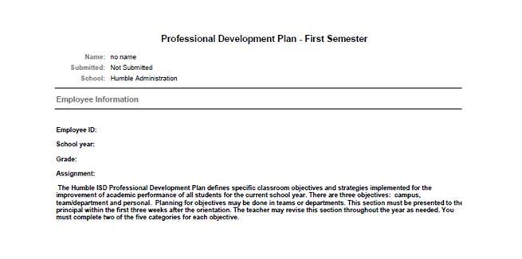

Rev. 4/1/2016 60 | P a g e

Humble ISD
Professional Development Plan
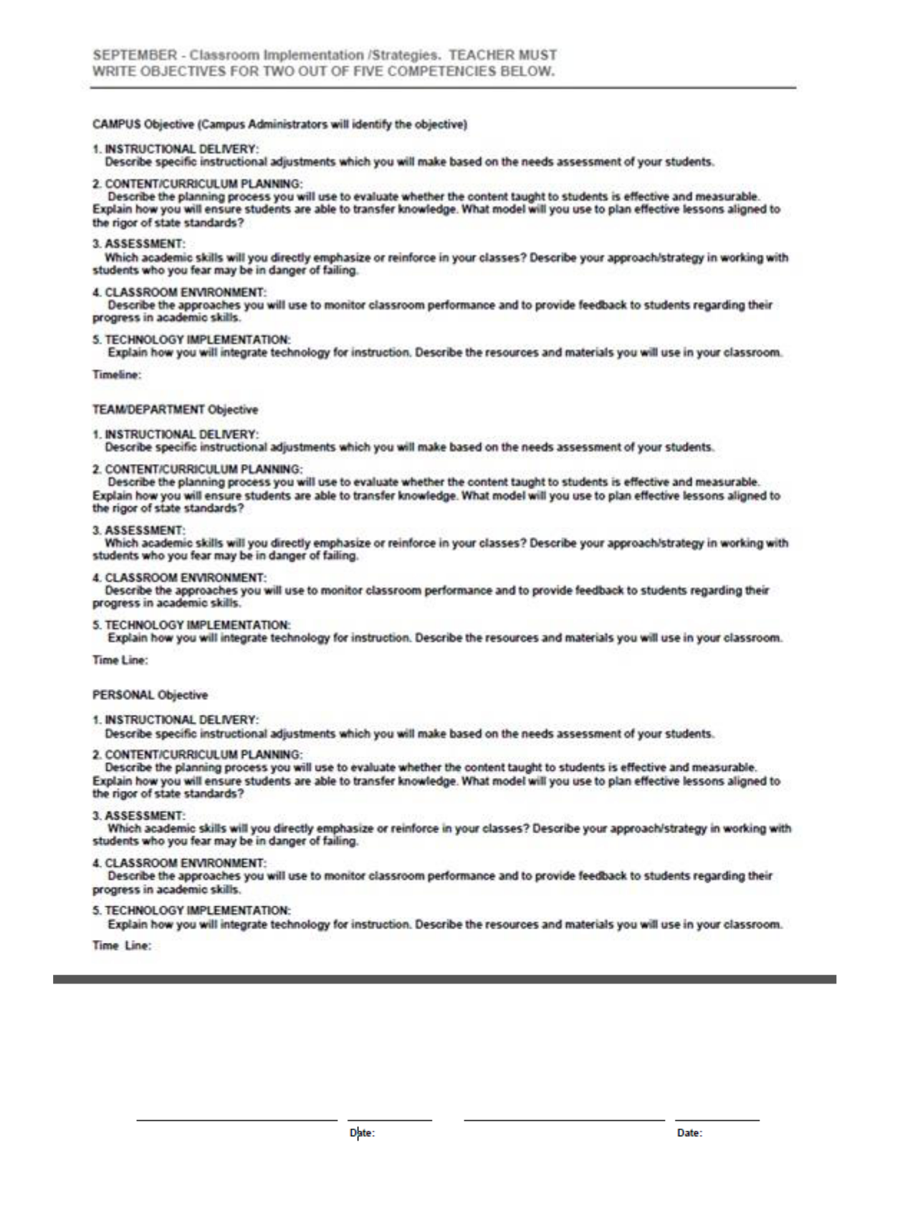

Rev. 4/1/2016 61 | P a g e

Humble ISD
Professional Development Plan
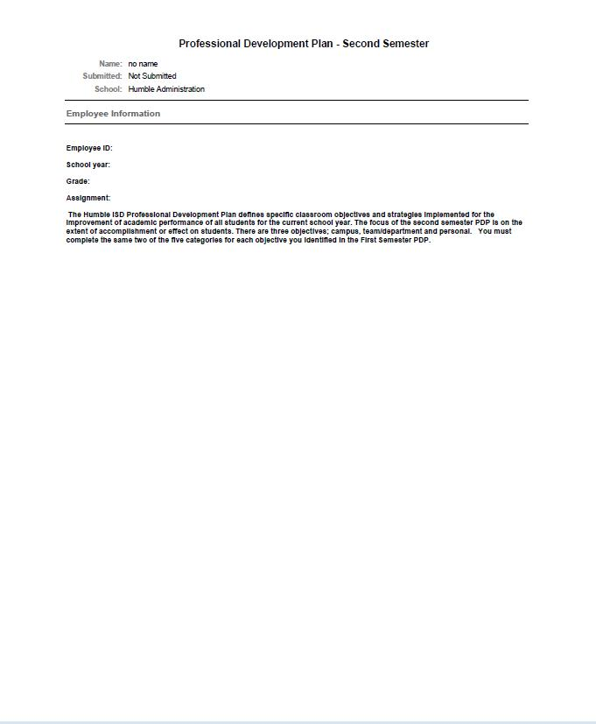

Rev. 4/1/2016 62 | P a g e

Humble ISD
Professional Development Plan
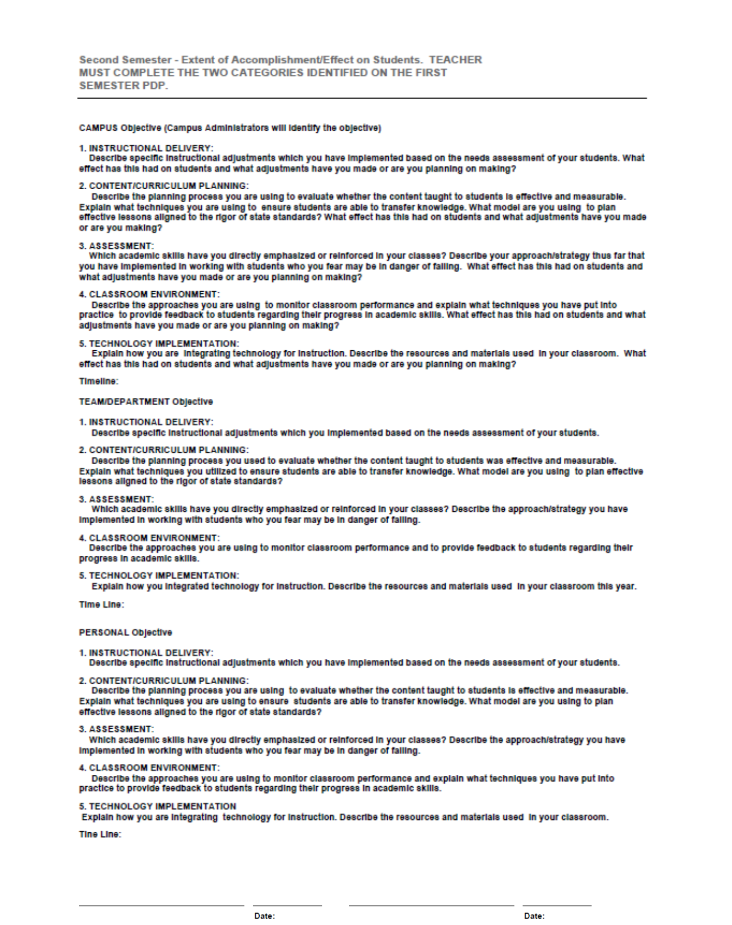

Rev. 4/1/2016 63 | P a g e

Humble ISD
Professional Development Plan
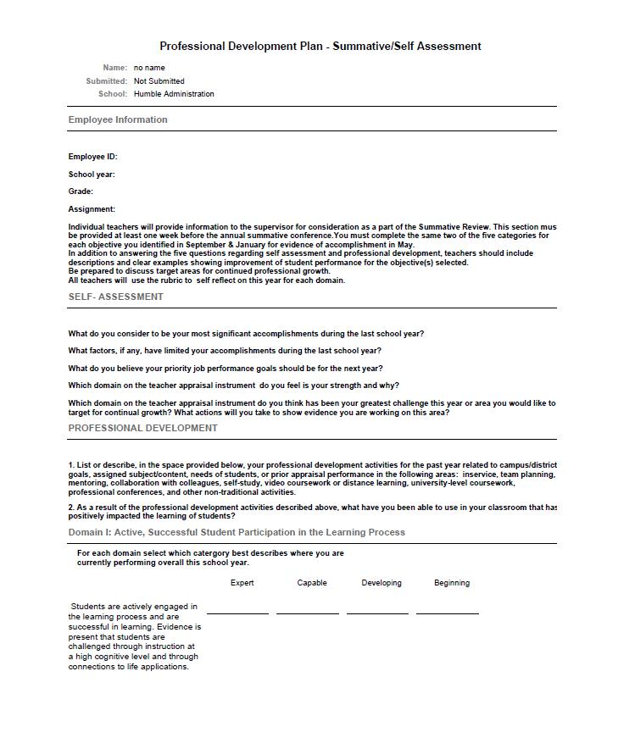

Rev. 4/1/2016 64 | P a g e

Humble ISD
Professional Development Plan
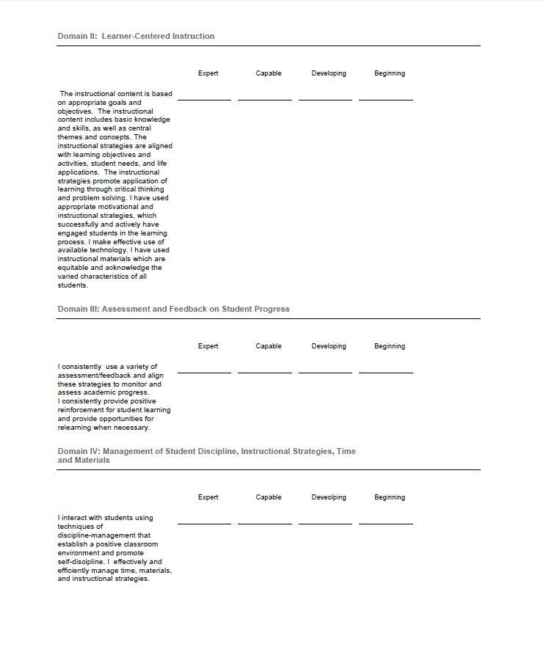

Rev. 4/1/2016 65 | P a g e

Humble ISD
Professional Development Plan
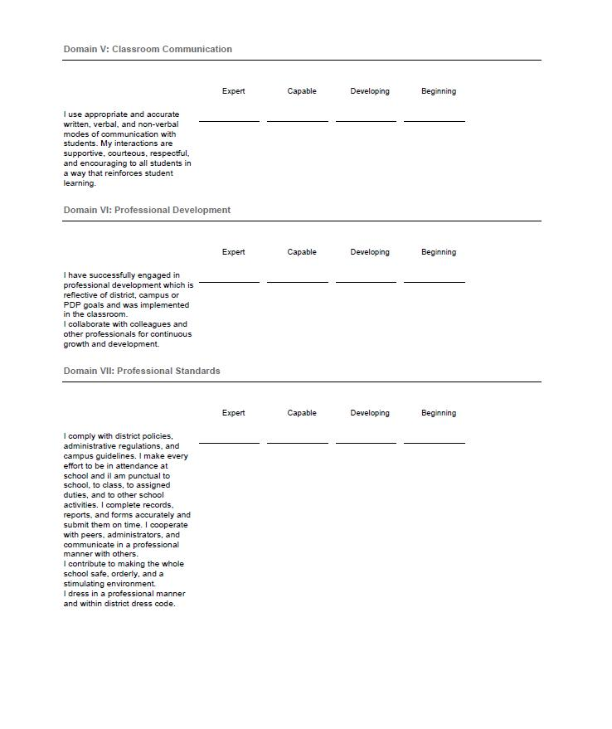

Rev. 4/1/2016 66 | P a g e

Humble ISD
Professional Development Plan
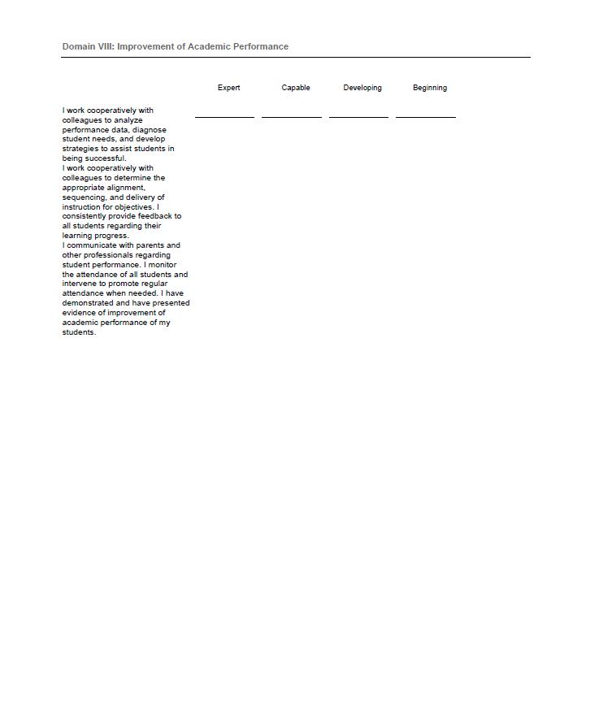

Rev. 4/1/2016 67 | P a g e

Humble ISD
Professional Development Plan
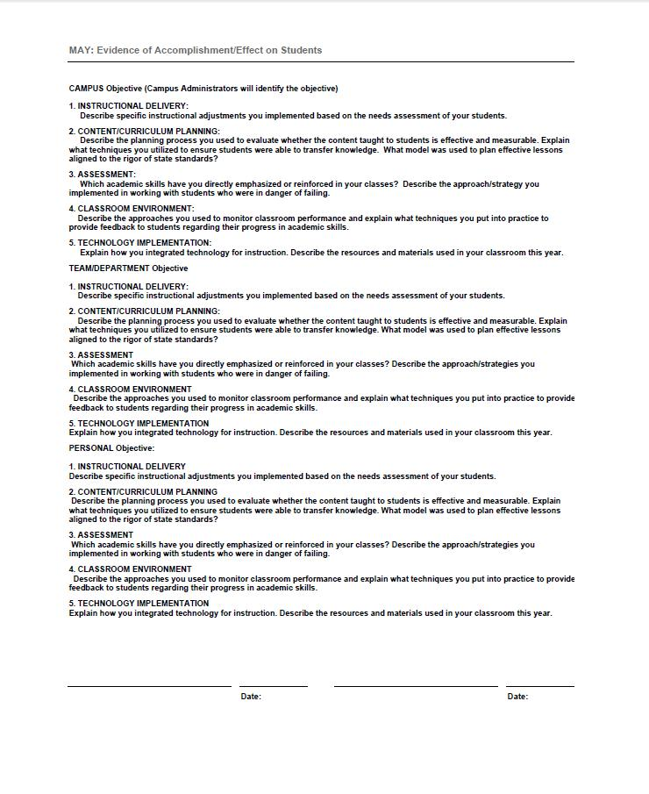

Rev. 4/1/2016 68 | P a g e

Humble ISD
Professional Development Plan

Appendix 9: Lead4Ward Webinar Schedule
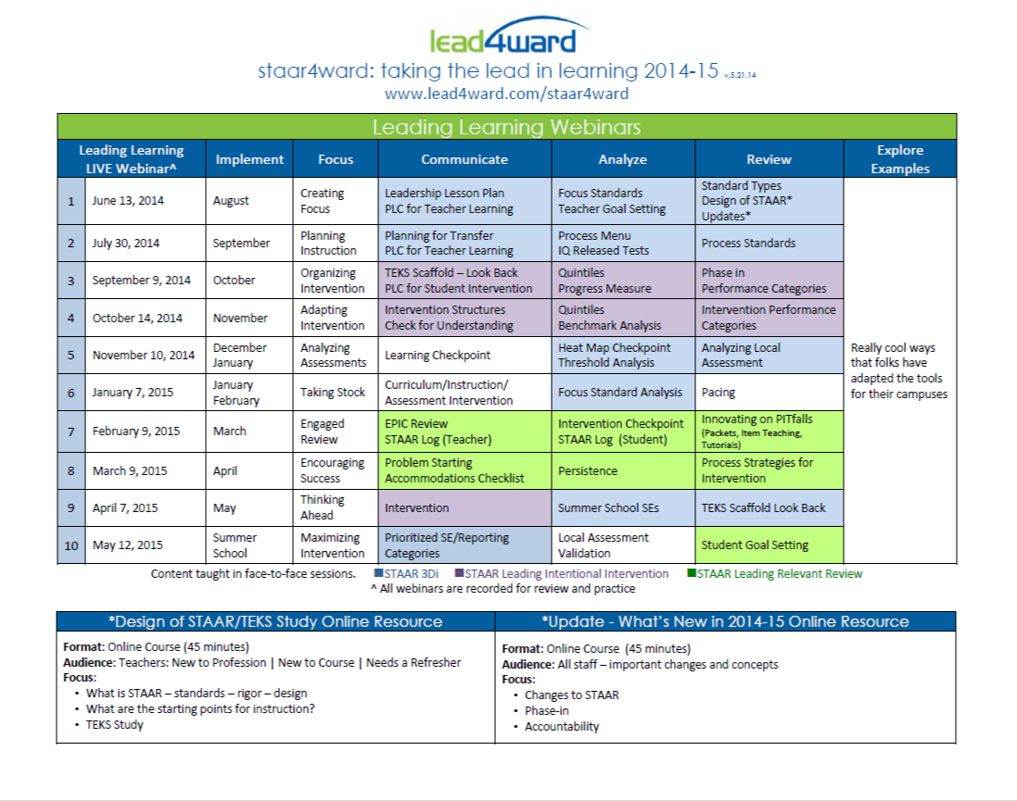

Rev. 4/1/2016 69 | P a g e

Humble ISD
Professional Development Plan

Appendix 10: Example of Department Professional Development Planning Memo

Memo

To: Assistant Superintendents, Department Directors, Coordinators and Specialists

From: Ebell, Steven

- Melissa Leigh, Coordinator of Professional Development Date: 9/23/2015

Re: Planning for Professional Development Sessions for Summer of 2016 and the 2016 – 2017 school year

Attachments: Life cycle of a Course, Professional Development Planning Spreadsheet

It is time for us to begin planning our Professional Development for this upcoming Summer and the

2015-2016 school year. All Professional Development sessions in Humble ISD will follow a consistent process for planning, delivery, monitoring and evaluation. These requirements are in place to ensure that all professional development is of the highest quality and has a lasting impact on employee performance and ultimately results in improved student achievement.

At this time there are several dates still undecided. The state has not released the testing calendar for the 2016 -2017 school year and our district calendar has not been set. Flexibility has to be kept in mind as we plan.

Timeline for 2016-2017 PD Planning

Planning Step | Deadline
Planning Meeting with PD | September 22 – September 30th , 2015
First Draft of PD Plan is Due | October 20th, 2015
Review Meeting with PD | October 20th – 28th, 2015
Final Draft of PD Plan | October 30th , 2015
PD Plan Reviewed by Executive Leadership | November 9th , 2015
Final Revisions | November 16th, 2015
PD Plan released to Principals | December 2nd and 3rd, 2015
PD Plan released to all Staff | December 18th , 2015
All Course Entry for Summer is Due | February 19th 2016
Courses Open for Registration | March 1, 2016
Fall/ Spring Course Entry is Due | May 1st, 2016

Needs Assessment:
Assessment of professional development needs across the district will include the following information:

- Clarification of district expectations for effective organizational, instructional leadership, and teaching that support employee groups in the attainment of student development success.
- A range of data sources that provide information about student performance

- District mission and goals

- Evaluative feedback on prior offerings

Planning for Professional Development

Of all of the professional development decisions made, none is more important than the linkage of efforts to district change and goals. By utilizing a planning framework a common language and planning

Rev. 4/1/2016 70 | P a g e

Humble ISD
Professional Development Plan

sequence will be employed ensuring that a standard process is in place.

Employing a backwards design model, the Humble ISD Professional Development Plan includes a planning framework to guide all campuses and departments in planning quality professional development or all employees. The process includes these concepts:

- Planning for professional development will begin with the end goals for student achievement based on a needs assessment.

- New practices or strategies are matched to the desired student achievement result. Careful consideration is given during the planning process for on-going support from district and campus personnel as the new development strengthens and becomes sustainable.

- Professional development activities build on the knowledge base needed to ensure success with new learning.

- Design of the professional development activities match the best delivery approach with the intended audience and the new skills that will be a result of the development activity.

Use the attached planning framework to guide you as you work through this process. This tool that has been designed to standardize how departments and campuses plan for professional development.

The following chart outlines the areas for consideration as you are planning professional development.
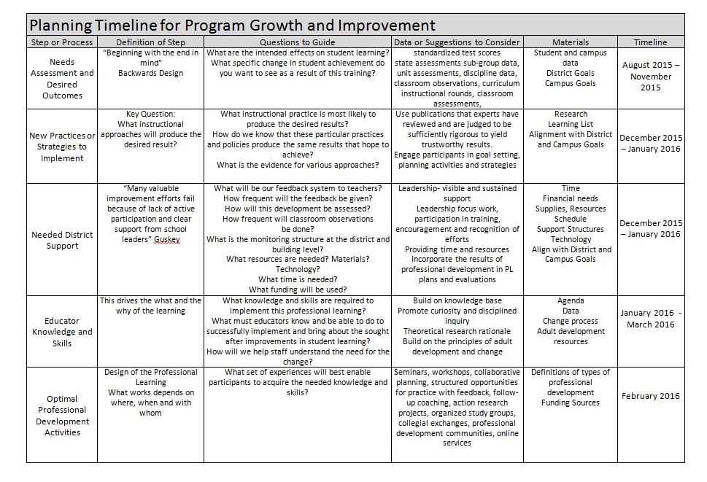

Professional Development can be delivered in many ways. Varying the delivery of your sessions will ensure that you are meeting the needs of the adult learners that you are trying to reach. The modes of professional development currently used in Humble ISD are as follows:

- Blended Professional Development or Flipped Professional Learning: using face to face, digital products or processes, and virtual interaction for ongoing learning;

- Professional Development Communities: a shared vision for running a school in which everyone can make a contribution, and staff are encouraged to collectively undertake activities and reflection in order to constantly improve their students’ performance;

- Job embedded: a learn-try-evaluate cycle that repeats over time, active teacher involvement

Rev. 4/1/2016 71 | P a g e

Humble ISD
Professional Development Plan

and immediate implementation;
- Seminars: events with a central theme, utilizing expert consultants and group participation;

- Workshops: introductory sessions to build awareness, provide basic information, and allow participants to determine future areas of concentration;

- Independent Study: a designated course of study completed independently, including checkpoint evaluation of progress and an end assessment of accomplishment;

- Book Studies: the reading of agreed upon book(s) that may offer insight into the improvement of education (or an aspect of); provide an opportunity to compare those practices that have improved organizations, businesses, and projects; provide an opportunity to keep abreast of the latest innovations that would improve schools and our educational system; and the discussion of the content of the book(s) in regularly scheduled sessions;

- Summer Institutes: events scheduled over (one or more days), offering a menu of sessions revolving around integrated themes, with expert presentations and opportunities for collegial discussion and planning;

- Conferences: local, state or national experiences selected to broaden knowledge and to assess adaptability of outside programs;

- Trainer of Trainers: a strand of concentrated study with a commitment to provide professional development for the District in the area of concentration;

- Pilot Participation: establishment of core teams of teachers and administrators at given sites to implement specific programs or strategies;

- Instructional Coaching: a strand of concentrated study plus a collegial support component that may include modeling, observations, collegial conversations, and reflection;

- Team Development: the training of a group of individuals in a core concept with the responsibility to assist implementation of the concept at the local site level;

- College/University Coursework: a designated course of study for which District or university credit is offered;

- Faculty/Grade level/Department Meetings: held for the purpose of formal study groups or teacher as a researcher of curriculum, instruction, technology and assessment design groups, or interdisciplinary planning or sharing of artifacts or analysis of student work.

Course Entry

Please refrain from entering courses into Eduphoria until after you have attended training. We will be using a standard for course entry, descriptions, course naming, and credits that will allow us to track our professional development offerings more concisely. The attached Life Cycle of a Workshop outlines the steps necessary for course entry and approval.

Assigning Credits

See the Life Cycle of a Workshop document for further information concerning assigning credit to your sessions.

Credit Type | When to use….. | Approval Process
GT | When assigning GT credit to a session portions of the entire session | GT Coordinator
 | need to give participants time to reflect on the new learning and
 | how it can be used to increase the depth and complexity of content
 | for all gifted students the teacher serves. For further information
 | on assigning GT credit please contact the district GT Coordinator.
Bilingual | When assigning credit for professional development that focuses on | Bilingual/ELS and LOTE
 | second language acquisition of English language learning students | Director
 | or non-limited English proficient students participating in a Dual
 | language program model. Methodologies for bilingual professional
 | development shall be research based and address native language
 | as well as English acquisition in grades PreK – 5th. This may include
 | instructional best practices for language transfer.
ESL | When assigning credit for professional development that focuses on | Bilingual/ESL and LOTE
 | second language acquisition of English language learning students. | Director
 | Methodologies for ESL professional development shall be research
 | based and address the acquisition of the English language. This may
 | include sheltered instruction, LEP assessment and program
 | placement/compliance in instruction and program design.

Rev. 4/1/2016 72 | P a g e

 |  | Humble ISD
 |  | Professional Development Plan
LOTE | When assigning credit for professional development that focuses on | Bilingual/ESL and LOTE
 | second language acquisition of a language other than English. | Director
 | Methodologies for LOTE professional development shall be
 | research based and be aligned with the ACTFL standards.
Technology | When assigning credit for professional development that focuses on | No Approval Process
 | Technology where the emphasis is on learning a new technology
 | application or using technology as a strategy to increase student
 | learning. It is important to use this credit to capture all sessions
 | where technology strategies or applications are being taught.
SBEC | SBEC credit should be assigned in addition to on/off contract credit | No approval process
 | so that all professional learning is captured with this credit type.
 | This is not an appropriate credit to attach to meetings where
 | professional learning is not occurring.
Meeting | Meeting credit should be assigned to all department, faculty, and | No approval process
 | committee meetings in which the entire focus is operations or
 | information sharing.
Off – Contract | Off- Contract credit is assigned to any session that occurs outside | No approval process
 | the regular workday for the staff attending or after regular contract
 | days.
On – Contract | On-Contract credit is assigned when the professional development | No approval process
 | session occurs during the regular workday for the staff designated
 | to attend or during the contract period of each school year.
Custom Credit | Custom credit can be awarded for a variety of situations: | No approval process
 | Part of the session occurs before/after the regular workday hours | Use published Humble ISD
 | for the staff attending while a portion of the session occurs during | work calendar days to guide
 | regular workday hours. Please contact the professional | you with awarding custom
 | development office for guidance if you feel it is necessary to assign | credit
 | custom credit.

Training Schedule for Course Entry

Each department will set up a time with the Professional Development Coordinator to come and work with department staff on Eduphoria Course entry procedures.

Evaluation

As we close out current professional development sessions and plan for future ones, the following topics should drive our evaluations and planning for new sessions. Continuous improvement is our goal.

Rev. 4/1/2016 73 | P a g e

Humble ISD
Professional Development Plan
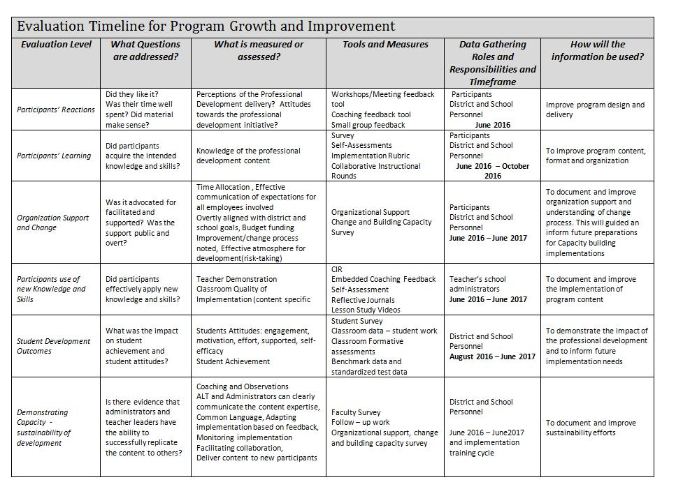

Eduphoria is set to assign a default survey to each course. At this time, this is the avenue that Humble ISD uses to gain feedback from our participants reactions. Our District Survey is a valuable part of the feedback cycle to drive continuous improvement of our professional development sessions.

Rev. 4/1/2016 74 | P a g e

Humble ISD
Professional Development Plan

Timeline for PD Planning and Course Entry
Planning Step | Deadline
Planning Meeting with PD | September 22nd – 30th, 2015
First Draft of PD Plan is Due | October 20th, 2015
Review Meeting with PD | October 20th – 28th, 2015
Final Draft of PD Plan | October 30th , 2015
PD Plan Reviewed by Executive Leadership | November 9th , 2015
Final Revisions | November 16th, 2015
PD Plan released to Principals | December 2nd and 3rd, 2015
PD Plan released to all Staff | December 18th , 2015
All Course Entry for Summer is Due | February 19th 2016
Courses Open for Registration | March 1, 2016
Fall/ Spring Course Entry is Due | May 1st, 2016

Do not hesitate to give me a call at 281-641-8380 or 832-233-4455, if I can help in anyway or if you have questions.

Thank you for working together with the Professional Development Department to plan purposeful professional learning for our employees that will increase rigorous, relevant and engaging learning for all of our students.

Rev. 4/1/2016 75 | P a g e

Humble ISD
Professional Development Plan

Appendix 11: Professional Development Advisory Committee Charter

Professional Development Advisory Committee Charter

Humble ISD Professional Development Advisory Committee

Focus Areas:

Advise on Professional Development offerings District wide.

Advise on the District Professional Development Plan

Advise on the process for planning, evaluating and tracking professional development for all employees

Rev. 4/1/2016 76 | P a g e

Humble ISD
Professional Development Plan

Purpose of the Professional Development Advisory Committee

This charter will outline the scope, objectives and overall approach for the work of the Professional Development Advisory committee. It will be the point of reference for committee goals and objectives, scope, organization, estimates, work plans and proposed budget impacts. In addition, it will serve as an agreement on the scope of the work between the Director of Professional Development and committee members. This document will clearly outline the roles and responsibilities the advisory committee has in regards to professional development of all Humble ISD employees.

Long-Term District Professional Development Initiatives

The Professional Development Department in collaboration with the Leadership Forum supports the following long-term professional development initiatives in Humble ISD:

- Closing the Leadership Gap: The International Center for Leadership in Education (ICLE)
- Closing the Relationship Gap: Ruby Payne

- Closing the Achievement Gap: Lead4ward

These long-term professional development initiatives provide sessions on reflective leadership and coaching, understanding students in poverty with researched-based strategies, and using data to make decisions regarding teaching and learning.

Professional development for all staff is differentiated based on needs and experience and organized into the following organizational structure:
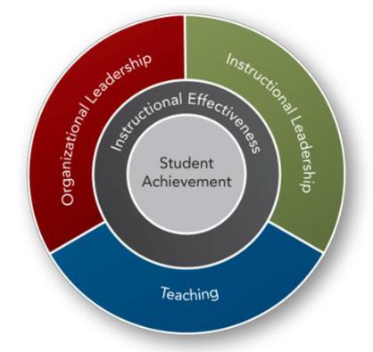

This graphic shows the relationship between student achievement and areas of district support

Daggett System for Effective Instruction

- Organizational Leadership: provides ongoing professional development support to maximize organizational efficiency and effectiveness.

- Instructional Leadership: provides ongoing professional development support to district and campus leaders to ensure the highest levels of student achievement.

- Teaching: provides ongoing professional development for curriculum, teaching and assessment to ensure the highest levels of student achievement.

Rev. 4/1/2016 77 | P a g e

Humble ISD
Professional Development Plan
The Professional Development Advisory Committee will provide feedback to the Director of Professional
Development on implementation of the district initiatives

Executive Summary
- Committee Goals:
o Advise on the Continuum of Learning for all campus and departments in the district

o Advise the leadership forum and district decision making committee of future district wide professional development

o Review data on planning, evaluation, and tracking of professional development offerings o Advise on processes and procedures for the Workshop suite in Eduphoria!

o Advise on refinement of the District Professional Development Plan

- Assumptions

o All members have an understanding of modalities for professional learning o All members have an understanding of adult learning theory

o All members have an understanding of the Standards for Professional Learning

- Timeline

o The PD Advisory Committee will meet at least twice a year o All meetings will be held outside of the school day

Project Overview

Humble ISD maintains a Professional Development Advisory committees composed of representatives from various departments, campuses and programs that serve in an advisory capacity to the Leadership Forum. The Professional Development Advisory Committees will meet a minimum of twice annually to review evaluation data of students’ performance, professional development evaluations, program evaluations and other performance data to determine specific professional development needs within the contact of the District Professional Development Plan. Recommendations from the Professional Development Advisory Committees are presented to the Leadership Forum no later than November of each year to be included in the budgeting/planning process for the coming school year.

Rev. 4/1/2016 78 | P a g e

 |  |  |  |  |  |  | Humble ISD
 |  |  |  |  |  |  | Professional Development Plan
 | Advisory Committee Organization Plans
 | Committee Role |  |  | Committee Member(s) |  |  | Responsibilities
 | Facilitator |  |  | Director of Professional Development |  |  | Facilitate meetings
 |  |  |  |  |  |  | Set agenda and meeting schedule
 | Secretary |  |  | Coordinator of Professional |  |  | Take minutes
 |  |  |  | Development |  |  | Send out reminders about meetings and
 |  |  |  |  |  |  | tasks to be completed
 | Two year staggered term |  |  | 2 Teacher representatives from high |  |  | Attend meetings
 | members |  |  | schools |  |  | Review any needed materials prior to
 | One member of each |  |  | 2 Teacher representatives for middle |  |  | meeting
 | group will be on cycle one |  |  | schools |  |  | Complete assigned tasks
 | of staggered membership |  |  | 2 Teacher representatives from |  |  | Give input on agenda items
 |  |  |  | elementary schools
 | Two year staggered term |  |  | 2 Employees from Operational |  |  | Attend meetings
 | members |  |  | departments |  |  | Review any needed materials prior to
 |  |  |  | 2 Employee representatives from |  |  | meeting
 |  |  |  | Educational Support Services |  |  | Complete assigned tasks
 |  |  |  | 2 Employee representatives from |  |  | Give input on agenda items
 |  |  |  | Curriculum and Instruction Division
 |  |  |  | 2 Employee Representatives from
 |  |  |  | technology
 | Standing member |  |  | Chief Academic Officer/Deputy |  |  | Attend meetings
 |  |  |  | Superintendent |  |  | Review any needed materials prior to
 |  |  |  |  |  |  | meeting
 |  |  |  |  |  |  | Complete assigned tasks
 |  |  |  |  |  |  | Give input on agenda items
 | Standing member |  |  | Assistant Superintendent of Curriculum |  |  | Attend meetings
 |  |  |  | and Instruction or designee |  |  | Review any needed materials prior to
 |  |  |  |  |  |  | meeting
 |  |  |  |  |  |  | Complete assigned tasks
 |  |  |  |  |  |  | Give input on agenda items
 | Standing member |  |  | Assistant of Superintendent of Human |  |  | Attend meetings
 |  |  |  | Resources or designee |  |  | Review any needed materials prior to
 |  |  |  |  |  |  | meeting
 |  |  |  |  |  |  | Complete assigned tasks
 |  |  |  |  |  |  | Give input on agenda items
 | Standing member |  |  | Chief Technology Office or designee |  |  | Attend meetings
 |  |  |  |  |  |  | Review any needed materials prior to
 |  |  |  |  |  |  | meeting
 |  |  |  |  |  |  | Complete assigned tasks
 |  |  |  |  |  |  | Give input on agenda items

Rev. 4/1/2016 79 | P a g e

