SAU 90 - Hampton School District


Professional Development
Plan

2017-2022
Introduction

The mission of the Hampton School District is to provide an encouraging educational environment where the unique talents and abilities of individual students are recognized and the learning experience is meaningful. Every student will achieve mastery through a firm foundation in core fundamentals, higher levels of thinking, problem-solving and critical/creative communication skills.

Creating and sustaining a teacher effectiveness system that enhances student achievement hinges on a well-developed professional development strategy focused on district goals. Currently, professional development is one of the most significant capacity-building investments in our public education system.

Purpose

The Hampton School District values professional development as fundamental to the success of the district. Professional development increases educators’ knowledge and enhances their professional skills, deepens educators’ understanding and appreciation for the varied needs of students and enhances educators’ capacity to facilitate the learning success of all students. This Professional Development Master Plan has been developed to provide the structure and means through which educators continuously enhance their professional competency and simultaneously satisfy the NH recertification requirements enumerated in Ed 512.03. The primary aim of this Master Plan is the enhancement of learning for all students. As a means to that end, the procedures and tools of this plan are intended to facilitate the individual and collective growth of all district educators. This plan recognizes that high quality professional development that improves the learning of all students is:

- driven by the results of a regular and systematic analysis of a variety of data and information on student learning

- focused on the effective implementation of research-based educational practices
- responsive to the unique learning needs and styles of each individual educator

- best accomplished through the development of collaborative learning communities whose goals are aligned with the improvement priorities of the district

Therefore, in conjunction with the New Hampshire Department of Education's Professional Development Master Plan guidelines, a committee was established to develop a SAU 90 Hampton School District Supervision and Professional Development Master Plan.

2

Members of this committee:

Kathleen Murphy, Superintendent – SAU 90
Lois Costa, Principal - Marston School
Timothy Lannan, Principal – Centre School
Jessica Parsons, Director of Pupil Services – SAU 90
Andrea Dutton, Teacher – Hampton Academy
Lisa Wenger, Teacher - Hampton Academy
Allison Bennett, Teacher – Marston School
Amber Levine, Teacher - Marston School

Amy Murphy, Teacher - Marston School
LJ Dutton, Teacher – Centre School
Michelle Witt, Teacher – Centre School

Jenny Salvia, Teacher – Centre School

Review Committee
As needed

School Board Members
Charlotte Ring

Selection to serve on the SAU 90 Professional Development Committee includes one of the following:

- Representation from each building for a five year term

- Membership will be staggered over the five year term with new members phased in yearly

3

SAU 90 Professional Development Committee Responsibilities:

Chair:
- Presides at each meeting

- Prepares agendas for meetings
- Communicates with Local Professional Development Committees
- Calls any special meetings

Secretary:

- Records, publishes and distributes minutes of all meetings to committee members and building principals within two weeks following a meeting

District Professional Development Committee (DPDC):
- Endorses the Professional Development Master Plan

- Processes and/or makes initial approval of CEUs for professional development activities

- Communicates professional development concerns to the SAU 90 Professional Development Committee

- Educates staff to the changes in the new SAU 90 Professional Development Master Plan
- Supports staff members with the Master Plan requirements

School Chair:
- Presides at all school meetings

- Serves as the district representative at SAU 90 Professional Development Committee

Appeals Subcommittee:

- Acts upon grievances relative to professional development that fail approval, CEU assignments, and the goal setting process

Amending the SAU 90 Professional Development Master Plan

Elicit suggestions for changing the SAU 90 Professional Development Master Plan annually as part of our survey. Suggestions can be offered in writing and sent to the chair of the District Professional Development Committee. The committee will review and vote upon the suggestion(s) at the next scheduled meeting.

4

Hampton School District Professional Development Plan

This plan is systematically organized to advance student learning. The domains of Highly Qualified Teachers, Instructional Improvement, Professional Development, and Teacher Effectiveness equally contribute to a continuous improvement model that enables students to achieve their highest potential
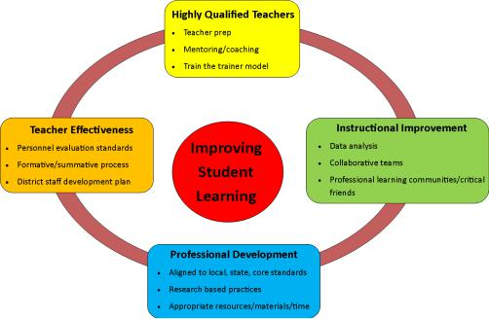

5

SAU 90 Principles of Effective Professional Development

The following principles of effective professional development identified below express our belief that prepared and supported educators help all students achieve a higher level of learning.

Effective professional development:

Focuses on educators as central to student learning

Focuses on individual, collegial, and organizational improvement

Respects and nurtures the intellectual leadership capacities of educators, principals, and others in the community

Reflects best available research and practice in teaching, learning, and leadership and is differentiated in its approach

Enables educators to develop further expertise in subject content, teaching strategies, uses of technologies, and other essential elements to teach to higher standards

Promotes continuous inquiry and improvement and is monitored for quality delivery and is evaluated using data on classroom instruction and student achievement

Is planned collaboratively by those who will participate in, and those who will facilitate that development

Is aligned vertically and horizontally

Requires substantial time and resources that are allocated through a clear district-wide process

SAU 90 GOALS Adopted 9/13/16

Goal #1 – Curriculum Assessment and Instruction – To continue to work toward 100% proficiency in core curriculum content and support an environment of academic challenge for all students.

- Continue the alignment of the curriculum to national standards while making curriculum an active part of teaching every day

- Use current assessments and standards to assist in the development of student reporting systems Preschool through Grade 8

- Incorporate the goals and objectives of the Hampton School District five year Technology Plan

- Continue to work with Winnacunnet High School to facilitate more successful transitions

- Align the Hampton Social Studies curriculum to the national standards

- Develop common assessment, both formative and performance based

Goal #2 – Human Capital Resources – To continue to ensure that the Hampton School District provides the highest quality of personnel to meet the educational, administrative and support needs of our learners.

- Reconsider the functional role (i.e. staffing) of technology in instruction and school operations

6

- Monitor the climate in all three school buildings

- Explore possible teacher leadership opportunities

- Advance working relationships with local higher education to benefit administrator, teacher, and student growth and success

Goal #3 – Communication – To continue to foster strong relationships with students, families and community through effective communication that is built on trust and shared responsibility.

Use multiple and appropriate methods of communication and engagement to reach all stakeholders and all of the various entities of the L community to develop partnerships and shared responsibilities for student success

Renew efforts to work with parents and families of students with special needs

Goal #4 – Governance – To continue to address the critical educational concerns and needs in the school district.

Review and maintain school district policies Complete School Board orientation

Review safety protocols and emergency plans for the district

Goal #5 – Finance and Facility – To continue to align resources to accomplish priorities within a balanced budget.

Identify opportunities for and achieve greater efficiencies through sustainable efforts Implement attainable and affordable recommendations from Safe Routes to School

Travel plan

Consider school safety recommendations and being to address improvements as resources permit

Goal #6 – Academy – To secure public support for a renovation project that addresses the facility

and program needs of Hampton Academy.

- Develop documents for public review that describe and illustrate the needs of the building project

The district is responsible for establishing and distributing its annual and/or long-range goals with specific action plans and timelines for achieving those goals by September 30th based on the analysis of data. This includes collection methods used to evaluate specific practices, partnerships with parents, community, and businesses in the area (see Data Collection Chart).

7

Data Collection Chart

Sources | Collection | Analysis | Decision Making
 | How often, when | Who analyzes, what process | (by school)
SBAC/ NECAP | Annually | Administration, Guidance, | For curriculum and instructional
Science / DLM |  | Educators | improvement
Curriculum Based | On-going | Administration, Guidance, | For curriculum and instructional
Assessments and |  | Educators | improvement
Performance Tasks
/Common
Assessments
Report Cards / | Tri-annually | Administration, Guidance, | For curriculum and instructional
Fountas & Pinnell |  | Educators | improvement
Benchmark / STAR |  |  | Track progress over time
Student needs | On-going | Administration, Guidance, | Monitoring individual student
assessment |  | Educators | performance and safety
(e.g. attendance, |  |  | Track progress over time
retention, behavior
incident, health &
wellness)
504, ESOL, Title I, | On-going | Administration, Guidance, | For curriculum and instructional
Special Education, |  | Educators | improvement
McKinney-Vento
Enrichment | On-going | Administration, Guidance, | For curriculum and instructional
opportunities |  | Educators | improvement
Parent/ Community | On-going | Administration, Guidance, | For curriculum and instructional
Input: |  | Educators | improvement, student safety
(forums, surveys,
PTA meetings,
District & Building
Committees, Parent-
Teacher
Conferences)
Portfolios | On-going | Administration, Guidance, | For curriculum and instructional
 |  | Educators | improvement
Teacher Supervision | On-going | Administration, Guidance, | For curriculum and instructional
and Evaluation |  | Educators | improvement, educator goal-
Model |  |  | setting

8

Analyzing and Using Data to Make Decisions Regarding Student Learning Needs

SAU 90 educators analyze the strengths and weaknesses evidenced in the data sources referenced in the Data Collection Chart. The results of the data points are reported to the local school faculties and School Boards. School leadership groups, in collaboration with educators, will work to identify specific professional development needs based on the information. The district’s budget includes provisions for professional development along with federal entitlements.

The process for making instructional program recommendations and for planning professional development activities will follow the steps outlined below:

- Data is collected and analyzed

- Learning goals are developed by using the Self-Assessment Worksheet to determine strengths or needs, and then prioritized.

- The District Leadership teams prioritize goals taking student achievement, time, and resource constraints into consideration.

- Goals are disseminated to staff by October 1st to be used in their self-assessment and in preparation of their Individual Professional Development Plans (IPDP). Individual staff members develop their IPDP by October 31st.

- Individual Professional Development Plans provide opportunities for educators to gain expertise in the areas of planning and preparation, classroom practice, classroom climate and the school’s role and organization as outlined in the SAU 90 Evaluation and Supervision protocols; as well as to meet their needs in addressing District/School priorities.

- Student outcomes are measured by assessment data as previously outlined.

IPDP plans are revised, if necessary, based on new opportunities/needs, student learning outcomes, and the SAU 90 Evaluation and Supervision protocols.

In order to evaluate the impact of the professional development activities on student achievement, all staff will complete a Goals Reflection Form to assess the effectiveness of their activities towards achieving their goals.

Information from the Data Collection Chart allows SAU 90 educators to:

- improve instruction and advance student learning

- provide feedback to students and parents

- use this data as one measure of accountability

- identify professional development needs

- increase sharing of effective practices among teachers

- drive curriculum renewal

- focus on what students still need to know

- support continuous development

9

SAU 90 Individual Professional Development Planning Process

 | Option 1 |  | Job Embedded Option
 | Traditional Model |  | Action Plan Model
1. | Staff member does self-reflection (Self-Reflection |  | 1. Staff member does self-reflection (Self-Reflection
 | Worksheet) |  | Worksheet)
2. | Review District/School Goals | 2. | Review District/School Goals
3. | Develop Individual Professional Development Goals | 3. | Develop Individual Professional Development Goals
4. | Identify specific activities to achieve goals | 4. | Complete the Job Embedded Professional Development
 |  | Application
5. | Write, then review plan and Individual Professional | 5. | Meet with your administrators for approval
 | Development Goals with supervisor, by October 31st
6. | Carry out plan | 6. | Review your timeline and meet in accordance of your
 |  | IPDP.in your plan
7. | Complete a Goals Reflection upon completion of | 7. | Agree on CEU hours` with your administrator
 | activities by May 31st
8. | Track activities on a Cumulative Record Form | 8. | Share out your experience and findings to staff.

* Option 1 and Job Embedded Option can be combined

All persons who select the Job Embedded Option should assemble a professional support team. The only support team requirement is the inclusion of a building administrator.

10

Process for Developing Your Individual Professional Development Plan (IPDP)

This process has been developed in accordance with ED 512.03

See MyLearningPlan.com instruction sheet to complete online entry of activities

- Familiarize yourself with the SAU 90 Goals, your District Improvement Plan, and your building goals

  - SAU 90 Goals are a result of collaboration between educators, administrators, the School Board, and the community.

  - Your District Improvement Plan is the result of various efforts in your local school district represented by professional staff, school board, administration, and community members. This plan is a document which identifies the improvement goals, the data that support the need for those goals, the action designed to meet or achieve the goals, and the criteria for success. It has also been submitted to the New Hampshire Department of Education for the purpose of accessing grants.

  - Individual school building goals have been established with staff and administration input relative to the identified needs of the building in relation to the district goals.

  - It is important for you to align your Individual Professional Development Plan with the SAU , and school goals.

  - Each certified educator shall develop an individual professional development plan consistent with the educator’s certification. This plan shall:

  - Focus on increased student performance
  - Satisfy requirements for certification - ED 610.02 a-I
  - Be directly linked to the goals of the district

  - Reflect the content of the district’s curriculum and National Common Core Standards, as related to an individual’s proficiency

  - Address educator competencies
  - Include activities for professional growth
  - Include an evaluation component based on data or other collected evidence

- Develop Your Individual Professional Development Goals

● Refer to your previous year Goals Reflection Form and any other individually specific data to develop goals based on your needs and those of your students that align with the district and school goals. These goals need to be very specific and should include a purpose and an outcome that can be demonstrated with evidence.

- Identify Specific Activities to Achieve Goals - see Activities section

- Write your PD Goals Form (IPDP) by October 31st
● Draft your responses on the appropriate PD Goals form on My Learning Plan (IPDP) ● Review your draft plan with your supervisor

● Make any revisions necessary

- Implement Specific Activities to Achieve Your IPDP Option 1:

● Document the completion of the specific activities you select to help you achieve your goals.

11

    - Complete Professional Development CEU Approval Form within 90 days of activity (summer work will be submitted no later than December 1)

  - Share the PD Goals Form with your supervisor as part of your summative evaluation.
Use it to develop your subsequent year’s goals.
    - By May 31st of each year, complete your PD Goals Reflection and revise/update goals as needed (Professional Development Goals Reflection and Evaluation Form).

  - Use My Learning Plan to maintain records for Recertification

      - Individuals will be personally responsible for maintaining your certification and for recording your professional development CEUs into My Learning Plan.

    - The SAU 90 Personnel Office will send out a reminder to principals in September of the year your certification expires.

    - By April 15th of your recertification year submit a Portfolio of professional development activities from My Learning Plan separated by field of specialty and other.

- Submit the Goals Reflection and Evaluation Form to your supervisor by May 31st . Use it to develop/review your subsequent year’s Individual Professional Development Goals sheet

(IPDP). If you are a non-continuing contract employee or if it is your certification year you will meet with your supervisor prior to end of the school year.

Suggestions for Questions to Help Write
Your Individual Professional Development Plan

What are the goals and desired outcomes? (BE CLEAR) What would you see if you were successful? What would you have changed and for whom?

What are the most important outcomes to assess and why?

What knowledge, skills, strategies, and dispositions are you looking for?

How can these important outcomes be measured? Include interviews,

observations, products, analysis, performance tasks, or focus group results. How can evaluation contribute to the continuation of your growth and that of
your students?

12

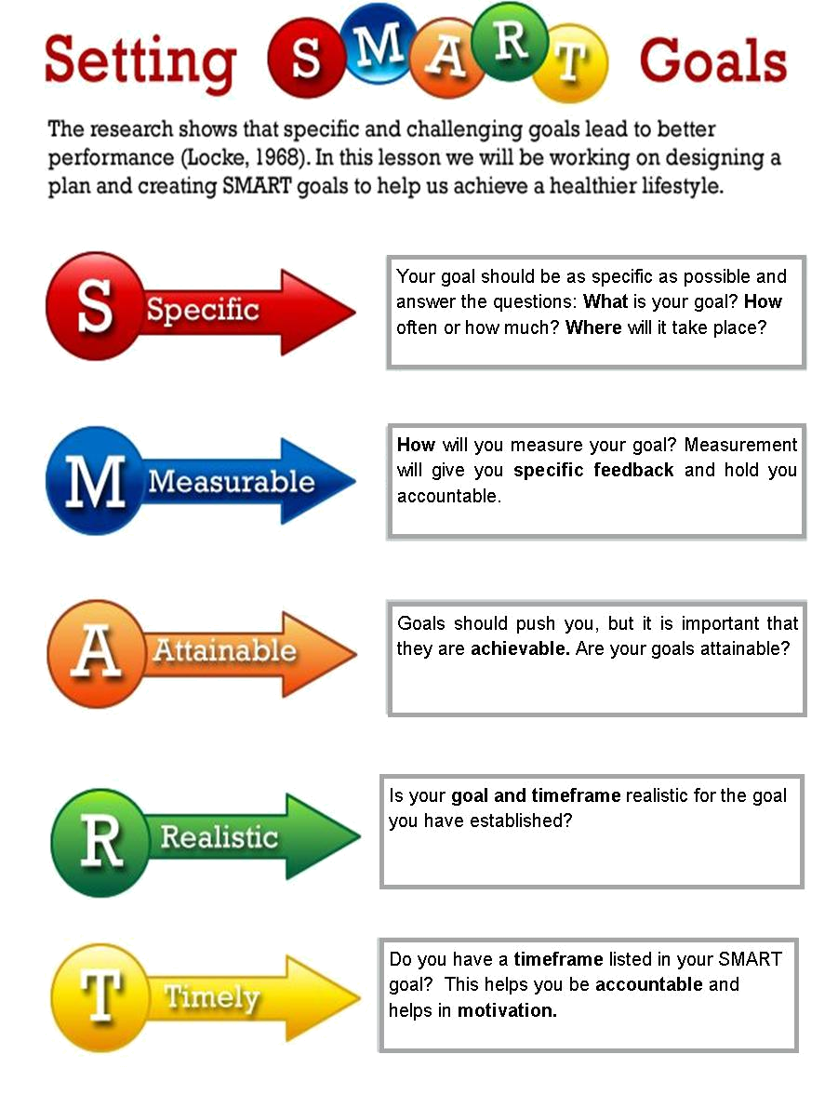

13
Summary of Recertification Requirements

The State Board of Education mandates that each school district in New Hampshire will be responsible for overseeing the recertification of all professional staff members. The Professional Development Master Plan is designed to help professional staff members meet recertification requirements.

The Plan includes:

  - Knowledge of all subject and content areas taught and field(s) of specialization for which recertification is sought

  - Activities or efforts to reinforce school or district improvement goals or both

  - Activities or efforts focused on increasing student achievement

  - Knowledge of effective, developmentally-appropriate teaching strategies and best practices for the subject and content areas taught and for which recertification is sought; and

- Activities that promote continuous improvement in exercising professional responsibilities and obligations

The example below highlights another possible method for certification.

Example 1: A professional staff member with one endorsement needs 75 clock hours with 30 of those hours in his/her knowledge or subject or field of specialization. The remaining 45 hours can be achieved from the above (a-e).

Endorsement Area x 30 hours (component 1)

30 hours

Other areas (a-e) 45 hours

75 hours

In accordance with ED 512.06 certified paraprofessionals who are employed by the SAU shall be required to have a minimum of 50 hours in areas determined by the school or district of their employment.

How to Complete Professional Development Requirements: Option 1

To complete the minimum of 75 clock hours in accordance with ED 512.03 (a) (4) professional development activities should be in the major professional development components as listed below:

- Knowledge of subject and content areas taught and field(s) of specialization for which certification is sought

- Knowledge of effective, developmentally-appropriate teaching strategies and best practices for the subject and content areas taught for which recertification is sought

- Knowledge of learners and learning

14

Professional Development Activity Choices for Option 1

Professional development activities have been outlined in the following 15 experiences that can aid the professional in developing a growth plan that meets their unique goals as specified during the goal-setting process. A focus on building knowledge and in fulfilling ED 512.02 is inherent to all the activities. Some activities fulfill some purposes better than others. All activities selected must be included in the staff member’s approved Individual Professional Development Plan. Individual plans may be amended as needed with the approval of the individual’s principal’s or supervisor’s approval.

You will receive CEUs based on meeting the requirements of the professional development activities. There are four different purposes that these activities can be grouped into:

- Includes activities that focus on developing awareness. These activities are designed to raise awareness through the introduction of new information

- Includes activities that help teachers translate new knowledge into practice

- Includes activities that focus on practicing new methodologies that improve teaching and learning

- Includes activities that provide opportunities to reflect on teaching and learning.

Activities:

Activity | Description | Hours Awarded | Completion/
 |  |  | verification
 |  |  | Requirements
1. Study in Content | This category provides opportunities for | Up to 30 CEUs | Professional
Area or Externship | teachers to engage in learning what they are | per certification | Development CEU
 | expected to practice in their classrooms. For | area will be | Approval Form
 | their own professional growth, teachers need | awarded per 3 | Detailed Log and
 | to have authentic experiences outside of the | year cycle. | Evidence must be
 | classroom; changing teachers’ conceptions of |  | submitted before any
 | the nature of learning and teaching. These |  | hours will be
 | experiences in each teacher’s particular field |  | awarded.
 | of study allow the teacher to learn the content,
 | process, culture, and ethos of their subject
 | matter. This type of professional development
 | is best suited for summer work/activities,
 | where teachers can become part of a team in a
 | business or research setting and bring the
 | experience back to the classroom.
2.Curriculum | Curriculum is the way content is designed and | Up to 30 CEUs | Professional
Development, | delivered. Putting new curriculum into | per content area | Development CEU
Implementation, | practice in the class can serve as a powerful | can be awarded | Approval Form must
and Refinement | professional development opportunity. | per 3 year cycle. | be submitted before
 | Through using a particular curriculum with |  | any hours will be
 | students, reporting on what happens, and |  | awarded.
 | reflecting with others on different ideas and
 | activities, teachers can learn about their own |  | Detailed Log and
 | teaching and their students’ learning. |  | Evidence must be
 |  |  | submitted before any

15

 | New curriculum units provide an alternative |  | hours will be
 | experience with traditional topics or introduce |  | awarded.
 | new topics that are not currently part of the
 | curriculum. New units must meet the
 | following criteria:
 | Teach important competencies as
 | recommended by the Hampton School District
 | curriculum, be grade level appropriate and be
 | accessible to all students
 | Curriculum development includes the
 | processes of design, enhancement,
 | differentiation, and refinement.
3.College or | College level course aligned with the | 15 hours per credit | Certificate of
University Courses | educator's content area, professional |  | attendance/
• Traditional | responsibilities, or teaching assignment and |  | attendance roster and
• Online | offered by an accredited institution of higher |  | evaluation/reflection
• Hybrid | learning. |  | completed on My
 |  |  | Learning Plan/ Oasys
 |  |  | An official hard copy
 |  |  | transcript and/or
 |  |  | grade report must be
 |  |  | sent to the SAU
 |  |  | upon completion.
 |  |  | An overview of
 |  |  | learned knowledge
 |  |  | to be shared with
 |  |  | colleagues/ teaching
 |  |  | team/ staff
4.Workshops, | Activities that are aligned with School/District | Equal workshop | Certificate of
Seminars, | goals and the educators' teaching assignment | contact | attendance/
Institutes, | and/or area of certification. | Participation | attendance roster and
Conferences |  | Hours | detailed log
 |  |  | Evaluation/reflection
 |  |  | completed on My
 |  |  | Learning Plan/Oasis
 |  |  | An overview of
 |  |  | learned knowledge
 |  |  | to be shared with
 |  |  | colleagues/teaching
 |  |  | team/staff
5. Action Research | Examining one's own teaching or professional | Not to exceed 30 | Request for approval
 | practice and its impact on students by | hours | and
 | engaging in a research project involving |  | evaluation/reflection

16

 | current student performance and/or school |  | completed on My
 | programs |  | Learning Plan/Oasis
 |  |  | Documentation of
 |  |  | research and
 |  |  | conclusion to be
 |  |  | maintained by staff
 |  |  | member
 |  |  | An overview of
 |  |  | learned knowledge to
 |  |  | be shared with
 |  |  | colleagues/teaching
 |  |  | team/staff
6. Examining | Educators examine student work to understand | Up to 30 CEUs in | Professional
Student Work and | thinking and learning strategies in order to | a 3-year cycle, per | Development CEU
Outcomes | identify learning needs and the appropriate | certification. | Approval Form
 | teaching strategies to meet those needs. |  | Evidence reflecting
 | Examples include: rubric development, review |  | student change and
 | of national, state and district test results, or |  | growth.
 | examining student work collectively. These
 | examples lead to sharing standards that will
 | guide instructional practices. This includes
 | work beyond the usual job related teaching
 | responsibilities.
7. Professional | Participating on any School/District | Up to 10 CEUs | Request for approval
Committee Work | Committee designed to further the education | per committee per | and
 | of the students, staff & community. | year | evaluation/reflection
 |  |  | completed on My
 | Curriculum Committees, Teacher |  | Learning Plan/Oasis
 | Effectiveness, Etc. |  | An overview of
 |  |  | learned
 |  |  | knowledge/group
 |  |  | determinations to be
 |  |  | shared with
 |  |  | colleagues/ teaching
 |  |  | teams/staff/district
8.Professional | Direct supervision of an Intern candidate | Up to 30 CEUs | Professional
Mentoring & | working towards certification from an | per year | Development CEU
Coaching | accredited teacher preparation program |  | Approval Form
 | or working one on one as a mentor with
 | another professional to assist in improving |  | Detailed Log
 | their instructional strategies. The mentor will |  | reflecting mentorship
 | be involved in the scheduling that will allow |  | and accomplishments
 | for multiple observations where the goal is |  | or certificate from
 | focused on improving teaching strategies. |  | sponsoring
 |  |  | institution.
9. Student | Educators can serve as a mentor/advisor to an | Up to 15 CEUs | Professional

17

Mentoring | at-risk student within the structure of a school | per year. | Development CEU
 | program. |  | Approval Form,
 |  |  | Detailed Log
 |  |  | reflecting mentorship
 |  |  | and accomplishments
 |  |  | or certificate from
 |  |  | sponsoring
 |  |  | institution.
10.Professional | A network is an organized professional | 10 CEUs per year | Professional
Networks | community that shares a common purpose. | for each | Development CEU
 | Teachers join networks to share their own | organization, up to | Approval Form
 | knowledge and experience. In education, | 30 CEUs for | Certificate of
 | these networks are organized to improve | serving as a board | attendance, letter of
 | instructional practices and address student | member | recommendation, or
 | needs as well as support school reform. The |  | meeting notes
 | most important elements of maintaining a |  | *Credit for this
 | network are to keep people engaged and |  | activity will be
 | connected. Effective networks are discourse |  | awarded to those who
 | communities that enable teachers to meet |  | demonstrate active
 | regularly (either in person or electronically) to |  | involvement by
 | solve problems, consider new ideas, evaluate |  | serving on board
 | alternatives, or reflect on specific issues in |  | committees or
 | education and content area. Examples of |  | attending meetings
 | networks include active membership in such |  | regularly.
 | organizations as NCTM, ASCD, NELMS,
 | NHASP, NEA, PTAN, ISTE, NCTE, etc.
11.Developing/ | This activity designates teachers, | Up to 25 CEU per | Professional
Presenting | administrators, or other school personnel as | certification* | Development CEU
Educational | leaders. Teachers who develop or present |  | Approval Form
Workshops or | workshops increase their own knowledge and | CEU Award: for | Copies of
College Courses | skills. These individuals are responsible for | each hour of | presentation
 | preparing others to use new programs, | presentation, a | materials,
 | strategies, concepts, or participate in change | maximum of 5 | program/agenda,
 | Teaching a course related to the educator's | CEU’s of | attendance
 | area of certification or to the professional | CEU’s of | verification /
 | area of certification or to the professional | preparation will be | verification /
 | responsibilities of educators | preparation will be | documentation.
 | responsibilities of educators | awarded. For a | documentation.
 |  | repeated workshop,
 |  | presenters will
 |  | receive CEU’s for
 |  | the equivalent of
 |  | additional
 |  | presentation time
 |  | plus one CEU for
 |  | preparation per
 |  | additional
 |  | presentation hours
12. Professional | This activity provides opportunities to reflect | Up to 15 CEUs | Request for approval

18

Readings, Video | on teaching and learning through professional | per year per | and
and Audio Tapes, | journals, books, videos, Internet, and audio | certification | evaluation/reflection
Webinars | tapes. This allows educators to raise |  | completed on My
 | awareness through the introduction of new |  | Learning Plan/Oasis
 | information and to build on existing |  | An overview of
 | knowledge. An increased understanding of |  | learned
 | information specific to the content areas of |  | knowledge/group
 | teaching methodologies will be gained. |  | determinations to be
 |  |  | shared with
 |  |  | colleagues/ teaching
 |  |  | teams/staff/district
 |  |  | Detailed log
13. Publication | Publication directly related to best practices in | Up to 45 CEUs | Professional
Related to the | the educator's area of certification, | annually | Development CEU
Education | professional teaching responsibilities and/or |  | Approval Form End
Profession | School/District goals |  | Product is the
 |  |  | published article with
 |  |  | verification of
 |  |  | publication date.
14. Developing | Developing community or business | Up to 10 CEUs | Professional
community or | partnerships Working in a collaborative | per activity and/ or | Development CEU
business | partnership with community, business, | per year. | Approval Form
partnerships | industry, higher education or social service |  | Copies of
 | agencies to improve the educator's knowledge | *You cannot get | presentation
 | of content, practical application, career | hours for the same | materials,
 | opportunities, or community resources to | activity done each | program/agenda,
 | advance student achievement | year. | attendance
 |  |  | verification /
 |  |  | documentation.

19

Possible Forms of Documented Educator Evidence

Evidence of Activities | Evidence of |  | Evidence Used to | Evidence Used to | Suggestions for
 | Educator's Learning |  | Examine Impact on | Examine Impact | Evidence
 |  |  | Students' Learning | on Other Student | Collection
 |  |  |  | Outcomes
 |  |  |  |  | (Portfolio of
 |  |  |  |  | Work)
• Curriculum | • Written reflection | Results of: |  | • Discipline data | • It's not just about
documents, lesson | • Oral | • | standardized | • Attendance data | what you did; it's
plans, log of activities | reflection/explanation | assessments |  | • Health | about what you
and time | with a supervisor, | • classroom |  | records/visits to | learned
• Meeting dates, | colleagues, PLCs, | assessments |  | the nurse | • It's about
attendance list, | mentor | • Examples of |  | • Behavior records | working to
discussion notes, book | • Application of new | student projects, |  | • Other | "improve" rather
titles, copies of student | methods and/or | papers, daily work |  |  | than trying to
work | materials exhibited | • | Student portfolios |  | "prove"
• Research plan, data | through unit plans, | • | Video of students |  | • Less is more -
collection, analysis and | instructional | presentations or |  |  | make a concise
interpretation of results | materials, video of | activities |  |  | collection of
• Syllabus, papers, | lessons, formal | • Skill inventories or |  |  | carefully selected
projects, transcript | observation by | checklists |  |  | evidence
• Handouts and other | supervisor, mentor, | • | Anecdotal notes |  | • Pick illustrative
materials, certificate of | colleagues, PLCs |  |  |  | examples rather
attendance | • Samples of students' |  |  |  | than including
 | work |  |  |  | everything
 | • Projects, papers, etc. |  |  |  | • Avoid creating a
 | from courses |  |  |  | "scrapbook" (a
 | • Other |  |  |  | collection of
 |  |  |  |  | personally
 |  |  |  |  | meaningful
 |  |  |  |  | mementos)
 |  |  |  |  | • Avoid creating a
 |  |  |  |  | "steamer trunk"
 |  |  |  |  | (container stuffed
 |  |  |  |  | with materials)
 |  |  |  |  | • Use technology
 |  |  |  |  | to record students'
 |  |  |  |  | projects, students'

20

How to Complete Professional Development Requirements:
Job Embedded Professional Development

Teachers may choose to complete a job embedded activity that is grounded in day-to-day teaching practices and is designed to enhance their content-specific instructional practices with the intent of improving student learning. The activity must be school or classroom based and integrated into the workday, consisting of teachers assessing and finding solutions for immediate, authentic problems of practice. The activity must be aligned with state standards and school and district goals.

The teacher must develop a plan that clearly identifies the job embedded activity to be implemented. The teacher will determine the duration of the plan with his direct supervisor. The supervisor and the teacher will identify the amount and quality of professional development credit that will be earned for the activity. The plan must identify regular and consistent documentation that will monitor the progress and effectiveness of the activity. The teacher and supervisor will schedule regular meetings to assess progress and review documentation. Upon completion of the activity, the teacher will share his experience and findings with staff members in an effort to contribute to the development of all teachers.

The teacher must assemble a professional support team that consists minimally of the teacher’s direct supervisor. The role of the support team is to provide honest, constructive feedback and support to aid in a successful learning experience for the teacher.

Professional Support Team Members & Support Roles |  | TEAM MEMBER

Administrator(s) responsible for supervision at building level

A peer (a least one) who knows how I teach and manage my work

Individual skilled at organization and follow-through

Individual skills in using and interpreting student data

An educator whose skills and knowledge I admire

Colleague willing and able to be a critical friend

Examples of job embedded activities include, but are not limited to:

Action Research-Teachers participate in a systematic investigation of teaching practice. Coaching- focus on the technical aspects of instruction.

Critical Friends Groups-Teachers meet and analyze each other’s work, including artifacts such as student work, lesson plans, or assessments.

Data Teams/Assessment Development-Teachers meet and analyze the results from standardized tests or teacher-created assessments. Together they formulate what the evidence from the data tells them about student learning and discuss teaching approaches to improving learning.

21

Examining Student Work/Tuning Protocol-Teachers examine student work to develop a common understanding of good work and evaluate teaching methods.

Lesson Study-teachers alternate in preparing a lesson to demonstrate a specific teaching and learning goal. Other teachers observe and document what they see. After the lesson, the teachers meet and discuss the strengths of the lesson and provide suggestions for improvement.

Mentoring- Peer support for teachers as they gain experience in the teaching field.

Portfolios-Teachers assemble lesson plans, student work, reflective writing and other materials that are used to prepare for teaching or are used directly in the classroom. The teacher will present the portfolio to a group of peers and/or a coach.

Professional Learning Communities-Teachers collaborate to analyze their practice and discuss new strategies and tactics, testing them in the classroom and reporting the results to each other.

Study Groups-Teachers read and react to educational research or other literature on teaching and student learning. The topics are directly related to school improvement goals or student data.

Appeal Process:

If you are dissatisfied with a decision of your Local Professional Development Committee, you must submit a Right of Appeal Form along with three copies of your Denied CEU Approval Form with copies of your Individual Professional Development Plan attached to each to the SAU Professional Development Committee within 15 days of receipt of the decision.

The SAU 90 Professional Development Committee Chair will convene a committee of a minimum of three members of the SAU 90 Professional Development Appeals Committee including at least one administrator to review your request.

A meeting will be set within 10 school days and the appellant must be present at the review. (Note: The appellant and the PDC Appeals Committee have the right to have a union representative present at the meeting.)

If the decision of the PDC Appeals Committee is unacceptable, the appellant may request review of the case by the Superintendent. Two copies of the Right of Appeal Form and Denied CEU Approval Form must be sent to the Superintendent of Schools within ten days of the Professional Development Appeals Committee’s disposition. The decision of the Superintendent is final and binding.

22

Credit Conversion

SAU 90 allows for CEU hours to be converted to college credit hours for the purpose of salary advancement at the rate of 15 hours equivalent to one college credit. Up to 105 hours may be converted in each five-year Professional Development Master Plan period and only once per track advancement. Conversion hours must be earned while under the SAU 90 contract. Any hours for which an employee is paid may not be used for conversion. See Application for Credit Conversion form to apply for credit conversion. A meeting must be set up with your Professional Development Chair for prior approval before submitting conversion hours to the Superintendent.

Conversion of Continuing Education Units to Graduate Credit

The purpose of using continuing education units for graduate credit, which may or may not result in and advancement on the salary scale, is defined by the following criteria:

- Continuing education units (CEUS) are earned beyond the regular work day/year of the classroom teacher

- Hours spent have not been compensated through a salary or stipend designated by SAU 90 or any other sponsor.

- Activities less than one hour will need to be combined to whole hours for submission purposes.

*Graduate Coursework and Online graduate courses will already contain graduate credit.
Examples of acceptable credit conversion activities |  | Examples of CEUs only:
Professional Days over contract hours |  | In service Days during contract hours
Mentoring/internship over contract hours |  | Mentoring/Internships
Weekend Seminars/workshops |  | Workshops during contract hours
Conferences and Institutes |  | Training sessions
Summer Workshops/Retreats |  | Local Building/District Committees
Professional/State Committees |  | Field Trips
Community Forums

Please note: At the Superintendent’s discretion, credit for conversion hours may be awarded based on evidence of work above and beyond the normal school day/year. Up to 105 hours may be converted in each five-year Professional Development Master Plan period and only once per track advancement.

Examples:

College or Graduate Level Student teacher internships that require meetings or paperwork with a college advisor outside the school time frame.

School Building Committee work accepted that requires a product to be presented to an administrator and has logged outside hours.

Teachers may request a meeting of the District Professional Development Committee at any time to review acceptable conversion hours. Teachers must also, due to budgetary constraints, apply for conversion before the September budget review of the next fiscal school year, if anticipating a salary step move.

23

APPENDIX

Forms

Individual Professional Development Goals

Individual Professional Development Goals Job Embedded Option Reflection of Professional Development Experience Worksheet

Professional Development Goals Reflection and Evaluation Professional Development CEU Approval Form (MLP)

Professional Development Cumulative Record (Recertification) Professional Development Right of Appeal

Application for Credit Conversion

Course Approval for Tuition Reimbursement/Professional Development Conference PD Form Example

Detailed Log Form Example

24

SAU 90 INDIVIDUAL PROFESSIONAL DEVELOPMENT GOALS
(In MLP it is called PD Goals Form)
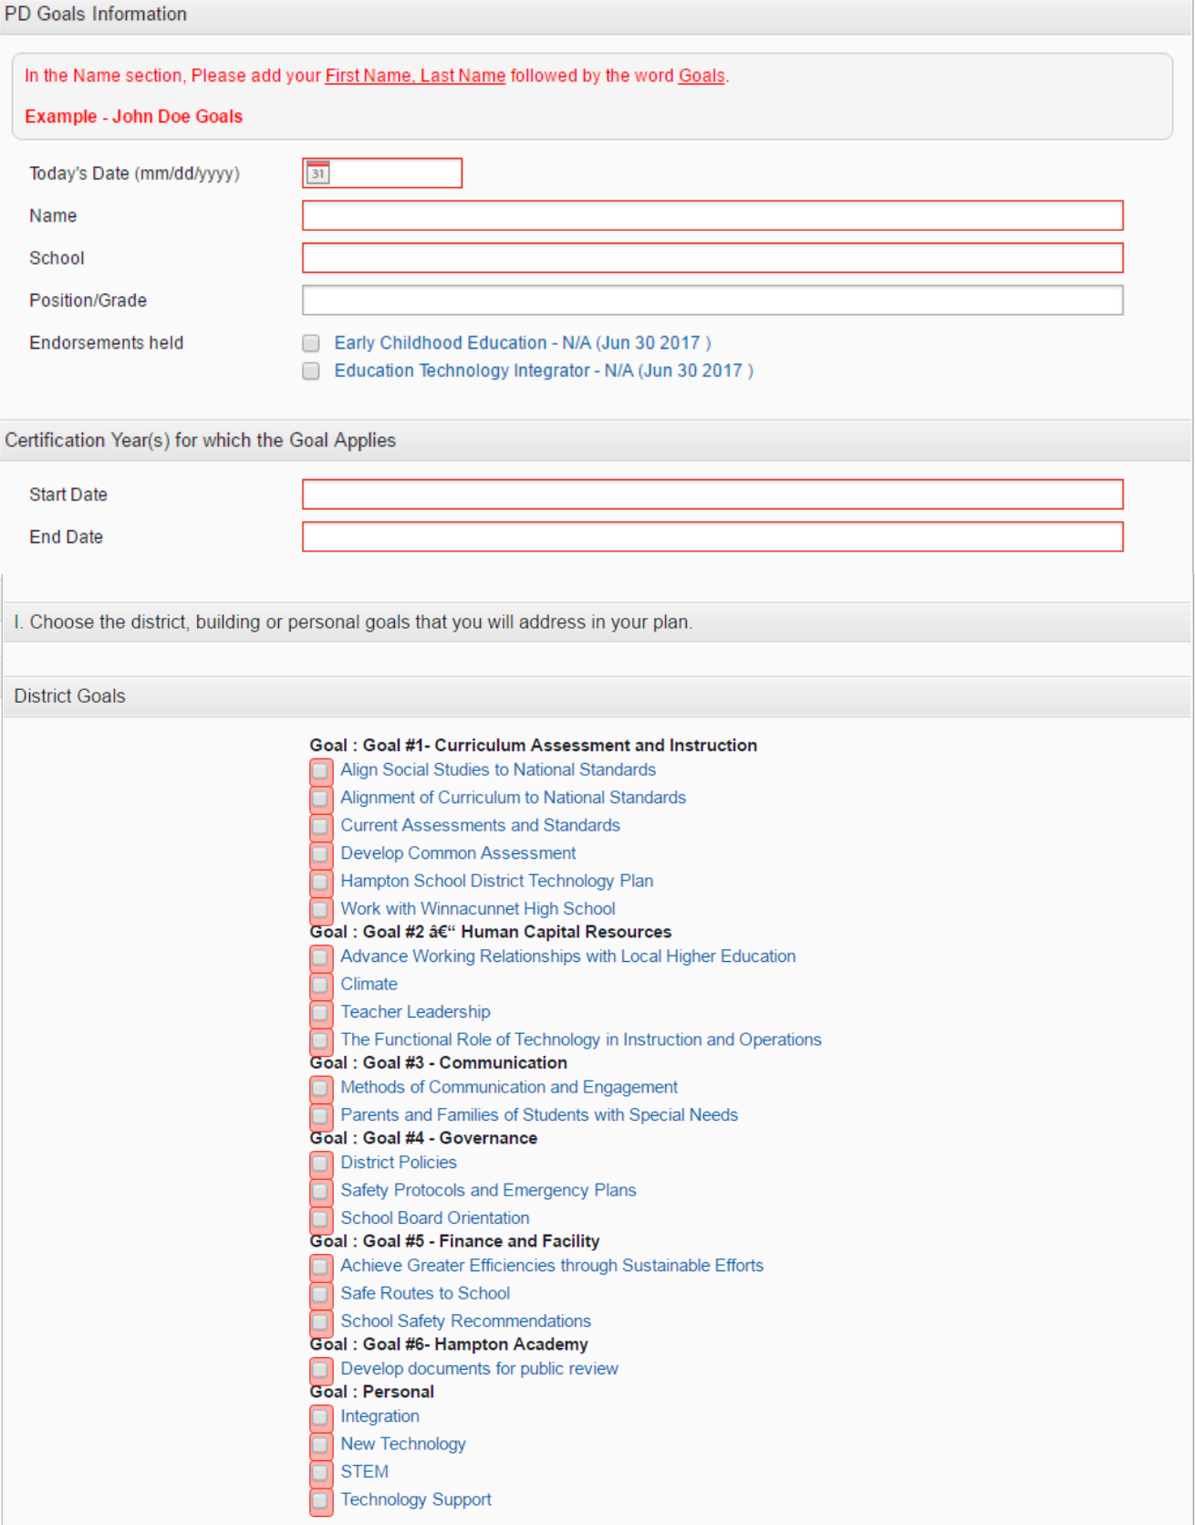

25
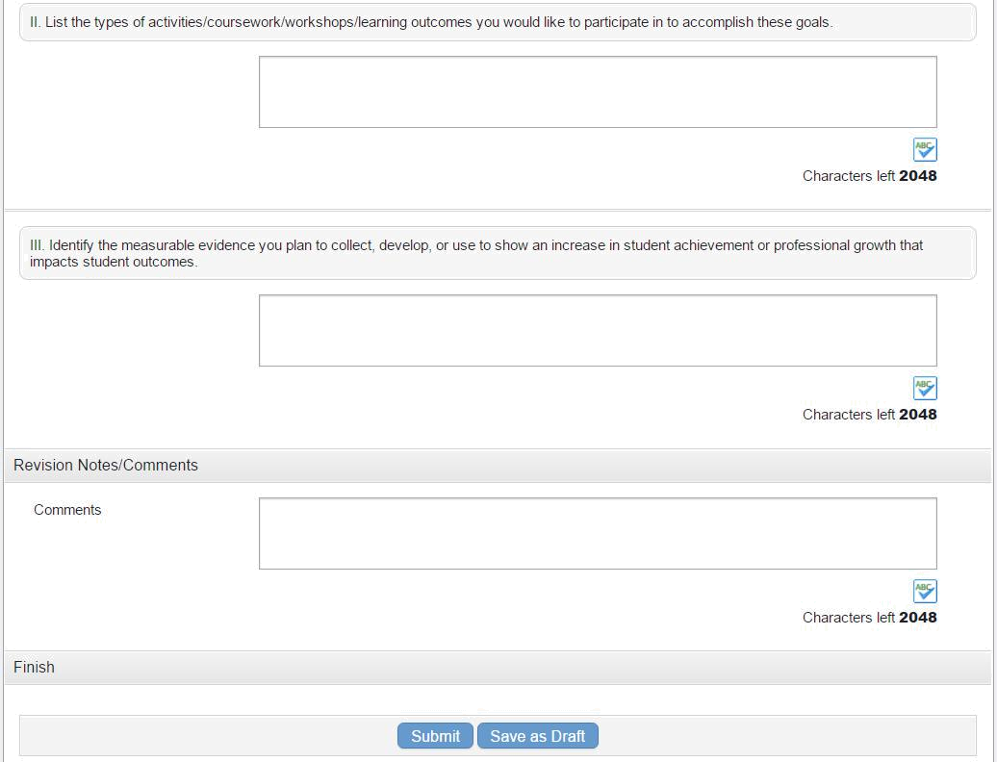

26
Job Embedded Professional Development Application

Name:_______________________________________Date:_________________________

School:____________________________Position:_________________________________

Targeted certification for activity:______________________________________________

Supervisor who will be overseeing the activity:___________________________________

Start date for activity______________________ End date for activity_________________

Title of activity_____________________________________________________________

Professional support team members (consisting minimally of direct supervisor)

_________________________________ _________________________________
_________________________________ _________________________________
_________________________________ _________________________________

How is this activity aligned to your personal, school and district goals:

What problem within your practice are you working to improve?

Explain the activity in detail:

How will this activity enhance your content-specific instructional practice?

How will this enhance student learning?

How will this activity be implemented into your work day?

How will you document your progress and effectiveness of the activity?

---------------------------------------------------------------------------------------------------------------------
-
To be filled out with supervisor:

Agreed upon meeting times to assess progress and review documentation:

Amount of professional development credit (determined with supervisor):

How will you share your experience and findings with staff members in an effort to contribute to the development of all teachers?

Teacher signature:____________________________________Date___________________

Supervisor signature:__________________________________Date___________________

27

SAU 90 Professional Development Goals Reflection and Evaluation (Found in My Learning Plan)
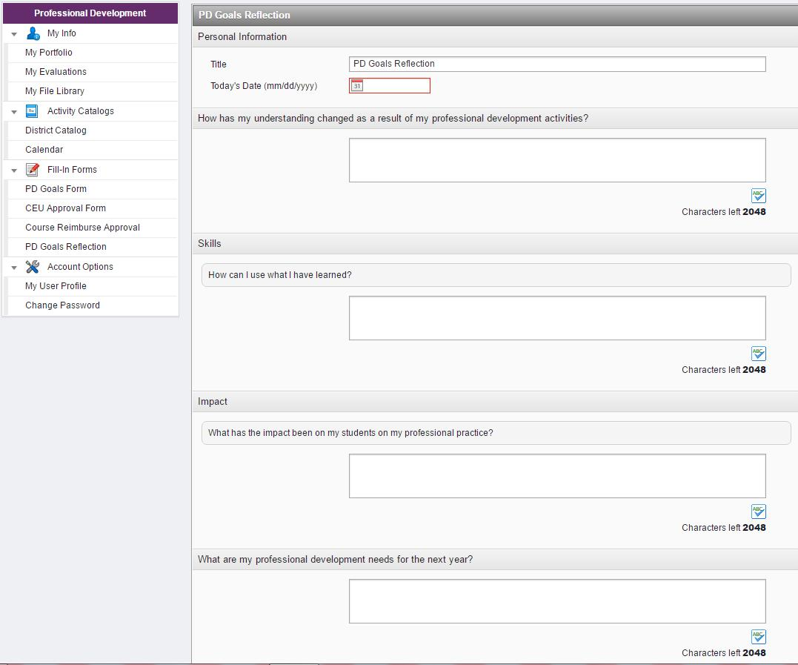

28
SAU 90 PROFESSIONAL DEVELOPMENT CEU APPROVAL FORM

This form must be completed by any staff member seeking professional development credit and submitted to the Local Professional Development Committee (LPDC). The individual must submit this form to the LPDC representative. This application will be reviewed at the next regularly scheduled meeting of the LPDC. All forms must be submitted to within 90 days to the Local LPDC. Summer work needs to be submitted no later than November 30th.
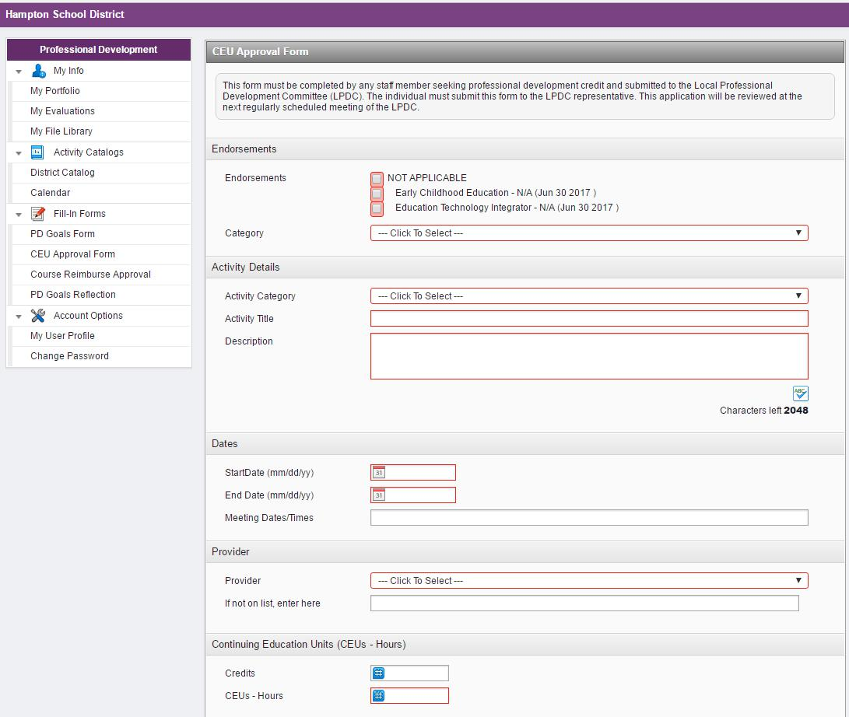

29

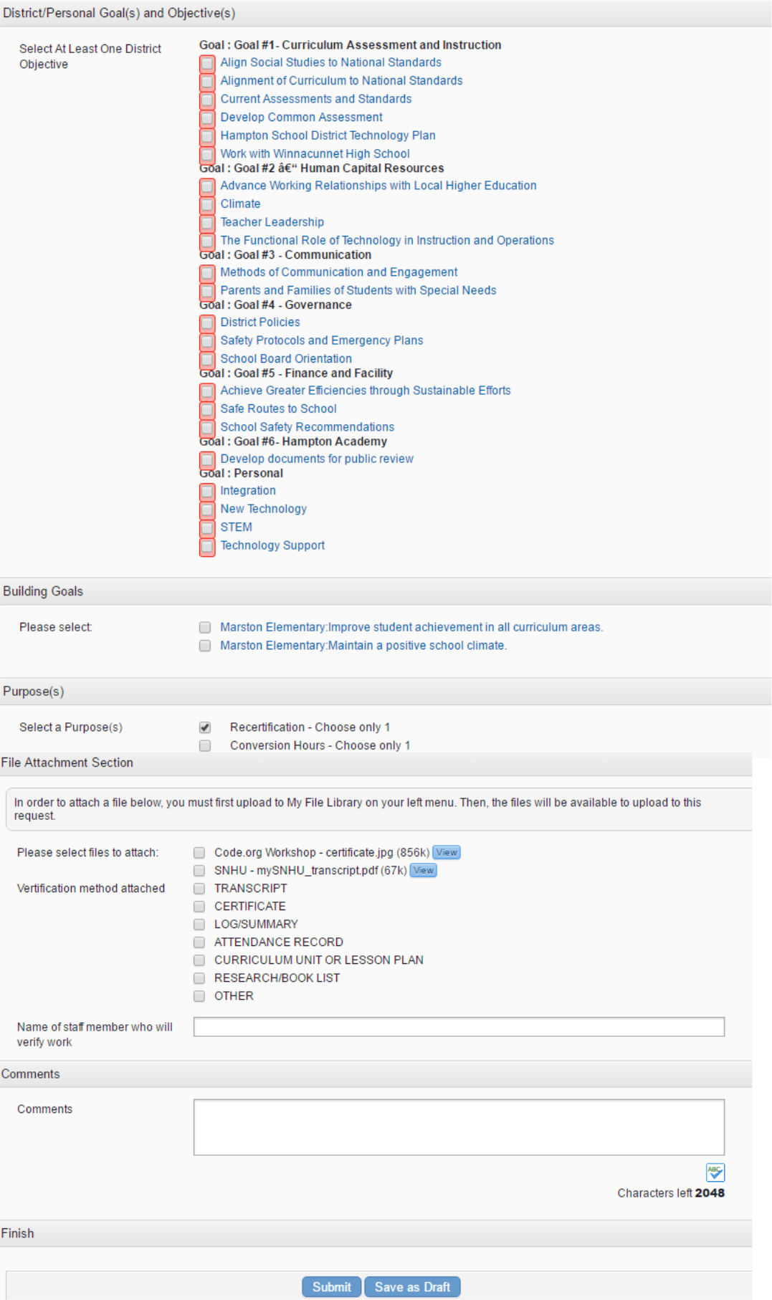

30

SAU 90 PROFESSIONAL DEVELOPMENT CUMULATIVE RECORD One per endorsement

Name ________________________________________

Date Submitted __________________

School ________________________________________

Date credential expires ____________

Total Re-certification CEUs needed _________

Number of pages _____ Page # _____

Each educator is responsible for accumulating 75 CEUs of professional growth every three years. A minimum of 30 CEUs shall be devoted to professional development activities in each area of specialization. The additional 45 CEUs may be accrued in either your area of specialization or through District activities. Hours accrued for the 45 additional CEUs need to be only listed once.

Please have a separate page for each of your endorsements (duplicate this page as needed).

Activity and Date | Endorsement | Other
(chronological order is preferred) | (Subject or Area of | (list CEUs)
 | Specialization: list
 | CEUs)

Subtotal:

Total:

Principal’s Signature __________________________________Date ___________________

31

SAU 90 PROFESSIONAL DEVELOPMENT RIGHT OF APPEAL

Name: _______________________________________________ Date: _______________

School: _______________________________________________

Part I: The educator will complete this application to appeal a decision by the District Professional Development Committee (DPDC) and submit it to the Review Committee along with three copies of the denied Professional Development CEU Approval Form and the current Individual Professional Development Goals. This shall be done within 15 days of receipt of the decision.

Title and description of the activity:

Rationale for Appeal:

Part II: The Review Committee will convene a meeting to review your request as written above.

Part III: The Review Committee will complete this form and notify the appellant of the decision within ten (10) school days after the date of the meeting.

Decision regarding appeal:

Signatures of Review Committee:

Date:

Date:

Date:

Date:

32

SAU 90 APPLICATION FOR CREDIT CONVERSION

Name: _________________________________________________ Date: _____________

School: __________________________________________

Past practice has allowed for professional development hours over and above college credit to be converted at the rate of 15 CEUs equal to one college credit for the purpose of track advancement. Up to 105 CEUs may be converted in each five year professional development plan (this conversion is only applicable to the SAU 90 salary schedule and may not be accepted if the staff member seeks employment outside SAU 90).

Conversion hours must be earned while under the SAU 90 teacher contract.

I hereby apply to convert _________ CUEs, as demonstrated by the attached Professional

Development CEU Approval Forms in areas other than college courses, to __________ credits, as

documented by the attached Professional Development CEU Approval Forms for track advancement.

Professional Development CEU Approval Forms attached:

________________________________________________________

Employee signature: ________________________________________ Date: __________

Personnel Approval: ________________________________________ Date: __________

Credit(s) granted: ___________ not granted: __________

Reason for denial:

33
COURSE APPROVAL FOR TUITION

REIMBURSEMENT/PROFESSIONAL DEVELOPMENT
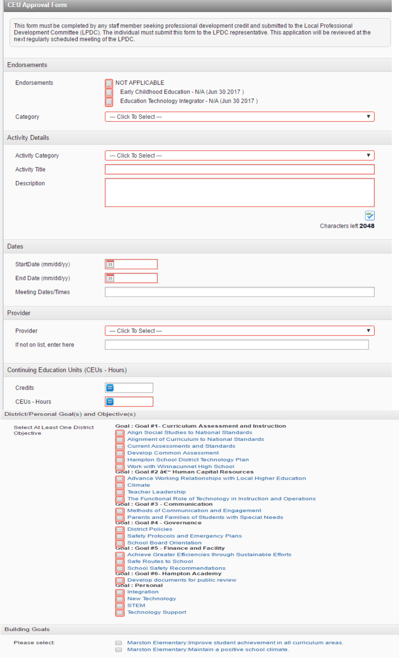

34

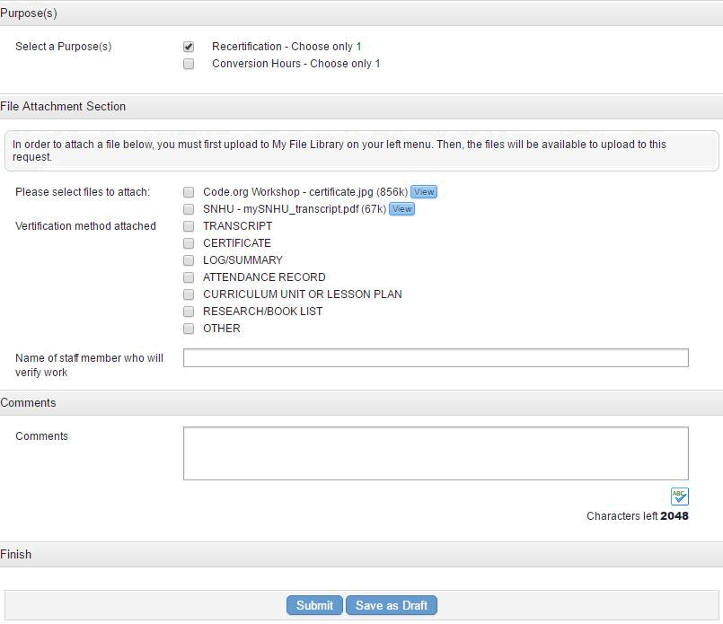

Course Approval for Tuition Reimbursement

Per Article XIV, Section 14-1of the agreement between the Seacoast Education Association and School Administrative Unit No. 90 School Board, the school district shall reimburse teacher for graduate approves courses up to a maximum allowed per Article XIV and provided that evidence of a grade of “B” or better received. The graduate course must have been approved by the Superintendent of his designee in advance of enrollment.

To be reimbursed please follow these steps:
- Before enrolling in a graduate course , obtain approval through My Learning Plan
- After completing course, submit the following documents through My Learning
Plan.
  - Transcript with a grade of “B” or better
  - Proof of payment

35
Conference PD Form Example
Name:

School:
Conference Title:
Dates Attended:
Name of Workshops | Provider | Description of Workshop | Time in Workshop
Attended:

Total Time:

Detailed Log Form Example:

Name:
School:
Date | Duration | Type of | Your | Provide specific details of the | Evidence of what was done
 |  | Activity | Role | activity or describe subject | during this time
 |  |  |  | covered

36

