Indiana University - Purdue University Fort Wayne
Opus: Research & Creativity at IPFW

Other Graduate Research Graduate Student Research

5-2016

Behavior Strategies That Promote Academic Achievement for Students with Emotional and Behavioral Disorders Within the Inclusive Classrooms

Jenna Rios

Indiana University - Purdue University Fort Wayne

Follow this and additional works at: http://opus.ipfw.edu/grad_research

 Part of the Special Education and Teaching Commons

Recommended Citation

Jenna Rios (2016). Behavior Strategies That Promote Academic Achievement for Students with Emotional and Behavioral Disorders

Within the Inclusive Classrooms.

http://opus.ipfw.edu/grad_research/35

This Special Project is brought to you for free and open access by the Graduate Student Research at Opus: Research & Creativity at IPFW. It has been accepted for inclusion in Other Graduate Research by an authorized administrator of Opus: Research & Creativity at IPFW. For more information, please contact admin@lib.ipfw.edu.

Behavior Strategies that Promote Academic Achievement

BEHAVIOR STRATEGIES THAT PROMOTE ACADEMIC ACHIEVEMENT FOR STUDENTS WITH EMOTIONAL AND BEHAVIORAL DISORDERS WITHIN THE INCLUSIVE CLASSROOMS

Jenna Rios

A Special Project

Submitted to the faculty of the Office of the Graduate School

In partial fulfillment of the requirements

For the degree

Master of Science in Education with a Major in Special Education

In the Department of Professional Studies

Indiana University-Purdue University Fort Wayne

May, 2016
Behavior Strategies that Promote Academic Achievement ii

Accepted by the Graduate Faculty, Indiana University-Purdue University Fort Wayne, in partial fulfillment of the requirements for the degree of Master of Science in Education with a major in Special Education.

Special Project Committee

______________________________

Jane M. Leatherman, PhD, Chair

______________________________

Jeong-Il Cho, PhD

______________________________

Rama Cousik, PhD

Behavior Strategies that Promote Academic Achievement

Acknowledgements

I would like to thank my professor Dr. Jane Leatherman. She was there to guide and encourage me through this process. Without her encouraging words I would not have been able to complete this project. I would also like to thank the other committee members Dr. Cousik and Dr. Cho for helping to guide and support me through this project.

I would like to give praise to my heavenly father for making this opportunity happen in my life. My faith has brought me through this process. Without it, I would not have finished this project.

I would like to thank my husband, Frank for his never ending encouragement and support through this time. He has been truly amazing through this process. I would also like to thank my son, Lucas. Coming home to his smiling face and out stretched arms always made me smile especially on some of my tougher days.

I would like to thank all of my friends and family who have supported me during this time. I want to thank Terry for the long talks on my way home from class every week. She was one of my biggest supporters. Thank you Dad and Pam for taking Luke for many weekends so that I could get homework done. Thank you to my co-workers Shawn, Shayna, Betty, Brenda, and Donna, you ladies are such an encouragement to me every day. Without your support, I would not be in this job and would not have pursued this degree. To my church family, thank you for all the help with babysitting and prayers. You all are such a blessing in our lives.
Behavior Strategies that Promote Academic Achievement iv

Finally, I would like to thank my students. You are the reason I get up every day excited to go to work. You have made me fall in love with teaching. Your smiling faces were what kept me going some days through this process. You make my passion come alive.
Behavior Strategies that Promote Academic Achievement v

Abstract

This research study addresses how general education teachers can effectively teach students with emotional and behavioral disorders. When teachers use effective instructional practices that promote positive teacher-student interactions and a positive classroom climate, they are minimizing problem behaviors in the classroom (Conroy, 2012). The four research based strategies that this project focuses on are: Positive Praise, self monitoring, token economies, and positive behavioral interventions and supports. Teachers do not feel prepared and are overwhelmed by the number of behavior challenges they are faced with within the general education setting.
Behavior Strategies that Promote Academic Achievement vi

Table of Contents

Chapter 1: Introduction……………………………………………………………...…….1

Statement of problem……………………………………………………….......…1

Significance of Study…………………………………………………………...…2

Purpose of study………………………………………………………………...…2

Research approach……………………………………………………………..….2

Definition of terms…………………………………………………………….......3

Chapter 2: Literature Review……………………………………………………………...4

Introduction……………………………………………………………………......4

Emotional and behavioral disorders……………………………………………….4

Special Education Laws…………………………………………………………...6

Referral Process and Eligibility Decisions……………………………………......7

Individual educational plan (IEP)…………………………………………8

Functional behavioral assessment (FBA)…………………………………9

Behavioral intervention plan (BIP)………………………….…………...10

Student Teacher Relationship…………………………………………….……...11

Building a positive student-teacher relationship…………………..……………..12

Constructively correcting students……………………………………….12

Steps to follow after disciplining a child………………………….…......13

General Education teacher training………………………………….…….……..13

Strategies for students with emotional and behavioral disorders………….……..14

Positive Praise…………………………………………………….….......14

Self-monitoring………………………………………………….……….15
Behavior Strategies that Promote Academic Achievement vii

Positive behavioral interventions and supports (PBIS)……….…….…...18

Token Economy…………………………….……………….……….......20

Summary……………………………………….………………………………...21

Research questions…………………………………………………….……........22

Chapter 3: Methodology……………………………………………….……….………..23

Introduction………………………………….……………………….…………..23

Participants…………………………………………………….…………………23

Setting…………………………………………………………………….……...23

Research Design………………………………………………………..………...24

Recruitment and data collection procedures/methods…………………….……..24

Data analysis procedures………………………………………………….……...25

Rationale for the project…………………………………………………….........25

Summary………………………………………………………………….……...26

Chapter 4: Results………………………………………………………………………..27

Demographics of the participants and students………………………………….27

Characteristics of EBD in the general education class…………………………..28

Formal training and confidence level………………………………………........28

Strategies of support……………………………………………………..29

Positive reinforcement…………………………………………………..29

Self monitoring………………………………………………………….30

Positive behavioral supports…………………………………………….30

Token economy…………………………………………………………..31

Additional training……………………………………………………….............31
Behavior Strategies that Promote Academic Achievement viii

Summary of results……………………………………………………..………..31

Chapter 5: Resource Notebook…………………………………………………………..33

Section 1 Introduction…………………………………………………… 38

Section 2 What are Emotional and behavioral disorders?.……………….. 42

Section 3 Positive student-teacher relationships……………………….. 45

Section 4 What is a behavior plan? 69

Section 5 Positive Praise……………………………………….………… 80

Section 6 Token Economy……………………………………………... 85

Section 7 Self-Monitoring…………………………………………….………...113

Section 8 Positive Behavioral Interventions and Supports……………………..123

Section 9 Behavior Contracts………………………………………… 164

Conclusion…………..……………………………………………..… 190

References…………..……………………………………………… ………..191

Chapter 6: Final Thoughts and reflections……………………………………………...194

Discussion…………………………………………………………….………...194

Limitations……………………………………………………….…….……….194

Strengths……………………………………………………………...….. 195

Future Research………………………………………………………………...196

Conclusion…………………………………………………………..….………196

References…………………………………………………………………..….……….197

Appendix A CITI Training…………………………………………………...………...202

Appendix B IRB Approval……………………………………………………………..204

Appendix C Permission Letter from Principal ………………………………………..206
Behavior Strategies that Promote Academic Achievement ix

Appendix D Letter to Colleague……………………………………………………..…207

Appendix E Survey Questions...…………………………………………………….….208

Appendix F Research for Survey Questions.…………………………………………...211

Appendix G Survey Results...……………….………………………………………….213

Appendix H Resume...………………………………………………………………….218
Behavior Strategies that Promote Academic Achievement | 1

Chapter 1

Introduction

Most general education teachers can name at least one student they clearly remember as challenging their classroom management skills. The behaviors these teachers remember may look like outbursts, rude comments, yelling, and convincing other students to engage in negative behaviors (Kauffman & Landrum, 2009). As a result of such challenging behaviors, many teachers struggle to work with these students. It can be intimidating to interact with a child who is physically or verbally aggressive. Teachers need to use strategies in their classroom that will help them build positive relationships with students with emotional and behavioral disorders and be able to help these students become successful academically in their classrooms.

Statement of Problem

Many teachers in the general education setting are not comfortable with and/or may not understand the behaviors of students with emotional and behavioral disorders (EBD). They need to be confident in their ability to use effective behavior strategies that will help promote academic achievement for students with EBD in their classrooms. According to Kalis, Vannest, and Parker (2007), research has indicated that teachers of students with emotional and behavioral disorders do not use effective teaching practices. This increases the academic and behavioral deficits in children with emotional and behavioral disorders. There is a direct link between academic deficits and inappropriate classroom behaviors (Kalis et. al., 2007). It is crucial that teachers show supportive behavior in order to influence students motivational beliefs, engagement, and achievement (eg., Ahmed, Minnaert, vander Werf, & Kuyper, 2010; Fredricks,
Behavior Strategies that Promote Academic Achievement | 2

Blumenfeld, Friedel, & Paris, 2005; Lapointe, Legault, & Batiste, 2005; Patrick, Ryan & Kaplan, 2007). The way a teacher handles discipline in the classroom can directly affect their relationship with their students. This relationship can affect the student’s academic achievement (Pinchevsky & Bogler, 2014).

Significance of the Study

Many students who have emotional and behavioral disorders struggle to be successful in the inclusive classroom. There are many reasons these students may struggle when they go into the general education classroom. If teachers have positive behavior strategies that will help these students to be successful within their classroom, then the students will have more success and will want to be in the inclusive classroom.
Purpose of study

The purpose of the study was to investigate behavior strategies that promote academic achievement for elementary students with emotional and behavioral disorders within the inclusive classrooms. After completing this investigation, a teacher handbook was developed that will enhance their ability to support students in their classroom who have emotional and behavioral disorders in their classroom. The teachers will be able to help these students become more successful academically through specific behavior interventions.

Research approach

This study is a qualitative research design. An electronic survey was distributed to elementary teachers through Google program. The survey consisted of open ended questions asking about four research-based strategies: positive praise, self-monitoring, positive behavior supports, and token economy. The purpose of collecting this data was
Behavior Strategies that Promote Academic Achievement | 3

to find out how much knowledge the teachers have about students with EBD and whether they know how to use these research-based strategies. If they do know about them, how are they using them in their classrooms?

Definition of Terms

- Emotional and behavioral disorders (EBD): These students struggle to function in a traditional school setting. The student has something outside of school that is so hard to deal with that he/she struggles to function in school.

- Individualized educational plan: A written statement for each child with a disability. Each IEP is designed for one student and should be a truly individualized document (Lerner & Johns, 2012)

- IDEA: A law that focuses on special education students. This law requires that students with disabilities are given the same free and appropriate education that students without disabilities receive (www.parentcenterhub.org/repository/idea).

- Article 7 contains Indiana’s Special Education rules.

- Functional behavior assessment (FBA) is an assessment of how the child is behaving and why they are exhibiting their behaviors.

- Νο Χηιλδ Λεφτ βεηινδ Αχτ (ΝΧΛΒ): Α λαω τηατ ωασ οριγιναλλψ πασσεδ ιν 2001. Ιτ ωασ πασσεδ το ινσυρε τηατ αλλ στυδεντσ ωιτη δισαβιλιτιεσ ρεαχη α μινιμυμ προφιχιενχψ λεϖελ ον χηαλλενγινγ στατε αχαδεμιχ αχηιεϖεμεντ.
Behavior Strategies that Promote Academic Achievement | 4

Chapter 2

Literature review

Introduction

This literature review focuses on students with emotional and behavioral disorders. It defines emotional and behavioral disorders and how to work with students who have this disorder. The special education laws are discussed in detail. There are four research-based strategies that are discussed in this chapter; positive praise, self-monitoring, positive behavioral supports, and a token economy. This chapter also defines what a behavior intervention plan, individual educational plan, and what a functional behavior assessment is. No Child Left Behind (NCLB) is a law that ensures that all children have a fair and equal opportunity to earn a high quality education.

Emotional and behavioral disorders

Emotional disturbance is defined as a condition exhibiting an inability to learn that cannot be explained by intellectual, sensory, or health problems. These students are unable to build or maintain satisfactory interpersonal relationships with peers and teachers. They display inappropriate types of behaviors or feelings under normal circumstances, a general pervasive mood of unhappiness or depression, or a tendency to develop physical symptoms or fears associated with personal or school problems (Lerner

- Johns, 2012). According to Article 7 (2010), students must display one or more behaviors that exhibit the characteristics of EBD in order to qualify for services. The following are characteristics that the student must exhibit:

  - Develop physical symptoms or fears with teachers or school problems.

  - Υνηαππινεσσ ορ δεπρεσσιον
Behavior Strategies that Promote Academic Achievement | 5

- Unable to build interpersonal relationships.

- Inappropriate behaviors or feelings under normal circumstances

- Episodes of psychosis (Article 7, 2010).

About 8% of all students with disabilities is identified under the category of emotional disturbance. About 29% of these students are in general education classes, and about 24% are in resource rooms for part of the day (Lerner & Johns, 2012).

The way students feel about themselves are directly related to ED. Students may feel depressed all the time or have a low self concept. These feelings may interfere with the individual’s outlook on life and ability to learn. Behavior disorders involve behaviors such as aggression or antisocial behavior. A student who has a low self-esteem may engage in behaviors that lead to being socially isolated (Learner & Johns, 2012).

Students with emotional and behavioral disorders often come from environments that are not positive. They may have a history of abuse, homelessness, or neglect. This is not true for every student with EBD, but most of these students really struggle in school because of their hardships in life. For many of these students, because of the hard life they are living, the last thing on their mind is whether they know their math facts or how to spell a word. Their biggest worries may include but are not limited to whether their parent is safe while they are in school, whether they will have food to eat that evening, or whether they will have a place to lay their head at night. Teachers need to take this into consideration when they have these students in their classrooms. Usually their defiance is not just defiance; it is often times a cry for help. When the teacher figures out how to break through the walls the student has up, then the student will be able to learn from that teacher. It is important for the teacher to realize where the student has come and how
Behavior Strategies that Promote Academic Achievement | 6

much success they have had since the beginning. A teacher may look at an EBD student and say that the student is not completing his/her work. But the fact that the student is appropriately interacting in the general education classroom is a big deal. They may not be completing their assignment, but the fact that the student has not yelled at the teacher or thrown a chair at a teacher is a big success for that student.

Special Education Laws

IDEA: Congress originally passed the IDEA law in 1975. This law requires that students with disabilities are given the same free and appropriate education that students without disabilities receive (www.parentcenterhub.org/repository/idea). This law has been revised several times over the years. The most recent revision to this law was done in 2004. It strengthened the role of parents, extended rights for students with disabilities, and gave students with disabilities access to general education curriculum (Lerner & Johns, 2012).

No Child Left behind Act (NCLB): NCLB was passed in 2001. This law ensures that all children will have a fair and equal opportunity to earn a high quality education. Students with disabilities need to reach a minimum proficiency on challenging state academic achievement . NCLB requires that public schools bring students to proficiency in reading and math (Lerner & Johns, 2012).

511 IAC Article 7 - commonly referred to as simply "Article 7" -- contains Indiana's Special Education rules. The most recent version was updated in December 2014 (http://www.doe.in.gov/specialed/laws-rules-and-interpretations). It is a set of regulations that protect students with an IEP.
Behavior Strategies that Promote Academic Achievement | 7

Referral Process and Eligibility Decisions

When students are referred for special education there is a process that must be followed. They must be referred based on their academic and behavioral progress. Once referred, the case conference team meets to discuss the evaluation plan. Parents have to sign for an evaluation. Then an individual educational plan is developed. After that there is a multidisciplinary evaluation done. There is an eligibility meeting shortly after that with a case conference committee (a team of people who are knowledgeable about the student’s behavior and abilities who will determine the best placement and strategies for the student). The plan is developed, the parents sign, and then the plan is implemented. The case conference committee reconvenes when necessary to make changes (Lerner & Johns, 2012).

There are 6 stages of the referral process:

- The referral stages include pre-referral activities and referral.

- Initial planning.

- The assessment stages include multidisciplinary evaluation

- IEP meeting (writing the IEP).

- The instruction stages include implementing the IEP, teaching plan, and review and reevaluation of student’s progress.

The referral stages begin the IEP process. An instructional support team develops pre-referral activities for a student who is encountering difficulties in the general education classroom to be used by the general education teachers. Before referring a student for a special education evaluation, teachers use these interventions with the child.
Behavior Strategies that Promote Academic Achievement | 8

If the interventions are successful, the child does not need to be referred for an evaluation.

In order for the IEP process to be started, someone has to make a referral. A referral can be made by a teacher, a parent, other professionals who have contact with the student, or by the student. After a referral is made, school personnel must follow up. The parents must be notified and they have to sign a written form giving their consent for the referral. Appropriate multidisciplinary evaluations are conducted. Information is gathered and then a case conference meeting is held to discuss the results (Lerner & Johns, 2012).

At the case conference meeting, the IEP is discussed and written. The teacher of record (TOR) is responsible to make sure that the plan is being implemented in the classroom. The IEP should be reviewed and changed as needed (Lerner & Johns, 2012).

Individual educational plan (IEP). A student with EBD will have an individualized behavior plan (IEP). The IEP is a written statement for each child with a disability. Each IEP is designed for one student and should be a truly individualized document (Lerner & Johns, 2012).

There are certain things that MUST be in the IEP based on the IDEA law. The required elements of an IEP are as follows:

- Πρεσεντ λεϖελσ οφ αχαδεμιχ αχηιεϖεμεντ ανδ φυνχτιοναλ περφορμανχε. Ιν οτηερ ωορδσ, ηοω ισ τηε χηιλδ χυρρεντλψ δοινγ αχαδεμιχαλλψ ανδ ηοω δοεσ τηε χηιλδ’σ δισαβιλιτψ αφφεχτ ηισ ορ ηερ ινϖολϖεμεντ ανδ προγρεσσ ιν τηε γενεραλ χυρριχυλυμ?
Behavior Strategies that Promote Academic Achievement | 9

- Annual goal must be developed. This goal describes what the student will achieve in one year based on what the case conference committee thinks the child is capable of.

- Special education and related services must be described and the amount of time the child will spend in each. This must include whether there are supplementary aides and services.

- The amount of time the child will be away from his or her peers must be listed.

- How and if the child will participate in state and district wide assessments. Modifications must be listed in this section.

- When services and modifications will begin, how often they will be provided, where they will be provided, and how long they will last and

how school personnel will measure the child’s progress towards the annual goal (www.parentcenterhub.org/repository/idea).

Functional behavior assessment (FBA). A functional behavior assessment (FBA) is an assessment of how the child is behaving and why they are exhibiting their behaviors. This should be done before making a behavior plan. There are three things to consider when writing an FBA:

- Antecedent behavior (what is happening right before the behavior)

- Behavior (the behavior of concern)

- Consequences (what happens when the behavior occurs).

An FBA can give a clear description of the problem. It can also help identify whether a certain event in the day is throwing the child off. It will also help the teacher predict what
Behavior Strategies that Promote Academic Achievement | 10

behaviors may happen. For example, if there is a student in the classroom who hates to write and has not verbalized this to the teacher, this student may exhibit behavior problems daily during writing time. Using this method could give the teacher insight to what the student’s problem is. If the student is acting out every day at the same time, he/she probably does not want to do whatever is being done at that time in the classroom. The consequence can greatly affect the behavior. If a student is looking for attention and the teacher gives the student attention when they are doing something negative, then the teacher is likely to see the negative behavior continue to occur or increase. If the teacher only gives attention to the student when they are doing something positive, then the teacher will probably see positive outcomes in the student’s behavior (Lerner & Johns, 2012).

Behavior intervention plan (BIP). A behavior intervention plan (BIP) means a plan agreed upon by the case conference committee and incorporated into a student’s IEP that describes the pattern of behavior that impedes the student’s learning or the learning of others. The purpose of the function of the behavior as identified in a functional behavior assessment, the positive interventions and supports and other strategies to address the behavior, and if applicable, the skills that will be taught and monitored in an effort to change a specific pattern of behavior of the student. The behavioral intervention plan seeks to maximize consistency of implementation across people and settings in which the student is involved (Article 7, 2010). The BIP is decided upon at the case conference and must be carried through in order to be in compliance with the IEP. The special education teacher and general education teacher should work together to make sure that everyone is following through with this plan. The plan includes strategies that
Behavior Strategies that Promote Academic Achievement | 11

will help the student be successful in the general education setting. Four common strategies seen in student’s BIP are reviewed in the literature review.

Student-teacher relationship

Many teachers focus on the negative behaviors of students who have emotional and behavior disorders. It is so important for teachers to focus on the positive behaviors that their students are displaying. According to Murray and Greenberg (2006), children with greater support in relationships with teachers had fewer behavioral problems, had greater social competencies, and were better adjusted to school than were children with greater conflict in their relationships with their teachers. When teachers use effective instructional practices that promote positive teacher-student interactions and a positive classroom climate, they are minimizing problem behaviors in the classroom (Conroy, 2012). When students feel that you value and care for them as individuals, they are more willing to comply with your wishes (Boynton pg.6, 2005). Student-teacher relationships are directly impacted by teacher’s educational practices. The more willing general education teachers are with working with students with EBD, the more success their students will have. Students will resist rules and procedures if the relationship with their teacher is not a positive one (Boynton, 2005). Teacher attitudes can affect student behaviors. If a teacher is overwhelmed, and displays that behavior to the student, then the student may exhibit more difficult behaviors. Teacher attitudes towards student with EBD can also affect their willingness to welcome the student into their classroom, and whether they believe the student can be successful or not (Gaudreau et al., 2013).
Behavior Strategies that Promote Academic Achievement | 12

Building a positive student-teacher relationship

Constructively correcting students. “When correcting students, they need to reflect on what they did, be sorry that they disappointed you, and make a better choice in the future” (Boynton, 2005, p12). The consequence needs to be fair, quick, and meaningful. There are several steps that can be used to correct students’ behavior in the classroom:

- Review what happened. Talk with the student about why they got in trouble. Talk about ways to change the behavior if needed.

- Identify and accept the student’s feelings. Let the student know that their feelings are important and that they have a right to their own feelings. The teacher should have an understanding of the student’s perception.

- Review alternative actions. Discuss with the student what he could have done instead of what he did. Talk about why it is important to follow school rules and expectations.

- Let the student know that all students are treated the same. Talk to the student about how important it is for all students to follow the rules. Talk about why it is so important.

- Invoke an immediate and meaningful consequence. Follow your building procedures for the offense.

- Χομμυνιχατε αν εξπεχτατιον τηατ τηε στυδεντ ωιλλ δο βεττερ ιν τηε φυτυρε. Λετ τηε στυδεντ κνοω τηατ εϖεν τηουγη ψου αρε δισαπποιντεδ τηατ ηε/σηε βεηαϖεδ τηε ωαψ ηε/σηε διδ, τηατ ψου στιλλ χαρε αβουτ τηειρ ωελλ βεινγ. Μακε α φρεση σταρτ ωιτη τηε στυδεντ. Δο νοτ ηολδ α γρυδγε φορ τηε στυδεντ’σ αχτιονσ (Βοψντον, 2005).
Behavior Strategies that Promote Academic Achievement | 13

Steps to follow after disciplining a child. It is important for the teacher to touch base with the student after a discipline is given to the student. When the student handles the situation more appropriately the next time, the teacher should praise the child for making a good choice (Boynton, 2005). Changing a student’s behavior takes time. The teacher needs to be patient with the student. Correcting behavior is not an easy task.

General Education Teacher Training for Students with Emotional and Behavioral

Disorders

Based on the laws discussed previously, general education teachers will have students with EBD in their classrooms. General education teachers are not confident in their abilities to teach students with EBD. They are easily overwhelmed with the behaviors that students with EBD exhibit (Allday et al., 2012). Teacher will not gain confidence without receiving the proper training (Gaudreau et al., 2013). Pre-service teacher coursework in classroom behavior management did not adequately prepare teachers to teach in the classroom (O’Neill & Stephenson, 2013). There is very little pre-service teacher training in terms of behavior management in classrooms. Although there are behavior management classes offered, there is not enough training to provide quality training for general education teachers in this area. This may be a factor as to why teachers do not feel prepared and often times are overwhelmed by the number of behavior challenges they address with within the general education setting. Teachers need to be well prepared and confident that they can handle these behaviors within the general education classroom. The younger a student develops a good relationship with a teacher and negative behaviors are stopped within the classroom, the better off the student will
Behavior Strategies that Promote Academic Achievement | 14

be. If they can build good relationships with their teacher early in their school career, then they will be more successful with their education (Gaudreau et al., 2013).
Strategies for students with emotional and behavioral disorders

There are many strategies for working with students with emotional and behavioral disorders. Four main strategies are positive praise, self-monitoring, positive behavioral interventions and supports, and token economy. Positive praise is when a teacher praises a student for doing the right thing or doing what the teacher asks. Self-monitoring is when a student is responsible for recording his/her behavior or academic task. Positive behavioral interventions and supports are methods used to change behaviors within the classroom. They focus on positive behaviors. A token economy system is used where students can earn something within the classroom for completing work, making good decisions, and following classroom rules and expectations. Research has shown that these strategies are affective when working with students with emotional and behavioral disorders.

Positive praise. There is a positive correlation between teacher praise and students responding to an academic request (Southerland et al. 2002). When a teacher uses positive praise within the classroom, it has a positive effect on students with EBD in both academic and behavioral areas. This method is easy to use within the classroom and requires no special preparation. Teacher praise is most effective when it is behavior specific (Kalis et al. 2007). There are some effective ways to offer praise to children in the classroom. How the teacher praises the student will determine whether the student’s behavior changes. For example, if the teacher offers praise to a student who is shy in front of the entire class, the teacher may begin seeing negative behaviors because the
Behavior Strategies that Promote Academic Achievement | 15

student may have been embarrassed. Some effective ways to offer positive praise is to be specific about what the child did. Point out what the child is doing that is favorable. For example, “I love how neatly you are writing Jon. Good job!” Praise should be contingent upon the desired behavior. It is important to provide frequent praise when children are initially acquiring a skill. It should be teacher initiated. Praise should focus on children’s improvement and effort and it should be sincere (Conroy et al. 2009).

Self-monitoring. Students who apply self-monitoring strategies to academics “achieve more and are more satisfied with their work” (Mooney et al., 2005). Results add to an evidence-based report favorable effects of self management on academics for students with and without disabilities (Mooney et al., 2005). Self-monitoring requires the students to observe their behavior and record it. The student determines whether the target behavior occurred or not. The student tallies or marks in some way whether the behavior occurs or not (Menzies et al. 2009). This is a student-based strategy that is used to increase on-task student behavior. This is meant to encourage the student to handle themselves in a more appropriate way in the classroom and makes them more aware of their behavior because they are the ones looking for and monitoring it (Martel, 2009).

According to Martell, 2009, there are 9 steps needed for a successful self-monitoring program.

- Identify the specific behavior-In order for a behavior to be changed, the behavior must be defined and observed. For example, if a student is being

“disruptive” to the class, that behavior must be defined. One teacher’s idea of disruptive behavior could be chair throwing and screaming. Another teacher may see disruptive behavior as tapping a desk or a student
Behavior Strategies that Promote Academic Achievement | 16

standing at his/her desk. The behavior has to be defined so that it is clear what the student will be working on. So, if a student is being disruptive by raising his hand and talking before being called on, then the specific behavior is to wait to be called on before speaking in class. The behaviors that are being tracked could be academic goals or behavior goals.

- Collect baseline data-Once the specific behavior is chosen, then data needs to be collected on how often the behavior is occurring. Using a scatter plot can help determine the frequency and the intensity of the behavior. It can help the teacher easily see if the behavior is happening at a certain time of day as well. This data should be tracked for several days. Baseline data is collected before the intervention begins.

- Teach a replacement behavior- After defining and measuring the target behavior, then the replacement behavior should be clearly defined and recorded. Teaching the student another behavior to reduce the negative behavior will help the student have success. For example, a replacement behavior for a student who is calling out while his hand is raised could be to simply place a finger over his lips when he raises his hand to help him remember that he is not supposed to talk until called upon.

- Select or design a self-monitoring chart- A self-monitoring chart should fit the need of the student. It should be easy for the student to understand and easy to track the behavior. The student is responsible to chart this behavior on his own, so the student has to understand what he is tracking and how to track it. The most effective self-monitoring system does not take a lot of
Behavior Strategies that Promote Academic Achievement | 17

time to track the behavior. As the student begins to see his progress in a positive way, he will want to reach the goal and will want to work on replacing his behavior.

- Teach the student to use the system- When the system has been developed by the teacher, then the teacher has to take time modeling the system for the student. The teacher must teach the student how to effectively use this system. The student should have input on whether he thinks that he can keep track of this behavior. In the beginning, the teacher should watch the student closely as the student tracks his behavior. The teacher will redirect if needed and help to remind the student when he needs to track the behavior.

- Reinforce positive behavior- The teacher should be encouraging to the student to self-monitor and give praise to the student when the student showing the desired behavior by the teacher. The student will be more successful with this if the child has chosen the reward that he will get if he shows the desired behavior. The teacher can let the student choose from a list of things that the student would like to earn. The teacher and student should work together to determine a reward.

- Monitor the students’ progress- Even though the student is recording his behavior, the teacher should be recording it as well. This will be good data to see if self-monitoring had any effect on the student’s behavior. It also can be used to compare the student’s chart and the teacher’s chart. The student and the teacher can compare and discuss the charts. If the negative
Behavior Strategies that Promote Academic Achievement | 18

behavior is decreasing after self-monitoring is put in place, then this method is working for the student.

- Fade the role of the adult in the intervention- As the student becomes better at self-monitoring his behavior, then the teacher should gradually increase behavior expectations while at the same time decreasing immediate reinforcement. The goal is to have the student use self-monitoring independently. The teacher should still be monitoring the behavior to show that the student is having success with the intervention, but the teacher may not need to coach the student as much once the student understands how to use self-monitoring.

- Teach maintenance- As behavior improves, the interventions change to accommodate a less restrictive method of measurement. At this stage, the

teacher and student will meet periodically to discuss how the progress is going (Martel, 2009).

Positive behavioral interventions and supports (PBIS). Throughout the school day all students exhibit positive behavior at some point. As a teacher it is harder to focus on the positive behavior with a student who typically shows so many negative behaviors. It is easier in general to focus on negative behavior more than positive behavior.

Research shows that students respond better to the teacher when the teacher focuses on positive behaviors within the classroom (Ziropli, 2012). If the teacher is always focused on the negative, then the students will always feel like the teacher does not like them.

Positive behavioral support refers to the use of positive reinforcement strategies as the principal method of changing behavior (Zirpoli, 2012). PBIS provide a way for teachers
Behavior Strategies that Promote Academic Achievement | 19

to be able to deliver effective instruction to all students. This will increase the success rate and reduce negative behaviors within the classroom (Scott et al., 2007).

Positive behavioral interventions and supports are specifically designed to put rules and routines in place in the classroom to effectively decrease the number of problem behaviors that occur in the classroom. The way the classroom is arranged can affect the classroom environment and the number of problem behaviors as well (Scott et al. (2007). Instead of telling students what not to do, this program focuses on praising students for doing the right thing. This system encourages positive behaviors in a school or classroom and discourages negative behaviors. The teacher focuses on positive behaviors and not on the negative behaviors. According to the Office of Special Education Programs Technical Assistance Program (www.pbis.org/school/primary-level) there are 7 core principles of PBIS.

- Teach appropriate behavior to students: In order for PBIS to be carried out, the students must know what is expected of them. If they do not know what is expected, then PBIS will be ineffective.

- Intervene early: The earlier the behavior can be corrected, the more successful the student will be in the future.

- A multi-tiered model is used: Teachers should be differentiating behavioral instruction within their classrooms.

- Use research-based interventions: Using research-based interventions will ensure that teachers are implementing strategies that will be effective for a variety of their students.
Behavior Strategies that Promote Academic Achievement | 20

- Monitor student progress: When teachers monitor student progress and use it as an assessment tool, they can then use the information they gather from those assessments to determine the effectiveness of an intervention.

- Use data to make decisions: Ongoing data is collected and used to analyze the effectiveness of an intervention. This can be good information for teachers to use to determine if the intervention they are using for their student(s) is working.

- Use assessment for three different purposes: PBIS screens data, determine the data based on data by time of day, problem behavior, and location, and progress monitoring to determine if the interventions are working

(www.pbis.org/school/primary-level ).

Token economy. A token economy program is a symbolic reinforcement system. It is called an economy system because it is based on a monetary system, with money as the most common form of tokens (Zirpoli, 2012). In a token economy, each student is assigned a job. The student then receives classroom money for completing their job. Some teachers may use tokens or tickets instead of money. Some examples of student jobs could be pencil sharpener, librarian, messenger, line leader, or caboose. The money that the student earns for a job can be turned in for rewards. Many teachers use a classroom store as a basis for review redemption. The store can be used as often as the students need it (weekly, bi-weekly, or monthly). This should be determined by the classroom teacher and should be used as often as the class in general would need the reward.

Students can also earn money for other things that they do in the classroom (or outside the classroom) like completing work, following expectations in the hallway, or
Behavior Strategies that Promote Academic Achievement | 21

helping others. This can be used to help mold behaviors in the classroom. For example, if a teacher has a student who calls out all of the time then they can use the token economy to encourage that student to raise her/his hand. The teacher can reward the student with classroom money or tickets every time the student raises his/her hand to speak instead of calling out. Using a token economy is also a great way to teach students about earning, spending, and saving money.

A token economy is beneficial for the entire classroom. The teacher can modify any behavior that he/she wants to. If a student is not raising his hand and he is calling out, then the teacher can give the child a ticket or a classroom dollar every time the student raises his hand without calling out. This is a positive and easy way to change behaviors that are not appropriate for the classroom. The biggest challenge with a token economy and the most important is that the teacher needs to be consistent with following through with the positive reinforcement and the negative reinforcement of this program.

Summary

Students who have EBD seem to struggle within the general education setting. General education teachers who work with students with EBD could benefit from using research-based strategies to help these students become more successful within the general education setting. Student-teacher relationships are very important to establish. This is a factor in student’s academic and behavioral success within the general education classroom. There are four research-based strategies that can help students become more successful within the general education setting. The four strategies are positive praise, self monitoring, positive behavioral supports, and token economies.
Behavior Strategies that Promote Academic Achievement | 22

Research questions

Research supports that general education teachers are not confident in teaching students with emotional and behavioral disorders and that they do not receive enough training on how to work with students with EBD. Based on the literature review, there are three questions that continue to arise. These questions are investigated within this research project.

- Do general education teachers know the definition of emotional and behavioral disorders?

- Do general education teachers know and use behavior strategies that will promote academic achievement for their students with emotional and behavioral disorders within their classrooms?

- What additional strategies would the teachers like information or training on?
Behavior Strategies that Promote Academic Achievement | 23

Chapter 3

Methodology

Introduction

This chapter discusses the participants in the study, the setting, research design, and the methods and procedures. This research addressed behavior strategies that teachers use to promote academic achievement for students with emotional and behavioral disorders within the inclusive classroom. The survey was given to general education teachers in a K-5 elementary classroom located in a rural area in Northeastern Indiana.

Participants

The participants in this study were general education teachers in a rural elementary school in Northeast Indiana. The school consists of 21 teachers working with students ranging from kindergarten to fifth grade. There are 20 female teachers and one male teacher in the building. There are 2 kindergarten teachers, 2 first grade teachers, and the rest of the grade levels have 3 teachers per grade level. There is also 1 gym teacher, 1 music teacher, 1 art teacher, and 1 technology teacher.

Setting

This elementary school is located in a rural area in Northeast Indiana. There are a total of four schools in this district. This study focused on only one of the schools. The student population at this school for the 2014-15 school year was 387 students. The percent of students who were white that attended this school at the time that the data was collected was 81.1%. The percent of students who were English Language Learner students were 8%. The percent of students attending the school as free and reduced lunch
Behavior Strategies that Promote Academic Achievement | 24

students at the time was 61.3%. There percent of special education students were 15%. The percent of students who passed both English language arts and math on the ISTEP test was 72.7%. The school has a 96.3% attendance rate. In 2014 testing year, the school received a C for the letter grade.

Research design

The co-investigator took the CITI training before starting this research (appendix A). The research design for this study was a qualitative research design. A survey was developed after the research was approved by the International Review Board (appendix B). The principal of the school gave her permission (through a letter) stating that she is aware that the co-investigator is conducting research in her school (appendix C). A survey was distributed to elementary teachers through Google forms. The link to the survey was sent to the principal in an email developed by the co-investigator. The principal forwarded the email to the general education teachers in the building.
Recruitment and data collection procedures/methods

After being approved by the IRB, a survey was sent out to staff members regarding research- based strategies that teachers use in their classrooms to promote positive relationships between the teacher and the student who has emotional and behavioral disorders and academic success when these strategies are used. The principal gave approval and agreed to send the survey out through her email. Before the survey was sent, a recruitment letter was sent to the staff via email (Appendix D) explaining why the teachers were being surveyed. It gave information about the co-investigator as well. The survey was conducted through Google Forms and there was a link on the email so
Behavior Strategies that Promote Academic Achievement | 25

that the teachers could get to it easily. Once the teacher completed the survey, the co-investigator analyzed the data.

Data analysis procedures

Data was collected and analyzed to see how many teachers are knowledgeable and use the research-based strategies within their classrooms. The data was used to produce a resource notebook for teachers to use with strategies, forms, and examples of how to use the strategies explained.

Rationale for the project:

The book The Educator’s Guide to Preventing and Solving Discipline Problems was written by Mark Boynton and Christine Boynton. This book offers strategies to help teachers cope with behavior issues when they occur in their classrooms. It also offers ideas for school beliefs concerning discipline, promoting positive teacher-student relations, and establishing clearly defined parameters of acceptable classroom behavior. The goal of the book was to clearly define classroom and building wide discipline strategies that teachers and buildings can use. The strategies can apply to all students in the classroom, but more specifically focus on the at-risk behavior students (Boynton, 2005).

This book addresses the relationships between teachers and students within the general education classroom in detail. It offers a good guideline for teachers to handle discipline within their general education classrooms with confidence. It also addresses building wide disciplines.

There is a gap in the research between effective classroom discipline and teaching strategies that support students with behavior issues or disabilities within the general
Behavior Strategies that Promote Academic Achievement | 26

education classroom. The research that is being conducted within this thesis addresses strategies that support students with behavior disorders within the general education classroom.

Summary

This was a qualitative research design. A survey was developed by the co-investigator and sent out by the co-investigator’s principal through Google forms. The survey focused on strategies that teachers use to promote academics for students with emotional and behavioral disorders within the general education classroom.
Behavior Strategies that Promote Academic Achievement | 27

Chapter 4

Results

This survey was developed to investigate how teachers use behavior strategies that promotes academic achievement for students with emotional and behavioral disorders (EBD) in the general education setting. This survey was distributed to teachers through Google forms. These research questions were developed to give the researcher a better understanding of how teachers feel and know how to teach students with emotional and behavioral disorders. The results of the survey will be presented by major themes of the survey questions. The raw data for the survey is presented in Appendix K.

Demographics of the participants and students

The survey was sent out to 21 teachers. Of the 21 teachers, 11 responded to the survey. Of the 11 teachers who responded, 40% of them teach kindergarten through second grade. 60% of them teach third grade through fifth grade. The age ranges of the teachers were as follows: 40% were 18-30 years old, 30% were 31-45 years old, and 30% of them were 46-65 years old. The teachers were also surveyed on the number of years they have been teaching elementary school. Those results are as follows: 40% have taught elementary school 1-5 years. 10% have taught elementary school 6-10 years, and 50% have taught elementary school 16 years or more. Of the teachers polled, 40% of them said that they did not have students in their classroom that had EBD.

Four of the eleven teachers polled said that 4% of their students are students with EBD. One of the teachers said that 10% of their students were students with EBD. One teacher said that more than 10% of their classroom is made up with students with EBD.
Behavior Strategies that Promote Academic Achievement | 28

Characteristics of EBD in the general education class.

When asked what the characteristics of students with EBD within the general education class, teachers responded that students who have EBD like to be in control. They are not able to sit still, easily distracted, and are easily upset. They can be defiant, throw temper tantrums, can be disruptive for attention, and are often alone. They are fidgety, angry, dislike change, and need lots of attention. Students with EBD have outbursts, throw objects, bang head, laying/crawl on floor, walking out of classroom, and avoid work.

Formal Training and confidence level.

In this survey, 70% of the teachers claimed that they have had no formal training on how to work with students with EBD. Of the teachers surveyed, 20% said that they have had an in-service workshop as a part of a broader course dealing with students with disabilities. One teacher said that he/she had 5 or more formal college courses dealing with educating students with EBD.

When asked if the teacher is confident in teaching students with EBD in their classrooms, 20% stated that they are confident in teaching students with EBD while 80% of the teachers stated that they are not confident in their ability to teach students with EBD. The teachers were asked why they are or are not confident in teaching students with EBD. One teacher stated that he/she is not confident in teaching students with EBD because he/she is not trained in safe holds when the student becomes violent. Two teachers stated that they feel confident, but would never turn down the opportunity for more training on how to handle students with EBD. Another teacher stated that he/she would like to learn more ways to get through to a student who is struggling with more
Behavior Strategies that Promote Academic Achievement | 29

than just the concept of the lesson. Another teacher asked what to do when a student bolts from the classroom.

Strategies of support

The majority of the survey questions asked about teacher knowledge and experience with different types of strategies to support students with EBD in the inclusive classroom. The strategy cluster questions follow.

Positive reinforcement.

Teachers were asked what is their definition of positive reinforcement. General

comments suggest that positive reinforcement is rewarding good behavior only, and is

providing positive feedback in multiple ways to change a student’s behavior. One teacher

said that positive reinforcement is noticing when a student is doing the correct thing and

rewarding them for it. Another said that it is encouraging the child and making positive

comments when the child is acting appropriately. Another teacher said it is reminding

them what the right thing to do is. Many of the responses suggested reinforcing and

praising positive behavior, offering rewards, and encouraging appropriate behavior. All

of the participants stated that they use positive reinforcement in their classroom.

The comments shared ways that the teachers use positive reinforcement in their classrooms. One teacher stated that he/she hands out skittles or smarties for students who are working hard and not disturbing others. They offer free time on the iPads if the students work is done. They also post exceptional work on the wall. Teachers have prize boxes, classroom, and/or clips that can be moved up or down. Many of the teachers commented that they give verbal and specific praise.
Behavior Strategies that Promote Academic Achievement | 30

Self monitoring.

Teachers were asked what is their definition of self monitoring. Many teachers stated that self monitoring is students rating themselves or evaluating themselves in some way. One teacher stated that students become aware of their own feelings and take actions when they feel they need to. Another teacher said that the students have their own rubric at their desk and they monitor their own behavior that way. Teachers stated that this helps students become aware of their own feelings and take actions when they feel that they need to do so. Of the teachers surveyed, 33.3% said that their students who have ED self monitor and 66.7% of the students with ED in the teacher’s classroom do not self monitor.

Teachers were asked what techniques their students with emotional and behavioral disorders use to self-monitor. Of the teachers surveyed, 6 out of 11 teachers stated that their students do not self-monitor. Some said that they use positive reinforcement, calm tones, and attention when the student seems to be frustrated or struggling with a concept. Others stated that they use verbal monitoring and visuals to help remind the students to make good choices.

Positive behavioral supports.

Participants were asked what is their definition of positive behavioral supports? One participant responded that he/she was not sure. Consistent supports are in place in the classroom that helps students in a positive manner. When teachers were surveyed, 67% of the teachers said that they use behavioral supports in their classroom and 33% of the teachers said that they do not use behavioral supports in their classrooms. Teachers
Behavior Strategies that Promote Academic Achievement | 31

stated that they used positive behavioral supports in their classrooms by using visual schedules, reminders, social stories, and helping conduct FBA’s and create BIP’s.
Token economy.

When teachers were asked if they used a token economy, 70% said that they do use a token economy in their classroom, while 30% said they do not use a token economy. The teachers who use token economies said that they feel that using the system in their classroom is beneficial. Students feel satisfaction in earning “money”. It acknowledges students who make good choices. Participants feel that students will typically try harder to earn rewards. When the rewards are instantaneous, students may try harder to do the right thing.

Additional Training

When asked if teachers feel that they would benefit from having more training on how to work with students with EBD, 100% of them said that they would benefit from more training on how to work with students with EBD. They were asked what kind of additional training they would be interested in and 90% were interested in an in-service during collaboration Wednesday. Of the respondents, 60% of them said that they would like professional development on teaching strategies that help students with EBD. One teacher said that he/she would like small group or one-on-one meetings with the ED teacher(s).

Summary of results

Based on the data given from the surveys returned, students who have emotional and behavioral disorders are not confident, are easily angered, and like to be in control. Of the participants surveyed, 8 out of 11 stated that they are not confident in
Behavior Strategies that Promote Academic Achievement | 32

teaching students with emotional and behavioral disorders. The four strategies that were investigated the survey were positive reinforcement, self monitoring, positive behavioral supports, and token economies. All of the participants stated that they could benefit from additional training. Additional training will be very important for the participants in the survey.
Behavior Strategies that Promote Academic Achievement 33

Behaviors Strategies that Promote Academic Achievement for Students with

Emotional and Behavioral Disorders within the Inclusive Classrooms


Jenna Rios

Behavior Strategies that Promote Academic Achievement 34

Chapter 5

Handbook

Table of Contents

Section Introduction…………...…………………………………………………38

Overview…………………………………………………………………………39

My Story…………………………………………………………………………40

Purpose of the Handbook………………………………………... 41

How to use the handbook………………………………………………………...41

Section 2 What are Emotional and Behavioral Disorders? 42

Emotional and Behavioral Disorders (EBD)………………...…………………..43

Section 3 Positive Student-Teacher Relationships…………...…………………….45

Student/Teacher relationships……………………………………………………46

How to use the interviews Description……………...…………... 47

My first day of Third Grade Interview example…………………………………48

My Final day of Third Grade Interview example………………………………..49

How to use the “I Am” form Description………………..………………………50

I Am……………………………………………………………………………...51

Sample Interest Survey Letter and Interest Survey Description 52

Sample interest survey letter regarding student interest……................................53

Points to remember about building positive relationships……………………….55

Teacher-to-Parent communication form Description………..……………… 57

Teacher-to-parent communication form……..…………………………………..58

Teacher-Classroom management Self-Reflection Inventory….. 60
Behavior Strategies that Promote Academic Achievement 35

Behavior Autopsy Description…………….…………………………………..…51

Parent-to-Teacher Communication Form………………..………………………61

Teacher classroom management self-reflection inventory…….. 62

Behavior Autopsy Description…………………………………………………...67

Behavior Autopsy……………….………………………………….……………68

Section 4 What is a Behavior Plan? 69

Behavior Intervention Plan……………….……………………... 70

Behavior Intervention Plan template Example…………….…………………….71

Behavior Intervention Plan template…………………………………………….72

Behavior Intervention Plan example……………………………………………..75

ABC Analysis Example Description…………………………………………….78

ABC Analysis Example……………………………………………………….…79

Section 5 Positive Praise……………………………………………………………80

Positive Praise……………………………………………………………………81

Caught being good……………………………………………………………….82

Bucket Filler……………………………………………………………………...83

Guidelines for Effective Praise…………………………………………………..84

Section 6 Token Economy………………………………………………………….85

Mrs. Rios’ Classroom Letter Description………………………………………..86

Mrs. Rios’ Classroom Letter……………………………………………………..87

Daily Note………………………………………………………………………..93

Daily Points Sheet………………………………………………………………..94

Point Sheet Example……………………………………………………………..95
Behavior Strategies that Promote Academic Achievement | 36

My Behavior System………………………………………….………………….96

My Classroom Economy Program………………………….…............................99

The Token Economy Wallet……………………….…………………………...100

The Token Economy Money…………………………………………………...101

The Bank Log…………………………………………..………………………102

The Clip Chart System………………………………….………………………103

Section 7 Self-Monitoring…………………………………………………………113

Self-Monitoring…………………………………………………………………114

Self-Monitoring Form 1………………………………………………………...115

Self-Monitoring Form 2………………………………………………………...116

Self-Monitoring Form 3………………………………………………………...117

Self-Monitoring Form 4………………………………………………………...118

Self-Monitoring Form 5………………………………………………………...119

Self-Monitoring Form 6………………………………………………………...120

Behavior Think Sheet…………………………………………………………..122

Section 8 Positive Behavioral Intervention Strategies………………………….....123

Positive Behavioral Interventions and Supports………………………………..124

Top 17 Classroom Management Strategies …………………............................126

Effective Teaching Strategies…………………………………………………..128

Promoting Positive and Effective Learning Environments…………………….130

Effective Classroom Plan Description………………………………………….132

Effective Classroom Plan………………….…………………............................133

Environmental Inventory………………………….……………………………136
Behavior Strategies that Promote Academic Achievement 37

Problem Solving Sheet…………………………….…………... 138

Decision Making Sheet Description……………………………………………139

Decision making Sheet…………………………………………………………140

Choice Boards and Menu Boards………………………………………………141

Section 9 Behavior Contracts……………………………………………………..164

What is a behavior Contract? 165

Forced-Choice Reinforcement Survey………………………... 168

Forced-Choice Survey and Behavior Contract Description….. 173

Behavior Contract 1…………………………………………………………….174

Behavior Contracts 2 and 3 Description………………………………………..176

Behavior Contract 2…………………………………………………………….177

Behavior Contract 3…………………………………………………………….178

Behavior Contract 4…………………………………………………………….179

Behavior Contract 5 Description……………………………………………….180

Behavior Contract 5…………………………………………………………….181

Behavior Contract 5 Example………………………….…………………….…182

Behavior Contract 6………………………………………………………….…183

100 Free or inexpensive rewards for Individual Students……………………...184

Conclusion……………………………………………………………………………...190

References……………………………..………………………………………………..190
Behavior Strategies that Promote Academic Achievement 38

Section 1

Introduction


https://tbeasleyteach.wordpress.com/

Behavior Strategies that Promote Academic Achievement | 39

Overview

This handbook is developed for teachers based on survey given to teachers. It is a tool that teachers can use to help them better assist students with emotional and behavioral disorders in their classroom. This handbook is not limited to students with emotional and behavioral disorders. It can also be used for any student who is having difficulty staying on task behaviorally in the general or special education classroom.

General education teachers are not confident in their abilities to teach students with EBD. They are easily overwhelmed with the behaviors that students with EBD exhibit (Allday et al., 2012). General education teachers can make a big impact on students with emotional and behavioral disorders. If general education teachers are not confident in how to teach students with Emotional and Behavioral disorders, then the student can sense this. It will affect the relationship between the teacher and the student. This handbook offers many different strategies and samples to help manage the behavior of students with emotional and behavioral disorders so that the teacher can have a positive relationship with the general education and help the student be successful academically in the general education classroom.
Behavior Strategies that Promote Academic Achievement | 40


My Story

My name is Jenna Rios. I graduated from the University of Central Florida with a bachelor’s degree in Elementary Education in December of 2009. I substitute taught in Florida for 6 months after I graduated college. I moved to Indiana in 2010 and continued to substitute teach in Indiana for another 1 ½ years. During my substitute teaching experiences, I was able to

work in long term positions. One of the long term positions I taught in was an intermediate (3rd-5th grade) classroom. I was unsure of teaching special education, but thought “Hey, it is a short term position. This should show me if I want to teach in special education.” Through this position I discovered that this is my true passion. The teacher that I was substitute teaching for retired at the end of that year. In 2012, I took over in the intermediate emotional disabilities classroom as the full time teacher and added Mild Interventions to my license. I have been teaching students with emotional and behavioral disorders for 4 years now. I absolutely love what I do. I am so thankful that I decided to take a substitute position in a special education class despite my reservations. Although I am these student’s teacher, I learn so much from them every day. They keep me on my toes and give me a unique perspective on life.
Behavior Strategies that Promote Academic Achievement | 41

Purpose of the Handbook

The purpose of this handbook is to offer strategies to general education teachers who have students who are struggling behaviorally in their classrooms. The handbook was created for those teachers who are at a loss as to what to try next to help students with behavioral issues to learn academics. It is designed to provide positive and effective tools that will promote academics in the classroom for students with emotional and behavioral disorders.

How to Use the Handbook

This is a user friendly handbook that teachers can use. It has many printable resources that can be quickly adapted for any student. The strategies in handbook are based on research from the literature review. They are both defined and then explained how to implement. It is a quick and easy source for teachers.
Behavior Strategies that Promote Academic Achievement 42

Section 2

What are Emotional and Behavioral Disorders?
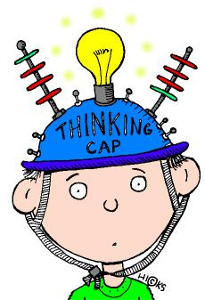

http://www.bretlsimmons.com/2011-05/problem-solving-101/

Behavior Strategies that Promote Academic Achievement | 43

Emotional and Behavioral Disorders (EBD)

Emotional disturbance is defined as a condition exhibiting an inability to learn that cannot be explained by intellectual, sensory, or health problems. These students are unable to build or maintain satisfactory interpersonal relationships with peers and teachers. They display inappropriate types of behaviors or feelings under normal circumstances, a general pervasive mood of unhappiness or depression, or a tendency to develop physical symptoms or fears associated with personal or school problems (Lerner

- Johns, 2012). According to Article 7, students must display one or more behaviors that exhibit the characteristics of EBD in order to qualify for services. The following are characteristics that the student must exhibit:

  - Develop physical symptoms or fears with teachers or school problems.

  - Unhappiness or depression

  - Unable to build interpersonal relationships.

  - Inappropriate behaviors or feelings under normal circumstances

  - Episodes of psychosis (Article 7, 2010).

About 8% of all students with disabilities are identified under the category of emotional disturbance. About 29% of these students are in general education classes, and about 24% are in resource rooms for part of the day (Lerner & Johns, 2012).

The way students feel about themselves are directly related to ED. Students may feel depressed all the time or have a low self-concept. These feelings may interfere with the individual’s outlook on life and ability to learn. Behavior disorders involve behaviors such as aggression or antisocial behavior. A student who has a low self-esteem may engage in behaviors that lead to being socially isolated (Learner & Johns, 2012).
Behavior Strategies that Promote Academic Achievement | 44

Students with emotional and behavioral disorders often come from environments that are not positive. They may have a history of abuse, homelessness, or neglect. This is not true for every student with EBD, but most of these students really struggle in school because of their hardships in life. For many of these students, because of the hard life they are living, the last thing on their mind is whether they know their math facts or how to spell a word. Their biggest worries may include but are not limited to whether their parent is safe while they are in school, whether they will have food to eat that evening, or whether they will have a place to lay their head at night. Teachers need to take this into consideration when they have these students in their classrooms. Usually their defiance is not just defiance; it is often times a cry for help. When the teacher figures out how to break through the walls the student has up, then the student will be able to learn from that teacher. It is important for the teacher to realize where the student has come and how much success they have had since the beginning. A teacher may look at a student with EBD and say that the student is not completing his/her work. But the fact that the student is appropriately interacting in the general education classroom is a big deal. They may not be completing their assignment, but the fact that the student has not yelled at the teacher or thrown a chair at a teacher is a big success for that student.
Behavior Strategies that Promote Academic Achievement | 45

Section 3

Positive Student-Teacher Relationships
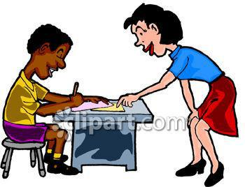

http://tx.english-ch.com/teacher/ronald/others/-teachers-and-students-rapport/
Behavior Strategies that Promote Academic Achievement | 46

Student/ Teacher Relationships

The relationship between a teacher and a student is extremely important. If this is

strained, it can be very difficult for both the student and the teacher if there is a strained

relationship. When teachers use effective instructional practices that promote positive

teacher-student interactions and a positive classroom climate, they are minimizing

problem behaviors in the classroom (Conroy, 2012). When students feel that you value

and care for them as individuals, they are more willing to comply with your wishes

(Boynton pg. 6, 2005).Teacher attitudes can affect student behaviors. If a teacher is

overwhelmed, and displays that behavior to the student, then the student may exhibit

more difficult behaviors. Teacher attitudes towards students with EBD can also affect

their willingness to welcome the student into their classroom, and whether they believe

the student can be successful or not (Gaudreau et al., 2013). This section of the handbook

offers many strategies that will help build a positive student-teacher relationship. In turn,

this will help promote academics. After the behaviors are under control, academics will

fall into place.
Behavior Strategies that Promote Academic Achievement | 47

How to use the interviews

These interviews are intended for the teacher to get to know the students in their

classroom and see the growth that has taken place throughout the year. The first student

interview is “My First Day of Third Grade”. This is intended to be given the first day of

school. The interview will give insight to the teacher about what the student’s likes and dislikes

are. It will also show the teacher other things too. If the teacher decides not to read the interview

out loud to the student, the teacher can see how well the student can read, how their writing is,

and if they know how to spell. They will also be able to see if the student likes to write or not.

The second interview is called “My Final Day of Third Grade”. It is intended for the last

day of school. Once the students complete this interview, then the teacher can compare the two

interviews and show the growth from the first day of school to the last day of school. It will show

the differences in handwriting, spelling, and interests from the beginning of the school year to the

end.
Behavior Strategies that Promote Academic Achievement 48

My First Day of Third Grade


This is how I write my name:


I am____________ inches tall and weigh pounds.

My best friend's name is:

My favorite thing to play:

My favorite color:

My favorite book:

My favorite TV show:

My favorite food:

When I grow up, I want to:

Something I really like:

Something I really don't like:

My favorite thing about myself:


Something I want to do this year:

Retrieved from: http://www.positivelysplendid.com/wordpress/wp-content/uploads/2013/05/interview-third-grade.pdf

Behavior Strategies that Promote Academic Achievement | 49

My Final Day of Third Grade



This is how I write my name:



I am inches tall and weigh pounds.

My best friend's name is:

My favorite thing to play:

My favorite color:

My favorite book:

My favorite TV show:

My favorite food:

When I grow up, I want to:

My favorite thing about the third grade was:

Something cool that I learned this year:



Something I want to learn in the fourth grade:

Something I want to do this summer:

Retrieved from: http://www.positivelysplendid.com/wordpress/wp-content/uploads/2013/05/interview-third-grade

Behavior Strategies that Promote Academic Achievement | 50

How to use the “I Am” form

The “I Am” form is a tool that teachers can use to get to know their students

better. It can be given at any time during the school year. It is a good way to build a

relationship with your students because it gives you an insight to the things they like to

do, what makes them happy, sad, scared and what they want to do with their lives. This

can be used as a conversation starter between the teacher and the student, or it can be

used as a class activity.

This is a great tool to use to get to know students with emotional and behavioral

disorders because they will tell you what makes them happy and sad. Based on this

knowledge, you can figure out what could be a motivator for the student. If comic books

make a student happy, then as a teacher I will offer time to spend reading a comic book

as a reward for good behavior.
Behavior Strategies that Promote Academic Achievement | 51

Name:_____________

Date:__________

I Am

I love _________________ because

________________________________.

- wonder

______________________________________________________. I am happy when:

_____________________________________________________________. I am scared when:

_____________________________________________________________.

I worry about __________________________________ because

_______________________________________________________________________.

I hope to:

______________________________________________________________________.

I am sad when

_________________________________________________________________.

In the future I will

______________________________________________________________.

http://www.edutopia.org/blog/fostering-classroom-relationships-larry-ferlazzo-katie-hull-

sypnieski
Behavior Strategies that Promote Academic Achievement | 52

Sample Interest Survey Letter and Interest Survey

The sample interest survey letter can be sent home with your students at

the beginning of the year for the parents to fill out and send back. The letter explains to

the parents what the interest survey is and how to complete the form. It is very beneficial

to find out from the parents what works at home with their child. Rewards that are used at

home could be something that is offered at school if appropriate. Knowing what the

parents allow their child to do at home for a reward could be something that the child

works for in school as well. For example, if a child really likes to play video games, then

the teacher and parent could work together to offer the child the reward of playing video

games when he/she gets home from school if the child completes all of his/her work for

the day.
Behavior Strategies that Promote Academic Achievement 53

Sample Interest Survey Letter Regarding Student Interest

Dear Parents,

Welcome to First Grade! I am excited to get to know your child and looking forward to working with you over the next year to support your child’s education. In order to get a “jump start” in developing a relationship with your child you can help me by filling out the following information and returning it to me as soon as possible. Knowing what activities and interests your child has helps me to develop curriculum that is exciting and meaningful for your child. Knowing areas you perceive as more difficult for your child helps me to stretch and encourage your child in new areas or places s/he might be tempted to avoid. Thanks for your help. Parents are the most important people in a child’s life, and we need to work together for the benefit of your child. With home and school working together I know that each and every student can have the most successful year yet.

Behavior Strategies that Promote Academic Achievement | 54

Sample Interest Survey Letter Regarding Student Interest

Child’s Name:

Areas I see as strengths for my child: (academic or social)

Areas I see as more difficult for my child: (academic or social)

What I hope my child will learn this year:

My child’s interests are: (include favorite magazines, toys, activities, outings, play acting, math, art, computer time, sports, etc.)

Things my child perceives as especially rewarding: (e.g., special privileges, leadership roles, special food, stickers, baseball cards, movies, etc.)

Things about my child that are special: (include pets, siblings, clubs, grandparents or other people involved closely with your child)

csefel.vanderbilt.edu/briefs/wwb12.pdf
Behavior Strategies that Promote Academic Achievement | 55

Blackboard Notes

Points to Remember about

Building Positive Relationships with
Students

Show students you care by:

- Giving them a personal greeting each day when they arrive

- Asking about their feelings e.g., dialogue journals

- Asking about their life outside of school e.g., listening bear

- Listening to them

• Eating in the cafeteria occasionally with students

- Recognizing birthdays in some way

- Sending cards and positive messages home, e.g., happygrams

- Finding out about their hobbies and special talents, e.g., interest surveys

- Making home visits

- Sharing something personal about yourself

- Spending time playing with them — at recess or during free classroom time

- Establishing positive relationships with every child regardless of their academic or social abilities

- Getting to know their parents through home visits and classroom meetings

- Calling parents periodically to report their child’s success or accomplishments

Show students you believe in them by:

- Identifying negative self-talk

- Promoting positive self-talk

- Communicating your belief they can succeed

- Making “I can” cans out of empty juice cans and
Behavior Strategies that Promote Academic Achievement 56

drop strips of paper in them on which students have written skills they have learned, e.g., math facts, spelling words, sharing with others, helping. (This is also useful to show parents the child’s progress.)

- Making phone calls to students to applaud their special efforts or accomplishments

- Helping every child in the classroom to appreciate other’s special talents and needs

- Following their lead, listening carefully to their ideas and being an “appreciate audi- ence” at times

Show students you trust them

by:

- Inviting students to help with daily tasks and classroom responsibilities

- Offering curriculum choices

- Encouraging collaboration among students

• Encouraging students to help each other

- Sharing your thoughts and feelings with them

csefel.vanderbilt.edu/briefs/wwb12.pdf

Behavior Strategies that Promote Academic Achievement | 57

Teacher-to-Parent Communication Form

This explains the “give me five” method. It can be used at the beginning of the

school year so that the student and the parents know what your expectations are in your

classroom. In the parent-to-teacher communication form, the parents can share what rules

they have at home. This is good information for the teacher because knowing what is

expected at home will help the teacher hold the student accountable at school. For

example, if being respectful towards adults is a rule at home and it is a rule at school,

then the teacher can hold the student accountable to that. The teacher can address issues

at school knowing what the parent expectations are.
Behavior Strategies that Promote Academic Achievement 58

Teacher-to-Parent Communication Form

Classroom and Family Rules

At school your children are learning about how to do well in school and are practicing 5 classroom rules. You can help support your children’s learning by commenting and praising them when you notice them following these rules at home.

Ask your child , “Show Me Five” (hold up your hand). See how rules many they remember! Ask them to show you how they follow these rules, one at a time.

The Show Me Five Rules are:

Listening Ears: (To remind children to quietly listen and pay attention to the speaker.) Praise them at home when they are using their listening ears when others are talking.

Eyes on Teacher: (To remind children to look at the teacher and pay attention.) Praise children at home when they are looking at you with their listening eyes.

Behavior Strategies that Promote Academic Achievement 59

Keep Hands to Self: (To remind children to keep their hands to themselves.) Praise your child when s/he keeps her hands to own body.

Use Walking Feet: (Reminds children about walking slowly – and saving running feet for outside!) Praise your children for using their walking feet inside the house.

Use Inside Voice: (To remind children to learn to talk quietly and not disturb others.) Praise your children for using polite and quiet inside voices.

Record on the Parent-to-Teacher Communication Form your experiences talking about your family rules with your child and send this form back to school with your child.

Behavior Strategies that Promote Academic Achievement | 60

Teacher-Classroom Management Self-Reflection Inventory

This is a wonderful tool to help teachers evaluate the way they are teaching their

class. Sometimes the problem is not how we are teaching, but our behavior management.

This is a great tool to assess ourselves as teachers on how we are teaching our student. It

first talks about assessing our classroom rules. Are they effective? Then it assesses our

schedule. Is there too much transition time in our daily schedule? Is there a lull that is

causing students to act out? It also assesses our classroom environment and organization.

There are spaces for future goals for each section in this self assessment.
Behavior Strategies that Promote Academic Achievement | 61

Parent-to-Teacher

Communication Form


Classroom and Family Rules

Child’s Name:

Record on this form your experiences talking about your family rules with your child and send this form back to school with your child.

Your child may draw a picture of one of your household rules here too.

csefel.vanderbilt.edu/briefs/wwb12.pdf
Behavior Strategies that Promote Academic Achievement | 62

The Incredible Years®

Teacher Classroom Management Self-Reflection

Inventory Proactive Teacher Strategies

Date: Teacher Name:

Teachers learn extensively from self-reflection regarding their classroom management and the teaching strategies they are using that are working or not working. From these reflections teachers determine personal goals for making changes in their approaches to bring about the most positive learning climate they can. Use this Inventory to think about your strengths and

limitations and determine your goals. |  | 1 – Never 3 – Occasionally 5 - Consistently
Proactive Teacher – Rules
1. | I state rules positively and clearly and they are posted on the |  | 1 | 2 | 3 | 4 | 5
 | wall. They are reviewed and practiced as needed.
2. | I use nonverbal cues and signals to communicate rules as well |  | 1 | 2 | 3 | 4 | 5
 | as words (e.g., pictures of rules such as raise quiet hands, quiet
 | voice, five on the floor, ears open)
3. | I have taught children the “show me five” signal and use it. |  | 1 | 2 | 3 | 4 | 5
4. | I state requests or give directions respectfully using brief |  | 1 | 2 | 3 | 4 | 5
 | descriptions of positive behaviors desired (e.g., “please keep
 | your hands to your own body”) .
5. | I use “when-then” commands. |  | 1 | 2 | 3 | 4 | 5
6. | I give students choices and redirections when possible. |  | 1 | 2 | 3 | 4 | 5
7. | I avoid negative commands, corrections, demands, and yelling at |  | 1 | 2 | 3 | 4 | 5
 | children.
8. | I get children’s attention before giving instructions. |  | 1 | 2 | 3 | 4 | 5
9. I redirect disengaged children by calling out their name with a |  |  | 1 | 2 | 3 | 4 | 5
 | question, standing next to them, making up interesting games,
 | and nonverbal signals.
10. I give frequent attention, praise and encouragement to children |  |  | 1 | 2 | 3 | 4 | 5
 | who are engaged and following directions.

Behavior Strategies that Promote Academic Achievement | 63


11. I communicate with parents about classroom rules and schedules

and send home the Teacher-to-Parent Communication forms. | 12345

Future Goals About Rules:

Proactive Teacher - Schedules
1. | My classroom routines and schedules are consistent, predictable | 1 | 2 | 3 | 4 | 5
 | and allow for flexibility.
2. | I post classroom schedules on the wall in a visible place for | 1 | 2 | 3 | 4 | 5
 | children, parents and visitors.
3. | Visual pictures/cues are used to indicate different activities on | 1 | 2 | 3 | 4 | 5
 | schedule (e.g., small group circle time, unstructured play time,
 | teeth brushing or hand washing, outside play, lunch).
4. | My classroom schedule alternates active and vigorous activities | 1 | 2 | 3 | 4 | 5
 | (outside activities or free choice) with less active activities (story
 | time).
5. | I provide a balance between teacher-directed and child-directed | 1 | 2 | 3 | 4 | 5
 | activities.
6. | I have a system in place for students to choose between play
 | areas during unstructured times (center cards for activity areas | 1 | 2 | 3 | 4 | 5
 | such as block center, dress up and kitchen pretend play area,
 | book area).

Behavior Strategies that Promote Academic Achievement | 64


7. | My large group circle time is scheduled for no longer than 20 | 1 | 2 | 3 | 4 | 5
 | minutes.
8. | My large group circle time includes many active responses from
 | children (e.g., singing and movement, stretch breaks, holding | 1 | 2 | 3 | 4 | 5
 | cue cards, acting out responses, answering verbally as group,
 | puppet play) to encourage high rates of engagement.
9. | Free play or center time in my classroom is the longest activity | 1 | 2 | 3 | 4 | 5
 | during play- allowing children time to choose materials, play and
 | clean up.

Future Goals About Schedules:

Behavior Strategies that Promote Academic Achievement | 65

Proactive Teacher - Transitions
1. | I avoid unnecessary transitions and keep waiting time minimal. | 1 | 2 | 3 | 4 | 5
2. | I systematically teach students the expectations for transitions. | 1 | 2 | 3 | 4 | 5
3. | I warn students before a transition begins and transitions are not | 1 | 2 | 3 | 4 | 5
 | rushed.
4. | I use a consistent cue to signal a transition (e.g., bells, song, | 1 | 2 | 3 | 4 | 5
 | clap, lights turned on and off).
5. | I use visual pictures/cues and auditory sounds to note schedule, | 1 | 2 | 3 | 4 | 5
 | transition cards, tape on floor for line up, quiet area, pictures for
 | daily jobs).
6. | I start circle time activity when a few children are ready to begin | 1 | 2 | 3 | 4 | 5
 | and do not wait for everyone.
Future Goals About Transitions:
Proactive Teacher - Classroom Environment and Organization
1. | My classroom is well equipped with a variety of toys and | 1 | 2 | 3 | 4 | 5
 | materials so that children of all skill levels have something to
 | play with.
2. | My classroom is organized by learning centers and number of
 | children allowed in a center is limited with visual reminders | 1 | 2 | 3 | 4 | 5
 | of how many children are allowed (e.g., hooks with names,
 | clothespins etc.).
3. | I have put picture labels are on low shelves to help children find | 1 | 2 | 3 | 4 | 5
 | and return materials.

Behavior Strategies that Promote Academic Achievement | 66

4. I have provided toys that promote social interaction are present |  | 1 | 2 | 3 | 4 | 5
 | in all learning centers (e.g., puppets, wagons, large floor puzzles,
 | turn-taking games etc.)
5. I have a systematic rotation plan in effect to increase novelty |  | 1 | 2 | 3 | 4 | 5
 | and curiosity (e.g., sand or bubble table open at certain times).
6. My classroom provides visual cues to children to signal whether |  | 1 | 2 | 3 | 4 | 5
 | an area or activity is open or closed (e.g., stop sign, sheet
 | covering sand table or computer).
7. | Materials are enlarged in my classroom for children with
 | visible motor impairments (e.g., larger crayons, paper, etc.) and | 1 | 2 | 3 | 4 | 5
 | stabilized for better manipulation (taped to table, Velcro board,
 | trays).
8. I provide visual cues throughout classroom to remind child of |  | 1 | 2 | 3 | 4 | 5
 | target skill (e.g., sharing, helping, teamwork).
9. A large physical structure is provided in my classroom for circle |  | 1 | 2 | 3 | 4 | 5
 | time and children sit on carpet squares or mats.
10. I prepare materials for small group activities so they are ready to |  | 1 | 2 | 3 | 4 | 5
 | go before children arrive for the day.
11. I plan cooperative activities are planned on a daily basis (e.g., |  | 1 | 2 | 3 | 4 | 5
 | large collages, class books, cooking activities etc.).
12. | Children are visible at all times. Shelving is no higher than 4 feet | 1 | 2 | 3 | 4 | 5
 | tall.
13. I place inattentive or easily distractible children close by me. |  | 1 | 2 | 3 | 4 | 5
Future Goals for Environmental Structure and Planning:

csefel.vanderbilt.edu/briefs/wwb12.pdf

Behavior Strategies that Promote Academic Achievement | 67

Behavior Autopsy

This is wonderful for students to use to reflect on their behavior. The students

have to think about what they did wrong and explain how they are going to change their

behavior. Students can be required to complete this on their own, or they can sit with the

teacher and complete the form. The form has to be sent home to the parents to be signed.
Behavior Strategies that Promote Academic Achievement | 68

Name:_________________ Date:_____________

Behavior Autopsy

I got in trouble because:

________________________________________________________________________

________________________________________________________________________

________________________________________________________________________

________________________________________________________________________

This was wrong because:

________________________________________________________________________

________________________________________________________________________

________________________________________________________________________

Next time I will:

________________________________________________________________________

________________________________________________________________________

________________________________________________________________________

My consequences are:

________________________________________________________________________

________________________________________________________________________

Developed by Jenna Rios
Behavior Strategies that Promote Academic Achievement 69

Section 4

What is a Behavior Plan?


thestatuswoe.wordpress.com

Behavior Strategies that Promote Academic Achievement | 70

Behavior Intervention Plan

A behavior intervention plan (BIP) means a plan agreed upon by the case conference committee and incorporated into a student’s individual educational plan (IEP). It describes the pattern of behavior that impedes the student’s learning or learning of others. The purpose is to describe the behavior of concern, suggest strategies that will help change the desired behavior, and goals to be met. It also describes an emergency plan in case the student becomes frustrated or has an outburst. It describes exactly what the teacher is to do if there is a problem with the student. If a student with an IEP has a behavior plan, then what is in the behavior plan must be implemented in the classroom. The plan includes strategies that will help the student be successful in the general education setting.

A behavior plan should be very detailed. It should describe what to do on field trips, what to do when the student has an issue within the classroom, and how the general education teacher can help the student if there is an issue. It should be clear and easy to understand. It must be developed in a case conference. The committee must sign off on this plan in order for it to go into effect.
Behavior Strategies that Promote Academic Achievement | 71

Behavior Intervention Plan Template and example

A behavior intervention plan is developed in the case conference with the case conference committee. The plan should be very detailed so that everyone involved knows what to expect. It needs to have a clear description of how the plan will be implemented. For example, if the student is to be in general education for the entire day, what is the plan if the student has an outburst while in the general education classroom? Will the special education aide go to the room to get the student? Will the student be allowed to walk back to the classroom on his/her own? What will happen on days that there is a field trip? All of these questions are examples of things that need to be answered in the behavior plan. Once a behavior plan is developed and reviewed by the teachers involved, they should have very clear picture on what to do with the student once he/she comes to the classroom.
Behavior Strategies that Promote Academic Achievement 72

Behavior Intervention Plan Template


Strengths of Student:(be specific in this section of IIEP)

Operational Definition of Behavior(s): (Insert in Text box 1 – Behaviors of Concern in IIEP)

Function of Behavior (from FBA):(Insert in Text box 2 – Functions of Behavior in IIEP)

Previously Attempted Interventions and Resulting Effectiveness: (Baseline Data)(Insert
in Progress Monitoring section in IIEP)

Functional Behavior Assessment Hypothesis statement: three-step process—when X occurs, the
student does Y, in order to achieve Z (function). (Insert in Text box 2 – Functions of Behavior in IIEP)

Behavior Strategies that Promote Academic Achievement 73


The INTERVENTION PLAN: Description of Intervention(s): (Insert in Text box 3 - Positive

Strategies/Instructional Experiences)

Behavior Goal:

(Describe objectives, procedures, and data to be collected.)

Prevention Techniques-

Teaching Replacement Behaviors-

Environmental changes necessary-

Positive Reinforcement-

Planned Consequences-

Behavior Strategies that Promote Academic Achievement | 74


Method of Recording: (Insert in Text box 3 - Positive Strategies/Instructional Experiences)

Crisis Plan: (Insert in Text box 3 - Positive Strategies/Instructional Experiences)

Schedule for Program Review Date (Insert in Text box 3 - Positive Strategies/Instructional Experiences)

_________________________________________________ _______

Student Signature Date
_________________________________________________ _______
Parent/Guardian’s Signature Date
_________________________________________________ _______

General Education Teacher’s Signature Date
_________________________________________________ _______
Teacher of Record Signature Date
_________________________________________________ _______

Signature Date
_________________________________________________ _______
Signature Date
_________________________________________________ _______

Signature Date

Developed by Northeastern Special Education Cooperative
Behavior Strategies that Promote Academic Achievement | 75

Example of Behavior Intervention Plan


Strengths of Student:(be specific in this section of IIEP)

The student does well academically. He is a great reader, does well in math, and puts others before himself. He uses reading skills, has good reasoning for problem solving, and can carry on an interesting conversation.

Operational Definition of Behavior(s): (Insert in Text box 1 – Behaviors of Concern in IIEP)

The student has tendencies to blurt out, refuses to complete required work at times, and will plug his ears when he does not want to hear what the teacher is telling him (this only happens when he is very frustrated). He often times tries to tattle on other students or try to correct them when it is not his place to correct them.

Function of Behavior (from FBA):(Insert in Text box 2 – Functions of Behavior in IIEP)

-Gaining attention

-sensory stimulation
-other impulsive; lack of emotional regulation

Previously Attempted Interventions and Resulting Effectiveness: (Baseline Data)(Insert
in Progress Monitoring section in IIEP)

-The student is given several reminders throughout the day to raise his hand to answer a question.

-He is very motivated by the points that he earns throughout the school day. He always wants to have a high score.

-He earns rewards throughout the day (free time with friends or free time on the Chromebook) for positive behavior.

Functional Behavior Assessment Hypothesis statement: three-step process—when X occurs, the
student does Y, in order to achieve Z (function). (Insert in Text box 2 – Functions of Behavior in IIEP)

When instruction is happening, the student talks out instead of raising his hand in order to achieve student recognition of his intelligence.

The INTERVENTION PLAN: Description of Intervention(s): (Insert in Text box 3 - Positive
Strategies/Instructional Experiences)

Behavior Goal:

The student will raise his hand to respond to the teacher during instruction 8 out of 10 times.

(Describe objectives, procedures, and data to be collected.)

Prevention Techniques-

-The student will mark a tally every time he is calling out during instruction. For every tally mark he loses a point. If he has zero tally marks during an instruction period, then he can earn computer time.

Behavior Strategies that Promote Academic Achievement | 76


Teaching Replacement Behaviors-

-The student will be taught to write down his interruption questions. When the lesson is over then he will be able to share his questions and/or comments.

Environmental changes necessary-

-The student is allowed to work under his desk as long as he is quiet, working, and not distracting other students.

-The student is allowed to stand at his desk as long as he is quiet, working, and not distracting other students.

-The student will have a place in the room that he can go to to calm down if he needs to.

-The student’s seating will be adjusted as needed.

-He will be able to walk around when time allows as he may need the extra sensory breaks throughout the day.

Positive Reinforcement-

-The student will earn points for good behavior in the ED classroom as well as the general education classroom.

-He will also earn classroom money for positive behavior. As he earns money he will be able to buy things from the classroom store on a bi-weekly basis.

-The student works for positive praise from the teacher. If he is complimented and/or recognized for positive behaviors, he usually will work for the teacher.

Planned Consequences-

-If the student does not behave, he will not earn points in the classroom. He will not earn classroom money and may move down on the behavior system due to his behavior.

-He will also lose out on extra privileges offered to students with good behavior.

Method of Recording: (Insert in Text box 3 - Positive Strategies/Instructional Experiences)

-point sheet

-student documentation
-drag sheet
Behavior Strategies that Promote Academic Achievement | 77


Crisis Plan: (Insert in Text box 3 - Positive Strategies/Instructional Experiences)

ED Classroom: When the student becomes angry he will talk with the ED staff about what is making him angry. They will process through the problem together. If the student is not able to do this, then he will go to the take a break room to take a break. He will use the calming techniques he has been taught. After he is calm, one of the ED staff members will process through the problem with him.

General Education Room: If the student becomes upset while in the general education classroom, then the general education teacher will call an ED staff member to come talk to the student in the general education classroom. If the student asks to come back to the classroom because he is mad then the general education teacher will call an ED staff member to come to the classroom to talk with him. If he is unable to calm down then the ED staff member will escort the student back to the ED classroom. He will go to the take a break room (TAB) to process through the problem. Any work that the student will miss while he is gone will be sent to the ED classroom for him to work on. If the student is able to work through the problem before the class period is over, then he will be escorted by the ED staff member back to the general education classroom. If that person feels that Ryan needs continued support, then s/he will stay in the room until s/he is sure that he is calm enough to be successful on his own. If he is, then the ED staff member will leave.

Adding additional subjects in general education: As long as the student receives an 85% or higher for 2 weeks in a row, then he will be able to add an additional subject to his day in the general education setting. If he is falling behind or struggling in a subject then the ED teacher can determine whether this time needs to be extended or if an aide needs to be sent out to the general education classroom with the student during the subject he is struggling in. He is currently attending all special classes, math, and whole group reading.

Field trips: The student will be allowed to go on all field trips and extracurricular activities offered by the general education classes. It will be determined by ED teacher whether the student will be allowed to attend these activities based on the student’s behavior data.

Schedule for Program Review Date (Insert in Text box 3 - Positive Strategies/Instructional Experiences)

_________________________________________________ _______
Student Signature Date

_________________________________________________ _______
Parent/Guardian’s Signature Date
_________________________________________________ _______
General Education Teacher’s Signature Date

_________________________________________________ _______
Teacher of Record Signature Date
_________________________________________________ _______
Signature Date

_________________________________________________ _______
Signature Date
_________________________________________________ _______
Signature Date

Developed by Northeastern Special Education Cooperative Written by Jenna Rios
Behavior Strategies that Promote Academic Achievement | 78

ABC Analysis Example

Sometimes it is hard to know or see a pattern of behavior with a child. This chart lays the data out for the teacher in an easy to read chart. It shows the teacher what is going on, what part of the day it is happening, and what subject is being taught at the time. It also describes the possible function. This will really help see where the student is struggling. If there is a pattern, then the teacher can possibly modify the student’s day, or make a behavior plan to help the student get through the subject they are struggling in.
Behavior Strategies that Promote Academic Achievement | 79

ABC

Analysis

Example

Name: George

Description of behavior(s) of interest: humming loudly, telling an inappropriate joke, putting head on desk, refusal to participate, throwing books.

Date | Time | Antecedent | Behavior | Consequence | Possible
 |  |  |  |  | Function
2/7 | 9:40am | Teacher announces it is time for | Tells | Peers laugh, class | Escape/Atten.
 |  | reading | inappropriate | disrupted
2/7 | 9:45am | Teacher calls on George to read | Throws book | Sent to office | Escape
 |  | first
 |  | Teacher asks George to pay | George crouches | George can't see
2/8 | 9:35am | Teacher asks George to pay | down so he can't | George can't see | Escape
 |  | attention | see | instruction
2/8 | 9:40am | Teacher instructs class to move | George sighs, | George doesn't join | Escape
 |  | into reading groups | puts head on desk | his group
 |  | Teacher asks George to move to | George slams his | George's teacher
2/8 | 9:42am | Teacher asks George to move to | George slams his | warns him not to | Escape
 |  | his reading group | book shut | throw book
 |  |  | George throws
 |  |  | his book and | Avoids reading
2/8 | 9:50am | Teacher says go to your group | walks out of the | Avoids reading | Escape
 |  |  |  | group | Escape
 |  |  | class towards the | group
 |  |  | principal's office

Reprinted with permission: Freeman, R. L., Britten, J., McCart, A., Smith, C., Poston, D., Anderson, D., Edmonson, H., Baker, D., Sailor, W., Guess, D., & Reichle, J. (1999). (Module 2) Functional Assessment [Online]. Lawrence, KS: Kansas University Affiliated Program, Center for Research on Learning.

Available: uappbs.lsi.ku.edu
Behavior Strategies that Promote Academic Achievement 80

Section 5

Positive Praise


www.kozzi.com

Behavior Strategies that Promote Academic Achievement | 81

Positive Praise

There is a positive correlation between teacher praise and students responding to an academic request (Southerland et al. 2002). When a teacher uses positive praise within the classroom, it has a positive effect on students with EBD in both academic and behavioral areas. This method is easy to use within the classroom and requires no special preparation.

Some effective ways to offer positive praise is to be specific about what the child did. Point out what the child is doing that is favorable. For example, “I love how neatly you are writing Jon. Good job!” Praise should be contingent upon the desired behavior. It is important to provide frequent praise when children are initially acquiring a skill. It should be teacher initiated. Praise should focus on children’s improvement and effort. It should be sincere (Conroy et al. 2009).
Behavior Strategies that Promote Academic Achievement | 82
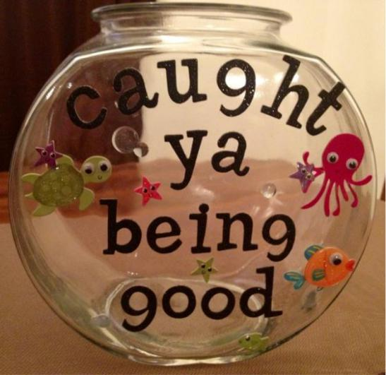

wolfelicious.blogspot.com

When students are caught being good in the classroom they are able to put their

fish with their name on it in the fish bowl. This gives them a chance to have their name

drawn out of the bowl when the teacher draws a name for a reward.
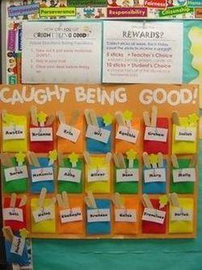

http://evelynclancy.weebly.com/classroom-management.html

When students are caught being good, they can put a stick into their pocket on the board. At the end of the week, the students earn a reward for the amount of sticks they have in their pocket.
Behavior Strategies that Promote Academic Achievement | 83
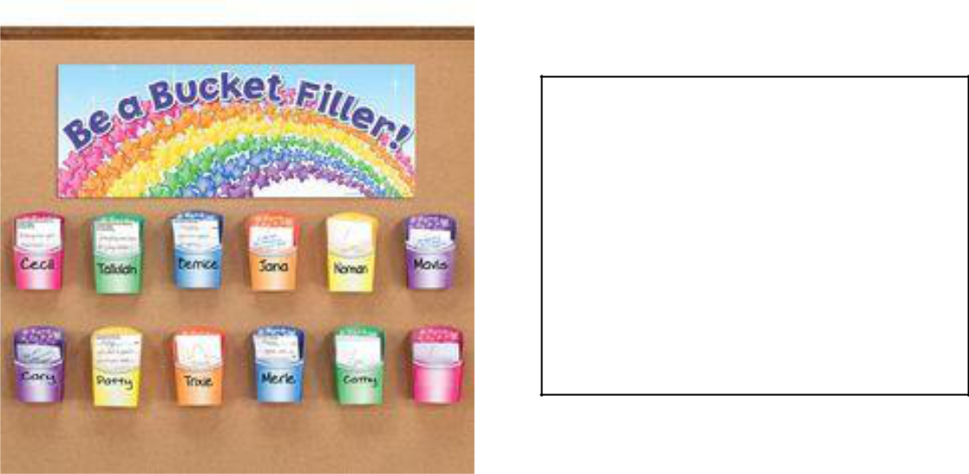

Students can use this to fill each other’s buckets. This system is based off of the book Have you Filled a Bucket Today? By Carol McCloud. They write ways that they have filled other’s buckets by giving compliments to each other. Teachers can also fill student’s buckets.

www.pinterest.com
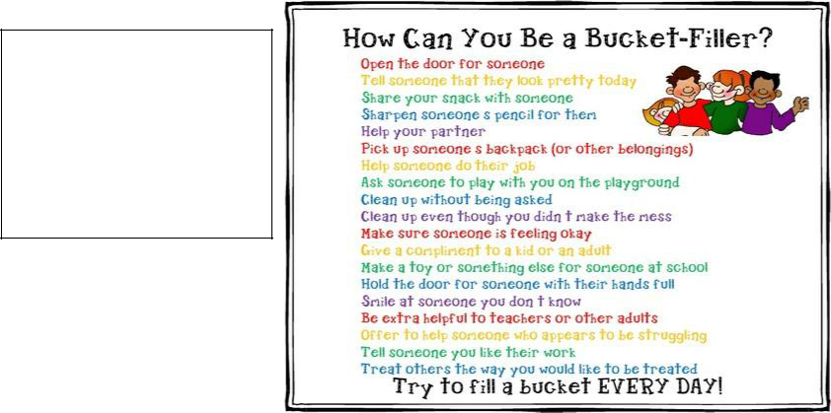

These are examples

of ways to “fill a bucket” that can be

posted in the classroom.

www.theclassroomcreative.com
Behavior Strategies that Promote Academic Achievement 84

GUIDELINES FOR EFFECTIVE PRAISE

(Applies primarily to praise associated with instruction and student performance)

Effective Praise

- Is delivered contingently upon student performance of desirable behaviors or genuine accomplishment

- Specifies the praiseworthy aspects of the student's accomplishments

- Is expressed sincerely, showing spontaneity, variety and other non-verbal signs of credibility.

- Is given for genuine effort, progress, or accomplishment which are judged according to standards appropriate to individuals.

- Provides information to students about their competence or the value of their accomplishments.

- Helps students to better appreciate their thinking, problem-solving and performance.

- Attributes student success to effort and ability, implying that similar successes can be expected in the future.

- Encourages students to appreciate their accomplishments for the effort they expend and their personal gratification.

Ineffective Praise

- Is delivered randomly and indiscriminately without specific attention to genuine accomplishment

- Is general or global, not specifying the success.

- Is expressed blandly without feeling or animation, and relying on stock, perfunctory phrases.

- Is given based on comparisons with others and without regard to the effort expended or significance of the accomplishment of an individual.

- Provides no meaningful information to the students about their accomplishments.

- Orients students toward comparing themselves with others.

- Attributes student success to ability alone or to external factors such as luck or easy task.

- Encourages students to succeed for

external reasons -- to please the teacher, win a competition or reward, etc.

http://www.adprima.com/managing.htm

This can be used as a good guideline to remember about what effective praise is and what it is not. So many times teachers can get in the habit of giving ineffective praise without even realizing that they are doing it. This chart is a great reminder as to what positive praise is.

Behavior Strategies that Promote Academic Achievement 85

Section 6

Token Economy
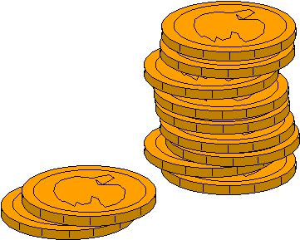

littlepiggyreads.blogspot.com

Behavior Strategies that Promote Academic Achievement | 86

Mrs. Rios’ Classroom Letter

My classroom letter is sent out every year at the beginning of the school year to each student. This letter explains all of the procedures used in my classroom. It explains my token economy in detail. When a new student comes to my classroom, this letter is sent home with them. I expect the parent to read through the letter with the child. They both are to sign and return the letter. If it is returned by a certain date, then the child earns a reward for returning it on time. This ensures that the parent understands the procedures of my classroom. Parents are encouraged to talk with me about any questions or concerns they have.
Behavior Strategies that Promote Academic Achievement | 87

Mrs. Rios’ Classroom Letter

Dear Parents/ Guardians,

I am very excited to have the opportunity to work with your child during this school year. A good learning experience is built on a cooperative effort between parent/guardian, child, and teacher. I expect to work closely with you to meet your child’s educational and social needs. It is vital that we communicate with each other to fulfill these goals. With your participation in and out of the classroom, we can look forward to a productive, creative, and fun year together.

I am excited about this new school year. I hope we can work together to make it one of growth, discovery, and significance for your child. Please don’t hesitate to contact me with any questions, concerns, or comments you may have. I am expecting to have a WONDERFUL year with your child. Thank you for this opportunity.

Sincerely,

Jenna Rios
Behavior Strategies that Promote Academic Achievement | 88

Classroom Letter Continued:

Homework

I give homework four days a week. Homework will be given Monday thru Thursday. Your child will also need to spend 20 minutes a night reading.

Classroom Expectations

These are our classroom expectations:

- Speak with permission.

- Stay in assigned area.

- Respect materials, others, and yourself.

- Work and play quietly.

- Follow directions.

Incentive Coupons

When your child is caught doing something positive they will have the chance to earn an incentive coupon. Their daily points will also earn them incentive coupons.

Classroom Money

Students have the opportunity to earn classroom money daily. They earn money for points that they earn, for good behavior, doing their classroom job that they have weekly, and for going to their general education classes. Every two weeks students will have the opportunity to participate on the classroom store. They use their classroom money that they have earned for the last two weeks to buy things from the classroom store.

Our Behavior System

The behavior system we use in our classroom is leveled system. Your child will be traveling the road to Rios Resort. Each student has his/her own boat. The students will “travel” through the system until they reach Rios Resort. On Rios Resort they will earn different incentives and privileges in the classroom. The next few pages describe what our point system is and how it works.
Behavior Strategies that Promote Academic Achievement | 89

Points System

Students can earn a maximum of 100 points per day. Every hour each student can earn 10 points. They can earn points for appropriate behavior anytime in that hour. The total number of points they can earn during the school hours is 70. The other 30 points come from appropriate bus behavior, having their daily note signed and returned, homework completed/desk organized with each of these being worth 10 points. The number of points earned for the day will be on the daily letter. Students will also receive incentive coupons for exceptional behavior.

Students may earn points for but not limited to:

Staying in their seat

Staying on task and using time wisely

Completing assignments

Being polite

Neatness

Honesty

Raising hand for permission

Participation in lessons

Lining up appropriately

Helping others

Students will not earn points for inappropriate behavior such as but not limited to:

Talking out

Being out of their area at inappropriate times

Not using classroom time effectively

Arguing

Name calling/cursing

Not following directions

Tattling

Making noise at inappropriate times

Throwing objects
Behavior Strategies that Promote Academic Achievement | 90

At the end of the day the points are added up to determine how the student has behaved during the day. Positive behavior will always be rewarded in some way by the teacher and/or aide. Points will follow the scale that is seen here:

100-92 Excellent moves up 1 step

91-87 | Good | does not move up or down
86-75 | Fair | moves down 1 step
74-0 | Poor | moves down 2 steps

The daily scores are tracked and determine student’s progress through the level system. Level System

There are three levels the students work through C,B, and A. Each level has 10 steps. After the student reaches 10A, they move to Rios Resort. The student will receive extra incentives when they reach Rios Resort. All students entering the program begin on 5B. Students work their way through the levels by daily points earned (see previous page on how points are earned). Here are the levels:

Level C- is the most restrictive and has no privileges.

Level B- is moderately restrictive. The student will start to earn privileges within the classroom.

Level A- is the least restrictive. Students receive the maximum privileges which include in room freedoms. As the student moves through level A, they will be able to attend more specials and academic classes with their general education class.

Rios Resort-This is the highest level the student can reach. On this level, students will attend all specials and be able to go out for an academic with their general education class. Students will also have the opportunity to sit where they choose at lunch.

TAB (Take A Break)- This is a quiet place in our room where student can go when they are feeling upset. It is a place to calm down or just relax when they need it. Students will continue to earn points when they recognize that they need to go to TAB and they voluntarily walk there. If the student abuses this TAB privilege to avoid work, then a time limit will be established for how long they will be allowed to stay in the TAB room.

If a student is continuously disruptive and refuses to follow teacher direction, they will be asked to go to TAB. If they still refuse and continue to be disruptive, they will be escorted to TAB and will not earn points.

Hold Level- This level is extremely restrictive. Students MUST stay in their area while on hold. Lunch will be eaten quietly in the classroom at
Behavior Strategies that Promote Academic Achievement | 91

their desk. During recess they will sit on the bench outside, but not allowed play with other students. In order to be taken off hold, the student must receive a 90% or higher 2 days in a row.

Placing a student on hold will be decided by the teachers. This will depend upon the severity and circumstances of the incident. Students returning from suspensions will also be placed on Hold. Parents will be notified when the student is placed on Hold.

Daily Letter

Students receive a daily letter that explains the day’s events and the effort and progress they have made for that day. It is on the daily letter that most of the communication between home and school will take place. The daily letter provides an excellent chance for families to praise and reward students for the positive gains they are making. It is VERY important that the students return the daily letter signed EVERY day. The students will lose points if the note is not returned signed. If something happens to the daily letter, please call or send a note.
Behavior Strategies that Promote Academic Achievement | 92

Closing

Please sign below and return this last page with your child once you have read through this letter. I look forward to working with you and your child this year. Let’s make it a great year! ☺


I have carefully read and understand all the expectations Mrs. Rios has for my student this year.

Student Signature _____________________Date: __________

Parent Signature ______________________Date: __________
Behavior Strategies that Promote Academic Achievement | 93
Daily Note
Name: _____________ | Date: ___________
 | Satisfactory | Let’s Work On
 |  | It
Was respectful towards teachers and fellow
students
Did not self harm (bang head or bite himself)
Spoke with permission
Responds appropriately when spoken to

Today’s Score: _________ Current Level: __________

Comments or concerns:
Teachers:

_____________________________________________________________
_____________________________________________________________
_____________________________________________________________
__________________
Parents:

_____________________________________________________________
_____________________________________________________________
____________

Homework: Read for 20 minutes, Mastery Math Facts, Spelling
_____________________________________________________________

Parent’s Signature: _______________________

Produced by Jenna Rios
Behavior Strategies that Promote Academic Achievement | 94

Daily Points

Behavior Goal: Student will reduce his anger outbursts (throwing chair, cursing at teachers, screaming in take a break (TAB) room) to less than 2 outbursts per month.

10 | 10 | 10 | 10 | 10 | 10 | 10
9 | 9 | 9 | 9 | 9 | 9 | 9
8 | 8 | 8 | 8 | 8 | 8 | 8
7 | 7 | 7 | 7 | 7 | 7 | 7
6 | 6 | 6 | 6 | 6 | 6 | 6
5 | 5 | 5 | 5 | 5 | 5 | 5
4 | 4 | 4 | 4 | 4 | 4 | 4
3 | 3 | 3 | 3 | 3 | 3 | 3
2 | 2 | 2 | 2 | 2 | 2 | 2
1 | 1 | 1 | 1 | 1 | 1 | 1
8-9 | 9-10 | 10-11 | 11-12 | 12-1 | 1-2 | 2-3

Produced by Jenna Rios

Daily Total

________

Key:
OIT: Outburst in TAB |  |  | NFD: Not following
directions
REF: Refusal to work |  |  | R: Rude

SD: See documentation

Behavior Strategies that Promote Academic Achievement | 95

Point Sheet Example
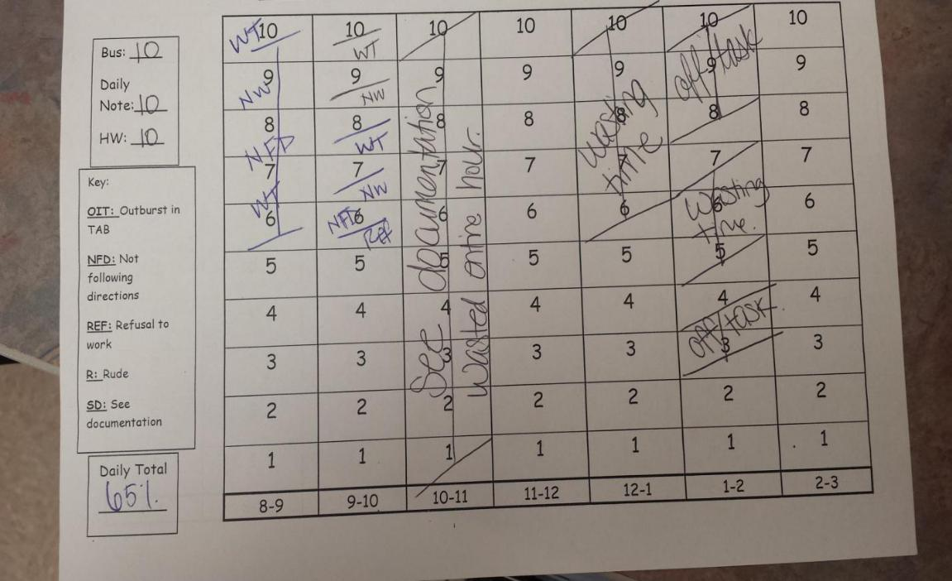

This is an example of a point sheet that was made on the previous page. The teacher and/or classroom aides are in charge of taking points away when needed. Each hour of the school day the student is given 10 points. The student earns 10 points for the bus, the daily note signed and returned, and homework completed. Between those points and the hourly points, there is 100 points that can be earned in a school day. Based on the student’s behavior, they earn or lose points every hour.

As pictured above, this particular student had the roughest time at the 10:00 hour. He/she struggled throughout the day, but earned all of his/her points during the 11:00 and 2:00 hours. This is great documentation to show when the roughest part of the day is for a student. “WT” stands for wasting time and “NW” stands for not working. The key on the side of the paper helps for a substitute to know what to write if they need to take points. Based on the student’s points, he/she only earned a 65% that day. If a student has a low score, I usually call the parent to explain what happened that day. I use this page to help when I call because I can easily see what happened throughout the day if I am not in the room and something happens. If a major incident happens, then we write “SD” for see documentation. This is kept in a word form that the teacher and aides have access to so that we can write what happened that day.
Behavior Strategies that Promote Academic Achievement 96

My Behavior System
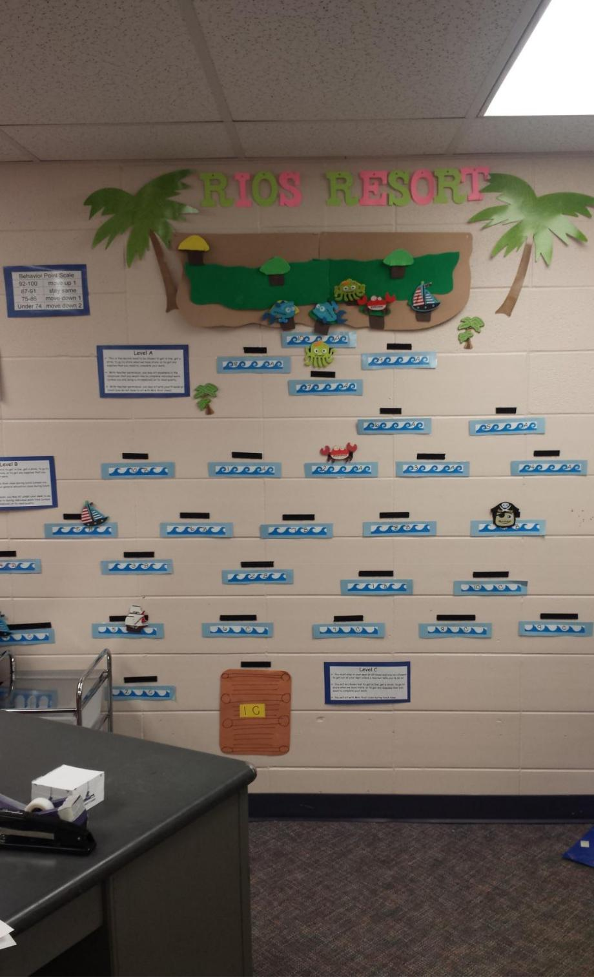

Behavior Strategies that Promote Academic Achievement | 97
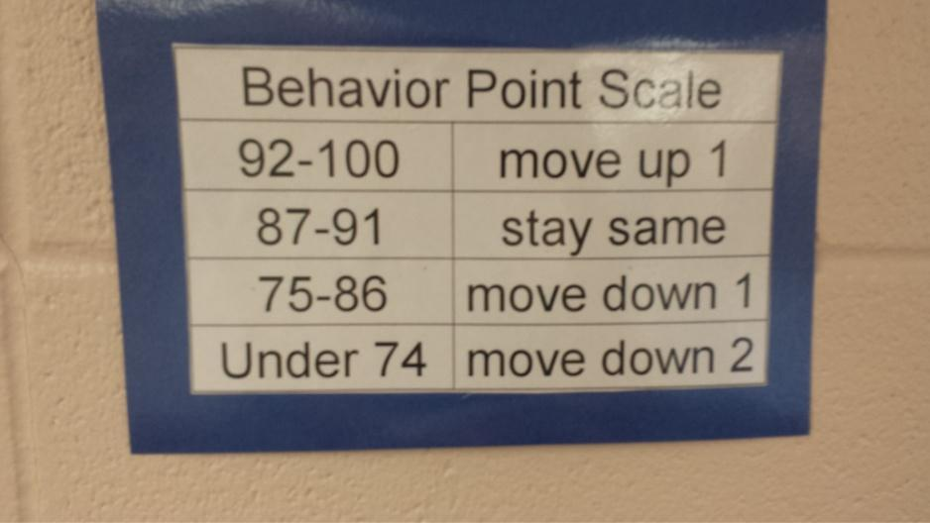
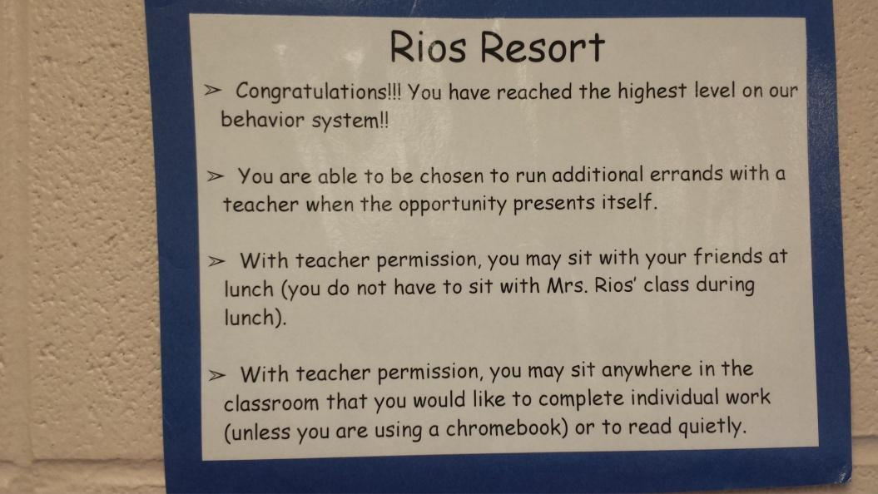
Behavior Strategies that Promote Academic Achievement | 98
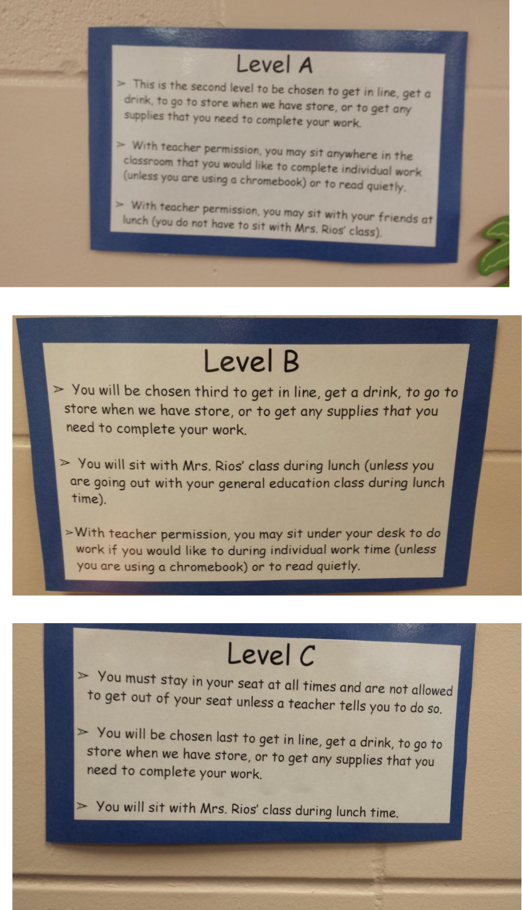
Behavior Strategies that Promote Academic Achievement | 99

My Classroom Economy

“My Classroom Economy” is an online program that offers free resources to teachers to print and use in their classroom for a token economy. The programs are split into several different sections. There is a token economy for kindergarten through first grade, one for second and third grade, one for fourth and fifth grade, and goes all the way up to high school. It suggests different jobs based on the age level of the students.

The objective of this token economy is to teach kids how a real economy works. They earn and save money, have jobs, and even get fined for certain behaviors. Students are saving money to spend in the classroom store. In this program they call it an auction. They suggest using this auction once a month. I use a classroom store. I have store every 2 weeks in my classroom. This gives the students enough time to earn and save money.

This economy is very effective because it really teaches students responsibility. It teaches them how to manage money and will help set them up for the real world. http://myclassroomeconomy.org/ is where all the free materials are for “My Token Economy” is. This is also where I got all of the information I have shared on this page.

(http://myclassroomeconomy.org/)
Behavior Strategies that Promote Academic Achievement | 100

The Token Economy Wallet
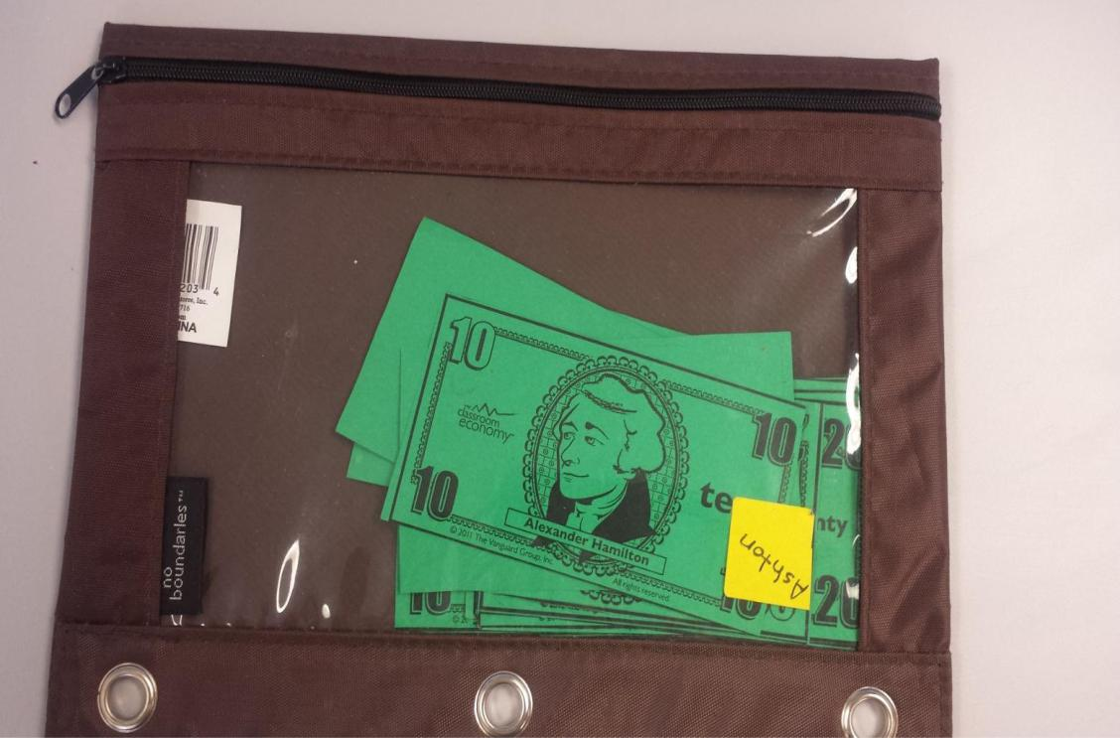

This is the wallet (pouch) used to keep the student’s money in. The students are responsible to keep these at their desks. As they get paid, they keep their money in this pouch. At the end of the two weeks, they can turn their money in to the bank when they are ready to go to the classroom store. They have to put their money in order and count it all before they turn it in just like they would if they were going to a real bank.
Behavior Strategies that Promote Academic Achievement | 101

The Token Economy Money
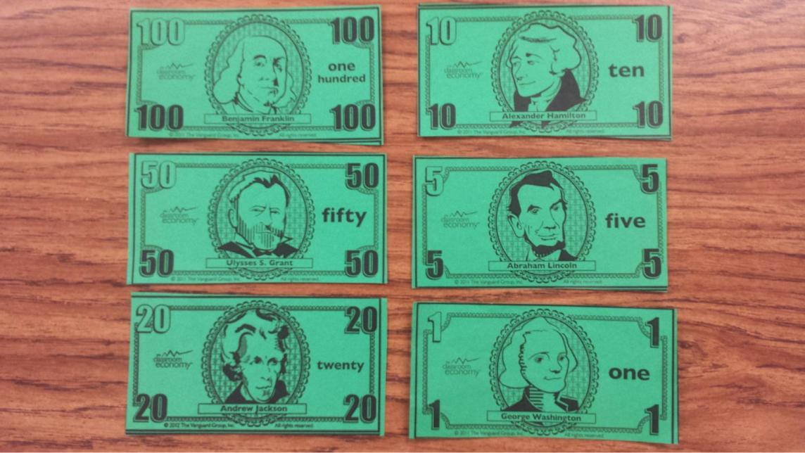

This is the Token Economy money that I use. It is on the “Classroom Economy” website that can be printed and used. I printed it on green paper. I keep all of the money in a “bank” at my desk. My aides also have a “bank” at their desks. Students can earn money for being on task, completing work, following directions, and being appropriate outside of the classroom.
Behavior Strategies that Promote Academic Achievement | 102

The Bank Log
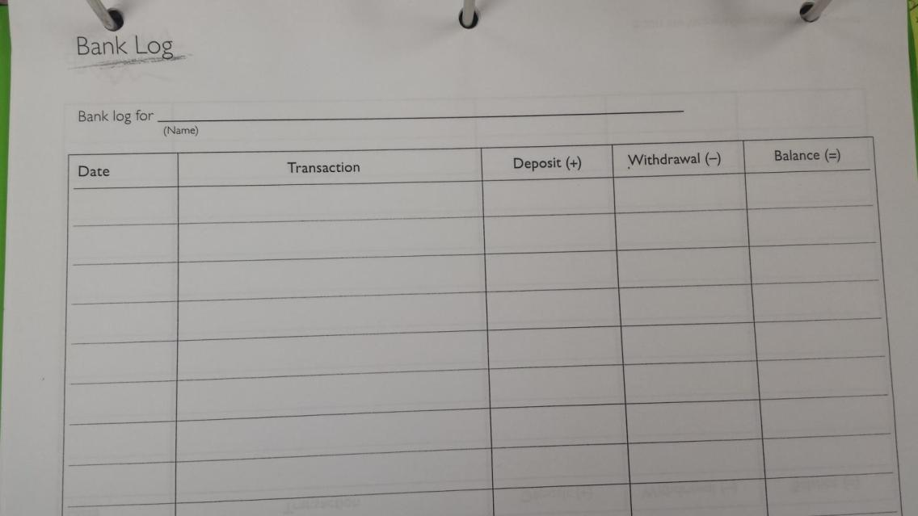

This is used to log each student’s transaction. In my classroom, I am the one in charge of this job. Students could keep track of their own money by using this sheet. It is a good way to teach them how to balance a check book. This is what I use to keep track of each student’s bank account.
Behavior Strategies that Promote Academic Achievement 103

The Clip Chart System
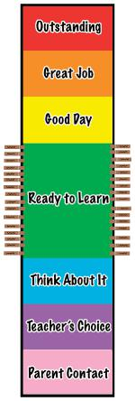

www.newmanagement.com

Behavior Strategies that Promote Academic Achievement | 104

Clip Chart:

A clip chart is a great tool that allows students to be rewarded for positive behavior, while discouraging negative behavior. Each student will have a clothespin, or clip, with his or her name on it. Everyone will start on “ready to learn” at the beginning of each day, and clips can be moved up and down throughout the day based on behavior (www.acupcakefortheteacher.com).

How it Works:

A clip chart consists of just two items.

- A laminated strip of paper that has been divided into seven levels,

- A set of clothespins with the name of a student written on each one.

The clothespins are clipped to the left and right edges of the “ready to learn” level of the chart. During the course of the day, the clothespins move up and down the chart based upon the behavior choices each student makes. Good behavior causes the clothespin to move up one level. Inappropriate behavior will cause the clothespin to move down one level.

Advantages of Using a Clip Chart:

- A student’s clothespin travels up and down the chart based upon his behavior. If he’s making good choices, it’s going to be moving up. If not, it’s going down. This up-and-down movement encourages the students. If a student has an outburst at any part of the day, they have a chance to move up again if their pin was moved down.

- All of the clothespins start in the middle level, “ready to learn”, and not at the top of the chart. This can give a false sense of accomplishment. All of the
Behavior Strategies that Promote Academic Achievement | 105

clothespins are clipped to the edge of the middle level. Every student begins their day in a neutral spot and then attempt to work their way up the chart. As the student moves up, they experience a true sense of accomplishment as the clothespin moves up the chart because of good choices.

Getting Started with the Clip Chart

This system is very easy to prepare. It is only a few simple steps to prepare for this in your classroom. The first thing you need to do is make the levels. You can print out the labels on white paper and glue them to construction paper. Then you can laminate the system. For the clothespins, you can write the names of your students on the clothespins or your students can write their names on the clothespins. Whichever you prefer will work just fine.

Introducing the Chart to Your Students:

You can introduce the Clip Chart to your students at any point in the year. Even if you’ve already spend several months using something such as a Pocket Chart with the colored squares of paper, you can change what you’ve been doing and head in a new direction.

It’s a fact of life that things change over time and your students need to experience this on-going change in order to get a grip on reality. It is all part and parcel of what they learn during the school year that is in addition to the academic skills we’re trying to impart. Rest assured that switching to the Clip Chart is not that big a deal.

The chart should be hung on the wall in such a way that there is a bit of space between the wall and the chart itself. Having a space will make it easy for students to reposition their clothespins. You want the re-clip process to be as pain-free as possible.
Behavior Strategies that Promote Academic Achievement | 106

Using Your Clip Chart:

Making the chart is the most difficult stretch of the trip. Using it is pretty simple and fun.

Clip Up:

Since the advantage of the Clip Chart is that it is capable of displaying the results of,

and thus reinforcing, positive behavior, make sure you focus on that as much as possible. That’s not to say that you’re going to have clothespins moving up for simple, everyday actions. It’s just that we want to keep the climate and interactions as positive as we can.

When it comes to moving a clothespin from one level to the one above it, there are two ways to go.

- You move a student’s clothespin from one level to another.

- The student moves it

The students should be doing the moving. It is going to take a bit of time for the student to walk to the chart and repositioned his clip; nevertheless, think of it as twenty seconds well spent.

If you want to eliminate the need for words, you could certainly use sign language. The sign phrase that can be used consists of two parts. The first one starts off with the index finger and middle finger held out like a pair of scissors. Then bring them together the way a pair of scissors closed when you are making the cutting action. After this “clip” message,
Behavior Strategies that Promote Academic Achievement | 107

then morph your hand into thumbs up sign. As the signs are being shown, also mouth the words “Clip Up.” It won’t take but a day before they are able to receive the message loud and clear.

Clip Down:

Having a child move his clothespin down one level- and know it’s always just one level for each move- is a bit more delicate. They’re going to feel bad enough as it is, so do not make a really big deal about it. At the same time, there are situations when it is necessary to make a point about inappropriate behavior and will have someone leave the group to move a clothespin down. The teacher could also go move the chart for the child. This is not something that the teacher will want to do often. It gives the child ownership when he/she has to move the clothespin themselves.

One Level per Move

Clothespins should move just one level each time it moves. The students need to have plenty of opportunity to move back up and if they feel that they are moved too far down, then you may lose them altogether.

Clip Down Documentation

As much as the Clip Chart is meant to focus on positive behavior, there are those students that need to be held accountable for their poor choices. Documenting the specific misbehavior will enable you to better deal with those situations. The one disadvantage to the Clip Chart is that there’s no record of why a student’s clothespin ended up in one of the levels below READY TO LEARN. We just know that it did. Although this might not be much of an issue when the level is reached is THINK ABOUT IT or TEACHER’S CHOICE, it will be an issue if a student ends up on PARENT CONTACT. If a student’s
Behavior Strategies that Promote Academic Achievement | 108

clothespin ends up in PARENT CONTACT but the teacher doesn’t actually follow through and make the contact, then level might as well be labeled GET OUT OF JAIL FREE. One of the easiest ways to maintain a record of misbehavior is to have the student fill out a paper to indicate why they have been asked to move the clothespin down a level.
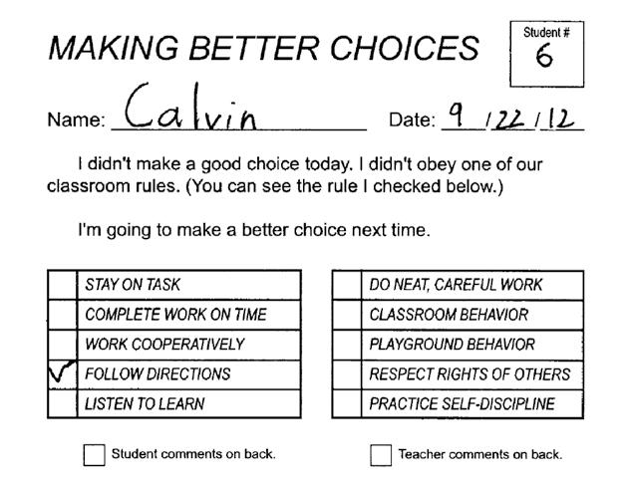

Having a form for the student to fill out will provide the teacher with the information they will need when they speak to the student, parent, and/or both after school. The accumulated forms will clearly identify what had gone wrong that day.

The beauty of knowing what needs to be addressed, without having to guess or search your memory, is that: 1) you will look more professional since you know what behavior is causing the problem; and 2) you will be encouraged to act on the misbehavior by asking the student to move his clothespin from TEACHER’S CHOICE to the PARENT CONTACT level when the behavior of the student warrants such action.
Behavior Strategies that Promote Academic Achievement | 109

Without this documentation, you might hesitate to ask that the clothespin be moved down. Threatening to intervene but not actually intervening is a sign of weakness, so it is extremely important for the teacher to follow through. Students will not take the teacher seriously if they do not follow through.

End of the Day

When the day is over, or just before the new day begins, have a student reset all of the clothespins to the READY TO LEARN level. The grace you extend in this regard sends an encouraging message to your students. It says that it is a brand new day and that they can start over.

Grading

Some teachers take grades based on behavior. If you would like to keep a simple record of how your students are doing with the Clip Chart, you can easily add a grade keeping component to the process of resetting the clothespins to the READY TO LEARN level.

Grade Keeping:

- Assign a score for each level (Outstanding=7, Great Job=6, Good Day=5, Ready To learn=4, Think About It=3, Teacher’s Choice=2,
Parent Contact=1).

- Before the clothespins are returned to the starting level, have the student write the student score on a grade sheet.

- Once the scores have been recorded, the clothespins can then be reset for the new day.
Behavior Strategies that Promote Academic Achievement | 110

Intervention Levels

We’ve already dealt with the PARENT CONTACT level and the need for documentation for anyone who ends up in that level. The other two intervention levels below READY TO LEARN are much easier to handle.

Think About It

This first level below READY TO LEARN is really a warning area. THINK ABOUT IT is designed to merely indicate that a student had made a bad choice. There’s no onerous consequence associated with the level. Just move your clip down and get back on task. After all, everyone needs a chance to show that he can learn from his mistakes. With that thought in mind, let’s lightn the language a bit and not even call it a warning. If there’s no actual consequence for ending up on this level, maybe we should call it a reminder. The word “reminder” is just so much more positive than the over-used Old School “warning.” Maybe it’s me but warning sounds so confrontational. So negative. So punitive. The word warning is just not a very forgiving or loving word. It’s more of a relationship killer than anything else.

Teacher’s Choice

This level is labeled TEACHER’S CHOICE so that the teacher has some latitude in regard to the actual intervention employed for any student whose clothespin ends up in this level at the close of the day. Not all students respond to the same consequence in the same way. So for those few, a talk is all that is needed. There are some students, on the other hand, who need a bit more action in order to convince them that they need to
Behavior Strategies that Promote Academic Achievement | 111

change their ways. Loss of privileges, restriction from a favorite activity, or a phone call home to parents are just a few options. Try to keep the consequence reasonable and of a short duration. It would actually be better to restrict a student from recess five days in a row for five repeated offenses than to assign a five-day loss of recess for one infraction. To lose a portion of recess each day a poor choice is made reinforces the all-important philosophy that every day is a fresh start. Assigning long-term consequences only fosters resentment and resistance on their part and frustration on yours. Besides, research indicates that punishment is the least effective way to make a change in a child’s behavior or attitude anyway.

You don’t have to wait for the end of the day to crack out some kind of intervention for anyone whose clothespin touches down in the TEACHER’S CHOICE level. You can talk privately with any student whose behavior is less than appropriate and let him know that you won’t be waiting until the end of the day to assign a consequence. The child will receive the consequence upon entry to that level. The beauty of TEACHER’S CHOICE is the freedom you have to intervene. Use this power wisely and you can have a profound impact on how a student chooses to navigate the day; abuse the freedom and you might end up starting a mutiny.

Beyond the Basics

It is so important to keep everything as simple as possible for the first month or two. You, and your students, are going to need a bit of time to figure out exactly how it works in your classroom. This will require some tria-and-error. That’s to be expected with any new idea. You’ve got to live with it before you truly know it. After a month or two, though, you might want to think about how the whole thing could be modified to
Behavior Strategies that Promote Academic Achievement | 112

keep it both exciting and motivating as the year progresses. After all, novelty is a form of fun and fun is a student need. Anything you can do to add a new twist on your Clip Chart will help to boost their interest and your effectiveness in maintaining a positive classroom environment.

(Clip Chart description developed by Rick Morris)
Behavior Strategies that Promote Academic Achievement 113

Section 7

Self-Monitoring


adoption-provplace.org

Behavior Strategies that Promote Academic Achievement 114

Self-Monitoring

Self-monitoring requires the student to observe their behavior and record it. The student determines whether the target behavior occurred or not.. The student tallies or marks in some way whether the behavior occurs or not (Menzies et al. 2009). This is a student based strategy that is used to increase on-task student behavior. This is meant to encourage the student to handle themselves in a more appropriate way in the classroom and makes them more aware of their behavior because they are the ones looking for and monitoring it (Martel, 2009). Students who apply self-monitoring strategies to academics “achieve more and are more satisfied with their work.” Results add to evidence-based report favorable effects of self-management on academics for students with and without disabilities (Mooney et al., 2005). On the next pages there are 6 examples of self-monitoring charts.

Behavior Strategies that Promote Academic Achievement | 115

Name: _____________________ |  |  |  |  |  |  |  |  | Date: ________________
 |  | Tracking School Behaviors (Self-monitoring Form 1)
I am keeping track of school behaviors that I am doing. This is what it looks like:
If we had to take turns in gym, I remembered to do it!
1 | 2 | 3 | 4 |  | 5 | 6 |  | 7 | 8 | 9 |  | 10

I was OK when I or my team didn’t win today:( I even said something nice to the winners)
1 | 2 | 3 | 4 | 5 | 6 | 7 | 8 | 9 | 10

When something worried me I remembered to tell an adult, calm myself, & make a plan
1 | 2 | 3 | 4 | 5 | 6 | 7 | 8 | 9 | 10

I made good decisions today with other students
1 | 2 | 3 | 4 | 5 | 6 | 7 | 8 | 9 | 10
https://www.thewatsoninstitute.org/wp-content/.../self-monitoring.doc

This could be used for a student who may have difficulties in gym. The chart should be taken with the student to gym and at the end of the period the student would color in a block of he felt he did the statement. Then he would take it back to the special education room and discuss it with his teacher. He could earn rewards for completing the tasks (https://www.thewatsoninstitute.org/wp-content/.../self-monitoring.doc).
Behavior Strategies that Promote Academic Achievement | 116

My In-Class Checklist (Self-Monitoring Form 2)

I raised my hand | The teacher called | I answered a | I heard these words
 | on me | question

*The student could tally the times that they completed one of these tasks in a class period. Students can earn a reward after a certain number of tallies. Students can also be limited as to how many tallies they are allowed to have in the box.

https://www.thewatsoninstitute.org/wp-content/.../self-monitoring.doc
Behavior Strategies that Promote Academic Achievement |  |  |  |  | 117
My Self-Monitoring Form (Self-Monitoring Form 3)
Name:____________________ |  |  |  | Date: _____________
 |  | Was I paying attention to my assigned work?
Morning meeting |  | Y | N
 |  | Was I following the classroom rules?
 |  |  | YN
 |  | Was I paying attention to my assigned work?
Reading |  | Y | N
 |  | Was I following the classroom rules?
 |  |  | Y | N
 |  | Was I paying attention to my assigned work?
Literacy Stations |  | Y | N
 |  | Was I following the classroom rules?
 |  | Y | N
 |  | Was I paying attention to my assigned work?
Math |  | Y | N
 |  | Was I following the classroom rules?
 |  | Y | N
 |  | Was I paying attention to my assigned work?
Science |  | Y | N
 |  | Was I following the classroom rules?
 |  | Y | N
 | Total number of Y (yes)=__________
 |  |  | My Goal: __________
Signed: _____________ |  |  | _________________ |  | ______________
Student |  |  |  | Teacher | Parent
www.pediastaff.com

This form can be used by the student or the teacher. They can circle yes or no based on their behaviors. Students can earn a reward for the amount of yeses they receive throughout the day.
Behavior Strategies that Promote Academic Achievement |  |  |  |  |  |  |  | 118
 | My Week at School (Self-Monitoring Form 4)
 |  | _____/_____/_____ |  |  |  |  |  | Earn Smiles!!!
 | Stayed in area |  | Attention to lessons |  |  |  | Finished work
 | a.m. | p.m. | a.m. |  | p.m. |  | a.m. |  | p.m.
Monday
Tuesday
Wednesday
Thursday
Friday


I did it myself
(0-1 prompt)

Had some trouble
(2-4 prompts)

I’ll try harder!
(5+ prompts)

lifimuthe.blog.com

The chart above has 3 desired behaviors listed. Students can earn various rewards based on the amount of smiley’s they earn throughout the day, and throughout the week. This can be something that the teacher starts off doing and then the student can take over. It is small enough to be taped on the student’s desk.

Behavior Strategies that Promote Academic Achievement 119

Self-Monitoring Form 5
 | Behaviors: |  |  | Reading |  |  |  | English |  |  |  | Spelling |  |  |  | Math |  |  |  | S.S.
 | Completed my
 | assigned work |  |  |  |  |  |  | Y | N |  |  | Y | N |  |  | Y | N |  |  | Y | N
 |  |  |  | Y | N
 | I used my self control
 | strategies if I got |  |  |  |  |  |  | Y | N |  |  | Y | N |  |  | Y | N |  |  | Y | N
 | upset |  |  | Y | N |  |  | Y | N |  |  | Y | N |  |  | Y | N |  |  | Y | N
 | I did my assigned job in |  |  | Y | N |  |  | Y | N |  |  | Y | N |  |  | Y |  |  |  | Y
 | small group |  |  |  |  |  |  |  |  |  |  |  |  |  |  | N |  |  |  | N
 | Teacher’s
 | Initials
 | I met my goal: |  |  | Y | N |  |  | Y | N |  |  | Y | N |  |  | Y N |  |  |  | Y N
 | I had: S=some help;
 | N= no help; L=lots of
 | help today
 | I Completed departure activities |  |  |  |  |  |  | Y | N
 |  |  |  |  |  |  |  | Y | N |  |  | This form can be placed at the
 | All by myself |  |  |  |  |  |  |  |  |  |  | student’s desk. The teacher
 |  |  |  |  |  |  |  |  |  |  |  | can monitor the behavior, or
 | I kept my “cool” |  |  |  |  |  |  |  |  |  |  | the student can mark the
 |  |  |  |  |  |  |  |  |  |  |  | behavior. The teacher must
 | A | = all day; |  |  |  |  |  |  |  |  |  | sign off on this form daily. This
 |  |  |  |  |  |  |  |  |  |  |  | will help make the students
 |  |  |  |  |  |  |  |  |  |  |  | more aware of their behavior
 | M | = most of the day; |  |  |  |  |  |  |  |  |  | if they have to mark whether
 |  |  |  |  |  |  |  |  |  |  |  | they have met their goals or
 | NM | = not much of the day |  |  |  |  |  |  |  |  |  | not. The student can earn
 | NM |  |  |  |  |  |  |  |  |  |  | rewards for their good
 |  |  |  |  |  |  |  |  |  |  |  | behavior on a daily basis.

www.wisconsinpbisnetwork.org/assets/files/.../SelfMonitoring.pdf

Behavior Strategies that Promote Academic Achievement |  |  |  |  | 120
Name: __________________ |  |  |  | Date: ___________________
 | Self-Monitoring Form 6
 | Beginning of Day
 | Safe Hands, |  | Follows | Completes | 8 yes=
 | Feet, and |  | Teacher’s | Work or
 | Objects |  | Directions | Task |  | Stamp
Morning | Yes |  | Yes | Yes
Meeting
8:10-8:30 | No |  | No | No
Phonics | Yes |  | Yes | Yes
8:30-8:45 | No |  | No | No
Whole Group | Yes |  | Yes | Yes
Reading
8:45-9:45 | No |  | No | No
Small Group | Yes |  | Yes | Yes
Reading
9:45-10:15 | No |  | No | No
 |  | Middle of Day
Writer’s | Yes |  | Yes | Yes | 8 yes=
Workshop
10:15-10:45 | No |  | No | No |  | Stamp
Lunch | Yes |  | Yes | Yes
10:50-11:10 | No |  | No | No
Recess | Yes |  | Yes | Yes
11:10-11:40 | No |  | No | No
Read Aloud | Yes |  | Yes | Yes
11:45-12:00 | No |  | No | No

Behavior Strategies that Promote Academic Achievement | 121

End of Day
Specials | Yes | Yes | Yes | 8 yes=
12:00-12:30 | No | No | No |  | Stamp
Math | Yes | Yes | Yes
12:30-1:30 | No | No | No
Science/Social | Yes | Yes | Yes
Studies | No | No | No
1:30-2:30 | No | No | No
Pack up | Yes | Yes | Yes
2:30-2:45 | No | No | No
3 Stamps= Reward at Home

This form can be split into three parts, beginning of day, middle of day, and end of day. These three parts can be put on the student’s desk in small parts so they do not get overwhelmed. For example, teachers can Velcro and laminate the chart. The beginning of day can be put on the child’s desk and a dry erase marker can be used to circle the yes or no. The same procedure can be followed for the middle of day and the end of day. At the end of the day, the charts can be erased and reused the next morning.
Behavior Strategies that Promote Academic Achievement | 122

Behavior Think Sheet

You have made choices that have caused you to need to stop and “Think about it.”

Name: ___________ Date: _______

- What was my behavior?

______________________________________________
______________________________________________
________________________________________
- What were the reasons for my behavior?

______________________________________________

______________________________________________
________________________________________
- How did my behavior affect others?
______________________________________________

______________________________________________
________________________________________
- What is my plan to improve my behavior?
______________________________________________

______________________________________________
________________________________________
- Do I need to apologize to anyone? If so, to who and why?
______________________________________________

______________________________________________

________________________________________

Student Signature: ______________ |  |  | Teacher Signature:
Parent Signature: _______________ |  |  | ______________
 | goalbookapp.com

*Students can use this form to think through a behavior incident. The student can fill this out on their own, or the teacher can complete this with the student.
Behavior Strategies that Promote Academic Achievement 123

Section 8

Positive and Behavioral Intervention Strategies


pd.sstr1.org

Behavior Strategies that Promote Academic Achievement | 124

Positive Behavioral Interventions and Supports:

Positive behavioral interventions and supports (PBIS) are specifically designed to put rules and routines in place in the classroom to effectively decrease the number of problem behaviors that occur in the classroom. The way the classroom is arranged can even affect the classroom environment and the number of problem behaviors (Scott et al. 2007).

According to the Office of Special Education Programs Technical Assistance Program there are 7 core principles of PBIS.

- Teach appropriate behavior to students: In order for PBIS to be carried out, the students must know what is expected of them. If they do not know what is expected, then PBIS will be ineffective.

- Intervene early: The earlier the behavior can be corrected, the more successful the student will be in the future.

- A multi-tiered model is used: Teachers should be differentiating behavioral instruction within their classrooms.

- Use research-based interventions: Using research-based interventions will ensure that teachers are implementing strategies that will be effective for a variety of their students.

- Monitor student progress: When teachers monitor student progress and use it as an assessment tool, they can then use the information they gather from those assessments to determine the effectiveness of an intervention.
Behavior Strategies that Promote Academic Achievement | 125

- Use data to make decisions: Ongoing data is collected and used to analyze the effectiveness of an intervention. This can be good information for teachers to use to determine if the intervention they are using for their student(s) is working.

- Use assessment for three different purposes: PBIS screens data, determine the data based on data by time of day, problem behavior, and location, and progress monitoring to determine if the interventions are working

(www.pbis.org/school/primary-level ).

On the following pages are examples of strategies to assist with PBIS
Behavior Strategies that Promote Academic Achievement | 126

Top 17 Classroom Management Strategies that should be

emphasized in every classroom

 | Strategy |  | Description
1. | Increase ration of positive to | • | At least 4 to 1
 | negative teacher to student | • | Positive interaction every 5 minutes
 | interactions | • | Follow correction for rule violation
 |  |  | with positive reinforce for rule
 |  |  | following
2. | Actively Supervise at all times | • | Positively reinforce rule following
 |  |  | behaviors
3. | Positively interact with most | • | Physical, verbal, visual contact
 | students during lesson | • | Group v. individual
 |  | • | Instructional & Social
4. | Manage minor (low | • | Signal occurrence
 | intensity/frequency) problem | • | State correct response
 | behaviors positively and quickly | • | Ask student to restate/show
 |  | • Disengage quickly & early
5. | Follow school procedures for | • | Be consistent & business-like
 | chronic problem behaviors | • | Pre-correct for next occurrence
6. | Conduct smooth &efficient | • | Taught routine
 | transitions between activities | • | Engage students immediately
7. | Be prepared for activity | • | Prepare filler activities
 |  | • | Know desired outcome
 |  | • | Have materials
 |  | • | Practice presentation fluency
8. | Begin with clear explanations of | • | Advance organizer
 | outcomes/objectives | • | Point of reference
9. | Allocate most time to instruction | • | Fill day with instructional activities
 |  | • Maximize teacher led engagement
 | Strategy |  | Description
10. | Engage students in active | • | Write
 | responding | • | Verbalize
 |  | • | Participate

Behavior Strategies that Promote Academic Achievement |  |  | 127
11. | Give each student multiple ways to | • | Individual v. choral responses
 | actively respond | • | Written v. gestures
 |  | • | Peer-based
12. | Regularly check for student | • | Questions
 | understanding | • | Affirmative gestures
 |  | • | Written action
13. | End activity with specific feedback | • | Academic v. social
 |  | • | Individual v. group
14. | Provide specific information about | • | Homework
 | what happens next | • | New activity
 |  | • | Next meeting
15. | Know how many students met the | • | Oral
 | objective/outcomes | • | Written
 |  | • | Sample
16. | Provide extra time/assistance for | • | More practice
 | unsuccessful students | • | More instruction
17. | Plan for next time activity | • | Firm up outcome
 | conducted | • | New outcome
 |  | • | Test
(Lewis, 2007)
Behavior Strategies that Promote Academic Achievement | 128


Effective Teaching Strategies

- There are high rates of engaged time

- There are high rates of student success

- Teacher maintains student attention

- There are smooth and effective transitions teach rules about transition pre-corrects & advanced organizers
- Clear group rules

stated positively

stated succinctly

stated in observable terms

made public

enforced

small number

taught

• Positive climate

communicate expectations for achievement safe, orderly, and focused environment for work smooth group prevention management strategies
Behavior Strategies that Promote Academic Achievement | 129


- Rapid pacing

- Frequent questioning

- Appropriate feedback given to students

always provide immediate feedback in the acquisition phase always provide precise feedback combine feedback with instruction

- There are high expectations for student learning

- Incentives and rewards are used to promote excellence

- Personal interactions between teachers and students are positive

(Lewis, 2007)
Behavior Strategies that Promote Academic Achievement | 130

Promoting Positive & Effective Learning Environments

Classroom Checklist

(Lewis, 2007)


Instruction

Advanced organizers given

Specific explanations and clear instructions given

Lesson well paced

Student attention maintained throughout lesson

Opportunity for student practice

Frequent and detailed positive feedback given to students

Appropriate error correction and review strategies employed

Classroom Management

Pre-corrects given

Active positive interactions with students

Positive feedback given to students

Smooth transitions between lessons/activities

Differential reinforcement used appropriately

Non Instructional time is kept to a minimum
Behavior Strategies that Promote Academic Achievement | 131


Positive, predictable, orderly learning environment maintained

Classroom rules posted and enforced consistently and equitably

Individual behavior change strategies implemented appropriately
Behavior Strategies that Promote Academic Achievement | 132

Effective Classroom Plan Description

The effective classroom plan template is designed for teachers to be able to use to evaluate their procedures within their classrooms. Teachers should list their classroom rules (there should only be 5 rules). They should be observable, measurable, positively stated, and have a clear meaning. A plan should be written on how to introduce the classroom rules.

It is very helpful to write out student routines. This will help the teacher to see if they are easy to follow, and it is a good platform to use to teach the students at the beginning of the school year.

The last part of the template is identifying procedures for encouraging appropriate behavior. This will help keep the teacher on track with praising the students. This is where the use of a token economy can be imbedded into the classroom plan.
Behavior Strategies that Promote Academic Achievement | 133

Effective Classroom Plan

List Classroom Rules:

1.

2.

3.

4.

5.

Are they observable, measurable, positively stated, with no question about meaning?

Do the rules coincide with school-wide expectations?

Identify Procedures for Teaching Classroom Rules: | Record dates taught &
 | reviewed
How will they be taught?

Identify your attention signal: | Date taught

Determine your daily/hourly schedule:

Is your schedule posted?

Behavior Strategies that Promote Academic Achievement | 134

Identify Student Routines (e.g. requesting assistance, entering class, sharpening pencils,

class dismissal, passing in papers, grading papers, transitions, working with peers, etc.)

List routines and steps taught | Date

Behavior Strategies that Promote Academic Achievement | 135

Identify Teacher Routines (e.g. greeting and escorting students, signaling for attention,

giving directions, providing feedback or corrections, grading, etc.

List routines and steps taught | Date
Identify procedures for encouraging appropriate behavior:

Whole Group

Individual Student

Identify procedures for discouraging problem behaviors

(Lewis, 2007)
12345
12345
12345
12345
Behavior Strategies that Promote Academic Achievement | 136

ENVIRONMENTAL INVENTORY Rate each feature using the following scale:
1 = inconsistent or unpredictable ……….5 = consistent and predictable

Physical Space: Is physical space organized to allow access to instructional materials?
• Work centers are easily identified and corresponds with instruction

• Traffic flow minimizes physical contact between peers and maximizes teacher ‘s mobility
Attention: Does the teacher gain the attention of the students prior to instruction?
• A consistent and clear attention signal is used across instructional contexts

• Uses a variety of techniques to gain, maintain, and regain student attention to task.

Time: Does the teacher initiate instructional cues and materials to gain, maintain, and regain student attention?

• | Materials are prepared and ready to go. | 1 | 2 | 3 | 4 | 5
• | Pre-corrects are given prior to transitions. | 1 | 2 | 3 | 4 | 5
• | Common intrusions are anticipated and handled with a consistent procedure. | 1 | 2 | 3 | 4 | 5
 | Unexpected intrusions are minimized with an emphasis on returning to
 | instruction.
• | Students engaged at high rates during individual work | 1 | 2 | 3 | 4 | 5
• | Down-time (including transitions) is minimal | 1 | 2 | 3 | 4 | 5
Behavior Management: Does the teacher have universal systems of PBS in place?

• | Rules are posted | 1 | 2 | 3 | 4 | 5
• | Rules are referred to at appropriate times | 1 | 2 | 3 | 4 | 5
• | Students receive verbal praise for following rules | 1 | 2 | 3 | 4 | 5
• | Corrections are made by restating the rule/expectation and stating the | 1 | 2 | 3 | 4 | 5
 | appropriate replacement behavior.
• | Continuum of consequences for encouraging expected behaviors | 1 | 2 | 3 | 4 | 5
• | Continuum of consequences for discouraging expected behaviors | 1 | 2 | 3 | 4 | 5
• | Maintains a 4:1 ratio of positive to negative statements | 1 | 2 | 3 | 4 | 5

12345
12345
12345
12345
12345
12345
Behavior Strategies that Promote Academic Achievement | 137


Routines: Does the teacher have procedures and routines that are clear and consistently followed?

• Start of class

• Working in groups

• Working independently

• Special events (movies, assemblies, snacks, parties)

• Obtaining materials and supplies

• Using equipment (e.g. computer, tape players)

• | Managing homework and other assignments | 1 | 2 | 3 | 4 | 5
• | Personal belongings (e.g. coats, hats) | 1 | 2 | 3 | 4 | 5
• | Entering/exiting classroom (e.g. using restroom/drinking fountain, going to | 1 | 2 | 3 | 4 | 5
 | library, moving around room
Curriculum and Content: Does the teacher implement effective instruction strategies?
• | Assignments can be completed within allotted time period | 1 | 2 | 3 | 4 | 5
• | Content presented at student level resulting in high rates of engagement | 1 | 2 | 3 | 4 | 5
• | Frequently checks student learning for understanding | 1 | 2 | 3 | 4 | 5
• | Instructional focus builds on student’s current and past skills | 1 | 2 | 3 | 4 | 5
• | Gives clear set-up and directions for task completion | 1 | 2 | 3 | 4 | 5

Based on the observation, summarize strengths and weaknesses of universal PBS implementation in the classroom.

(Lewis, 2007)

*This scale can be filled out to see where the teacher rates. The teacher can see what they need to work on in order to have a more structured classroom. This will help with behavior problems. It will also help promote academics. When the behavior is under control, academics will follow.
Behavior Strategies that Promote Academic Achievement | 138
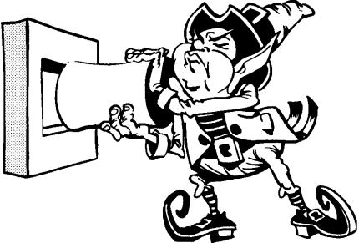

Problem Solving Sheet

1. . What was the problem?

______________________________________

- When?

____________________________________________

Where?
____________________________________________

With whom?

_______________________________________________

- What positive choices could you have made?

_______________________________________________________

_______________________________________________________

- What will you learn?

_____________________________________________

_____________________________________________

(Rockwell, 1995)

This template can be used for students who need to think about their behavior. When they have done something wrong, they need to grab a “problem solving sheet.” This sheet will help the student be able to think through what they did wrong, and how to fix the problem. Some students may need assistance with this task. It may need to be something that the teacher helps them write to insure they are really thinking through the problem. The teacher will need to review this sheet with the student.
Behavior Strategies that Promote Academic Achievement | 139

How the Decision Making Sheet works:

When students need to think about their behavior because they did not make a good choice, then they fill out a decision thinking sheet. The student will discuss this with the teacher when they are finished filling this page out. The teacher may decide (depending on the student’s age and ability) to fill this out with the student. This will allow time for the teacher and the student to process through the mistake that they made. This will help the student work through what they did wrong and why. It also helps build the relationship between the teacher and the student.
Behavior Strategies that Promote Academic Achievement | 140

DECISION-

MAKING

SHEET

- What was happening before the problem occurred?

________________________________________________________________________
________________________________________________________________________

- What was your behavior when the problem began?
____________________________________________________________________

____________________________________________________________________

- How did you feel?
_________________________________________________________________

_________________________________________________________________

- What other things could you have done? Name at least four that would have been more appropriate.
_________________________________________________________________
_________________________________________________________________
- Which one of the four behaviors you listed in question 4 would you like best?

________________________________________________________
____________________________________________
- Why would you prefer to do that?

__________________________________________________________
______________________________________________

- What would you have earned if you had chosen that behavior instead of the one you described in question 2?

_____________________________
_______________________

- What has the problem behavior earned for you?

____________________________________________________________________
______________________________________________________
- How are you feeling now?

________________________________________________________
___________________________________________

- Did you make any good decisions in spite of the problem? What were they?

__________________________________________________________________
____________________________________________________

- What can you do now to help yourself have a good day?

________________________________________________________________________
________________________________________________________________________

(Rockwell, 1995)
Behavior Strategies that Promote Academic Achievement | 141

Choice Boards and Menu

Boards

The following pages list different menu boards that could be used in the classroom. There are several different examples and templates that can be used. Menu boards are great tools that can be used to help with building relationships between students and teachers as well as helping students control their behaviors. Choice boards and menus help keep students on task.
Behavior Strategies that Promote Academic Achievement | 142

Tic-Tac-Toe

T ic-Tac-Toe choice boards give students the opportunity to participate in multiple tasks that allow them to practice skills they’ve learned in class or to demonstrate and extend their understanding of concepts. From the board, students either choose or are assigned three adjacent or diagonal tasks to complete.

Choice boards address student readiness, interest, or learning preferences. They are easily adapted to a subject area.

Steps:

- Identify the outcomes and instructional focus of a unit of study.

- Use assessment data and student profiles to determine student readiness, learning styles, or interests.

- Design nine different tasks.

- Arrange the tasks on a choice board.

- Select one required task for all students. Place it in the center of the board.

- Students complete three tasks, one of which must be the task in the middle square. The three tasks should complete a Tic-Tac-Toe row.
Behavior Strategies that Promote Academic Achievement 143

Adaptations:

- Allow students to complete any three tasks—even if the completed tasks don’t make a Tic-Tac-Toe.

- Assign students tasks based on readiness.

- Create different choice boards based on readiness. (Struggling students work with the options on one choice board while more advanced students have different options.)

- Create choice board options based on learning styles or learning preferences. For example, a choice board could include three kinesthetic tasks, three auditory tasks, three visual tasks.

- Author Rick Wormeli offers the following Tic-Tac-Toe board based on Gardner’s (1991) multiple intelligences.

Interpersonal | Kinesthetic | Naturalist
Task | Task | Task
Logical | Student | Intrapersonal
Task | Choice | Task
Interpersonal | Musical | Verbal
Verbal Task | Task | Task

(Heacox, 2005) (Wormeli, 2006)

Behavior Strategies that Promote Academic Achievement | 144

Tic-Tac-Toe

Tic-Tac-Toe Examples

Larisa Bailey, Lead-Deadwood Middle School, created the following Tic-Tac-Toe Choice Board for a 6th grade math unit on fractions, decimals, and percents.

Define fraction, decimal, | Complete a chart of | Play the game Request or
and percent. Draw a | conversions for fractions, | Request Challenge. (The
picture to illustrate each | decimals, and percents. | game is like Go Fish, but you
Complete lesson using | All | Illustrate ways in which
equivalent fraction, | Notetaking Guide | fractions, decimals, and
decimal, and percent | 5.7 | percents are used in
Color equivalent squares | Play the game Recall or | Complete the Hidden
to reveal a hidden picture | Recall Challenge. (The game | Name Puzzle and then
of an endangered species! | is like Concentration, but you | create a puzzle of your

Behavior Strategies that Promote Academic Achievement | 145

Lead-Deadwood High School teachers Kim Fundaun, Laura Shuck, and Brook Kilian developed a

choice board for a 9th grade general science unit on heredity and genetics.

Summarize | Classify | Draw
Facts or ideas which are | Dominant and recessive | Meiosis and mitosis
important in determining | traits as they relate to
Predict |  | Show
What a person might look | Unit Test | A model of a DNA strand
like using the Punnett |  | with a key
Survey | Interview | Judge
Genetics – hair color, eye | A person whose career or | 3 websites on genetics
color – graph your findings | hobby deals with genetic/ | and heredity

Behavior Strategies that Promote Academic Achievement 146

Tic-Tac-Toe

Tic-tac-toe, also known as Think-tac-toe, is a differentiation tool that offers collection of activities from which students can choose to do to demonstrate their understanding. It is presented in the form of a nine square grid similar to a tic-tac-toe board and students may be expected to complete from one to “three in a row”. The activities vary in content, process, and product and can be tailored to address different levels of student readiness, interests, and learning styles. The center square may be left open for the student to select an activity of their own. Tic-tac-toe activities may be given to every student in the class, higher ability students for extension activities, or lower students for review and practice.

Involvement in this strategy encourages independent learning. Teachers should check in with students periodically and require students to keep a log of their progress.

In place of lengthy activities, the tic-tac-toe board may also be used with shorter, open-ended questions posed at varying levels of Blooms Taxonomy.

Behavior Strategies that Promote Academic Achievement | 147

Example Tic-tac-toe board for reviewing a math unit:

Write clear directions for | Solve two of the | Create a math rap or
performing the math | five challenge | rhyme that will help
computation skills | problems | someone remember
from this unit |  | a concept from this unit
Create three word | Student Choice | Define the unit’s
problems from | Activity | vocabulary words with
information learned | (with teacher approval) | sketches or drawings
in this unit
Complete the review | Develop a game using | Identify four
problems in | skills learned | ways the concepts in
the text book | in this unit | this unit are used
 |  | in the real world

Behavior Strategies that Promote Academic Achievement | 148

Directions: Choose activities in a tic-tac-toe design. When you have completed the activities in a row–horizontally, vertically, or diagonally–you may decide to be finished. Or you may decide to keep going and complete more activities.

I choose activities # , # , # , #

Do you have ideas for alternate activities you’d like to do instead? Talk them over with your teacher.

I prefer to do the following alternate activities:
Behavior Strategies that Promote Academic Achievement | 149

Novel Think-Tac-Toe

Another choice board which is a variation of the Tic-tac-toe board is called Novel Think-Tac-Toe developed by Carol Ann Tomlinson. In addition to offering nine choice activities, Novel Think-Tac-Toe is a differentiation strategy designed for students to explore character, setting, and theme in novels of their choice. Two versions of the grid are used to make this a tiered strategy in order to address students at different readiness levels.

(Tomlinson, 2003)
Behavior Strategies that Promote Academic Achievement | 150

Tic-Tac-Toe Menu

1. | 2. | 3.

4. | 5. | 6.

7. | 8. | 9.

Behavior Strategies that Promote Academic Achievement | 151

Directions: Choose activities in a tic-tac-toe design. When you have completed the activities in a row–horizontally, vertically, or diagonally–you may decide to be finished. Or you may decide to keep going and complete more activities.

I choose activities # , # , # , #

Do you have ideas for alternate activities you’d like to do instead? Talk them over with your teacher.

I prefer to do the following alternate activities:
Behavior Strategies that Promote Academic Achievement | 152
Name:__________________________________________________

“ Think-Tac-Toe”

Select and comp let e activities from t he choice board in a t ic-t ac-t oe design. When you comp let e t he activities in a row you may decide t o be finished. Or you may decide t o keep going and comp let e more activities.

Can you design and draw a |  | Use a Venn Diagram to compare and | Design and draw an original
building using only squares? |  | contrast two monuments of your | monument celebrating a person,
What about using only |  | choice. | place, or event of
triangles? Circles? Try it! |  |  | your choice.
Is there one |  | Pretend you and a friend are | Select your favorite
monument that means more to |  | visiting the Washington Monument | Select your favorite
 |  | visiting the Washington Monument | person who designed a
you than the others? | In | . What would you say to each | person who designed a
you than the others? | In | other? Write a skit about your | monument . Draw a picture of
your writer’s notebook , write |  | other? Write a skit about your | monument . Draw a picture of
 |  | conversation. Act it out using | him or her next to the
about it and how it makes you |  | conversation. Act it out using | him or her next to the
 |  | puppets. | monument he or she designed.
feel. |  | puppets. | monument he or she designed.
feel. |  |  | Write why t his person is your
 |  |  | favorite.
Design a building |  | Using the shapes template
using a rectangle, |  | on your computer
square, triangle and |  | desk top, draw something | Play the
circle in KidPix. You |  | you spy in your classroom | Patterns game in Logic
may use more than one of any |  | that is a circle, square, rectangle or | Blocks.
shape. |  | triangle.
Name your building. |  | Write the name of the
Print your design. |  | object , if you can.

 | Behavior Strategies that Promote Academic Achievement |  | 153
CHOICE BOARD FOR MULTIPLE |  | INTELLIGENCES
 | Verbal/Linguistic | Logical/Mathematical | Visual/Spatial
 | • Write instructions | • Create a timeline | • Create a poster
 | • Keep a personal journal | • Compare/contrast | • Draw a map
 | • Create a poem | ideas | • Create visual diagrams
 | • Create TV ads | • Create an outline for a story | • Draw from different
 | • Read stories to others | • Design a map | perspectives
 | • Retell in your own words | • Decipher codes | • Create a comic strip
 | • Teach concept | • Create patterns | • Graph results of a
 | mapping | • Design a game to | survey
 | • Create crossword | show...
 | puzzle
 | Interpersonal | Free Choice | Body Kinesthetic
 | • Tell stories | Free Choice | • Make up a cooperative game
 | • Teach a cooperative |  | • Practice physical
 | game |  | exercise
 | • Role play a situation |  | • Conduct hands-on
 | • Discuss and come to a |  | experiments
 | conclusion |  | • Construct a model or
 | • Survey or interview |  | representation
 | others
 | Musical Rhythmic | Naturalist | Intrapersonal
 | • Create raps | • Collect and categorize data, | • Keep a personal journal
 | • Play musical instruments | materials, or ideas | • Write about personal
 | • Write to music | • Discover or experiment | experiences
 | • Teach dance steps | • Take a field trip | • Think about and plan…
 | • Make up sounds and | • Study means of survival | • Review or visualize
 | sound effects | • Adapt materials to a new | • How would it feel to…
 | • Writeajingle | use | • Imagine and write
 | • Create rhymes that... | • Label and classify | about the future
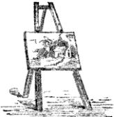



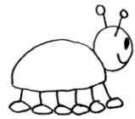
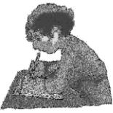


(Heacox, 2005) (Wormel, 2006)
Behavior Strategies that Promote Academic Achievement | 154

Name

Figurative Language Choices Board

Directions: Choose two activities from the choices below. Make sure your choices correspond with the two symbols your teacher assigned you.
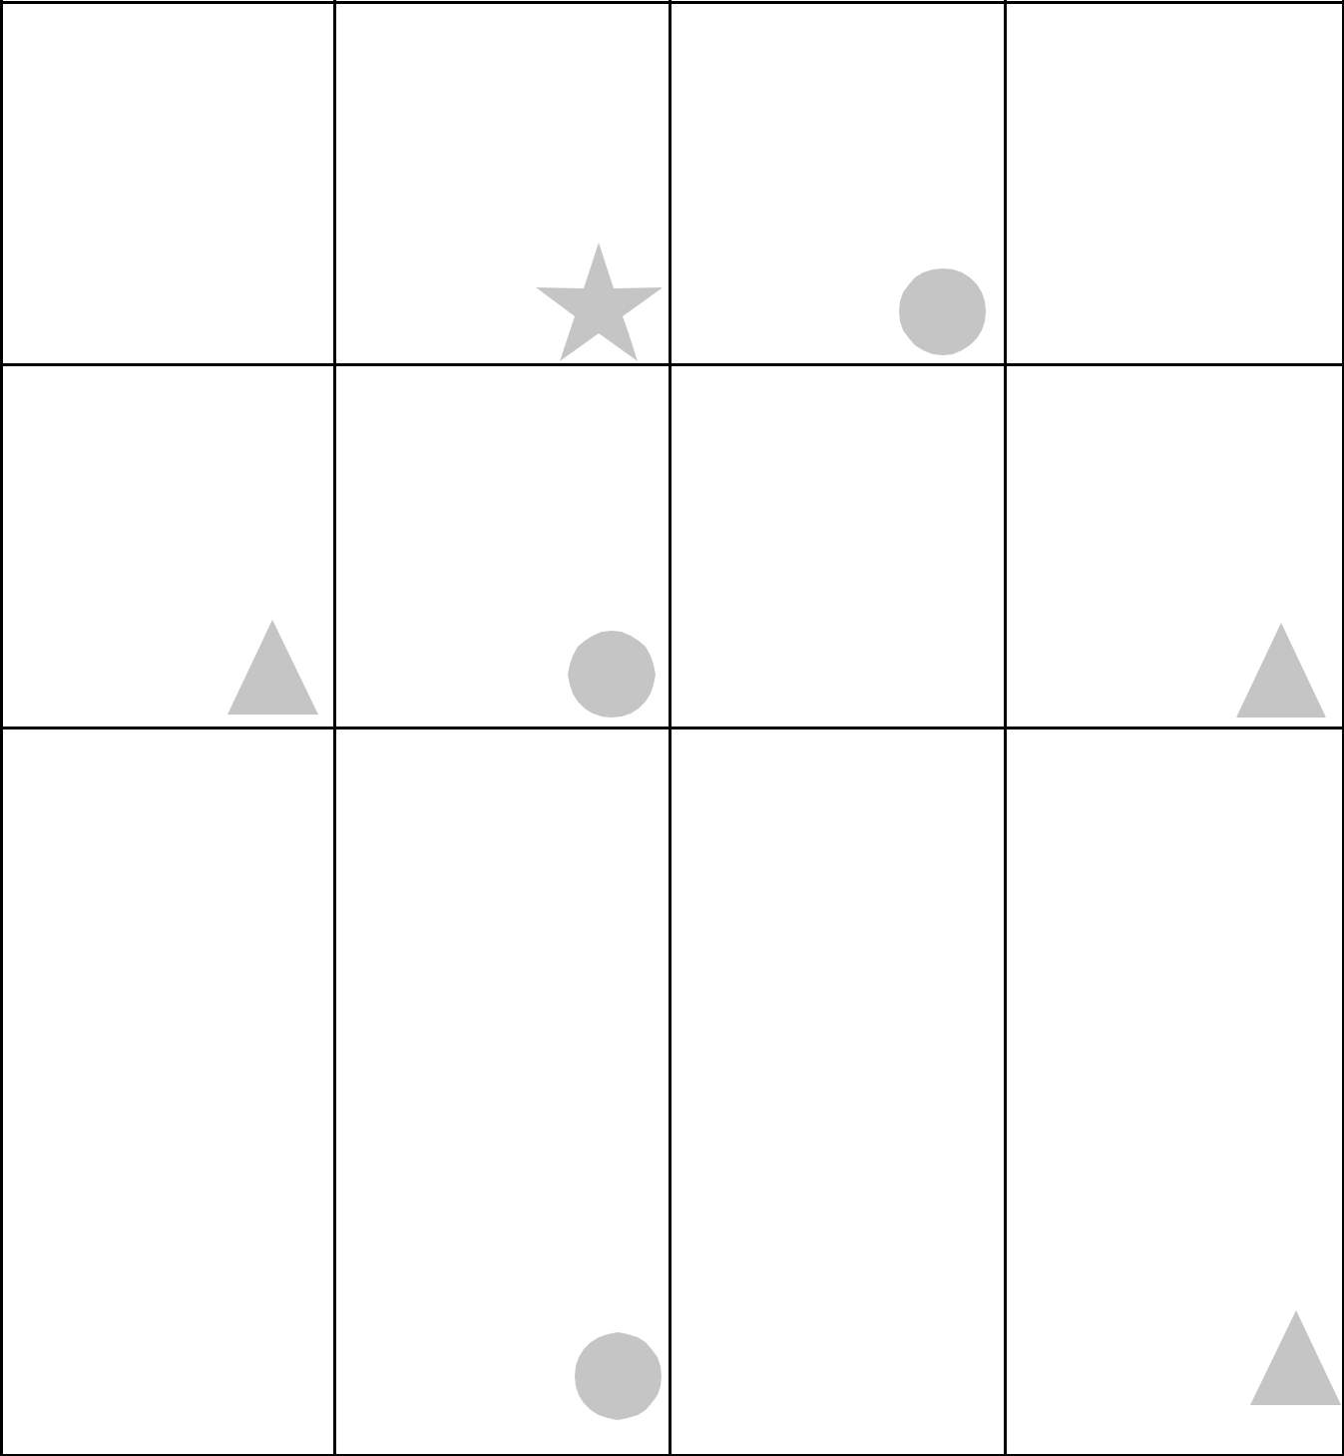

Perform a 30-second | Perform a | Make a WANTED | Write a letter to a
radio advertisement | one-minute puppet | poster using at least | friend using at least
to encourage people | show that teaches | two metaphors. | five different kinds of
to use oxymorons | about apostrophes. | Include a picture. | figurative language
when they talk. |  |  | in the text.

Interview an idiom of | Create at least | Create a picture | Write at least three
your choosing and | four newspaper | dictionary for these | jokes or puns using
write the transcript of | headlines using an | terms: idiom, simile, | one kind of figurative
the interview. | oxymoron in each. | metaphor, paradox, | language in each.
 |  | personification,
 |  | oxymoron, and
 |  | apostrophe.

Make a comic strip |  | Write a short story | Make a Venn |  | Create a set of six
with three characters |  | about a homework | diagram that |  | idiom flash cards.
using different |  | machine. Include | compares and |  | Be sure to include
kinds of figurative |  | one simile, one | contrasts metaphors |  | the answers on the
language. |  | personification, and | and similes. Write |  | backs of the cards.
 |  | one metaphor. | at least three
 |  |  | sentences to
 |  |  | summarize
 |  |  | the diagram.
Write one scene of |  | Act out four | Create your own |  | Create three
a play that shows |  | figurative language | crossword puzzle |  | mathematics story
personification |  | terms for a friend. | that includes these |  | problems for others
for at least three |  | Have your friend | terms: idiom, |  | to solve using a
characters. |  | guess the terms you | simile, oxymoron, |  | different figurative
 |  | are acting out. | metaphor, |  | language descriptor
 |  |  | personification, |  | in each problem.
 |  |  | paradox, and
 |  |  | apostrophe.

Behavior Strategies that Promote Academic Achievement | 155

Directions: Choose activities in a tic-tac-toe design. When you have completed the activities in a row–horizontally, vertically, or diagonally–you may decide to be finished. Or you may decide to keep going and complete more activities.

I choose activities # , # , # , #

Do you have ideas for alternate activities you’d like to do instead? Talk them over with your teacher.

I prefer to do the following alternate activities:
Behavior Strategies that Promote Academic Achievement | 156

Menu

Amenu offers students a way to make decisions about what they will do in order to meet class requirements. A menu could be for a single lesson, a week-long lesson, or even a

month-long period of study. Once the teacher has decided on what the essential understandings and/or skills are, she/he can begin to create a menu.

Steps:

- Identify the most important elements of a lesson or unit.

- Create an imperative or required assignment or project that reflects the minimum understanding you expect all students to achieve.

- Create negotiables which expand upon the main dish or imperative assignment or

project. These negotiables often require students to go beyond the basic levels of Bloom’s Taxonomy. For example, they often include activities that require synthesis, analysis, or evaluation.

- Create a final optional section that offers students the opportunity for enrichment. The optional section often reflects activities that students can use for extra credit.

Author Rick Wormeli suggests placing the menu options in a restaurant menu style (see below) that could include appetizers, a main dish, side dishes, and even desserts. He suggests the following format.
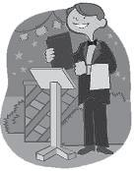

Appetizers (Negotiables)

- A list of assignments or projects

- Students select one item to complete

The Main Dish (Imperatives)

- An assignment or project that everyone must complete

Side Dishes (Negotiables)

- A list of assignments or projects

- Students select two items to complete

Desserts (Options)

- Optional but irresistible assignments or projects

- Options should be high interest and challenging

- Students choose one of these enrichment options

(Wormeli, 2006)
Behavior Strategies that Promote Academic Achievement | 157

Menus

Todd County teacher, Deanna Brodkorb, adapted Wormeli’s menu suggestions to fit the needs of her high school journalism class. Brodkorb included aspects of the Layered Curriculum® approach (see page 7) into her project menu choices. By completing just the Main Dish items students could earn a C. The Main Dish includes the basic information Brodkorb wanted all students to know, understand, and do. Brodkorb adapted the dessert portion and made it a requirement for an A grade.

The Journalism Cafe´

Complete all items to earn a C grade.

- 1 newspaper story that includes a photograph, graphic, or video clip

- Your newspaper story converted into a broadcast story

- 2 PhotoShops, either a continuance of tutorials or original projects

- 4 journals (equal to ½ typed page)

- Participation in the production of all news videos

Side Dishes

Choose at least two side dishes to earn a B grade. If you wish to earn an A grade, you must complete five different side dishes.
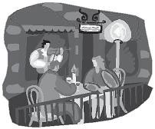

- Additional PhotoShop

- Additional newspaper story

- Additional broadcast story

- Editorial

- Editorial cartoon

- Advertisement design

- Photograph/graphic

Dessert

Complete one for an A grade.

- Video tape an event

- PowerPoint (either stand alone or to be used in a video)

- Redesign of a newspaper masthead

- Sell advertisements

- Lay out two newspaper pages

- Write a script

- Create a personal video production
Behavior Strategies that Promote Academic Achievement | 158


MENU PLANNER

Menu for: Due:

All items in the main dish and the specified number of side dishes must be complete by the due date. You may select among the side dishes and you may decide to do some of the desserts items, as well.


Main Dishes (complete all)

1

2

3

4


Side Dishes (Select )

1

2

3

4


Desserts (Optional)

1

2



1

2

3

4

Behavior Strategies that Promote Academic Achievement

MENU CONTRACT EXAMPLE

“Probability” Due:

All items in the main dish and the specified number of side dishes must be complete by the due date. You may select among the side dishes and you may decide to do some of the desserts items, as well.

Main Dishes (complete all)

Complete the “meteorology simulation” on p. 88-89 of your textbook.

Create a list of 10 pairs of events. 5 pairs should contain events that are dependent; 5 pairs should contain events that are independent. Explain each classification.
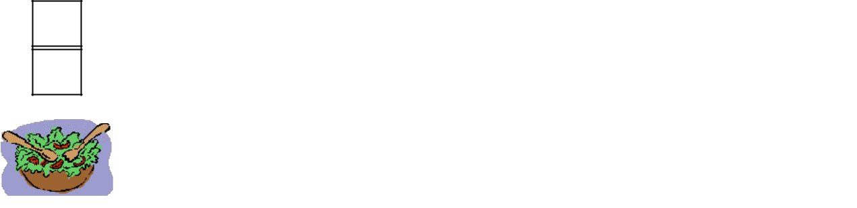

Complete the “frequency table” assignment on p. 506-507 of your textbook.

Examine the attached list of functions.

Side Dishes (Select_2 )

1

2

3


Work with a partner to analyze the game of “Primarily Odd.” See your teacher for game cubes and further instructions.

Design a “game spinner” that has this probability distribution: P(red) =0.1; P(green) = 0.2; P(blue) = 0.3; P(yellow) = 0.4.

Suppose a dart lands on a dartboard made up of four concentric circles. For the center of the board (the “bull’s eye”), r=1.5; the remaining rings have widths of

1.5. Use your understanding of area and probability to determine the probability of

1) hitting a “bull’s eye” and 2) landing in the outermost ring.

1

2

Desserts (Select 1)

Figure the probability of “Murphy’s Law” and make a case for whether or not it should indeed be a “law.”

Use a frequency table to chart the colors that your classmates wear for a week. Then, use probability to predict how many students will wear a certain color on a given day.

(Wormeli, 2006)

Behavior Strategies that Promote Academic Achievement | 160

Other Types of Choice Boards
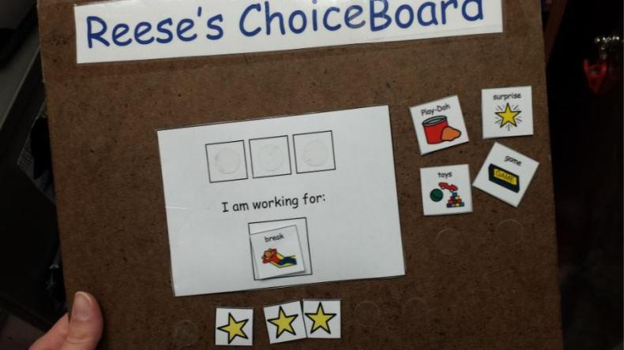
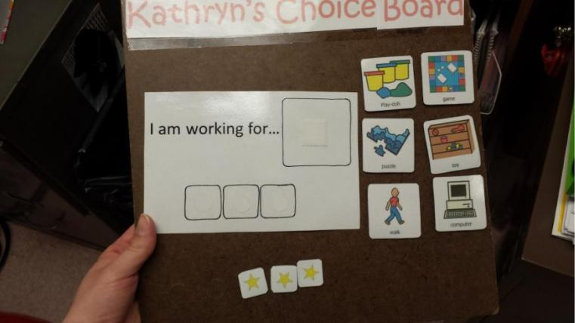

These Choice Boards are used with students who need quick motivation to get work done. They have 5 to 6 different choices of things that they are interested in doing. When they complete a task, THE STUDENT puts a star in a square. When the student earns all three stars, then they get the reward that they chose. It is pre-determined how long they get to spend on the activity they chose. The teacher can set the limit or the student can if the teacher is willing to work with what the student suggested.
Behavior Strategies that Promote Academic Achievement | 161

(The Choice Boards pictured were made by Jenna Rios)
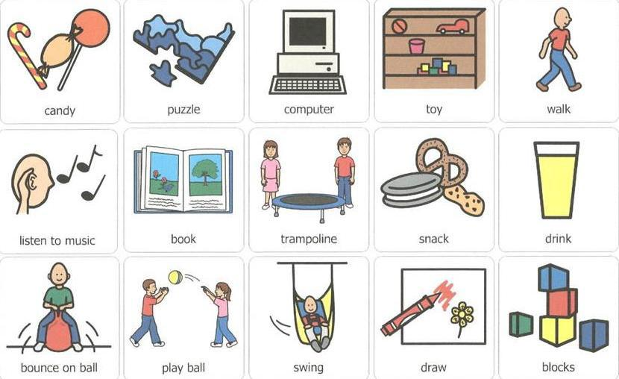
Behavior Strategies that Promote Academic Achievement | 162
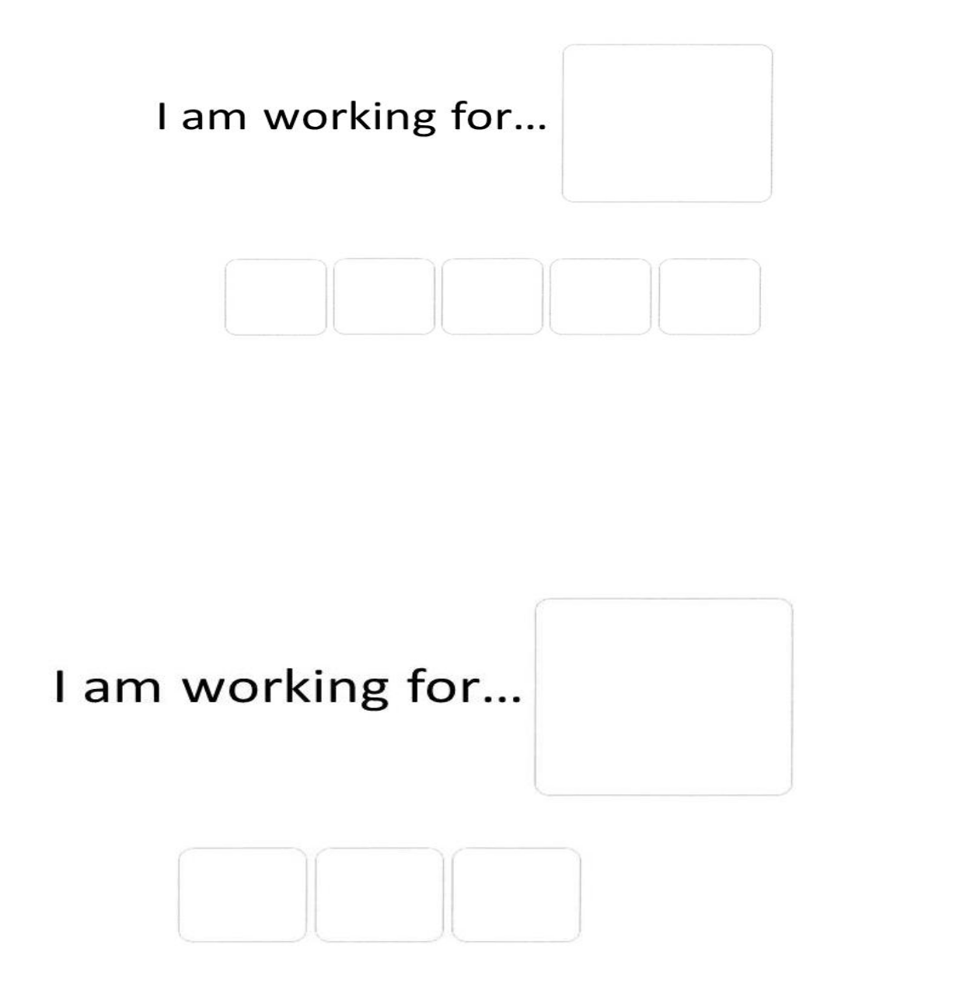
Behavior Strategies that Promote Academic Achievement | 163
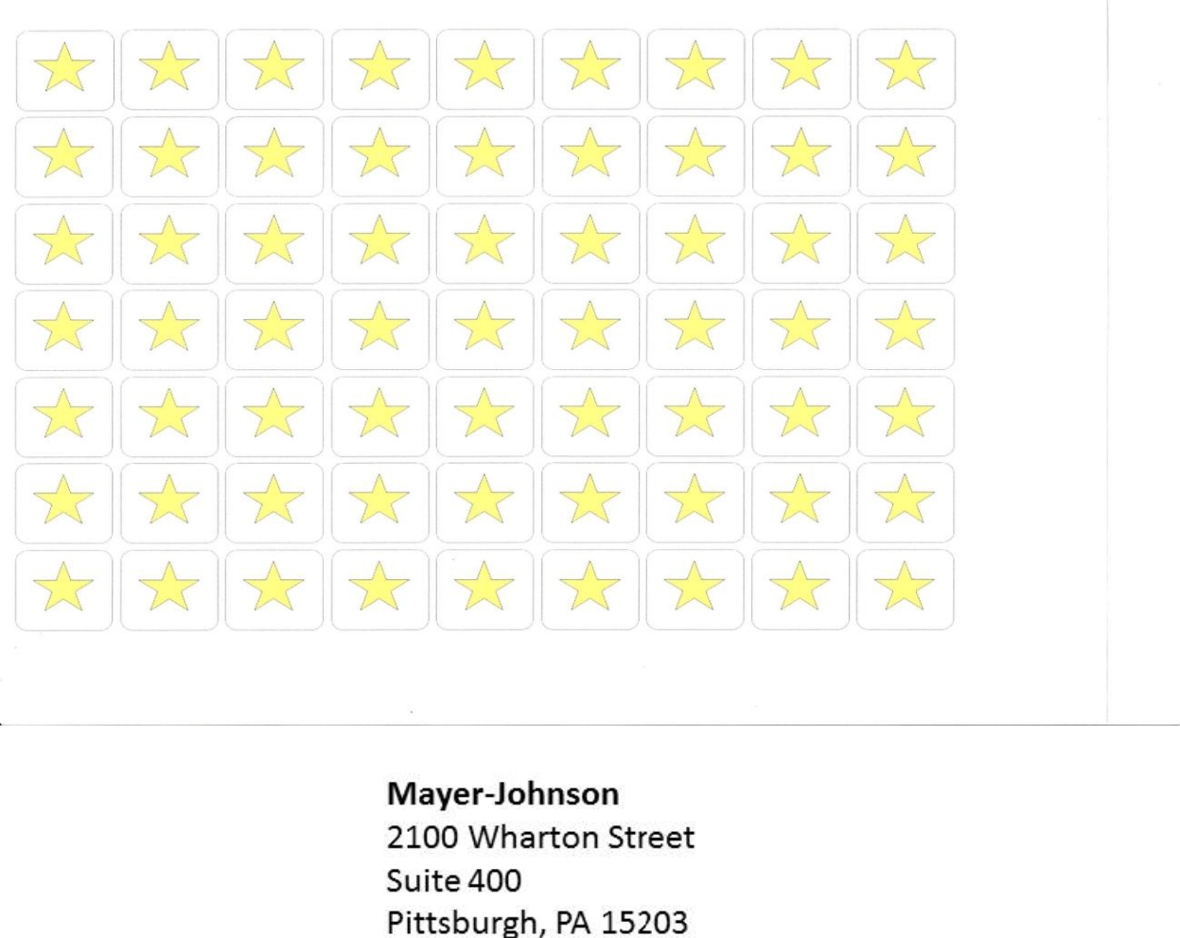
Behavior Strategies that Promote Academic Achievement 164

Section 9

Behavior Contracts


https://prezi.com/c-jttkgcv8jy/classroom-management-plan/
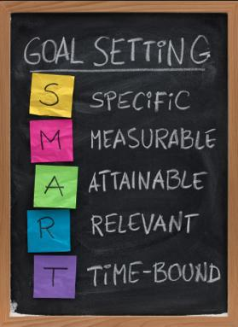

behaviorpsych.blogspot.com

Behavior Strategies that Promote Academic Achievement | 165

What Is A Behavior Contract?

A behavior contract is an agreement between the teacher, student, and the student's parents that sets limits for student behavior, rewards good choices, and outlines consequences for bad choices. This type of program sends a clear message to the child that "This behavior can not continue. Here is what we need to see from you and here is what you will see in response to your choices in the classroom."

Step 1 - Customize The Contract

First, make a plan for change. Use this Behavior Contract form as a guide for the meeting you will soon have with the student and his/her parents. Tailor the form to your particular situation, taking into consideration the personality and preferences of the child you are helping.

Step 2 - Set Up A Meeting

Next, hold a meeting with the involved parties. Perhaps your school has an assistant principal in charge of discipline; if so, invite this person, too. The student and his/her parents should attend as well.

Focus on 1-2 particular behaviors that you would like to see change. Don't try to change everything at once. Take baby steps toward major improvement so that it feels more "do-able" to the child.

Also, the parents will feel less defensive towards you if you make it seem like there's only a little "fine-tuning" to be done. Make it clear that you called this meeting because you care about this child and want to see him/her improve in school this year. Emphasize
Behavior Strategies that Promote Academic Achievement | 166

that the parent, student, and teacher are all part of the same team. Convey that "I can't do it without you. We're all in this together."

Step 3 - Communicate the Consequences

Define the tracking method to be used on a daily basis for monitoring student behavior. Describe the rewards and consequences that correlate with behavior choices. Be very specific and clear in this area. Use quantitative numbers wherever possible. Involve the parents in providing the rewards and consequences, taking much of the pressure of enforcement out of your hands. Constant school-to-home communication will go a long way towards significant progress with this child. Make sure that the chosen consequences are truly important to this particular child; you can even ask the child for input which will make him/her buy into the process even further. Have all involved parties sign the agreement and end the meeting on a positive note.

Step 4 - Schedule A Follow-Up Meeting

Schedule a follow-up meeting to discuss progress and make adjustments to the plan as needed. The follow-up meeting should be in 2-6 weeks, depending upon your assessment of the situation. Let the child know that the group will be meeting again soon to discuss progress.

Step 5 - Be Consistent In The Classroom

In the meantime, be very consistent with this child in the classroom. Stick to the wording of the behavior contract agreement to a "t." When the child makes good behavior choices, heap sincere praise upon him/her. When the child makes not so good choices, do not be
Behavior Strategies that Promote Academic Achievement | 167

apologetic; if needed, pull out the contract and review the terms that were agreed upon. Emphasize the positives that come along with good behavior choices and help the child to get used to new habits of good behavior.

Step 6 - Be Patient And Trust The Plan

Most of all, be patient. Do not give up on this child. While you may feel like pulling your hair out right now, as you see the child grow and develop, you may find this relationship to be one of the most rewarding of your teaching career. Such children often need extra love and positive attention so don't let your frustrations get the best of you.

In Conclusion

You might be surprised at the huge feeling of relief that all involved parties feel just by having an agreed-upon plan. Now that you all know how to proceed, a happy ending is in sight. Use your teacher's intuition to start yourself on a more peaceful and productive path with this child.

http://k6educators.about.com/cs/classroommanageme3/a/behaviorpact.htm
Behavior Strategies that Promote Academic Achievement | 168

Forced-Choice Reinforcement Survey

Name: _____________________________

In order to identify possible classroom reinforcers, it is important to go directly to the source, namely, you the student. Below is a paragraph that provides instructions for completing a series of “controlled choice” survey items about individual reinforcement preferences. Please read the following paragraph carefully:

“Let’s suppose that you have worked hard on an assignment and you think that you could have done a super job on it. In thinking about a reward for your effort, which one of the two things below would you most like to happen? Please choose the one from each par that you would like the best and mark an ”X” in the blank that comes in front of it. Remember, mark only one blank for each pair.”

- _____ Teacher writes “100” on your paper. (A)

 | _____ | Be first to finish your work. (CM)
2. | _____ | A bag of chips. (CN)
 | _____ | Classmates ask you to be on their team. (P)
3. | _____ | Be free to do what you like. (I)
 | _____ | Teacher writes “100” on your paper. (A)
4. | _____ | Classmates ask you to be on their team. (P)
 | _____ | Be first to finish your work. (CM)
5. | _____ | Be free to do what you like. (I)
 | _____ | A bag of chips. (CN)

- _____ Teacher writes “100” on your paper. (A)

_____ | Classmates ask you to be on their team. (P)
7. _____ | Be first to finish your work. (CM)
_____ | Be free to do what you like. (I)

Behavior Strategies that Promote Academic Achievement 169

- _____ A bag of chips. (CN)

_____ Teacher writes “100” on your paper. (A)

9. _____ Classmates ask you to be on their team. (P)

_____ Be free to do what you like. (I)

10. _____ Be first to finish your work. (CM)

_____ A bag of chips. (CN)

- _____ Teacher writes “A” on your paper. (A)

_____ Be the only one that can answer a question. (CM)

12. _____ A candy bar (CN)

_____ Friends ask you to sit with them. (P)

- _____ Be free to go outside. (I)

_____ Teacher writes “A” on your paper. (A)

14. _____ Friends ask you to sit with them. (P)

_____ Be the only one that answers a question. (CM)

- _____ Be free to go outside. (I)

_____ A candy bar. (CN)

- _____ Teacher writes “A” on your paper. (A)

_____ Friends ask you to sit with them. (P)

Behavior Strategies that Promote Academic Achievement 170

17. _____ Be the only one that can answer a question. (CM)

_____ Be free to go outside. (I)

- _____ A candy bar. (CN)

_____ Teacher writes “A” on your paper. (A)

19. _____ Friends ask you to sit with them. (P)

_____ Be free to go outside. (I)

20. _____ Be the only one that can answer a question. (CM)

_____ A candy bar. (CN)

- _____ Teacher writes “Perfect” on your paper. (A)

_____ Have only your paper shown to the class. (CM)

22. _____ A can of soda. (CN)

_____ Classmates ask you to be class leader. (P)

23. _____ Be free to play outside.(I)

_____ Teacher writes “Perfect” on your paper. (A)

24. _____ Classmates ask you to be class leader. (P)

_____ Have only your paper shown to the class. (CM)

- _____ Be free to play outside. (I)

_____ A can of soda. (CN)

Behavior Strategies that Promote Academic Achievement 171

26. _____ Teacher writes “Perfect” on our paper. (A)

_____ Classmates ask you to be class leader. (P)

27. _____ Have only your paper shown to the class. (CM)

_____ Be free to play outside. (I)

- _____ A can of soda. (CN)

_____ Teacher writes “Perfect” on your paper. (A)

29. _____ Classmates ask you to be class leader. (P)

_____ Be free to play outside. (I)

30. _____ Have only your paper shown to the class. (CM)

_____ A can of soda. (CN)

31. _____ Teacher writes “Excellent” on your paper. (A)

_____ Have your paper put on the bulletin board. (CM)

- _____ A pack of gum. (CN)

_____ Friends ask you to work with them. (P)

33. _____ Be free to work on something you like. (I)

_____ Teacher writes “Excellent” on your paper. (A)

34. _____ Friends ask you to work with them. (P)

_____ Have your paper put on the bulletin board. (CM)

Behavior Strategies that Promote Academic Achievement |  | 172
35. _____ | Be free to work on something you like. (I)
_____ | A pack of gum. (CN)

36. _____ Teacher writes “Excellent” on your paper. (A)

_____ Friends ask you to work with them (P)

37. _____ Have your paper put on the bulletin board. (CM)

_____ Be free to work on something you like. (I)

38. _____ A pack of gum. (CN)

_____ Teacher writes “Excellent” on your paper. (A)

39. _____ Friends ask you to work with them. (P)

_____ Be free to work on something you like. (I)

40. _____ Have your paper put on the bulletin board. (CM)

_____ A pack of gum. (CN)

Thank you for taking the time to complete this survey.

(Fort Wayne Community Schools)
Behavior Strategies that Promote Academic Achievement | 173

Forced Choice Survey and Behavior Contract 1:

Behavior contract one can be used to modify behavior in the classroom. The teacher should first give the Forced Choice Survey to the student. This will help the teacher to know what motivates the student. The Forced Choice Survey should be given to every student before making a behavior contract. Sometimes students do not always know or cannot always tell you what will motivate them. If you give them a reward that does not motivate them, then they will not work for the reward and the behavior contract will not work.

The student and the teacher should work together to make Behavior contract one. There should be input from both the teacher and the student. It is very important to follow through with whatever is written on the behavior contract, so it will be important for the privileges to be something that the teacher can offer whenever the child earns it. For example, if a child wants to earn an extra recess, then the teacher will need to make sure that someone will be available to take the student out for an extra recess when he/she has earned it. There are 6 examples of behavior contracts on the pages that follow.
Behavior Strategies that Promote Academic Achievement | 174


Behavior Contract 1

Behavior Expectations:

1._____________________________________________________________________

2._____________________________________________________________________

3._____________________________________________________________________

4._____________________________________________________________________

Privileges for meeting the conditions of the contract:

1._____________________________________________________________________

2._____________________________________________________________________
Behavior Strategies that Promote Academic Achievement | 175

Consequences/Restrictions for failing to meet the conditions of the contract:

1._____________________________________________________________________

2._____________________________________________________________________

I understand that I must meet all Behavior Expectations listed above in order to earn both of my privileges each day. Failure to meet the Behavior Expectations listed above will result in my earning of both consequences/restrictions listed above.

Privileges and Consequences/Restrictions will be earned on the same/following day (choose one).


Child’s Signature Parent’s Signature

For a more detailed set of prewritten behavior contracts, please visit any of the following sites:

www.parentcoachplan.com |  | www.behavior- |  |  | www.teenbehaviorcontracts.com
 |  | contracts.com

Retrieved from: www.behavior-contracts.com
Behavior Strategies that Promote Academic Achievement | 176

Behavior Contracts 2 and 3

The Behavior Contract 2 and 3 are used to list certain expectations that the student is required to meet. Once they meet the expectations, then they earn privileges for this. There are also consequences listed for the behavior. I allow the students to help decide what their privileges and consequences are. I list the expectations based on their IEP goals. The student and the teacher both sign the contract to show ownership. This also will be something that can be pulled out when the student is not behaving as a way to redirect.

The student needs to understand the behavior expectations. They need to know exactly what each expectation looks like and means. If the student does not understand the expectation, then they will not be able to follow through.
Behavior Strategies that Promote Academic Achievement | 177

Behavior Contract 2

Behavior Expectations:

1.______________________________________________________________________

2.______________________________________________________________________

3.______________________________________________________________________

4.______________________________________________________________________

Privileges for meeting the conditions of the contract:

1.______________________________________________________________________

2.______________________________________________________________________

Consequences/Restrictions for failing to meet the conditions of the contract:

1.______________________________________________________________________

2.______________________________________________________________________

I understand that I must meet all Behavior Expectations listed above in order to earn both of my privileges each day. Failure to meet the Behavior Expectations listed above will result in my earning of both consequences/restrictions listed above.

Privileges and Consequences/Restrictions will be earned on the same/following day
(choose one).
___________________________ |  | ___________________________
Student Signature |  | Teacher Signature
Retrieved from: www.freebehaviorcontracts.com

Behavior Strategies that Promote Academic Achievement | 178
Behavior Contract 3

I, ________________________, agree to make the following positive behavior changes:

______________________________________________________________________________

______________________________________________________________________________

______________________________________________________________________________

_____________________

When I have successfully completed this contract, I will be rewarded by:

______________________________________________________________________________

______________________________________________________________________________

______________________________________________________________________________

If I do not make the appropriate changes, I will have this consequence:

______________________________________________________________________________

We will review my contract on this date: _______ / _______ / _______.

Student Signature: _____________________________________ Date: _______________

Teacher Signature: _____________________________________ Date: _______________

Retrieved from: www.freebehaviorcontracts.com
 | Behavior Strategies that Promote Academic Achievement |  |  |  |  |  |  |  |  |  |  |  |  |  | 179
 |  | Behavior Contract 4
 | ___________’s Weekly Report |  |  |  |  |  |  |  | Week of: __________
 |  |  | Mon. |  |  | Tues. |  |  |  | Wed. |  | Thurs. |  | Fri.
 | Did I sign up for lunch |  | Y |  | N | Y |  |  |  | Y | N | Y | N | Y | N
 | without being reminded?
 | Did I put my red folder in |  |  |  |  | N
 |  |  | Y |  | N |  |  |  |  | Y | N | Y | N | Y | N
 | my cubby? |  |  |  | N
 | Did I turn in homework that |  | Y |  | N | Y |  | N |  | Y | N | Y | N | Y | N
 | was due? |  |  |  |  | Y |  | N
 | Did I act appropriately today |  | Y |  | N | Y |  | N |  | Y | N | Y | N | Y | N
 | in class, at lunch, and at
 | recess?
 | Did I speak respectfully to |  | Y |  | N | Y |  | N |  | Y | N | Y | N | Y | N
 | others without raising my
 | voice?
 | Did I walk away from a |  | Y |  | N | Y |  | N |  | Y | N | Y | N | Y | N
 | situation when I felt myself
 | getting upset?
 | How was my behavior today?
 | If it wasn’t 4 stars, explain
 | on back.
 | Parent Signature
 | Return to school everyday!
 |  |  |  | www.scholastic.com


This behavior contract could be set or taped on the student’s desk. This would be something to use for a younger student. Every day the student will rate how their behavior was throughout the day. They can earn a total of four stars. They will color in the amount of stars that they earn throughout the day. They will earn rewards based on their behavior throughout the day. The rewards and frequency of the rewards will need to be determined based on the student.
Behavior Strategies that Promote Academic Achievement | 180

Behavior Contract 5:

Behavior contract 5 can be used as a tool throughout the week to earn rewards. The numbers can be changed if you would like to change them. The scale of what the student can earn is between 0-5 on this behavior contract. If one of the desired behaviors were for the student to turn in homework for example and the student turned in the homework, but only half of it was complete, then the student would only earn a 3 out of 5. If the student’s goal was to raise his/her hand to speak then the teacher would rate the child based on how many times the child raised his/her hand to speak that day.

The student earns daily privileges for earning 12+ points per day on this behavior contract. That means that if the student earns at least 12 points in the day, they would earn the reward either the next day, or at the end of the day that they earned the points. The same thing happens with the restrictions. If the child earns 9 points or less, then they will have to serve the consequences either at the end of that day, or the next day. The bonus privilege should be something a little more exciting than the daily privileges. It should be a prize that the child would really be excited about earning so that they will work hard to earn the points.

The key to using this behavior contract is consistency. It is so important to follow through with this contract (or any contract). If the child works hard to earn the reward and the teacher does not follow through, then the child will stop trying to work for the reward. This contract is a very powerful tool to use with students who are really struggling behaviorally.
Behavior Strategies that Promote Academic Achievement | 181

Behavior Contract 5
______________’s Weekly Behavior Chart

For the week of: ______ to ______

Desired Behavior | Mon, | Tues. | Wed. | Thurs. | Fri.
 | /5 | /5 | /5 | /5 | /5
 | /5 | /5 | /5 | /5 | /5
 | /5 | /5 | /5 | /5 | /5
Daily Total (Out of 15)
 | /15 | /15 | /15 | /15 | /15
(Notice: Each Desired Behavior is worth up to 5 points per day.)
Daily Privileges for earning 12+ points per day:
1.
2.
3.
Daily Restrictions for earning 9 or less points per day:
1.
2.
3.
Bonus privilege for earning all points for the day!
©2010 Complete Parenting Solutions. All rights reserved. Visit us at www.ParentCoachPlan.com
Behavior Strategies that Promote Academic Achievement | 182

Behavior Contract 5 Example

______________’s Weekly Behavior Chart

For the week of: ______ to ______

Desired Behavior |  | Mon, | Tues. |  | Wed. | Thurs. | Fri.
I will return my daily note |  | /5 | /5 |  | /5 | /5
signed. |  |  |  |  |  |  | /5
I will raise my hand to |  | /5 | /5 |  | /5 | /5
speak. |  |  |  |  |  |  | /5
I will not roam around the
classroom. |  | /5 | /5 |  | /5 | /5 | /5
Daily Total (Out of 15) |  |  | /15 |  | /15 | /15 | /15
 |  | /15
(Notice: Each Desired Behavior is |  | worth up to 5 |  | points per day.)
Daily Privileges for earning 12+ points per day:
1. | I will earn 10 minutes of free time on the computer.
2. | I will earn 10 classroom dollars.
3. | I will earn 5 minutes of the teacher’s undivided attention.
Daily Restrictions for earning 9 or less points per day:
1. | I will lose half of my recess time.
2. | I will not earn 10 classroom dollars.
3. | I will lose free time at the end of the day.

Bonus privilege for earning all points for the day!

I will be able to play a board game with a friend during free time.

©2010 Complete Parenting Solutions. All rights reserved. Visit us at www.ParentCoachPlan.com
Behavior Strategies that Promote Academic Achievement | 183

Behavior Contract 6
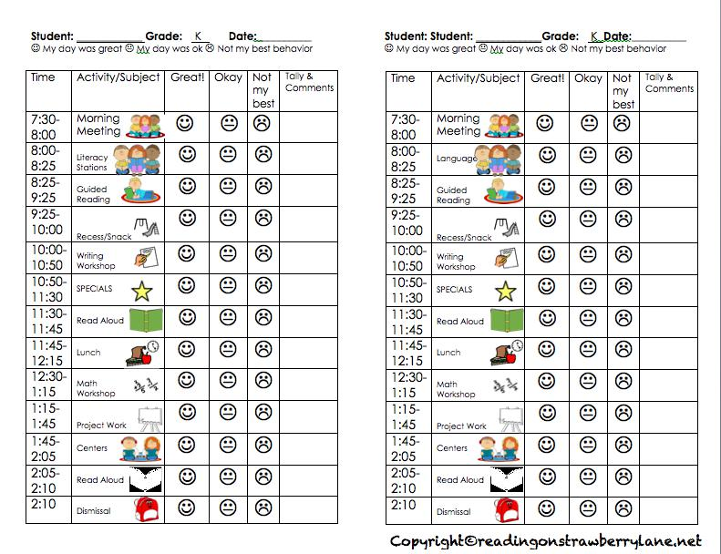

This behavior contract is an example of what to use for younger students. They earn a smiley for each subject of the day. This will help motivate the student to have a great day. It also can serve as documentation to show where the student struggles throughout the day. This could easily sit on the student’s desk.
Behavior Strategies that Promote Academic Achievement 184

100 Free or Inexpensive Rewards for Individual Students

Elementary Level

- Assist the custodian

- Assist with morning announcements over the PA system

- Be a helper in another classroom

- Be featured on a photo recognition board

- Be recognized during announcements

- Be the first one in the lunch line

- Be the leader of a class game

- Be the line leader or the caboose

- Be the scout (Person who goes ahead of class to tell the special teacher they are on the way)

- Be the teacher's helper for the day

- Borrow the principal’s chair for the day

- Buzz cut a design in an agreeable male’s head

- Choose a book for the teacher to read aloud to the class

- Choose any class job for the week

- Choose music for the class to hear

- Choose the game during physical education

- Choose which homework problem the teacher will give the answer to for a freebie

- Cut the principal’s tie off and have your picture featured on a bulletin board with the neck part of the tie as the frame. Keep the tip for a souvenir.

Behavior Strategies that Promote Academic Achievement 185

- Dance to favorite music in the classroom

- Design a class/school bulletin board

- Design and make a bulletin board

- Do half of an assignment

- Draw on the chalkboard

- Draw on a small white board at desk

- Draw pictures on the chalkboard while the teacher reads to the class (illustrating the story being read)

- Duct tape the principal to the wall during lunch or an assembly

- Earn a free pass to a school event or game

- Earn a gift certificate to the school store or book fair

- Earn a pass to the zoo, aquarium, or museum

- Earn a trophy, plaque, ribbon or certificate

- Earn an item such as a Frisbee, hula hoop, jump rope, paddleball or sidewalk chalk, which promote physical activity

- Earn extra computer time

- Earn extra credit

- Earn free tutoring time from the teacher (spelling secrets, math secrets, writing secrets)

- Earn play money to be used for privileges

- Earn points for good behavior to “buy” unique rewards (e.g. Autographed items with special meaning or lunch with the teacher)

- Earn the privilege of emailing a parent at work telling of accomplishments

Behavior Strategies that Promote Academic Achievement 186

- Eat lunch outdoors with the class

- Eat lunch with a teacher or principal

- Eat lunch with an invited adult (grandparent, aunt, uncle)

- Eat with a friend in the classroom (with the teacher)

- Enjoy a positive visit with the principal

- Enjoy class outdoors for the whole class

- Enter a drawing for donated prizes among students who meet certain grade standards

- Get “free choice” time at the end of the day

- Get a “no homework” pass

- Get a drink from the cold water fountain (There is always one fountain that is better)

- Get a flash cards set printed from a computer

- Get a video store or movie theatre coupon

- Get extra art time

- Go on a walking field trip (earn privilege for whole class)

- Go to the library to select a book to read

- Have a drawing lesson

- Have a free serving of milk

- Have a teacher read a special book to the entire class

- Have an extra recess

- Have teacher share a special skill (e.g. Sing)

- Have the teacher make a positive phone call home

Behavior Strategies that Promote Academic Achievement 187

- Help in a lower level class

- Keep a stuffed animal at desk

- Learn how to do something special on the computer- like graphics or adding sound

- Learn how to draw something that looks hard, but with help is easy

- Listen to music while working

- Listen with a headset to a book on audiotape

- Make deliveries to the office

- Name put on scrolling marquee with a specific message “Emily Jones says smile and eat your veggies.”

- Operate the remote for a PowerPoint lesson

- Pick a game at recess that everyone plays including the teacher

- Play a computer game

- Play a favorite game or puzzle

- Read a book to the class

- Read morning announcements

- Read outdoors

- Read to a younger class

- Receive a “mystery pack” (gift-wrapped items such as a notepad, folder, puzzle, sports cards, etc.)

- Receive a 5-minute chat break at the end of the class or at the end of the day

- Receive a note of recognition from the teacher or principal

- Receive a plant, seeds and a pot for growing

Behavior Strategies that Promote Academic Achievement 188

- Receive art supplies, coloring books, glitter, bookmarks, rulers, stencils, stamps, pens, pencils, erasers and other school supplies

- Receive verbal praise

- Select a paperback book to take home to read from the teacher’s personal library

- Sit at the teacher's desk for the day or a set amount of time

- Sit next to the teacher during story time

- Sit with a friend at lunch, assembly, etc.

- Take a free homework pass

- Take a trip to the treasure box (non-food items such as water bottles, stickers, key chains, temporary tattoos, yo-yo’s, bubbles, spider rings, charms and pencil toppers)

- Take care of the class animal

- Take class animal home for school vacation time

- Take home a class game for a night

- Teach the class a favorite game

- Teach the class a math lesson

- Use colored chalk

- Use the teacher's chair

- Walk with a teacher during lunch

- Watch a video instead of recess

- Work as the Principal apprentice for 20 minutes

- Work in the lunchroom

Behavior Strategies that Promote Academic Achievement | 189

- Write with a marker for the day

- Write with a special pen for the day

- Write with a special pencil for the day.

©2008 Laura Riffel-Behavior Doctor Seminars-Permission to Copy- May not sell or change-
Behavior Strategies that Promote Academic Achievement | 190

Conclusion

Students with emotional and behavioral disorders are students who can learn. They may not look different on the outside, but on the inside, they are very different. They are smart boys and girls who have had a life that some people cannot even imagine. They have seen and done things that to some people seem unthinkable. This does not make them bad people.

As teachers we should have an open mind with these students. They will challenge you. Some days will be harder than others. My hope is that this handbook has given you some tools that will make it easier to work with students with emotional and behavioral disorders. This book does not have all of the answers. There are still more resources out there to be found, but this will be a good start to your search for strategies that will help your more difficult students.
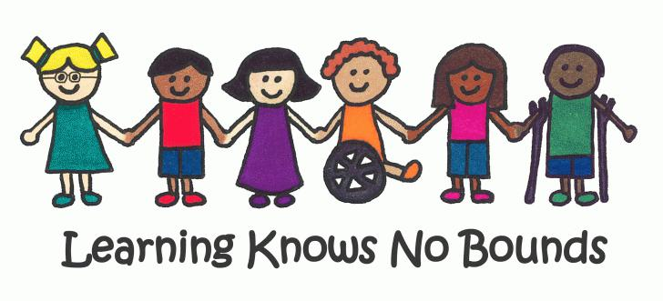

www.hamiltoncentral.org

The End
Behavior Strategies that Promote Academic Achievement 191

References

Allan Allday, R., Hinkson-Lee, K., Hudson, T., Neilsen-Gatti, S., Kleinke, A., & Russel, C., (2012). Training General Educators to Increase Behavior Specific Praise: Effects on Students with EBD. Behavioral Disorders, 37(2), 87-98.

Boynton, M., & Boynton, C (2005). The Educator’s Guide to Preventing and Solving Discipline Problems. Association for Supervision and Curriculum Development.

Conroy, M.A., & Southerland, K.S. (2012). Effecrtive Teachers for Students with Emotional/Behavioral Disorders: Active Ingredients Leading to Positive Teacher and Student Outcomes. Beyond Behavior, 22(1). 7-13

Freeman, R. L., Britten, J., McCart, A., Smith, C., Poston, D., Anderson, D., Edmonson, H., Baker, D., Sailor, W., Guess, D., & Reichle, J. (1999). (Module 2) Functional Assessment [online]. Lawrence, KS: Kansas University Affiliated Program, Center for Research on Learning.

Gaudreau, N., Royer, E., Beaumont, C., & Flanagan, T. (2013). Classroom Behaviour Management: The Effects of In-Service Training on Elementary Teachers’ Self-Efficacy Beliefs. Mcgill Journal of Education, 48(2), 359-382

Heacox, Diane. “Promoting Student Independence and Responsibility in

AcademicallyDiverse Classrooms. 2005 ASCD Annual Conference.

Orlando, FL. April 2005.

Behavior Strategies that Promote Academic Achievement 192

Lerner, J.W., & Johns, B.H. (2012). Learning Disabilities and Related Mild Disabilities. Wadsworth Cengage Learning, Belmont, CA.

Lewis, T., “Making connections” (2007). Small Group Strategies

Martel, Heather A., “Effective Strategies for general and Special Education Teachers” (2009). Senior Honors Thesis. Paper 210

Menzies, H.M., Lane, K., & Lee, J. (2009). Self-Monitoring Strategies for Use in the Classroom: A Promising Practice to Support Productive Behavior for Students With Emotional or Behavioral Disorders. Beyond Behavior, 18(2), 27-35

Riffel, Laura (2008). Behavior Doctor Seminars.

Rockwell, S., (1995) Back Off, Cool Down, Try Again. The Council for Exceptional Children, Reston, VA.

Scott, T. M., Park, K.L., Swain-Badway, J., & Landers, E. (2007). Positive behavior Support in the Classroom: Facilitating Behaviorally Inclusive Learning Environments. International Journal Of Behavioral Consultation & Therapy, 3(2), 223-235.

Special Education Rules Title 511 Article 7 Rules 32-47, Indiana Department of Education, 2010.

Tomlinson, C. (2003). Fulfilling the Promise of the Differentiated

Classroom. Alexandria, VA: Association for Supervision and

Curriculum Development, (ASCD).

Behavior Strategies that Promote Academic Achievement 193

Wormeli, Rick. Fair Isn’t Always Equal: Assessing & Grading in the

Differentiated Classroom.Portland, ME: Stenhouse, 2006, pages 65-66.

Workshop Presentation. 2nd Annual SDE National Conference on

Differentiated Instruction: Theory Into Practice. Las Vegas, NV.

18 July 04.

Behavior Strategies that Promote Academic Achievement | 194

Chapter 6

Discussion

The purpose of the needs assessment survey was to investigate teachers’ understanding and present evidenced-based classroom management strategies for elementary students with emotional and behavioral disabilities. There are many resource books that explain how to handle behaviors within the classroom. My handbook was made as a simple guide for teachers who are looking for strategies to help students with emotional and behavioral disorders. The results of the survey show that teachers who work in the general education classroom with students who have emotional and behavioral disorders feel that they could benefit from more training on how to work with these students. Teachers have shared that they are not confident in working with these students. Of the teachers surveyed, 70% stated that they did not have formal training on how to work with students with emotional and behavioral disorders.

Limitations

One of the limitations in this study is that it was a small sample size, in which 21 teachers were asked to participate, but only 11 teachers returned the survey. This was a 52% return rate. Because of the small number of teachers who responded, the results may have been skewed. Having a larger sample size would have provided more data. The way some of the questions were worded may have had an effect on how teachers responded to the question. The handbook only addresses students with emotional and behavioral disorders. These strategies could be used for students who do not have a disability, but the research focus was on students with emotional and behavioral disorders.
Behavior Strategies that Promote Academic Achievement | 195

Strengths

This research study will be very beneficial for teachers who have students in their class who have EBD. The relationship between the teacher and the student directly correlates with how successful students with EBD are academically in the general education setting. If teachers are not confident in teaching these students, then they can use this handbook as a reference to help them with strategies to teach students with emotional and behavioral disorders.

This handbook is a useful tool for general education elementary teachers and special education teachers. It can be very useful for teachers who have students in their general education classroom with emotional and behavioral disorders. The survey showed a strong need for additional training for general education teachers. The survey also showed that teachers are not confident in their ability to teach students with EBD.

Teachers were asked to participate in a survey. The survey showed a strong need for additional training for general education teachers. The survey also showed that teachers are not confident in their ability to teach students with EBD. The online format that I used to survey the teachers was very easy to use. It offered easy to read charts and percentages that helped me develop my conclusions about the survey. The teachers were able to easily respond to the survey. I feel that this was one of the reasons that there was such a high return rate on the surveys.
Behavior Strategies that Promote Academic Achievement | 196

Future Research

Future research for this project should survey a larger number of participants in the survey. They could include the feeling of the parents and the student about their thoughts about being in the general education setting. Future research could also find out what kind of training teachers are getting in their undergraduate studies that help them teach students with emotional and behavioral disorders. They also could research the success rate of teacher-student relationships and the effects on the student’s academic success within the general education classroom. This would need to be specific to students with emotional and behavioral disorders.

Conclusion

The results in this survey proved that more training is needed for students with emotional and behavioral disorders. The teachers felt that they would benefit from additional training in working with students with emotional and behavioral disorders. This research is very relevant to our general education teachers today. As time goes on, students with emotional and behavioral disorders will be required to go to the general education setting. The general education teachers need to be well prepared to work with students with emotional and behavioral disorders. This handbook will be a wonderful resource for teachers looking for strategies to build relationships with students with emotional and behavioral disorders and help these students succeed academically in their classrooms.
Behavior Strategies that Promote Academic Achievement 197

References:

Allan Allday, R., Hinkson-Lee, K., Hudson, T., Neilsen-Gatti, S., Kleinke, A., & Russel, C.s. (2012). Training General Educators to Increase Behavior-Specific Praise: Effects on Students with EBD. Behavioral Disorders, 37(2), 87-98.

Ahmed, W., Minnaert, A., van der Werf, G., & Kuyper, H. (2010). Perceived social support andearly adolescents’ achievement: The meditational roles of motivational beliefs andemotions. Journal of Youth Adolescence, 39, 36-46.

Anderson, J. (2002). Individualized Behavior Contracts. Intervention In School & Clinic, 37(3), 168.

Blood, E., Johnson, J. W., Ridenour, L., Simmons, K., & Crouch, S. (2011). Using an iPodTouch to Teach Social and Self-Management Skills to an Elementary Student with Emotional/Behavioral Disorders. Education & Treatment Of Children, 34(3), 299-321.

Boynton, M., & Boynton, C (2005). The Educator’s Guide to Preventing and Solving Discipline Problems. Association for Supervision and Curriculum Development.

Conroy, M. A., Sutherland, K. S., Snyder, A., Al-Hendawi, M., & Vo, A. (2009). Creating a Positive Classroom Atmosphere: Teachers' Use of Effective Praise and Feedback. Beyond Behavior, 18(2), 18-26.

Behavior Strategies that Promote Academic Achievement 198

Conroy, M. A., & Sutherland, K. S. (2012). Effective Teachers for Students with Emotional/behavioral Disorders: Active Ingredients Leading to Positive Teacher and Student Outcomes. Beyond Behavior, 22(1). 7-13.

Creswell, J. W. (2013). Educational Research. Upper Saddle River, New Jersey:

Pearson Education, Inc.

Fredricks, J. A., Blumenfeld, P., Friedel, J., & Paris, A. (2005). School Engagement. In K. A. Moore & L. H. Lippman (Eds.), What do children need to flourish?: Conceptualizing and measuring indicators of positive development (pp. 305-321). New York, NY: Springer.

Gaudreau, N., Royer, E., Beaumont, C., & Flanagan, T. (2013). Classroom Behaviour Management: The Effects of In-Service Training on Elementary Teachers’ Self-Efficacy Beliefs. Mcgill Journal Of Education, 48(2), 359-382

Hawkins, R., Musti-Rao, S., Hughes, C., Berry, L., & McGuire, S. (2009). Applying a Randomized Interdependent Group Contingency Component to Classwide Peer Tutoring for Multiplication Fact Fluency. Journal Of Behavioral Education, 18(4), 300-318. doi:10.1007/s10864-009-9093-6
Heacox, Diane. “Promoting Student Independence and Responsibility in

Academically Diverse Classrooms. 2005 ASCD Annual Conference.

Orlando, FL. April 2005.

Hess, L. L. (2003). “Contract” Isn't a Four-Letter Word. Momentum (0026914X), 34(3), 55-57.

Behavior Strategies that Promote Academic Achievement 199

Indiana State Board of Education, Special Education Rules (2010). Article 7.

Retrieved from www.doe.in.gov.

Kalis, T. M., Vannest, K. J., & Parker, R. (2007). Praise Counts: Using Self-Monitoring to Increase Effective Teaching Practices. Preventing School Failure, 51(3), 20-27.

Kauffman, J.M., & Landrum, T. J. (2009) Characteristics of emotional and behavioral disorders of children and youth (9th ed.). Upper Saddle River, NJ: Pearson Education, Inc.

Lapointe, J. M., Legualt, F., & Batiste, S. J. (2005). Teacher interpersonal behavior and adolescents’ motivation in mathematics: A comparison of learning disabled, average, and talented students. International Journal of Educational Research, 43, 39-54.

Lerner, J.W., & Johns, B.H. (2012). Learning Disabilities and Related Mild Disabilities.Wadsworth Cengage Learning, Belmont, CA.

Martel, Heather A., “Effective Strategies for General and Special Education Teachers” (2009). Senior Honors Thesis. Paper 210.

Menzies, H. M., Lane, K., & Lee, J. (2009). Self-Monitoring Strategies for Use in the Classroom: A Promising Practice to Support Productive Behavior for Students With Emotional or Behavioral Disorders. Beyond Behavior, 18(2), 27-35.

Murray, C., & Greenberg, M. T. (2006). Examining the Importance of Social Relationships and Social Contexts in the Lives of Children with High-Incidence Disabilities. Journal Of Special Education, 39(4), 220-233.

Behavior Strategies that Promote Academic Achievement 200

O’Neill, S., & Stephenson, J. (2013). One Year On: First-Year Primary Teachers’ Perceptions of Preparedness to Manage Misbehaviour and Their Confidence in the Strategies They Use. Australasian Journal Of Special Education, 37(2), 125-146

Patrick, H., & Ryan, A.M. (2005). Identifying adaptive classrooms: Dimensions of the classroom social environment. In K.A. Moore & L. H. Lippman (Eds.) What do children need to flourish?: Conceptualizing and measuring indicators of positive development (pp. 271-287). New York, NY: Springer.

Pinchevsky, N., & Bogler, R. (2014). The Influence of Teachers' Perceived Self-Efficacy and Role Impact on their Preferences in Adopting Strategies to Resolve Conflict Situations with Students. International Studies In Educational Administration (Commonwealth) Council For Educational Administration & Management (CCEAM)), 42(2), 111-125.

Ryan, J. B., Pierce, C. D., & Mooney, P. (2008). Evidence-Based Teaching Strategies for Students with EBD. Beyond Behavior, 17(3), 22-29.

Ryan, J. B., Reid, R., & Epstein, M. H. (2004). Peer-Mediated Intervention Studies on Academic Achievement for Students with EBD. Remedial & Special Education, 25(6), 330-341.

Scott, T. M., Park, K. L., Swain-Bradway, J., & Landers, E. (2007). Positive Behavior Support in the Classroom: Facilitating Behaviorally Inclusive Learning Environments. International Journal Of Behavioral Consultation & Therapy, 3(2), 223-235.

Behavior Strategies that Promote Academic Achievement 201

Skinner, C. H., Williams, R. L., & Neddenriep, C. E. (2004). Using Interdependent Group Oriented Reinforcement to Enhance Academic Performance in General Education Classrooms. School Psychology Review, 33(3), 384-397

Special Education Rules Title 511 Article 7 Rules 32-47, Indiana Department of Education, 2010.

Sutherland, K. S., Wehby, J. H., & Yoder, P. J. (2002). Examination of the Relationship between Teacher Praise and Opportunities for Students with EBD To Respond to Academic Requests. Journal Of Emotional And Behavioral Disorders, 10(1), 5-13.

Zirpoli T. J. (2012). Behavior Management Positive Applications for Teachers. Upper Saddle River, New Jersey: Pearson Education, Inc. Indiana Department of Education

Behavior Strategies that Promote Academic Achievement 202

Appendix

Appendix A-Citi Training

These pages have been removed to protect confidentiality.

Behavior Strategies that Promote Academic Achievement 203

These pages have been removed to protect confidentiality.

Behavior Strategies that Promote Academic Achievement 204

Appendix B-IRB Approval

These pages have been removed to protect confidentiality.

Behavior Strategies that Promote Academic Achievement 205

These pages have been removed to protect confidentiality.

Behavior Strategies that Promote Academic Achievement 206

Appendix C-Permission letter from principal

This page has been removed to protect confidentiality.

Behavior Strategies that Promote Academic Achievement | 207

Appendix D

9/2/15
Dear Colleague,

I am a graduate student at Indiana University- Purdue University Fort Wayne. For my final project, I am conducting research on strategies that help build positive relationships between general education teachers and their students with emotional and behavioral disorders within the inclusive classroom.

Because you are a classroom teacher in the general education setting and you may have students with emotional and behavioral disorders in your classroom, I am inviting you to participate in this study. Even if you do not currently have students in your classroom with emotional and behavioral disorders I ask you to consider participation in this survey.

The survey is about effective strategies that you know and use in your classroom with students who have emotional and behavioral disorders. The survey will take approximately 15 minutes to complete.

There is no compensation for responding nor is there any known risk. In order to ensure that all information will remain confidential, please do not include your name or any other identifiable data. There is an attached link that will take you directly to the survey. Participation is strictly voluntary and you may refuse to participate at any time.

If you have any questions or would like to participate in the research.

Thank you,
Behavior Strategies that Promote Academic Achievement | 208

Appendix E

Survey questions:

Behavior strategies that promote academic achievement for students with emotional and behavioral disorders (EBD) in the general education setting

*Please complete this survey to the best of your knowledge. When answering these questions, please think about your teaching career as a whole and not just about the students in your classroom this year. Thank you for your time.

- What grade level of students do you teach?

  - Elementary K-2

  - Elementary 3-5

- What is your age?

  - 18-30

  - 31-45

  - 46-65

- How many years have you taught elementary school?

  - 1-5 years

  - 6-10 years

  - 11-15 years

  - +16 years

- What are the characteristics of students with emotional and behavioral disorders (EBD) that you have seen in your classroom?

- What percentage of students in your classroom each year are students diagnosed as EBD?

  - None

  - 4%

  - 5-10%

  - More than 10%

- How much formal training have you had related to teaching students with EBD?

  - None
Behavior Strategies that Promote Academic Achievement 209

  - An in-service workshop as a part of a broader course dealing with students of disabilities.

  - 1-4 formal college courses dealing with educating students with EBD

  - 5 or more formal college courses dealing with educating students with

EBD

- I am confident in my ability to teach students with EBD in my classroom.

  - Yes

  - No

- If you answered “yes” to the previous question, please explain why you are confident. If you answered “no” to the previous question, in what areas do you feel you could benefit from additional resources or training?

- What is your definition of positive reinforcement?

- I use positive reinforcement in my classroom.

  - Yes

  - No

- Please describe how you use positive reinforcement in your classroom.

- What is your definition of self-monitoring?

- My students with ED self-monitor in the classroom.

  - Yes

  - No

- What techniques do your students use to self monitor?

- What is your definition of positive behavioral supports?

Behavior Strategies that Promote Academic Achievement 210

- I use positive behavioral supports in my classroom.

  - Yes

  - No

- How do you use positive behavioral supports in your classroom?

- A token economy is often used as a way to help mold behaviors in a classroom. It is often used in the form of giving out classroom money, tokens, or tickets. Do you use a token economy in your classroom?

  - Yes

  - No

- If you do use a token economy, do you feel that it is beneficial in your classroom? Why?

- Please list any other strategies that you use with students with EBD in your classroom.

- Do you feel that you would benefit from having more training on how to work with students with EBD?

- What kind of additional training would you be interested in?

  - In-service during collaboration Wednesday.

  - Professional development on teaching strategies that help students with EBD.

  - Small group or one-on-one meetings with the ED teacher(s).

  - Other_________________________________________________

Thank you for your responses.

Behavior Strategies that Promote Academic Achievement |  | 211
 | Appendix F
Survey Question | Research (appropriate citation)
What are the characteristics of | Lerner, J.W., & Johns, B.H. (2012). Learning
students with emotional and
behavioral disorders (EBD) that | Disabilities and Related Mild
you have seen in your classroom?
 | Disabilities.Wadsworth Cengage Learning,
 | Belmont, CA.
What is your definition of positive | Allan Allday, R., Hinkson-Lee, K., Hudson, T.,
reinforcement?
 | Neilsen-Gatti, S., Kleinke, A., & Russel, C.s.
 | (2012). Training General Educators to Increase
 | Behavior-Specific Praise: Effects on Students with
 | EBD. Behavioral Disorders, 37(2), 87-98.
What is your definition of positive | Lerner, J.W., & Johns, B.H. (2012). Learning
behavioral supports?
 | Disabilities and Related Mild
 | Disabilities.Wadsworth Cengage Learning,
 | Belmont, CA.
A token economy is often used as | Lerner, J.W., & Johns, B.H. (2012). Learning
a way to help mold behaviors in a
classroom. It is often used in the | Disabilities and Related Mild
form of giving out classroom
money, tokens, or tickets. Do you | Disabilities.Wadsworth Cengage Learning,
use a token economy in your
classroom? | Belmont, CA.
Do you feel that you would benefit | Gaudreau, N., Royer, E., Beaumont, C., &
from having more training on how
to work with students with EBD?

Behavior Strategies that Promote Academic Achievement | 212

Flanagan, T. (2013). Classroom Behaviour

Management: The Effects of In-Service Training on

Elementary Teachers’ Self-Efficacy Beliefs. Mcgill

Journal Of Education, 48(2), 359-382

What is your definition of self- Blood, E., Johnson, J. W., Ridenour, L., Simmons, monitoring?

K., & Crouch, S. (2011). Using an iPodTouch to

Teach Social and Self-Management Skills to an

Elementary Student with Emotional/Behavioral

Disorders. Education & Treatment Of Children,

34(3), 299-321.

Behavior Strategies that Promote Academic Achievement | 213

Appendix G

Survey Results

- What grade level of students do you teach?

• | Elementary k-2 | 40% (4)
• | Elementary 3-5 | 60% (6)

- What is your age?

• | 18-30 | 40% (4)
• | 31-45 | 30% (3)
• | 46-55 | 30% (3)

- How many years have you taught elementary school?
• | 1-5 years | 40% (4)
• | 6-10 years | 10% (1)
- 11−15 ψεαρσ 0% (0)
• +16 years | 50% (5)

- What are the characteristics of students with emotional and behavioral disorders (EBD) that you’ve seen in your classroom?

  - They like to be in control and when it doesn’t go their way, they frequently act out.

  - Not able to sit still for a long period of time, very easily distracted, very easily upset if things do not go their way they would like them to end up, sometimes very loud in their voices, always looking for any type of friendship from other students. Writing skills tend to be lacking, formation of letters and numbers tend to be reversed or backwards at times.
  - Temper tantrums. Knowing the right thing to do and not doing it.
  - Defiant, self isolation, disruptive for attention

  - Characteristics vary upon the individual child. Some are fidgety, some dislike change, some perseverate, some are humorous, some like lots of attention, others don’t really care. Some students blurt out, while others are extremely quiet. Some are highly intelligent, others struggle. Probably the one thing they have in common is their inability to control their impulses and filter their responses to life in the school setting.

  - Anger
  - Refusal to work by yelling at the teacher, throwing objects, tearing up paper.
  - Less emotional maturity compared to students of similar age.

  - Outbursts, throwing objects, banging head, laying/crawling on floor, walking out of classroom, avoiding work.

  - Outbursts, crying, oversensitivity.

- What percentage of students in your classroom each year are students diagnosed as EBD?

• | None | 40% (4)
• | 4% | 40% (4)
• | 5-10% | 10% (1)
• | More than 10% 10% (1)

Behavior Strategies that Promote Academic Achievement | 214

6) How much formal training have you had related to teaching students with EBD?
• None 70% (7)
  - An in-service workshop as a part of a broader course dealing with students with

disabilities.20% (2)
  - 1-4 formal college courses dealing with educating students with EBD 0% (0)
  - 5 or more formal college courses dealing with educating students with EBD 10% (1)

- I am confident in my ability to teach students with EBD in my classroom.

• | yes | 20% (2)
• | no | 80% (8)

- If you answered “yes” to the previous question, please explain why you are confident. If you answered “no” to the previous question, in what areas do you feel you could benefit from additional resources or training?

  - I am not trained on safe holds when they are violent

  - I feel I handle EBD students well, but would never turn down a chance to have additional training to better service my students.

  - I feel confident with my teaching. I feel like I can teach all students in some way regardless of specific training, however, additional training is usually useful. Learning additional strategies, techniques, and interventions can never hurt. When a student with EBD is in the gen ed. classroom, that means they are ready for it and can handle it.

  - Ways to get through to the student who is struggling with more than just the concept of the lesson. What to do if he/she bolts from my room? What to do if he/she hurts another student who may have laughed at their answer-not in a mean way, but in a silly way?

  - My master’s is in special education, specifically students with EBD.

- What is your definition of positive reinforcement?
  - Rewarding good behavior only.
  - Providing positive feedback in multiple ways to change a student’s behavior.

  - Positive reinforcement is noticing when a student is doing the correct thing and rewarding them for it.
  - Positive reinforcement encourages appropriate behaviors.

  - Encouraging the child and making positive comments, smiles, etc. when the child is acting in an appropriate way. This encouragement makes the child act appropriately because they seek the positive interactions.

  - Reminding them the right thing to do- assigning them a job that makes he/she accountable and helps he/she make others accountable

  - Reinforcing student behavior in a cheerful, friendly way as to encourage repeat behavior.
  - Reinforcing and praising positive behavior.

  - Rewarding for expected behavior of the classroom setting we have made rules and the students need to follow these rules
  - Reinforcement that encourages appropriate behavior.

- I use positive reinforcement in my classroom.
• | Yes | 100% (10)
• | No | 0

Behavior Strategies that Promote Academic Achievement | 215

- Please describe how you use positive reinforcement in your classroom.

  - I do hand out skittles or smarties for students who are working hard and not disturbing others. Free time on the iPads if work is done and correct and neatly done. Posting of exceptional work on the wall.

  - Our classroom management system allows students to move up and down a color spectrum chart throughout the day. There are chances for tickets and a ticket drawing, as well as, classroom coupons and our prize box.

  - Students are allowed to move their clips up when seen doing the correct thing.
  - Compliment slips, “Dewey” the cat sits on their desks, shout outs, phone calls home
  - Verbal and specific praise. Earning points, class cash, etc.
  - As described above

  - Praising the child if he/she is doing good work-reminding them that they are capable of doing good work
  - Positive praise, behavior contracts, star charts, classroom economy system, free app time.
  - I acknowledge students who are doing the right thing/making positive choices.

  - Verbal praise, compliments, thumbs up, smiles, encouraging statements, sometimes treats like Skittles, extra recess, lunch in classroom, etc.

- What is your definition of self-monitoring?

  - Self-monitoring is when students are rating themselves based on how they feel in situations.

  - I equate self-monitoring with self-control.
  - Students monitoring their own behavior.
  - Students mark their own rubric for behavior
  - The student evaluating themselves on 1 or 2 behaviors on a daily basis.
  - Having the child monitor their behavior using a tool we’ve decided upon together.
  - Getting work done without bothering others and checking it for mistakes

  - The ability to self-monitor and regulate your emotions and behaviors. (Recording and rating behavior)

  - Students become aware of their own feelings, and take actions when they feel they need to.

- My students with ED self-monitor in my classroom.
• | Yes | 33.3%
• | No | 66.7%

- What techniques do your students use to self monitor?

  - I don’t feel that my student self monitors.

  - Positive reinforcement, calm tones, attention when they seem to be frustrated or struggling with a concept

  - Checking the answers on an answer sheet which becomes available once they are finished.

  - We’re working to find a technique/tool
  - Number rating scales verbal monitoring.
  - Do you mean my regular education students or EBD students?
  - A visual to help remind them to make good choices.
  - Ι ηαϖεν’τ υσεδ σελφ−μονιτορινγ ιν μψ χλασσροομ.
Behavior Strategies that Promote Academic Achievement | 216

- What is your definition of positive behavioral supports?
  - PBS-Functional behavior assessments and behavior intervention plans.
  - Not sure how this is different than positive reinforcement.
  - I am not sure
  - Consistent supports in place in the classroom that helps students in a positive manner
  - Drag sheets, class cash, candy, stickers, smiley faces, high fives, etc.
  - Mentors, social stories
  - Not sure

  - Supporting/acknowledging positive behavior…. but this seems the same as reinforcement so I am not sure.

- I use positive behavioral supports in my classroom.
• | yes | 66.7% (4)
• | no | 33.3% (2)

- How do you use positive behavioral supports in your classroom?
  - Help conduct FBA’s and create BIP’s
  - Visual schedules and reminders of how to calm themselves when they are upset.
  - Not this year but social stories.
  - I’m not really sure
  - Given when needed/deserved.

- A token economy is often used as a way to help mold behaviors in a classroom. It is often used in the form of giving out classroom money, tokens, or tickets. Do you use a token economy in your classroom?

• | yes | 70% (7)
• | No | 30% (3)

- If you do use a token economy, do you feel that it is beneficial in your classroom and explain why.

  - Yes. They have to earn the money to exchange it for something they want to buy- if they earn more money they have more to spend and buy extra costing items or additional items they like.

  - Yes. Students earn money while working and doing their jobs. They feel satisfaction earning “money”.
  - Yes. But only for a short period. They get tired of it.

  - Yes. It acknowledges students who make good choices. It allows other children to know what they need to work on.

  - Yes. Students enjoy earning money.
  - I feel that students typically try harder to earn these rewards.

  - Yes. It is beneficial in my classroom. My students like the instantaneous reward when they are doing the right thing.

- Please list any other strategies that you use with students with EBD in your classroom.

  - I have no students who are EBD
  - Visual supports, social stories
  - Behavior sheets, etc.

  - Ι τρψ το βυιλδ α ρελατιονσηιπ οφ τρυστ, ενχουραγεμεντ, ανδ υνδερστανδινγ. Ι ωιλλ αδαπτ τεαχηινγ ορ ρεθυιρεμεντσ το τηε ινδιϖιδυαλ χηιλδ ανδ τηειρ νεεδσ.
Behavior Strategies that Promote Academic Achievement | 217

- Do you feel that you would benefit from having more training on how to work with students with EBD?

• | Yes | 100% (10)
• | No | 0%
22) What kind of additional training would you be interested in?
• | in-service during collaboration Wednesday. |  | 90% (9)
• | Professional development on teaching strategies that help students with EBD |  |  |  | 60% (6)
• | Small group or one-on-one meetings with the ED teacher(s) |  |  | 10% (1)
• | Other | 0% (0)

Behavior Strategies that Promote Academic Achievement 218

Appendix H

These pages have been removed to protect confidentiality.

Behavior Strategies that Promote Academic Achievement 219

These pages have been removed to protect confidentiality.

