PTR TOOLS

1
Table of Contents

 | Fidelity Checklist for Individualized (FBA) Implementation Process |  |  |  |  |  |  |  |  |  |  |  |  |  |  |  |  |  |  |  |  |  |  |  |  |  |  |  |  |  |  |  | 3-4
 | PTR Process-Specific Activities for Each Step |  |  |  |  |  |  |  |  |  |  |  |  |  |  |  |  |  |  |  |  |  |  |  |  |  |  |  |  |  |  |  | 5-10
 | STEP 1: GOAL SETTING AND PROGRESS MONITORING |  |  |  |  |  |  |  |  |  |  |  |  |  |  |  |  |  |  |  |  |  |  |  |  |  |  |  |  |  |  |  | 11-19
 |  | Step 1 Goal Setting Forms |  |  |  |  |  |  |  |  |  |  |  |  |  |  |  |  |  |  |  |  |  |  |  |  |  |  |  |  |  |  | 11-16
 |  | Step 1: Individualized Behavior Rating Scale Tool (IBRST) |  |  |  |  |  |  |  |  |  |  |  |  |  |  |  |  |  |  |  |  |  |  |  |  |  |  |  |  |  |  | 17
 |  | Step 1: Guiding Questions to Set up the IBRST |  |  |  |  |  |  |  |  |  |  |  |  |  |  |  |  |  |  |  |  |  |  |  |  |  |  |  |  |  |  | 18-19
 | STEP 2: FUNCTIONAL BEHAVIOR ASSESSMENT AND HYPOTHESIS |  |  |  |  |  |  |  |  |  |  |  |  |  |  |  |  |  |  |  |  |  |  |  |  |  |  |  |  |  |  |  | 20-51
 |  | Step 2: PTR FBA Elementary |  |  |  |  |  |  |  |  |  |  |  |  |  |  |  |  |  |  |  |  |  |  |  |  |  |  |  |  |  |  | 20-25
 |  | Step 2: PTR FBA Secondary-Multiple Teachers |  |  |  |  |  |  |  |  |  |  |  |  |  |  |  |  |  |  |  |  |  |  |  |  |  |  |  |  |  |  | 26-32
 |  | Step 2: PTR FBA Secondary-One Teacher |  |  |  |  |  |  |  |  |  |  |  |  |  |  |  |  |  |  |  |  |  |  |  |  |  |  |  |  |  |  | 33-38
 |  | Step 2: PTR FBA Student Version-Multiple Teachers |  |  |  |  |  |  |  |  |  |  |  |  |  |  |  |  |  |  |  |  |  |  |  |  |  |  |  |  |  |  | 39-44
 |  | Step 2: PTR FBA Student Version-One Teacher |  |  |  |  |  |  |  |  |  |  |  |  |  |  |  |  |  |  |  |  |  |  |  |  |  |  |  |  |  |  | 45-49
 |  | Step 2: PTR FBA Summary Table Cheat Sheet |  |  |  |  |  |  |  |  |  |  |  |  |  |  |  |  |  |  |  |  |  |  |  |  |  |  |  |  |  |  | 50
 |  | Step 2: PTR FBA Summary Table Blank Form |  |  |  |  |  |  |  |  |  |  |  |  |  |  |  |  |  |  |  |  |  |  |  |  |  |  |  |  |  |  | 51
 | STEP 3: PTR BEHAVIOR INTERVENTIONS AND COACHING/FIDELITY |  |  |  |  |  |  |  |  |  |  |  |  |  |  |  |  |  |  |  |  |  |  |  |  |  |  |  |  |  |  |  | 52-63
 |  | Step 3: PTR Intervention Checklist-Elementary |  |  |  |  |  |  |  |  |  |  |  |  |  |  |  |  |  |  |  |  |  |  |  |  |  |  |  |  |  |  | 52
 |  | Step 3: PTR Intervention Checklist-Secondary |  |  |  |  |  |  |  |  |  |  |  |  |  |  |  |  |  |  |  |  |  |  |  |  |  |  |  |  |  |  | 53
 |  | Step 3: PTR Intervention Checklist-Student |  |  |  |  |  |  |  |  |  |  |  |  |  |  |  |  |  |  |  |  |  |  |  |  |  |  |  |  |  |  | 53
 |  | Step 3: PTR Intervention Checklist-Scoring Table Elementary |  |  |  |  |  |  |  |  |  |  |  |  |  |  |  |  |  |  |  |  |  |  |  |  |  |  |  |  |  |  | 55-56
 |  | Step 3: PTR Intervention Checklist-Scoring Table Instructions Secondary |  |  |  |  |  |  |  |  |  |  |  |  |  |  |  |  |  |  |  |  |  |  |  |  |  |  |  |  |  |  | 57
 |  | Step 3: PTR Behavior Intervention Plan Template |  |  |  |  |  |  |  |  |  |  |  |  |  |  |  |  |  |  |  |  |  |  |  |  |  |  |  |  |  |  | 58-59
 |  | Step 3: PTR Coaching/Training/Fidelity Checklist Option A |  |  |  |  |  |  |  |  |  |  |  |  |  |  |  |  |  |  |  |  |  |  |  |  |  |  |  |  |  |  | 60-61
 |  | Step 3: PTR Coaching/Training/Fidelity Checklist Option B Example |  |  |  |  |  |  |  |  |  |  |  |  |  |  |  |  |  |  |  |  |  |  |  |  |  |  |  |  |  |  | 62
 |  | Step 3: PTR Coaching/Training/Fidelity Checklist Option B Blank |  |  |  |  |  |  |  |  |  |  |  |  |  |  |  |  |  |  |  |  |  |  |  |  |  |  |  |  |  |  | 63
 | STEP 4: PROGRESS MONITORING/DATA-BASED DECISION-MAKING |  |  |  |  |  |  |  |  |  |  |  |  |  |  |  |  |  |  |  |  |  |  |  |  |  |  |  |  |  |  |  | 64-65
 |  | Step 4: Guidance for making data-based decisions |  |  |  |  |  |  |  |  |  |  |  |  |  |  |  |  |  |  |  |  |  |  |  |  |  |  |  |  |  |  | 64-65
 | OPTIONAL FORMS |  |  |  |  |  |  |  |  |  |  |  |  |  |  |  |  |  |  |  |  |  |  |  |  |  |  |  |  |  |  |  | 67-72
 |  | Teacher/Consultant Alliance Scale |  |  |  |  |  |  |  |  |  |  |  |  |  |  |  |  |  |  |  |  |  |  |  |  |  |  |  |  |  |  | 67
 |  | PTR Classroom Team Survey |  |  |  |  |  |  |  |  |  |  |  |  |  |  |  |  |  |  |  |  |  |  |  |  |  |  |  |  |  |  | 68-69
 |  | PTR Teacher Work Style Survey |  |  |  |  |  |  |  |  |  |  |  |  |  |  |  |  |  |  |  |  |  |  |  |  |  |  |  |  |  |  | 70
 |  | PTR Paraeducator Work Style Survey |  |  |  |  |  |  |  |  |  |  |  |  |  |  |  |  |  |  |  |  |  |  |  |  |  |  |  |  |  |  | 71
 |  | PTR Work Style Score Comparison Sheet |  |  |  |  |  |  |  |  |  |  |  |  |  |  |  |  |  |  |  |  |  |  |  |  |  |  |  |  |  |  | 72

2
Prevent-Teach-Reinforce

Fidelity Checklist for Individualized (FBA) Implementation Process

Instructions: Indicate whether or not the following activities occurred in the development of intervention strategies to address your student’s problem behaviors.

1. | Was a team (defined as at least one other person other than the teacher) | YES | NO
 | formed to discuss the behavior and develop plans for intervention?
2. | Did the team include the student or was student input considered at each | YES | NO
 | step of the process?
3. | Did the team identify and define a minimum of one problem behavior to | YES | NO
 | be decreased?
4. | Did the team identify and define a minimum of one appropriate/alternative | YES | NO
 | behavior to be increased?
5. | Did the team come to consensus on the behaviors identified, the | YES | NO
 | definitions, and the progress-monitoring method?
6. | Was a daily progress-monitoring data system established to measure | YES | NO
 | occurrence of problem and appropriate behaviors identified for decrease
 | and increase?
7. | Did the data measure have a minimum of 3 days of baseline data? | YES | NO
8. | Did the teacher and the student provide input on the functional behavior | YES | NO
 | assessment?
9. | Did the functional behavior assessment result in a hypothesis statement or | YES | NO
 | summary that included the target behavior and the triggers (antecedents)
 | and the function based on consequences that follow problem behavior?
10. | Did the team come to consensus on the hypothesis statement? | YES | NO

3
11. | Did the behavior intervention plan include at least one strategy that | YES | NO
 | prevented the behavior from occurring by addressing the antecedent in the
 | hypothesis?
12. | Was the prevention strategy written in sufficient detail so that another | YES | NO
 | adult who was not at the meeting could implement the strategy?
13. | Did the behavior intervention plan include at least one strategy that taught | YES | NO
 | the student a new, appropriate behavior that would replace the problem
 | behavior?
14. | Was the replacement behavior strategy written in sufficient detail so that | YES | NO
 | another adult who was not at the meeting could implement the strategy?
15. | Did the behavior intervention plan include at least one strategy that | YES | NO
 | reinforced the replacement behavior and no longer reinforced the problem
 | behavior, linking back to the consequences/function in the hypothesis?
16. | Was the reinforcement strategy written in sufficient detail so that another | YES | NO
 | adult who was not at the meeting could implement the strategy?
17. | Did the teacher and the student (if applicable) come to consensus on the | YES | NO
 | plan strategies?
18. | Did another school-based consultant/team member train the teacher and | YES | NO
 | the student to do the plan?
19. | Was in-class support provided to the teacher after the plan began to be | YES | NO
 | implemented?
20. | Was there a plan for collecting behavior plan implementation fidelity? | YES | NO
21. | Was there a follow-up meeting to review the fidelity and the progress- | YES | NO
 | monitoring data to determine whether the behavior plan was effective?

4
PTR Process—Specific Activities for Each Step

Check or |  |  |  | Step |  | Comments
N/A
MEETING | 1. OPTIMAL SCENARIO—Steps 1 and 2 are completed |  |  |  | Step 1: Goal Setting
(Tools/Forms: Identifying the Problem Table, Individualized Behavior Rating Scale)
 | 1. | Confirm that team included all relevant team members (at secondary,
 |  | consider inclusion of the student)
 | 2. | If additional team members are needed, develop an action plan for who will
 |  | contact the person and by what date (action plan can be verbal)
 | 3. | Obtain input from team on behaviors to be decreased. :
 | 4. | Clearly define each behavior identified in observable and measurable terms.
 | 5. | Reach consensus on primary problem behavior(s) to be targeted
 | 6. | Obtain input from team on behaviors to be increased that would replace the
 |  | problem behavior(s) identified as targets.
 | 7. | Clearly define each behavior identified in observable and measurable terms.
 | 8. | Develop the Individualized Behavior Rating Scale Tool (IBRST) (see Guiding
 |  | Questions for Developing the Behavior Rating Scale)
 | 9. | Ensure person who will be recording the IBRST understands how to use it.
 | 10. | Established a start date for using the IBRST.
 | 11. | If you have not yet done an observation of the student, schedule a day/time
 |  | to do one.
 | 12. | For each problem behavior identified, make a plan for completing the PTR
 |  | Assessment
 |  |  | • Complete at meeting—If you have time left to do the PTR
 |  |  | Assessment (FBA), decide if (a) time will be given during the
 |  |  | meeting for each team member to individually complete a PTR
 |  |  | assessment on each of the problem behavior(s) targeted OR (b) a
 |  |  | group interview will be conducted.
 |  |  | • Homework—If time is running out, decide if each team member who
 |  |  | knows the child and the performance of the behavior well to
 |  |  | complete a PTR Assessment or other FBA form prior to next
 |  |  | meeting. Or, if the team does not choose to do the PTR
 |  |  | Assessment as homework, decide how they will do it at the next
 |  |  | meeting (see bullet above—complete at meeting).
 | 13. | Confirm date and time for Meeting 2 if the meeting is concluded with Step 1.
 |  | If continuing with the meeting, go to Step 2-item 1.

5
  Check or | Step | Comments
N/A

Step 2: PTR Assessment (Functional Behavior Assessment)

Tools: PTR Assessment (one completed for each problem behavior), PTR Assessment Organization Table
Prior to meeting: Complete the PTR Assessment Summary Table and the hypothesis statement prior to the meeting if the PTR Assessment was completed as homework.

- If this is meeting 2, review IBRST recordings (data). Determine if (a) IBRST is working for the teacher; and (b) Targeted behaviors are still of concern.
    - If the IBRST is not working as intended, make any necessary modifications to improve its functionality.
- Option A—If PTR Assessment was done as homework, provide team members with the Assessment Organizational Summary Table and the draft hypothesis(es)

Option B—IIf PTR Assessment was not done as homework, either give each team member ~ 15 minutes to complete it in the meeting or do a group interview for each problem behavior targeted. Complete the Assessment Organization Summary Table during the meeting (if time permits).

- Review information on Summary Table and get clarification on antecedents, functions, consequences.
- Add, remove, or adapt information on Summary Table as needed after clarifications.
- Gain team consensus on hypothesis(es).

- If consensus obtained, skip to item 7. If consensus not obtained, determine next steps:
  - Additional information needed? If yes, schedule classroom observation

  - Additional measures needed? If yes, determine measures and provide

  - Schedule brief follow-up meeting to review additional information and/or measures (if applicable)
- If time allows, provide each team member with a PTR Intervention Checklist and intervention fact sheets or document describing interventions OR specific intervention fact sheets that may work well with the hypothesis. Ask them to rank order interventions (between 2-4 in Prevent; must teach replacement skill/behavior, must reinforce replacement behavior with functional equivalence)

- If time allows, review intervention rankings, ensure match to hypothesis, and come to consensus on a minimum of one prevent, one way to teach replacement behavior, and one reinforce (providing same function as hypothesis).

6
  Check | Step | Comments
or N/A
MEETING 2 (In Ideal World):
Step 3: Behavior Intervention Plan
Tools: PTR Intervention Checklist, PTR Intervention Scoring Table, Blank Support Plan templates (or electronic version)

1. If this is a new meeting, review IBRST recordings (data). Determine if (a) IBRST is working for the teacher; and (b) Targeted behaviors are still of concern.

• If the IBRST is not working as intended, make any necessary modifications to improve its functionality.

2. Provided a visual of the PTR Intervention Scoring Table. If not used (e.g., only one team member is making intervention selections), go to Item 3.

3. Discussed the rankings and interventions selected by team members in each category (prevent-teach-reinforce)

4. Reached consensus on top ranked interventions from each category to be included in behavior intervention plan.

5. Ensure that the interventions selected from each category match the hypothesis information.

6. Ensured that the top ranked interventions selected were also selected by the teacher (or other intervention agent).

7. If top interventions were not the ones selected by the teacher:

• Ensure that the teacher is willing to do the interventions selected by the team
• If the teacher is not willing, ask the other team members if it is agreeable to go with the interventions selected by the teacher.

8. Take each intervention selected by the team and begin to write the support plan:
• Ask the team for a description of how they wish to use the intervention

• If the team is unable to describe the intervention in the required detail, provide some examples of how the intervention might work and/or ask guiding questions to help determine the specific steps of the intervention

• Write each step down (task analysis) so that the behavior intervention could be clearly understood and implemented by anyone working with the student

9. Once the plan is completed, review the steps of the interventions to make sure they are accurate

7
- Determine who will be doing the interventions and the materials/resources that are needed (if necessary).
  - If interventions need to be constructed or purchased, determine who will be responsible
- Schedule a time to train the teacher (or intervention agent) in the intervention plan.
- Schedule a time for a follow-up meeting to review data (within 3 weeks of behavior plan implementation).
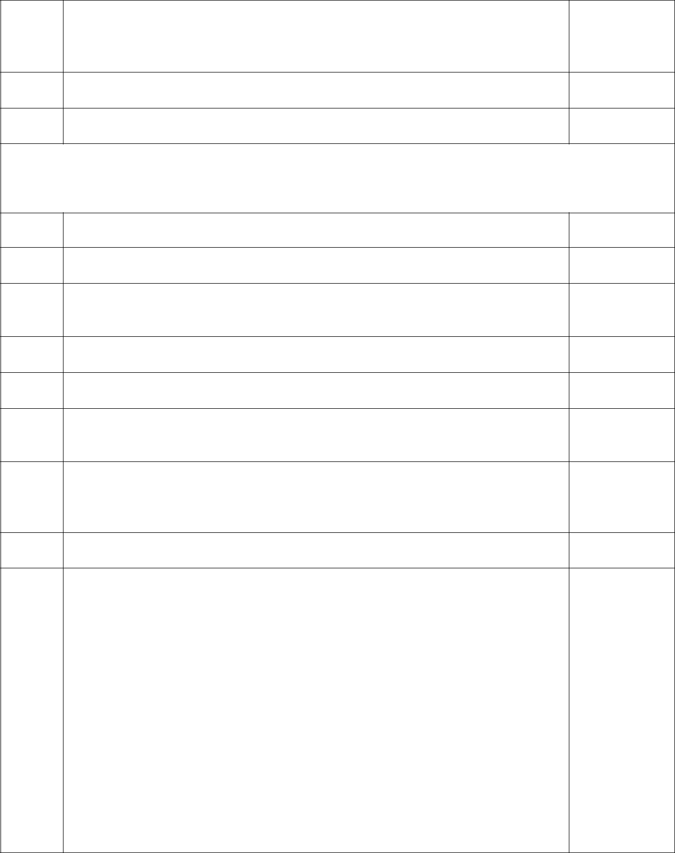
Step 3b: Coaching

Tools: Coaching/Fidelity Checklist (option 1 or Option 2), Fidelity Development Guide

- Prepare a Coaching/Fidelity Checklist/Measure for each intervention

- Provide the teacher and other intervention agents with a copy of the checklist/measure
- Review each step of the interventions with the teacher. Review/training can be through discussion and/or Q & A. If the teacher is willing, role play implementing the interventions

- For each step on the Coaching/Fidelity Checklist, record whether the teacher could or could not role play or describe the behavior.
- If there are any steps not performed or described accurately, provide additional review/activities for practice.
- If the teacher appears comfortable with the interventions and showed competent performance on most of the plan (e.g., 80% or more), schedule first date of implementation with the student.

- Determine with the teacher if the student needs to be trained to do the intervention. If yes, ask the teacher who would be best to train the student— you or the teacher. If the teacher will be training the student, try to be present or have someone from the team be present, if possible.

- Ask the teacher if you should model the intervention with the student prior to the teacher implementing it.
- If the teacher appeared to have difficulties performing the behaviors required to do the interventions during your coaching/training session (e.g., scored less than 80%):
  - Ask the teacher if the interventions need to be modified so that they can be implemented accurately.
  - If the teacher cannot implement the intervention, go back to the interventions selected/rank ordered and select another intervention from the appropriate category as a replacement. Schedule another time to train the teacher in the new intervention (if applicable).

  - At times, you may decide to go ahead and have the teacher try to implement the intervention in the classroom with the student and determine after that time if modifications or changes need to be made. (Teachers may not be comfortable with role-playing or they may do better with the student when it is the “real” performance).

8
Check |  |  | Step | Comments
or N/A
 | 10. | Determine how fidelity will be measured. If self-assessment will be the method,
 |  | determine the frequency of the teacher completing a self-assessment of
 |  | implementation.
 | 11. | If applicable, schedule one observation for fidelity. If the teacher is
 |  | implementing with adequacy (e.g., 80%), self-assessments can be completed
 |  | by the teacher. .
 | 12. | If the teacher is having difficulties implementing the interventions, one or more
 |  | of the following can occur:
 |  | • | Review the performance with the teacher and ask for their input on the
 |  |  | features of the intervention that make it difficult for them to implement
 |  | • | Ask the teacher if they wish to modify the intervention to make it
 |  |  | easier for implementation or if they wish to replace the intervention.
 |  | • | Schedule another fidelity observation
 | 13. | Schedule due dates/method for receiving fidelity self-assessments and IBRST
 |  | recordings. Upon review of the documents, ensure that the teacher is
 |  | implementing with fidelity and that the student is making the desired behavior
 |  | changes (trend line is going in the desired direction).
 | 14. | Additional observations can be conducted if the teacher appears to be
 |  | implementing with low fidelity and/or the student is not changing in the desired
 |  | direction.
MEETING | 3 or 4
Step 4: Evaluation
Tools: Individualized Behavior Rating Scales, Graphs (optional), Fidelity Scores,
Social Validity Scale, Teacher/Consultant Alliance Scale (Optional)
 | 1. | Review all data including implementation fidelity, Behavior Rating Scales, and
 |  | Graphs.
 |  | a. | If desired, Excel graphs can be created with the IBRST data. If
 |  |  | graphs are not made, ensure that the points on the Behavior Rating
 |  |  | Scale are connected and that a vertical line is drawn on the date
 |  |  | showing when the intervention began.
 | 2. | Determine decision rules for:
 |  | a. | Adequate fidelity score
 |  | b. | Adequate behavior change
 | 3. | Discuss with the team the impact of the intervention.
 | 4. | If the student is improving, determine the next steps. Possible actions can
 |  | include:
 |  | a. | Expanding/generalizing the intervention: If the teacher is
 |  |  | implementing the intervention in one routine, other routines can be
 |  |  | selected. Or if the intervention may be implemented in a new setting
 |  |  | or by a different person. If the intervention is generalized, determine if
 |  |  | new people will be implementing the intervention and the training
 |  |  | needs.
 |  | b. | Parts of the intervention may be faded (e.g., the schedule of
 |  |  | reinforcement, the amount of prompting, moving to student self-
 |  |  | management). If fading is indicated, this should be done in a
 |  |  | systematic fashion.
 |  |  |  | 9

  - New goals can be established. (e.g., IBRST measures for each rating on 5 point scale can be adjusted to raise the bar or another behavior can be targeted for intervention).
- If the student is not improving, determine first if the intervention has been implemented with fidelity (fidelity scores). If yes, the following options can be considered:

  - The hypothesis may be incorrect. If this is suspected, decide if more data are needed or if the interventions need to be adjusted to fit a revised hypothesis.
  - If more data are needed, determine the method in which it will be collected (e.g., another group interview, observations, etc.)

  - If a new hypothesis is generated, go back to Step 3 and repeat through Step 5.

- If social validity is desired, ask teacher to complete social validity scale.

- Schedule another follow-up meeting to review plan extensions/generalization or new plan.


YOU DID IT!!!!! PAT YOURSELF ON THE BACK!

10
Step 1: Broad Goal-Setting

Goals for: ____________________________
 | (Student’s Name)
Behavioral | Social | Academic


Broad Goals

Short-Term Goals

Short-Term Goals

PTR Form 3b

11
Step 1: Simplified Goal Setting—Version 2 Modified

____________________________

(Student’s Name)

Behavior


Decrease

Increase

12
 |  | Step 1: Structured Goal Setting
 | Student Name: __________________________________
 | BEHAVIORS TO DECREASE
 | Target Behavior: |  |  | Operational Definition:
BEHAVIORS TO INCREASE

 | Target Behavior: |  |  | Operational Definition:

13
Step 1: Structured Goal Setting (Version 3)

Student Name:

Directions: In the left column, list between ONE to THREE behaviors you wish to see less of and more of from the student.


Behaviors to DECREASE (see less)
Target Behavior | Definition (clear and observable)
1.

2.

3.

Behaviors to INCREASE (see more) | Definition (clear and observable)

1.

2.

3.

14

Step 1: Goal Setting

Student Version

- What is your dream? What do you want to be doing 3-5 years from now?

- What could help you reach your dream? What could school, family, or other people do and what could you do? What opportunities are already available that could help?

- What is keeping you from your dream? What are the challenges that are making it hard? What are some of your fears if you don’t get to reach your dream?

- Choices are very important for everyone. Examples of big choices most people have is the type of work they will do for money, the type of fun activities they do in the evenings and weekends, where and when they go for shopping or fun activities, friends to do things with, etc. Some smaller choices most people have each day is what they wear, the clothes they buy, what they eat for breakfast, lunch, and dinner, etc. What choices do you get to make most days? What choices do you wish you could make most days?

- Who are the most important people in your life? They can include people from school, people from your family, friends, girlfriends or boyfriends, people who live in the city or other important people who may live further away? Are there any people you wish could be included as important people?

15
Step 1: Goal Setting-Student Version

Student Name: __________________________________

WHAT BEHAVIORS DO YOU WISH YOU WOULDN’T DO SO MUCH IN SCHOOL?


 | Target Behavior(s): |  |  | Definition:
WHAT BEHAVIORS DO YOU WISH YOU WOULD DO MORE IN SCHOOL? WHAT BEHAVIORS WOULD YOU LIKE TO DO MORE THAT WOULD LET YOU MEET YOUR GOALS?

 | Target Behavior(s): |  |  | Definition:

16
 |  |  |  |  |  |  |  |  |  |  | Step 1: Individualized Behavior Rating Scale Tool (IBRST)
 | Student: |  |  |  |  |  |  |  |  |  |  |  |  |  | School: |  |  |  |  |  |  |  |  |  |  |  |  |  |  |  |  |  |  | Teacher(s):
 | Target Behavior |  |  |  |  | Date
 |  |  |  |  |  |  |  | 5 |  | 5 |  |  | 5 |  | 5 |  | 5 |  |  | 5 |  |  | 5 |  | 5 |  | 5 |  | 5 |  | 5 |  | 5 |  |  | 5 |  | 5 |  |  | 5 |  | 5 |  | 5 |  | 5 |  | 5
 |  |  |  |  |  |  |  | 4 |  | 4 |  |  | 4 |  | 4 |  | 4 |  |  | 4 |  |  | 4 |  | 4 |  | 4 |  | 4 |  | 4 |  | 4 |  |  | 4 |  | 4 |  |  | 4 |  | 4 |  | 4 |  | 4 |  | 4
 |  |  |  |  |  |  |  | 3 |  | 3 |  |  | 3 |  | 3 |  | 3 |  |  | 3 |  |  | 3 |  | 3 |  | 3 |  | 3 |  | 3 |  | 3 |  |  | 3 |  | 3 |  |  | 3 |  | 3 |  | 3 |  | 3 |  | 3
 |  |  |  |  |  |  |  | 2 |  | 2 |  |  | 2 |  | 2 |  | 2 |  |  | 2 |  |  | 2 |  | 2 |  | 2 |  | 2 |  | 2 |  | 2 |  |  | 2 |  | 2 |  |  | 2 |  | 2 |  | 2 |  | 2 |  | 2
 |  |  |  |  |  |  |  | 1 |  | 1 |  |  | 1 |  | 1 |  | 1 |  |  | 1 |  |  | 1 |  | 1 |  | 1 |  | 1 |  | 1 |  | 1 |  |  | 1 |  | 1 |  |  | 1 |  | 1 |  | 1 |  | 1 |  | 1
 |  |  |  |  |  |  |  | 5 |  | 5 |  |  | 5 |  | 5 |  | 5 |  |  | 5 |  |  | 5 |  | 5 |  | 5 |  | 5 |  | 5 |  | 5 |  |  | 5 |  | 5 |  |  | 5 |  | 5 |  | 5 |  | 5 |  | 5
 |  |  |  |  |  |  |  | 4 |  | 4 |  |  | 4 |  | 4 |  | 4 |  |  | 4 |  |  | 4 |  | 4 |  | 4 |  | 4 |  | 4 |  | 4 |  |  | 4 |  | 4 |  |  | 4 |  | 4 |  | 4 |  | 4 |  | 4
 |  |  |  |  |  |  |  | 3 |  | 3 |  |  | 3 |  | 3 |  | 3 |  |  | 3 |  |  | 3 |  | 3 |  | 3 |  | 3 |  | 3 |  | 3 |  |  | 3 |  | 3 |  |  | 3 |  | 3 |  | 3 |  | 3 |  | 3
 |  |  |  |  |  |  |  | 2 |  | 2 |  |  | 2 |  | 2 |  | 2 |  |  | 2 |  |  | 2 |  | 2 |  | 2 |  | 2 |  | 2 |  | 2 |  |  | 2 |  | 2 |  |  | 2 |  | 2 |  | 2 |  | 2 |  | 2
 |  |  |  |  |  |  |  | 1 |  | 1 |  |  | 1 |  | 1 |  | 1 |  |  | 1 |  |  | 1 |  | 1 |  | 1 |  | 1 |  | 1 |  | 1 |  |  | 1 |  | 1 |  |  | 1 |  | 1 |  | 1 |  | 1 |  | 1

KEY:
Problem Behavior |  |  |  | : Definition |  |  |  |  |  |  |  | Time/Routine: |  | All day | Specific Time/Routine:
5 | = Terrible day
4 | = Typical bad day
3 | = So-so day
2 | = Good day
1 | = Fantastic day
Replacement/Alternate Desired Behavior; |  |  |  |  |  |  |  |  |  |  |  | Definition |  | Time/Routine:All day |  | Specific Time/Routine:
5 | = Fantastic day
4 | = Good day
3 | = So-so day
2 | = Typical bad day
1 | = Terrible day
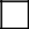

17
Step`1: Guiding Questions to Set Up the Individualized Behavior Rating Scale Tool

After your team reaches consensus on the top 2-5 goals of intervention, you are ready to set up the behavior rating scale for them to use each day. The following questions will help you in guiding the team to determine the anchors for each behavior.

Prior to setting up the IBRST, ensure that you have done the following two activities:

- Clearly defined a minimum of one problem behavior to be decreased and one appropriate behavior to be increased. If your team identified more than 5 behaviors to be targeted, guide them to prioritize one or two behaviors to be targeted for the interventions.

- Attempt to find out whether the team will be interested in tracking behavior occurrence throughout the entire school day, by problematic routine, by period/subject, etc. Some teachers and paraprofessionals will be overwhelmed and may just want to concentrate on a routine in which the behavior occurs (or does not occur) on a consistent basis.

Guiding Questions for EACH behavior that will be targeted:

If the behavior is one that the child may not have the same number of opportunities to perform each day (e.g., initiate social interactions appropriately, communicate the need to chill out), consider using %age of time.

- Starting with the top ranked problem behavior, determine the appropriate metric (frequency, duration, intensity, latency) by asking the following questions:

  - What concerns you the most about the problem behavior (e.g., hitting, kicking, screaming, yelling out, throwing pencil down, etc.)? Is it (how often, how many times, the number of behavioral episodes), etc.? Or is it how long the behavior or behavioral episode lasts? Or is it how strong or intense the behavior or behavioral episode is?
    - (Only ask the following question if the behavior of concern is related to following instructions or starting work when requested) Or is it how long it takes before the student engages in the requested behavior?

- Once you have established the metric, you can now ask them questions to help set up the 5-point Likert scale. For problem behaviors, ask the following questions related to the time period over which the team stated they would track the behavior (e.g., whole day, routine specific, time specific, activity specific, etc.):

Frequency metric questions
  - Think back over the last month. What would you consider to be a typical bad day? How many times would you estimate that (the student) (specific behavior) during the (day or specific routine)?

    - The response provided can be set at Rating 4.
  - Then a terrible day would be more than X times (put in the top number team suggested in “a.”.
    - The response can be set at Anchor 5.
  - What would be a fantastic day for (the student)? How many times would you like to see the behavior occur to consider it a fantastic day?

    - The response can be set at Anchor 1
  - What would be a good day?
    - The response would be set at Anchor 2
  - What would be a so-so day (not good but not really bad)?
    - The response would be set at Anchor 3.

Duration, intensity, latency metrics

To set the anchors for other metrics, you repeat the same procedures above and substitute the appropriate metric word (e.g., duration—how long the behavior lasts, the amount of time the child does the behavior in one episode; intensity—how hard, loud, far, etc. does the child do the behavior).

Appropriate behavior

18
Your team has a choice. Because the behavior rating scale allows a team to graph the data points, it makes the most sense for problem behaviors to decrease (line trend goes down) and appropriate behaviors to increase (line goes up). If your team prefers this traditional method of graphing behavior, you would use the same guiding questions for appropriate behavior anchors and “flip” the order of the anchors. That is, the typical bad day for an appropriate behavior would be set at anchor ‘2’ rather than 4, the terrible day would be ‘1’ rather than ‘5’, the fantastic day would be ‘5’ rather than ‘1’, and the good day would be a ‘4’ rather than a ‘2’. The constant would be the ‘3’ (a so-so day).

The other option would be to keep the scales consistent. That is, the 5, 4, 3, 2, and 1 ratings would indicate the same types of day. For example, a 5 would be a terrible day for both problem and appropriate behavior.

Other tips:

- The anchors do not have to be even (same # of data points within each anchor). For example, you can have a team say that on a typical or average day, the behavior occurs about 8 or 9 times (anchor 4), a really bad day is more than 10 times (anchor 5), a really good day (goal-anchor 1) is 0-1 times, an okay day (anchor 3) is 5-6 times, and an almost good day (anchor 2) is about 3 or 4 times. Your goal here is to set up the scale in a format that will allow the teacher to use the entire scale in recording the occurrence and nonoccurrence of behavior. If you prefer to have every possible number included, you can use ranges (e.g., in the above example, 2 times isn’t represented. You can increase the range for anchor 1 to 0-2 times or you could increase the range for anchor 2 to 2-4 times. If you will be doing this, always ask the team what would be most accurate for them when recording the behaviors.
- Each behavior can have a different metric. That is, your team may have 2 or 3 behaviors they are targeting. One could be frequency, one could be duration, and another could be percentage of time or some other metric. This is determined by the behavior and the responses to the guiding questions.

- Occasionally, you may have a team who is concerned about 2 different metrics for the same behavior. For example, a team may be concerned by both how often a child hits and its intensity. If the team would like to track both metrics, you would have one row of the Behavior Rating Scale be Hitting-frequency and one row Hitting-duration.

Training the teacher

The easiest and best way to train the teacher to use the IBRST is to ask them to use it immediately after development. If your meeting is at the beginning of the school day, once the IBRST is developed, say, “Let’s test this out. Think about the student’s behavior yesterday. What would you rate (problem behavior #1) for yesterday?” After the teacher gives the response, ask them “why did you select that rating?” If it appears that the teacher is comfortable with how to rate the behavior and they seem to understand how to use the tool, repeat the practice for all other behaviors on the IBRST.

19
Student ________________ Responder __________________ Behavior _____________

Step 2: PTR Functional Behavior Assessment-Elementary

Directions:

- The following PTR Functional Behavior Assessment is comprised of three sections, Prevent, Teach, and Reinforce, and is 4-pages in length.

- Complete one PTR Functional Behavior Assessment for each problem behavior targeted on the Behavior Rating Scale. For example, if both ‘hitting others’ and ‘screaming’ are listed on the BRS, two PTR Functional Behavior Assessments will be completed.
- Do not complete the assessment on any prosocial/desired behaviors targeted on the Behavior Rating Scale
- List the problem behavior on the top of each assessment form to ensure responses are given for that behavior only.
- Answer each question by checking all the appropriate areas that apply, or by writing the response(s) that best describe events related to the problem behavior specified.
Student ________________ Responder __________________ Behavior ___________________

PTR Functional Behavior Assessment: Prevent Component

1a. Are there times of the school day when problem behavior is most likely to occur? If yes, what are they?


___ Morning ___ Afternoon

___ Before meals

___ During meals

___ After meals

___ Arrival ___ Dismissal

Other:_________________________________________________________________________

1b. Are there times of the school day when problem behavior is very unlikely to occur? If yes, what are they?

___ Morning ___ Afternoon

___ Before meals

___ During meals

___ After meals

___ Arrival ___ Dismissal

Other: ___________________________________________________________________________

2a. Are there specific activities when problem behavior is very likely to occur? If yes, what are they?

___ Reading/LA | ___ Writing | ___ Math | ___ Science
___ Independent work | ___ Small group work | ___ Large group work | ___ Riding the bus
___ One-on-one | ___ Computer | ___ Recess | ___ Lunch
___ Free time | ___ Peer/cooperative | ___ Centers | ___ Discussions/Q&A
___ Worksheets, | work | ___ Specials (specify) | ___ Transitions (specify)
seatwork |  | ____________ | ________________

Other: ____________________________________________________________________________

2b. Are there specific activities in which problem behavior is very unlikely to occur? What are they?

___ Reading/LA | ___ Writing | ___ Math | ___ Science
___ Independent work | ___ Small group work | ___ Large group work | ___ Riding the bus
___ One-on-one | ___ Computer | ___ Recess | ___ Lunch
___ Free time | ___ Peer/cooperative | ___ Centers | ___ Discussions/Q&A
___ Worksheets, | work | ___ Specials (specify) | ___ Transitions (specify)
seatwork |  | ____________ | ________________

Other: _______________________________________________________________________________

3a. Are there specific classmates or adults whose proximity is associated with a high likelihood of problem behavior? If so, who are they?

___ Peers |  | Specify:______________________ | ___ Bus driver
___ Teacher(s) |  | Specify: ______________________ | ___ | Parent
___ | Paraprofessional(s) | Specify: ______________________ | ___ | Other family member
___ | Other school staff | Specify_______________________ | (Specify)_______________

Other: _______________________________________________________________________________

3b. Are there specific classmates or adults whose proximity is associated with a high likelihood of problem behavior not being exhibited? If so, who are they?

21

Student ________________ | Responder __________________ Behavior ___________________
___ Peers | Specify:______________________ | ___ Bus driver
___ Teacher(s) | Specify: ______________________ | ___ Parent
___ Paraprofessional(s) | Specify: ______________________ | ___ Other family member (Specify)
___ Other school staff | Specify: ______________________ | __________________________
Other: _______________________________________________________________________________


- Are there specific circumstances in which the problem behavior is very likely to occur? Please indicate the top 3-5 circumstances that are the most likely to trigger the problem behavior.

___ Request to start task | ___ Task too difficult | ___ Transition | ___ Student is alone
___ Being told work is wrong | ___ Task too long | ___ End of preferred | ___ Unstructured time
___ Reprimand or correction | ___ Task is boring | activity | ___ ‘Down’ time (no
___ Told “no” | ___ Task is repetitive | ___ Removal of | task specified)
___ Seated near specific peer | (same task daily) | preferred item | ___ Teacher is attending
___ Peer teasing or comments | ___ Novel task | ___ Start of non- | to other students
___ Change in schedule |  | preferred activity

Other: _________________________________________________________________________________

If the problem behavior happens most often during academic time/work, does the student have the skills to do
the work being requested? Yes No
- Are there specific circumstances in which the problem behavior is very unlikely to occur?

- Are there conditions in the physical environment that are associated with a high likelihood of problem behavior? For example, too warm or too cold, too crowded, too much noise, too chaotic, weather conditions….

___ Yes (specify) ___________________________________________________________________

___ No

- Are there circumstances unrelated to the school setting that occur on some days but not on other days that may make problem behavior more likely?

___ | Illness | ___ No medication |  | ___ Drug/alcohol abuse |  | ___ Home conflict
___ | Allergies | ___ | Change in medication | ___ | Bus conflict | ___ | Sleep deprivation
___ Physical condition |  | ___ Hunger |  | ___ Fatigue |  | ___ | Stayed with non-
___ | Hormones or | ___ | Parties or social event | ___ | Change in routine |  | custodial parent
 | menstrual cycle | ___ | Change in diet | ___ | Parent not home

Other:__________________________________________________________________________________

Additional comments not addressed above in the Prevent Component.

22
Student ________________ Responder __________________ Behavior ___________________

PTR Functional Behavior Assessment: Teach Component

1. Does the (problem behavior) seem to be exhibited in order to gain attention from peers?
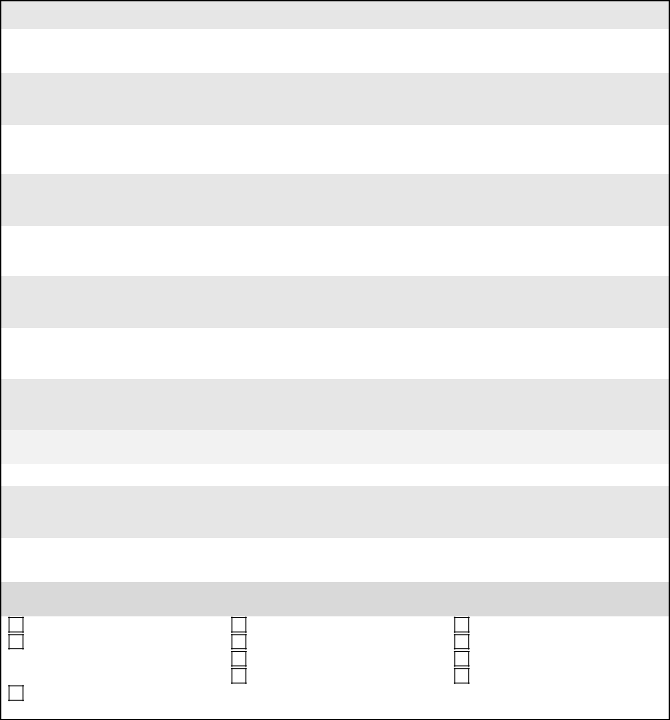

___ Yes List the specific peers: _____________________________________________________

___ No

- Does the (problem behavior) seem to be exhibited in order to gain attention from adults? If so, are there particular adults whose attention is solicited?

___ Yes List the specific adults: _____________________________________________________

___ No

- Does the (problem behavior) seem to be exhibited in order to obtain items or preferred activities (games, electronics, materials, food) from peers or adults?

___ Yes List the specific objects: _____________________________________________________

___ No

- Does the (problem behavior) seem to be exhibited in order to avoid or delay a transition from a preferred activity to a non-preferred activity?

___ Yes List the specific transitions:___________________________________________________

___ No

- Does the (problem behavior) seem to be exhibited in order to avoid or delay a non-preferred (difficult, boring, repetitive) task or activity?

___ Yes List the specific non-preferred tasks or activities__________________________________

___ No

- Does the (problem behavior) seem to be exhibited in order to get away from a non-preferred classmate or adult?

___ Yes List the specific peers or adults________________________________________________

___ No

- What behaviors could the student be taught to do that would help meet academic goals? Select 3-5 behaviors that would academically enable the student to participate and meet academic goals.
Recognize the need for help | Make positive comments | Learning strategies
Socially engage (e.g., working | Organizational strategies | Time management
cooperatively with peers, | Ask for help | Attend school regularly
cooperate) | Self-regulation (controls | Appropriately communicate
Participate, persist, and be | temper, obeys rules, copes with | needs
engaged | stress and anxiety)

23
Student ________________ Responder __________________ Behavior ___________________

Additional comments not addressed above in the Teach Component.


24
Student ________________ Responder __________________ Behavior ___________________

PTR Functional Behavior Assessment: Reinforce Component

- What responses (consequences) typically occur after the student engages in the problem behavior?

Identify the top 3-5 responses that adults or peers almost always do immediately after the student does the problem behavior.


___ Sent to time-out | ___ Gave personal space | ___ Verbal reprimand
___ Chair time-out | ___ Sent to behavior specialist/counselor | ___ Stated rules
___ Head down | ___ Assistance given | ___ Physical prompt
___ Sent to office | ___ Verbal redirect | ___ Peer reaction
___ Sent home | ___ Delay in activity | ___ Physical restraint
___ Calming/soothing | ___ Activity changed | ___ Removal of reinforcers
 | ___ Activity terminated | ___ Natural consequences (Specify)
 |  | ___________________

Other:______________________________________________________________________________

- Does the student enjoy praise from teachers and other school staff? Does the student enjoy praise from some teachers more than others?

___ Yes List specific people ________________________________________________________________
___ _{No}

- What is the likelihood of the student’s appropriate behavior (e.g., on-task behavior; cooperation; successful performance) resulting in acknowledgment or praise from teachers or other school staff?

___ Very likely ___ Sometimes ___ Seldom ___ Never

- What is the likelihood of the student’s problem behavior resulting in acknowledgment (e.g., reprimands, corrections) from teachers or other school staff?

___ Very likely ___ Sometimes ___ Seldom ___ Never

- What school-related items and activities are most enjoyable to the student? What items or activities could serve as special rewards?

___ Social interaction with adults | ___ Music | ___ Art activity
___ Social interaction with peers | ___ Puzzles | ___ Computer
___ Playing a game | ___ Going outside | ___ Video games
___ Helping teacher | ___ Going for a walk | ___ Watching TV/video
___ Line leader | ___ Reading | ___ _{Objects (Specify}) ___________________
___ Going to media center | ___ Extra PE time | __________________________________
___ Sensory activity (specify⁾ | ___ Extra free time | ___ Food (Specify) _____________________
____________________ |  | __________________________________

Other(s):_______________________________________________________________________________

Additional comments not addressed above in the Reinforce Component.

25
Student ________________ Responder __________________ Behavior ___________________

Step 2: PTR Functional Behavior Assessment/Secondary Multiple teachers-Prevent

Component

1a. Are there times of the period/class when (problem behavior) is most likely to occur? If yes, what are they?
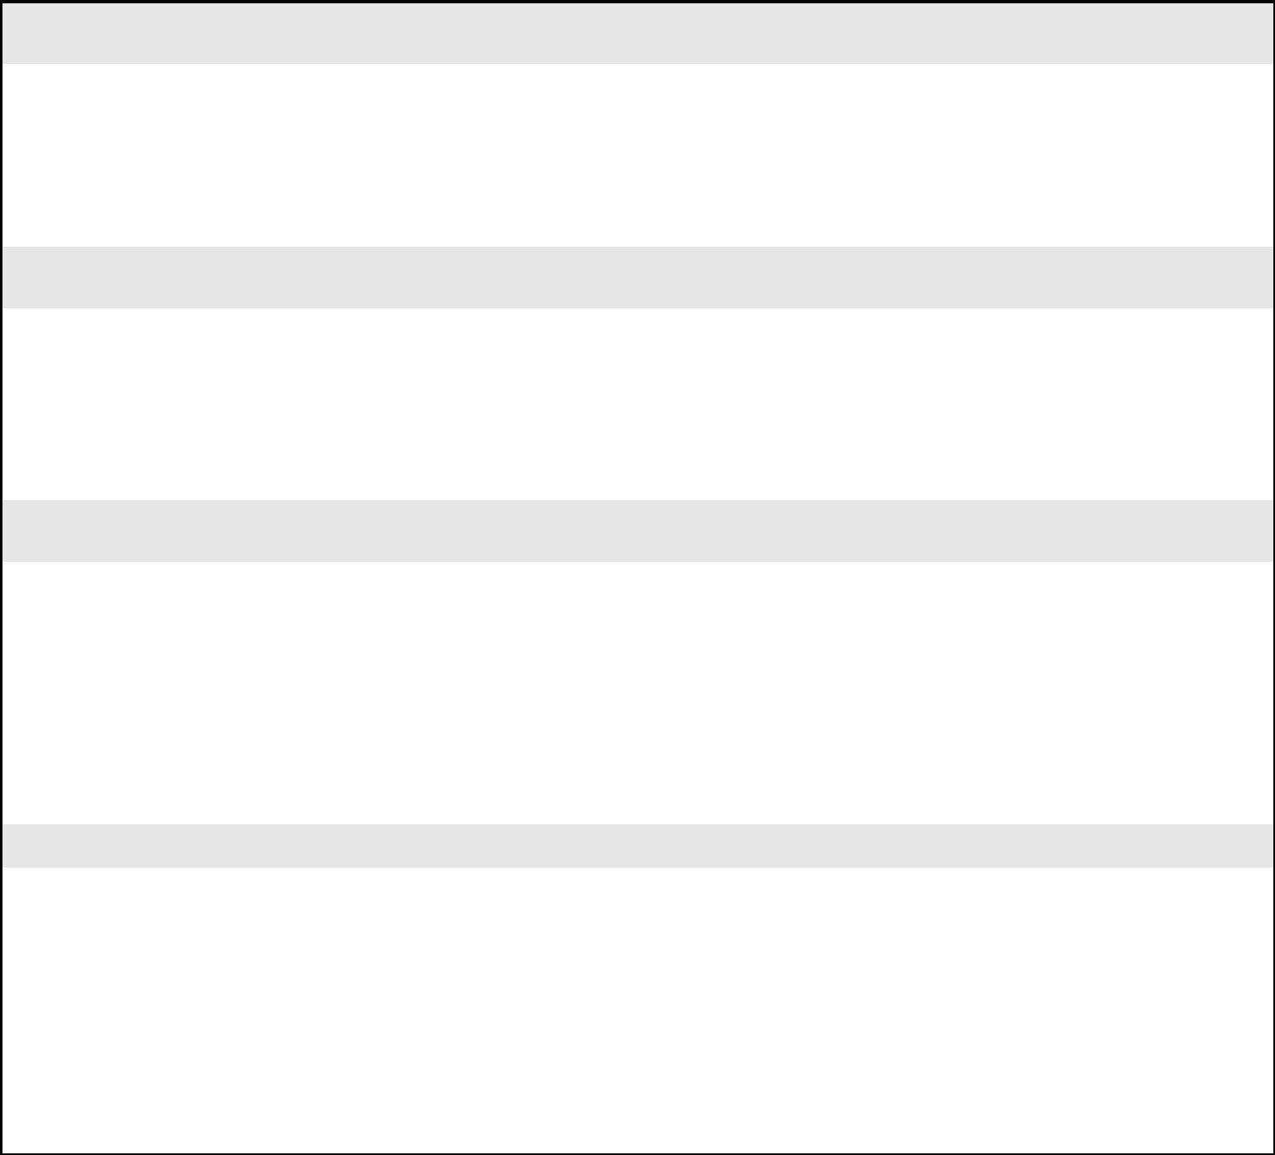

___ Upon entry into the class |  | ____ Last half of the class
___ | Beginning of the class | ____ End of class/Dismissal
___ | Midpoint of the class

Other:_________________________________________________________________________

1b. Are there times of the period/class when (problem behavior) is least likely to occur? If yes, what are they?

___ Upon entry into the class |  | ____ Last half of the class
___ | Beginning of the class | ____ End of class/Dismissal
___ | Midpoint of the class

Other: ___________________________________________________________________________

2a. Are there specific activities within the class/subject when (problem behavior) is very likely to occur? If yes, what are they?
___ | Large group | ___ Writing tasks | ___ Hands-on tasks
 | Work | ___ Small group | ___ Discussions/Q&A
___ | Independent work | work | ___ Other (specify)
___ One-on-one |  | ___ Computer | ___ Peer or
___ | Free time | ___ During | cooperative
 |  | announcements | work

Other: ____________________________________________________________________________

2b. Are there specific activities or subjects when (problem behavior) is very unlikely to occur? What are they?

___ | Large group | ___ Writing tasks | ___ Hands-on tasks
 | Work | ___ Small group | ___ Discussions/Q&A
___ | Independent work | work | ___ Other (specify)
___ One-on-one |  | ___ Computer | ___ Peer or
___ | Free time | ___ During | cooperative
 |  | announcements | work

Other: _______________________________________________________________________________

26
Student ________________ Responder __________________ Behavior ___________________

3a. Are there specific classmates or adults whose proximity is associated with a high likelihood of (problem behavior)? If so, who are they?

___ Peers | Specify:______________________ | ___ Bus driver
___ Teacher(s) | Specify: ______________________ | ___ Parent
___ Paraprofessional(s) | Specify: ______________________ | ___ Other family member
___ Other school staff | Specify_______________________ | (Specify)_______________
 |  | ____ Other person (specify)
 |  | _______________________
3b. Are there specific classmates or adults whose proximity is associated with a high likelihood of (problem behavior) not being exhibited? If so, who are they?

___ Peers | Specify:______________________ | ___ Bus driver
___ Teacher(s) | Specify: ______________________ | ___ Parent
___ Paraprofessional(s) | Specify: ______________________ | ___ Other family member (Specify)
___ Other school staff | Specify: ______________________ | __________________________
 |  | ___ Other person (specify)
 |  | ______________________________

4. Are there specific circumstances that are associated with a high likelihood of (problem behavior)?

___ Request to start work | ___ Task too difficult | ___ Transition | ___ Student is alone
___ Telling student work is | ___ Task too long | ___ End of preferred | ___ Unstructured time
wrong | ___ Task is boring | activity | ___ ‘Down’ time (no
___ Reprimanding or correcting | ___ Task is repetitive | ___ Removal of | task specified)
___ Told “no” | (same task daily) | preferred item | ___ Teacher is attending
___ Seated near specific peer | ___ Novel task | ___ Start of non- | to other students
___ Peer teasing or comments |  | preferred activity
___ Change in schedule

Other: _________________________________________________________________________________

If academic demands are associated with (problem behavior)s, does the student possess the skills to engage in the academic activity without assistance?

____________________________________________________________________________

- Are there specific circumstances in which (problem behavior) is very unlikely to occur? Please specify.

- Are there conditions in the physical environment that are associated with a high likelihood of (problem behavior)? For example, too warm or too cold, too crowded, too much noise, too chaotic, weather conditions….

___ Yes (specify) ___________________________________________________________________

___ No

27
Student ________________ Responder __________________ Behavior ___________________

- Are there circumstances unrelated to the school setting that occur on some days and not on other days that may make (problem behavior) more likely?

___ | Illness | ___ No medication |  | ___ Drug/alcohol abuse |  | ___ Home conflict
___ | Allergies | ___ | Change in medication | ___ | Bus conflict | ___ | Stayed with non-
___ | Physical condition | ___ | Hunger | ___ | Fatigue |  | custodial parent
___ | Hormones or | ___ | Parties or social event | ___ | Change in routine | ___ | Conflict with
 | menstrual cycle | ___ | Change in diet | ___ | Parent not home |  | parents
 |  |  |  | ___ | Conflict with | ___ | Conflict with
 |  |  |  |  | girlfriend or |  | friends
boyfriend
Other: _____________________________________________________________________________________

Additional comments not addressed above in the Prevent Component.

28
Student ________________ Responder __________________ Behavior ___________________

PTR Functional Behavior Assessment Secondary: Teach Component

1. Does the (problem behavior) seem to be exhibited in order to gain attention from peers?
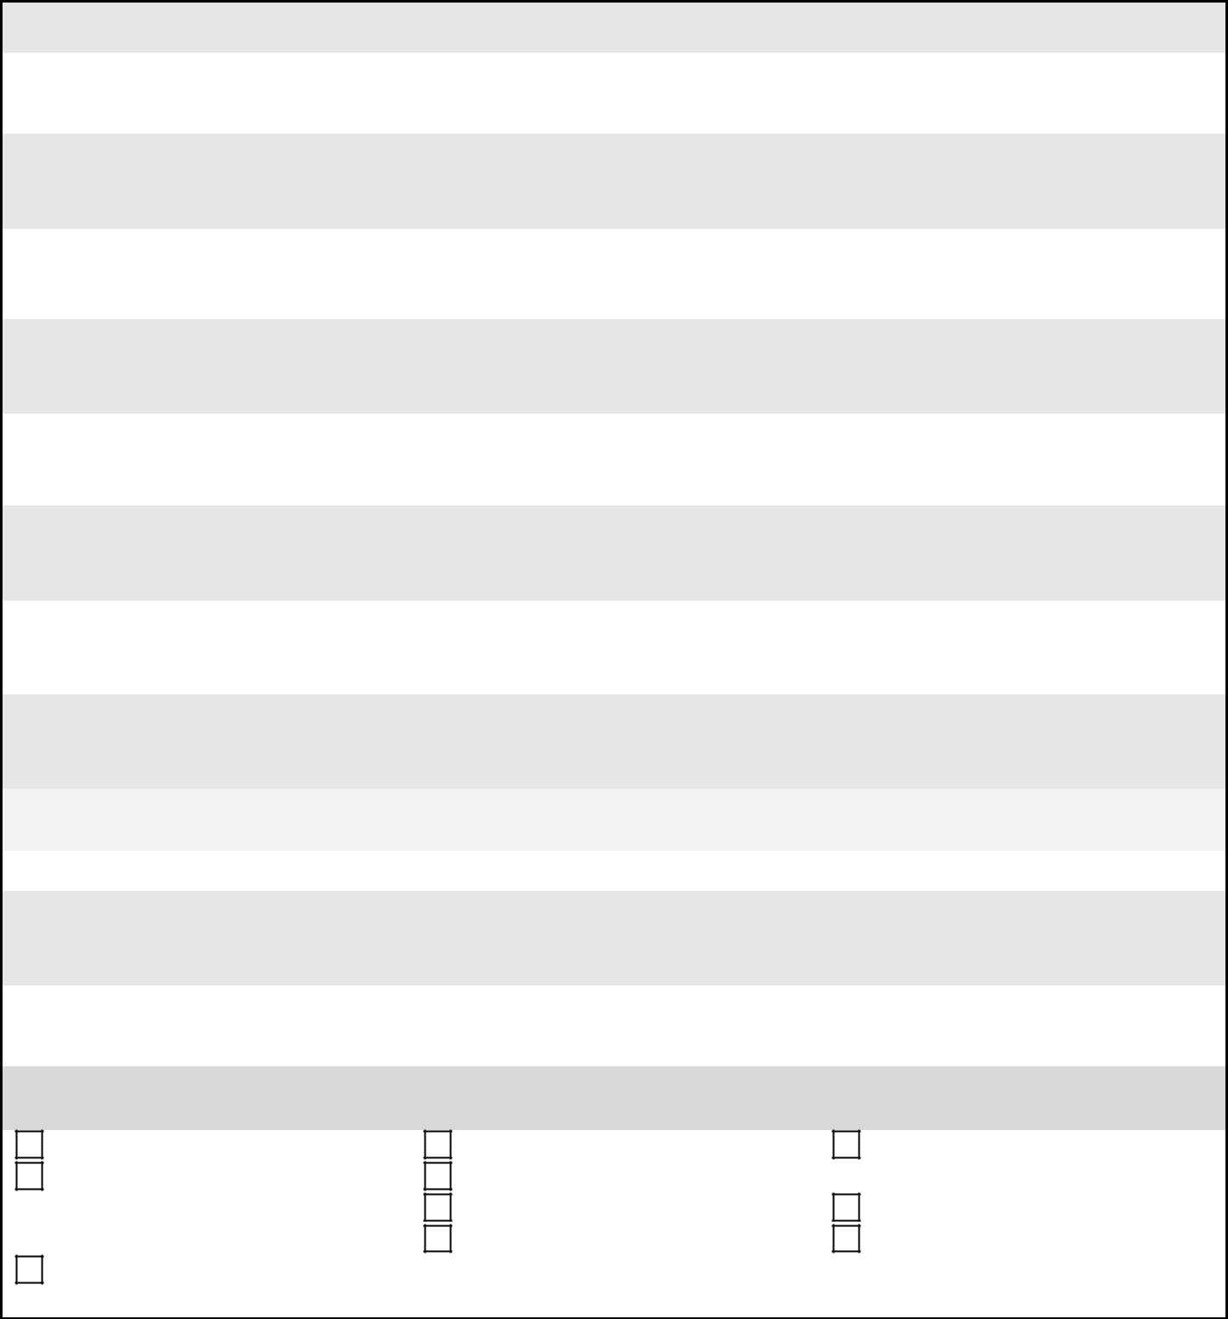

___ Yes List the specific peers: _____________________________________________________

___ No

- Does the (problem behavior) seem to be exhibited in order to gain attention from adults? If so, are there particular adults whose attention is solicited?

___ Yes List the specific adults: _____________________________________________________

___ No

- Does the (problem behavior) seem to be exhibited in order to obtain items or preferred activities (games, electronics, materials, food) from peers or adults?

___ Yes List the specific objects: _____________________________________________________

___ No

- Does the (problem behavior) seem to be exhibited in order to avoid or delay a transition from a preferred activity to a non-preferred activity?

___ Yes List the specific transitions:___________________________________________________

___ No

- Does the (problem behavior) seem to be exhibited in order to avoid or delay a non-preferred (difficult, boring, repetitive) task or activity?

___ Yes List the specific non-preferred tasks or activities__________________________________

___ No

- Does the (problem behavior) seem to be exhibited in order to get away from a non-preferred classmate or adult?

___ Yes List the specific peers or adults________________________________________________

___ No

- What behaviors could the student be taught to do that would help meet academic goals? Select 3-5 behaviors that would academically enable the student to participate and meet academic goals.
Study skills | Homework completion | Work productively (complete
Socially engage (e.g., working | Organizational strategies | and turn in assignments)
cooperatively with peers, | Attend class | Time management
cooperate) | Self-regulation (controls | Arrive to class on time
Participate, persist, and be | temper, obeys rules, copes with
engaged | stress)

29
Student ________________ Responder __________________ Behavior ___________________

Additional comments not addressed above in the Teach Component.

30
Student ________________ Responder __________________ Behavior ___________________

PTR Functional Behavior Assessment Secondary: Reinforce Component

- What consequence(s)/responses of others typically happen immediately after the student’s (problem behavior)? Select the top 3-5 that adults and/or peers almost always do immediately after the problem behavior.


___ Sent to time-out | ___ De-escalation (e.g., LSCI or other) | ___ Verbally reprimanded
___ Sent to crisis room | ___ Sent to behavior specialist/counselor | ___ Verbally redirected
___ Asked to put head | ___ Assistance given | ___ Stated rules
down | ___ Allowed to delay activity | ___ Physically prompted
___ Sent to office/ODR | ___ Changed the activity | ___ Peers react (laugh, make
___ ISS | ___ Ended the activity | comments)
___ OSS | ___ Calmed/soothed | ___ Physically restrained
___ Ignored |  | ___ Removed reinforcers
 |  | ___ Natural consequences (Specify)
 |  | ___________________
Other:______________________________________________________________________________

- Does the student enjoy praise from teachers and other school staff? Does the student enjoy praise from some teachers more than others?

___ Yes List specific people ________________________________________________________________
___ _{No}

- What is the likelihood of the student’s appropriate behavior (e.g., on-task behavior; cooperation; successful performance) resulting in acknowledgment or praise from teachers or other school staff?

___ Very likely ___ Sometimes ___ Seldom ___ Never

- What is the likelihood of the student’s (problem behavior) resulting in acknowledgment (e.g., reprimands, corrections) from teachers or other school staff?

___ Very likely ___ Sometimes ___ Seldom ___ Never

- What school-related items and activities are most enjoyable to the student? What items or activities could serve as special rewards?

___ Social interaction with adults ___ Social interaction with peers ___ Teacher or office assistant ___ Going to media center ___ Sensory activity (specify⁾

____________________
___ Given leadership opportunities

___ Listening to | ___ Doing art
music | ___ Using the computer
___ Being outside | ___ Video/electronic games/apps
___ Going for a walk | ___ Watching TV/DVD/Movie
___ Reading | ___ _{Objects (Specify}) ___________________
___ Extra PE time | __________________________________
___ Extra free time | ___ Food (Specify) _____________________
 | __________________________________

Other(s):_______________________________________________________________________________

31

Student ________________ Responder __________________ Behavior ___________________

Additional comments not addressed above in the Reinforce Component.


32
Student ________________ Responder __________________ Behavior ___________________

Step 2: PTR Functional Behavior Assessment/ Secondary (One teacher)-Prevent Component

1a. Are there times of the school day when (problem behavior) is most likely to occur? If yes, what are they?
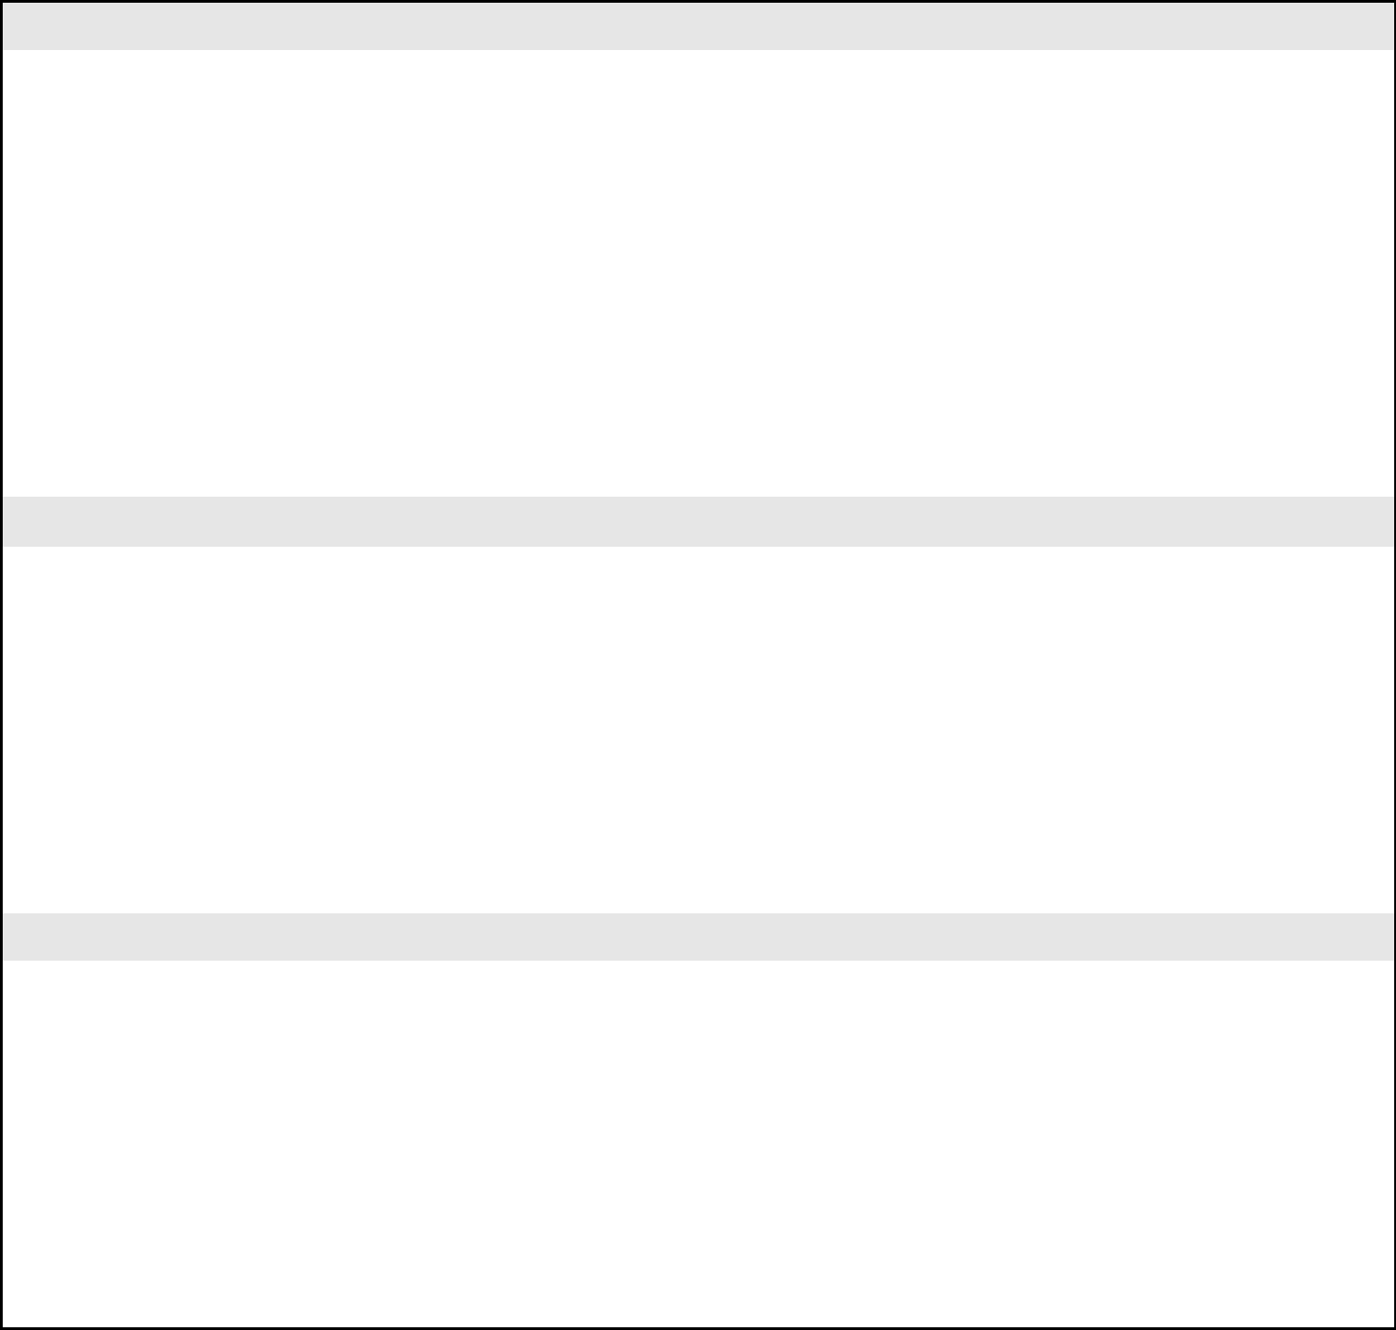
 | ___ Before first class |  | ___ Before |  | ___ During lunch |  | ___ | After | ___ | Arrival Time
 | ___ Morning |  | Lunch |  | ___ Homeroom |  |  | lunch | ___ Dismissal Time
 | ___ Afternoon |  | ___ Between
 |  |  | Classes
 | Other:_________________________________________________________________________
 | 1b. Are there times of the school day when (problem behavior) is least likely to occur? If yes, what are they?
 | ___ | Morning | ___ Before |  | ___ During lunch |  | ___ | After | ___ | Arrival
 | ___ | Afternoon | lunch |  |  |  |  | lunch | ___ | Dismissal
 |  |  | ___ Between
classes

Other: ___________________________________________________________________________

2a. Are there specific activities or subjects when (problem behavior) is very likely to occur? If yes, what are they?

___ | Core subjects (specify) | ___ | Writing tasks | ___ Large group | ___ Hands-on tasks
_______________________ |  | ___ Small group |  | Work | ___ On the bus
___ Independent work |  |  | work | ___ At locker | ___ Discussions/Q&A
___ One-on-one |  | ___ Computer |  | ___ After school | ___ Between
___ | Free time | ___ | Peer or | activities (specify) | classes/transitions
___ | Extra-curricular |  | cooperative | ______________ | (specify)
___ During announcements |  |  | work | ___ Electives | ____________________
 |  |  |  | (specify)
 |  |  |  | ________________
Other: ____________________________________________________________________________

2b. Are there specific activities or subjects when (problem behavior) is very unlikely to occur? What are they?

___ Core subjects (specify) | ___ | Writing tasks | ___ Large group | ___ Hands-on tasks
_______________________ | ___ Small group |  | Work | ___ On the bus
___ Independent work |  | work | ___ At locker | ___ Discussions/Q&A
___ One-on-one | ___ Computer |  | ___ After school | ___ Between
___ Free time | ___ | Peer or | activities (specify) | classes/transitions
___ Extra-curricular |  | cooperative | ______________ | (specify)
___ During announcements |  | work | ___ Electives | ____________________
 |  |  | (specify)
 |  |  | ________________
Other: _______________________________________________________________________________

33
Student ________________ Responder __________________ Behavior ___________________

3a. Are there specific classmates or adults whose proximity is associated with a high likelihood of (problem behavior)? If so, who are they?

___ Peers | Specify:______________________ | ___ Bus driver
___ Teacher(s) | Specify: ______________________ | ___ Parent
___ Paraprofessional(s) | Specify: ______________________ | ___ Other family member
___ Other school staff | Specify_______________________ | (Specify)_______________
 |  | ____ Other person (specify)
 |  | _______________________
3b. Are there specific classmates or adults whose proximity is associated with a high likelihood of (problem behavior) not being exhibited? If so, who are they?

___ Peers | Specify:______________________ | ___ Bus driver
___ Teacher(s) | Specify: ______________________ | ___ Parent
___ Paraprofessional(s) | Specify: ______________________ | ___ Other family member (Specify)
___ Other school staff | Specify: ______________________ | __________________________
 |  | ___ Other person (specify)
 |  | ______________________________

4. Are there specific circumstances that are associated with a high likelihood of (problem behavior)?

___ Request to start work | ___ Task too difficult | ___ Transition |  | ___ Student is alone
___ Telling student work is wrong | ___ Task too long | ___ End of preferred |  | ___ Unstructured time
___ Reprimanding or correcting | ___ Task is boring | activity |  | ___ ‘Down’ time (no
___ Told “no” | ___ Task is repetitive | ___ Removal of |  |  | task specified)
___ Seated near specific peer | (same task daily) | preferred item |  | ___ Teacher is attending
___ Peer teasing or comments | ___ Novel task | ___ Start of non- |  |  | to other students
___ Change in schedule |  | preferred activity

Other: _________________________________________________________________________________

If academic demands are associated with (problem behavior)s, does the student possess the skills to engage in the academic activity without assistance? ____________________________________________________________________________

- Are there specific circumstances in which (problem behavior) is very unlikely to occur? Please specify.

- Are there conditions in the physical environment that are associated with a high likelihood of (problem behavior)? For example, too warm or too cold, too crowded, too much noise, too chaotic, weather conditions….

___ Yes (specify) ___________________________________________________________________

___ No

34
Student ________________ Responder __________________ Behavior ___________________

- Are there circumstances unrelated to the school setting that occur on some days and not on other days that may make (problem behavior) more likely?

___ | Illness |  | ___ | No medication | ___ | Drug/alcohol abuse | ___ | Home conflict
___ | Allergies |  | ___ | Change in medication | ___ | Bus conflict | ___ | Stayed with non-
___ | Physical condition |  | ___ | Hunger | ___ | Fatigue |  | custodial parent
___ | Hormones or |  | ___ | Parties or social event | ___ | Change in routine | ___ | Conflict with parents
 | menstrual cycle |  | ___ | Change in diet | ___ | Parent not home | ___ | Conflict with friends
 |  |  |  |  | ___ | Conflict with girlfriend or
 |  |  |  |  |  | boyfriend
Other: _____________________________________________________________________________________

Additional comments not addressed above in the Prevent Component.

35
Student ________________ Responder __________________ Behavior ___________________

PTR Functional Behavior Assessment Secondary: Teach Component

1. Does the (problem behavior) seem to be exhibited in order to gain attention from peers?
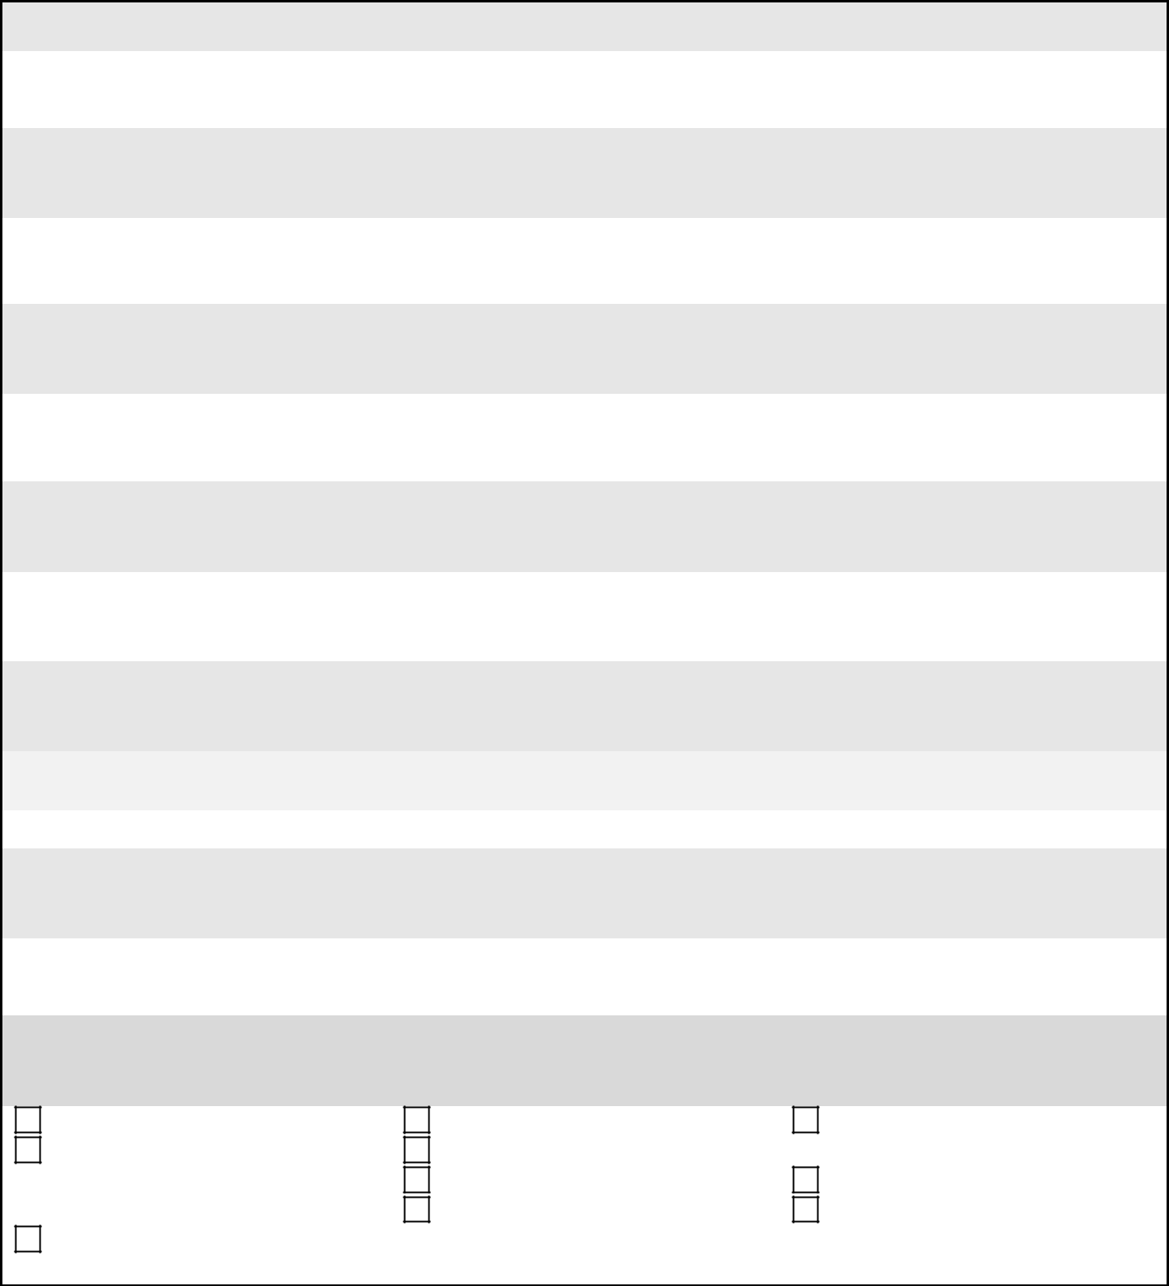

___ Yes List the specific peers: _____________________________________________________

___ No

- Does the (problem behavior) seem to be exhibited in order to gain attention from adults? If so, are there particular adults whose attention is solicited?

___ Yes List the specific adults: _____________________________________________________

___ No

- Does the (problem behavior) seem to be exhibited in order to obtain items or preferred activities (games, electronics, materials, food) from peers or adults?

___ Yes List the specific objects: _____________________________________________________

___ No

- Does the (problem behavior) seem to be exhibited in order to avoid or delay a transition from a preferred activity to a non-preferred activity?

___ Yes List the specific transitions:___________________________________________________

___ No

- Does the (problem behavior) seem to be exhibited in order to avoid or delay a non-preferred (difficult, boring, repetitive) task or activity?

___ Yes List the specific non-preferred tasks or activities__________________________________

___ No

- Does the (problem behavior) seem to be exhibited in order to get away from a non-preferred classmate or adult?

___ Yes List the specific peers or adults________________________________________________

___ No

- What behaviors could the student be taught to do that would help meet academic goals? Select 3-5 behaviors that would academically enable the student to participate and meet academic goals.

Study skills | Homework completion | Work productively (complete
Socially engage (e.g., working | Organizational strategies | and turn in assignments)
cooperatively with peers, | Attend class | Time management
cooperate) | Self-regulation (controls | Arrive to class on time
Participate, persist, and be | temper, obeys rules, copes with
engaged | stress)

36
Student ________________ Responder __________________ Behavior ___________________

Additional comments not addressed above in the Teach Component.

37
Student ________________ Responder __________________ Behavior ___________________

PTR Functional Behavior Assessment Secondary: Reinforce Component

- What consequence(s)/responses of others typically happen immediately after the student’s (problem behavior)? Select the top 3-5 that adults and/or peers almost always do immediately after the problem behavior.

___ Sent to time-out | ___ De-escalation (e.g., LSCI or other) | ___ Verbally reprimanded
___ Sent to crisis room | ___ Sent to behavior specialist/counselor | ___ Verbally redirected
___ Asked to put head | ___ Assistance given | ___ Stated rules
down | ___ Allowed to delay activity | ___ Physically prompted
___ Sent to office/ODR | ___ Changed the activity | ___ Peers react (laugh, make
___ ISS | ___ Ended the activity | comments)
___ OSS | ___ Calmed/soothed | ___ Physically restrained
___ Ignored |  | ___ Removed reinforcers
 |  | ___ Natural consequences (Specify)
 |  | ___________________
Other:______________________________________________________________________________

- Does the student enjoy praise from teachers and other school staff? Does the student enjoy praise from some teachers more than others?

___ Yes List specific people ________________________________________________________________
___ _{No}

- What is the likelihood of the student’s appropriate behavior (e.g., on-task behavior; cooperation; successful performance) resulting in acknowledgment or praise from teachers or other school staff?

___ Very likely ___ Sometimes ___ Seldom ___ Never

- What is the likelihood of the student’s (problem behavior) resulting in acknowledgment (e.g., reprimands, corrections) from teachers or other school staff?

___ Very likely ___ Sometimes ___ Seldom ___ Never

- What school-related items and activities are most enjoyable to the student? What items or activities could serve as special rewards?

___ Social interaction with adults ___ Social interaction with peers ___ Teacher or office assistant ___ Going to media center ___ Sensory activity (specify⁾

____________________

___ Given leadership opportunities

___ Listening to music | ___ Doing art
___ Being outside | ___ Using the computer
___ Going for a walk | ___ Video/electronic games/apps
___ Reading | ___ Watching TV/DVD/Movie
___ Extra PE time | ___ _{Objects (Specify}) ___________________
___ Extra free time | __________________________________
 | ___ Food (Specify) _____________________
 | __________________________________

Other(s):_______________________________________________________________________________

Additional comments not addressed above in the Reinforce Component.

38

Student ________________ Responder __________________ Behavior ___________________

Step 2: PTR FBA/Student Version-Multiple Teachers-Prevent Component

1a. Are there times of the (period/class/subject) when you are most likely to do (problem behavior)? If yes, what are they?
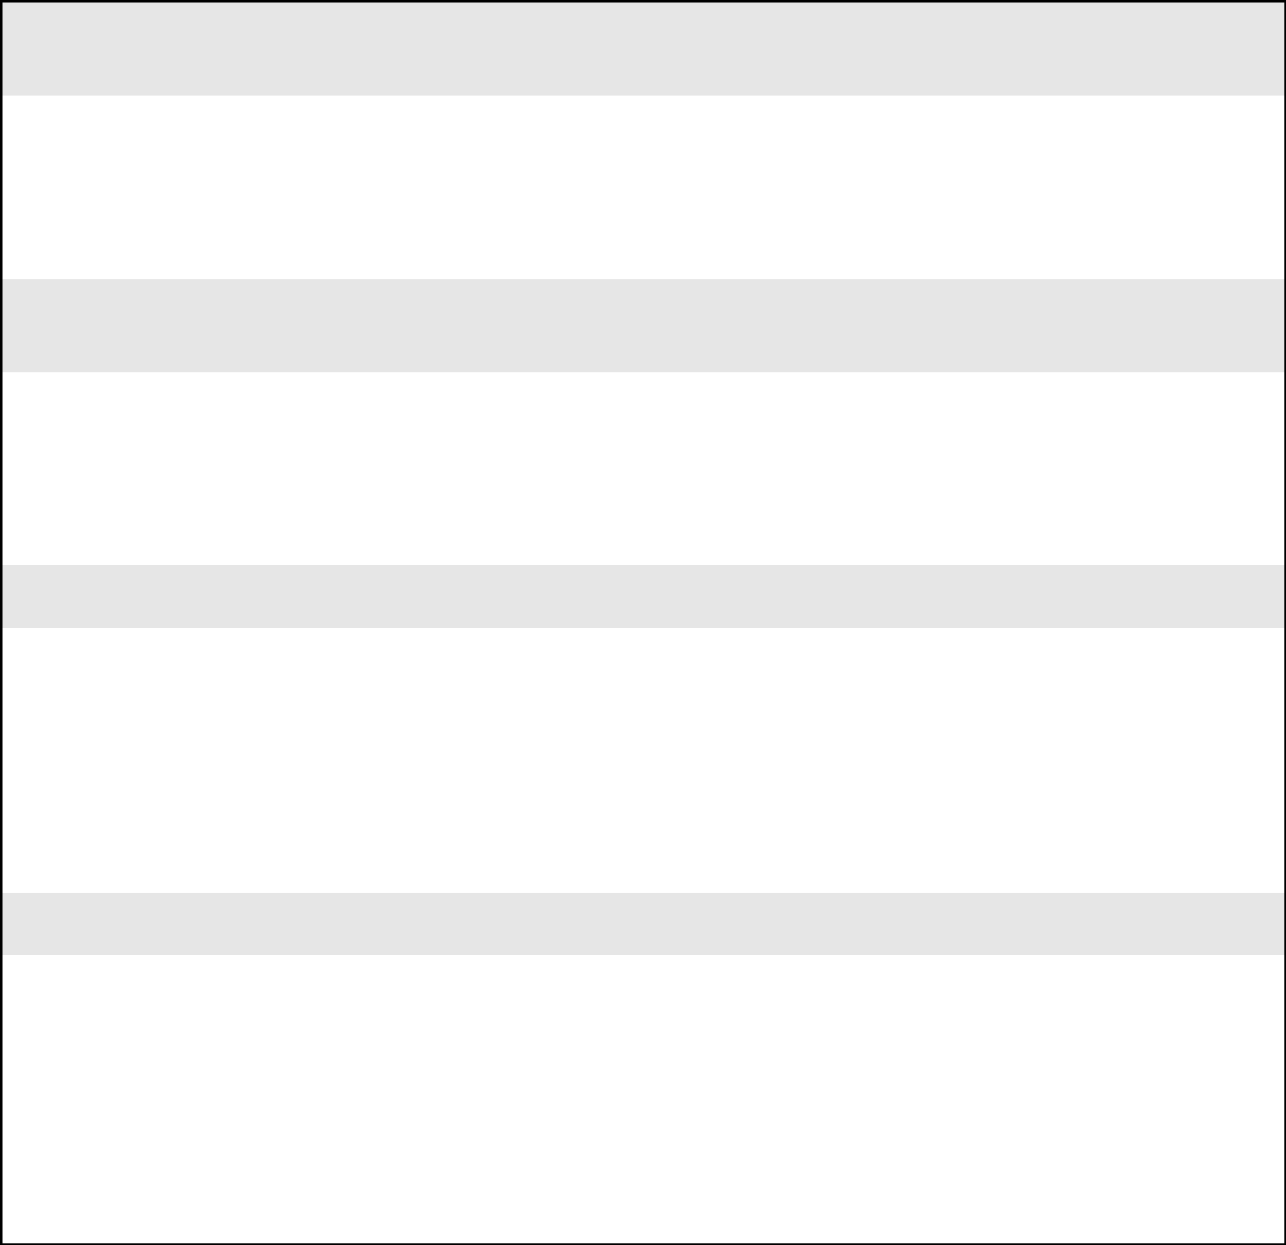
___ Upon entry into the class |  | ____ Last half of the class
___ | Beginning of the class | ____ End of class/Dismissal
___ | Midpoint of the class

Other:_________________________________________________________________________

1b. Are there times of the (period/class/subject) when you are least likely to do (problem behavior)? If yes, what are they?

___ Upon entry into the class |  | ____ Last half of the class
___ | Beginning of the class | ____ End of class/Dismissal
___ | Midpoint of the class

Other: ___________________________________________________________________________

2a. Are there specific activities within the class/subject when you are most likely to do (problem behavior)? If yes, what are they?
___ | Large group | ___ Writing tasks | ___ Hands-on tasks
 | Work | ___ Small group | ___ Discussions/Q&A
___ | Independent work | work | ___ Other (specify)
___ One-on-one |  | ___ Computer | ___ Peer or
___ | Free time | ___ During | cooperative
 |  | announcements | work

Other: ____________________________________________________________________________

2b. Are there specific activities within the class/subject when you are least likely to do ((problem behavior))? What are they?
___ | Large group | ___ Writing tasks | ___ Hands-on tasks
 | Work | ___ Small group | ___ Discussions/Q&A
___ | Independent work | work | ___ Other (specify)
___ One-on-one |  | ___ Computer | ___ Peer or
___ | Free time | ___ During | cooperative
 |  | announcements | work

Other: _______________________________________________________________________________

39
Student ________________ Responder __________________ Behavior ___________________

3a. Are there specific classmates or adults who, when they are around you, result in you more likely doing ((problem behavior))? If so, who are they?

___ Classmate | Specify:______________________ | ___ Bus driver
___ Teacher(s) | Specify: ______________________ | ___ Parent
___ Paraprofessional(s) | Specify: ______________________ | ___ Other family member
___ Other school staff | Specify_______________________ | (Specify)_______________
 |  | ____ Other person (specify)
 |  | _______________________
3b. Are there specific classmates or adults who, when they are around, result in you not doing ((problem behavior))? If so, who are they?

___ Classmate | Specify:______________________ | ___ Bus driver
___ Teacher(s) | Specify: ______________________ | ___ Parent
___ Paraprofessional(s) | Specify: ______________________ | ___ Other family member (Specify)
___ Other school staff | Specify: ______________________ | __________________________
 |  | ___ Other person (specify)
 |  | ______________________________

4. Are there specific circumstances that result in you being more likely to do the ((problem behavior))?

___ Asked to start work | ___ Work too difficult |  | ___ Between classes | ___ Alone time
___ Being told work is wrong | ___ Work is too long |  | ___ End of preferred | ___ Unstructured time
___ Being reprimanded or | ___ Work is boring |  | activity | ___ ‘Down’ time (no
corrected | ___ Work is repetitive |  | ___ Teacher takes away | task specified)
___ Told “no” |  | (same task daily) | preferred item | ___ Teacher is attending
___ Seated near specific | ___ | New work | ___ Start of non- | to other students
classmate | ___ | Between activities | preferred activity
___ Classmates teasing or
making comments
___ Schedule changed

Other: _________________________________________________________________________________

If the ((problem behavior)) happens most often during academic time/work, do you think you are able to do the work being asked of you without help? Yes No (explain)

______________________________________________________________________

- Are there specific circumstances that result in it being very unlikely that you do the (problem behavior))? Please specify.

40
Student ________________ Responder __________________ Behavior ___________________

- Are there conditions in the physical environment that make it more likely for you to do (problem behavior)? For example, too warm or too cold, too crowded, too much noise, too chaotic, weather conditions….
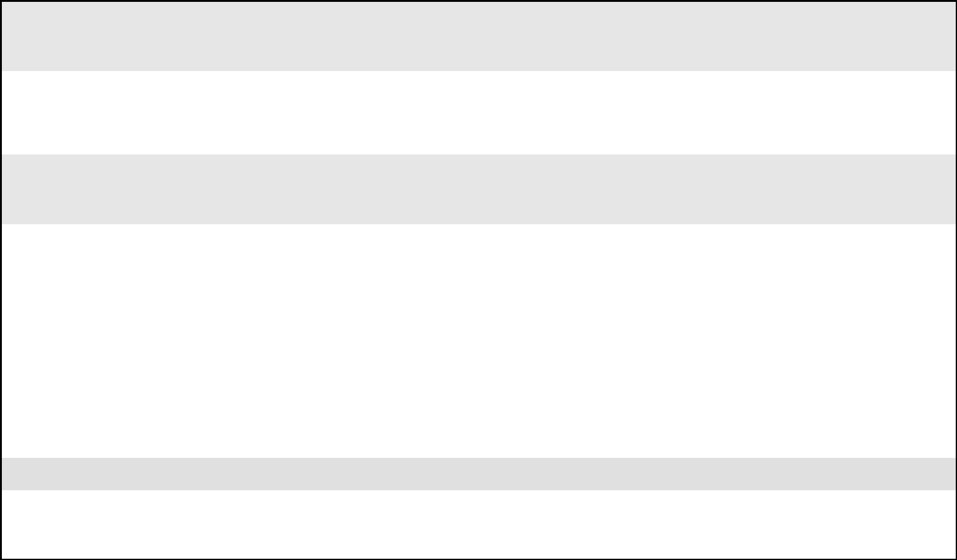

___ Yes (specify) ___________________________________________________________________

___ No

- Are there things that are unrelated to the school setting that happen on some days but not on other days that may make ((problem behavior)) more likely?

___ When ill | ___ Didn’t take medication | ___ Drugs/alcohol |  | ___ Problems at home
___ Days allergies are | ___ Changed medication | ___ Fight/argument on bus |  | ___ Stayed with non-
bad | ___ Hungry (missed meals) | ___ | Fatigued | custodial parent
___ Hormonal or during | ___ Went to a party | ___ Routine changed |  | ___ Fight with parents
menstrual cycle | ___ Diet changed | ___ | Parent not home | ___ Fight with friends
 |  | ___ | Fight with girlfriend
 |  | or | boyfriend
Other: _____________________________________________________________________________________

Additional comments not addressed above in the Prevent Component.

41
Student ________________ Responder __________________ Behavior ___________________

PTR Functional Behavior Assessment/Student: Teach Component

- Does ((problem behavior)) get you attention from classmates?
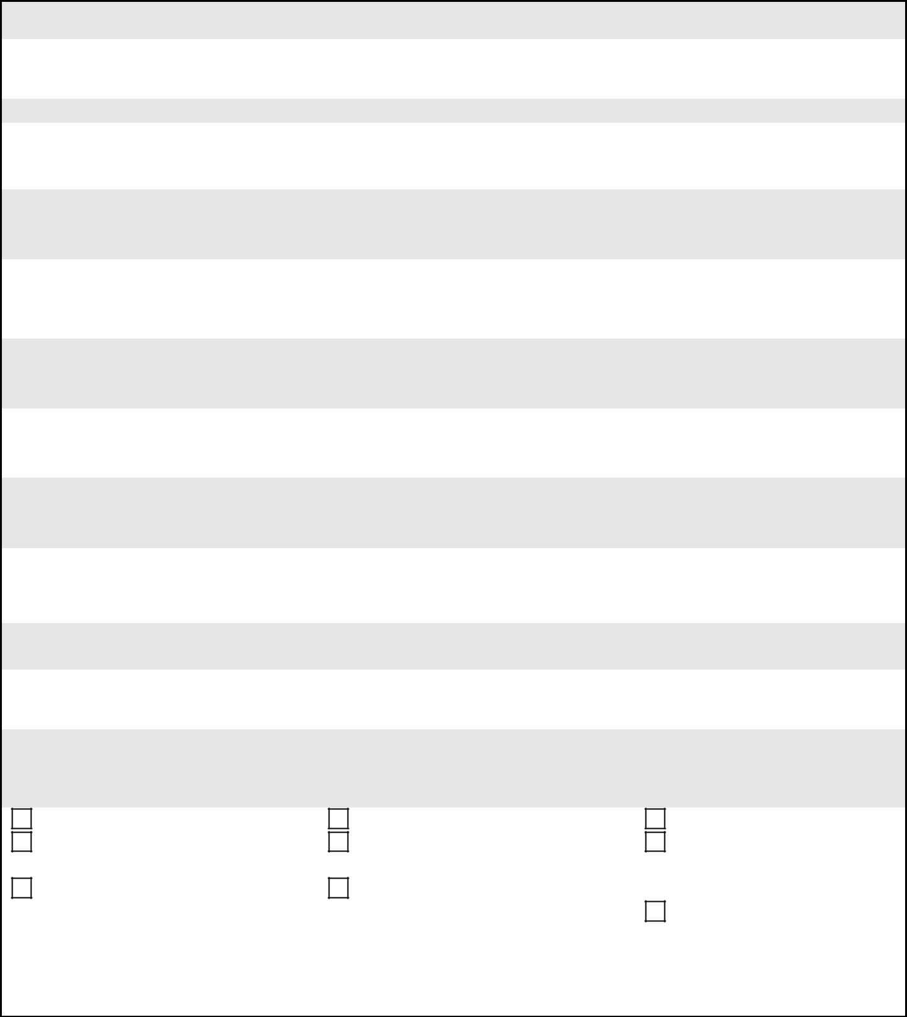

___ Yes List the specific classmates: _____________________________________________________

___ No

- Does ((problem behavior)) get you attention from adults?

___ Yes List the specific adults: _____________________________________________________

___ No

- Does ((problem behavior)) get you items or preferred activities (games, electronics, materials, food) from classmates or adults?

___ Yes List the specific objects or preferred activities:

___________________________________________________
___ No

- Does ((problem behavior)) get you to avoid or delay a transition from a preferred activity to a non-preferred activity?

___ Yes List the specific transitions:___________________________________________________

___ No

- Does ((problem behavior)) get you to avoid or delay a non-preferred (difficult, boring, repetitive) task or activity?

___ Yes List the specific non-preferred tasks or activities__________________________________

___ No

6. Does ((problem behavior)) get you away from a non-preferred classmate or adult?

___ Yes List the specific classmates or adults________________________________________________

___ No

- What behaviors could you do that would help you meet your academic and future goals? Select 3-5 behaviors that would allow you to participate in class, make passing grades, and get credits toward graduation.

Study skills | Study skills | Study skills
Socially engage (e.g., working | Socially engage (e.g., working | Socially engage (e.g.,
cooperatively with peers, cooperate) | cooperatively with peers, cooperate) | working cooperatively with
Participate, persist, and be | Participate, persist, and be | peers, cooperate)
engaged | engaged | Participate, persist, and be
 |  | engaged
Others: __________________________________________________________________________

42
Student ________________ Responder __________________ Behavior ___________________

Additional comments not addressed above in the Teach Component.


43
Student ________________ Responder __________________ Behavior ___________________

PTR Functional Behavior Assessment/Student: Reinforce Component

1. What typically happens immediately after you do ((problem behavior))?


___ Sent to time-out | ___ De-escalation (e.g., LSCI or other) | ___ Verbally reprimanded
___ Sent to crisis room | ___ Sent to behavior specialist/counselor | ___ Verbally redirected
___ Asked to put head | ___ Assistance given | ___ Stated rules
down | ___ Allowed to delay activity | ___ Physically prompted
___ Sent to office/ODR | ___ Changed the activity | ___ Classmates react (laugh, make
___ ISS | ___ Ended the activity | comments)
___ OSS | ___ Calmed/soothed | ___ Physically restrained
___ Ignored |  | ___ Removed reinforcers
 |  | ___ Natural consequences (Specify)
 |  | ___________________
Other:______________________________________________________________________________

- Do you enjoy praise from teachers and other school staff? Do you enjoy praise from some teachers more than others?

___ Yes List specific people ________________________________________________________________
___ _{No}

- When you do appropriate behavior (e.g., on-task behavior; cooperation; successful performance), how likely is it that a teacher or someone in school praises or gives you a positive comment?

___ Very likely ___ Sometimes ___ Seldom ___ Never

- When you ((problem behavior)), how likely is it that a teacher or someone in school responds to you (e.g., reprimands, corrections)?

___ Very likely | ___ Sometimes | ___ Seldom | ___ Never
5. What school-related items and activities are most enjoyable to you?
___ Social interaction with adults |  | ___ Listening to | ___ Doing art
___ Social interaction with |  | music | ___ Using the computer
classmates |  | ___ Being outside | ___ Video/electronic games/apps
___ Teacher or office assistant |  | ___ Going for a walk | ___ Watching TV/DVD/Movie
___ Going to media center |  | ___ Reading | ___ _{Objects (Specify}) ___________________
___ Sensory activity (specify⁾ |  | ___ Extra PE time | __________________________________
____________________ |  | ___ Extra free time | ___ Food (Specify) _____________________
___ Given leadership opportunities |  |  | __________________________________

Other(s):_______________________________________________________________________________

Additional comments not addressed above in the Reinforce Component.

44
Student ________________ Responder __________________ Behavior ___________________

Step 2: PTR Functional Behavior Assessment/Student Version (1 teacher)-Prevent Component

1a. Are there times of the school day when you are most likely to do ((problem behavior))? If yes, what are they?
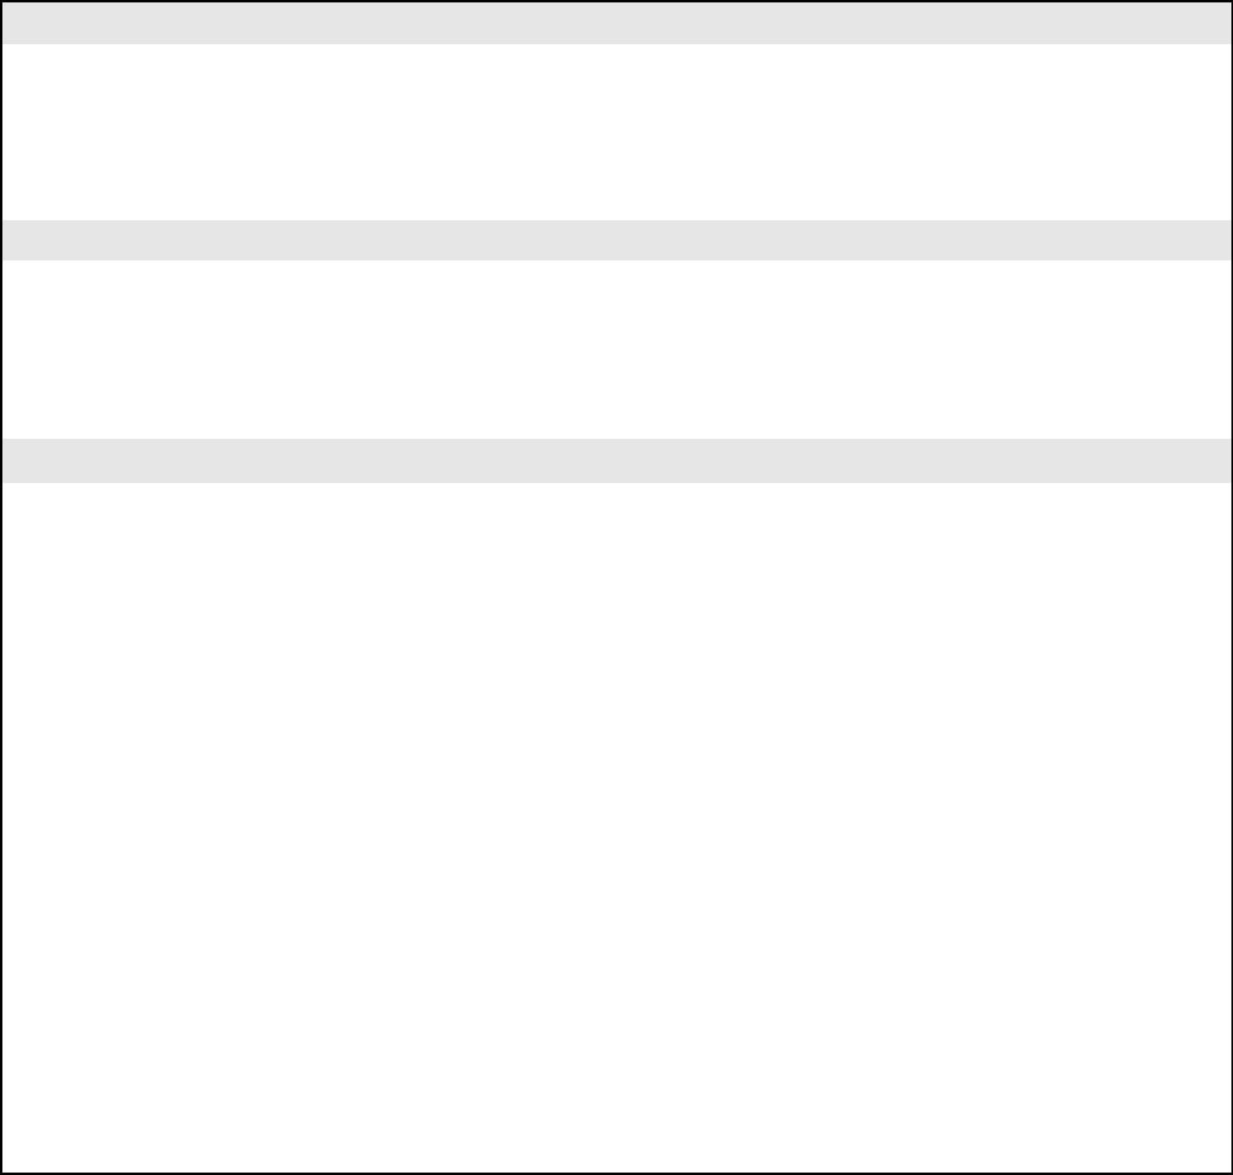
___ Before first class |  | ___ Before | ___ | During lunch |  | ___ After |  | ___ | Arrival Time
___ | Morning | lunch | ___ | Homeroom |  | lunch |  | ___ | Dismissal Time
___ | Afternoon
Other:_________________________________________________________________________

1b. Are there times of the school day when you are least likely to do ((problem behavior))? If yes, what are they?

___ | Morning | ___ Before | ___ During lunch |  | ___ After |  | ___ | Arrival
___ | Afternoon | lunch |  |  | lunch |  | ___ | Dismissal
 |  | ___ Between
 |  | classes
Other: ___________________________________________________________________________

2a. Are there specific activities or subjects when you are most likely to do ((problem behavior))? If yes, what are they?

___ | Core subjects (specify) | ___ | Writing tasks | ___ Large group |  | ___ Hands-on tasks
_______________________ |  | ___ Small group |  | Work |  | ___ On the bus
___ Independent work |  |  | work | ___ At locker |  | ___ Discussions/Q&A
___ One-on-one |  | ___ Computer |  | ___ After school |  | ___ Between
___ | Free time | ___ | Classmate or | activities (specify) |  | classes/transitions
___ | Extra-curricular |  | cooperative | ______________ |  | (specify)
___ During announcements |  |  | work | ___ Electives |  | ____________________
 |  |  |  | (specify)
 |  |  |  | ________________
Other: ____________________________________________________________________________
2b. Are there specific activities or subjects when you are least likely to do ((problem behavior))? What are they?
___ | Core subjects (specify) | ___ | Writing tasks | ___ Large group |  | ___ Hands-on tasks
_______________________ |  | ___ Small group |  | Work |  | ___ On the bus
___ Independent work |  |  | work | ___ At locker |  | ___ Discussions/Q&A
___ One-on-one |  | ___ Computer |  | ___ After school |  | ___ Between
___ Free time |  | ___ | Classmate or | activities (specify) |  | classes/transitions
___ | Extra-curricular |  | cooperative | ______________ |  | (specify)
___ During announcements |  |  | work | ___ Electives |  | ____________________
 |  |  |  | (specify)
 |  |  |  | ________________
Other: _______________________________________________________________________________

45
Student ________________ Responder __________________ Behavior ___________________

3a. Are there specific classmates or adults who, when they are around you, result in you more likely doing ((problem behavior))? If so, who are they?

___ Classmate |  | Specify:______________________ | ___ Bus driver
___ Teacher(s) |  | Specify: ______________________ | ___ Parent
___ Paraprofessional(s) |  | Specify: ______________________ | ___ Other family member
___ Other school staff |  | Specify_______________________ | (Specify)_______________
 |  |  | ____ Other person (specify)
 |  |  | _______________________
3b. Are there specific classmates or adults who, when they are around, result in you not doing ((problem behavior))? If so, who are they?

___ Classmate | Specify:______________________ | ___ Bus driver
___ Teacher(s) | Specify: ______________________ | ___ Parent
___ Paraprofessional(s) | Specify: ______________________ | ___ Other family member (Specify)
___ Other school staff | Specify: ______________________ | __________________________
 |  | ___ Other person (specify)
 |  | ______________________________

4. Are there specific circumstances that result in you being more likely to do the ((problem behavior))?

___ Asked to start work | ___ Work too difficult |  | ___ Between classes |  | ___ Alone time
___ Being told work is wrong | ___ Work is too long |  | ___ End of preferred |  | ___ Unstructured time
___ Being reprimanded or corrected | ___ Work is boring |  | activity |  | ___ ‘Down’ time (no
___ Told “no” | ___ Work is repetitive |  | ___ Teacher takes away |  |  | task specified)
___ Seated near specific classmate |  | (same task daily) | preferred item |  | ___ Teacher is attending
___ Classmates teasing or making | ___ | New work | ___ Start of non- |  |  | to other students
comments | ___ | Between activities | preferred activity
___ Schedule changed

Other: _________________________________________________________________________________

If the ((problem behavior)) happens most often during academic time/work, do you think you are able to do the work being asked of you without help? Yes No (explain) ______________________________________________________________________

- Are there specific circumstances that result in it being very unlikely that you do the ((problem behavior))? Please specify.

- Are there conditions in the physical environment that make it more likely for you to do ((problem behavior))? For example, too warm or too cold, too crowded, too much noise, too chaotic, weather conditions….

___ Yes (specify) ___________________________________________________________________

___ No

46
Student ________________ Responder __________________ Behavior ___________________

- Are there things that are unrelated to the school setting that happen on some days but not on other days that may make ((problem behavior)) more likely?
___ |  | When ill |  | ___ | Didn’t take medication | ___ | Drugs/alcohol | ___ | Problems at home
___ Days allergies are bad |  |  |  | ___ Changed medication |  | ___ Fight/argument on bus |  | ___ Stayed with non-
___ |  | Hormonal or during |  | ___ | Hungry (missed meals) | ___ | Fatigued |  | custodial parent
 |  | menstrual cycle |  | ___ | Went to a party | ___ | Routine changed | ___ | Fight with parents
 |  |  |  | ___ | Diet changed | ___ | Parent not home | ___ | Fight with friends
 |  |  |  |  |  | ___ | Fight with girlfriend or
 |  |  |  |  |  |  | boyfriend
Other: _____________________________________________________________________________________

Additional comments not addressed above in the Prevent Component.

47
Student ________________ Responder __________________ Behavior ___________________

PTR Functional Behavior Assessment/Student: Teach Component

- Does ((problem behavior)) get you attention from classmates?
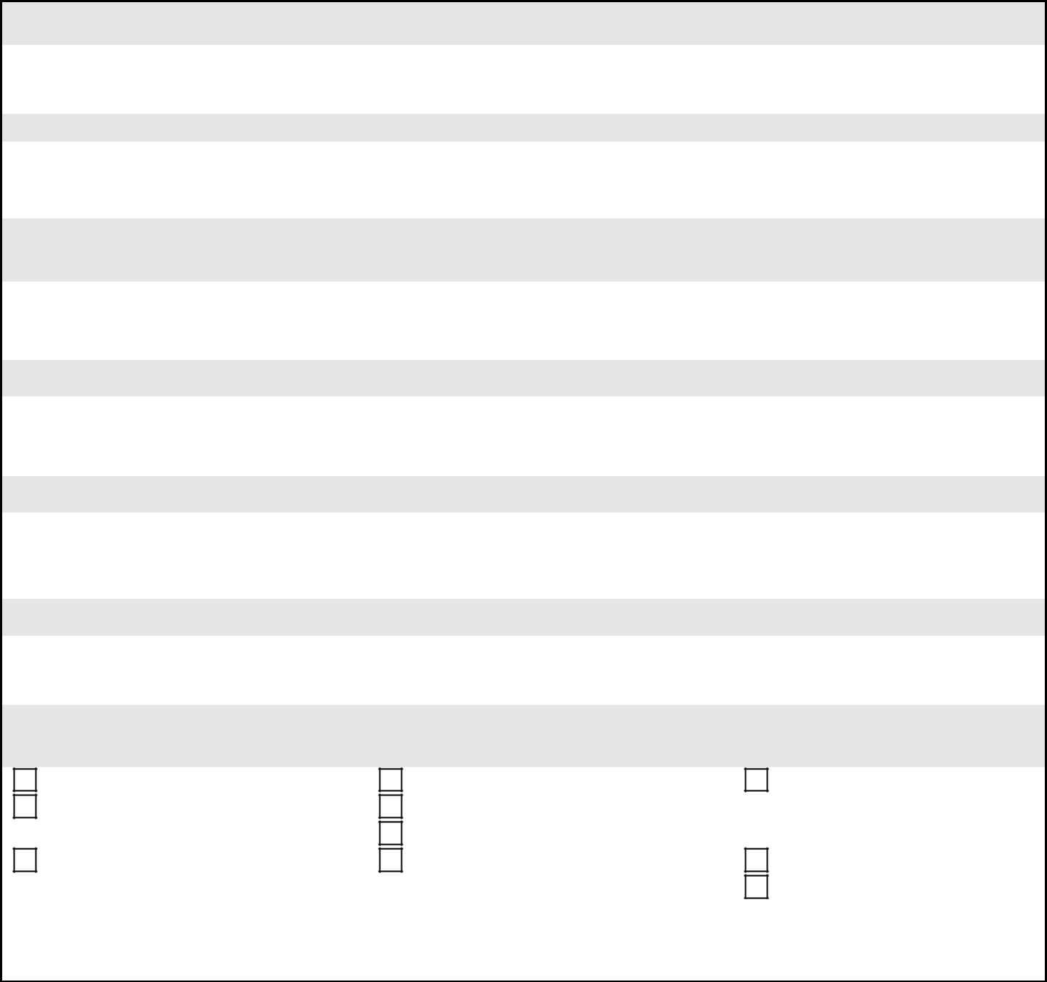

___ Yes List the specific classmates: _____________________________________________________

___ No

- Does ((problem behavior)) get you attention from adults?

___ Yes List the specific adults: _____________________________________________________

___ No

- Does ((problem behavior)) get you items or preferred activities (games, electronics, materials, food) from classmates or adults?

___ Yes List the specific objects or preferred activities: ___________________________________________________

___ No

- Does ((problem behavior)) get you to avoid or delay a transition from a preferred activity to a non-preferred activity?

___ Yes List the specific transitions:___________________________________________________

___ No

- Does ((problem behavior)) get you to avoid or delay a non-preferred (difficult, boring, repetitive) task or activity?

___ Yes List the specific non-preferred tasks or activities__________________________________

___ No

6. Does ((problem behavior)) get you away from a non-preferred classmate or adult?

___ Yes List the specific classmates or adults________________________________________________

___ No

- What behaviors could you do that would help you meet your academic and future goals? Select 3-5 behaviors that would allow you to participate in class, make passing grades, and get credits toward graduation.

Study skills | Homework completion | Work productively
Socially engage (e.g., working | Organizational strategies | (complete and turn in
cooperatively with peers, cooperate) | Attend class | assignments)
Participate, persist, and be | Self-regulation (controls temper, | Time management
engaged | obeys rules, copes with stress) | Arrive to class on time
Others: __________________________________________________________________________

48
Student ________________ Responder __________________ Behavior ___________________

PTR Functional Behavior Assessment/Student: Reinforce Component

1. What typically happens immediately after you do ((problem behavior))?

___ Sent to time-out | ___ De-escalation (e.g., LSCI or other) |  | ___ Verbally reprimanded
___ Sent to crisis room | ___ Sent to behavior specialist/counselor |  | ___ Verbally redirected
___ Asked to put head | ___ Assistance given |  | ___ Stated rules
down | ___ Allowed to delay activity |  | ___ Physically prompted
___ Sent to office/ODR | ___ Changed the activity |  | ___ Classmates react (laugh, make
___ ISS | ___ Ended the activity |  | comments)
___ OSS | ___ Calmed/soothed |  | ___ Physically restrained
___ Ignored |  |  | ___ Removed reinforcers
 |  |  | ___ Natural consequences (Specify)
 |  |  | ___________________
Other:______________________________________________________________________________

- Do you enjoy praise from teachers and other school staff? Do you enjoy praise from some teachers more than others?

___ Yes List specific people ________________________________________________________________
___ _{No}

- When you do appropriate behavior (e.g., on-task behavior; cooperation; successful performance), how likely is it that a teacher or someone in school praises or gives you a positive comment?

___ Very likely ___ Sometimes ___ Seldom ___ Never

- When you ((problem behavior)), how likely is it that a teacher or someone in school responds to you (e.g., reprimands, corrections)?
 | ___ Very likely | ___ Sometimes | ___ Seldom | ___ | Never
 | 5. What school-related items and activities are most enjoyable to you?
 | ___ Social interaction with adults |  | ___ Listening to music | ___ Doing art
 | ___ Social interaction with classmates |  | ___ Being outside | ___ Using the computer
 | ___ Teacher or office assistant |  | ___ Going for a walk | ___ Video/electronic games/apps
 | ___ Going to media center |  | ___ Reading | ___ Watching TV/DVD/Movie
 | ___ Sensory activity (specify⁾ |  | ___ Extra PE time | ___ _{Objects (Specify}) ___________________
 | ____________________ |  | ___ Extra free time |  | __________________________________
 | ___ Given leadership opportunities |  |  | ___ Food (Specify) _____________________
 |  |  |  |  | __________________________________

Other(s):_______________________________________________________________________________

Additional comments not addressed above in the Reinforce Component.

49
Facilitator Form

Step 2: PTR Functional Behavior Assessment Summary Table: “Cheat Sheet”

Student: ____________________________ School: ___________________________________ Date: _____________________

 |  | Behavior | Prevent (Antecedent) Data | Function (Teach) Data | Consequences (Reinforce) Data
Problembehavior | Nameofproblem | behavior | Include information from the | Include information from the | Include information from the
Problembehavior | Nameofproblem | behavior | Prevent component of the PTR | Teach component of the PTR | Reinforce component of the PTR
 |  |  | assessment (items #1a, 2a, 3a, 4, 5, | assessment (items #1 through #6) | assessment (items #1 & 4)
 |  |  | 6)
Appropriatebehavior | Nameofpro-social | orreplacementbehavior | Include information from the | Include information from the | Include information from the
Appropriatebehavior | Nameofpro-social | orreplacementbehavior | Prevent component of the PTR | IBRST or other sources that | Reinforce component of the PTR
 |  |  | assessment (items #1b, 2b, 3b) | provide the replacement behaviors; | assessment (items #2, 3, & 5)
 |  |  |  | (if student PTR used, items #7, 8,
 |  |  |  | 9).


Possible Hypotheses

 | When…. | He/she will….. | As a result, he/she ……
ProblemBehavior | Include the relevant data from the problem | Behavior being evaluated | Function (from problem behavior
ProblemBehavior | behavior prevent data above |  | teach data)
ReplacementBehavior | Copy what you have in the row above (problem | Write in the new behavior/skill or, | Copy what | you have in the row
ReplacementBehavior | behavior when) | replacement behavior | above | (problem | behavior
 |  |  | function).

50
 | Step 2: PTR Functional Behavior Assessment Summary Table
Student: ____________________________ |  | School: ___________________________________ |  | Date: _____________________
Behavior | Antecedent (Prevent Data) |  | Function (Teach) Data | Consequences (Reinforce) Data


Appropriate behavior Problem behavior
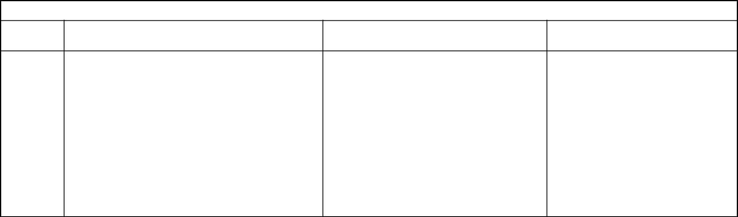

Possible Hypotheses

When…. | He/she will….. | As a result, he/she ……

Problem | Behavior
Replacement | Behavior

51
 |  |  |  |  |  |  |  | Step 3: PTR Intervention Checklist/Elementary
Student: |  |  |  |  | School: |  |  |  |  | Date: |  |  |  |  |  |  | Completed by:
Hypothesis:
 |  |  |  | Prevention |  |  |  |  |  |  | Teaching |  |  |  |  |  |  |  |  |  |  |  | Reinforcement
 |  |  | Interventions |  |  |  |  |  |  |  | Interventions |  |  |  |  |  |  |  |  |  |  |  | Interventions
Providing Choices |  |  |  |  |  |  |  |  |  | **Replacement Behavior (What |  |  |  |  |  |  |  |  | **Reinforce Replacement Behavior (Write
 |  |  |  |  |  |  |  |  |  | appropriate behavior will be taught?) |  |  |  |  |  |  |  |  | in the function of the problem behavior from
 |  |  |  |  |  |  |  |  |  | Functional Equivalent |  |  |  |  |  |  |  |  | the hypothesis)
 |  |  |  |  |  |  |  |  |  | Alternate Skill (desired) |  |  |  |  |  |  |  |  |  |  |  | ** Function
 |  |  |  |  |  |  |  |  |  |  |  |  |  |  |  |  |  |  |  |  |  | Additional
Transition Supports |  |  |  |  |  |  |  |  |  | Specific Academic Skills |  |  |  |  |  |  |  |  | ** Discontinue Reinforcement of Problem
 |  |  |  |  |  |  |  |  |  |  |  |  |  |  |  |  |  |  | Behavior
Environmental Supports |  |  |  |  |  |  |  |  |  | Problem Solving Strategies
Changes to task demands/curriculum |  |  |  |  |  |  |  |  |  | General Coping Strategies
(presentation, content, amount)
Stay Close (positive caring, comments; non- |  |  |  |  |  |  |  |  |  | Specific Social Skills
contingent-reinforcement)
Classroom Management |  |  |  |  |  |  |  |  |  | Teacher Pleasing Behaviors
Setting Event Modification |  |  |  |  |  |  |  |  |  | Learning Skills Strategies
Increase Opportunities to Respond |  |  |  |  |  |  |  |  |  | Self-Management (self-monitoring)
Peer Modeling or Peer Support |  |  |  |  |  |  |  |  |  | Independent Responding
 |  |  |  |  |  |  |  |  |  | Increased Engaged Time
Does the severity or intensity of the student’s problem behavior pose a threat to self or others? |  |  |  |  |  |  |  |  |  |  |  |  |  |  |  |  |  | Yes |  |  |  | No
If yes, is a crisis intervention plan needed? |  |  |  |  |  |  |  | Yes |  | No
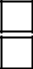
**All asterisked interventions need to be selected and included in the student’s PTR Intervention Plan

52
Step 3: PTR Interventions Checklist-SECONDARY Version

Student: _________________ School:_________________ Date:_______ Behavior:_______________ Completed by:________
Hypothesis:_____________________________________________________________________________________________________________
________________________________________________________________________________________________

Prevention |  | Teaching |  | Reinforcement
Interventions |  | Interventions (behaviors that will help |  | Interventions
 |  | meet academic goals)
 Providing Choices |  | **Replacement Behavior | **Reinforce Replacement Behavior
 |  |  Functional Equivalent |  |  ** Function
 |  |  Alternate skill (desired) |  |  Additional
 Transition Interventions/Planning |  |  Study Skills/Test-taking Strategies |  **Discontinue Reinforcement of
 |  |  |  | Problem Behavior
 Visual Cues/Tools |  |  Social Problem Solving Strategies
 Curricular/Assignment Modification/Flexibility |  |  General Coping Strategies
 Opportunities to Respond |  |  Cognitive Behavior Therapy
 Classroom Management |  |  Learning Strategy Instruction
 Setting Event Modification |  |  Self-Management
 Increase Non-Contingent Reinforcement |  |  Basic Academic Skills
 Peer Support/Cooperative Grouping Activities |  |  Specific Social Skills Training
Does the severity or intensity of the student’s problem behavior pose a threat to self or others? |  |  | Yes | No
If yes, is a crisis intervention plan needed? | Yes | No
**All asterisked interventions need to be selected and included in the student’s PTR Intervention Plan

53
Step 3: PTR Interventions Checklist-SECONDARY Version-Student

Student: _________________ School: __________________ Date: _______ Behavior: _______________ Completed by: ________

Directions: Under each category, check 2-4 interventions you think would work and would be okay with you to try.

 | Prevention |  |  | Teaching |  |  | Reinforcement
 | Interventions |  |  | Interventions (behaviors that will |  |  | Interventions
 |  |  |  | help you reach your goals)
 Given Choices |  |  |  | **Replacement Behavior |  |  | **Reinforce Replacement Behavior
 |  |  |  |  _______________________ |  |  |  Escape, avoid, delay
 |  |  |  |  |  |  |  Get attention, specific activity/item
 Helping with transitions between classes/activities |  |  |  |  Study Skills/Test-taking Strategies |  |  |  **Having the teacher not let me escape
 |  |  |  |  |  |  | or get attention for my problem behavior
 Visual reminders/checklists |  |  |  |  Social Problem Solving Strategies
 Change tasks/activities to make less difficult, more |  |  |  |  General Coping Strategies
interesting
 Get More Opportunities to Respond and Get |  |  |  |  Cognitive Behavior Therapy
Positive Comments
 Whole Classroom Management Plan |  |  |  |  Learning Strategy Instruction
 Interventions that address the days that I come to |  |  |  |  Self-Management
school angry/unhappy because of things that have
happened at home or with friends
 Have more positive comments from your |  |  |  |  Basic Academic Skills
teacher(s)
 Classmate Support/Cooperative Grouping |  |  |  |  Specific Social Skills Training
Activities
When you do (problem behavior) can it hurt you or others (teachers, classmates)? |  |  |  |  | Yes | No
If yes, do you need a crisis management plan? |  |  | Yes | No

54
Facilitator Form

Step 3: Intervention Scoring Table—Elementary

Directions:

- Gather all completed PTR Intervention Checklists.
- List the interventions selected number 1 by each team member.
- List the intervention selected number 2 by each team member and so on until all interventions are listed.
- Determine the mean rank of all interventions selected.
- List the interventions in order of rank.
- Place an asterisk next to the interventions selected as number 1 by the teacher.
- As a team, discuss the ranked interventions and come to a consensus on at least one Prevent, one Teach, and one Reinforce strategy.

55
Facilitator Form

Step 3: Intervention Scoring Table

Student: ______________________ School:_______________________ Date:________ Completed by: ______________________
Hypothesis:__________________________________________________________________________________________________
____________________________________________________________________________________________________________

 | Prevent | Rank | Teach | Rank | Reinforce | Rank
1. |  |  | 1. Replacement behavior |  | 1. Reinforce replacement behavior
 |  |  |  Functional Equivalent |  |  Functional
 |  |  |  Alternate Skill |  |  Additional
2. |  |  | 2. |  | 2.
3. |  |  | 3. |  | 3.
4. |  |  | 4. |  | 4.
5. |  |  | 5. |  | 5.
6. |  | - | 6. |  | 6.
7. |  |  | 7. |  | 7.
A replacement behavior must be included in the student’s behavior intervention plan.

56
Facilitator Form

Step 3: Intervention Scoring Table—Secondary

Directions:
- Gather all completed PTR Intervention Checklists (Teacher(s), student)
- List the interventions selected number 1 in each category by each team member.
- List the intervention selected number 2 in each category by each team member and so on until all interventions are listed.
- Review the interventions ranked by the primary/core teacher and the student.
- Highlight/mark the highest ranked intervention that is on both the teacher’s and the student’s list (i.e., in common with both).
- Determine if the intervention selected is linked with the hypothesis.
- As a team, discuss the interventions in agreement with the teacher and the student and come to a consensus.

- Develop the strategy into a task analyzed sequence of steps.

57
Facilitator/Team Form

Step 3: Behavior Intervention Plan

Hypothesis:

PREVENT Interventions

Intervention |  | Description and Steps |  | Comments
Strategy
TEACH Interventions
Intervention |  | Description and Steps |  | Comments
Strategy

58
Facilitator/Team Form

REINFORCE Intervention

Intervention | Description and Steps | Comments
Strategy

59
Step 3: Coaching/Training Checklist

Directions for developing the form:

- Select an intervention and write its name under the appropriate category (e.g., Prevent, Teach, Reinforce).

- As a team, use the specific, step-by-step behavior intervention plan to identify the core adult behaviors that would be observed during implementation of the intervention. Write one step in each line under the correct category (e.g., Prevent, Teach, Reinforce).
- Repeat steps 1 & 2 for the remaining interventions.

Directions for completing the form:

- Conduct training during a time when students are not present.
- As a team, discuss the steps of implementation
- Next, select methods that will be used to have teachers practice each step (e.g., discussion, Q & A, role play).
- Circle the Y if the teacher/person implementing the plan correctly implements step(s).
- Circle the N if the teacher/person implementing the plan does not correctly implement step(s).
- Calculate the percent score.
- If the percent score is less than 100%, the team should discuss if further training is needed or develop a plan to ensure the weak steps are addressed during technical assistance.

60
Step 3: Coaching/Intervention Training Checklist

Student: ______________________________________________________________________

Name of person(s) implementing intervention: ________________________________________

Date of Training: _______________________________________________________________

 | Did the
 | implementer
Core Adult Behavior Components of Intervention | complete the
 | step?
PREVENT Component
1. | Yes | No
2. | Yes | No
3. | Yes | No
4. | Yes | No
5. | Yes | No
6. | Yes | No
TEACH Component
1. | Yes | No
2. | Yes | No
3. | Yes | No
4. | Yes | No
5. | Yes | No
6. | Yes | No
REINFORCE Component
1. | Yes | No
2. | Yes | No
3. | Yes | No
4. | Yes | No
5. | Yes | No
6. | Yes | No
TOTAL (# Yes / # Total)
Percent Score

61
Step 3: PTR Plan Assessment (Fidelity)—Example

 | Teacher: |  |  | Student: |  |  |  | Date: |  | Observation | Self-Assessment
 |  |  |  |  |  | Interventions |  |  |  |  |  |  | Implemented |  |  | Impact
 |  |  |  |  |  |  |  |  |  |  |  |  |  |  |  | (1 = no
 |  |  |  |  |  |  |  |  |  |  |  |  |  |  |  | impact; 5
 |  |  |  |  |  |  |  |  |  |  |  |  |  |  |  | = great
 |  |  |  |  |  | PREVENT |  |  |  |  |  |  |  |  |  | impact)
 | Transition Supports—visual checklist |  |  |  |  |  |  |  |  |  |  |  | Y/N/NA |  | 12345
 |  | • Visual checklist provided to Isaiah
 |  | • Choice of reinforcement presented and described on checklist |  |  |  |  |  |  |  |  |  |  | Y/N/NA
 |  |  |  |  |  | TEACH
 | Replacement behavior—academic engagement |  |  |  |  |  |  |  |  |  |  |  | Y/N/NA |  | 12345
 | • Checklist reviewed during study skills class
 | • | Goal set |  |  |  |  |  |  |  |  |  |  | Y/N/NA
 | • Gave 1 minute at end of class for Isaiah to self-assess |  |  |  |  |  |  |  |  |  |  |  | Y/N/NA
 | • Reviewed Isaiah’s self-assessment and gave feedback |  |  |  |  |  |  |  |  |  |  |  | Y/N/NA
 | Replacement behavior—escape by asking to be excused |  |  |  |  |  |  |  |  |  |  |  | Y/N/NA |  | 12345
 | • Prior to non-preferred activity, provided a verbal prompt/cue to remind Isaiah that
 |  | he can ask to be excused.
 |  |  |  |  |  | REINFORCE
 | Reinforce academic engagement |  |  |  |  |  |  |  |  |  |  |  | Y/N/NA |  | 12345
 | • Presented choice reinforcement menu to Isaiah when goal met
 | • | Provided verbal praise |  |  |  |  |  |  |  |  |  |  | Y/N/NA
 | • Provided reinforcement for surpassing goal |  |  |  |  |  |  |  |  |  |  |  | Y/N/NA
 | Reinforce asking to be excused |  |  |  |  |  |  |  |  |  |  |  | Y/N/NA |  | 12345
 | • Provide 1 minute break each time Isaiah asks to be excused
 | Discontinue reinforcement of problem behavior |  |  |  |  |  |  |  |  |  |  |  | Y/N/NA |  | 12345
 | • Got Isaiah’s attention and used agreed upon signal when Isaiah stops
 |  |  |  |  |  |  |  |  |  |  |  |  | Y/N/NA
 | • Waited for Isaiah’s attending response
 |  |  |  |  |  |  |  |  |  |  |  |  | Y/N/NA
 | • Tapped activity on teacher copy of checklist to remind Isaiah to be engaged
 |  |  |  |  |  |  |  |  |  |  |  |  | Y/N/NA
 | • Sidebar in hallway if Isaiah stops again
 |  |  | Behavior Plan Assessment Implementation: Total # of Y/Y + N total

62
Step 3: PTR Plan Assessment (Fidelity)

Teacher: | Student: | Date: | Observation | Self-Assessment

 |  | Interventions |  |  |  |  |  | Implemented |  |  | Did it have the
 |  |  |  |  |  |  |  |  |  |  | desired impact on
 |  |  |  |  |  |  |  |  |  |  | behavior?
 |  |  |  |  |  |  |  |  |  |  | (1 = no impact; 2 =
 |  |  | PREVENT |  |  |  |  |  |  |  | some impact; 3 =
 |  |  |  |  |  |  |  |  |  |  | great impact)
 | Prevention Intervention (Name) |  |  |  |  |  |  | Y/N/NA |  | 1 2 3
 |  |  | TEACH
 | Replacement behavior |  |  |  |  |  |  | Y/N/NA |  | 1 2 3
 |  | REINFORCE
 | Reinforce replacement behavior |  |  |  |  |  |  | Y/N/NA |  | 1 2 3
 | Behavior Plan Assessment: Y/Y + N total

63
Step 4: Monitoring/Follow-Up
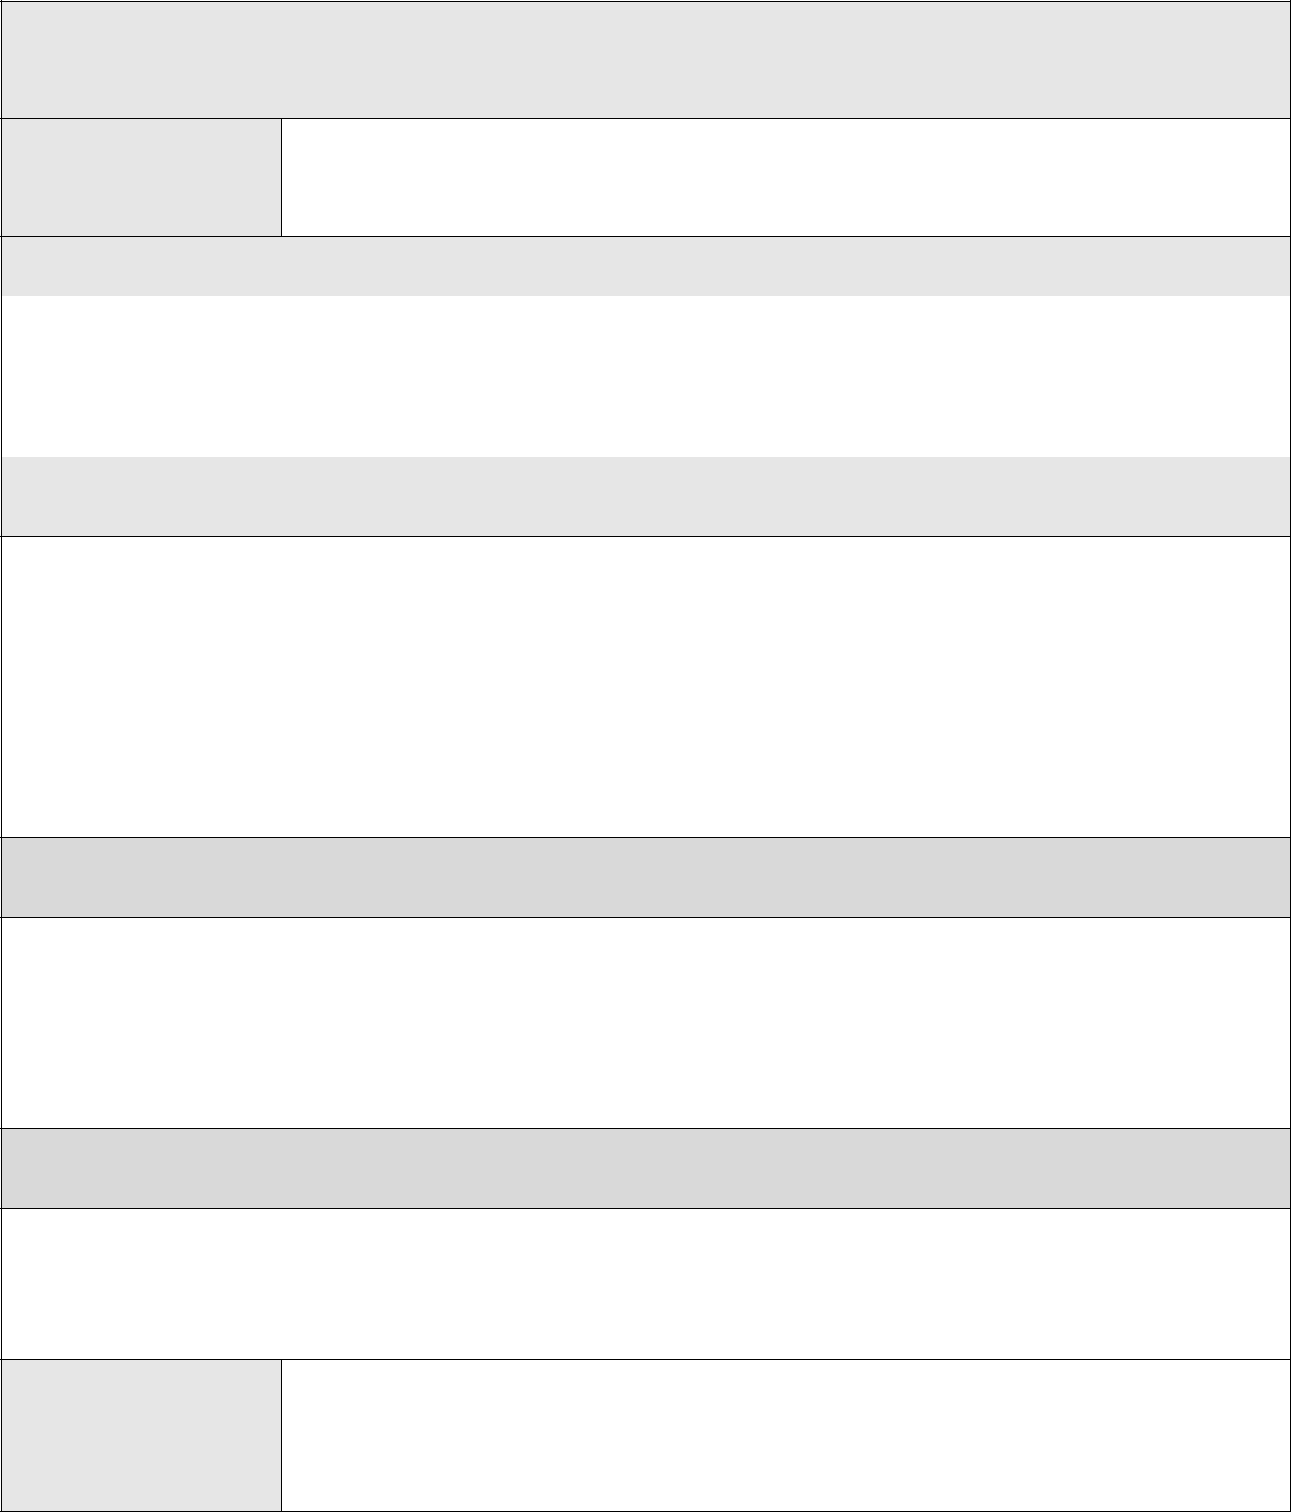

Set a date for follow-up meeting (within 3 weeks) to evaluate effectiveness of behavior intervention plan

Date and time

Data-Based Decision Making Points

 | 1. | Was the intervention successful – did behavior meet criterion levels? If yes, jump to question 5
 |  | below. | YES | NO
 | 2. | NO, intervention not successful: Was the plan implemented as intended? What were the fidelity
 |  | scores? _______________________ | YES | NO
- NO, intervention not successful; YES, plan was implemented as intended. Determine next step:

  - Give the plan more time

Date of next follow-up meeting (no more than 3 weeks) ____________
  - Modify the plan
Date of meeting to develop modified plan ________________

Date to train the teacher in the modified plan ______________
Date of next follow-up meeting (no more than 3 weeks) _____________
  - Conduct a more comprehensive FBA
Team/facilitator conducting FBA: _________________
Date by when FBA will be completed: _____________
Date of meeting to develop hypothesis and plan (no more than 3 weeks)_______________

- NO, intervention not successful: NO, plan was NOT implemented as intended.

  - Retrain the teacher

  - Modify the plan to make more feasible
    - Date of meeting to develop modified plan ____________

    - Date of next follow-up meeting (no more than 3 weeks) __________________
  - Select new interventions that are more acceptable and match the hypothesis
    - Date of meeting to develop new plan ________________
    - Date of next follow-up meeting (no more than 3 weeks) ___________________

- YES, intervention effective and YES, plan implemented as intended.

  - Extend the plan by implementing in another problematic routine or with other people

  - Establish new goal/increase criterion
  - Teach a new skill
  - Fade out parts of the plan
  - Other (specify) ___________________________________

Date and time 2nd follow-

up meeting

64
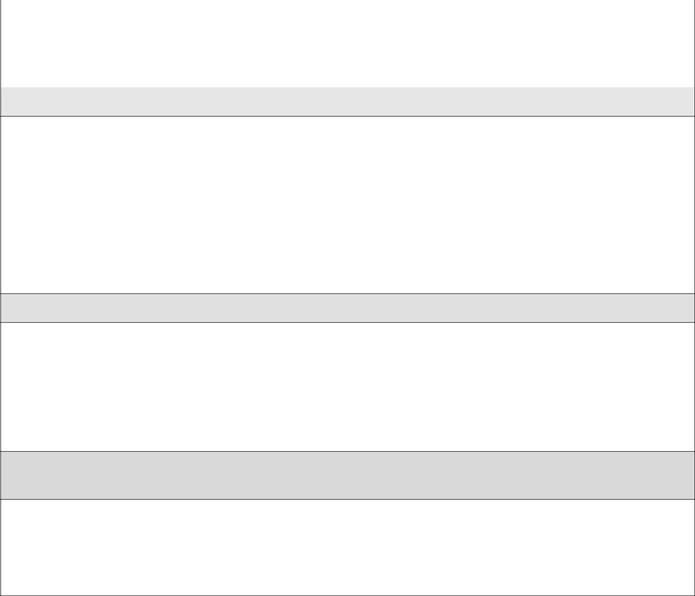 | 1. | Was the intervention successful – did behavior meet criterion levels? If yes, jump to question 5
 |  | below | YES | NO
 | 2. | NO, intervention not successful: Was the plan implemented as intended? What were the fidelity
 |  | scores? ______________________ | YES | NO
- NO, intervention not successful; YES, plan was implemented as intended. Determine next step:

  - Give the plan more time

Date of next follow-up meeting (no more than 3 weeks) ____________
  - Modify the plan
Date of meeting to develop modified plan ________________

Date to train the teacher in the modified plan ______________
Date of next follow-up meeting (no more than 3 weeks) _____________
  - Conduct a more comprehensive FBA
Team/facilitator conducting FBA: _________________
Date by when FBA will be completed: _____________

Date of meeting to develop hypothesis and plan (no more than 3 weeks)_______________

- NO, intervention not successful: NO, plan was NOT implemented as intended. Determine next step.

  - Retrain the teacher

  - Modify the plan to make more feasible
    - Date of meeting to develop modified plan ____________
    - Date of next follow-up meeting (no more than 3 weeks) __________________
  - Select new interventions that are more acceptable and match the hypothesis
    - Date of meeting to develop new plan ________________

Date of next follow-up meeting (no more than 3 weeks) ___________________

- YES, intervention effective and YES, plan implemented as intended. Determine next step.

  - Extend the plan by implementing in another problematic routine or with other people

  - Establish new goal/increase criterion
  - Teach a new skill
  - Fade out parts of the plan
Other (specify) ___________________________________

65

Optional Forms

66
Teacher/Consultant Alliance Scale

Name: School:

Date: Role: Teacher Consultant (circle one)

Teacher/Consultant with whom you have been working:

Directions: Circle the appropriate descriptor that best represents your experience with the teacher or consultant with whom you have been working.

 | 1 = Never | 2 = Seldom 3 = Sometimes 4 = Other | 5 = Always
1. | The teacher/consultant and I agree on the most important |  | 1 | 2 | 3 | 4 | 5
 | goals for intervention.
2. | I feel confident of the teacher/consultant’s ability to help the |  | 1 | 2 | 3 | 4 | 5
 | situation.
3. | The teacher/consultant communicates effectively. |  | 1 | 2 | 3 | 4 | 5
4. | The teacher/consultant and I trust one another. |  | 1 | 2 | 3 | 4 | 5
5. | The teacher/consultant is approachable. |  | 1 | 2 | 3 | 4 | 5
6. | The teacher/consultant and I are working together |  | 1 | 2 | 3 | 4 | 5
 | collaboratively to improve the situation.
7. | I feel satisfied with the utility and practicality of the |  | 1 | 2 | 3 | 4 | 5
 | suggestions and ideas provided by the teacher/consultant.
8. | The teacher/consultant followed through with commitments |  | 1 | 2 | 3 | 4 | 5
 | and responsibilities.
9. | Overall, the teacher/consultant has shown a sincere desire to |  | 1 | 2 | 3 | 4 | 5
 | understand and improve the situation.
10. | The time spent working with the teacher/consultant was |  | 1 | 2 | 3 | 4 | 5
 | effective and productive.

67

PTR Classroom Team Survey

School: _______________________ Student: _________________________

Complete this survey if the team meets on a regular basis for planning purposes.

- Our team meets for planning purposes:

Rarely Monthly 0 1

Bimonthly

2

Weekly

3

Daily
4

- Our team plans daily classroom activities collaboratively:

Rarely Occasionally Frequently Usually 0123

Almost Always 4

- Our team plans collaboratively around implementing IEP objectives and making

adaptations and modifications for children in the classroom:
Rarely Occasionally Frequently Usually Almost Always
0 1 2 3 4

- Our team communicates well and problem solves collaboratively:

Strongly Disagree Disagree Neutral Agree 0123

Strongly Agree 4

- We interact and work with children across developmental domains and disciplines:

Rarely Occasionally Frequently Usually Almost Always 01234

- Professional roles and responsibilities are shared across team members members:

Strongly Disagree Disagree Neutral Agree Strongly Agree 01234

- Parents play an active role on their child’s team regarding the identification of goals, supports and services, modifications and adaptations.

Strongly Disagree Disagree Neutral Agree Strongly Agree
0 1 2 3 4

- Our team has access to additional resources (e.g., technology, personnel, classroom materials, etc.) to help us work with children in the classroom.

None Limited Adequate Good Excellent
0 1 2 3 4

PTR Form 2a

68

Please answer the following questions:

1. List some strengths of the Team.

2. What challenges face the Team?

3. What are the most pressing needs of the team?

4. What might help to enhance the team’s productivity?

PTR Form 2a

69
PTR Teacher Work Style Survey

Directions: Circle the number that indicates your level of agreement / disagreement with each statement.

 |  |  | Disagree |  |  | Agree
1. | I supervise paraeducators closely................................................................... |  | 1 | 2 | 3 | 4 | 5 | N/A
2. | I prefer a flexible work schedule. . ................................................................ |  | 1 | 2 | 3 | 4 | 5 | N/A
3. | I let paraeducators know exactly what is expected. ....................................... |  | 1 | 2 | 3 | 4 | 5 | N/A
4. | I provide (or at least determine) all the materials that will be used..... .......... |  | 1 | 2 | 3 | 4 | 5 | N/A
5. | I provide a written work schedule. ................................................................. |  | 1 | 2 | 3 | 4 | 5 | N/A
6. | I expect the paraeducator to think ahead to the next task. ............................. |  | 1 | 2 | 3 | 4 | 5 | N/A
7. | I determine the instructional methods that will be used ................................ |  | 1 | 2 | 3 | 4 | 5 | N/A
8. | I encourage the paraeducator to try new activities independently. ................ |  | 1 | 2 | 3 | 4 | 5 | N/A
9. | I give explicit directions for each task ........................................................... |  | 1 | 2 | 3 | 4 | 5 | N/A
10. |  | I always do several things at one time. ........................................................ | 1 | 2 | 3 | 4 | 5 | N/A
11. |  | I like working with paraeducators that willingly take on new challenges... | 1 | 2 | 3 | 4 | 5 | N/A
12. |  | I like taking care of details. .......................................................................... | 1 | 2 | 3 | 4 | 5 | N/A
13. |  | I require the paraeducator to be punctual ..................................................... | 1 | 2 | 3 | 4 | 5 | N/A
14. |  | I like to get feedback on how I can improve as a supervisor ....................... | 1 | 2 | 3 | 4 | 5 | N/A
15. |  | I like to bring problems out in the open ....................................................... | 1 | 2 | 3 | 4 | 5 | N/A
16. |  | I like to give frequent performance feedback to the paraeducator ............... | 1 | 2 | 3 | 4 | 5 | N/A
17. |  | I like to discuss activities that do not go well .............................................. | 1 | 2 | 3 | 4 | 5 | N/A
18. |  | I like working with other adults ................................................................... | 1 | 2 | 3 | 4 | 5 | N/A
19. |  | I encourage paraeducators to think for themselves ...................................... | 1 | 2 | 3 | 4 | 5 | N/A
20. |  | I am a morning person ................................................................................. | 1 | 2 | 3 | 4 | 5 | N/A
21. |  | I speak slowly and softly.............................................................................. | 1 | 2 | 3 | 4 | 5 | N/A
22. |  | I work best alone with little immediate interaction ..................................... | 1 | 2 | 3 | 4 | 5 | N/A
23. |  | I need a quiet place to work without distractions ........................................ | 1 | 2 | 3 | 4 | 5 | N/A
24. |  | I prefer that no one else touches my things.................................................. | 1 | 2 | 3 | 4 | 5 | N/A
25. |  | I prefer to work from a written plan............................................................. | 1 | 2 | 3 | 4 | 5 | N/A

PTR Form 2b

70
PTR Paraeducator Work Style Survey

Directions: Circle the number that indicates your level of agreement / disagreement with each statement.

 |  |  | Disagree |  |  | Agree
1. | I like to be supervised closely. ....................................................................... |  | 1 | 2 | 3 | 4 | 5 | N/A
2. | I prefer a flexible work schedule..... .............................................................. |  | 1 | 2 | 3 | 4 | 5 | N/A
3. | I like to know exactly what is expected. ........................................................ |  | 1 | 2 | 3 | 4 | 5 | N/A
4. | I prefer to decide which materials to use ....................................................... |  | 1 | 2 | 3 | 4 | 5 | N/A
5. | I like having a written work schedule ............................................................ |  | 1 | 2 | 3 | 4 | 5 | N/A
6. | I need time to think ahead on the next task. ................................................... |  | 1 | 2 | 3 | 4 | 5 | N/A
7. | I like to determine the instructional methods I use ........................................ |  | 1 | 2 | 3 | 4 | 5 | N/A
8. | I like to try new activities independently. ...................................................... |  | 1 | 2 | 3 | 4 | 5 | N/A
9. | I like to be told how to do each task .............................................................. |  | 1 | 2 | 3 | 4 | 5 | N/A
10. |  | I like to do several things at one time. ......................................................... | 1 | 2 | 3 | 4 | 5 | N/A
11. |  | I like to take on challenges and new situations. ........................................... | 1 | 2 | 3 | 4 | 5 | N/A
12. |  | I like taking care of details. .......................................................................... | 1 | 2 | 3 | 4 | 5 | N/A
13. |  | I like to be very punctual ............................................................................. | 1 | 2 | 3 | 4 | 5 | N/A
14. |  | I like to give feedback on how I prefer to be supervised ............................. | 1 | 2 | 3 | 4 | 5 | N/A
15. |  | I like to bring problems out in the open ....................................................... | 1 | 2 | 3 | 4 | 5 | N/A
16. |  | I like to get frequent feedback on my performance ..................................... | 1 | 2 | 3 | 4 | 5 | N/A
17. |  | I like to discuss when activities do not go well ........................................... | 1 | 2 | 3 | 4 | 5 | N/A
18. |  | I like working with other adults ................................................................... | 1 | 2 | 3 | 4 | 5 | N/A
19. |  | I like to think things through for myself ...................................................... | 1 | 2 | 3 | 4 | 5 | N/A
20. |  | I am a morning person ................................................................................. | 1 | 2 | 3 | 4 | 5 | N/A
21. |  | I like to speak slowly and softly .................................................................. | 1 | 2 | 3 | 4 | 5 | N/A
22. |  | I like to work alone with little immediate interaction .................................. | 1 | 2 | 3 | 4 | 5 | N/A
23. |  | I need a quiet place to work without distractions ........................................ | 1 | 2 | 3 | 4 | 5 | N/A
24. |  | I prefer that no one else touches my things.................................................. | 1 | 2 | 3 | 4 | 5 | N/A
25. |  | I prefer to work from a written plan............................................................. | 1 | 2 | 3 | 4 | 5 | N/A

PTR Form 2c

71
PTR Work Style Score Comparison Sheet

Directions: Transfer scores from the Teacher and Paraeducator Work style forms to this form. Look for areas of agreement and disagreement. However, there are no ‘right’ or ‘wrong’ responses. Determine areas of concern and solutions in light of the areas of agreement and disagreement.

Paraeducator |  |  |  |  |  |  |  |  | Item Content |  |  |  | Teacher
Disagree |  |  | Agree |  |  |  |  |  |  |  | Disagree |  |  | Agree
1 | 2 | 3 | 4 | 5 | . . .N/A | .........1. |  |  | Closeness of | . ..........................supervision | 1 | 2 | 3 | 4 | 5 | N/A
1 | 2 | 3 | 4 | 5 | N/A. . . | ........2. | Flexibility of work schedule. .................... |  |  |  | 1 | 2 | 3 | 4 | 5 | N/A
1 | 2 | 3 | 4 | 5 | N/A. . . | .........3. | Preciseness of expectations. ...................... |  |  |  | 1 | 2 | 3 | 4 | 5 | N/A
1 | 2 | 3 | 4 | 5 | N/A. . . | ........4. | Decisions on materials to use .................... |  |  |  | 1 | 2 | 3 | 4 | 5 | N/A
1 | 2 | 3 | 4 | 5 | N/A. . . | ........5. | Written work schedule .............................. |  |  |  | 1 | 2 | 3 | 4 | 5 | N/A
1 | 2 | 3 | 4 | 5 | N/A.... | ........6. | Time to think ahead. .................................. |  |  |  | 1 | 2 | 3 | 4 | 5 | N/A
1 | 2 | 3 | 4 | 5 | N/A.... | ........7. | Decisions on instructional methods ......... |  |  |  | 1 | 2 | 3 | 4 | 5 | N/A
1 | 2 | 3 | 4 | 5 | N/A.... | ........8. | Trying new activities independently. ........ |  |  |  | 1 | 2 | 3 | 4 | 5 | N/A
1 | 2 | 3 | 4 | 5 | N/A.... | ........9. | Specifying how to do each task ................. |  |  |  | 1 | 2 | 3 | 4 | 5 | N/A
1 | 2 | 3 | 4 | 5 | N/A.... | .......10. |  | Doing several things at one time. ............. |  |  | 1 | 2 | 3 | 4 | 5 | N/A
1 | 2 | 3 | 4 | 5 | N/A.... | .......11. |  | Taking on challenges . ............................. |  |  | 1 | 2 | 3 | 4 | 5 | N/A
1 | 2 | 3 | 4 | 5 | N/A.... | .......12. |  | Taking care of details. .............................. |  |  | 1 | 2 | 3 | 4 | 5 | N/A
1 | 2 | 3 | 4 | 5 | N/A.... | .......13. |  | Punctuality ............................................... |  |  | 1 | 2 | 3 | 4 | 5 | N/A
1 | 2 | 3 | 4 | 5 | N/A.... | .......14. |  | Giving/getting feedback on supervision .. |  |  | 1 | 2 | 3 | 4 | 5 | N/A
1 | 2 | 3 | 4 | 5 | N/A.... | .......15. |  | Dealing with problems out in the open .... |  |  | 1 | 2 | 3 | 4 | 5 | N/A
1 | 2 | 3 | 4 | 5 | N/A.... | .......16. |  | Giving/getting feedback ........................... |  |  | 1 | 2 | 3 | 4 | 5 | N/A
1 | 2 | 3 | 4 | 5 | N/A.... | .......17. |  | Discussing activities that do not go well .. |  |  | 1 | 2 | 3 | 4 | 5 | N/A
1 | 2 | 3 | 4 | 5 | N/A.... | .......18. |  | Working with other adults ........................ |  |  | 1 | 2 | 3 | 4 | 5 | N/A
1 | 2 | 3 | 4 | 5 | N/A.... | .......19. |  | Thinking things through for myself ......... |  |  | 1 | 2 | 3 | 4 | 5 | N/A
1 | 2 | 3 | 4 | 5 | N/A.... | . . . . . . . .20. Morning person ....................................... |  |  |  |  | 1 | 2 | 3 | 4 | 5 | N/A
1 | 2 | 3 | 4 | 5 | N/A.... | .......21. |  | Speak slowly and softly ........................... |  |  | 1 | 2 | 3 | 4 | 5 | N/A
1 | 2 | 3 | 4 | 5 | N/A.... | .......22. |  | Working alone - little interaction ............. |  |  | 1 | 2 | 3 | 4 | 5 | N/A
1 | 2 | 3 | 4 | 5 | N/A.... | .......23. |  | Quiet place to work/no distractions ......... |  |  | 1 | 2 | 3 | 4 | 5 | N/A
1 | 2 | 3 | 4 | 5 | N/A.... | .......24. |  | Touching others' things ............................ |  |  | 1 | 2 | 3 | 4 | 5 | N/A
1 | 2 | 3 | 4 | 5 | N/A.... | .......25. |  | Working from a written plan .................... |  |  | 1 | 2 | 3 | 4 | 5 | N/A

PTR Form 2d

72

