STUDENT TRAVEL LOG

Name: School:

Grade: I live blocks from the school

REMEMBER: Be safe when you walk--always walk with friends or a responsible adult. When walking to and from the school remember Elmer The Safety Elephant's poem:

Look all ways
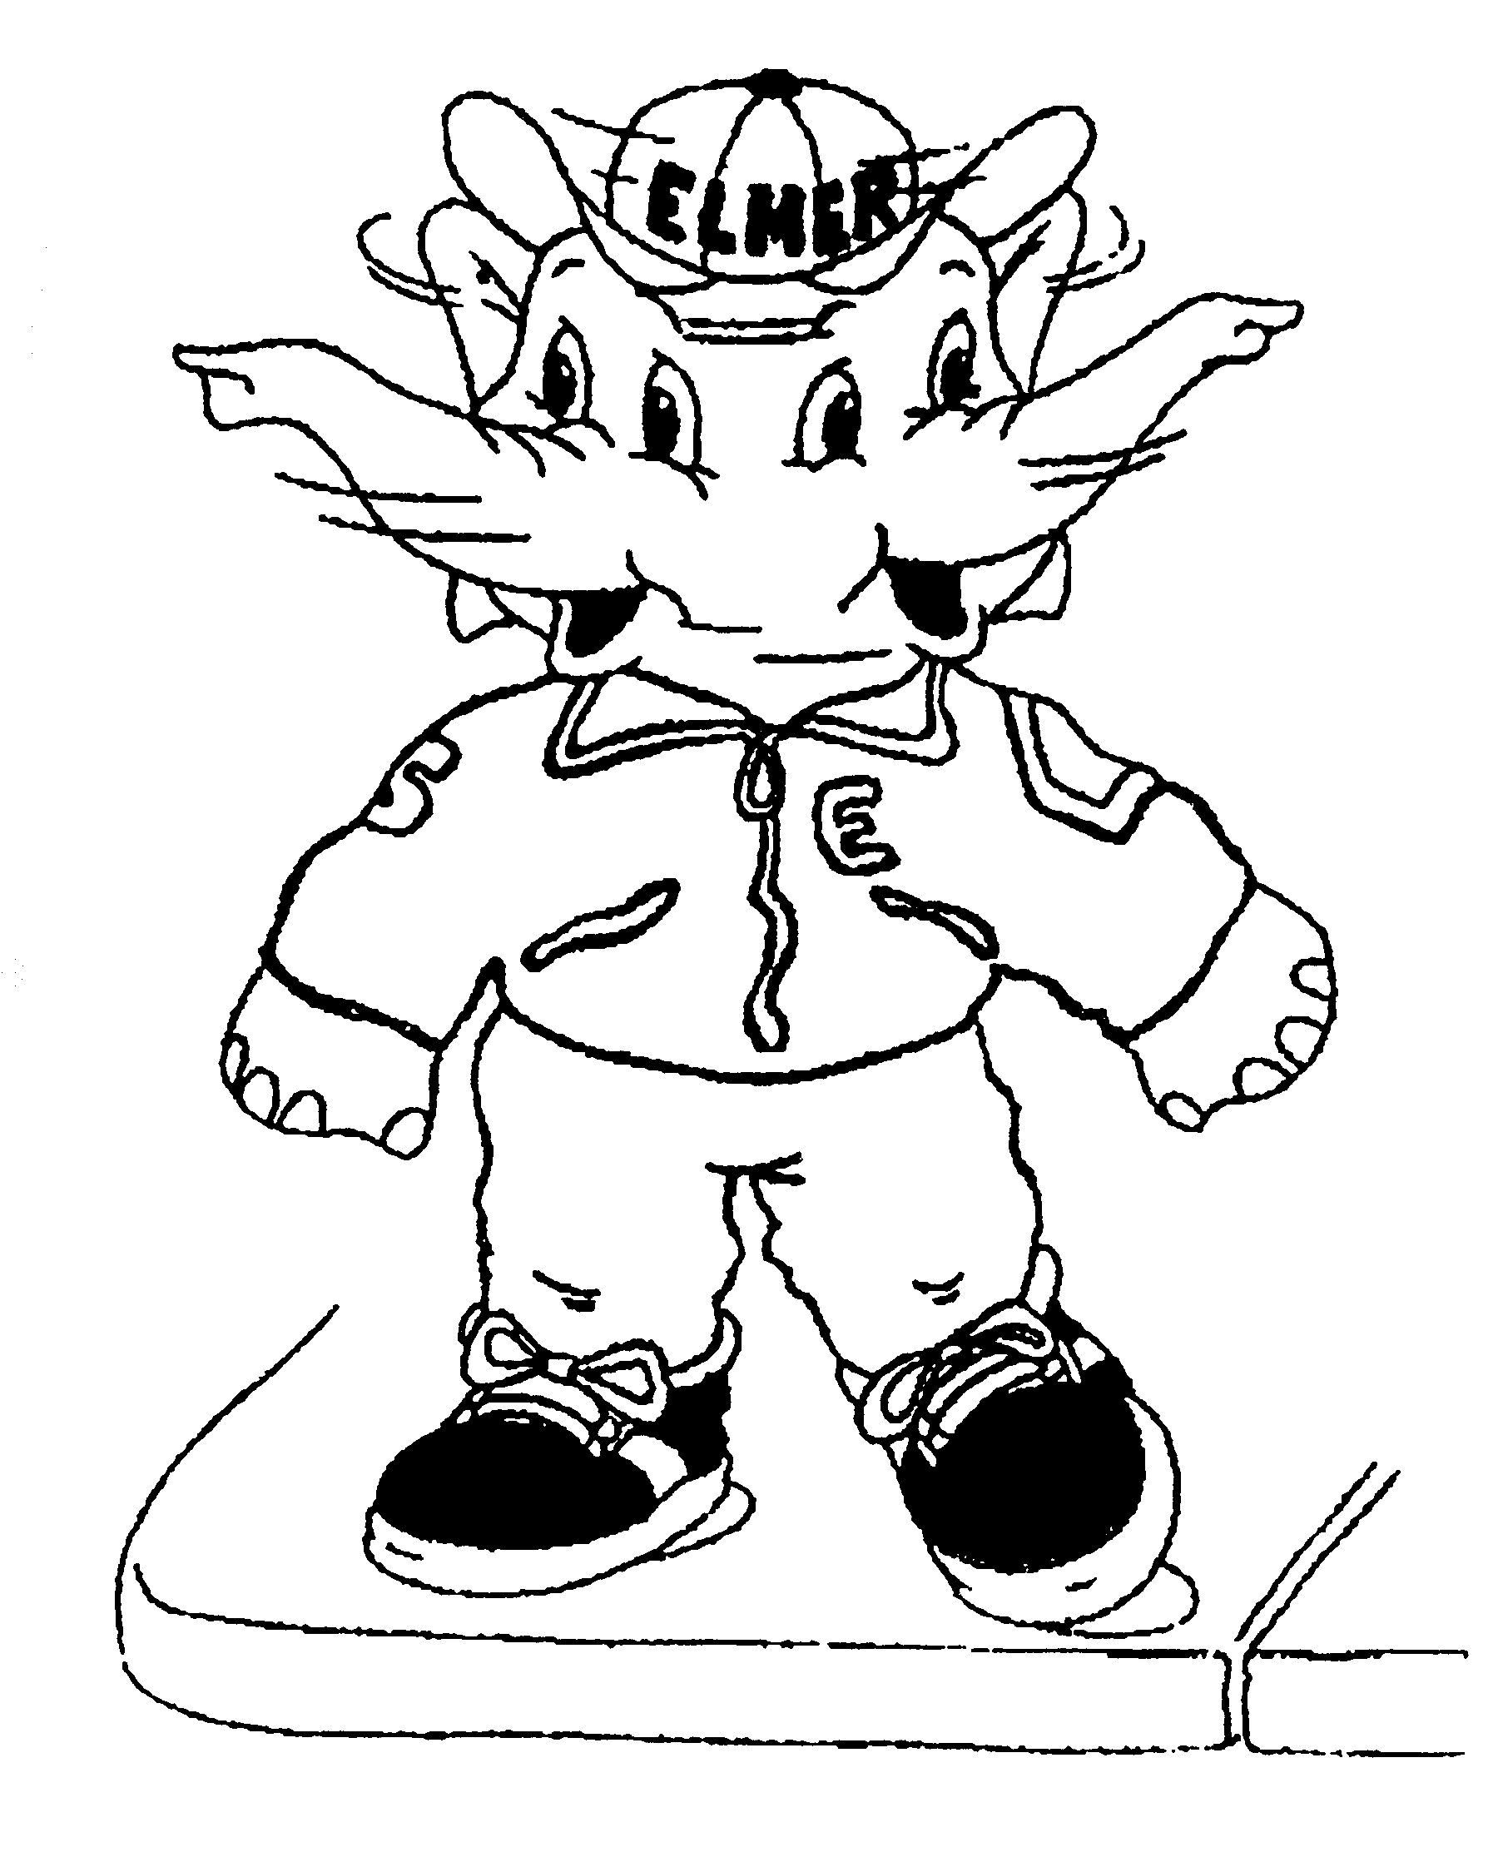

Before you cross the street Use your eyes and ears Before you use your feet

Mark off the days you walk to school and home. If your school has a Kilometre Club, fill in the number of kilometres you complete each week.

Date | Yes, I walked to school | Yes, I walked home from school | # kilometres I completed in the Kilometre Club

Students who participate regularly in the Walk to School program or the Kilometre Club, or both, can send their completed Travel Logs to (local Health Unit) and we will send you a certificate of achievement!

