Standard Bowling Reference Card

Use pencil to keep foot/dot positions and arrow mark references.
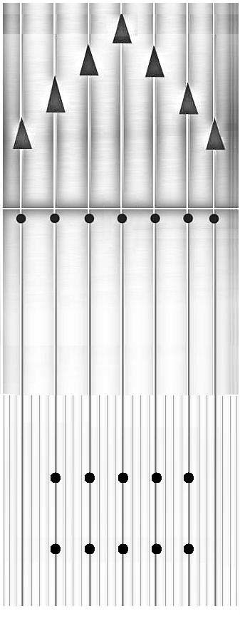

Series Score | Avg. Per Game
340 | 113
360 | 120
380 | 127
400 | 133
420 | 140
440 | 147
460 | 153
480 | 160
500 | 167
520 | 173
540 | 180
560 | 187
580 | 193
600 | 200
620 | 207
640 | 213
660 | 220
680 | 227
700 | 233
720 | 240
740 | 247
760 | 253
780 | 260
800 | 267

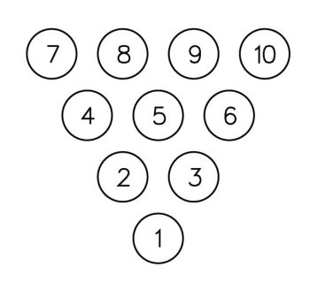

Remarks

Lane Setup Notes

Left Lane Right Lane

Position | Result | Position | Result

