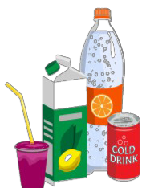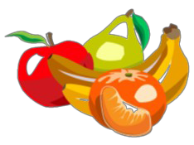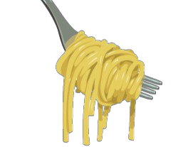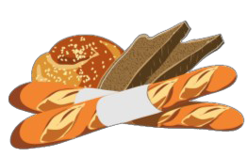

Grocery**List**

Dairy/Fridge Baking/Dry Goods Sauces/Condiments Frozen

□

□

□

□

□

□

□

□

□

□

□

□

□

□

□

□

□

□

□

□

□

□

□

□

Butter Cheese Shredded

String

Block/Sliced Heavy Cream Cream Cheese Dips

Eggs

Half & Half Milk

Sour Cream Yogurt

Oatmeal Oil Olive Oil

Coconut Oil

Vegetable Oil Shortening Sugar

Brown Sugar

Granulated Sugar Powdered Sugar Vanilla

Yeast

Mayonnaise Mustard Peanut Butter Salsa

Soy Sauce Steak Sauce Tarter Sauce

Fruits

Ice Cream Juice Pizza

Potato Products Vegetables

□

□

□

□

□

□

□

□

□

□

□

□

□

□

□

□

□

□

□

□

□

□

□

Beans/Pasta/Grains Fresh Vegetables

□

Beans

□

□

□

□

□

□

□

□

□

□

□

□

□

□

□

□

□

□

Asparagus Broccoli Carrots Cauliflower Celery Corn Cucumbers Lettuce Onions Peppers Potatoes Spinach Squash Tomatoes Zucchini

□

□

Lasagna

Mac and Cheese Noodle Mixes Ramen

Rice Brown Instant White Wild

Spaghetti

□

Canned Goods □

□

□

□

□

□

□

□

□

□

□

□

□

□

□

□

□

□

Applesauce Canned Beans Canned Fruits Canned Soups Carrots

Corn

Diced Tomatoes Green Beans Tomato Sauce Tuna

Spaghetti Sauce Canned Peas

□

□

□

□

□

□

□

□

□

□

□

□

□

□

Bacon Chicken Ground Beef Deli Meat Fish

Ham

Hot Dogs/Brats Pork

Sausage Turkey

□

□

□

□

□

□

□

□

□

□

□

□

□

□

□

□

□

□

□

□

Black Pepper Cinnamon Cumin Garlic

Onion Powder Oregano Paprika Parsley

Salt

□

□

□

□

□

□

□

□

□

□

□

□

Apples Bananas Berries Grapes

Lemons/Limes Melons Oranges Peaches

Plums

Drinks

□

□

□

□

□

□

□

□

□

□

□

Water Juice Soda Tea

□

Cereal

□

□

□

□

□

□

Pancake Mix Pop Tarts Syrup

Bakery

□

Sauces/Condiments □

□

Bagels Bread Buns

Pita Bread Rolls Tortillas

□

□

□

□

□

□

□

□

□

□

□

□

□

□

□

□

□

Baking Powder Baking Soda Canned Milk Chocolate Chips Baking Cocoa Cornstarch Flour

Food Coloring

□

□

BBQ Sauce Dressing

□

□

□

□

□

□

□

□

□

Honey Hot Sauce Ketchup

Baking/Dry Goods

Breakfast

Fresh Fruits

Spices/Herbs

Meats