 |  |  |  |  |  |  |  |  |  |  | 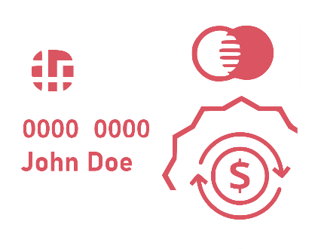
 | RECURRING
 | CREDIT CARD AUTHORIZATION FORM
 | Company Name: |  |  | Paymentrequest Company LTD
 | Company Address: |  |  | 102 Credit Avenue
 | City/State/ZIP: |  |  | Fortwidth, California, CA 20345
 |  |  | PRINCIPLE EXPLAINED
 | You authorize regularly scheduled charges to your checking/savings account or credit card. You will be charged the amount indicated below each billing period. A receipt for each payment will be emailed to you and the charge will appear on your bank statement. You agree that no prior-notification will be provided unless the date or amount changes, in which case you will receive notice from us at least 10 days prior to the payment being collected.
 |  |  | CARDHOLDER CONSENT
 | By signing this document, I |  |  |  | John Doe |  |  | authorize |  | COMPANY NAME |  |  |  | to
 |  |  |  |  | (Full Name) |  |  |  |  | (Business Name)
 | charge my credit card indicated below for |  |  |  |  |  | $1,200.00 |  | on the |  | 25th |  | of each
 |  |  |  |  |  |  | (Amount $) |  |  |  | (Day/Date)
 | Month |  |  | for payment of my |  | Electrical bike rent
 | (Frequency) |  |  |  |  | (Type of Bill)
 | Billing Address:
 | City/State/ZIP:
 | Phone or Email:
 | SIGNATURE: |  |  |  |  |  |  |  | Date:
 |  |  | CREDIT CARD INFO
 | Cardholder Name: |  |  | John Doe
 | Credit Card Type: |  |  | VISA
 | Account Number: |  |  | 0000 0000
 | Expiry Date: |  |  | Dec-21
 | CVV (Digits): |  |  | 0000
 |  |  |  |  |  |  |  |  |  |  | © TemplateLab.com

