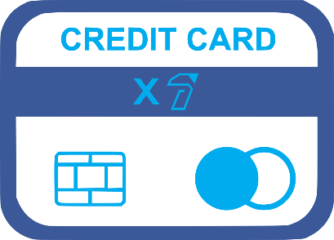  COMPANY NAME |  | One Time Credit Card Authorization Form
Sign and complete this form to authorize COMPANY NAME HERE to make a one-time debit to your credit card listed below.
By signing this form you give us permission to debit your account for the amount indicated on or after the indicated date. This is permission for a single transaction only, and does not provide authorization for any additional unrelated debits or credits to your account.

Payment System
 |  | CARDHOLDER INFORMATION
 |  | Company /Name:
 |  | Billing Address:
 |  | City/State/ZIP:
 |  | Phone or Email:
 |  | Date:
 |  | CREDIT CARD INFORMATION
 |  | Account Type: |  |  |  | ☐ | Visa |  |  | ☐ | MasterCard
 |  |  |  |  |  | ☐ | American Express |  |  | ☐ | Discover
 |  | Cardholder Name:
 |  | Account Number:
 |  | Expiration Date:
 |  | CVV2 (digits):
 |  | VERIFICATION
 |  | Signature:
 |  | Date:
 |  | Payment purpose:
 |  | I authorize the above named business to charge the credit card indicated in this authorization form according to the terms outlined above. This payment authorization is for the purpose stated above, for the amount indicated above only, and is valid for one-time use only.
 |  |  |  |  |  |  |  | © TemplateLab.com

