100 CUSTOMER SATISFACTION SURVEY RESULTS - PRODUCT X

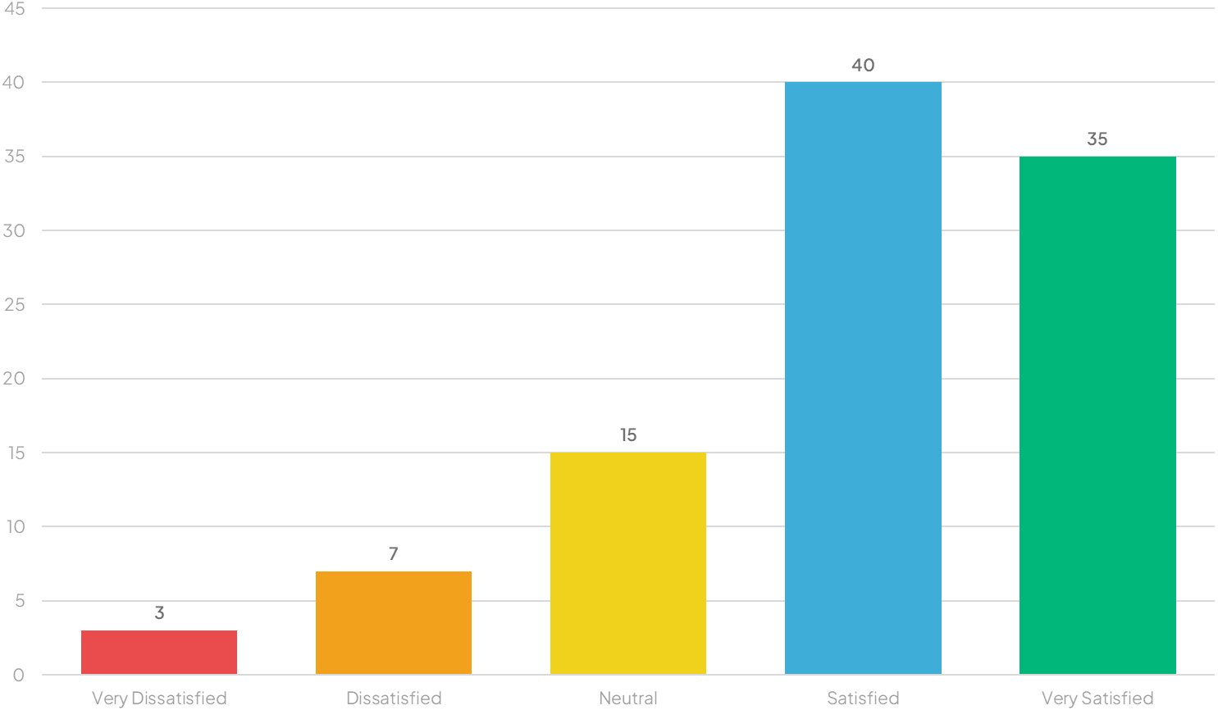

People