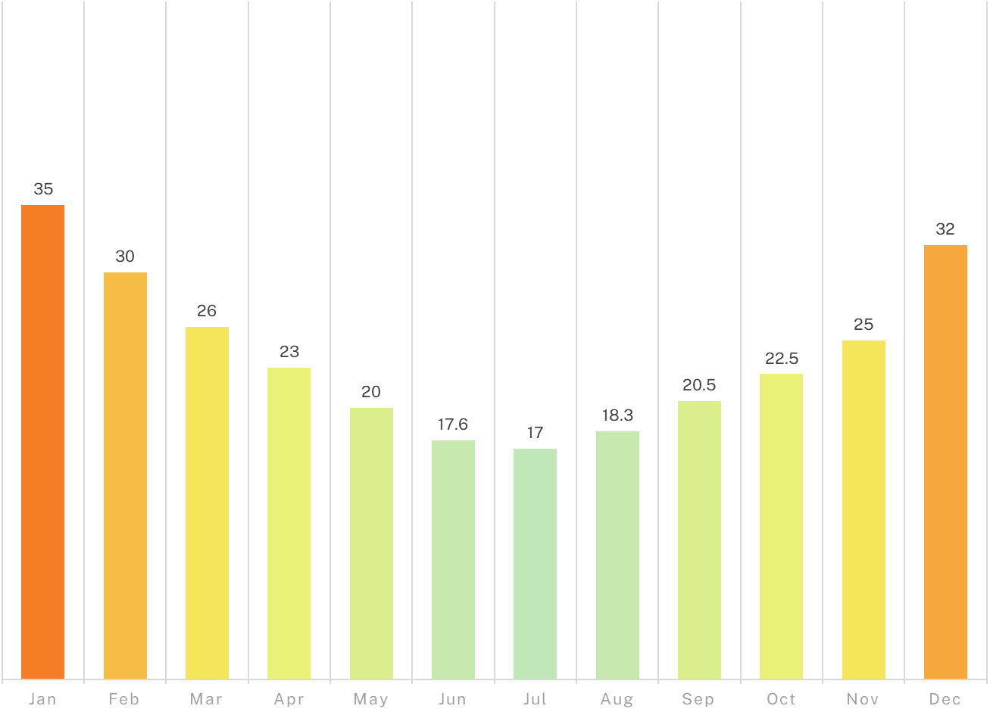

**Cold**

0°C - 12.5°C

**Cool**

13°C - 25°C

**Warm**

25.5°C - 36°C

**Hot**

37°C - 50°C

**Sydney Australian Temperature Trends**

*Exploring Average Temperatures Across Australia from 2010 to 2020 taken from* ***Meteorological Institute of Australis***

**Temperature bar graph template**