Retail outlets, including stores or shops, focusing on clothing, footwear, accessories, and fashion-related merchandise

**Fashion Stores**

Retail stores primarily specializing in providing a diverse range of food, beverages, household essentials, and groceries

**Grocery Stores**

Cafés or coffeehouses providing   
a diverse selection of coffee beverages, snacks, and light   
meals within a laid-back setting

**Coffee Shops**

Stores specializing exclusively in offering electronic devices, gadgets, appliances, and technology-related products

**Electronics Stores**

The variety and quality of products available for purchase in the store, including brands, styles, and options

**Product Selection**

The level of assistance, support, and friendliness provided by the staff to customers during their shopping experience

**Customer Service**

The perceived affordability and competitiveness of the prices of products and services offered by the store

**Price**

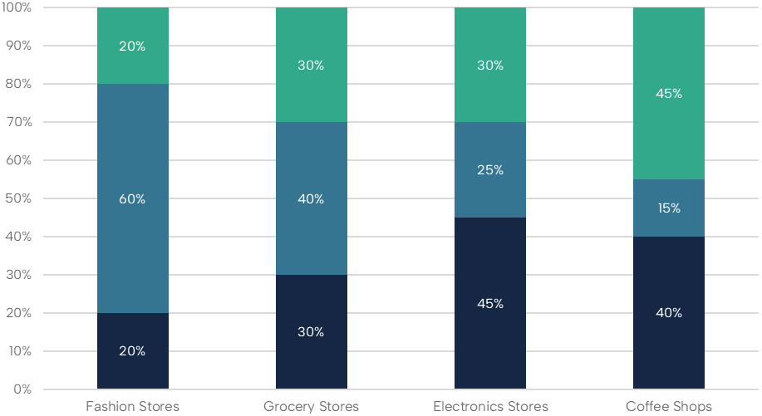

**EVALUATION OF SHOPPING EXPERIENCE AT SHOPPING CENTERS**

Stacked bar template