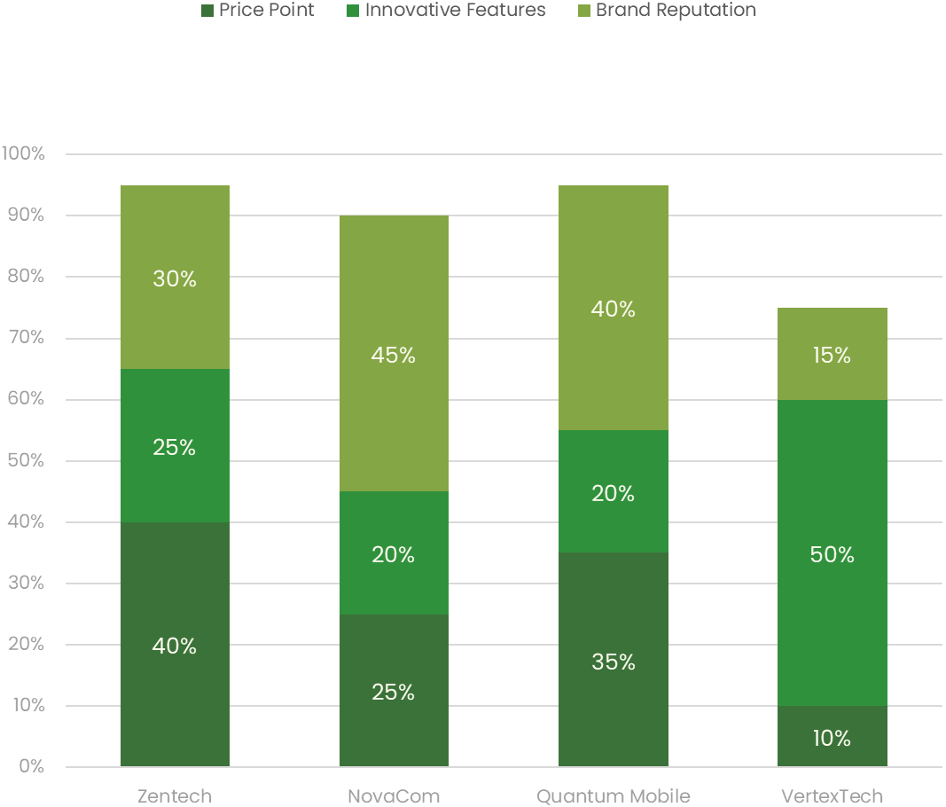

Focus on budget-friendly, offering competitive features for budget-conscious consumers

Price Point

Focus on innovation, introducing cutting-edge technologies, appealing greatly to consumers seeking advanced features

Innovative Features

Maintain a strong reputation for reliability, attracting consumers valuing trusted reputation among phone manufacturers

Brand Reputation

**Electronics Brand Preference**

Segmented bar graph template