Horizontal bar graph template

The survey was conducted from **04/01/2024 - 04/15/2024**, with

data collected over a 2-week period

Featuring a cohort of **500 participants**,

the research received active engagement throughout the survey process

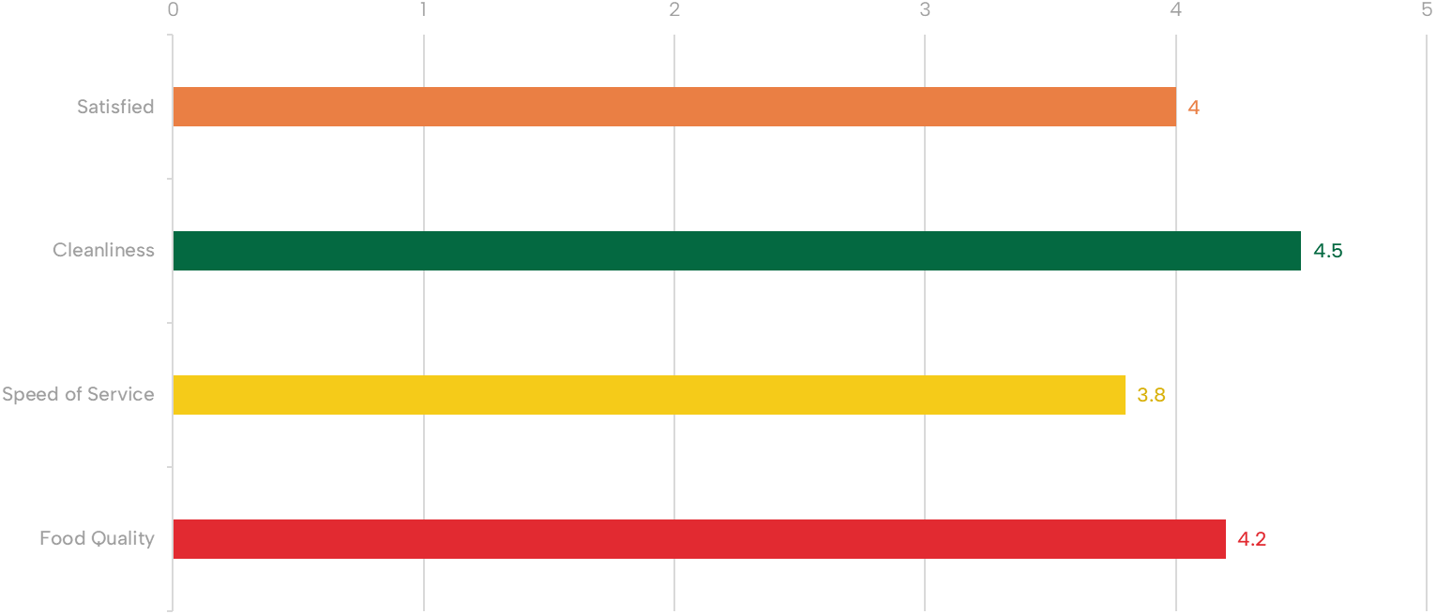

Point

**FAST FOOD X FEEDBACK - UNDERSTANDING CUSTOMER SATISFACTION**