Double bar graph template

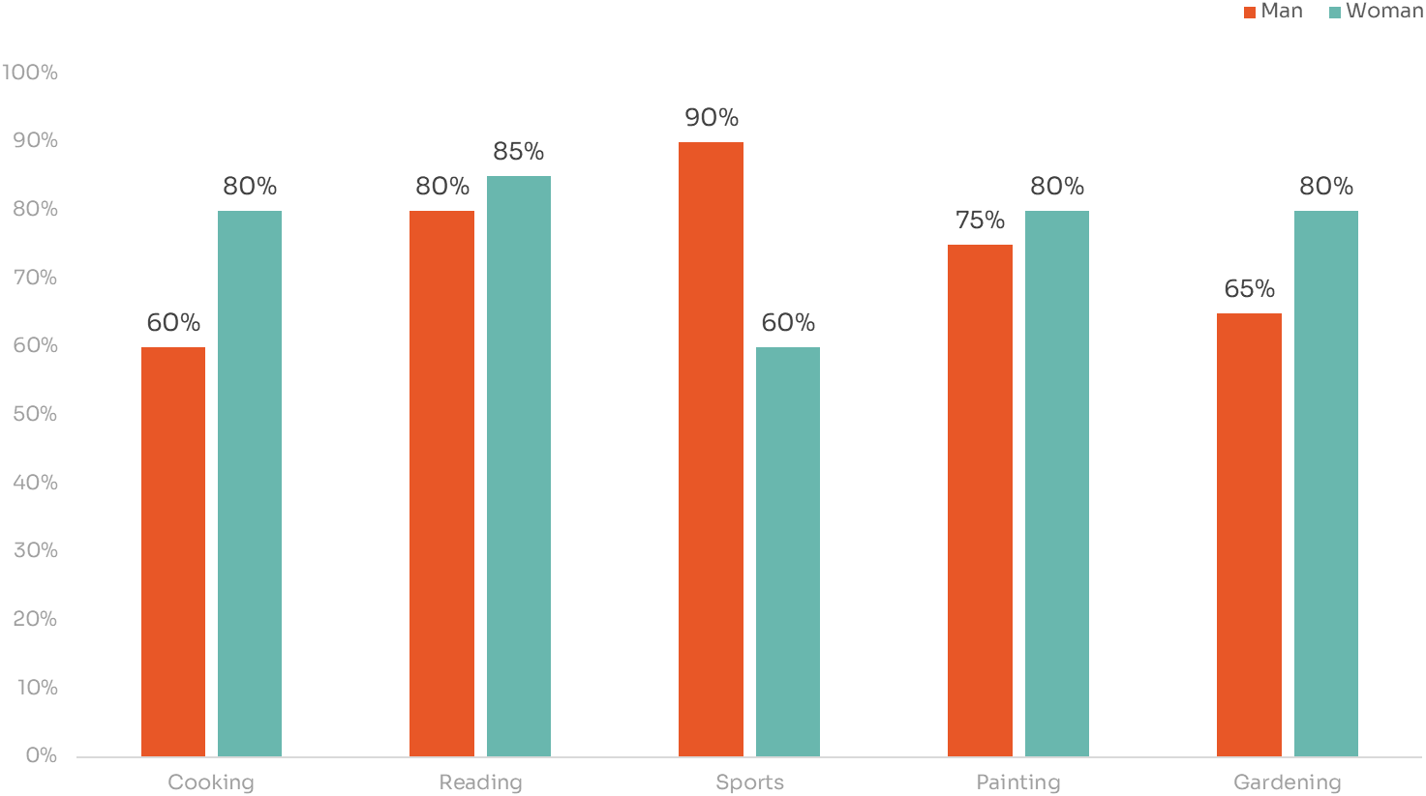

Analyzing Gender-based Hobbies Preferences among Individuals - Data collected from a Survey Conducted in April 2024

**GENDER HOBBIES PREFERENCE SURVEY**