1000

Surveyors

2 months

Survey time

50

Total Area

18 - 45

Age Range

$4,000

Average Income

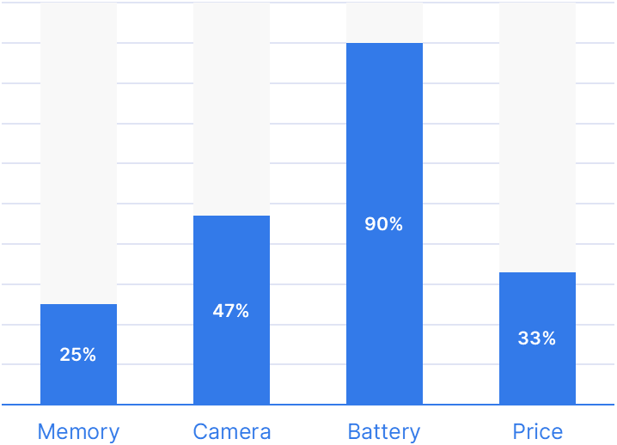

Product

Number Two

VS

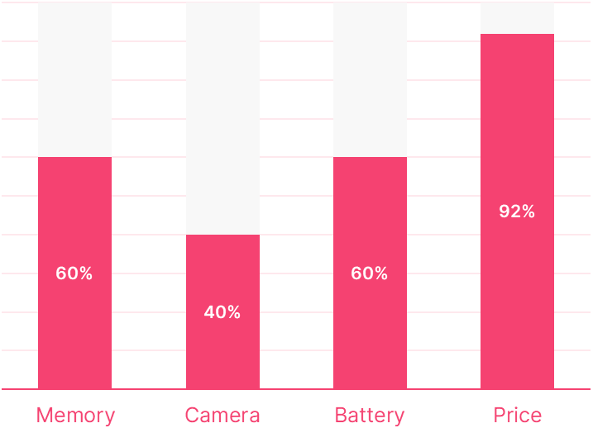

Product

Number One

COMPARISON BAR GRAPH

2024