 | CAR PAYMENT SCHEDULE
 | 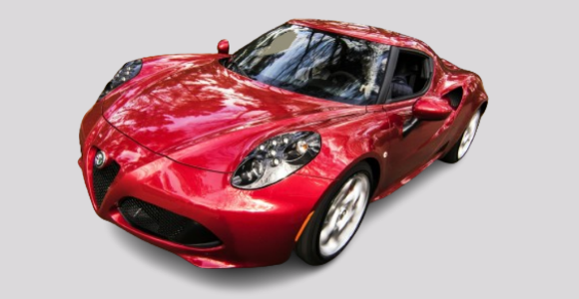 |  |  |  | Make and Model: | Velocity Motors - Thunderbolt V8
 |  |  |  |  | Engine: | 4.0L V8 Turbocharged
 |  |  |  |  | Year: | 2024
 |  |  |  |  | Fuel Type: | Premium Unleaded
 |  |  |  |  | Price: | $38,500.00
 |  |  |  |  | Down Payment: | $7,700.00
 |  |  |  |  | Loan Provider: | National Bank of Greece
 | Input Data |  |  |  | Loan Summary
 | Annual interest rate |  | 7% |  | Scheduled payment |  | $1,122.10
 | Loan term (in years) |  | 2.5 |  | Scheduled no. of payments |  | 30
 | Payments per year |  | 12 |  | Actual no. of payments |  | 28
 | Loan amount |  | $30,800 |  | Total extra payments |  | $2,700.00
 | Extra payment |  | $100 |  | Total interest |  | $2,611.53
 | Period | Scheduled  Payment | Extra  Payment | Total  Payment | Principal | Interest | Balance
 | 0 |  |  |  |  |  | $30,800.00
 | 1 | $1,122.10 | $100.00 | $1,222.10 | $942.44 | $179.67 | $29,757.56
 | 2 | $1,122.10 | $100.00 | $1,222.10 | $948.52 | $173.59 | $28,709.05
 | 3 | $1,122.10 | $100.00 | $1,222.10 | $954.63 | $167.47 | $27,654.41
 | 4 | $1,122.10 | $100.00 | $1,222.10 | $960.79 | $161.32 | $26,593.63
 | 5 | $1,122.10 | $100.00 | $1,222.10 | $966.97 | $155.13 | $25,526.66
 | 6 | $1,122.10 | $100.00 | $1,222.10 | $973.20 | $148.91 | $24,453.46
 | 7 | $1,122.10 | $100.00 | $1,222.10 | $979.46 | $142.65 | $23,374.00
 | 8 | $1,122.10 | $100.00 | $1,222.10 | $985.75 | $136.35 | $22,288.25
 | 9 | $1,122.10 | $100.00 | $1,222.10 | $992.09 | $130.01 | $21,196.16
 | 10 | $1,122.10 | $100.00 | $1,222.10 | $998.46 | $123.64 | $20,097.70
 | 11 | $1,122.10 | $100.00 | $1,222.10 | $1,004.87 | $117.24 | $18,992.83
 | 12 | $1,122.10 | $100.00 | $1,222.10 | $1,011.31 | $110.79 | $17,881.52
 | 13 | $1,122.10 | $100.00 | $1,222.10 | $1,017.79 | $104.31 | $16,763.73
 | 14 | $1,122.10 | $100.00 | $1,222.10 | $1,024.31 | $97.79 | $15,639.41
 | 15 | $1,122.10 | $100.00 | $1,222.10 | $1,030.87 | $91.23 | $14,508.54
 | 16 | $1,122.10 | $100.00 | $1,222.10 | $1,037.47 | $84.63 | $13,371.07
 | 17 | $1,122.10 | $100.00 | $1,222.10 | $1,044.10 | $78.00 | $12,226.97
 | 18 | $1,122.10 | $100.00 | $1,222.10 | $1,050.78 | $71.32 | $11,076.19
 | 19 | $1,122.10 | $100.00 | $1,222.10 | $1,057.49 | $64.61 | $9,918.70
 | 20 | $1,122.10 | $100.00 | $1,222.10 | $1,064.24 | $57.86 | $8,754.45
 | 21 | $1,122.10 | $100.00 | $1,222.10 | $1,071.04 | $51.07 | $7,583.42
 | 22 | $1,122.10 | $100.00 | $1,222.10 | $1,077.87 | $44.24 | $6,405.55
 | 23 | $1,122.10 | $100.00 | $1,222.10 | $1,084.74 | $37.37 | $5,220.81
 | 24 | $1,122.10 | $100.00 | $1,222.10 | $1,091.65 | $30.45 | $4,029.17
 | 25 | $1,122.10 | $100.00 | $1,222.10 | $1,098.60 | $23.50 | $2,830.57
 | 26 | $1,122.10 | $100.00 | $1,222.10 | $1,105.59 | $16.51 | $1,624.98
 | 27 | $1,122.10 | $100.00 | $1,222.10 | $1,112.62 | $9.48 | $412.35
 | 28 | $414.76 | $0.00 | $414.76 | $412.35 | $2.41 | $0.00
 |  |  |  |  |  |  | © TemplateLab.com

