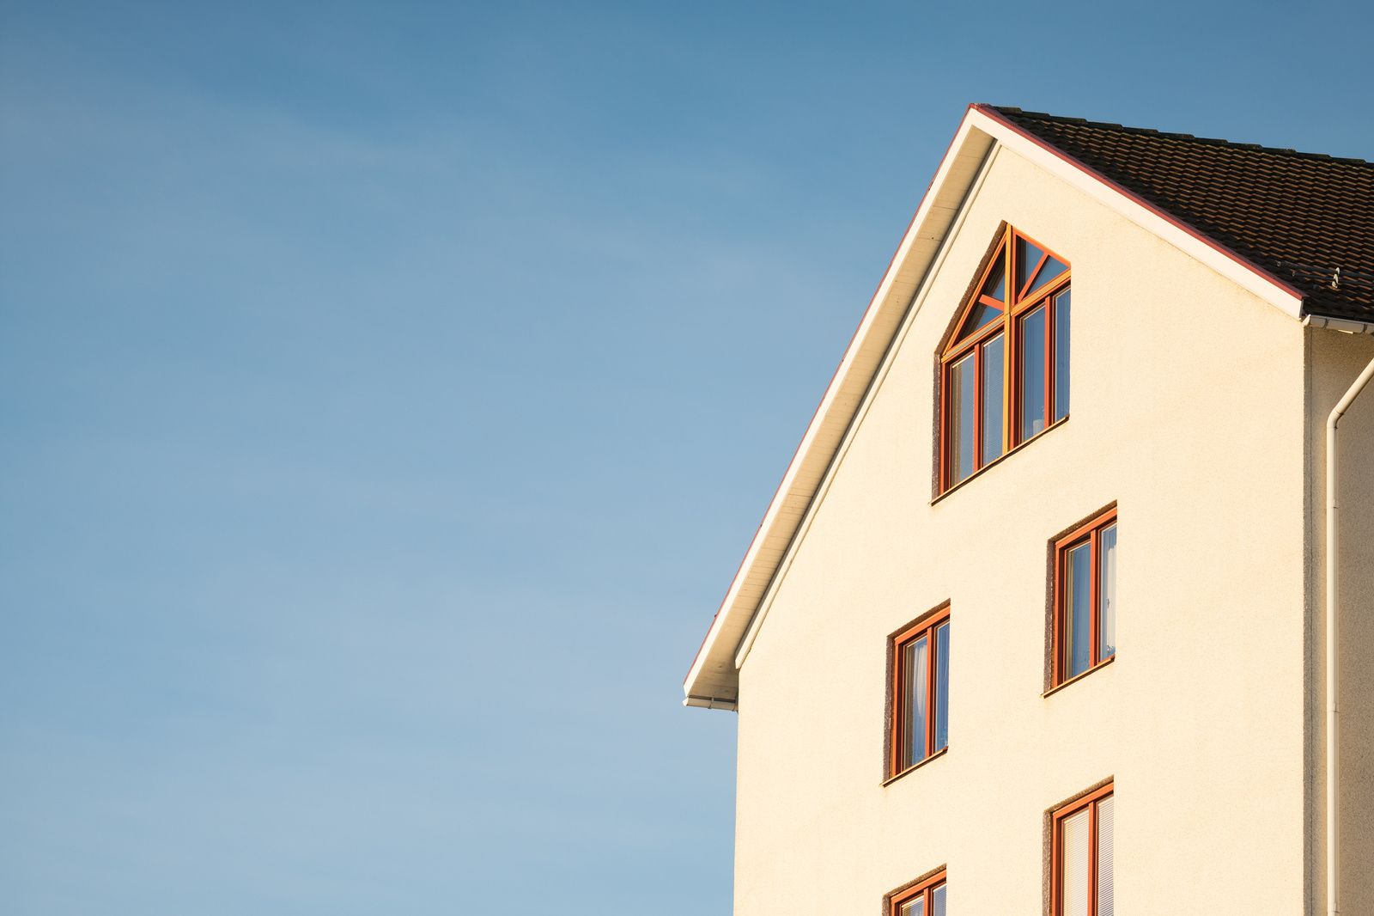

**Property Description**

Nestled in the heart of Luxury Estates City, this   
stunning modern estate embodies luxury living at its finest. Meticulously designed with clean lines and sophisticated finishes, the residence offers an unparalleled level of comfort and elegance. From the breathtaking views to

the meticulously landscaped grounds, every aspect of

this property exudes opulence and refinement.

**Key Features**

Expansive floor-to-ceiling windows offering panoramic views of the surrounding landscape

**1.**

**2.**

Gourmet chef's kitchen with high-end appliances and marble countertops

**3.**

Outdoor entertainment area featuring

a heated swimming pool, spa, and fully equipped outdoor kitchen

**4.**

Smart home technology controlling lighting, climate, and security systems

**Amenities**

Gated entrance with 24-hour security

Tennis court and fitness center exclusively for residents

Convenient access to upscale dining, shopping, and

entertainment options

Lot Size

1.5 acres

Property Type

Single-Family Residence

Interior Square Footage

6,500 sq ft

Address

1 Elite Boulevard, Luxury Estates City, Prestige County, St., Any City 123

Year Built

2021

Bedrooms

5

Bathrooms

6 full, 2 half

Architectural Style

Modern

Homeowners Association Fee

$1,200/month

Property Taxes

$35,000/year

**Pricing Information**

123-456-7890

COMPANYNAME.COM

CONTACT FOR MORE INFORMATION

**$5,750,000**

SALE PRICE

BUY NOW

**Company Name**

Specializes in real estate

**Luxurious Modern Estate**

**in Prime Location**