 | 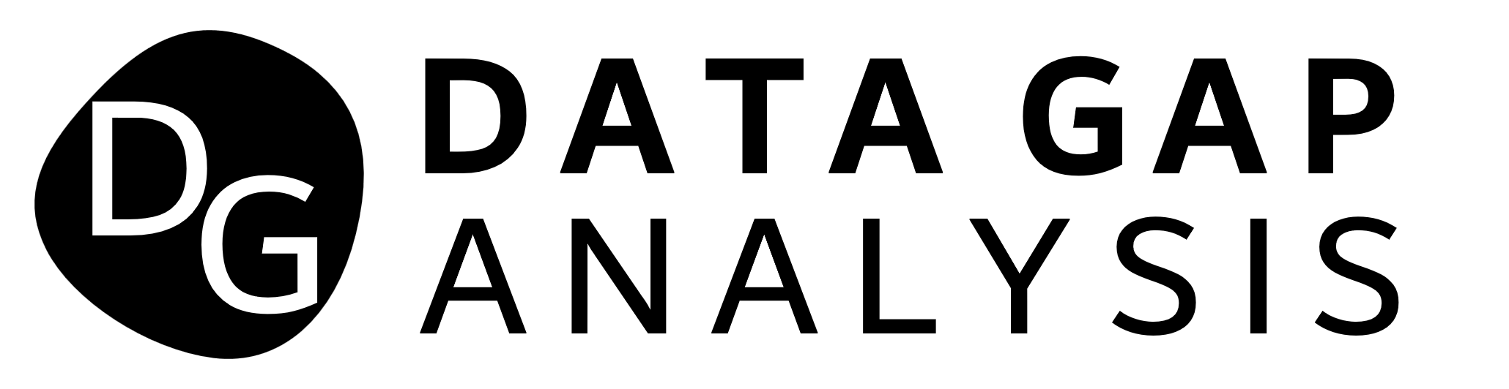 |  |  |  |  |  | COMPANY NAME
 |  |  |  |  |  |  | 145 West Avenue, 21323 New York
 |  |  |  |  |  |  | info@mycompanyname.com
 |  |  |  |  |  |  | (555) 123-456-7890
 | Use Data Gap Analysis Template to evaluate your organization’s actual performance against goals you set to keep your company going forward. Identify gaps between where you are now and where you want to be. Propose possible next steps to bridge the identified gaps. The overall goal is to improve data accuracy, completeness, and alignment with your strategic objectives.
 | Data Accuracy and Completeness |  |  |  |  |  | Representation of Key Metrics
 |  | GAP DESCRIPTION: |  |  |  |  |  | GAP DESCRIPTION:
 |  | Essential data elements are absent or incomplete. Data lacks desired quality, granularity, or timeliness. |  |  |  |  |  | Gaps may exist in tracking KPIs accurately. Incomplete financial data.
 |  | CONSEQUENCES: |  |  |  |  |  | CONSEQUENCES:
 |  | The conclusions that are drawn become relativized and imprecise. |  |  |  |  |  | This can hinder decision-making and forecasting.
 |  | PRIORITY: | MEDIUM |  |  |  |  | PRIORITY: | LOW
 |  | POSSIBLE NEXT STEPS: |  |  |  |  |  | POSSIBLE NEXT STEPS:
 |  | Establish clear guidelines for data collection, storage, and management - aligned with business goals. |  |  |  |  |  | Ensure consistent data capture across systems and departments. Use APIs and automation.
 | Technology Infrastructure and Data Security |  |  |  |  |  | Supply Chain and Inventory Data
 |  | GAP DESCRIPTION: |  |  |  |  |  | GAP DESCRIPTION:
 |  | Gaps in data storage, retrieval, and security. Inadequate protection against data breaches. |  |  |  |  |  | Gaps in tracking inventory. Incomplete supplier information.
 |  | CONSEQUENCES: |  |  |  |  |  | CONSEQUENCES:
 |  | Loss of data and exposing of critical data to competition and unwanted audience. |  |  |  |  |  | Can lead to stockouts or excess stock and affects procurement decisions.
 |  | PRIORITY: | HIGH |  |  |  |  | PRIORITY: | LOW
 |  | POSSIBLE NEXT STEPS: |  |  |  |  |  | POSSIBLE NEXT STEPS:
 |  | Ensure compliance with privacy laws. Protect data from breaches and unauthorized access. |  |  |  |  |  | Invest in robust data warehousing solutions. Leverage cloud platforms for scalability and accessibility.
 | Risk and Compliance Data |  |  |  |  |  | Customer Data and Insights
 |  | GAP DESCRIPTION: |  |  |  |  |  | GAP DESCRIPTION:
 |  | Regulatory compliance gaps. Inadequate risk assessment data. |  |  |  |  |  | Incomplete or outdated customer profiles. Gaps in understanding customer behavior.
 |  | CONSEQUENCES: |  |  |  |  |  | CONSEQUENCES:
 |  | This can result in legal risks and prevents effective risk management. |  |  |  |  |  | This affects marketing and sales strategies and also leads to missed opportunities.
 |  | PRIORITY: | MEDIUM |  |  |  |  | PRIORITY: | LOW
 |  | POSSIBLE NEXT STEPS: |  |  |  |  |  | POSSIBLE NEXT STEPS:
 |  | Define validation rules to flag incomplete or erroneous data. Contact SME for risk management. |  |  |  |  |  | Create data lakes for raw data storage and exploration.
 |  |  |  |  |  |  |  |  | © TemplateLab.com

